3GPP TSG-RAN WG4 Meeting # 96-e R4-200XXXX
Electronic Meeting, 17 – 27 August, 2020

Agenda item: 13.1
Source: Moderator (Apple Inc.)
Title: Email discussion summary for [96e][330] FR2_enhTestMethods
Document for: Information

Introduction
The email discussion on Rel-17 enhanced test methods for FR2 is organized as follows:
Topic #1 covers aspects related to the high DL power and low UL power test cases (including the scope of remaining issues, UE beam management sensitivity, and path loss comparisons).
Topic #2 covers aspects related to polarization mismatch (including aspects related to the EIRP measurements and UL demodulation by test equipment).
Topic #3 covers aspects related to the test setup for inter-band DL CA in FR2 (including aspects related to 1 AoA vs. distributed AoAs).
Three documents were submitted to the top level agenda, and the moderator’s recommendations are captured in Topic #4 (although this topic is not used for email discussion).

Topic #1: High DL power and low UL power test cases
Main technical topic overview. The structure can be done based on sub-agenda basis.

Companies’ contributions summary
T-doc number | Company | Proposals / Observations
R4-2009960 | Apple Inc. | Remaining issues with the test methodology for high DL power and low UL power test cases  Proposal 1: Progress the work on the high DL power / low UL power objective in two tracks: one examining possible enhancements to the permitted test methods listed in TR38.810 and another focusing on alternative methods.
R4-2010856 | MVG Industries, Sony | Summary and Further Results on Impact of phase variation on beam pattern for NF test method  Observation 1: Beam patterns and spherical coverage curve are not sensitive to a phase curvature of 65deg at 28GHz which corresponds to 0.3m range length  Observation 2: Beam patterns and spherical coverage curve are not sensitive to a phase curvature of 59deg at 38GHz which corresponds to 0.3m range length  Proposal 1: the following factors shall be taken into account for the simulation setup for studying the phase curvature impact:  - Simulated Frequency: 28 GHz, and 38GHz  - DUT size: length: 150 mm; width: 70 mm; height: 7mm  - Array inter-element distance: λ/2  - Array size: 4x1 linear array at 28GHz and 38GHz  - Array offset (wrt DUT’s physical center): (x=-75; y=-35; z=0) mm  - Measurement antenna
R4-2011218 | Keysight Technologies | On Test methodology for high DL power and low UL power test cases  Observation 1: White box testing generally requires the declaration by the manufacturer which antenna panel is active in any UL/DL test direction and the detailed locations of the panels within the DUT for full test case coverage  Observation 2: For CATR test systems based on IFF test methodology white box vs black box testing makes little difference  Observation 3: For DFF and DNF systems, white box testing could eliminate the offset MU and potentially yield quality of quiet zone MUs for DFF and DNF based test systems similar to those of CATR based test systems  Observation 4: Feedback whether enhanced testability methods need to perform beam peak searches and spherical coverage tests was inconclusive.  Observation 5: If white box test approach is selected for an enhanced NF test methodology, x-y-z positioning systems to fully automate test cases will likely affect the Quality of QZ MU and increase test system complexity.  Observation 6: If white box test approach is selected for an enhanced NF test methodology, a vendor declaration is required which antenna panel is active in any UL/DL test direction and the detailed locations of the panels within the DUT.  Observation 7: For white box testing, the min. range lengths for NF systems capable of single direction, TRP, and spherical coverage test cases is larger than for black box testing  Observation 8: The reduction in pathloss for NF systems is about 13dB (11dB) for black (white) box testing when compared to IFF.  Observation 9: Performing black-box DNF measurements with a UE and offset antennas in the known beam peak direction can yield incorrect EIRP/EIS measurements  Observation 10: Performing accurate black-box DNF measurements with a UE and offset antennas requires local searches around the known beam peak direction to improve EIRP/EIS measurements.  Observation 11: When performing DNF measurements of NR FR2 devices utilizing beam forming, the beam forming of the UE towards the DNF measurement probe could result in measurements of undesired beams and incorrect EIRP/EIS beam peak measurements  Observation 12: Assuming a 30cm QZ diameter and a 20cm range length, near-field path loss differences up to ~17dB can be observed.  Observation 13: The novel NF testing approach with Transform shows very promising measurement accuracies for NF EIRP measurements  Observation 14: The novel NF testing approach with Transform can accurately predict the offset of the antenna array from the centre of QZ.  Observation 15: Large uncertainties can be observed for TRP for measurements performed in the NF utilizing the black back box approach.  Observation 16: With the offset of the antenna array known, e.g., estimated with the enhanced NF methodology introduced in this contribution, very accurate TRP measurements in the NF can be made with a TRP offset compensation approach  Proposal 1: Keep the black box test approach for NR FR2 conformance testing  Proposal 2: Adopt the effective antenna aperture approach, i.e., taking into account the frequency dependence of the max antenna array aperture, for DNF and possibly DFF range length determinations  Proposal 3: DNF systems to utilize an FF probe and UBF activation that allows the UE to select the intended beam.  Proposal 4: The DNF testing methodology without any transform cannot be considered for NR FR2 testing for EIRP/EIS based metrics.  Proposal 5: Feedback from industry is requested whether to continue efforts in terms of simulations and empirical investigations on this enhanced NF methodology with transform  Proposal 6: When performing TRP measurements in the NF, the offsets should be compensated to improve the measurement uncertainty.
R4-2011281 | Rohde & Schwarz | Views on test methods for high DL power and low UL power TCs  Proposal []: RAN4 to focus on solving testability issues for the following test cases:  - Transmit OFF power.  - (Receiver) Spurious emissions  - Spurious emission band UE co-existence
R4-2011456 | Qualcomm Incorporated | FR2 testability enhancement for UE emissions  Observation 1: It is beneficial to pursue alternative solutions to reduce the gap between testability limits and core requirements, even if the result is only a partial reduction in the gap.

Open issues summary
Before e-Meeting, moderators shall summarize list of open issues, candidate options and possible WF (if applicable) based on companies’ contributions.

Sub-topic 1-1: Scope of remaining issues
Sub-topic description:
Open issues and candidate options before e-meeting:
Issue 1-1-1: Whether the scope of the impacted high DL power and low UL power test cases can be further narrowed
- Proposals
  - Alt 1-1-1-1: According to WF in R4-1913070:
    - 6.3.2 Transmit OFF power
    - 6.5.1 Occupied bandwidth
    - 6.5.2.3 Adjacent channel leakage ratio
    - 6.5.3.2 Additional spurious emissions
    - 7.5 Adjacent channel selectivity (case 1)
    - 7.6.2 In-band blocking
    - 7.9 Receiver spurious emissions
  - Alt 1-1-1-2: According to R4-2011281 (R&S):
    - Transmit OFF power.
    - (Receiver) Spurious emissions
    - Spurious emission band UE co-existence

Issue 1-1-2: Whether specialized test systems can be considered
- Proposals
  - Alt 1-1-2-1: Yes
  - Alt 1-1-2-2: No

Issue 1-1-3: Whether manufacturer declarations can be considered
- Proposals
  - Alt 1-1-3-1: Yes
  - Alt 1-1-3-2: No
  - Alt 1-1-3-3: further study which detailed information from the vendor declaration is necessary should be discussed and decided

Sub-topic 1-2: UE beam management sensitivity to magnitude/phase variation of the DL signal
Sub-topic description
Open issues and candidate options before e-meeting:
Issue 1-2-1: Whether a study on study on UE beam management sensitivity to magnitude/phase variation of the DL signal needed
- Proposals
  - Alt 1-2-1-1: Yes
  - Alt 1-2-1-2: No

Issue 1-2-2: Simulation assumptions
- Proposal: According to R4-2010856 (MVG, Sony)

Sub-topic 1-3: Common understanding of path loss comparison across system types
Sub-topic description
Open issues and candidate options before e-meeting:
Issue 1-3-1: Whether RAN4 can reach a common understanding on the path loss comparison across IFF/DFF and NF system types
- Proposals
  - Alt 1-3-1-1: According to R4-2011218:
f [GHz] | Antenna Config. 1, 2, and 3  - BLACK BOX -  (PC3 Devices: D=5cm) |  | Antenna Config. 1 and 2  - WHITE BOX -  (PC3 Devices: D=5cm)
 | IFF/DFF | NF | DFF | NF
 | Path Loss with 1m range length | Path Loss with 0.22m range length | Path Loss with 0.88m range length | Path Loss with 0.28m range length
24.25 | 60.16 | 46.86 | 59.01 | 48.93
30 | 62.01 | 48.71 | 60.85 | 50.78
40 | 64.51 | 51.21 | 63.35 | 53.28
43.5 | 65.24 | 51.94 | 64.08 | 54.00
52.6 | 66.89 | 53.59 | 65.73 | 55.65

  - Alt 1-3-1-2: Further study is needed

Companies views’ collection for 1st round

Open issues
Issue | Company Comments
Issue 1-1-1: Whether the scope of the impacted high DL power and low UL power test cases can be further narrowed | Keysight: Alt 1-1-1-1: the SI should focus on test cases that RAN informed industry about and that require relaxations. Limiting the test cases to just regulatory test cases was not the original intent. Even though ACS relaxations have improved, we should continue to keep ACS in the mix as relaxations are >0dB. OBW might have to be added pending discussions in RAN5.
Issue 1-1-2: Whether specialized test systems can be considered | Keysight: it is not very clear how a “specialized test system” is defined, e.g., is a specialized test system a currently not permitted system? We believe non-permitted test systems based on near field should be considered.  MVG: Agree with KS.
Issue 1-1-3: Whether manufacturer declarations can be considered | Keysight: we believe declarations could be considered. However, we believe that white box testing which relies on vendors declaration on antenna locations is not helping to improve the relaxations when compared to existing black box testing. Since we believe RAN4 should focus on black box approach, no additional declarations are really necessary.  MVG: Based on our simulations (presented and non-presented), we cannot conclude yet whether white box would help to improve relaxations. Declarations from vendors should be considered. Anyway, black box versus white box topic has been extensively discussed in RAN4 so we leave the ball to the manufacturers whether to go with either method.
Issue 1-2-1: Whether a study on study on UE beam management sensitivity to magnitude/phase variation of the DL signal needed | Keysight: Yes but we would approach this topic differently (more below).  MVG: We are open to further discuss simulation assumptions, if needed.
Issue 1-2-2: Simulation assumptions | Keysight: we believe the MVG/Sony assumptions need to be augmented and the focus should not just be the CDF curve around 50%-tile. The proposal is based on the 4x1 antenna array which was used for requirements definitions. Since this is a testability SI, we believe that the antenna assumptions should be based on the 8x2 antenna assumptions used for all the other PC3 testability work.  The coordinate system in R4-2010856 seems to be different than what has been agreed for smartphones as well, e.g., top of UE is z in 3GPP but in this contribution x is used for top/bottom, etc.).  Furthermore, the beam steering assumptions were not specified in the MVG/Sony contribution. To keep consistency with previous work, we believe similar/same beam steering assumptions as in G.3.1 of 38.810 should be leveraged. Using the assumptions of the contribution with a 4x1 antenna placed horizontally in the top right corner and beam steering assumptions with 22.5deg and 45deg granularity, a 7.5deg step size grid (leveraging the existing beam peak search grid) as well as NF antenna pattern assumptions and Matlab simulations similar to what was used for spherical coverage simulations for PC3, we get the following spherical coverage curves at a NF range length of 0.3m and in the FF (assumed 20m). While the CDF near and at 50% tile is similar, we can already see that the beam peak (max EIRP) is different.  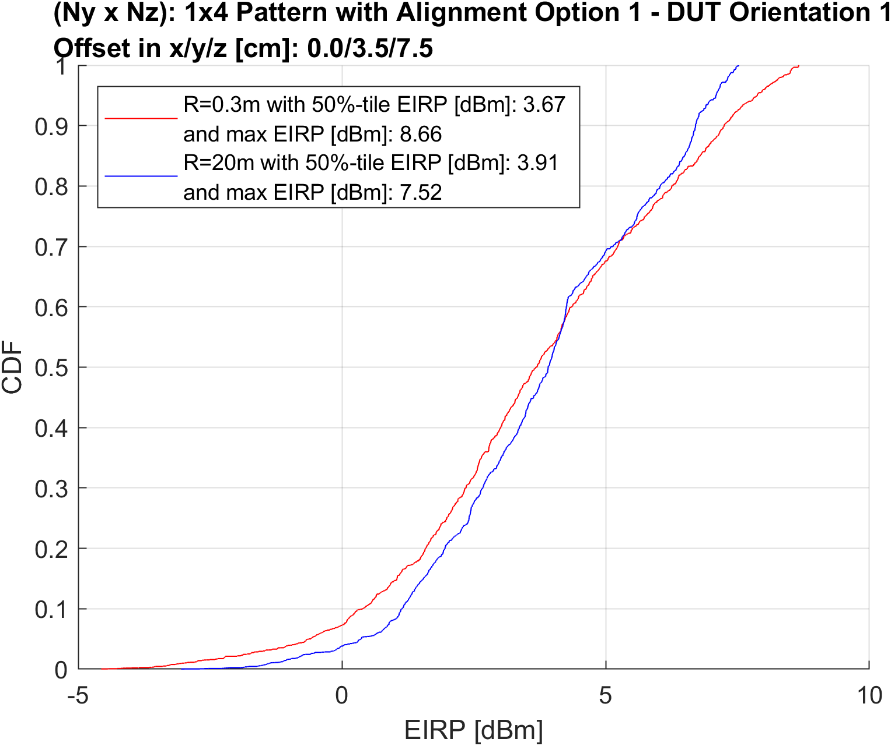  When we change the simulation assumptions to an 8x2 antenna array placed vertically and re-used the assumptions (front and back antenna array, etc) from G.3.1 of 38.810 and assume an offset of 12.5cm in y (approaching the edge of the 30cm diameter QZ), we get the following CDF curve. Again, at 50%-tile, the NF and FF curves match but the beam peaks are different. We therefore do not agree with Observation 1 of R4-2010856  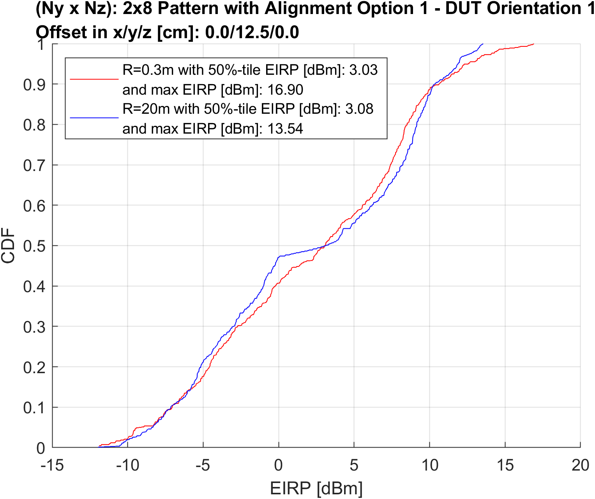
Issue 1-2-2: Simulation assumptions | MVG: Based on KS comments on antenna array orientation versus reference coordinate system, we would like to re do our simulation and see if any effect is captured. Thanks also KS for providing further simulation results. We think max EIRP delta, documented in first picture above is in line with what we have observed and documented in our contribution Table 2 (28GHz), and Table 4 (38GHz). Here the delta has been computed by comparing the directivity of each beam. Basically, we are dealing with radiation patterns so the normalization assumption is antenna efficiency (loss) has not been considered so that D(θ,φ)=G(θ,φ), and TRP=1 (0dBm) hence EIRP=TRP* D(θ,φ)= D(θ,φ). We think our observation 1 in R4-2010826 is in line with the outcomes from KS simulations for the 4x1 linear array. 1dB delta on max EIRP can be considered a “small” delta when comparing to the whole MU for MOP.  We are fine with simulating an 8x2 antenna array offset by 12.5cm on Y axis and see whether around 3dB delta observed by KS can be reproduced. On the other hand, we do encourage KS to repeat simulation when at 45cm for the 8x2 antenna array. We strongly think that the delta is increasing with the phase curvature of the spherical wave at the DUT. 30cm is probably a NF limit when testing 8x2 antenna array.  MVG2: we have some comments about the above spherical coverage and specifically:  - It looks EIRP is better at 30cm than 20m. Typically, the gain in FF is better than the gain in FF. Any comments?  - There are no clear differences between results for 4x1 and 8x2 antenna array. We would have expected to have better alignment between 30cm and 20m results for 4x1 antenna array than 8x2 antenna array. Any comments?  One more comment is about our results in R4-2010826. We don’t think orientation matters in our results since we take a fine step size (1deg per step). We think that for TR, it could be meaningful to have both 4x1 and 8x2 results since 4x1 array is mostly used in commercial smartphones.  Keysight:  Based on the above feedback, I believe that our analyses are likely not aligned. I was planning to introduce some our results and the underlying assumptions for our analyses in the next meeting. As I discussed earlier, in our tool, we are modeling the antenna patterns based on NF pattern assumptions (they converge to FF for large range lengths). Figure 18 of R4-2011218 shows the differences of the 8x2 pattern in the FF and NF (for an antenna centered at (0,0). The peak gain is slightly higher in the FF as in NF; is this what you were wondering about? I think you have a typo above in question #1 (“Typically, the gain in FF is better than the gain in FF. Any comments?”).  Our analysis, however, does not stop at the antenna gain or directivity as we take into account the path loss the between the offset UE antenna array and the measurement probe and compensate the path loss between center of QZ and measurement probe; I believe you might not take the difference in path loss of the offset antenna into account if I look at your explanation above? Unless your analyses are for the white-box approach, we believe that this path loss difference is essential. This also explains why in the example presented here our peak EIRP for the NF case is higher than in FF as the peak was realized with the UE antenna array closer than 15cm from the measurement antenna. As you can see, we are assuming black box in our simulations.  I should probably also point out that for every grid point, we try every antenna pattern available to the UE based on the codebook in G.3.1 of 38.810 and pick the beam that yields the best EIRP at the measurement probe.  Regarding your second question/comment. The simulation assumptions for 4x1 and 8x2 cases are different, e.g., different offsets and different array orientations (I assumed vertical for 8x2 and my 4x1 assumed horizontal like you did in your contribution). However, our results showed better alignment between 30cm and 20m for 4x1 (max EIRP difference of ~1dB) when compared to 8x2 (~3.5dB). The CDF difference largely depend on the beam steering assumptions that were used and it is not clear what yours were.  You asked to simulate the 45cm case which we compare below with the 20m FF case. As you can see, the peak EIRP with 45cm range length is closer to FF (when compared to 30cm range length).  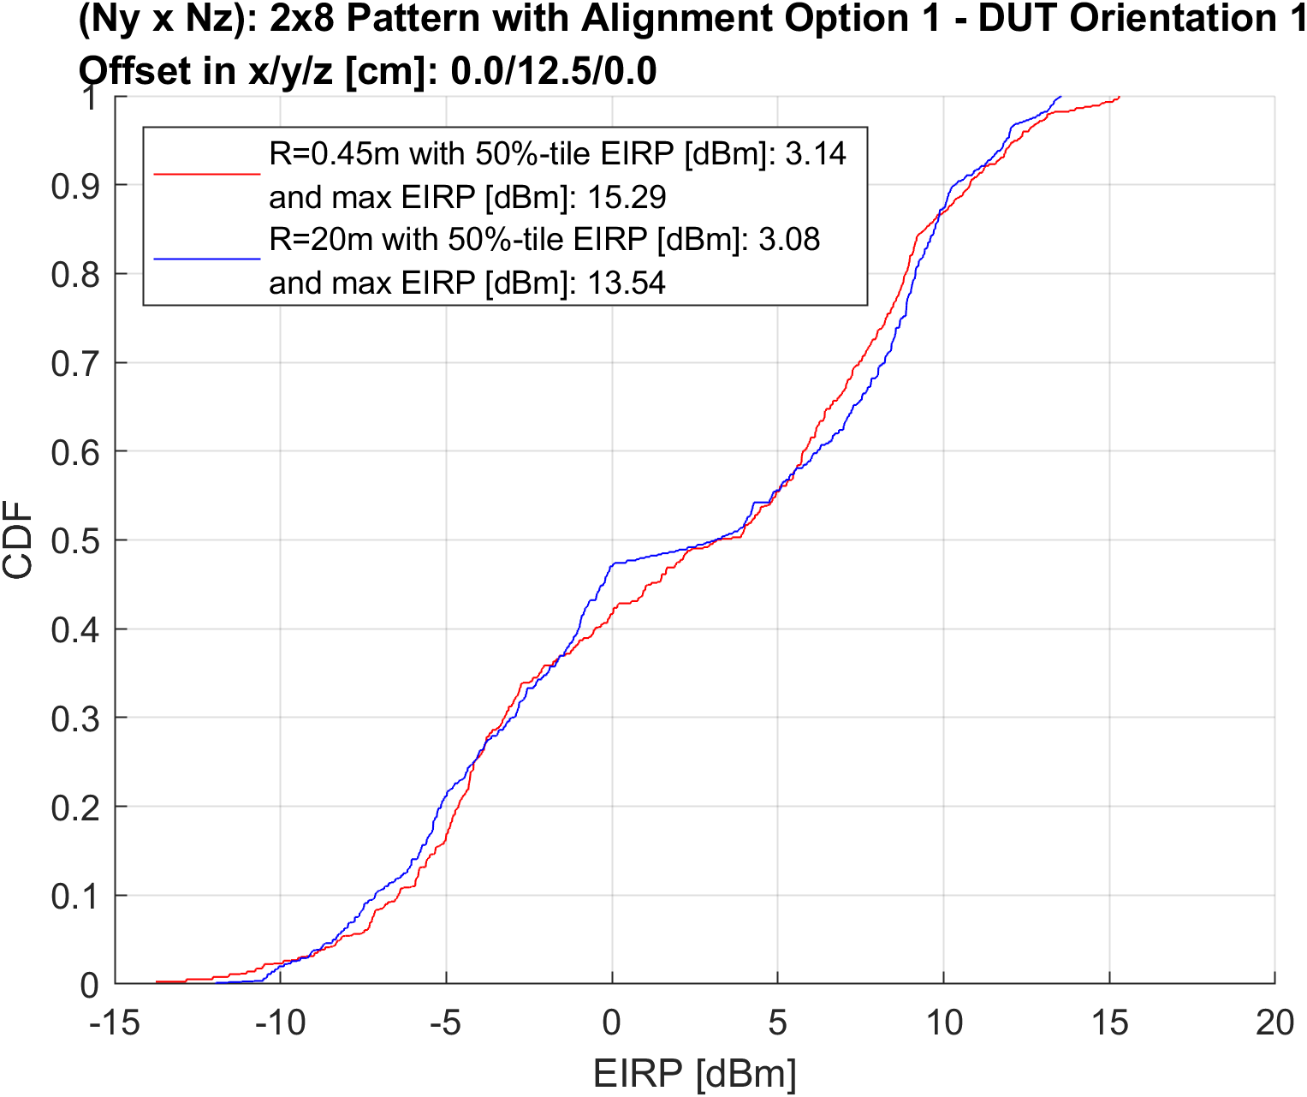  While I don’t oppose to simulate various cases, I think our simulations should consider different offsets (not just (9,12.5cm,0) rather than different antenna arrays. Since this is a testability SI, I think we should consider worst case (8x2) rather than status quo antenna assumptions.
Issue 1-3-1:  Whether RAN4 can reach a common understanding on the path loss comparison across IFF/DFF and NF system types | Anritsu: Not clear the intention of this sub-topic but we observed a slight difference in a range of 0.02 dB to 0.16dB. I guess the difference is coming just from the rounded range length (such as 0.28m is 0.275m indeed.)

CRs/TPs comments collection
Major close-to-finalize WIs and Rel-15 maintenance, comments collections can be arranged for TPs and CRs. For Rel-16 on-going WIs, suggest to focus on open issues discussion on 1st round.
CR/TP number | Comments collection
R4-2011218  (Keysight) | Anritsu: Though 1218 is not a CR, I would like to take a freedom to use this area to leave a comments and questions. To be sure, we are not against studying the NF measurement approach though we are skeptic with the benefit of NF measurement.  On Proposal 2: It is difficult to understand the idea of the effective antenna aperture. The actual antenna aperture size cannot change on the UE depending on the frequency. Only the possible way to calculate the range length should be based on the vendor declaration of aperture size.  On NF testing with a transform: Since there is no detailed procedure, if possible could you tell the following questions?  Q1: Does the measured signal need to be CW or modulated? If we measure by modulated waveform, we imagine that the measurement is utilizing the RS which is included in the UL signals and monitoring a phase change. Then we assume that another probe antenna to provide the phase reference.  On TRP testing in the NF: When we looked at Figure 21, we had a question why the histogram of the TRPs without correction are spread to the direction which is larger than the reference TRP. We imagined the reason why the uncertainties of TRP of NF measurement without transform is large is coming from the lack of calibration with probe antenna directivity. But if it is the error factor, the error should spread to the direction of smaller TRP value.  Do you have any idea on the method to measure EIS? When we measure EIRP we can rotate the DUT and change the probe antenna direction. However when we measure EIS, we suppose multiple probe antennas are necessary to create the magnetic field at the UE side which is equivalent to the DL beam from far-field.  Generally speaking, reference antenna gain is guaranteed only by far field. If we measure the absolute power at near field, do you think that we need to calibrate antenna gain specially at the near field measurement distance?
 | Company B
YYY | Company A
 | Company B

Summary for 1st round

Open issues
Moderator tries to summarize discussion status for 1st round, list all the identified open issues and tentative agreements or candidate options and suggestion for 2nd round i.e. WF assignment.
 | Status summary
Sub-topic#1 | Tentative agreements:  Candidate options:  Recommendations for 2nd round:

Recommendations on WF/LS assignment
 | WF/LS t-doc Title | Assigned Company,  WF or LS lead
#1

CRs/TPs
Moderator tries to summarize discussion status for 1st round and provides recommendation on CRs/TPs Status update
CR/TP number | CRs/TPs Status update recommendation
XXX | Based on 1st round of comments collection, moderator can recommend the next steps such as “agreeable”, “to be revised”

Discussion on 2nd round (if applicable)

Summary on 2nd round (if applicable)
Moderator tries to summarize discussion status for 2nd round and provided recommendation on CRs/TPs/WFs/LSs Status update suggestion
CR/TP/LS/WF number | T-doc Status update recommendation
XXX | Based on 2nd round of comments collection, moderator can recommend the next steps such as “agreeable”, “to be revised”

Topic #2: Polarization mismatch
Main technical topic overview. The structure can be done based on sub-agenda basis.

Companies’ contributions summary
T-doc number | Company | Proposals / Observations
R4-2009627 | MediaTek Inc. | Views on FR2 SISO EIRP test enhancement  Proposal 1: 2-port CSI-RS shall be provided in EIRP test procedure.  Proposal 2: 2-port CSI-RS can be simultaneous or sequent.  Proposal 3: Practical TPMI shall be provided in EIRP test procedure.
R4-2009961 | Apple Inc. | Views on the polarization mismatch objective  Proposal 1: RAN4 should identify a list of possible test methodology enhnacement techniques to address the issues identified with the EIRP measurement in the presence of polarization basis mismatch between the DUT and the test equipment.  Proposal 2: For UEs which exhibit the impact of polarization mismatch on EIRP measurement, it can be useful to quantify the impact on MU when measured according to the permitted methods in TR38.810 and to evaluate the tradeoff between test time and MU improvement as a function of polarization angles used in the sweeping approach.  Proposal 3: RAN4 should strive to enhance the FR2 RF test methodology to remove the necessity of using a UE test mode.
R4-2010129 | LG Electronics | EIRP measurement for polarization mismatch  Observation 1: A UE capable of 2Tx transmission may trigger only one polarization due to the polarization mismatch.  Observation 2: Whenever the UE triggers only one polarization for transmission, the equation of EIRP does not include UEâ€™s polarization gain.  Observation 3: UEâ€™s polarization gain has been assumed when RAN4 defined the EIRP requirements such as min. peak EIRP and EIRP spherical coverage.  Observation 4: In RAN4#93 meeting, eight possible test methodologies techniques for enhancement have been captured to minimize or remove the polarization mismatch.  Observation 5: Based on the result of the informal email discussion, six companies identify that there is a potential conflict between the core requirement and the current EIRP measurement procedure. However, four companies does not find the conflict.  Observation 6: Using TPMI can be a good solution to trigger 2Tx transmission for Rel-16 UEs in order to avoid the UEâ€™s behaviour such as triggering only one polarization for transmission.  Observation 7: The solution of using TPMI is only available to Rel-16 UEs since it is not allowed to use TPMI of [] to force Rel-15 UEs to trigger 2Tx transmission [6].  Observation 8: Based on the observation 7, the total EIRP does not include the polarization gain when Rel-15 UEs may trigger only one polarization due to the polarization mismatch.  Observation 9: Introducing the polarization scan method can be beneficial to minimize the polarization mismatch between the TE and Rel-15 UE. However, this test method will increase test times by a factor of N (# of scanning sector). If N is not chosen carefully, then the test times will be increased significantly.  Proposal 1: For Rel-16 UE, RAN4 should use TPMI of [] to force UE to trigger 2Tx transmission for the EIRP measurement.  Proposal 2: For Rel-15 UE, RAN4 should use the following equation for the EIRP measurement.  Proposal 3: For Rel-15 UE, RAN4 should also use the TPMI of] and] to force UE to trigger one polarization for the EIPR measurement.  Proposal 4: The polarization scan method should be an optional test methodology technique for Rel-15 UEs. These Rel-15 UEs can report N (# of polarization scan) to let the TE inform that it can support the polarization scan method.
R4-2010202 | Samsung | Discussion on dual polarization transmission for UL TX test  Observation 1: there is fundamental conflict between core requirement and EIRP measurement procedure. Core requirement is based on simultaneous 2TX but EIRP measurement procedure can not robustly enable 2TX.  Observation 2: current EIRP test method in TR 38.810 can correctly capture the power from UE. The remaining issue if how to enable simultaneous 2TX for 1 layer transmission with DFT-s-OFDM waveform.  Observation 3: Even UE supports UL full power transmission mode1, TMPI solution to enable 2TX transmission is not feasible for MOP requirements in clause 6.2 of TS 38.102-2 where nrofSRS-Ports = 1.  Observation 4: a method is needed to activate TX Diversity for UE under test.  Observation 5: FR2 EVM test is also feasible under TX Diversity mode as long as it is just dual polarization transmission with exactly the same signals without delay.  Proposal 1: focus on test methods which are reliable and easy to trigger 2TX transmission to align with EIRP core requirement.  Proposal 2: RAN4 study TX Diversity and/or Test Mode to be applied in EIRP measurement.  Proposal 3: UE side TX Diversity transmission (dual polarization transmission) is triggered by Test Equipment, which is a test mode to address polarization gain and also applicable for EVM measurement.
R4-2011217 | Keysight Technologies | On minimizing the impact of polarization basis mismatch between the TE and DUT on the RF testing  Observation 1: For coherent UEs, both Rel-15 and Rel-16 allow a TPMI to be used that forces single-layer transmission using two antenna ports.  Observation 2: For non-coherent UEs, Rel-15 does not allow a TPMI to be used that forces single-layer transmission using two antenna ports.  Observation 3: For non-coherent UEs, Rel-16 allows a TPMI to be used that forces single-layer transmission using two antenna ports with the newly introduced ul-FullPowerTransmission = fullpowerMode1 mode.  Observation 4: OEMs to comment whether RAN1â€™s definition of TPMI indices 2-5 forcing single-layer transmission using two antenna ports corresponds to the UE enabling two transmit chains at all times  Proposal []:  Proposal 1: RAN4 to focus on the polarization scan which can reliably force the UE to simultaneously transmit on both transmit chain/antennas in order to minimize the impact of polarization basis mismatch between the TE and DUT.
R4-2011423 | Sony, Ericsson | Views on testability enhancement for UE FR2 test  Observation 1: RAN4 has made an agreement that UE shall support two receivers with rank 1 reception for REFSENS.  Observation 2: The current test method can capture the UE transmitted power correctly, and how a UE uses one or more Tx chains to transmit is an implementation issue.  Observation 3: The mapping between digital ports and RF ports can be flexible in the implementation.  Observation 4: The non-coherent UEs cannot transmit over two TXs with rank 1 transmission.  Observation 5: The codebook-based transmission is typically used when the uplink/downlink reciprocity does not hold, which may be against the principle of beam correspondence test.  Observation 6: The power-up command in MOP tests can ensure the UE uses all the TXs it has.  Observation []: The power-up command in MOP tests can ensure the UE use all the TXs it has.  Proposal 1: The current EIS metric is feasible to be applied to different UE RF implementations, and shall be kept without any modification.  Proposal 2: If the EIS test metric would be modified, the new metric shall be able to distinguish between different performing UEs and take the test time into account.  Proposal 3: The current EIRP test is feasible to be applied to different UE RF implementations, and shall be kept without any modification.  Proposal []: If EIS test metric would be modified, the new metric shall be able to distinguish between different performing UEs and take the test time into account.
R4-2011457 | Qualcomm Incorporated | FR2 testability enhancement for polarization mismatch  Observation 1: ULFPTx feature does not guarantee dual pol transmit  Observation 2: ULFPTx is useful for Rel-16 UEs to allow compliance with EIRP requirements even when the UE is configured for multiple SRS ports and transmission on a single layer.  Proposal 1: If new DL polarization conditions are introduced for compliance testing in addition to those already captured by TS38.521-2 v16.4, the UE must additionally demonstrate compliance with each of the new DL polarization conditions.  Proposal 2: FR2 TE topology shall be enhanced by adopting dual polarization coherent receivers.

Open issues summary
Before e-Meeting, moderators shall summarize list of open issues, candidate options and possible WF (if applicable) based on companies’ contributions.

Sub-topic 2-1: FR2 EIRP SISO test enhancement
Sub-topic description:
Open issues and candidate options before e-meeting:
Issue 2-1-1: Whether TPMI side conditions are feasible to introduce to the test setup
- Proposals
  - Alt 2-1-1-1: Yes
  - Alt 2-1-1-2: No
  - Alt 2-1-1-3: Further study is needed, including other options

Issue 2-1-2: How to define TPMI side conditions
- Proposals
  - Alt 2-1-2-1: Practical TPMI shall be provided in EIRP test procedure
  - Alt 2-1-2-2: For Rel-16 UE, RAN4 should use TPMI of [$\begin{matrix}1 \\ 1\end{matrix}$] to force UE to trigger 2Tx transmission for the EIRP measurement, and for Rel-15 UE, RAN4 should also use the TPMI of$[\begin{matrix}1 \\ 0\end{matrix}$] and$[\begin{matrix}0 \\ 1\end{matrix}$] to force UE to trigger one polarization for the EIPR measurement.
  - Alt 2-1-2-3: Further study is needed

Issue 2-1-3: Whether and, if feasible, how to modify the definition of the total EIRP calculation
- Proposals
  - Alt 2-1-3-1: According to R4-2010129:
  - EIRP (Pol_{Link}=θ) = EIRP (Pol_{Link}=θ_{TPMI0}) + EIRP (Pol_{Link}=θ_{TPMI1})
  - EIRP (Pol_{Link}=φ) = EIRP (Pol_{Link}= φ _{TPMI0}) + EIRP (Pol_{Link}= φ _{TPMI1})
  - The total component of EIRP for Rel-15 UEs = max (EIRP (Pol_{Link}=θ), EIRP (Pol_{Link}=φ))
  - Alt 2-1-3-2: No
  - Alt 2-1-3-3: Further study is needed

Issue 2-1-4: Whether polarization scan method is feasible
- Proposals
  - Alt 2-1-4-1: Yes
  - Alt 2-1-4-2: Yes, for Rel-15 only and as an optional technique [according to R4-2010129]
  - Alt 2-1-4-3: Adopt method 0 (current procedure in TR 38.810) as basis for EIRP testing, any potential enhanced procedure (e.g. method 1, 5, and 7) can be allowed for testing as optional for specific UE implementation based on UE declaration [according to R4-2011236]
  - Alt 2-1-4-3 No

Issue 2-1-5: Whether a test mode to trigger TX diversity is sufficient and feasible
- Proposals
  - Alt 2-1-5-1: Yes
  - Alt 2-1-5-2: No

Issue 2-1-6: Whether a power up command to trigger TX diversity is sufficient and feasible
- Proposals
  - Alt 2-1-6-1: Yes
  - Alt 2-1-6-2: No

Issue 2-1-7: Whether 2-port CSI-RS is feasible to introduce to the test setup
- Proposals
  - Alt 2-1-7-1: Yes
  - Alt 2-1-7-2: No

Issue 2-1-8: 2-port CSI-RS shall be simultaneous or sequential
- Proposals
  - Alt 2-1-8-1: simultaneous
  - Alt 2-1-8-2: sequential
  - Alt 2-1-8-3: both are allowed

Sub-topic 2-2: Demodulation of UL by test equipment
Sub-topic description
Open issues and candidate options before e-meeting:
Issue 2-2-1: Whether FR2 test equipment topology shall be enhanced by adopting dual polarization coherent receivers
- Proposals
  - Alt 2-2-1-1: Yes
  - Alt 2-2-1-2: No
  - Alt 2-2-1-3: Further study is needed

Companies views’ collection for 1st round

Open issues
Issue | Company Comments
Issue 2-1-1: Whether TPMI side conditions are feasible to introduce to the test setup | Keysight: No (as outlined in R4-2011217)
Issue 2-1-2: How to define TPMI side conditions | Keysight: further study is needed, i.e., feedback from OEMs is needed whether RAN1’s definition of TPMI indices 2-5 forcing single-layer transmission using two antenna ports corresponds to the UE enabling two transmit chains at all times (Observation 4 from R4-2011217)
Issue 2-1-3: Whether and, if feasible, how to modify the definition of the total EIRP calculation | Keysight: no
Issue 2-1-4: Whether polarization scan method is feasible | Keysight: Alt 2-1-4-1: Yes (for Rel-15 and whether beyond Rel-15 is TBD)  Anritsu: Alt 2-1-4-4: To be studied further. Just to make sure, this polarization scan method is only to enable UE to transmit UL signals from both polarizations and not for the EVM measurement, isn’t it?
Issue 2-1-5: Whether a test mode to trigger TX diversity is sufficient and feasible
Issue 2-1-6: Whether a power up command to trigger TX diversity is sufficient and feasible
Issue 2-1-7: Whether 2-port CSI-RS is feasible to introduce to the test setup
Issue 2-1-8: 2-port CSI-RS shall be simultaneous or sequential
Issue 2-2-1: Whether FR2 test equipment topology shall be enhanced by adopting dual polarization coherent receivers | Keysight: Alt 2-2-1-3: Further study is needed  Anritsu: Alt2-2-1-3: Further study is needed. Especially it is appreciated if we can hear the view on how much (or how accurate) the phase relationship between the two polarization signals needs to be maintained as the coherent receiver.

CRs/TPs comments collection
Major close to finalize WIs and Rel-15 maintenance, comments collections can be arranged for TPs and CRs. For Rel-16 on-going WIs, suggest to focus on open issues discussion on 1st round.
CR/TP number | Comments collection
XXX | Company A
 | Company B
YYY | Company A
 | Company B

Summary for 1st round

Open issues
Moderator tries to summarize discussion status for 1st round, list all the identified open issues and tentative agreements or candidate options and suggestion for 2nd round i.e. WF assignment.
 | Status summary
Sub-topic#1 | Tentative agreements:  Candidate options:  Recommendations for 2nd round:

Suggestion on WF/LS assignment
 | WF/LS t-doc Title | Assigned Company,  WF or LS lead
#1

CRs/TPs
Moderator tries to summarize discussion status for 1st round and provided recommendation on CRs/TPs Status update suggestion
CR/TP number | CRs/TPs Status update recommendation
XXX | Based on 1st round of comments collection, moderator can recommend the next steps such as “agreeable”, “to be revised”

Discussion on 2nd round (if applicable)

Summary on 2nd round (if applicable)
Moderator tries to summarize discussion status for 2nd round and provided recommendation on CRs/TPs/WFs/LSs Status update suggestion
CR/TP/LS/WF number | T-doc Status update recommendation
XXX | Based on 2nd round of comments collection, moderator can recommend the next steps such as “agreeable”, “to be revised”

Topic #3: Inter-band CA within FR2
Main technical topic overview. The structure can be done based on sub-agenda basis.

Companies’ contributions summary
T-doc number | Company | Proposals / Observations
R4-2009962 | Apple Inc. | Views on test methodology for inter-band CA within FR2  Proposal 1: Further study is needed to determine whether non-colocated test antennas for DL inter-band CA verification is feasible from the perspective of ∆PSD at the UE after spatial filtering.
R4-2010802 | Rohde & Schwarz | Discussion on open issues of inter-band CA testability  Observation 1: Providing DL signals from the same AoA inter-band CA in FR2 with 2 bands is feasible for the Rel-16 frequency bands, without exceeding the MU for single carrier/intra-band CA.  Observation []: Imbalance can be larger for a single antenna test system, than estimated in [7].  Proposal 1: RAN4 agrees that the testing of Rel-16 inter-band CA using a single antenna from 1AoA is feasible.  Proposal 2: RAN4 discusses above questions to clarify the testing implications for inter-band CA with power imbalance.

Open issues summary
Before e-Meeting, moderators shall summarize list of open issues, candidate options and possible WF (if applicable) based on companies’ contributions.

Sub-topic 3-1: Need for offset feed antennas
Sub-topic description:
Open issues and candidate options before e-meeting:
Issue 3-1-1: Whether offset feed antennas need to be used for the FR2 DL inter-band CA test setup
- Proposals
  - Alt 3-1-1-1: Yes [see R4-1913931]
  - Alt 3-1-1-2: FFS: Evaluation of impact on UE performance (e.g. PSD difference) is needed
  - Alt 3-1-1-3: No (i.e. RAN4 agrees that using 1 AoA with single feed antenna is feasible) [see R4-2010802]

Companies views’ collection for 1st round

Open issues
Issue | Company Comments
Issue 3-1-1: Whether offset feed antennas need to be used for the FR2 DL inter-band CA test setup | Anritsu: Alt 3-1-1-1 Yes. But of course not forcing to use the offset antenna with every test system. We rather think that the design of the test system should be allowed to have a flexibility as far as the system keeps the measurement uncertainty within the maximum test system uncertainty (MTSU).  Rationales to support Alt 3-1-1-1 are as follows.  - Considering the situation that we are studying 47GHz band or even higher frequency such as 52GHz or more, we should avoid a description which may limit the future system design and cause another testability issues. Especially with the situation that more and more wider aggregated channel bandwidth is required.  - Unfortunately to say, RAN5 has not finished defining the measurement uncertainty for CA test cases (even with the single carrier cases). Thus we assume it is not mature to conclude that the system which is capable of transmitting 2 carriers from 1AoA can cover all the TRx test cases without giving any impacts on the existing single carrier test cases.  - There should be some ways to calibrate out the possible gain difference due to the corresponding antenna offset from the test equipment, for example the beam peak search can be carried out by both main antenna and offset antenna if the beam management of the UE is independent. Or perhaps we can utilize the functionality of UE beam lock for Rx and check the gain difference by measuring EIS from both main antenna and offset antenna. Thus gain loss of the UE antenna should be mitigated to the level which we can ignore the MU compared to the other major factor.  - FR2 test systems which were introduced in the market in an early stage such as year 2019 are not designed to cover test cases for CA for the sake of prioritizing tests for the single carrier. Thus there is a concern with the possibility of impacts to the existing single carrier tests when upgrading those systems to support 2CA input from 1AoA.

CRs/TPs comments collection
Major close to finalize WIs and Rel-15 maintenance, comments collections can be arranged for TPs and CRs. For Rel-16 on-going WIs, suggest to focus on open issues discussion on 1st round.
CR/TP number | Comments collection
XXX | Company A
 | Company B
YYY | Company A
 | Company B

Summary for 1st round

Open issues
Moderator tries to summarize discussion status for 1st round, list all the identified open issues and tentative agreements or candidate options and suggestion for 2nd round i.e. WF assignment.
 | Status summary
Sub-topic#1 | Tentative agreements:  Candidate options:  Recommendations for 2nd round:

Suggestion on WF/LS assignment
 | WF/LS t-doc Title | Assigned Company,  WF or LS lead
#1

CRs/TPs
Moderator tries to summarize discussion status for 1st round and provided recommendation on CRs/TPs Status update suggestion
CR/TP number | CRs/TPs Status update recommendation
XXX | Based on 1st round of comments collection, moderator can recommend the next steps such as “agreeable”, “to be revised”

Discussion on 2nd round (if applicable)

Summary on 2nd round (if applicable)
Moderator tries to summarize discussion status for 2nd round and provided recommendation on CRs/TPs/WFs/LSs Status update suggestion
CR/TP/LS/WF number | T-doc Status update recommendation
XXX | Based on 2nd round of comments collection, moderator can recommend the next steps such as “agreeable”, “to be revised”

Topic #4: Others
Main technical topic overview. The structure can be done based on sub-agenda basis.

Companies’ contributions summary
T-doc number | Company | Proposals / Observations
R4-2009959 | Apple Inc. | FR2 test method enhancement informal email discussion summary
R4-2009773 | Fraunhofer HHI, Fraunhofer IIS | Beam sweeping and test time reduction in FR2  Observation []:Issue to be addressedâ€”reduction of measurement uncertainty.  Observation []:Issue to be addressedâ€”reduction of measurement time.  Observation []:Beam sweeping can be used to reduce the time needed for FR2 testing.  Proposal []: As part of the enhanced test methods for FR2 study item, RAN4 should discuss beam sweeping techniques further.
R4-2011236 | vivo, CAICT | On enhanced test methods for FR2 RF  Observation 1: Developing specialized test systems is the only feasible way we can go at this stage, before some magical FR2 OTA systems appear. Otherwise, relaxation or remove of these high-DL-power and low-UL-power TCs shall be considered.  Observation 2: End-to-end analysis of the system path loss is beneficial to check the maximum/minimum power of the system and compare directly with the required power of these TCs. Frequency up&down conversion can be a further optimization to reduce the length of mm-Wave cables in the enhanced system.  Proposal 1: The study should initially focus on how to develop specialized test system to seek a reasonable solution for Objective 1.  Proposal 2: Before adopting â€œWhite boxâ€ approach for enhanced FR2 RF test methodology, which detailed information from the vendor declaration is necessary should be discussed and decided.  Proposal 3: System dynamic range study is strongly encouraged to compare the capability of the system with the required power of these unresolved TCs.  Proposal 4: Adopt method 0 (current procedure in TR 38.810) as basis for EIRP testing, any potential enhanced procedure (e.g. method 1, 5, and 7) can be allowed for testing as optional for specific UE implementation based on UE declaration.

The Moderator’s recommendations for these documents are the following:
R4-2009959: recommend noting, as it is for information only
R4-2009773: recommend postponing until the remaining objectives in the SI are added to the agenda
R4-2011236: recommend noting; Proposals 1, 2, 3 are handled in Topic #1, and Proposal 4 is handled in Topic #2

