3GPP TSG-RAN WG4 Meeting # 95-e R4-200XXXX

Electronic Meeting, 25 May – 05 June, 2020

**Agenda item:** 9.1.3.2

**Source:** Keysight Technologies

**Title:** TP to TR38.827 to avoid ambiguities for FR2 MIMO OTA Testing

**Document for:** Approval

# Introduction

This TP is to capture agreements to avoid ambiguities of relative positioning between probes, the 36 test points, the UE, and the channel model into TR 38.827 [1] based on discussion paper [2] and subsequent meeting summary discussions of thread 326.

# Conclusion

**Proposal 1: Include the draft text below in [1]**

# References

1. TR 38.827, Study on radiated metrics and test methodology for the verification of multi-antenna reception performance of NR User Equipment (UE), V1.2.0 (2020-03)
2. R4-2006743, On FR2 3D MPAC Ambiguities and Blocking, Keysight Technologies, 3GPP TSG-RAN WG4 Meeting # 95-e, June 2020
3. R4-2009047 Email discussion summary for [95e][326] FS_NR_MIMO_OTA_test, CAICT, 3GPP TSG-RAN WG4 Meeting # 95-e, June 2020

<<< START OF CHANGES >>>

<<< START OF CHANGE #1 >>>

### 6.2.3 3D Multi-Probe Anechoic Chamber (MPAC) for FR2

The 3D MPAC test method is the reference methodology for FR2 NR MIMO OTA testing. By arranging an array of antennas around the Equipment Under Test (EUT), a spatial distribution of angles of arrival in the 3D MPAC system may be simulated to expose the EUT to a near field environment that appears to have originated from a complex multipath far field environment.

As illustrated schematically in Figure 6.2.3-1, signals propagate from the base station/communication tester to the EUT through a simulated multipath environment known as a spatial channel model, where appropriate channel impairments such as Doppler and fading are applied to each path prior to injecting all of the directional signals into the chamber simultaneously through the probe array. The resulting field distribution in the test zone is then integrated by the EUT antenna(s) and processed by the receiver(s) just as it would do so in any non-simulated multipath environment. The 3D MPAC system with 6 dual-polarized probes (illustrated with black dots in Figure 6.2.3-1) placed on a sector with minimum radius of 0.75m from the centre of the test zone is permitted for NR FR2 MIMO OTA testing.

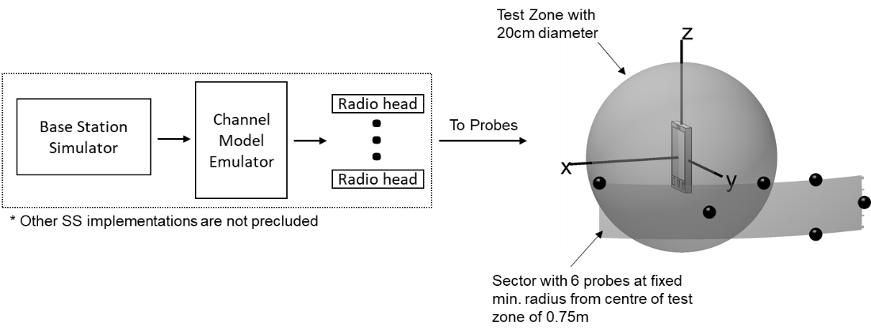

**Figure** **6.2.3-1: 3D MPAC system layout for NR FR2 MIMO OTA testing**

The exact probe locations with respect to the channel model coordinate system are tabulated in Table 6.2.3-1 and shown in Figure 6.2.3-2.

Table 6.2.3-1. FR2 3D MPAC Probe Locations

|  |  |  |
| --- | --- | --- |
| Probe Number | Theta/ZoA [deg] | Phi/AoA  [deg] |
| 1 | 90 | 75 |
| 2 | 85 | 85 |
| 3 | 85 | 55 |
| 4 | 85 | 95 |
| 5 | 95 | 95 |
| 6 | 90 | 105 |



**Figure 6.2.3-2: FR2 3D MPAC Probe Locations**

The 3D MPAC probes in Table 6.2.3-1 can be implemented using conventional millimetre-wave probes as well as IFF-based probes as long as the same probe configuration and same number of probes is used.

The channel model rotations assumed for this probe configuration are tabulated in Table 6.2.3-2.

Table 6.2.3-2. Channel Model Rotations

|  |  |  |  |
| --- | --- | --- | --- |
| InO CDL-A | | UMi CDL-C | |
| Phi [deg] | Theta [deg] | Phi [deg] | Theta [deg] |
| 70.0 | -2.0 | 107.0 | 15.0 |

<<< Skip unchanged sections >>>

<<< START OF CHANGE #2 >>>

# A.2 Test conditions and angle definitions

Free space is the test condition for both FR1 and FR2 MIMO OTA testing. The angle definition of the DUT orientation is specified in A.3

In order to achieve the FR2 test points tabulated in Table 6.2.3.2-1, the UE is rotated so that the test point w.r.t. to the UE coordinate system is aligned with the test system z axis.

<<< END OF CHANGES >>>