3GPP TSG-RAN WG4 Meeting #95-e draft R4-2008770

Electronic meeting, 25 May – 5 June, 2020

**Source:** Nokia, Nokia Shanghai Bell

**Title:** WF on referencing rules and how updates to donor specs are applied to the IAB specification

**Agenda item:** 6.5

**Document for:**  Approval

# 1 Background

In RAN4#94-e R4-2002484 giving guidelines how and when IAB TS shall reference UE and BS RF requirement specifications was agreed. The guidelines have been copied below, except emphasis is authors.

* Decision whether to reference will be taken case by case following the rules in this slide
* The examples in this slide are meant to illustrate the meaning, not to agree exact wording to be used in the specification.
* Referencing can be done only if requirement is the same, meaning that requirement values and principles are the same
  + Exact words do not need to be same. As a theoretical example, it can be said that ”BS type 2-O requirements in sub-clause x.x.x [ref X] apply for IAB-DU”
  + Referencing shall not be done if requirements are different, i.e. value or principle differs.
  + If referencing is used all node specific text and defiitions must be clarified (for example: Where ”base station RF bandwidth” is replced by ”IAB-DU RF bandwidth”)
  + Specific references must be made to versioned docuuments
* Referencing is not recommended if it results in a partial requirement
  + As a theoretical example, this means a case where specification would say ” BS type 2-O requirements in sub-clause x.x.x [ref X] apply for IAB-DU. In addition IAB-DU shall meet….”
* Referencing is not recommended if a complete specification sub-clause cannot be referenced
  + No referencing when it results in formulation ”BS type 2-O requirements in clause x.x.x [ref X] except [bad requirement] will apply for IAB-DU”
  + No referencing of individual tables or figures
* Referencing sub-clasues where requiremenst apply for frequencies which are not IAB frequencies is TBD
  + UE and BS specification shave many requirements which are band specific and result in tables containing many bands, its not clear if these sub-clauses should be referenced. Thsi coudl be similar to teh ”partial requirement” bullet above

Especially the highlighted guidelines have been resulted in multiple comments on submitted text proposals, and therefore it was seen useful to clarify these two bullets further.

**Practices in other RF core specifications**

Example from TS 37.105 how other RF core specifications are referenced:



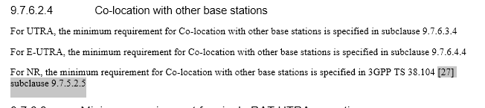

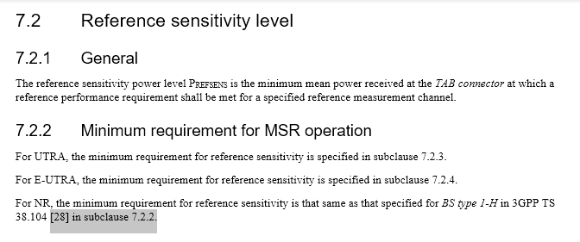

Both specific and non-specific reference to TS 38.104 exist, but still the reference without version number is used when pointing to a specific clause. This is against 3GPP drafting rules, but using a versioned reference here would mean that all bands added after version 15.1.0 would not be included. This has happened for MSR requirements, and it seems reference sensitivity for NR in MSR operation is not defined for bands introduced after version 15.1.0.

Several similar cases appear in most, if not all, RF core specifications, i.e. it seems somewhat normal to select convenience instead of following drafting rules to the letter.

# 2 Way forward

**Specific vs. non-specific references and specification maintenance**

**Option 1:** Knowingly break drafting rules and combine specific reference with non-versioned document when rules in R4-2002484 allow referencing

* most convenience as updates to e.g. TS 38.104 and TS 38.101-1/2 would automatically carry over to IAB spec
* updates in other specifications related to access link carry over also to backhaul link in case IAB-MT requirements are referenced

**Option 2:** Spell out all IAB-MT requirements explicitly in IAB TS, but reference IAB-DU requirements when applicable

* Behaviour and requirements of access link of IAB-Node stay automatically aligned with the one of BS
* Impact on IAB-MT, i.e. backhaul operation, and therefore a separate CR to IAB-TS needs to be always separately considered when a CR in 38.101-1/2 or TS 38-104 is done.

**Option 3:** Spell out all requirements explicitly in IAB TS

* Whenever a CR is done to TS 38.101-1/2 or TS 38.104, it needs to be considered whether a CR is needed also to IAB TS

**Detailed wording for references**

For specific wording used in referencing, the following wording is to be used:

“The minimum requirements specified for [BS type XX /UE] in TS 38.104[X], clause Y.Y.Y apply for IAB-[MT/DU/Node]”

This wording is deemed sufficient to convey that UE/BS specific terminology used in defining minimum requirements in UE/BS specifications will also apply for IAB. For example, UE channel bandwidth shall be understood to mean IAB-[MT/DU] channel bandwidth.