**3GPP TSG-WG RAN4 Meeting #95eRevsied R4-2006034**

**Electronic Meeting, 25 May - 5 June, 2020**

|  |  |  |  |  |  |  |  |  |
| --- | --- | --- | --- | --- | --- | --- | --- | --- |
| *CR-Form-v12.0* | | | | | | | | |
| **CHANGE REQUEST** | | | | | | | | |
|  | | | | | | | | |
|  | **38.101-3** | **CR** | **0223** | **rev** | **1** | **Current version:** | **16.3.0** |  |
|  | | | | | | | | |
| *For* [***HE******LP***](http://www.3gpp.org/3G_Specs/CRs.htm#_blank)*on using this form: comprehensive instructions can be found at* [*http://www.3gpp.org/Change-Requests*](http://www.3gpp.org/Change-Requests)*.* | | | | | | | | |
|  | | | | | | | | |

|  |  |  |  |  |  |  |  |  |
| --- | --- | --- | --- | --- | --- | --- | --- | --- |
| ***Proposed change affects:*** | UICC apps |  | ME | **X** | Radio Access Network |  | Core Network |  |

|  |  |  |  |  |  |  |  |  |  |  |
| --- | --- | --- | --- | --- | --- | --- | --- | --- | --- | --- |
|  | | | | | | | | | | |
| ***Title:*** | CR to TS 38.101-3: Switching time mask between two uplink carriers in EN-DC | | | | | | | | | |
|  |  | | | | | | | | | |
| ***Source to WG:*** | China Telecom, ZTE, CMCC, China Unicom, KDDI, Spreadtrum, CATT, CHTTL, Mediatek, OPPO, Huawei, HiSilicon, vivo, Xiaomi, Orange | | | | | | | | | |
| ***Source to TSG:*** | R4 | | | | | | | | | |
|  |  | | | | | | | | | |
| ***Work item code:*** | NR_RF_FR1-Core | | | | |  | ***Date:*** | | | 2020-05-01 |
|  |  | | | |  | |  | | |  |
| ***Category:*** | B |  | | | | | ***Release:*** | | | Rel-16 |
|  | *Use one of the following categories:* ***F*** *(correction)* ***A*** *(mirror corresponding to a change in an earlier release)* ***B*** *(addition of feature),* ***C*** *(functional modification of feature)* ***D*** *(editorial modification)*  Detailed explanations of the above categories can be found in 3GPP [TR 21.900](http://www.3gpp.org/ftp/Specs/html-info/21900.htm). | | | | | | | | *Use one of the following releases: Rel-8 (Release 8) Rel-9 (Release 9) Rel-10 (Release 10) Rel-11 (Release 11) Rel-12 (Release 12)* *Rel-13 (Release 13) Rel-14 (Release 14) Rel-15 (Release 15) Rel-16 (Release 16)* | |
|  |  | | | | | | | | | |
| ***Reason for change:*** | | For UE supporting maximum two concurrent transmission, Tx switching between two uplink carriers can enable 1 Tx on E-UTRA carier and 2 Tx on NR carrier. | | | | | | | | |
|  | |  | | | | | | | | |
| ***Summary of change:*** | | Introduce UE time mask requirements to allow switching between two uplink carriers for inter-band EN-DC. | | | | | | | | |
|  | |  | | | | | | | | |
| ***Consequences if not approved:*** | | UE is not allowed to support Tx switching between two uplink carriers. | | | | | | | | |
|  | |  | | | | | | | | |
| ***Clauses affected:*** | | New section 6.3B.4 | | | | | | | | |
|  | |  | | | | | | | | |
|  | | **Y** | **N** |  | | | |  | | |
| ***Other specs*** | |  | **X** | Other core specifications | | | | TS/TR ... CR ... | | |
| ***affected:*** | | **X** |  | Test specifications | | | | TS 38.521-3 | | |
| ***(show related CRs)*** | |  | **X** | O&M Specifications | | | | TS/TR ... CR ... | | |
|  | |  | | | | | | | | |
| ***Other comments:*** | |  | | | | | | | | |
|  | |  | | | | | | | | |
| ***This CR's revision history:*** | |  | | | | | | | | |

*< Start of change >*

### 6.3B.4 Output power dynamics for switching between two uplink carriers

#### 6.3B.4.1 E-UTRA and NR switching time mask between two uplink carriers

In addition to the requirements in 6.3B.0, the switching time mask specified in this sub-clause is applicable for an uplink band pair of a inter-band EN-DC configuration without SUL band when the capability *uplinkTxSwitchingPeriod* is present, and is only applicable for uplink switching mechanisms specified in sub-clause 6.1.0 of TS 38.214 [10], where E-UTRA UL carrier 1 is capable of one transmit antenna connector and NR UL carrier 2 is capable of two transmit antenna connectors, and the two uplink carriers are in different bands with different carrier frequencies. The UE shall support the switch between single layer transmission with one antenna port and two-layer transmission with two antenna ports on the two uplink carriers following the scheduling commands and rank adaptation, i.e., both single layer and two-layer transmission with 2 antenna ports, and single layer transmission with 1 antenna port shall be supported on NR UL carrier 2.

The switching periods described in Figure 6.3B.4.1-1 are only located in NR carrier, and the length of uplink switching period *X* is less than the value indicated by UE capability *uplinkTxSwitchingPeriod*.

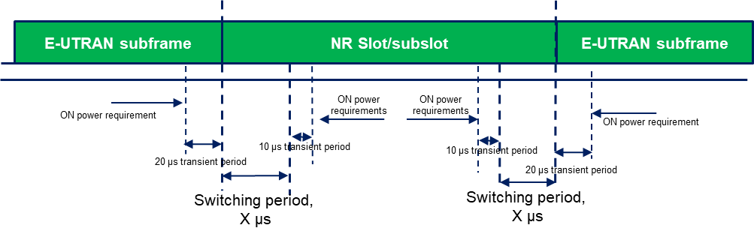

Figure 6.3B.4.1-1: Time mask for switching between E-UTRA UL carrier and NR UL carrier, where the switching period is located in NR carrier

The requirements apply for the case of co-located and synchronized network deployment for the two uplink carriers.

Editor Notes: Power class declaration for the uplink transmission switching follows the general definition of power class and is not changed due to the dynamic switching between the two uplink carriers. In Rel-16, the maximum power requirement should apply to the total transmitted power over all component carriers (per UE) when the transmissions on both carriers are assumed.

*< Start of change >*