TSG-RAN Working Group 4 (Radio) meeting #94bis-ER4-2005512

Electronic Meeting, April 20th – 30th 2020

**Source:** Ericsson

**Title:** TP to TR 37.941: Improvement of text in subclause 6.3.2

**Agenda item:** 6.19.2

**Document for:** Approval

# Introduction

At the last RAN4 meeting (RAN4#94-E) a draft technical report was created (TR 37.941) [1]. The contents in the first draft version was based purely on text copied from TR 37.840, TR 37.842, TR 37.843 and TR 38.817-02.

In this contribution we provide a text proposal to improve readability and quality of the text in subclause 6.3.2. At the end of this contribution a text proposal is attached for approval.

# Discussion

The improvements are summarized as:

1. FFS is removed.
2. Text is improved for increased readability.
3. Obvious errors are corrected.

# Conclusion

The attached text proposal is presented for approval.

# References

[1] R4-2002430, “Draft TR 37.941”, Huawei

TEXT PROPOSAL:

### 6.3.2 TRP measurement procedures

#### 6.3.2.1 General

Different procedures can be used to evaluate the TRP estimate. These procedures can provide either an *accurate* assessment or a controlled *overestimate* of the TRP. The choice of methods is based also on the available test setup, measurement equipment, and the measurement time. This clause describes the methods which are suitable for each type of requirements. Other relevant methods are not precluded. For each method, the test purpose (accurate or overestimate) is pointed out. A summary of the requirement types and measurement procedures is shown in 6.3.2-1.

In the following clauses the measurement procedures for different parameters are described under the assumption of equal angle sampling. Similar procedures can be also used with other types of spherical grids, given that the proper reference steps $Δθ_{ref}$ and $Δϕ_{ref}$ are determined.

A summary of TRP measurement procedures and their applicability to different OTA BS requirements is shown in table 6.3.2.1 -1. Note, OTA FR2 transmit ON/OFF power is excluded from the table although the core requirement is specified as TRP because conformance is verified through EIRP measurements.

Table 6.3.2-1: Applicability of TRP measurement methods to the type of emissions to be measured

|  |  |  |  |  |
| --- | --- | --- | --- | --- |
|  | **BS output power** | **Unwanted emissions: ACLR**  **(Note 1)** | **Unwanted emissions: SEM, OBUE** | **TX spurious emissions OTA (Note 2)** |
| Full sphere using reference steps (accurate) | X | X | X | X |
| Full sphere using sparse sampling (overestimate) |  |  |  | X (Note 3) |
| Two cuts + Pattern multiplication(accurate) (Note 4) | X | X | X |  |
| Two/three cuts (overestimate) |  | X | X | X (Note 3) |
| Beam-based directions | X | X (Note 5) | X (Note 5) |  |
| Peak method |  |  | X | X |
| Equal sector with peak average |  |  | X | X |
| Pre-scan (Note 2) |  | X | X | X |
| Reverberation chamber | X | X | X | X |
| Note 1: Two TRP measurements are needed.  Note 2: Pre-scan is needed to identify the frequencies of interest. Pre-scan can also be applied to ACLR, OBUE and SEM.  Note 3: At harmonic frequencies the use of this method is not applicable .  Note 4: Pattern multiplication is conditional.  Note 5: Applicable if the directivity of corresponding requirement at the reference direction is equivalent to the directivity at the reference direction when BS emits Prated,c,TRP and Prated,c,EIRP.  Note 6: If box is blank the method is not excluded but the methodology has not been described in subclause 6.3.3; if a suitable analysis is shown the method may be applied. | | | | |

The summation error (SE) is based on a reasonable number of test directions, the reference steps see figure 6.3.4.2-1. These steps depend on antenna size and frequency and correspond to the minimum beam width of a uniformly excited array. It has been agreed that a reasonable trade-off between accuracy and sampling is achieved when the SE is 0.75 dB for FR1 and 1.2 dB for FR2. For FR2, the beams are expected to be narrower than an FR1 and hence the SE is higher. For the SE derivation, refer to subclause 6.3.6.

#### 6.3.2.2 Procedures for BS output power

##### 6.3.2.2.1 General

**Test purpose:** Accurate TRP assessment.

The radiation source is assumed to be limited to the antennas on the BS and it’s not necessary to take the dimensions of the whole BS into account for calculations of the far-field distance and the reference angular resolution. The test choices are as follows.

##### 6.3.2.2.2 Two cuts with pattern multiplication

Use this method when the antenna symmetries are compatible with pattern multiplication, see subclause 6.3.2.5. Following steps are performed during the measurement:

1. Calculate the reference angular steps as described in subclause 6.3.2.1.

2. Align the BS to allow for proper pattern multiplication. Measure EIRP on two orthogonal cuts with steps smaller or equal to the reference steps according to step 1.

3. Apply pattern multiplication to extrapolate the two cuts data to full-sphere.

4. Apply numerical integration to obtain the TRP estimate.

##### 6.3.2.2.3 Full sphere

Following steps are performed during the measurement:

1. Calculate the reference angular steps as described in subclause 6.3.2.1. Other methods for determining the required angular steps are not precluded.

2. Choose the angular steps smaller than or equal to the reference angular steps.

3. Measure EIRP values on a spherical grid according to subclause 6.3.2.1. Having the poles of the measurement grid along the direction of the main beam shall be avoided.

NOTE:Spherical grids of subclause 6.3.2.2 (reference angular step criteria), 6.3.2.3 (spherical equal area grids), 6.3.2.4 (spherical Fibonacci grids) and 6.3.2.6 (wave vector space sampling grids) can also be used with proper angular steps.

4. Apply suitable numerical integration to calculate the TRP estimate.

##### 6.3.2.2.4 Beam-based directions

This method is only applicable if directivity of BS antenna is known for the operating frequency. For the Rel-13 AAS BS EIRP accuracy requirement, the peak EIRP of a beam is measured at the *beam peak direction* within the *beam direction pair*. Following the same approach, the peak EIRP of a beam can be obtained, which is used to derive TRP estimate using directivity of BS antenna as follows:

${TRP}_{Estimate}=\frac{{EIRP}_{peak}}{D_{EUT}}$

, where $D_{EUT}$ is the directivity of BS.

For the case of OTA BS output power, the directivity (DBSoutputpower) shall be defined as:

$D_{BSOutputpower}= \frac{P_{rated,c,EIRP}}{P_{rated,c,TRP}}$

#### 6.3.2.3 Procedures for SEM and OBUE

##### 6.3.2.3.1 General

**Test purpose:** Accurate or controlled overestimate of TRP.

The radiation source is limited to the antennas on the BS and it’s not necessary to take the dimension of the whole BS into account for calculations of the far-field distance and the reference angular steps. The test choices are as follows.

##### 6.3.2.3.2 Two cuts with pattern multiplication

Use the same procedure as in subclause 6.3.2.2.2.

##### 6.3.2.3.3 Two or three cuts

Use this method when the cuts described in subclause 6.3.2.5 can be identified, but the pattern multiplication is not applicable according to the requirements in subclause 6.3.2.5. This method will provide an overestimated value for TRP. Following steps are performed during the measurement.

1. Calculate the reference angular steps.

2. Measure EIRP on two orthogonal cuts with angular steps smaller than or equal to the reference steps according to step 3. Align the BS such that the cardinal cuts are measured. See figure 6.3.5.1.

3. Calculate the average EIRP in each cut and then the TRP estimate according to subclause 6.3.2.5.

4. If the TRP estimate is above the requirement limit, perform the measurement on a third cut (See figure 6.3.2.5-1) and repeat step 3.

##### 6.3.2.3.4 Full sphere

Use the same procedure as in subclause 6.3.2.2.3 for full sphere with appropriate reference steps.

##### 6.3.2.3.5 Beam-based directions

This method only applicable if directivity of BS antenna is available for the downlink operating band plus ΔfOBUE on either side of the band edge. Refer to subclause 6.3.2.2.4 for more details.

The pre-scan (refer to subclause 6.3.2.5.2), peak (refer to subclause 6.3.2.5.3) and equal sector with peak average methods (refer to subclause 6.3.2.5.4) are possible options.

#### 6.3.2.4 Procedures for ACLR

##### 6.3.2.4.1 General

**Test purpose:** Accurate or controlled underestimate of ACLR.

The methods described in this clause are used for assessment of the TRP values for ACLR. Depending on the method, the result can be accurate or a controlled underestimate of the ACLR. The latter applies if the TRP of the radiation in the adjacent band is overestimated. The radiation source is limited to the antennas on the BS and it’s not necessary to take the dimension of the whole BS into account for calculations of the far-field distance and the reference angular steps.

##### 6.3.2.4.2 TRP fraction method

Following steps are performed during the measurement.

1. For the TRP of the desired signal TRPd use a suitable method from subclause 6.3.2.2.

2. For the TRP of the emission TRPe use a method from subclause 6.3.2.3.

3. Evaluate the ratio $ACLR=\frac{TRP_{d}}{TRP_{e}}$.

#### 6.3.2.5 Procedures for transmitter spurious emissions and EMC emissions

##### 6.3.2.5.1 General

Test purpose of the procedures addressed in this clause is to measure accurate or controlled overestimate of TRP.

The methods described in this clause are used for assessment of the TRP for spurious emissions. The methods are given in a sequence with increasing accuracy, but also increasing measurement time. There is no mandatory order, in which to use these methods nor all of the methods should be used for evaluating TRP. Some of these methods can be skipped if they are deemed not necessary, for instance, the pre-scan and peak methods.

The radiation source is not limited to the antennas on the BS instead the entire physical dimensions of the BS must be taken into account for calculations of the reference angular steps, see subclause 6.3.4.1. Note that full-sphere sampling using reference angular steps is the only method that aims to provide an accurate TRP.

When available, using a beam sweeping test signal with these methods can reduce the test time and improve the uncertainty.

NOTE: as name of this clause captures both transmitter spurious emissions and EMC emissions, it shall be clarified that in case of radiated measurements of OTA AAS BS, *BS type 1-O* or *BS type 2-O*, the RF radiated spurious emissions includes the EMC radiated emissions, as RF radiated spurious emissions and EMC radiated emissions cannot be distinguished in the OTA measurement setup.

##### 6.3.2.5.2 Pre-scan

Pre-scan is a fast measurement method, which is performed over the entire spurious frequency range to identify spurious frequencies with emission power levels above a threshold. Note, it is not necessary to do pre-scan before executing the test methods in this clause, but it is recommended. It is also not meant to provide an estimate of TRP. Hence, other relevant test methods should be used for TRP estimation.

1. The distance can be shorter than the intended measurement distance between BS and the test antenna for evaluating TRP but should remain fixed throughout the scanning process.

2. Scan the surface around the BS.

3. Rotate the measurement antenna to cover all polarizations of emissions to detect the maximum emission.

4. Record the list of spurious emission frequencies and corresponding power levels, spatial positions of BS and test antenna polarization where the maximum power levels occurred.

5. For spurious frequencies with emission power levels more than 20 dB below the specified limit in then these spurious frequencies are considered compliant and no further measurements are required.

6. For all the other spurious frequencies that do not meet the criterion in Step 5, further measurements are required.

##### 6.3.2.5.3 Peak method

This method is applicable when the pre-scan method indicates the presence of emission peaks. The peak method can be skipped if there exist no emission peaks. Further, the method does not provide a TRP estimate instead the highest absolute EIRP is measured at each spurious frequency identified in the pre-scan. If the absolute EIRP meets the specified TRP limit, then it implies that the TRP estimate would meet the limit too. As a result, it is not needed to perform further measurement using the other methods. Following steps are

1. Find the direction of the peak emission EIRP or peak power density

2. Start with the spurious frequency that has the maximum power level recorded during pre-scan.

3. The BS and test antenna are oriented to the same position where the maximum power level is recorded during the pre-scan

Note: This set-up might not be applicable if pre-scan is performed in near-field.

4. BS and test antenna are moved around the position to identify and measure the peak EIRP.

5. If the peak EIRP for a spurious frequency is less than the specified limit then no further measurements are required else use the methods below to evaluate TRP estimates.

6. Repeat Steps 4 to 6 for the next strongest emission.

##### 6.3.2.5.4 Equal sector with peak average method

The Equal sector with peak average method can be considered as an extension to the peak method. It is performed on the list of spurious frequencies which have not met the limit using the peak method. The method takes into account several peak EIRPs of beams belonging to different sectors of the sphere. TRP estimate is calculated as the average of the peak EIRP in different sectors.

1. The measurement distance is in the far field.

2. The sphere is divided into $K$ equal sectors. The total number of sectors depend on the dimensions of BS. If the largest dimension is less than 60 cm, then each sector is a half quadrant of 45 degrees. Other techniques for determining the sector size are not precluded such as using the angular step.

3. For those spurious frequencies which need further measurements by the peak method, start with the spurious frequency that has the highest recorded power level.

4. Perform Steps 4 and 5 as in the peak method.

5. Move to the next sector with next higher emissions recorded and repeat Step 4 until all sectors are covered.

6. Calculate TRP estimate as , where is in linear units.



7. Repeat steps 4 and 5 for at least 7 spurious frequencies with the next higher emission in descending order.

8. If TRP estimate for each of the 8 spurious frequencies is less than the specified limit then no further measurements are required else use the other methods to evaluate TRP estimates.

##### 6.3.2.5.5 Two or three cuts with dense sampling

Following sequence can be used

1. Follow steps described in subclause 6.3.2.3.3 and calculate the TRP estimate. Note that no alignment is needed for spurious emissions.

2. Add the appropriate correction factor ΔTRP according to table 6.3.2.5.5-1 to ensure overestimation with 95% confidence.

3. Compare the (TRP estimate + ΔTRP) to the limit.

4. If the (TRP estimate + ΔTRP) is above the limit, perform the measurement on an additional third cut (see figure 6.3.2.5-1) and repeat steps 1 to 3.

Table 6.3.2.5.5-1: The correction factor for two or three cuts dense sampling

|  |  |  |
| --- | --- | --- |
|  | Three cuts | Two cuts |
| Correction factor ΔTRP (dB) | 2.0 | 2.5 |

##### 6.3.2.5.6 Full sphere with sparse sampling

Sparse angular sampling with a correction factor can be used to save measurement time. The only difference is in the used angular steps. Following sequence can be used:

1. Set the angular grid:

a. Non-harmonic frequencies: choose the angular steps $Δϕ$ and $Δθ$ smaller than or equal to 15 °. Calculate the sparsity factor (SF) as:

$$SF=\max\left(\frac{Δϕ}{Δϕ_{ref}},\frac{Δθ}{Δθ_{ref}}\right)$$

and the correction factor as:

$$\frac{SF-1}{SF_{max}-1} dB,$$

b. where $SF_{max}$ corresponds to 15 degrees angular step. If the sparsity factor is smaller than 1, the correction factor ΔTRP is 0 dB. Harmonic frequencies with fixed beam test signal: choose the angular steps smaller than or equal to the reference angular steps $Δϕ_{ref}$ and $Δθ_{ref}$. Correction factor ΔTRP is 0 dB.

c. Harmonic frequencies with beam sweeping test signal: set the angular steps to 15 degrees. Correction factor is ΔTRP 0 dB.

2. Measure EIRP (or power density multiplied by grid surface $4πd^{2}$) on a spherical grid according to subclause 10.8.2. Having the poles of the measurement grid along the direction of the main beam shall be avoided.

NOTE: Other spherical grids can also be used with proper angular sampling.

3. Apply a suitable numerical integration to calculate the TRP estimate.

4. Add the appropriate correction factor ΔTRP according to step 1 to ensure an overestimation with 95% confidence.

5. Compare the (TRP estimate + ΔTRP) with the limit. If the (TRP estimate + ΔTRP) is above the limit, choose a smaller angular step and repeat steps 2 - 4. If the sparsity factor is less than one, no significant improvement of accuracy is expected.

##### 6.3.2.5.7 Full sphere

Use the same procedure as in subclause 6.3.2.2.3 for full sphere with appropriate reference steps.

### 6.3.3 Angular alignment in TRP measurements

For the TRP test methods relying on finding EIRP peak measurements, guidance on how to find the peak with acceptable accuracy is required.

The following test methods relies on finding peak EIRP:

1. Beam-based direction (subclause 6.3.2.2.4)

2. Orthogonal cut grid (subclause 6.3.4.5)

3. Peak method (subclause 6.3.2.5.3)

4. Equal sector with peak average method (subclause 6.3.2.5.4)

For the above procedures, measuring maximum EIRP accurately is critical to the accuracy of TRP estimates. If the maximum value is not accurately sampled, this will result in measurement errors. In the worst case, the measurement error is larger than the MU, which is not acceptable. The measurement error is caused by angular misalignment which is the difference (in degrees) between the actual and the measured angular positions of the intended maximum EIRP. Figure 6.3.3-1 shows an example of angular misalignment, where the measured EIRP is at an angle equals to 1° while the actual angular position of the maximum EIRP is at 0° in the radiation pattern. This results in an absolute measurement error = $\left|maximum EIRP-measured EIRP\right|$ = 1 dB.



Figure 6.3.3-1: Angular misalignment

If the actual angular position of maximum EIRP is known (e.g., declared by manufacturers), measurement errors due to angular misalignment can be alleviated. However, if the actual angular position of maximum EIRP is not known, then the angular interval used in searching for the maximum EIRP and the peak search method can contribute to the measurement errors due to angular misalignment. The search is performed in the proximity of the expected angular position of maximum EIRP (e.g., a broadside radiation pattern). To determine the magnitude of the measurement error caused by angular misalignment, the angular step size can be expressed in terms of half-power beam width (HPBW) of test beams. If the angular step size is set to HPBW, the absolute measurement error can be as large as 3 dB. Table 6.3.3-1 summarizes the maximum absolute measurement error versus different angular step sizes. The absolute measurement errors were derived assuming a linear approximation between the maximum EIRP and the 2 HPBW points as illustrated in figure 6.3.3-2. The linear approximation gives us the worst-case scenario as can be observed in figure 6.3.3-2.



Figure 6.3.3-2: Linear approximation of measurement errors

Table 6.3.3-1: Angular misalignment vs measurement errors

|  |  |
| --- | --- |
| Angular misalignment | Maximum absolute measurement error (dB) |
| HPBW | 3 |
| $${HPBW}/2$$ | 1.5 |
| $${HPBW}/3$$ | 6.3.3 |
| $${HPBW}/4$$ | 0.75 |

Based on the measurement error in table 6.3.3-1, the measurement error should be within the *TRP summation error* to ensure the angular misalignment is not greater than ${HPBW}/4$ (for f ≤ 3 GHz and 3 GHz < f ≤ 6 GHz), and ${HPBW}/3$ (for 24.25 < f ≤ 29.5 GHz and 37 < f ≤ 40 GHz). Note, there is a trade-off between search time and angular misalignment (that is, the difference in actual and measured angular positions of intended peak EIRP). Larger misalignment for FR2 is reasonable since FR2 beams are in general narrower than FR1.

For the orthogonal cut procedure in subclauses 6.3.2.2.2 and 6.3.2.3.2, angular step size smaller than the reference angular step may be desired as outlined in step 2. In order to sample half power EIRP in addition to the maximum EIRP, the angular step size may be set to ${HPBW}/2$, where HPBW is the half-power beam width of the frequency under measurement.

### 6.3.4 TRP measurement grids

#### 6.3.4.1 Spherical equal angle grid

With the spherical equal angle grid, the grid spacing is uniform in $θ$ and $ϕ$ directions. The range of $θ$ angles from 0 to π is divided into $N$ equally spaced subintervals and the range of $ϕ$ angles from 0 to 2π is divided into $M$ equally spaced subintervals. The width of each subinterval in the $θ$- and $ϕ$-angle is given as:

$Δθ= \frac{π}{N}$ and $∆ϕ= \frac{2π}{M}$

The total number of angular sampling points is equal to $(N+1)×M$.

Let $n$ and $m$ be the indices used to denote the *n*th and *m*th angles, respectively. In practice, discrete samples of EIRP are measured at each sample point ($θ_{n}, ϕ_{m}$) by measuring its two orthogonally polarized components, ${EIRP}_{p1}(θ_{n},ϕ_{m})$ and ${EIRP}_{p2}(θ_{n},ϕ_{m})$. The EIRP sample are then used to approximate the definite integral for TRPReference as the discrete average sum of EIRP measured at different $θ$ and $ϕ$ angles.

${TRP}_{Estimate}=\frac{π}{2NM}\sum_{n=1}^{N-1}{\sum_{m=0}^{M-1}{EIRP(θ_{n},ϕ_{m})\sin{θ_{n}}}}$.

The above equation can be simplified considering $\sin{θ_{0}}$ = $\sin{θ_{N}}$ = 0. Thus the total number of angular sampling points is equal to (N – 1)M.

NOTE: TRPEstimate = TRPReference as $N$ and $M$ approach $∞$.

There is a trade-off between the accuracy of the TRPEstimate and the total number of sampling points. A large number of sampling points leads to long measurement time. Thus, it is important to achieve short measurement time and fulfilling the minimum *TRP summation error.* Subclause 6.3.4.2 outlines the criteria for determining the minimum number of sampling points to characterize. Other means for set the number of sampling points are not precluded.

One observation is that the equal angle grid points are not uniformly distributed on the sphere surface, and many are clustered towards the poles, as shown in figure 6.3.4.1-1.



Figure 6.3.4.1-1: Spherical equal angle sampling grid

#### 6.3.4.2 Reference angular step criteria

For each frequency, the reference angular steps $Δϕ_{ref}$ and $Δθ_{ref},$ in degrees, are calculated as [9]:



,

where D and Dcyl are defined in subclause 6.3.4.1. This implies a maximum angular step of 15°. The upper limit for these reference angular steps of 15° ensures a low Summation Error (SE) when $λ$ is large compared to the BS dimensions.

The reference steps can be derived as follows. Consider two short vertical current elements separated a distance *L* along the *z*-axis. The EIRP pattern of this source is

$\text{EIRP}\left(θ,ϕ\right)=\sin^{2}{θ\cos^{2}\left(k\cos{θ}\frac{L}{2}\right)}$

Here, the element factor is $\sin^{2}{θ}$ and $\cos^{2}{(k\cos{θ} L/2)}$ is the array factor contribution. To calculate the TRP value correctly, an angular sampling of $Δθ_{\text{ref}}=λ/L$ is required, see figure 6.3.4.2-1. But a single $ϕ$ is enough since the pattern is $ϕ$-independent (omni-directional).

Any current flowing on a line between the points $\left(x,y,z\right)=(0,0,±L/2)$ will correspond to source separations less than or equal to *L*. Hence its EIRP pattern will correspond to the same angular resolution, i.e., the average value will be correctly predicted using the same angular step.

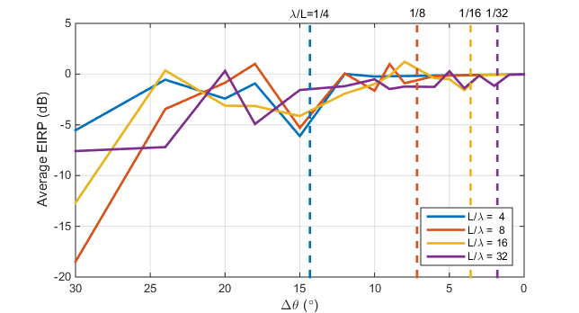

Figure 6.3.4.2-1: The average EIRP when using different angular steps $Δθ$ and the EIRP pattern of two short vertical current elements separated a distance L=4, 8, 12, 16, and 32 wavelengths, respectively. The dashed lines depict the reference angular step $\frac{λ}{L}=\frac{1}{4},\frac{1}{8},\frac{1}{12},\frac{1}{16},\frac{1}{32}$ radians for the used source separations

To proceed to more general sources two observations are useful:

1) A rotation of a source will not change the required $θ$ resolution, but the $ϕ$ resolution must be set equal to the $θ$ resolution.

2) If the source distribution is stretched along the z-direction, the $ϕ$-resolution will not change.

Based on these two observations and the angular resolution of the line source of length *L*, the following can be deduced.

1) If the line source is tilted 90 degrees down to the xy-plane, and then arbitrarily rotated around the *z*-axis, a flat disc of diameter *L* is generated. Based on observation 1, the angular resolution is .

2) If the disc is stretched a distance *h* along the z-axis (current elements are translated parallel to the z-axis), then the $Δϕ_{\text{ref}}=λ/L$ is unchanged, whereas the vertical angular resolution increases to ${Δθ}_{\text{ref}}=λ/\sqrt{L^{2}+h^{2}}$ to encompass the largest possible source separation within the cylinder.

The final shape of the source enclosure is hence a cylinder of diameter *L* and height *h*, and the angular steps required to get an accurate EIRP average (TRP value) are

$Δθ_{\text{ref}}=\frac{λ}{\sqrt{L^{2}+h^{2}}}=\frac{λ}{D}$, $Δϕ_{\text{ref}}=\frac{λ}{L}=\frac{λ}{D_{\text{cyl}}}$.

Here, $D$ is the diameter of the source enclosure, i.e., the diameter of the smallest sphere enclosing all sources, and $D_{\text{cyl}}$ is the diameter of the smallest *z*-directed circular cylinder that encloses all sources.

Other methods for determining the reference angular steps are not precluded.

Note: When sampling with the reference angular step, fine details of the radiation pattern are maybe not captured but the estimated TRP value is still accurate.

Spherical diameter is defined as the diameter of the smallest sphere enclosing the radiation source.

Cylindrical diameter is defined as the diameter of the smallest cylinder that encloses the radiation source along z-axis.

The spherical and cylindrical diameters are calculated as:

$D=\sqrt{d^{2}+w^{2}+h^{2 }}$

$D_{\text{cyl}}=\sqrt{d^{2}+w^{2}}$

The radiation source can be the antenna array or even the whole BS, depending on the emissions we consider. This is further explained in subclause 6.3.2.

Some basic definitions and relations are given here for readability.

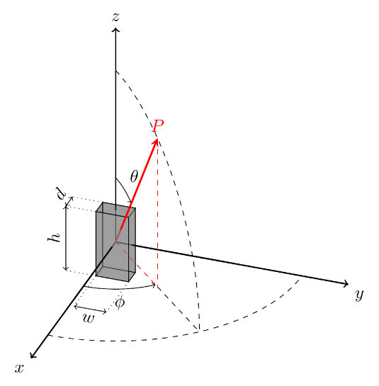

Figure 6.3.4.2-2: The dimensions of a radiation source are depth (d), width (w) and height (h)

Optionally, for the specific case of a Uniform Linear Array (ULA) system, the array spatial pattern could be defined as in the following equation.



Where spatial frequency  is defined as following:



Similar to Nyquist sampling in the time domain signal, the Rayleigh resolution for spatial domain signal to avoid the aliasing can be derived as:





where *d* is the separation distance between antenna elements and *m* is the number of antenna elements. If BS is mounted along the y-z plane as shown in f6.3.4.26.3.4.2-3, based on the above considerations on the Rayleigh resolution for spatial domain signal, then subinterval in the φ and θ in degrees angle is calculated as:

$Δθ_{ref}=min⁡(\frac{{180}^{∘}}{π}\arcsin{\frac{λ}{D_{Z}}}, {15}^{∘} )$

${Δϕ}_{ref}=\min\left(\frac{{180}^{∘}}{ π}\arcsin{\frac{λ}{D_{Y}}} , {15}^{∘}\right)$

Where *Dy* is length of radiating part of the BS along y-axis, *Dz* is length of radiated part of the BS along the z-axis and ** is wavelength for the measured frequency. Arcsine is in radians.

Figure 3

Figure 6.3.4.2-3: Spherical coordinate for OTA conformance testing of BS

In the NR coexistence study, it was assumed that antenna configuration for wide area BS is 8x16 supporting two orthorgonal polarizations. If BS mounted along y/z plane with antenna configuration 16x8 where 16 columns are assumed along the y-axis and 8 rows are assumed along the z-axis. Antenna elements are uniformly distributed with separation distance λ/2, therefore aperture size *Dy ≈ 8λ* and *Dz ≈ 4λ*. The uniform sampling in the spherical coordinate for this approach is demonstrated in the figure 6.3.4.2-4.

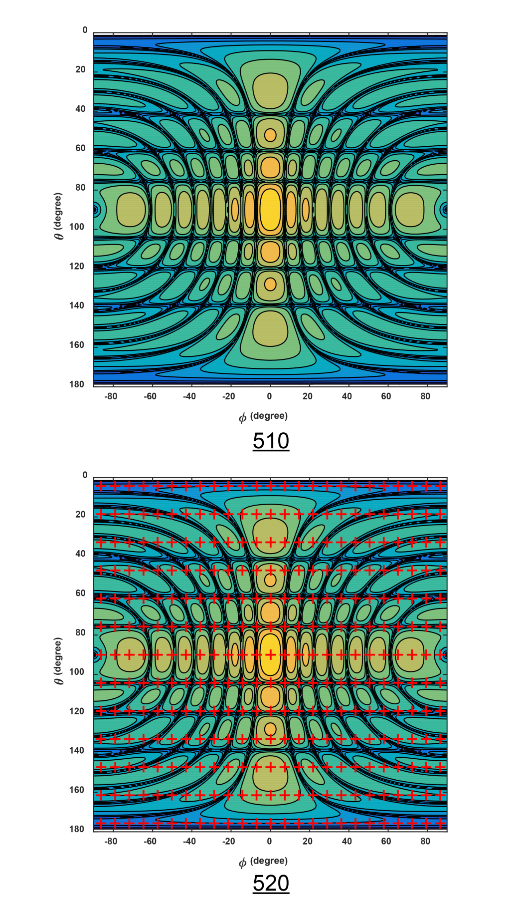

Figure 6.3.4.2-4: Uniform sampling in the spherical coordinate, red crosses denotes the sampling points

For a wanted signal and uniform antenna weights, the reference angular steps are approximately equal to the *beamwidth* (in degrees) of the main beam.





$∆ϕ_{ref}≅{BeW}_{ϕ}≅\frac{{FNBW}_{ϕ}}{2}Δθ_{ref}≅{BeW}_{θ}≅\frac{{FNBW}_{θ}}{2}$

where BeWφ and BeWθ are the *beamwidth* of the wanted signal in the φ-axis and θ-axis, respectively; and ${FNBW}_{ϕ}$ and ${FNBW}_{θ}$ are the first null beamwidth of the wanted signal in the φ-axis and θ-axis, respectively.

Using *beamwidth* of the wanted signal, the reference angular steps for each frequency within the *downlink operating* *band* including ΔfOBUE can be expressedas follows:





$Δϕ_{ref}=\frac{λ}{λ_{o}}{BeW}_{ϕ}=\frac{λ}{λ_{o}} \frac{{FNBW}_{ϕ}}{2}$ ${Δθ}_{ref}=\frac{λ}{λ_{o}}{BeW}_{θ}=\frac{λ}{λ_{o}} \frac{{FNBW}_{θ}}{2}$ where λo is the wavelength of the wanted signal, and BeWφ and BeWθ are the *beamwidth* in the φ-axis and θ-axis, respectively.

For the OTA BS radiated transmit power requirement, beamwidths at five different directions is declared by manufacturers. The declared beamwidth may be used to set BeWφ and BeWθ in the above equations provided the same beam is applied to test in-band TRP requirements. If the The numerical singularity at of a test beam is not declared, then the beamwidth can be obtained through measurements following the same procedure as the BS radiated transmit power requirement prior to TRP measurements.

In addition, the beamwidth of the wanted signal with uniform antenna weights, can be used to determine the physical dimensions of a radiation source as follows:





$D_{cyl}=\frac{λ_{o}}{{BeW}_{ϕ}}$ and for the ULA case:





#### 6.3.4.3 Spherical equal area grids

With the spherical equal area sampling grid, the spherical surface is partitioned into $N$ equal area regions. Let *n* be the index for the *n*th region and there is one point ($θ_{n},ϕ_{n}$) located in the centre of each region. The definite integral for TRPReference can be approximated as:

${TRP}_{Estimate}=\frac{1}{N}\sum_{n=1}^{N}{EIRP(θ_{n},ϕ_{n})}$

The total number angular sampling points is $N$. Unlike the spherical equal angle grid, the TRPEstimate equation is not weighted by $sin θ$. As shown in figure 6.3.4.3-1, the equal area grid points are distributed uniformly on the sphere but the pattern of $θ$ and $ϕ$ angles is irregular.

One possible way to estimate $N$ is as follows:



$N=\frac{4π}{∆θ_{ref}{∆ϕ}_{ref}}$

where $Δθ_{ref}$ and ${Δϕ}_{ref}$ are defined in 6.3.4.1. Other methods are possible and not precluded.



Figure 6.3.4.3-1: Spherical equal area sampling grid

#### 6.3.4.4 Spherical Fibonacci grids

The Fibonacci grid points are arranged along a generative spiral on the spherical surface. Similar to the equal area sampling grid, the Fibonacci grid generates points that are uniformly spaced in an isotropic way. Assume there are $I$ points in the Fibonacci sampling grid, then the definite integral for TRPReference can be approximated as:

${TRP}_{Estimate}=\frac{1}{I}\sum_{i=0}^{I-1}{EIRP(θ_{i},ϕ_{i})}$

where *i* = 0 .. $I-1$

$θ_{i}=\cos^{-1}\left(1-\frac{2i+1}{I}\right)$ and

$ϕ_{i}=\frac{2πi}{Ψ}$,

where $Ψ=\frac{1+\sqrt{5}}{2}$

The total number of angular sampling points is *I*, which can be estimated in a similar manner as in subclause 6.3.4.3. Like the spherical equal area grid, the TRPEstimate equation is not weighted by $sin θ$.



Figure 6.3.4.4-1: Spherical Fibonacci sampling grid

#### 6.3.4.5 Orthogonal cuts grids

Compared to the TX spurious emissions the OBUE emissions and ACLR are likely to experience the similar beamforming pattern as for the wanted signal. Due to this reason, it is easily predictable where the maximum of the emissions is going to be, hence the possibility to enhance the measurement method to achieve better accuracy. Here we choose to apply the pattern multiplication method [10].

In this method, at least two cuts (default) shall be used, an optional third cut can be added if needed. The alignment of the cuts must be along the symmetry planes of the antenna array. Note that theta reference steps apply to the vertical cuts and phi reference steps to the horizontal cuts.

The first mandatory cut is a horizontal cut passing through the peak direction of the main beam.

The second mandatory is a vertical cut passing through the peak direction of the main beam.

Using the data from these two mandatory cuts, a conditional pattern multiplication can be used.

The third optional cut is a vertical cut orthogonal to the first and the second cut.

Once the number and the orientation of the cuts are decided, the total EIRP is measured on the orthogonal cuts and the TRP is then calculated as follows: First the contributions from each cut is calculated as:

${EIRP}_{av,cut-n}=\frac{1}{P}\sum_{j=1}^{P}{EIRP(j)}$

where P is the number of sampling points. The final contribution for all cuts is calculated as:

${TRP}_{Estimate}=\frac{1}{N}\sum_{n=1}^{N}{{EIRP}_{av,cut-n}}$

where N is the number of cuts. Note that when orthogonal cuts are measured, the intersection points are measured multiple times and the repeated values can be removed from the samples before averaging.

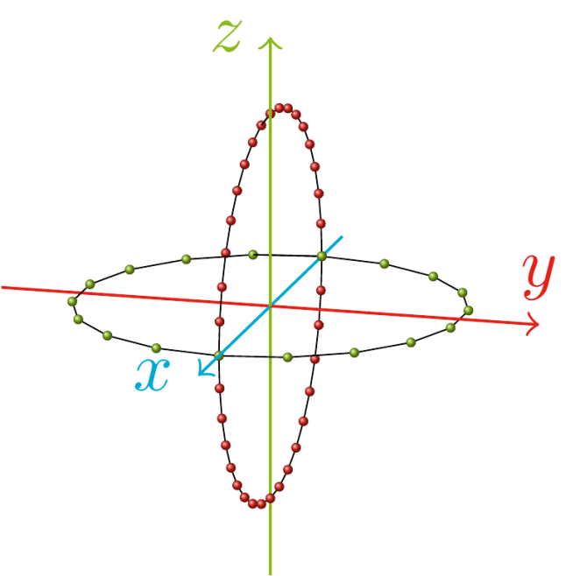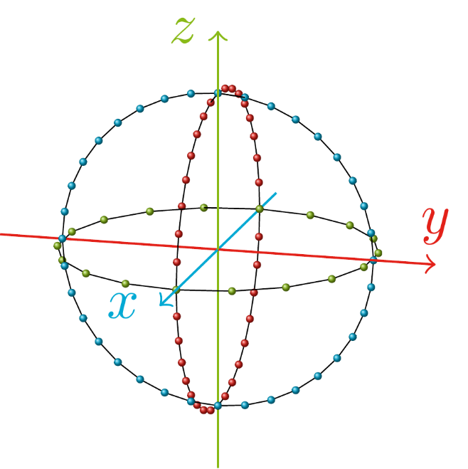

Figure 6.3.4.5-1: Example of orthogonal cuts geometry when the main lobe points along the x-axis. Two mandatory cuts grid (left) and the optional added third cut (right). The first two cuts are generated by rotating the BS around its z-axis and y-axis, respectively, and the optional third cut is generated by rotating the BS around its x-axis

Two cuts cut data gives a conservative TRP estimate (an overestimation of the real TRP). Through pattern multiplication a less conservative estimate is obtained, based on the calculation of the antenna array factor as a product of two terms, corresponding to the two cuts.

The following conditions for being able to apply pattern multiplication method are mandatory:

i. The vertical cut (and the main beam) is in the $xz$-plane

ii. The frequency of the emission is within the downlink operating band.

iii. The bandwidth of the emission is the same as the bandwidth of the in-band modulated signal

iv. The emission appears/disappears when the TX power is turned on/off.

v. The antenna arrays of the BS

1. Have rectangular grids of antenna element positions

2. Have symmetry planes that are vertical and horizontal.

3. Have parallel antenna planes

The antenna array is here assumed to be placed in the yz-plane. The pattern multiplication is performed in uv-coordinates and the data in the two cuts are denoted ${EIRP}_{cut1}^{}\left(ϕ\right)$ at $θ=θ_{H}$ and a vertical cut with data ${EIRP}_{cut2}^{}\left(θ\right)$ at $ϕ=0$. The data is split in two parts corresponding to the forward and backward hemisphere. The uv-coordinates are the projections of the angular directions onto the antenna plane, here the yz-plane. Using the spherical coordinates as depicted in figure 6.3.4.2-2 the u and v coordinates are defined as:

$\left\{\begin{matrix}u=\sin{θ\sin{ϕ}} \\ v=\cos{θ}\end{matrix}\right.$

Note that only the data on the coordinate axes are measured, and hence only the data $\text{EIR}{\text{P}}_{\text{cut1}}^{}\left(u\right)$ for $v_{H}=\cos{θ_{H}}$ (the horizontal cut) and $\text{EIR}{\text{P}}_{\text{cut2}}^{}\left(v\right)$ for $u=0$ (the vertical cut) are known. Moreover, only the points in the circular disc $u^{2}+v^{2}≤1$, a.k.a. the visible region, contribute to the TRP.

The pattern multiplication is used to calculate power density values outside the two cardinal cuts as:

$EIRP\left(u,v\right)=\frac{EIRP_{cut1}^{}\left(u\right)EIRP_{cut2}^{}\left(v\right)}{EIRP\left(0,v_{H}\right)}$

In Figure 6.3.4.5-2, the case where $v_{H}=0$ is illustrated.

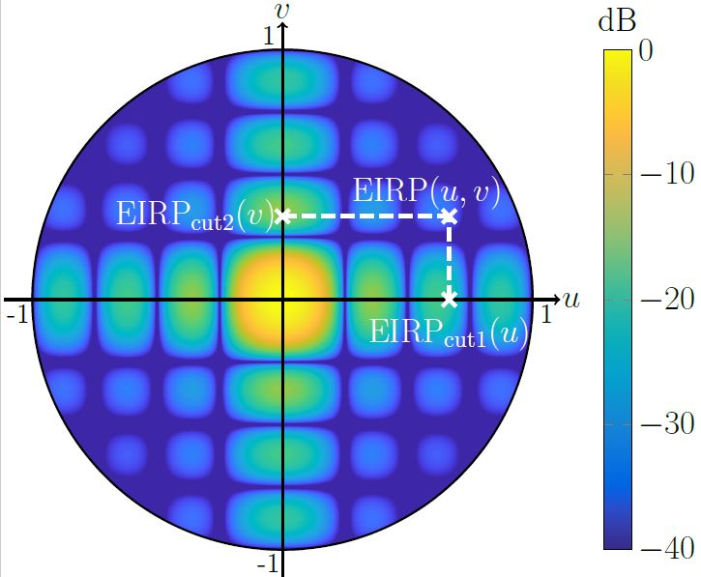

Figure 6.3.4.5-2: Example of pattern multiplication

The pattern multiplication is applied separately for the forward (fwd) and backward (bwd) hemisphere. The TRP is then calculated as

$TRP=\frac{1}{4π}\left[\iint_{fwd}{{EIRP}_{fwd}^{}\left(u,v\right)\frac{dudv}{\sqrt{1-u^{2}-v^{2}}}+}\iint_{bwd}{{EIRP}_{bwd}^{}\left(u,v\right)\frac{dudv}{\sqrt{1-u^{2}-v^{2}}}}\right]$

NOTE: The numerical singularity at $u^{2}+v^{2}=1$ must be treated with care, e.g. by changing the coordinate system to polar as in [10].

#### 6.3.4.6 Wave vector space sampling grid

Similar as Rayleigh sampling approach, BS is placed on the yz plane in the spherical coordinate and normal vector of BS is pointing along the x-axis as shown in figure 6.3.4.2-2. The angle φ and θ represent azimuth and elevation respectively, *u* and *v* represent the projection of normalized wave vector on y-axis and z-axis.

According to the relationship between the normalized wave vector and spherical coordinate, the wave vector can be represented as following:

$u=\sin\left(θ\right)\sin\left(ϕ\right), v=cos⁡(θ)$

TRP is defined in the spherical coordinate as following:



As TRP is defined in the wave vector coordinate, therefore TRP definition should be revised accordingly in the corresponding coordinate. For the TRP definition in normalized wave vector space, according to the 2D Jacobian transformation, the above equation could be adjusted as following, namely:

$dudv=\left|\frac{∂\left(u,v\right)}{∂\left(θ,ϕ\right)}\right|dθdϕ=\sin^{2}{θ\left|\cos{ϕ}\right|dθdϕ}$

Based on the above two equations, then we could get

$TRP=\frac{1}{4π}\iint_{fwd}{\frac{EIRP\left(θ,ϕ\right)}{\sin{θ}\left|\cos{ϕ}\right|}dudv}+\frac{1}{4π}\iint_{bwd}{\frac{EIRP\left(θ,ϕ\right)}{\sin{θ}\left|\cos{ϕ}\right|}dudv}$

where relationship between (θ,φ) and (*u*,*v* )is demonstrated in the equation before. Similar as discrete sampling process, the above equation is approximated in the far-field region as the sum of the total EIRP at a number of discrete directions as follows:

$TRP=\frac{{Δu}_{grid}Δv_{grid}}{4π}\left(\sum_{\begin{aligned}u^{2}+v^{2}<1 \\ cosϕ>0\end{aligned}}{\frac{EIRP\left(θ_{n},ϕ_{m,n}\right)}{\sin{θ_{n}}\left|\cos{ϕ_{m,n}}\right|} }+\sum_{\begin{aligned}u^{2}+v^{2}<1 \\ cosϕ<0\end{aligned}}{\frac{EIRP\left(θ_{n},ϕ_{m,n}\right)}{\sin{θ_{n}}\left|\cos{ϕ_{m,n}}\right|} }\right)$

The above considerations could be applied for both polarization.

Uniform sampling in the wave vector coordinate as shown in figure 6.3.4.6-1:

- Rayleigh resolution in y-axis:

- Rayleigh resolution in z-axis: $Δv_{grid}=\frac{λ}{D_{z}}$

Where *Dy* is length of radiating parts of BS along y-axis, *Dz* is length of radiating parts of BS along the z-axis.

Based on the uniform sampling grid on the yz plane, we could get the sampling point ($u_{m}$, $v_{n}$). In addition, according to the transformation between ($u_{m}$, $v_{n}$) and (φ,θ ), then azimuth and elevation (φm,n, θn) in the spherical coordinate could be derived correspondingly as shown in figure 6.3.4.6-2. Based on the (φm,n, θn) in the spherical coordinate, EIRP on the spherical coordinate could be measured.

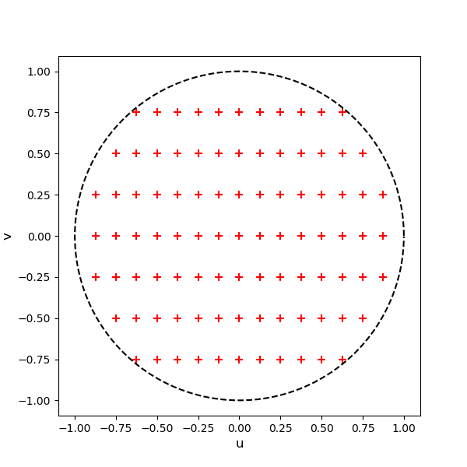

Figure 6.3.4.6-1: Sampling grid in the wave vector space

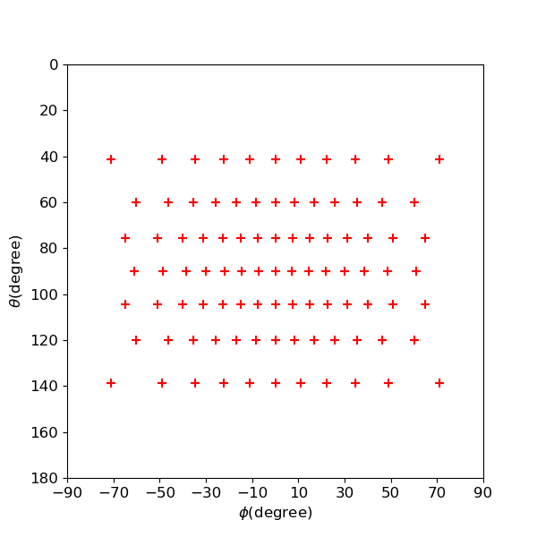

Figure 6.3.4.6-2: Sampling grid in the spherical coordinate

### 6.3.5 Aspects related to measurement of OTA unwanted emission

#### 6.3.5.1 Test range

Test of OTA unwanted emission required an OTA test environment, capable of measuring TRP emission under the condition that the test object is radiating the wanted signal at full power. To handle high RF power from the test object required careful planning of the setup (e.g. test personal and test equipment cannot be placed inside the test chamber during the test). To avoid measurement chamber influence and external interferer on the test result, use of a shielded anechoic chamber is preferable. A positioner is used to move the test object according to selected measurement grid for a proper TRP measurement. The emission is measured at the output RF port of the measurement antenna placed at a suitable test distance. In figure 6.3.5.1-1, a principle test environment suitable for OTA unwanted emission is depicted.

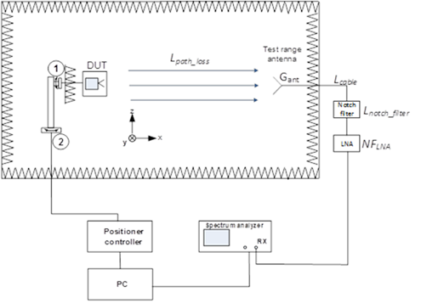

Figure 6.3.5.1-1: Principle test environment

The test environment may differ between OTA unwanted emission requirements; OTA ACLR, OTA OBUE and OTA spurious emission. For OTA spurious emission, a test environment similar to the one used for EMC radiated emission or a Shielded Indoor Anechoic Chamber (IAC) can be used. For OTA unwanted emission requirements defined within the in-band region other test environments could be considered e.g. CATR or IAC.

A band stop filter is needed to protect the measurement receiver from the wanted signal, achieving dynamic range for the emission to be measured with acceptable measurement uncertainty.

#### 6.3.5.2 Measurement distance

The measurement distance is the distance between the test object and the measurement antenna (or probe antenna). The measurement distance is usually determined by the signal-to-noise ratio (SNR) required for the measurement receiver to detect the emission level with acceptable measurement uncertainty. Unlike, EIRP, total radiated power (TRP) is not exclusively a far-field parameter. TRP is defined as the total radiated power radiated by an object, regardless to the distance. Since emission power levels tends to be low, it is essential to conserve the path-loss in the test setup, by minimizing the measurement distance. Another aspect is the for the lower limit (30 MHz) the far-field criteria would result in unpractical measurement distances for OTA testing. Further guidance on near-field testing can be found in annex F.

#### 6.3.5.3 Sampling grid selection

A dense full-sphere grid, i.e. using reference steps, will result in a very large number of measurement points to extract TRP per frequency, while a sparse grid requires a few measurements. The selection of grid and corresponding sampling resolution determines the measurement uncertainty error contribution related to sampling the radiating power over the sphere. Determining proper sampling grids for emission, assumptions of the spatial distribution of emission should be considered. If it can be established that the emission is radiating in all directions, the sample grid resolution can be significantly reduced.

The ability of direct emission in certain direction is set by the physical size of BS, number of radiating sources and correlation properties. For low frequencies, where D << , it is reasonable to believe that the radiated emission will be omni-directional, while for the case where D >> , there is a potential risk that emission leaking through the encapsulation or the antenna aperture can be directed in a certain direction. Therefore, the process to determine the sampling grid and corresponding resolution needs to include the frequency as one parameter. Consequently, a concept with a fixed sampling grid over the whole spurious frequency domain is not suitable to balance measurement uncertainty with test time.

### 6.3.6 TRP summation error

In practice, discrete samples of EIRP or power density are measured at different directions $(θ,ϕ)$ over the entire sphere, which are used to numerically approximate the surface TRPReference integral. The obtained value, TRPEstimate, is an approximation of TRPReference and the difference between them is defined as the *TRP summation error* (SE) which is

SE= | TRPEstimate – TRPreference | (in dB)

The SE is the error caused by the numerical integration of measured values on the grid to obtain TRPEstimate, given that the number of test points correspond to the reference angular steps, which are in turn dependent on antenna size and frequency, as described in subclause 6.3.4. A reasonable tradeoff between accuracy and sampling time is achieved when the SE = 0.75 dB.

## 6.4 Co-location measurements

TBD

## 6.5 Requirements classification

Based on the above spatial definitions, in table 6.5-1 captures classification of the radiated TX requirements and table 6.5-2 captures classification of the radiated RX requirements.

Table 6.5-1: Classification of radiated TX requirements

|  |  |  |
| --- | --- | --- |
| TX requirement | Description | Classification |
| Radiated transmit power | The minimum requirements for radiated transmit power, are placed on one or more manufacturer declared beams over a declared OTA peak direction set. OTA requirements for BS output power are defined for directional EIRP requirements as radiated transmit power requirements.  This requirement originates from the Rel-13 AAS BS requirement for the EIRP accuracy. | Directional |
| OTA BS output power | TRP metric is used for BS output power limit requirement. | TRP |
| OTA output power dynamics | OTA output power dynamics consists of the Total power dynamic range, as well as the RE power control dynamic range requirements.  For E-UTRA specification, the RE power control dynamic range requirement has no specific test and is tested together with the EVM. Furthermore, verification of the output power dynamics is not impacted by the spatial aspects around the BS. Therefore, the OTA output power dynamics requirements are considered as directional requirements. | Directional |
| OTA transmit OFF power | The OTA transmit OFF power is a co-location requirement in FR1, defined at the *co-location reference antenna* conductive output side, subject to scaling.  For FR2, it is defined as TRP requirement. | FR1: Co-location  FR2: TRP |
| OTA transient period | Same as OTA transmit OFF power, the OTA transient period is a co-location requirement in FR1, defined at the *co-location reference antenna* conductive output side, subject to scaling.  For FR2, it is defined as directional requirement. | FR1: Co-location  FR2: directional |
| OTA transmitted signal quality | EVM: The range of directions where the EVM requirement must be met is declared by the manufacturer as OTA coverage range, while the requirement itself is considered directional.  Frequency error: The frequency error is coherent and will have a ‘flat’ response in the spatial domain, i.e. OTA frequency error will not depend on the selection of the measurement point within beam’s compliance directions set. Therefore, single directional requirement can be applied.  TAE: In terms of testing effort it is beneficial, to coordinate testing of OTA TAE with testing of other transmitter parameters such as OTA frequency error and radiated transmit power. | Directional |
| OTA occupied bandwidth | For occupied bandwidth, the beam characteristics are not important. The requirement should however cover the fact that all transmitter is active and the system is operating at the maximum declared rated total radiated power. Occupied bandwidth is specified as a directional requirement valid over the OTA coverage range. | Directional |
| OTA ACLR | ACLR requirement is the ratio of two TRP measures: the total radiated filtered mean power centred on the assigned channel frequency to the total radiated filtered mean power centred on an adjacent channel frequency. | TRP |
| OTA operating band unwanted emission | The OBUE unwanted emissions requirement in the OTA domain must capture all emissions around the BS by application of the TRP metric. | TRP |
| OTA transmitter spurious emission | Similar to other Unwanted emissions requirements, the metric used to capture transmitter spurious emissions OTA is TRP. | TRP except for co-location requirements applicable in FR1 |
| OTA transmitter intermodulation | OTA transmitter intermodulation requirement relies on Unwanted emission requirements (i.e. operating band unwanted emission, transmitter spurious emission, and ACLR; all defined as TRP) in the presence of a wanted signal and an interfering signal.  No requirement for FR2 is defined. | Co-location |

Directional requirements are to be met over one of two defined directions sets, with each direction set being declared:

- the *OTA coverage range*: range of directions over which *directional requirements* associated with BS-UE communication are intended such as modulation quality, TAE and frequency error. It can be regarded as the range of directions which define the cell coverage. There is only one *OTA coverage range* per BS.

- the *OTA peak directions set*: intended for *directional requirements* which are intended for the centre of the beam for example EIRP accuracy. The *OTA peak directions set* must always be within the *OTA coverage range*. There may be more than one *OTA peak directions set* declared, the declarations cover the range of directions which a beam may be steered. As the BS may generate more than one type of beam with different beam widths and different steering capabilities the declaration allows for multiple *OTA peak direction sets* to be declared. The minimum set of declarations covers the beams with the narrowest and the widest beam widths.

Table 6.5-2: Classification of radiated Rx requirements

|  |  |  |
| --- | --- | --- |
| Rx requirement | Description and discussion | Classification |
| OTA sensitivity | Based on the Rel-13 EIS requirement declaration over the OSDD, the OTA sensitivity is directional requirement by definition.  Conformance testing for OTA sensitivity is performed for the five directions same as the Rel-13 AAS OTA sensitivity requirements. This requirement is not applicable for BS type 2-O. | Directional |
| OTA reference sensitivity level | Conformance testing for OTA reference sensitivity is performed for five directions declared by the manufacturer. | Directional |
| OTA dynamic range | It was agreed that the requirement assumes that the wanted signal and interfering signal come from the same direction. Testing is defined in the receiver target reference direction, meaning that this is directional requirement. This requirement is not applicable for BS type 2-O. | Directional |
| OTA in-band selectivity and blocking | The OTA blocking requirement is tested as follows:  - In the reference direction of the minSENS OSDD using the minSENS based requirement level  - In each of the 4 conformance direction at the extremities of the OTA REFSENS RoAoA using the REFSENS based requirement level. | Directional |
| OTA out-of-band blocking | Out of band blocking is a long test and hence it is optimum to minimize the number of conformance test directions. The antenna gain can be assumed to be maximum at the reference direction, therefore it is sufficient to show conformance at the reference direction only. | Directional, except for co-location requirement applicable for BS type 1-O |
| OTA receiver spurious emission | The Rx spurious emissions requirement follows the approach for the Tx spurious emissions, i.e. the emissions in the spurious region needs to be measured as TRP due to unknown radiation pattern. | TRP |
| OTA receiver intermodulation | Since RX sensitivity and blocking already test at all conformance directions, it is sufficient to test RX IM only in a single direction. | Directional |
| OTA in-channel selectivity | In channel selectivity requirement is tested in a single direction. | Directional |