 Wednesday, 4th April 2001

INVITATION TO THE 3GPP TSG RAN4 #17 MEETING

Dear Delegates,

Ericsson has the pleasure of inviting you to the 3GPP TSG RAN4 #17 Meeting on 21st May – 25th May 2001, in Gothenburg, Sweden.

The venue for this meeting will be:

Hotel Riverton

Stora Badhusgatan 26

SE-411 21 GÖTEBORG

Phone: +46 31 750 10 00, Fax: +46 31 750 10 01

E-mail: riverton@riverton.se http://www.riverton.se

For further details, see “HOTEL AND MEETING VENUE INFORMATION” below.

The meeting will take place the Hotel Riverton that is located in the center of Gothenburg. The meeting will start on 21st May 2001 at 09h00 and it will end on 25th May 2001 at 17h00.

Ericsson has made a block booking of hotel rooms at the Hotel Riverton at a special price of SEK 1039:-/night, including breakfast. Please use the attached hotel reservation form and return it not later than 26th April 2001. “The first come first served” principle will apply. Indicate also whether you would like to stay at the Hotel Riverton or whether you prefer to arrange your hotel booking yourself. If you like to stay at the Hotel Riverton, you should not book room yourself as the price includes a discount which is only valid if the reservation is made through Ericsson.

A social event is planned for Wednesday evening on 23rd May 2001. See the enclosed hotel reservation form.

THIS WILL BE A PAPERLESS MEETING. Documents will be distributed electronically on CD-ROM.
For allocation of document numbers please contact the 3GPP TSG RAN4 meeting the secretary, Mr. Cesar Gutierrez, phone: +33 4 92 94 4321, E-mail: cesar.gutierrez@etsi.fr.

Mrs. Barbro WARBERG is responsible for the administrative arrangements of the meeting. Please contact her directly if you have any questions related to the arrangements of the meeting.
Fax: +46 8 707 4800, Phone: +46 8 707 4751, mobile: +46 70 312 5160 and E-mail: barbro.b.warberg@telia.se

Should you need to apply for a visa to Sweden, remember to do it well in advance. Mrs. Helena BERG will supply you with the invitation letter from Ericsson Radio Systems AB. Please contact her if you need any assistance in this matter. Phone: +46 8 404 5309, Fax: +46 8 5087 7300,
Mobile: +46 70 534 1814, E-mail: helena.berg@era.ericsson.se

I look forward to seeing you in Gothenburg.

Ericsson Radio Systems AB

Yours sincerely,

Jonas Sundborg

Jonas Sundborg

Manager of Global Mobile Standards & Regulations

REGISTRATION

You are kindly asked to register to the meeting electronically via the 3GPP web site, see URL:
http://webapp.etsi.org/meetingcalendar/ViewMeetings.asp
Please register to the meeting not later than 18th May 2001.

TRAVEL INFORMATION

- Taxi
Choose a cab from Taxi Gothenburg, phone 650 000. Ask for a fixed rate (SEK 225).
Our address is Stora Badhusgatan 26.

- Public transportation
Take the airport bus to the Central Railway station (Centralstation) downtown Gothenburg.
Walk to the tram station in front of the Central Railway station.
Take either tram #2 towards Frölunda, #3 towards Högsbotorp or #7 towards Tynnered.
Exit at the Cathedral (Domkyrkan) stop.
Walk along Kungsgatan away from the Cathedral.
You will find the entrance to the Riverton Hotel after 150 m on your right hand side.

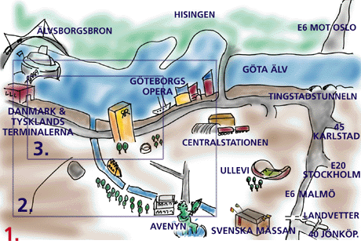
MAP WITH THE SURROUNDINGS OF MEETING VENUE

HOTEL RESERVATION FORM
3GPP TSG RAN4 #17 MEETING
21st- 25th May 2001

Please fill in this form and send it latest  26th April 2001 to: |  |  |  |  |  |  |  | Mrs. Barbro Warberg  E-mail: Barbro.B.Warberg@telia.se  Fax: +46 8 707 4800
Family Name: |  |  |  |  |  |  |  |  |  | First Name:
Company/Address:
Tel: |  |  | Fax: |  |  |  |  |  | E-mail:
Arrival Date: |  |  |  |  | Time of arrival: |  |  |  |  |  | Departure Date:

◻ Single room ◻ Double room

◻ Non smoking ◻ Smoking ◻ I do not need hotel accommodation

- Special food (e.g. vegetarian)

I will participate in the social event on 23rd May 2001 ◻ Yes ◻ No

Credit Card information in order to guarantee this reservation:

◻ AMEX ◻ VISA ◻ DINERS ◻ EC ◻ Other
Number |  | Validity
Date |  | Signature

