3GPP TSG-RAN WG4 Meeting #110 R4-2403897

Athens, GR, 26 Feb – 01 Mar, 2024
CR-Form-v12.2
CHANGE REQUEST
 | 38.751 | CR | 0005 | rev |  | Current version: | 18.0.0
For HELP on using this form: comprehensive instructions can be found at
http://www.3gpp.org/Change-Requests.

Proposed change affects: | UICC apps |  | ME | X | Radio Access Network |  | Core Network

Title: | CR to 38.751 on update of UE orientation
Source to WG: | vivo
Source to TSG: | R4
Work item code: | NR_FR2_multiRX_DL-Core |  |  |  |  |  | Date: |  |  | 2024-3-5
Category: | F |  |  |  |  |  | Release: |  |  | Rel-18
 | Use one of the following categories:  F (correction)  A (mirror corresponding to a change in an earlier release)  B (addition of feature),  C (functional modification of feature)  D (editorial modification)  Detailed explanations of the above categories can  be found in 3GPP TR 21.900. |  |  |  |  |  |  |  | Use one of the following releases:  Rel-8 (Release 8)  Rel-9 (Release 9)  Rel-10 (Release 10)  Rel-11 (Release 11)  …  Rel-16 (Release 16)  Rel-17 (Release 17)  Rel-18 (Release 18)  Rel-19 (Release 19)
Reason for change: |  | In RAN4#109, 3 additional UE orientations are agreed to be added for multiRx verificaiton, the TR should be updated accordingly
Summary of change: |  | Update the agreement on UE orientations
Consequences if not approved: |  | The wording in TR is not align with the agreement
Clauses affected: |  | 6.3.4
 |  | Y | N
Other specs |  |  | X | Other core specifications |  |  |  | TS/TR ... CR ...
affected: |  | X |  | Test specifications |  |  |  | TS 38.521-2
(show related CRs) |  |  | X | O&M Specifications |  |  |  | TS/TR ... CR ...
Other comments:
This CR's revision history:

***************************** START OF CHANGES ************************************

6.3.4 UE orientation
For the legacy 1AoA UE RF requirement and test for FR2, various UE alignment options (referred as orientations in this TR from these points onwards) are allowed as illustrated in the Figures in the Tables J.2-1 through J.2-3 of TS 38.101-2 Annex J. In theory, the test results with different UE orientations should be the same without considering the measurement grid uncertainty, because the 3D scan of 1AoA test is sampling UE’s sphere with test ‘point’. However, the 3D scan of 2AoA test is sampling UE’s sphere with test ‘vector’ corresponding to AoA pair. Different UE orientations will lead to different test ‘vector’ even at the same test point, and thus different 2AoA performance is expected.
Companies’ simulation results as provided in Annex A show that different UE orientations lead to significantly different 2AoA spherical coverage performance. Depending on different UE implementations, no standardized UE orientation could be found suitable for 2AoA performance test. RAN4 has agreed to specify the 2AoA spherical coverage performance in implementation agnostic manner, the most feasible way is to adopt the declaration approach.
Based on the theoretical analysis and simulation results, RAN4 achieves following conclusion:
1. UE requirement applies to UE declared orientation(s).
2. The UE RF requirement is derived assuming each UE is evaluated in the orientation that yields the best metric value.
3. All the candidate orientations (9 in total) discussed in this section for UE to choose from correspond to the ‘Alignment Options’ in Annex J (J.2) of TS 38.101-2.
4. 3 additional orientations should be considered. One example missing variant for alignment option 1 is shown in Figure 6.3.4-1
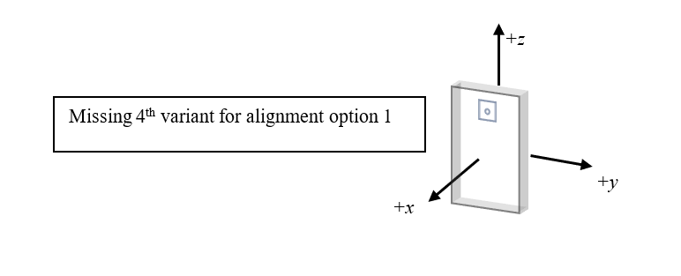
Figure 6.3.4-1 An example missing alignment option

***************************** END OF CHANGES ************************************

