3GPP TSG-RAN WG4 Meeting # 110 R4-2401078

Athens, GR, 26 Feb – 01 Mar, 2024

**Agenda item:** 8.1.4

**Source:** Moderator (vivo)

**Title:** Topic summary for [110][119] FR1_enh2_part2

**Document for:** Information

# Introduction

*Briefly introduce background, the scope of this email discussion (e.g. list of treated agenda items) and provide some guidelines for email discussion if necessary.*

# Topic #1: 4Tx Requirements

*Main technical topic overview. The structure can be done based on sub-agenda basis.*

## Companies’ contributions summary

|  |  |  |
| --- | --- | --- |
| **T-doc number** | **Company** | **Proposals / Observations** |
| [**R4-2400341**](https://www.3gpp.org/ftp/TSG_RAN/WG4_Radio/TSGR4_110/Docs/R4-2400341.zip) | Nokia, Nokia Shanghai Bell | Delta PpowerClsss for 4Tx for SRS antenna switching  **Observation 1**: Requirements associated with ΔTRxSRS for 8Rx with 4Tx as well as 4Rx with 4Tx have not been completed yet.  **Observation 2**: Some of ΔTRxSRS requirements are associated with the value of ΔPPowerClass.  ΔPPowerClass specific part in 38.101-1 (Rel-17)    **Observation 3**: A following exceptional relaxation is applicable to not only 26 dBm + 23 dBm PA configuration, but rather 26 dBm + 26 dBm PA configuration for PC2.  The value of ∆TRxSRS is 7.5dB for bands whose FUL_high is higher than the FUL_low of n79 and 6 dB for bands whose FUL_high is lower than the FUL_low of n79 during SRS transmission occasions with configured SRS resources consisting of one SRS port when the device is capable of power class 2 in the band and ΔPPowerClass = 0 dB and not indicating *txDiversity-r16*.  **Observation 4**: ΔPPowerClass can be different depending on combinations between configured SRS antenna switching resource, implemented PA configuration, how the UE uses PAs as pair like 26 dBm + 23 dBm, and their order, while there is no explicit way for gNB to identify the information.  **Observation 5**: For ΔPPowerClass for 4Tx/4Rx,  If the UE with 4Tx for PC1.5 with 4TxD capability (assuming 23 dBm x 4) is configured with SRS resources corresponding to   * t4ry or similar, ΔPPowerClass is 0 dB; * t2ry or similar, ΔPPowerClass is 3 dB, or * t1ry or similar, ΔPPowerClass is 6 dB   If the UE with 4Tx for PC1.5 without 4TxD capability (assuming 2 x 26 dBm + 2 x 23 dBm or 4 x 26 dBm) and if RAN4 follows a way mentioned in Observation 2, possible ΔPPowerClass is as follows.   * t4ry or similr, ΔPPowerClass is 0 dB; * t2ry or similar, ΔPPowerClass is 0 dB for the 1st port pair and 3 dB for the second port pair; or * t1ry or similar, ΔPPowerClass is 3 dB (for the 1st and 2nd SRS resource) and 6 (for the 3rd and 4th SRS resource).   **Proposal:** RAN4 should address ΔPPowerClass for 4Tx and requirements for SRS antenna in the future meetings with consideration of these shared observations. |
| [**R4-2400719**](https://www.3gpp.org/ftp/TSG_RAN/WG4_Radio/TSGR4_110/Docs/R4-2400719.zip) | Qualcomm | (NR_ENDC_RF_FR1_enh2-Core ) 4Tx RF issues |
| [**R4-2401260**](https://www.3gpp.org/ftp/TSG_RAN/WG4_Radio/TSGR4_110/Docs/R4-2401260.zip) | ZTE Corporation | ( NR_ENDC_RF_FR1_enh2-Core) Update TxD capabilities name and correct the requirements |
| [**R4-2401518**](https://www.3gpp.org/ftp/TSG_RAN/WG4_Radio/TSGR4_110/Docs/R4-2401518.zip) | vivo | Remaining TxD capability requirements for 4Tx  **Proposal:** Extend the still existing legacy capability “*txDiversity-r16*” cases in a case by case way according to the analysis in this paper.  **Option 1**: Extend the Rel-16 capability *txDiversity-r16* to include two 2Tx capability, e.g. *txDiversity-r16* or *[txDiversity2Tx-r18]*  **Option 2**: Extend the Rel-16 capability *txDiversity-r16* to general term including 4Tx case, e.g. “Tx Diversity capability/(ies)” |
| [**R4-2401519**](https://www.3gpp.org/ftp/TSG_RAN/WG4_Radio/TSGR4_110/Docs/R4-2401519.zip) | vivo | Extension for TxD capability requirements for 4Tx |
| [**R4-2402419**](https://www.3gpp.org/ftp/TSG_RAN/WG4_Radio/TSGR4_110/Docs/R4-2402419.zip) | Huawei, HiSilicon | R18 Cat-F CR 38.101-1 correction CR for 4Tx requirements    … |
| [**R4-2402420**](https://www.3gpp.org/ftp/TSG_RAN/WG4_Radio/TSGR4_110/Docs/R4-2402420.zip) | Huawei, HiSilicon | draft LS on verification of full power rank 2 UL operation for UE supporting 4Tx |
|  |  |  |

## Open issues summary

*Before Meeting, moderators shall summarize list of open issues, candidate options and possible WF (if applicable) based on companies’ contributions.*

### Sub-topic 1-1 4Tx TxD and others

*Sub-topic description*

*Open issues and candidate options before meeting:*

**Issue 1-1-1: Whether address ΔPPowerClass for 4Tx and requirements for SRS antenna**

* Proposals
  + Option 1: Yes (Nokia, [**R4-2400341**](https://www.3gpp.org/ftp/TSG_RAN/WG4_Radio/TSGR4_110/Docs/R4-2400341.zip))
    - RAN4 should address ΔPPowerClass for 4Tx and requirements for SRS antenna in the future meetings with consideration of these shared observations.
  + Option 2: No
    - Defining the current requirements to include two 2Tx capability. (vivo, [**R4-2401518**](https://www.3gpp.org/ftp/TSG_RAN/WG4_Radio/TSGR4_110/Docs/R4-2401518.zip))
  + Option 3: Others
* Recommended WF
  + TBD

**Issue 1-1-2: How to harmonize and revise the TxD related capabilities**

* Proposals
  + Proposal 1: Extend the still existing legacy capability “txDiversity-r16” cases in a case by case way.
    - Option 1: Extend the Rel-16 capability *txDiversity-r16* to include two 2Tx capability, e.g. *txDiversity-r16* or *[txDiversity2Tx-r18]*
    - Option 2: Extend the Rel-16 capability *txDiversity-r16* to general term including 4Tx case, e.g. “Tx Diversity capability/(ies)”

|  |  |  |  |
| --- | --- | --- | --- |
| **Index** | **Clauses** | **Contents** | **Suggested Changing option** |
| 1 | Table 6.2.3.1-1: Additional maximum power reduction (A-MPR) | NOTE 7: The 1Tx architecture is assumed. For power class 2 UE indicating **txDiversity-r16** [TS 38.306], the additional relaxation of [2] dB is applicable. | [Option 1] |
| 2a | Clause 6.2.4 Configured transmitted power  *Note: Depending on previous issue* | 3dB is applied during SRS transmission occasions with usage in SRS-ResourceSet set as ‘antennaSwitching’ with configured SRS resources in each SRS resource set(s) consisting of one SRS port when PC2 capable UE with **txDiversity-r16** capability or PC1.5 capable UE …; | [Option 1] |
| 2b | The value of ∆TRxSRS is 4.5dB (5.5/6.0/7.3) for bands …, or when UE indicating **txDiversity-r16** | [Option 1] |
| 2c | The value of ∆TRxSRS is 7.5dB (8.5/9.0/10.3) for bands …capable of power class 2 in the band and ΔPPowerClass = 0 dB and not indicating **txDiversity-r16** | [Option 2 slightly preferred] |
| 3 | Clause 6.2D.1 UE maximum output power for UL MIMO | If the UE is scheduled for single antenna-port PUSCH transmission by DCI format 0_0 or……. with the following exception: for UEs indicating **txDiversity-r16**, the requirements in clause 6.2G for the power class indicated by the ue-PowerClass. | [Option 2] |
| 4 | Clause F.8 EVM | For UE with multiple transmission antennas, if UE indicates IE ***txDiversity-r16***, | [Option 2] |

* + Proposal 2: Only consider extending the capability to a general case except the general part.
* Recommended WF
  + TBD

**Issue 1-1-3: Whether LS to RAN5 is needed.**

* Proposal
  + Proposal 1: Sending LS to RAN5 as following:

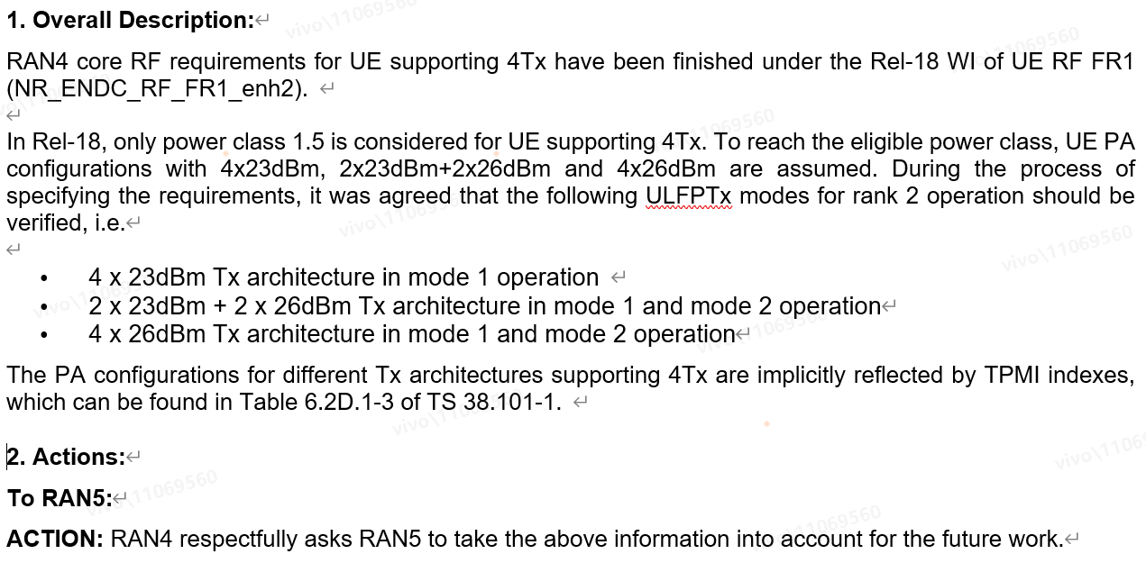

* Recommended WF
  + TBA

**Issue 1-1-4: Others.**

* Proposals
  + Proposal 1: As in CR [**R4-2400719**](https://www.3gpp.org/ftp/TSG_RAN/WG4_Radio/TSGR4_110/Docs/R4-2400719.zip).

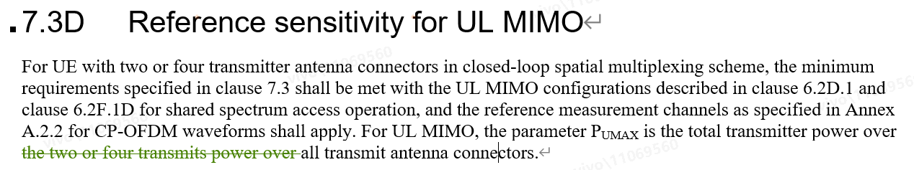

* Recommended WF
  + TBA