3GPP TR 38.751 V1.2.0 (2023-11)
Technical Report

3rd Generation Partnership Project;
Technical Specification Group Radio Access Network;
User Equipment (UE) RF requirements for NR frequency
range 2 (FR2) multi-Rx chain DL reception;
(Release 18)
The present document has been developed within the 3rd Generation Partnership Project (3GPP TM) and may be further elaborated for the purposes of 3GPP.
The present document has not been subject to any approval process by the 3GPP Organizational Partners and shall not be implemented.
This Specification is provided for future development work within 3GPP only. The Organizational Partners accept no liability for any use of this Specification.
Specifications and Reports for implementation of the 3GPP TM system should be obtained via the 3GPP Organizational Partners' Publications Offices.

3GPP
Postal address

3GPP support office address
650 Route des Lucioles - Sophia Antipolis
Valbonne - FRANCE
Tel.: +33 4 92 94 42 00 Fax: +33 4 93 65 47 16
Internet
https://www.3gpp.org

Copyright Notification
No part may be reproduced except as authorized by written permission.
The copyright and the foregoing restriction extend to reproduction in all media.

© 2023, 3GPP Organizational Partners (ARIB, ATIS, CCSA, ETSI, TSDSI, TTA, TTC).
All rights reserved.

UMTS™ is a Trade Mark of ETSI registered for the benefit of its members
3GPP™ is a Trade Mark of ETSI registered for the benefit of its Members and of the 3GPP Organizational Partners
LTE™ is a Trade Mark of ETSI registered for the benefit of its Members and of the 3GPP Organizational Partners
GSM® and the GSM logo are registered and owned by the GSM Association

Contents
Foreword 5
1 Scope 7
2 References 7
3 Definitions of terms, symbols and abbreviations 8
3.1 Terms 8
3.2 Symbols 8
3.3 Abbreviations 8
4 Background 9
5 System assumptions 10
5.1 Constraint of test system 10
5.1.1 Source/Probe locations 10
5.1.2 Test point distribution 10
5.2 Requirement applicability 11
5.3 Reference measurement channel 12
6 UE RF requirement 15
6.1 Requirement concept 15
6.1.1 General 15
6.1.2 Understanding of “panel” 15
6.1.3 Requirement metric 16
6.1.3.1 General 16
6.1.3.2 Overall probability based on evaluation over the whole sphere 16
6.1.3.2.1 Probability expression 16
6.1.3.2.2 OR combining 18
6.1.3.2.3 Arithmetic mean combining 18
6.1.3.3 Overall probability based on weight per TRP pair 18
6.1.3.4 Summary 19
6.2 Simulation methodology 20
6.2.1 Simulation assumption 20
6.2.1 Simulation procedure 20
6.3 Requirement design 21
6.3.1 DL power 21
6.3.2 Inter-beam interference 22
6.3.2.1 Standalone antenna array configuration (Ideal Case) 23
6.3.2.2 Realistic formfactor smart-phone (Practical Case) 25
6.3.2.3 Summary 27
6.3.3 ± AoA separation 27
6.3.4 UE orientation 30
6.3.5 AoA pairs for enhanced positioners 30
6.3.6 DL polarization combination 32
6.3.7 NTC vs. ETC 38
6.3.8 Consideration of AoA separation 39
6.3.8.1 Candidate AoA separation 39
6.3.8.2 1AoA vs 2 AoA 39
6.3.8.3 Specified vs declared 39
7 Conclusion 41
Annex <A>: Simulation results 42
A.1 General 42
A.2 AoA offset distribution with system simulation 42
A.3 Requirement applicability for sDCI and mDCI 47
A.4 Evaluation of EIS-based requirement 47
A.5 Impact of UE orientation 53
A.6 Impact of gain imbalance between antenna module 57
A.7 Test time estimates 60
A.8 Simulation campaign for requirement design 61
Annex <B>: Change history 63

Foreword

This Technical Report has been produced by the 3rd Generation Partnership Project (3GPP).
The contents of the present document are subject to continuing work within the TSG and may change following formal TSG approval. Should the TSG modify the contents of the present document, it will be re-released by the TSG with an identifying change of release date and an increase in version number as follows:
Version x.y.z
where:
x the first digit:
1 presented to TSG for information;
2 presented to TSG for approval;
3 or greater indicates TSG approved document under change control.
y the second digit is incremented for all changes of substance, i.e. technical enhancements, corrections, updates, etc.
z the third digit is incremented when editorial only changes have been incorporated in the document.
In the present document, modal verbs have the following meanings:
shall indicates a mandatory requirement to do something
shall not indicates an interdiction (prohibition) to do something
The constructions "shall" and "shall not" are confined to the context of normative provisions, and do not appear in Technical Reports.
The constructions "must" and "must not" are not used as substitutes for "shall" and "shall not". Their use is avoided insofar as possible, and they are not used in a normative context except in a direct citation from an external, referenced, non-3GPP document, or so as to maintain continuity of style when extending or modifying the provisions of such a referenced document.
should indicates a recommendation to do something
should not indicates a recommendation not to do something
may indicates permission to do something
need not indicates permission not to do something
The construction "may not" is ambiguous and is not used in normative elements. The unambiguous constructions "might not" or "shall not" are used instead, depending upon the meaning intended.
can indicates that something is possible
cannot indicates that something is impossible
The constructions "can" and "cannot" are not substitutes for "may" and "need not".
will indicates that something is certain or expected to happen as a result of action taken by an agency the behaviour of which is outside the scope of the present document
will not indicates that something is certain or expected not to happen as a result of action taken by an agency the behaviour of which is outside the scope of the present document
might indicates a likelihood that something will happen as a result of action taken by some agency the behaviour of which is outside the scope of the present document
might not indicates a likelihood that something will not happen as a result of action taken by some agency the behaviour of which is outside the scope of the present document
In addition:
is (or any other verb in the indicative mood) indicates a statement of fact
is not (or any other negative verb in the indicative mood) indicates a statement of fact
The constructions "is" and "is not" do not indicate requirements.

1 Scope
The objectives for NR frequency range 2 (FR2) multi-Rx chain DL reception from RF perspective are as follows.

- Introduce necessary requirement(s) for enhanced FR2-1 UEs with simultaneous DL reception with two different QCL TypeD RSs on single component carrier with up to 4 layer DL MIMO
- Enhanced RF requirements:
- Specify RF requirements, mainly spherical coverage requirements, for devices with simultaneous reception from different directions with different QCL TypeD RSs
- The legacy spherical coverage requirement for reception from a single direction will be kept
- PC3 will be prioritized, other power classes should be considered after the PC3 requirements framework is finalized

2 References
The following documents contain provisions which, through reference in this text, constitute provisions of the present document.
- References are either specific (identified by date of publication, edition number, version number, etc.) or non-specific.
- For a specific reference, subsequent revisions do not apply.
- For a non-specific reference, the latest version applies. In the case of a reference to a 3GPP document (including a GSM document), a non-specific reference implicitly refers to the latest version of that document in the same Release as the present document.
[1] 3GPP TR 21.905: "Vocabulary for 3GPP Specifications".
[2] 3GPP TR 38.871: “Study on NR frequency range 2 (FR2) Over-the-Air (OTA) testing enhancements”.
[3] R4-2219852, System Parameter Assumptions for Multi AoA Rx Testing, Keysight Technologies
[4] 3GPP TS 38.306: “User Equipment (UE) radio access capabilities”.
[5] R4-2217731, WF on FR2 UE RF requirements for 2AoA DL Rx, vivo
[6] R4-2218755, Further views on multi-Rx chain DL reception in FR2, Sony, Ericsson
[7] R4-2300709, On UE RF requirements for 2AoA FR2 DL MIMO, Qualcomm Incorporated[8] R4-2305750, Further views on multi-Rx chain DL reception in FR2, Sony, Ericsson
[9] RP-231452, Revised WID: Requirement for NR frequency range 2 (FR2) multi-Rx chain DL reception, Qualcomm
[10] R4-2307232, Discussion on System parameter assumption, UE architecture and conditions of UE RF requirements, Nokia, Nokia Shanghai Bell
[11] R4-2218042, On UE RF requirements for 2AoA FR2 DL MIMO, Qualcomm
[12] R4-2300146, Discussion for FR2 multi-Rx FOM, Murata Manufacturing Co., Ltd.
[13] R4-2300949, Discussion on UE RF requirements for simultaneous DL, LG Electronics
[14] R4-2301572, Evaluation on UE requirement of multi-Rx DL reception, vivo

3 Definitions of terms, symbols and abbreviations

3.1 Terms
For the purposes of the present document, the terms given in TR 21.905 [1] and the following apply. A term defined in the present document takes precedence over the definition of the same term, if any, in TR 21.905 [1].
Definition format (Normal)
<defined term>: <definition>.
example: text used to clarify abstract rules by applying them literally.

3.2 Symbols
For the purposes of the present document, the following symbols apply:
Symbol format (EW)
<symbol> <Explanation>

3.3 Abbreviations
For the purposes of the present document, the abbreviations given in TR 21.905 [1] and the following apply. An abbreviation defined in the present document takes precedence over the definition of the same abbreviation, if any, in TR 21.905 [1].
Abbreviation format (EW)
<ABBREVIATION> <Expansion>
AoA Angle of Arrival
DUT Device Under Test
MTRP Multiple Transmission and Reception Point
DCI Downlink control information
DL Downlink
RSRP Reference signal received power
SINR Signal-to-noise and interference ratio

4 Background
The existing Rel-15 NR FR2 minimum UE requirements are defined with an assumption that UE is equipped with a single antenna panel or two antenna panels but only capable to perform DL reception using a single RX beam/chain reception. Furthermore, the UE performance requirements are limited for DL MIMO rank 1 and 2. In FR2, 4-layer MIMO reception requires beam reception from at least two directions. Although this is supported by the MIMO features since Rel-15, no performance requirements have yet been specified. This is important for high-rate MIMO in FR2, as well as for FR2 HST scenarios.
During Rel-16 and Rel-17, the support of NR FR2 CA with IBM (Independent Beam Management) with simultaneous DL reception on different component carriers from the co-located and non-col-located TRPs was defined. The IBM concept implies a UE is capable of DL simultaneous reception on different UE panels/chains using separate beams on different component carriers and requires improved UE baseband and RF capabilities (multiple baseband chains and support of multiple antenna panels).
Several enhancements to enable efficient and robust DL multi-TRP/panel operation were introduced in the Rel-16 NR eMIMO WI. For instance, DL transmission schemes with simultaneous and non-simultaneous multi-beam reception from multiple TRPs/panels were introduced. The simultaneous reception may require support of simultaneous multi-panel operation with several independent RX beams/chains at the UE side. As part of this item, a new FR2 UE capability for simultaneous multi-beam reception was introduced (simultaneousReceptionDiffTypeD-r16). However, no RF, RRM or performance requirements were defined in Rel-16 and Rel-17 for FR2 UEs with simultaneousReceptionDiffTypeD-r16 capability.
Enhanced NR FR2 UEs with multi-beam simultaneous reception and multiple RX chains can provide a meaningful performance improvement in FR2 improving both demodulation performance (4-layer DL MIMO), RRM performance and improve RF spherical coverage. This work item aims to introduce the requirements for UEs capable of multi-beam/chain simultaneous DL reception on a single component carrier to achieve improved RF, RRM and UE demodulation performance.
Different implementation scenarios could be considered at the UE. Single-TCI reception on different beams has been supported by the RAN1 specifications since Rel-15 via the Type I codebook, which could be achieved at the UE with either a single panel or multiple panels. Alternatively, dual TCI operation can be combined with the Rel-17 mTRP framework even if the base station is actually deployed as a single TRP.
This WI therefore provides the requirements for both single and dual TCI assumptions to specify requirements for reception of 4-layer downlink MIMO with simultaneous reception at the UE from two different directions.

5 System assumptions

5.1 Constraint of test system
The RF requirement and its test system have a close relationship for multi-Rx UE, and RF Requirement discussions need to consider testability issue so that the defined requirement can be properly verified. 5.1.1 and 5.1.2 record the discussion in RF session and more details on test system can be found in [2].

5.1.1 Source/Probe locations
In theory, the UE performance can only be fully realized when any AoA pair on the sphere is tested, but considering the test complexity and time, a test system with full degrees of freedom for 2 active AoA is not pursued in R18, and some intermediate solutions have been proposed:
Option 1: One Fixed AoA1 (e.g. Peak) + Full set AoA2.
Option 2: Multiple AoA1 + Full set AoA2.
Option 3: Fixed offset between the two AoAs, both probes swept simultaneously.
Both option 1 and option 2 also require a test system with full degree of freedom because the separation between 2AoA still need to be variable, so the fixed relative AoA separation is considered as baseline for test setup and requirement design as show in Figure 5.1.1-1. For option 3, there are two variants: the first one uses the legacy positioner with 2 axes (either distributed or otherwise), and the second one uses an enhanced positioner with 3 degrees of freedom (3-axis positioner)
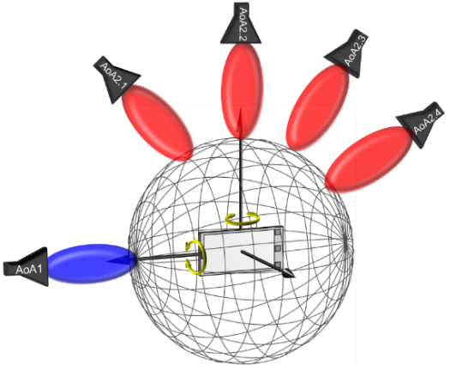
Figure 5.1.1-1 Illustration for fixed relative AoA separation

5.1.2 Test point distribution
In [3], the DL directions perceived by DUT is analysed. Due to the lack of full degree of freedom in the test system, when the probe is aligned with different axis, the test point distribution will also be different. Table 5.1.2-1 show the case when AoA separation is 60° as an example.
Table 5.1.2-1 DL direction perceived by the DUT from two different system configurations when the AoA separation is 60°
 | Probes in the xz plane | Probes in the yz plane
System Configuration | 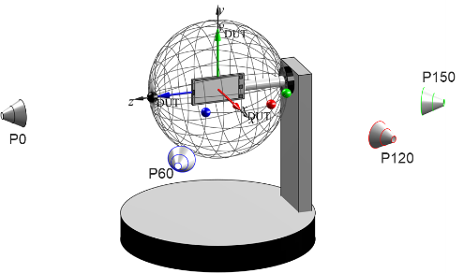 | 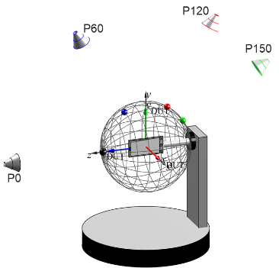
Constant-step | 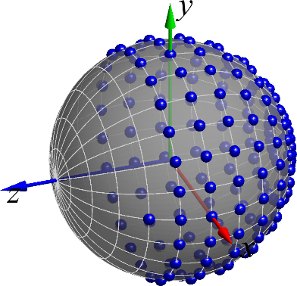 | 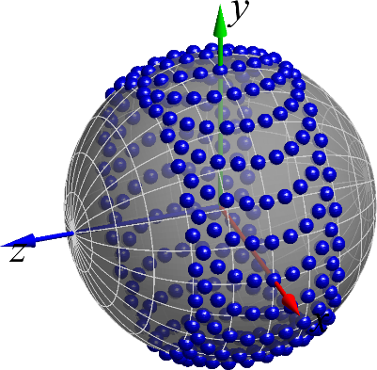
Constant-density | 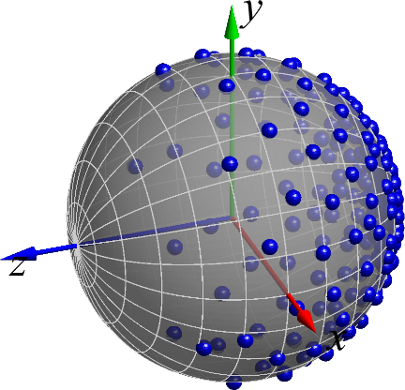 | 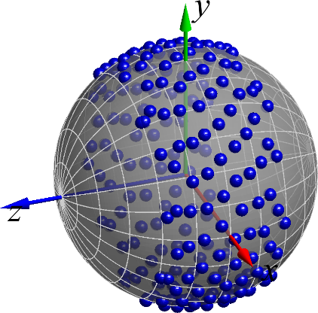

It is evident that no matter whether a constant-step or constant-density grid is used, when AoA1 traverse all test grid, the distribution of AoA2 will become irregular, when the probes are located in yz plane in the example test system above. Also evident is that for probe in the xz plane in the example system and a constant step-size grid, the regularity of the grid is preserved for both sources. Consequently, TE sources/probes that lie in the plane of constant phi with respect to the coordinate system defined by the positioner axes and a constant-step grid is considered as the primary configuration for test setup and requirement discussion.

5.2 Requirement applicability
For DL mTRP, there are two basic schemes are designed – single-DCI and multi-DCI, which are indicated by optional capabilities as shown below [4].
Table 5.2-1 Capabilities for multi-Rx UE
singleDCI-SDM-scheme-r16
Indicates whether the UE supports single DCI based spatial division multiplexing scheme.
multiDCI-MultiTRP-r16
Indicates whether the UE supports multi-DCI based multi-TRP PDSCH/PUSCH operation and support of fully/partially overlapping PDSCHs in time and non-overlapping in frequency.
…
overlapPDSCHsFullyFreqTime-r16
Indicates the maximal number of PDSCH scrambling sequences per serving cell when the UE supports PDSCHs with fully overlapping Resource Elements. The UE that indicates support of this feature shall support multiDCI-MultiTRP-r16.
…
overlapPDSCHsInTimePartiallyFreq-r16
Indicates whether the UE supports PDSCHs with partially overlapping Resource Elements. The UE that indicates support of this feature shall support overlapPDSCHsFullyFreqTime-r16.

Figure 5.2-1 illustrates the difference between multiple DCI and single DCI, and Table 5.2-2 summarizes different characteristics of single DCI and multi-DCI respectively.
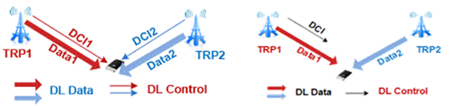
Figure 5.2-1: illustration of multiple DCI and single DCI
Table 5.2-2: Comparison between single DCI and multiple DCI
Single DCI | Multi-DCI
● Single transport block split across both TRPs. Allows true 4x4 demod because of single TB  ● common MCS, RB allocation  ● At the Tx side, each 2-port TRP is enabled for NCJT with up to 4L (non-coherent joint transmission). | ● Separate transport blocks  ● Independent MCS, RB allocations for each TRP (i.e spatial multiplexing is not guaranteed)  ● ‘PDSCH’ is structured as 2 parallel PDSCH channels, each with up to rank 2 – each layer pair shows up as interference to the other. It is up to UE implementation whether it can do joint 4L demod.

The performance of UEs supporting single-DCI and multi-DCI may be different but considering the requirement only guarantee the minimum performance and unified requirement is friendly to verification, the RF requirement is defined based on that multi-DCI with understanding that UE supporting single-DCI can also meet the requirement. The requirement applicability can be further explained as:
- The same requirement shall be applied to the UEs supporting either of the following two capability combinations:
- UE capabilities “multiDCI-MultiTRP-r16” and “overlapPDSCHsFullyFreqTime-r16”.
- UE capabilities “multiDCI-MultiTRP-r16” and “overlapPDSCHsInTimePartiallyFreq-r16”.
- No need to discuss and define the RF requirement for the UEs only supporting “multiDCI-MultiTRP-r16”.

5.3 Reference measurement channel
UE RF requirements for Multi-RX DL are specified for simultaneous Multi-RX chain DL reception from different directions for FR2-1 UE supporting up to 4 layers. RAN4 has agreed that UE RF requirements for simultaneous reception from different directions shall be based on single-layer reception for each DL direction with dual TCI configuration, i.e., total 2 layers for both directions. Existing Reference Measurement Channel (RMC) for UE RF requirement is limited to 1 layer, thus it is necessary to specify new RMC for 2 layer scenario for UE RF.
Depending on the DCI schemes the UE supports, RMC may be different.
For multi-DCI, transport blocks are separated for receptions from different directions, therefore throughput for each layer could be separately obtained. From the perspective of each TRP, the legacy RMC can be reused;
For single DCI, transport block is split across both TRPs for single DCI, therefore only an overall throughput of the 2 layer reception can be obtained. The legacy RMC can not be reused and a new RMC is needed.
RAN4 achieves following conclusion:
- For the UE supporting multi-DCI, the RMC of the single carrier can be reused for each layer, which is specified in Annex A.3.3.2-1 and A.3.3.2-2 of TS 38.101-2 (with one sided dynamic OCNG Pattern OP.1 TDD for the DL-signal as described in Annex A.5.2.1 of TS 38.101-2);
- For the UE supporting single DCI, the RMC is shown as Table 5.3-1 and Table 5.3-2 (with one sided dynamic OCNG Pattern OP.1 TDD for the DL-signal as described in Annex A.5.2.1 of TS 38.101-2)

Table 5.3-1: Fixed Reference Channel for Receiver Requirements (SCS 60 kHz, TDD)
Parameter | Unit | Value
Channel bandwidth | MHz | 50 | 100 | 200
Subcarrier spacing configuration $μ$ |  | 2 | 2 | 2
Allocated resource blocks |  | 66 | 132 | 264
Subcarriers per resource block |  | 12 | 12 | 12
Allocated slots per Frame |  | 23 | 23 | 23
MCS index |  | 4 | 4 | 4
Modulation |  | QPSK | QPSK | QPSK
Target Coding Rate |  | 1/3 | 1/3 | 1/3
Maximum number of HARQ transmissions |  | 1 | 1 | 1
Information Bit Payload per Slot
For Slots 0 and Slot i, if mod(i, 5) = {3,4} for i from {0,…,79} (NOTE 5) | Bits | N/A | N/A | N/A
For Slot i, if mod(i, 5) = {0,1,2} for i from {1,…,79} (NOTE 6) | Bits | 8456 | 16896 | 33816
Transport block CRC | Bits | 24 | 24 | 24
LDPC base graph |  | 1 | 1 | 1
Number of Code Blocks per Slot
For Slots 0 and Slot i, if mod(i, 5) = {3,4} for i from {0,…,79} (NOTE 5) | CBs | N/A | N/A | N/A
For Slot i, if mod(i, 5) = {0,1,2} for i from {1,…,79} (NOTE 6) | CBs | 1 | 2 | 2
Binary Channel Bits Per Slot
For Slots 0 and Slot i, if mod(i, 5) = {3,4} for i from {0,…,79} (NOTE 5) | Bits | N/A | N/A | N/A
For Slot i, if mod(i, 5) = {0,1,2} for i from {1,…,79} (NOTE 6) | Bits | 28512 | 57024 | 114048
Max. Throughput averaged over 1 frame | Mbps | 19.449 | 38.861 | 77.777
NOTE 1: Additional parameters are specified in Table A.3.1-1 and Table A.3.3.1-1.
NOTE 2: If more than one Code Block is present, an additional CRC sequence of L = 24 Bits is attached to each Code Block (otherwise L = 0 Bit).
NOTE 3: SS/PBCH block is transmitted in slot 0 with periodicity 20 ms
NOTE 4: Slot i is slot index per 2 frames
NOTE 5: When this DL RMC used together with the UL RMC for the transmitter requirements requiring at least one sub frame (1ms) for the measurement period, Slot i, if mod(i, 8) = {3,4,5,6,7} for i from {0,…,79} together with the TDD UL-DL configuration specified in A2.3.
NOTE 6: When this DL RMC used together with the UL RMC for the transmitter requirements requiring at least one sub frame (1ms) for the measurement period, Slot i, if mod(i, 8) = {0,1,2} for i from {0,…,79} together with the TDD UL-DL configuration specified in A2.3.

Table 5.3-2: Fixed Reference Channel for Receiver Requirements (SCS 120 kHz, TDD)
Parameter | Unit | Value
Channel bandwidth | MHz | 50 | 100 | 200 | 400
Subcarrier spacing configuration $μ$ |  | 3 | 3 | 3 | 3
Allocated resource blocks |  | 32 | 66 | 132 | 264
Subcarriers per resource block |  | 12 | 12 | 12 | 12
Allocated slots per Frame |  | 47 | 47 | 47 | 47
MCS index |  | 4 | 4 | 4 | 4
Modulation |  | QPSK | QPSK | QPSK | QPSK
Target Coding Rate |  | 1/3 | 1/3 | 1/3 | 1/3
Maximum number of HARQ transmissions |  | 1 | 1 | 1 | 1
Information Bit Payload per Slot
For Slots 0 and Slot i, if mod(i, 5) = {3,4} for i from {0,…,159} (NOTE 5) | Bits | N/A | N/A | N/A | N/A
For Slot i, if mod(i, 5) = {0,1,2} for i from {1,…,159} (NOTE 6) | Bits | 4096 | 8456 | 16896 | 33816
Transport block CRC | Bits | 16 | 24 | 24 | 24
LDPC base graph |  | 2 | 1 | 1 | 1
Number of Code Blocks per Slot
For Slots 0 and Slot i, if mod(i, 5) = {3,4} for i from {0,…,159} (NOTE 5) | CBs | N/A | N/A | N/A | N/A
For Slot i, if mod(i, 5) = {0,1,2} for i from {1,…,159} (NOTE 6) | CBs | 1 | 1 | 2 | 2
Binary Channel Bits Per Slot
For Slots 0 and Slot i, if mod(i, 5) = {3,4} for i from {0,…,159} (NOTE 5) | Bits | N/A | N/A | N/A | N/A
For Slot i, if mod(i, 5) = {0,1,2} for i from {1,…,159} (NOTE 6) | Bits | 13824 | 28512 | 57024 | 114048
Max. Throughput averaged over 1 frame | Mbps | 19.660 | 40.589 | 81.101 | 162.317
NOTE 1: Additional parameters are specified in Table A.3.1-1 and Table A.3.3.1-1.
NOTE 2: If more than one Code Block is present, an additional CRC sequence of L = 24 Bits is attached to each Code Block (otherwise L = 0 Bit).
NOTE 3: SS/PBCH block is transmitted in slot 0 with periodicity 20 ms
NOTE 4: Slot i is slot index per 2 frames
NOTE 5: When this DL RMC used together with the UL RMC for the transmitter requirements requiring at least one sub frame (1ms) for the measurement period, Slot i, if mod(i, 16) = {7,…,15} for i from {0,…,159} together with the TDD UL-DL configuration specified in A2.3.
NOTE 6: When this DL RMC used together with the UL RMC for the transmitter requirements requiring at least one sub frame (1ms) for the measurement period, Slot i, if mod(i, 16) = {0,…,6} for i from {0,…,159} together with the TDD UL-DL configuration specified in A2.3.

6 UE RF requirement

6.1 Requirement concept

6.1.1 General
The requirement concept is mainly categorized into two types in the discussion. One is based on 2AoA directional sensitivity statistics, which is similar to the legacy REFSENS and spherical coverage, e.g., “joint” sensitivity, sensitivity tolerance, new CCDF formula, etc., and the details of proposals can be found in [5]. The most critical problem with this approach is that when two AoAs need to search for sensitivity simultaneously, the test complexity rises significantly. Another is based on the functionality verification under 2AoAs with a fixed DL power level [6], and the merit of this approach is that it can reduce the test overhead, but the concern is that such simplification may not reasonably validate UE performance. In [7], the simulation results to compare these two approaches above are provided.

Table 6.1.1 Simulation results for PC3 UE under different requirement concept
AoA separation (deg) | Modules on opposite faces |  | Modules on adjacent faces
AoA separation (deg) | Coverage fraction ‘M’ for functionality verification | Coverage fraction from sensitivity CCDF | Coverage fraction ‘M’ for functionality verification | Coverage fraction from sensitivity CCDF
150 | 49.4 % | 49.4 % | 25.2 % | 25.3 %
120 | 49.4 % | 49.2 % | 35.6 % | 36.0 %
90 | 35.2 % | 35.6 % | 33.7 % | 34.0 %
60 | 2.5 % | 2.5 % | 25.5 % | 27.3 %

The results show that there is good correlation between the coverages predicted by the two methods. To alleviate the test overhead for multi-Rx UE, the functionality verification with fixed DL power is agreed as requirement concept.

6.1.2 Understanding of “panel”
The terminology “panel” appears often in FR2 RF discussion but there is never a clear interpretation, and the reason is that this term is closely related to the UE implementation and behaviour. To avoid put unnecessary restriction on UE design, the “panel” will be not referenced in both final RF requirement and test configuration. However, from RF requirement design perspective, a clear meaning of “panel” is very helpful for the discussion, and the following logical “panel” definition is used which is only focus on its behaviour rather than physical implementation.
“Panel” is defined as a group of antenna element that controls beam independently and has the following attributes
- Within a panel, one beam can be selected and used for DL reception.
- Across different panels, multiple beams (each selected per panel) may be used for DL reception.
- ‘Beam’ is assumed to mean spatial filter associated with reception.
- A physical panel with dual polarization is assumed as two “panels”.

6.1.3 Requirement metric

6.1.3.1 General
Two similar proposals were made along with the respective mathematical framework. Both aim to capture the probability of supporting 2 AoA reception for a given AoA separation but differ in the weighting assigned to the outcomes of all tested pairs. One method aims to capture the overall probability based on evaluation over the entire sphere, while the other limits evaluation to some subset of AoA pairs.

6.1.3.2 Overall probability based on evaluation over the whole sphere

6.1.3.2.1 Probability expression
The ideal metric for the requirement is the probability of supporting 2AoA reception when the 2 AoAs are randomly selected. This is the general case, assuming no TE constraints. To this end, a regional probability metric is first established to capture the probability of a UE to support 2TRP Rx, given a fixed (regional) location of one of the TRPs (from the UE’s perspective). The sample space for this probability is the collection of all AoA pairs formed from TRP2 locations that cover the entire sphere (blue surface in the ‘ideal case’ in figure 6.1.3.2-1) and a given TRP1 location (white star in the ‘ideal case’ in figure 6.1.3.2-1).
Ideal case: Each TRP is presented to the UE at any random location (white star). The UE is evaluated when second TRP is moved across all locations on the test sphere (blue surface)
Figure 6.1.3.2-1: ‘Regional Probability’ sample space for the general AoA pair case
Specifically, for the fixed TRP (‘TRP1’) at some AoA (θ₁,φ₁), the regional probability is evaluated as a spatial average of the pass/fail outcomes for all locations of TRP2.:
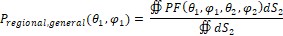
Where:
The AoA of the fixed TRP (‘TRP1’) is (θ₁,φ₁).
The AoA of the TRP paired with the fixed TRP (‘TRP2’) is (θ₂,φ₂).
PF (θ₁,φ₁,θ₂,φ₂) is the pass/fail outcome (1/0 respectively) of the 2TRP functionality test under the agreed UERF test conditions.
dS₂ is the elemental area associated with the AoA of TRP2
An overall probability that a UE can support 2TRP operation when the TRPs are positioned randomly around the UE can be defined by taking a spatial average of the regional probability over all possible positions of the fixed TRP on the sphere:
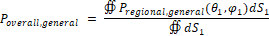
This expression can be re-written as:
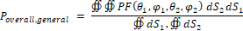
While this overall probability was derived by arbitrarily choosing a TRP whose location was fixed for the regional probability, the final expression is symmetric for both TRPs. We can therefore conclude that the choice of the specific TRP to use as the ‘fixed TRP’ for the calculation is not significant, at least for the general case where there are no restrictions on availability of test AoA pairs.
The regional probability formulation above is now modified for discrete sampling on for a lat-long (constant step-size grid). The expression for constrained probability becomes a weighted sum over all sample points:
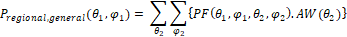
Where:
AW(θ_{x}) are the area weights associated with the entire sample space of grid points where TRPx can be located. In this case, the weights would be the discretized version of , or
The overall probability can similarly be discretized as:
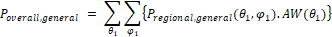
Where AW shares the same meaning as defined above.
This formulation highlights that if the regional probability can be established for every point on the sphere, it is possible to define an overall probability for the UE. It further highlights that it is possible to decouple the grid used to define the regional probabilities and the grids used by the paired TRP directions to compute the regional probabilities.
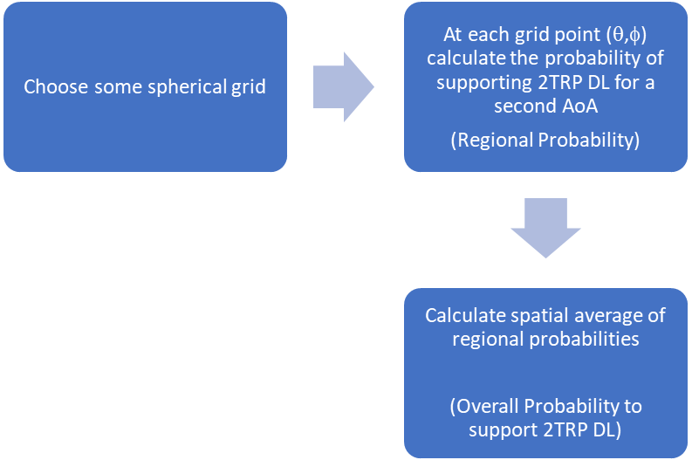
To modify the formulation above to reflect TE constraints where each grid point (blue star in figure 2.1.3-1) is paired with just 2 unique grid points (green stars in figure 6.1.3.2-2) the equation for the metric can be rewritten as:
Where the regional constrained probability calculated at each grid point is modified to depend on a reduced set of test AoA pairs.

The two locations (green stars) that the paired TRP (TRP2) can assume in the TE correspond to the intersection of the circle of possible paired TRP locations and the projection of the plane containing the UE and sources on the test sphere.
The orange circle represents the set of all TRP2 locations that are separated from the TRP1 location (blue star) by some fixed AoA separation.
Figure 6.1.3.2-2: ‘Constrained Regional Probability’ sample space for the case constrained by practical TE considerations
There are multiple ways to quantify this constrained regional probability, described in subsections below.

6.1.3.2.2 OR combining
In this method, the constrained regional probability for each point is considered ‘1’ if that point is successful in at least one of the AoA pairs it participates in. This strategy represents the ‘OR combining’ method.

6.1.3.2.3 Arithmetic mean combining
Note that mathematical formulation of the regional probability in the general case shows it to be a weighted sum of all P/F outcomes. The area weights are those associated with the entire sample space of grid points that contribute to the weighted sum. When the entire sample domain for the constrained regional probability consists only of 2 sample points, the weights for each sample in that sample space equal 0.5. The arithmetic mean method for a small number of equidistant points is therefore consistent with the general formulation for regional probability:

6.1.3.3 Overall probability based on weight per TRP pair
Recall that if the AoAs of the two TRPs can be arbitrary values rather than with a fixed offset in between, a full double surface integral needs to be performed to sweep through all the possible combinations of AoA1 and AoA2 to calculate the probability P that the device can successfully connect to two TRPs
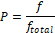
(6.1.3.3-1)
where
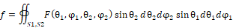
(6.1.3.3-2)
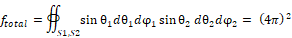
(6.1.3.3-3)
if both panels have SINR larger than -1 dB; otherwise, it equals 0. In this case, it can be observed that the corresponding weight factor for each TRP pair should be .
Now consider that only a fixed offset would be applied to between AoA1 and AoA2, the same weight factor can still be used if we see this as a subset of the full double surface integral. However, since a constant offset between AoA1 and AoA2 needs to be applied (e.g., AoA2 = AoA1+ offset), a Dirac delta function needs to be plugged into the integral , so that we only count the AoA pairs which has the required offset.
Assuming a case that the offset is only applied to plane, e.g., , where c is a constant offset, the integral of f in 6.1.3.3-2 becomes as below. Please note that since is from 0° to 180°, needs to be wrapped within the same range.
(6.1.3.3-4)
by integral over and , the double surface integral will be degraded to a single surface integral, as shown in 6.1.3.3-5. The detail of derivation can be found in the appendix.
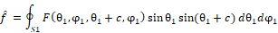
(6.1.3.3-5)
Moreover, to correctly calculate the probability, the total weight (assuming all test points can pass the SINR threshold -1dB) also needs to be correctly computer as well. For a completed double surface integral, the total weight equals (4π)². However, for the subset that has a fixed offset between AoA1 and AoA2, the total weight varies with the AoA offset values, which are shown in Figure 6.1.3.3-1. The value is computed numerically with the integral below but with constrain that should be wrapped within the range from [0° 180°].
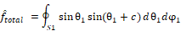
(6.1.3.3-6)
Figure 6.1.3.3-1 The total weight with different AoA offset values
With and , the percentage of spherical coverage can be computed. As the results are weighted per TRP pair, the + offset and -offset pairs will be treated as two pairs or samples. The coverage probability can be computed as:

6.1.3.4 Summary

After considering the Pros and Cons of different methods, RAN4 agreed to use overall probability with arithmetic mean combining as the metric for this feature.

6.2 Simulation methodology

6.2.1 Simulation assumption
Based on the requirement concept in 6.1.1, the simulation assumptions are agreed as show in Table 6.2.1.
Table 6.2.1 Simulation assumptions
 | Simulation assumption | Note
# of antenna module | 2 , dual polarized
array of element antenna in each antenna module | 4x1
Antenna location (front, back, top-side, left-side, right-side, bottom-side) | combination of the lists  (e.g., left and right, Right and Top, Left and top, .etc.) | Two antenna modules located at same side is not precluded

6.2.1 Simulation procedure
The details of simulation procedure are described below:
1. For one UE implementation
2. For one UE orientation
3. Run EM simulation to obtain per-beam antenna gain patterns
- Constant step size is suggested <= 5°
- Performance difference between V/H element can be considered
- Normalize antenna gain to align with the gain drop between peak EIS and spherical coverage in current spec
- Other calibration method also can be used.
4. For one angular separation
5. For one test grid point in 3D scan
- Select beam based on RSRP (or SINR)
5.1 Calculate SINR of AoA+ and AoA- respectively
- SINR = P_signal/(Noise + P_interf)
Where the P_signal is the power of wanted signal and the P_interf is the power of interference, Noise(dBm)= -174 +10*log10(CBW) +NF, CBW is channel bandwidth, NF =10
5.2 If SINR>=-1, PASS, otherwise, FAIL
5.3a OR combining the results of AoA+ and AoA-
5.3b No logic combination of the results of AoA+ and AoA-, but treat them as two separate points (e.g., arithmetic mean)
- Other methods for +/- offset data are not precluded
- Companies are encouraging to provide analysis on the pros and cons for each “combination” method
5.4 Add weighting (sin θ or Clenshaw-Curtis Quadrature)
6. Repeat for other test grid point
7. Calculate the spherical coverage percentage
8. Repeat for other angular separation
9. Repeat for other UE orientations
10. Repeat for other UE implementations

A noteworthy point is the calibration in step 3, and the intention is to minimize the difference between companies in simulation campaign. The following options were discussed to accommodate simulation data that is typically much better than the standard:
Option 1: Adjust the beam shape or scale the antenna gain to make UE align with both peak EIS and spherical coverage.

Option 2: Adjust the fixed DL power to align with real UE spherical coverage power level, e.g., if the spherical coverage in spec is -74.4 dBm with 10.9 dB gain drop and the UE only have 6 dB gain drop, then the fixed DL power need to be adjusted to -79.3 in the simulation.

Option 3: Meet any one calibration condition as long as the other condition is met or exceeded. Two examples:
- If a UE only has 6 dB drop from peak to 50th %ile, but the standards requirement for that parameter is 11 dB, the proposed calibration condition would be to align the peak direction to the REFSENS condition.
- If a UE has 15 dB drop from peak to 50th %ile, but the standards requirement for that parameter is 11 dB, the proposed calibration conditions would be to align the 50th %ile direction to the spherical coverage EIS condition.
The intention of calibration is to ensure that simulation results are comparable across all companies when performance of antenna module or other detailed simulation setup are different, so there should be a datum line existing after the calibration is performed. Based on this principle, both option 1 and option 2 can be used as calibration method, and then overall probability of PC3 UE will not exceed the 50% for any UE under any AoA offset.

6.3 Requirement design

6.3.1 DL power
From the beginning of the discussion on how to design the requirement, it has been recognized that given a UE implementation, UE two-AoA reception performance, i.e., the two-AoA coverage probability, depends not only the AoA offset between the two AoAs, but also the DL power from the two TRPs.
While in the real field, the DL power level from the two TRPs are likely to be different, a fixed DL power level was chosen to facilitate the requirement definition and testing, as it avoids many complexities in clearly quantifying the UE performance of the two AoAs, especially in the sDCI case. Furthermore, with varying power levels, the testing overhead is expected to increase as multiple power levels need to be tested.
As for the exact DL power level, there were several proposals:
Option 1: Use different DL power levels for the two AoAs.
To ensure not to degrade the coverage compared with single DL reception, the spherical coverage requirement of 50th %-tile of the CCDF of EIS measured for one of the DL directions should be equal or close to the legacy requirement. DL power level for the other DL direction can be relaxed with respect to the AoA separation.
Option 2: Both DL powers are higher that legacy spherical coverage requirement
Since the two-AoA spherical coverage requirements for simultaneous multi-Rx chain DL reception cannot meet the legacy spherical coverage requirements for the single direction considering the mutual interference between the beams from two AoAs, and simultaneously choosing best Rx beam peak direction from two AoAs for all possible AoAs separation pairs cannot be guaranteed, it is proposed to define Z dBm tolerance for simultaneous multi-Rx chain DL reception.
In addition, some relaxation compared to the legacy spherical coverage EIS level is proposed to account for polarization impairments in commercial UEs that are not fully reflected in simulation.
Option 3: Both DL powers are same as the legacy spherical coverage requirement EIS level
This option argues that the legacy spherical coverage EIS level should be reused as the DL power in the requirement, based on which the two-AoA coverage probability can be derived accordingly.
In the end, the EIS level of the legacy spherical coverage requirement, e.g., specified in Table 7.3.4.3-1: EIS spherical coverage for power class 3 in TS 38.101-2, is chosen. Under this DL power level, the two-AoA coverage probability is derived.

6.3.2 Inter-beam interference
The simulation requirement for multi-Rx RF is being defined based on the minimum signal-to-interference-and-noise ratio (SINR) of the AoA1 and AoA2, and is significantly affected by the inter-beam interference. An example of inter-beam interference observed at the UE in a multi-TRP DL transmission scenario is shown in Figure 6.3.2-1 which demonstrates that the signal (S2) transmitted from TRP2 creates interference to the UE antenna panel receiving the signal (S1) transmitted from TRP1; h11 (h12) is the path gain/loss of the channel between the TRP1 (TRP2) and the UE, and P_h11 (P_h12) is the corresponding power.
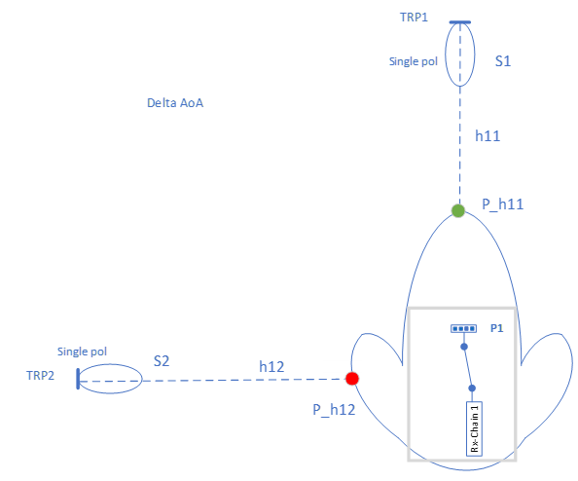
Figure 6.3.2-1: UE beam radiation pattern example for wanted signal from AoA1 and interference from AoA2
To study the effect of inter-beam interference in multi-TRP DL transmission, a UE equipped with three antenna arrays/modules/panels (each on its top, left and right surfaces) is assumed where each antenna array can steer the beam in seven different directions as shown in Figure 6.3.2-2, namely:
1. Beam set for Antenna Array #1 (7 beams shown in variation of blue color),
2. Beam set for Antenna Array #2 (7 beams shown in variation of green color),
3. Beam set for Antenna Array #3 (7 beams shown in variation of red color),
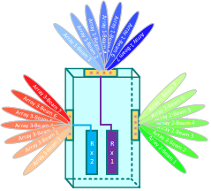
Figure 6.3.2-2: FR2 UE with 3 antenna panels with 7 beams for each panel
where the description of 7 beams selected from any beam set (group) is provided in Table 6.3.2-1.
Table 6.3.2-1: Beam index and description for a UE antenna panel
Beam Index | Description
Beam 1 | -45o with respect to Boresight Beam
Beam 2 | -30o with respect to Boresight Beam
Beam 3 | -15o with respect to Boresight Beam
Beam 4 | Boresight Beam
Beam 5 | +15o with respect to Boresight Beam
Beam 6 | +30o with respect to Boresight Beam
Beam 7 | +45o with respect to Boresight Beam

6.3.2.1 Standalone antenna array configuration (Ideal Case)
Figure 6.3.2.1-1 shows the standalone configuration with 1x4 UE antenna arrays and angular range over which each one of the 21 beams (7 beams on each of the three antenna modules) is dominant and has the highest RSRP over the other beams and Figure 6.3.2.1-2 shows the example UE beam radiation pattern receiving the desired signal from the direction of AoA1 on the main lobe and the interference signal from the direction of AoA2 on the side lobe.
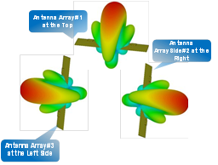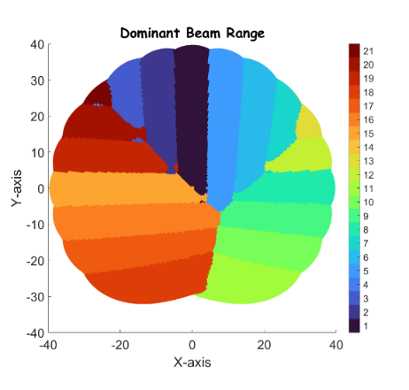
Figure 6.3.2.1-1: (a) Standalone antenna array configuration, (b) Angular range for dominant beams
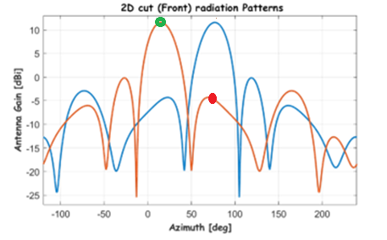
Figure 6.3.2.1-2: UE beam radiation pattern for AoA1 and interference from AoA2
Considering AoA offset of 90º and the beam radiation patterns of two panels, one in red and one in blue, receive the signals from two TRPs are shown in Figure 6.3.2.1-2, ‘Green Circle’ and ‘Red Circle’ on the red beam radiation pattern will denote the received power of the wanted signal from one TRP and the interference signals (e.g. AoA1) from the other TRP (e.g., AoA2), and subsequently the signal-to-interference-ratio (SIR) can be defined as the ratio of the antenna gain values corresponding to the ‘Green Circle’ to that of the ‘Red Circle’. In general, this interference power/gain is due to the sidelobe of the beam radiation pattern receives the unwanted signal from the other AoA.
Next, the CCDF plot of SIR of AoA1 is presented for the case when Array #1’s Boresight beam is used for the reception of the wanted signal from TRP1, whereas one of the 14 beams of Array #2/Array #3 is used for the reception of the wanted signal from AoA2.
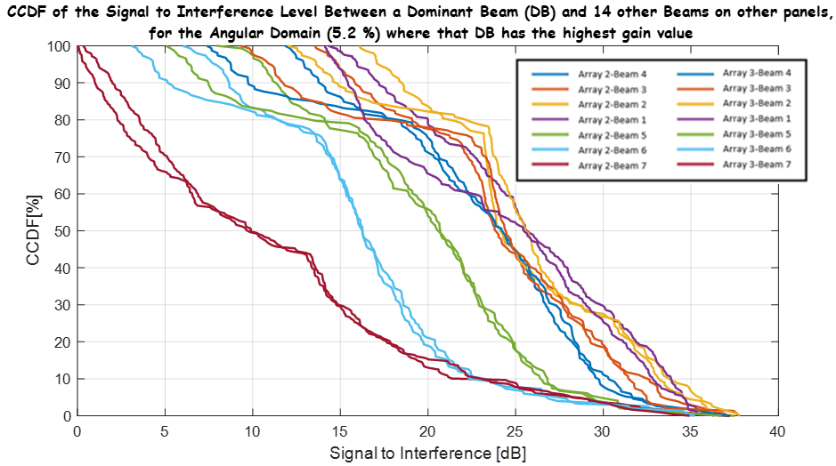
Figure 6.3.2.1-3: CCDF of AoA1’s SIR
To evaluate the CCDF, the antenna radiation pattern with 1º resolution in azimuth and elevation domain is used providing 65160 constant step size grid points and then 2500 points are selected to approximate an uniform density grid. These selected points are then sorted in a descending order and are plotted as the CCDF curves.
The legend ‘Array x-Beam y’ where and to be interpreted as described in Figure 6.3.2-2 and Table 6.3.2-1. Figure 6.3.2.1-3 shows the CCDF of SIR of AoA1 for the case when the antenna panels are configured in a standalone fashion as shown in Figure 6.3.2.1-1(a) and the interference signal coming from AoA2 direction aligns with the direction of one of the 14 beams of Array#2 and Array#3 and hence creates different interference scenarios to the signal received at ‘Array 1-Beam 4’, resulting in different CCDF curves in Figure 6.3.2.1-3.
From Figure 6.3.2.1-3, the SIR values corresponding to the 50th percentile of the CCDF curves is shown in Table 6.3.2.1-1 where it is worth noting that the interference from the TRP2 signals arriving from the AoA2 direction becomes significant when the angular separation between AoA1 and AoA2 is low.

Table 6.3.2.1-1: SIR at 50-percentile of CCDF of Figure 6.3.2.1-3
Beam Index (Array 2/Array 3) | SIR at 50-percentile of CCDF (dB)
Beam 7 | 10
Beam 6 | 17
Beam 5 | 21
Beam 4 | 24
Beam 3 | 24
Beam 2 | 26
Beam 1 | 26

6.3.2.2 Realistic formfactor smart-phone (Practical Case)
The electromagnetic simulations of a realistic smartphone Mechanical Computer Aided Design (M-CAD) assumes that front and rear surfaces of the smartphone are made up of glass, chassis is metallic and frame is made up of plastic (see Figure 6.3.2.2-1 andTable 6.3.2.2-1 below for more details). Furthermore, the UE is assumed to have one antenna array/module/panel on each of its left, top, and right surfaces; each antenna module is a standalone uniform linear array of four single polarized antenna elements placed half a wavelength apart from each other.

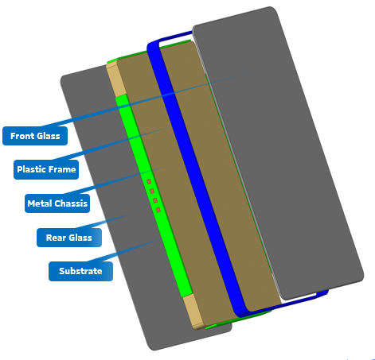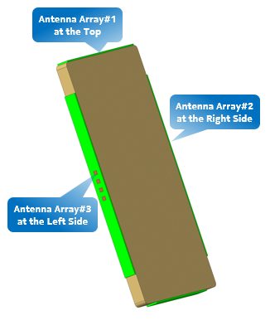
Figure 6.3.2.2-1: Details of a realistic smartphone M-CAD

Table 6.3.2.2-1: Material parameters for electromagnetic simulations
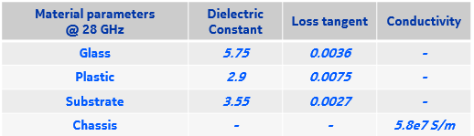
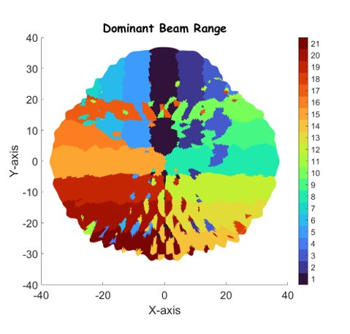
Figure 6.3.2.2-2: Angular range for dominant beams of a realistic formfactor smart-phone UE
Figure 6.3.2.2-2 shows the angular range over which each one of the 21 beams of a realistic formfactor smart-phone UE is dominant. Similar to Section 6.3.2.1, the assumption is that the boresight beam of Antenna Array #1 is the dominant beam used for receiving the signals from AoA1 whereas the AoA2’s dominant beam must be selected from the remaining 14 beams of Antenna Array #2 and #3. Next, the plot of CCDF of SIR of AoA1 for a realistic formfactor smart-phone UE is presented.
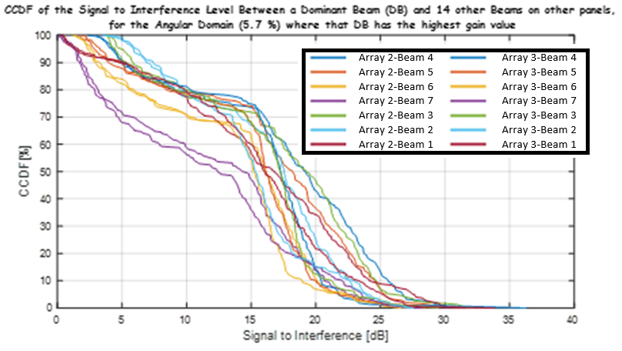
Figure 6.3.2.2-3: CCDF of AoA1’s SIR for a realistic formfactor smart-phone UE
In Figure 6.3.2.2-3, it is observed that due to the change of the beam shapes caused by the surrounding components in the real mobile phone, the difference of CCDF of SIR become less compared with those based on the analysis of the ideal beams in Figure 6.3.2.1-3. However, it is again observed that the performance of Array 2-Beam 7 and Array 3-Beam 7 is worst compared to the other 12 beams of Array 2 and Array 3 as the CCDF curves for these two beams is relatively located in the leftmost region. Furthermore, the SIRs corresponding to ‘Array 2-Beam 5’/‘Array 3-Beam 5’ and ‘Array 2-Beam 6’/‘Array 3-Beam 6’ are higher compared with that of ‘Array 2-Beam 7’/‘Array 3-Beam 7’. This is aligned with the previous results that the SIR increases as the angular separation between AoAs increases.
Table 6.3.2.2-2: SIR at 50-percentile of CCDF of Figure 6.3.2.2-3
Beam Index (Array 2/Array 3) | SIR at 50-percentile of CCDF (dB)
Beam 7 | 13
Beam 6 | 15.5
Beam 5 | 16
Beam 4 | 17.5
Beam 3 | 17.5
Beam 2 | 18
Beam 1 | 16

The SIR values corresponding to the 50th percentile of the CCDF curves of Figure 6.3.2.2-3 is shown in Table 6.3.2.2-2. It is also observed from Table 6.3.2.1-1 and Table 6.3.2.2-2 that there is a significant difference (up to 16 dB in the ideal case and up to 5 dB in the practical case) between the SIR at 50-percentile of CCDF (dB) for different AoA offset scenarios.
The spherical coverage is worse if the AoA offset is small and spherical coverage becomes better if the AoA offset is larger which share the same trends. However, in Figure 6.3.2.2-3, it is observed that the plots corresponding to ‘Array 2-Beam 1’ and ‘Array 3-Beam 1’ (shown in brown colour) shows that the beam with largest AoA separation might not be the best beam in all the cases. The intuitive reasoning behind this is that depending on the beam pattern, the gain of the side lobe of the beam receiving signals from AoA1 might be large or small in the direction of AoA2 which is illustrated in the Figure 6.3.2-1.

6.3.2.3 Summary
The important observations of inter-beam interference study can be summarized as follows:
1. For small AoA offset scenario, the effect of inter-beam interference will be large.
2. With increasing AoA offset, the effect of inter-beam interference reduces.
3. The largest AoA offset scenario might not have lowest inter-beam interference due to the significant side lobe gain of the UE beam radiation pattern at that AoA offset.
4. The UE beam radiation pattern, gain of the side lobes, AoA offset will have a direct impact on the inter-beam interference effect.

6.3.3 ± AoA separation
Due to the constraint of test system, the set of possible paired TRP locations for each test point reduces to 2 points, as show in Figure 6.3.3-1
Figure 6.3.3-1 Progressive test limitations due to practical considerations
A corollary is that given the agreed test system constraints, a complete test implies every AoA for each TRP is paired with 2 AoAs associated with the other TRP. Unfortunately, s simple 2TRP scan like legacy practice under fixed AoA separation does not exercise the UE with all AoA pairs the TE can produce. The post processed data (CCDF of sensitivity, relative to REFSENS) collected from the 2TRP scan shows bias for the following conditions:
1. A pair of UEs that have mirror image coverage patterns can show different statistics for the coverage of the two TRPs. See left sub-figure in figure 6.3.3-2. (Mirror image UEs: UE with modules in the top + left faces versus a UE with modules in the top + right faces)
2. A given UE can register different statistics for a TRP depending on whether the second TRP is introduced at a positive or negative AoA separation See right sub-figure in figure 6.3.3-2.
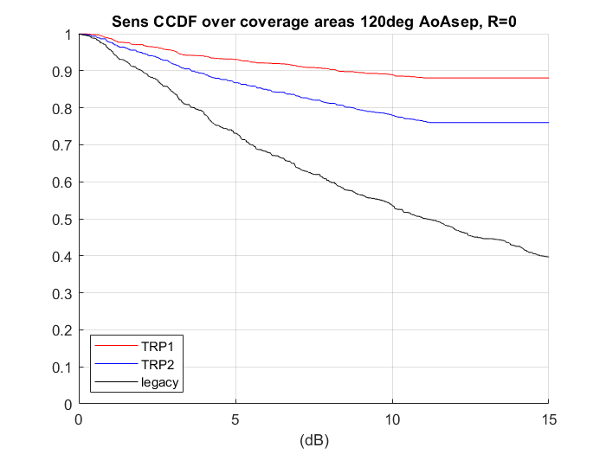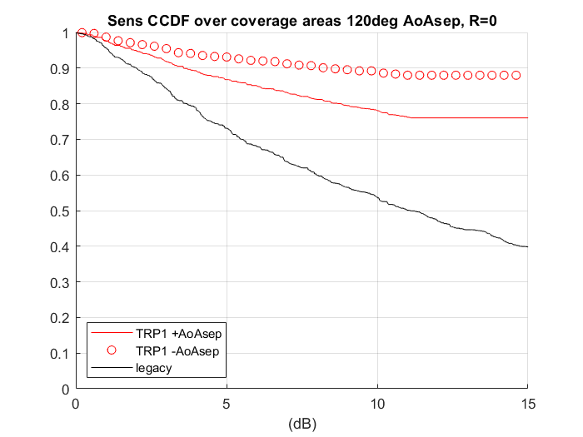
Figure 6.3.3-2: Impact of not exercising the UE over all possible AoA pairs
To dig deeper into why a UE with symmetric behaviour for both TRPs should exhibit different post-processed data associated with each TRP, it is useful to study the grid quality in further detail. Figure 6.3.3-3 graphically shows the TRP coverage patterns with the 2TRP scan identified in the previous section. The grids covered by both TRPs are identical, but each location for each TRP only shows one paired AoA.
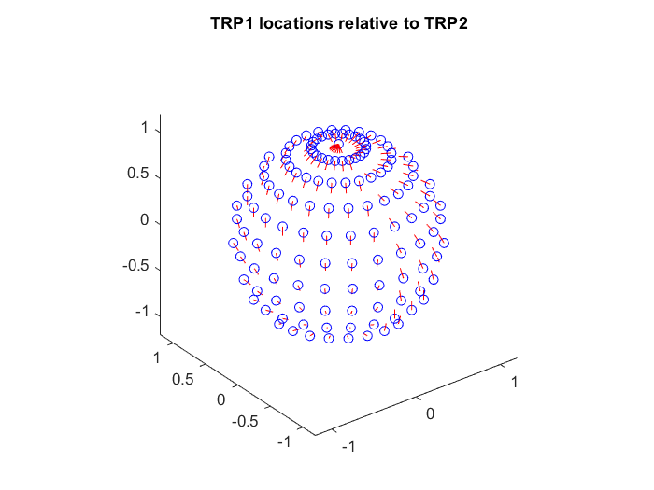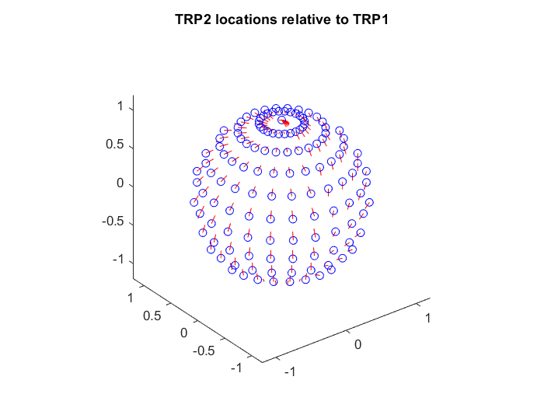
Blue dots are grid point locations of a TRP during the scan, from the UE’s perspective. TRP1 to the left, TRP2 to the right
For each grid point location of one TRP, the companion AoA associated with the other TRP is along the direction indicated by the red segments.
Obs. 2: The paired AoAs point in opposite directions for the same region of the test sphere for the 2 TRPs
Obs. 1: For each TRP, each AoA has only one paired AoA associated with the other TRP (just one red segment is attached to each grid point)

Figure 6.3.3-3 Missing AoA pairs in the 2TRP scan
As evident from the observations in the figure, there are missing AoA test pairs (only one red segment attached to each grid point). Fortunately, for this scan, the omission of test AoA pairs is complementary across the two TRPs. In other words, if the locations of TRP1 and TRP2 are interchanged and the scan repeated (i.e complementary scan), the missing AoA pairs get tested and none of the previously tested AoA pairs gets re-tested. The combined data set from both scans has neither omitted AoA pairs, nor repeated pairs. The grid statistics as well as the impact of performing this complementary scan on the UE described earlier is shown in figure 6.3.3-4. Applying this improved scan to example UE completes the 2 TRP data set. The data set shows ‘improved’ statistics, but these are based merely on added AoA test directions from the complementary scan, rather than a genuine improvement at the UE.

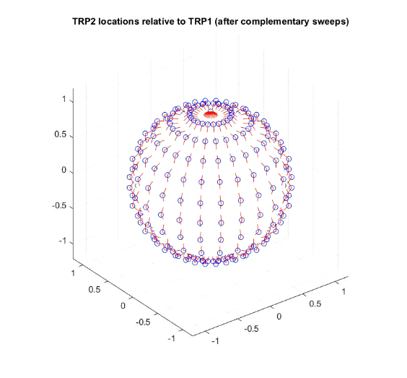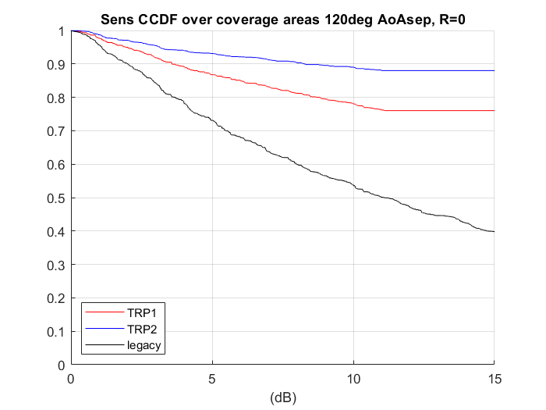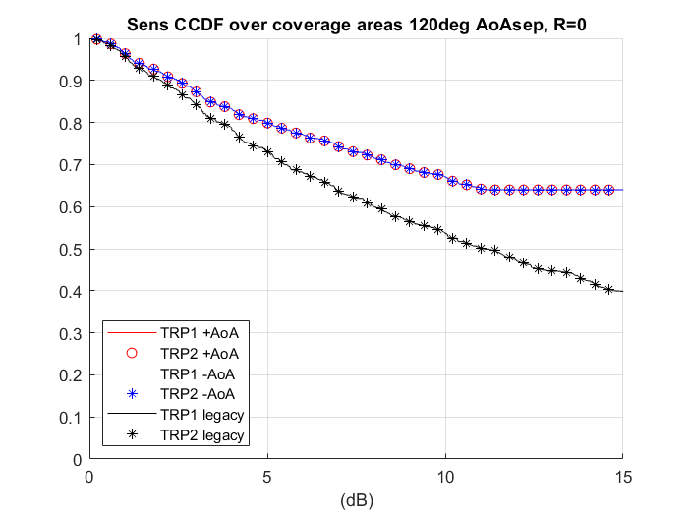
Obs. 1: After complementary pair scan, for each TRP, each AoA has two paired AoAs associated with the other TRP (note 2 red segments attached to each grid point)
Grid and pair AoA patterns look identical for both TRPs for the complementary pair version of the 2TRP scan
TRP sensitivity statistics prior to complementary pair scan
TRP sensitivity statistics after complementary pair scan shows ‘improved performance’ after addition of data missing AoA pairs
Figure 6.3.3-4: Complementary pair version of 2TRP scan
Based on the analysis above, both +AoA offset and –AoA offset for each test point shall be considered in requirement evaluation. This arrangement is equivalent to the complementary scan technique.

6.3.4 UE orientation
For the legacy 1AoA UE RF requirement and test for FR2, various UE alignment options (referred as orientations in this TR from this points onwards) are allowed as illustrated in the Figures in the Tables J.2-1 through J.2-3 of TS 38.101-2 Annex J. In theory, the test results with different UE orientations should be the same without considering the measurement grid uncertainty, because the 3D scan of 1AoA test is sampling UE’s sphere with test ‘point’. However, the 3D scan of 2AoA test is sampling UE’s sphere with test ‘vector’ corresponding to AoA pair. Different UE orientations will lead to different test ‘vector’ even at the same test point, and thus different 2AoA performance is expected.
Companies’ simulation results as provided in Annex A show that different UE orientations lead to significantly different 2AoA spherical coverage performance. Depending on different UE implementations, no standardized UE orientation could be found suitable for 2AoA performance test. RAN4 has agreed to specify the 2AoA spherical coverage performance in implementation agnostic manner, the most feasible way is to adopt the declaration approach.
Based on the theoretical analysis and simulation results, RAN4 achieves following conclusion:
1. UE requirement applies to UE declared orientation(s).
2. The UE RF requirement is derived assuming each UE is evaluated in the orientation that yields the best metric value.
3. All the candidate orientations discussed in this section for UE to choose from correspond to the ‘Alignment Options’ in Annex J (J.2) of TS 38.101-2.

6.3.5 AoA pairs for enhanced positioners
During investigation of projected UE performance with the legacy positioner, it became evident that different overall probabilities are calculated for the same UE, depending on its orientation in the positioner. See figure 6.3.5-3.
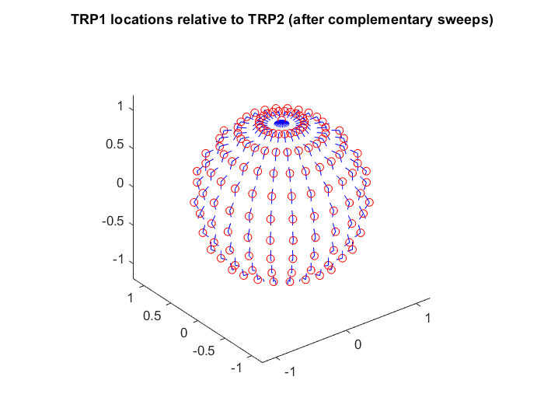
The difference can be traced back to the agreed TE constraints that only tests the UE for AoA pairs that lie along longitudes in the reference coordinate system defined by positioner axes. See figure 6.3.5-1.
Red dots are grid point locations where the regional probability is calculated.
For each grid point location, the companion AoA associated with the other TRP is along the direction indicated by the blue segments.
Figure 6.3.5-1: AoA pairs lie along longitudes of the UE spherical reference coordinate system with the agreed TE.
This bias problem can be resolved by including AoA pairs that are not limited to the same longitude as is the case for the agreed TE, see figure 6.3.5-2.
One possibility is to average 2TRP performance data in the TE across multiple different orientations of the UE in the positioner. This method has been adopted successfully in the past for single TRP scenarios, but this method may not be suitable for 2TRP scenarios (where 2 directions are involved at one time):
1. The primary problem is inability to include at each grid point, ‘AoA pairs that are not limited to the same longitude’. The legacy positioner does not retain the same grid for all orientation possibilities.
2. A further problem is that even if the UE faces are pointing as desired, the actual module coverage directions may not be well centered around the respective face normals. Such UEs would face additional challenges with a procedure that introduces bias. At a minimum it would complicate the requirement derivation process.
A better and more precise approach would be to diversify the collection of AoA pairs used to calculate regional probability at each grid point. This can be achieved by modify the agreed TE concept to use a 3-axis positioner rather than the legacy 2-axis positioner. Figure 6.3.5-2 shows the intended effect of the added degree of freedom from the UE’s perspective. Recall that the legacy 2-axis positioner in combination with a complementary sweep or +/-AoAsep scan is only able to pair each grid point to AoAs along the blue arrows, respectively. The 3-axis positioner is intended to allow each grid point to be additionally paired with AoAs along the green arrows.
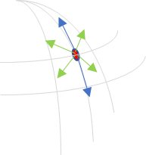
Blue arrows – directions of paired AoAs with 2-axis positioner and complementary scan.
Green arrows – necessary additional directions of paired AoAs to reduce bias.
v
The intent is to sample the outcomes in spatially uniform directions to reduce bias.
The orange circle represents the set of all AoAs that are separated from the evaluation grid location by some fixed AoA separation.
Figure 6.3.5-2: Scheme to combat bias introduced by AoA pairs limited to lie along longitudes of agreed grid.
Referring to the mathematical formulation of overall probability, for the 3-axis positioner, the regional probability at each grid point can be determined from outcomes of a configurable number of AoA pairs that are spatially well distributed (6 shown) rather than just the two pairs that lie along the longitude associated with the grid point. The overall probability can be calculated from the regional probabilities over the sphere. The mathematical formulation also highlights the dissociation of the grid points where the regional probabilities are calculated from the locations of the paired AoAs for each grid point. Since multiple runs are no longer required to generate multiple AoA pairs at each point, the 2TRP scan can be simplified for the 3-axis positioner by dropping the requirement for enhancements such as the complementary pair sweep or combining data from +AoAsep and -AoAsep scans.
Figures 6.3.5-3 shows the impact on calculated overall probability to support 2TRP DL of using a 3-axis positioner as described above to reduce bias for an example UE. The performance projections use a 5-degree step size and 6 AoA pairs per grid point (i.e. 6 stops for the roll motor at each grid point). Also assumed is a scan strategy that ensures neither source is blocked. It is evident that the projected performance trends are largely robust to UE orientation in the 3-axis positioner. Note however that due to non-zero size of any positioning mechanism, some declaration must be instituted so the UE is not oriented in way that it is partially blocked by the mechanism. Fortunately, this ‘UE alignment option’ is already established and recorded in TR38.810, Annex C, and can be retained for this feature.
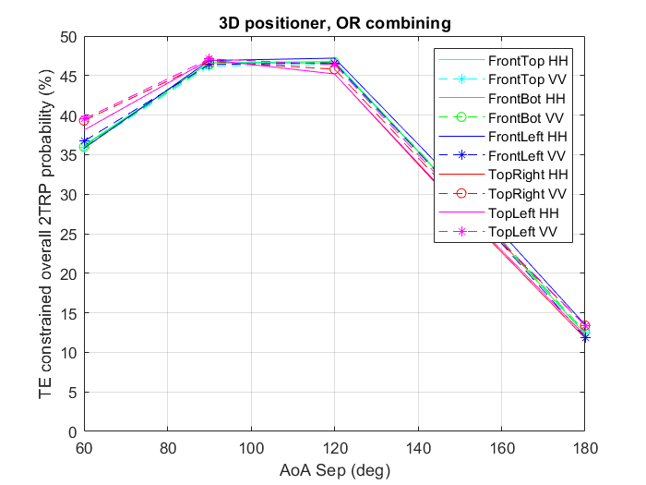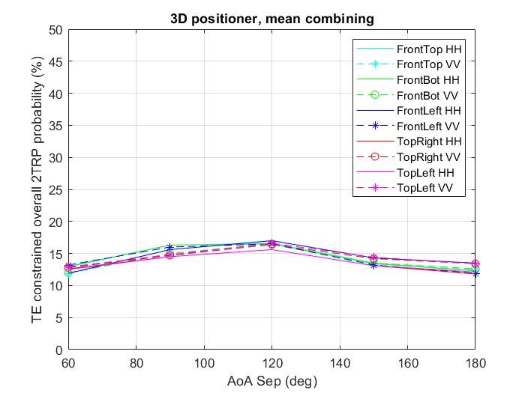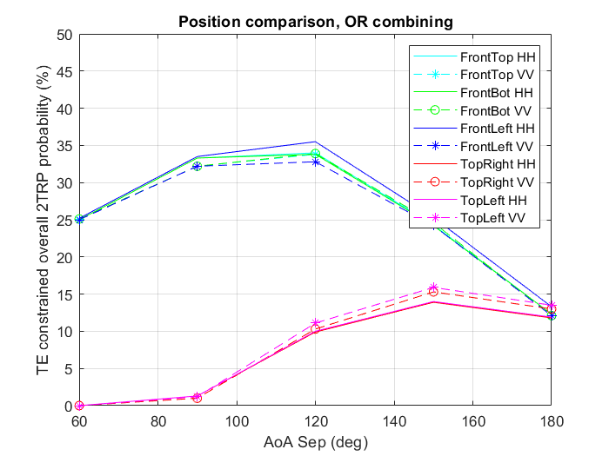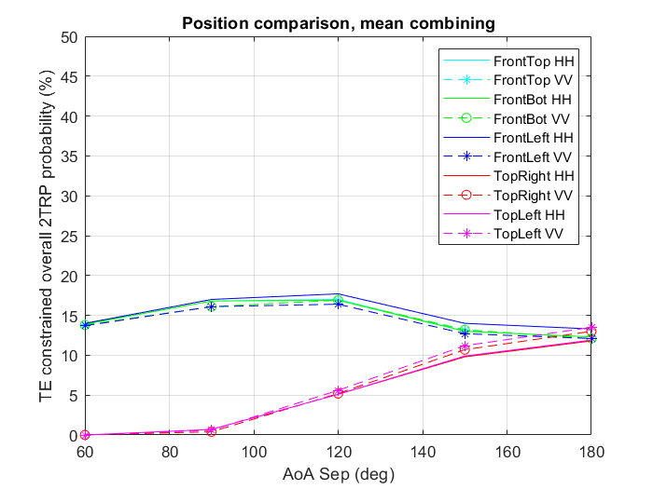
Bias from using a legacy 2-axis positioner.
Positioner upgrade
Figure 6.3.5-3: Bias removal using a 3-axis positioner.
Due to pragmatic considerations, this positioner enhancement is not pursued for this WI.

6.3.6 DL polarization combination
There are four different DL polarization combinations, i.e., (TRP1_{θ}, TRP2_{θ}), (TRP1_{φ}, TRP2_{θ}), (TRP1_{θ}, TRP2_{φ}) or (TRP1_{φ}, TRP2_{φ}). It is known that the UE performance can differ if the same polarization or orthogonal polarization is adopted by the two probes in testing. With the same polarization, a higher correlation between the two DL data streams can be expected, especially when the AoA offset is small, representing the worst-case performance.
In deciding which combination to use for verification, there are two main considerations. First, the requirements should be derived based on the worst-case polarization match at the UE, and should apply for any combination of DL polarizations from each TRP. Second, there is a need to minimize the testing overhead while ensuring good testing coverage.
In the two-AoA simulations, the worst-case polarization match between the 2 TRPs is assumed. In other words, the transmitted signal from one TRP is considered interference without any polarization isolation at the UE when decoding the transmitted signal from the other TRP.
It was also pointed out that the radiation pattern of V-pol and H-pol of an antenna module is not exactly same, and when metal blockage exist, the difference may be amplified due to the reflection as shown in the Figure below. In practical UE design, to avoid severe blockage, the metal frame near the antenna module can be removed and replaced by other materials, but the V/H element may still suffer from different loss, which still lead to difference between V-pol and H-pol.
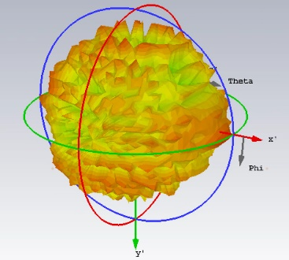
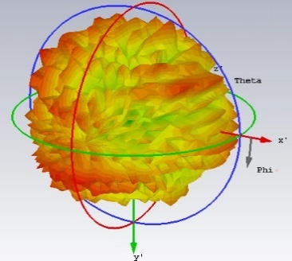
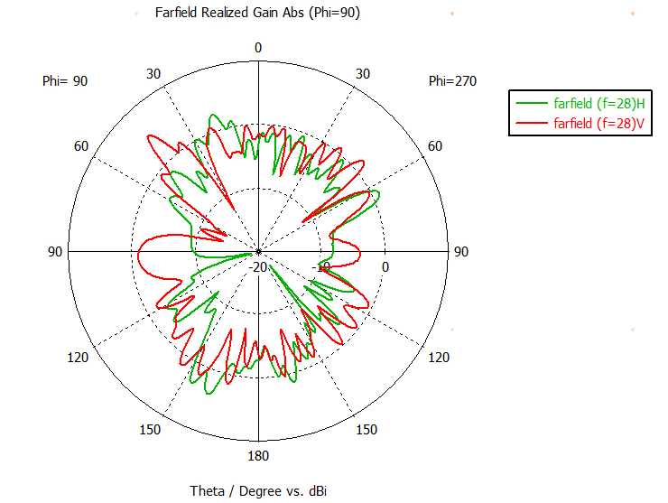

Figure 6.3.6-1The radiation pattern of a pair of V/H element in 1x4 antenna module
If the gain difference exists between V-pol and H-pol, for each receiver branch, the projection from θ and φ should be calculated, and the following procedure to calculate received signal can be used:
Step-1: Extract the antenna gain in θ direction and φ direction in module reference system when only V-elements are activated, i.e., G_{V,θM} (θ_{M}, φ_{M}) and G_{V,φM} (θ_{M}, φ_{M})
Step-2: Extract the antenna gain in θ direction and φ direction in module reference system when only H-elements are activated, i.e., G_{H,θM} (θ_{M}, φ_{M}) and G_{H,φM} (θ_{M}, φ_{M})

Figure 6.3.6-2 illustration of antenna gain in θ direction and φ direction
Step-3: For the DL signal from each TRP in the TE coordinate system, transform the TRP location into the module reference system, e.g., for antenna module#1, AoA1(θ₁, φ₁)→AoA1(θ_{1M#1}, φ_{1M#1}), AoA2(θ₂, φ₂) → AoA1(θ_{2M#1}, φ_{2M#1}) and for antenna module#2, AoA1(θ₁, φ₁) →AoA1(θ_{1M#2}, φ_{1M#2}), AoA2(θ₂, φ₂) → AoA1(θ_{2M#2}, φ_{2M#2})

Figure 6.3.6-3 illustration of coordinate system transformation
Step-4: The received signal for each antenna module (after MRC of rank1 DL) can be calculated when DL signal polarization is (θ,θ), e.g., the received signal from AoA1 by antenna module#1 is:
The received signal from AoA1 by antenna module#2 is:

Step-5: The received signal for each antenna module (after MRC of rank1 DL) can be calculated when DL signal polarization is (φ, φ), e.g., the received signal from AoA1 by antenna module#1 is:
The received signal from AoA1 by antenna module#2 is:

The whole formula is shown in Table below:

Table 6.3.6-1 The formula for received signal
θθ DL | Module #1 | Module #2
Signal level(*)
TRP1 location transformed to module reference system
TRP 2 location transformed to module reference system

φφ DL | Module #1 | Module #2
Signal level(*)
TRP1 location transformed to module reference system
TRP 2 location transformed to module reference system

(*For simplicity, the DL signal in formula is normalized to 1)
The method above is a simplified one compared to the realistic MRC implementation at UE receiver, in figure 6.3.6-4, a simulation is performed to compare UE performance projections using the method above against a more realistic LMMSE type demodulation for two orientations of the UE. The UE model is a ‘4-component type’ described in Table 6.3.6-1. The MMSE solver assumed RSRP-based beam selection and a noise covariance matrix that depends on both, the uncorrelated thermal noise of the receiver and the correlated noise from the interferer. Channel estimation is genie type based on knowledge 4 component antenna gains and AWGN assumption.

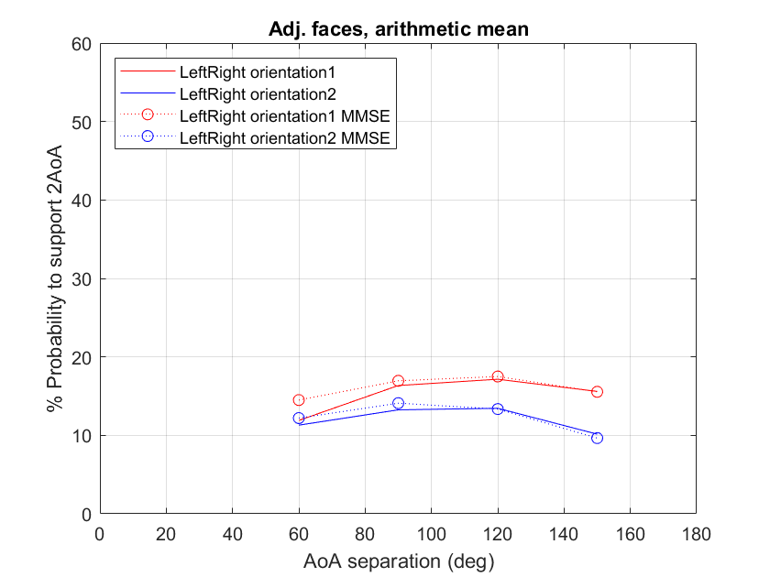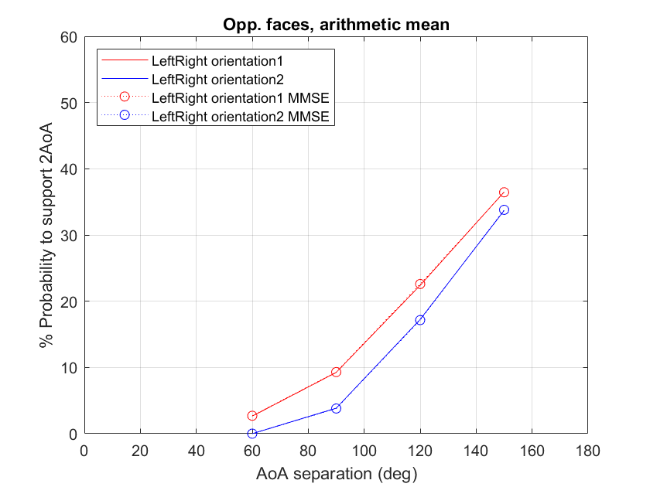
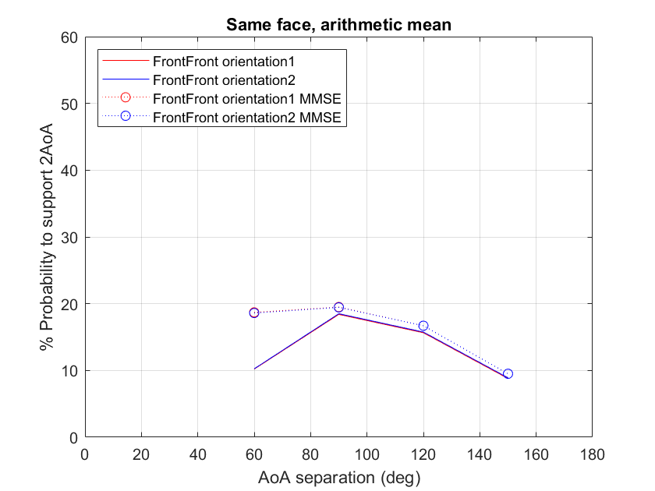
Figure 6.3.6-4: UE performance difference between LMMSE vs RAN4 simplified SINR estimation
Some observations are listed below:
1. For UEs with modules on opposite faces, there is not much difference between the simplified RAN4 SINR method and the LMMSE-based method. The similarity is expected since this type of UE does not have significant overlap of coverage areas, so SINR tends to be noise limited.
2. For UEs with modules on adjacent faces, there can be significant overlap in coverage. Some AoA pairs (specifically those with lower AoA offsets) are interference limited. For these scenarios, MMSE can help significantly because of polarization mismatch in the general case between the 2 rank1 DLs.
3. The characteristic of the MMSE based receiver to help in interference limited cases becomes clear for a UE with modules on the same face. This type of UE has a lot of spatial overlap and therefore strong interference for low AoA offsets. The MMSE based received performs better than the RAN4 SINR calculation estimate for narrow AoA offsets where interference limited cases become more dominant.
To further investigate how the gain imbalance will impact on the UE performance under the method above, Figure 6.3.6-5 show the overall probability performance gap between θθ DL and φφ DL, and three implementations are considered: Implementation#1 is 2 panels in the same side, Implementation#1 is 2 panels in the adjacent side, Implementation#3 is 2 panels in the opposite side. The X dB additional gain difference is added to V pattern and H pattern separately, 1.e., +X/2 dB to V pattern and -X/2 dB to H pattern. Both the results of OR combing and arithmetic mean are provided.

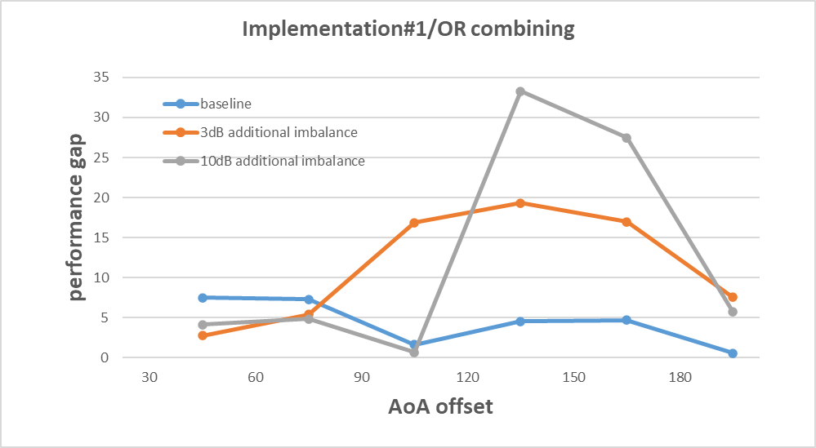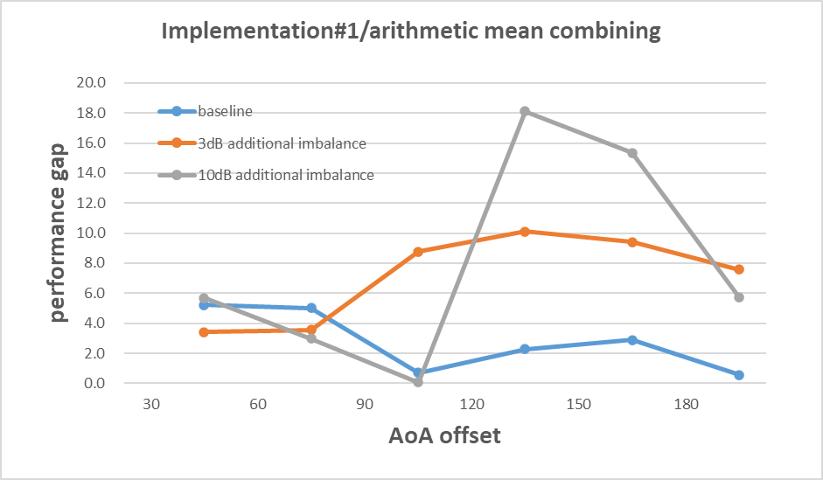
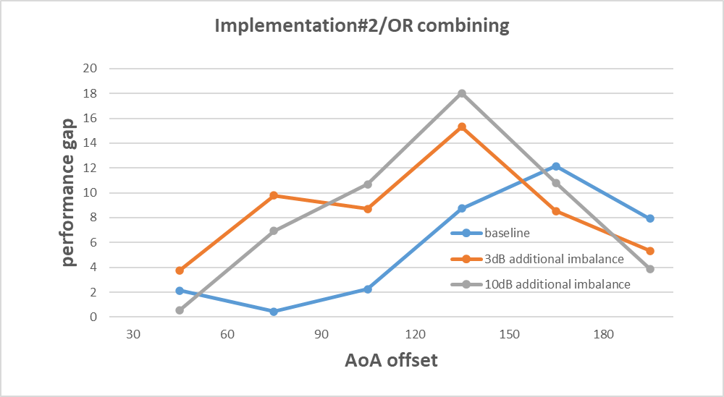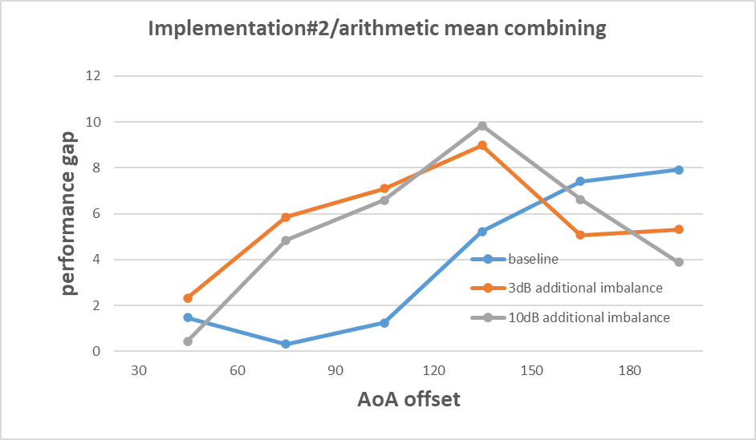
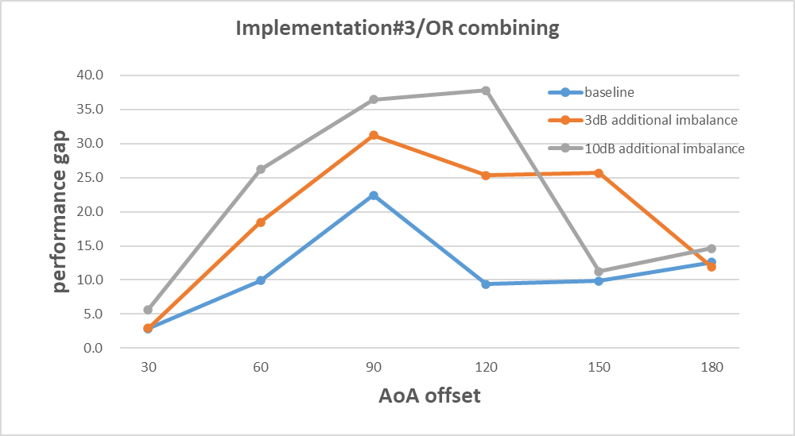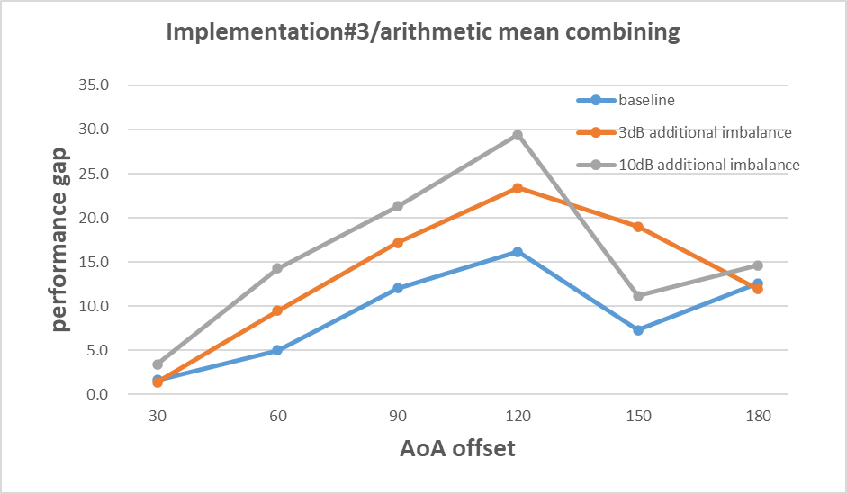
Figure 6.3.6-5 Performance gap between θθ DL and φφ DL
The results show that when gain difference increase, the performance gap is not always enlarged since the gain difference will affect the received signal in both V branch and H branch and how the performance gap changes depending on panels location, AoA offset, etc. To reduce the performance gap between different polarization of DL polarization, one possible way is to construct final results by averaging the performance between θθ DL and φφ DL. Figure 6.3.6-6 shows that how the gain difference impact on the results after average.

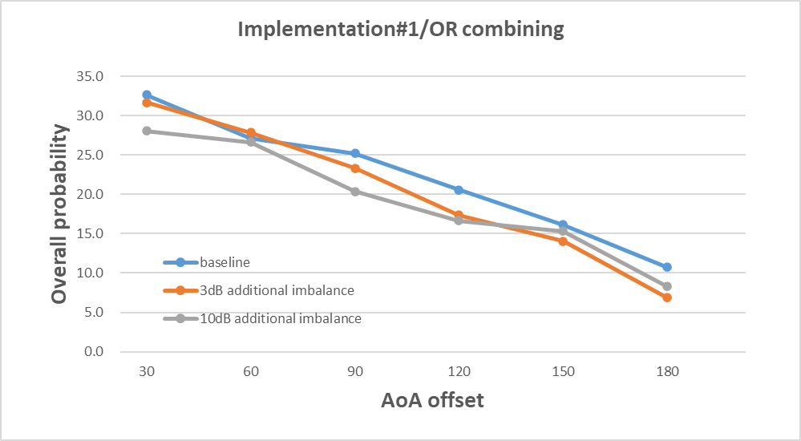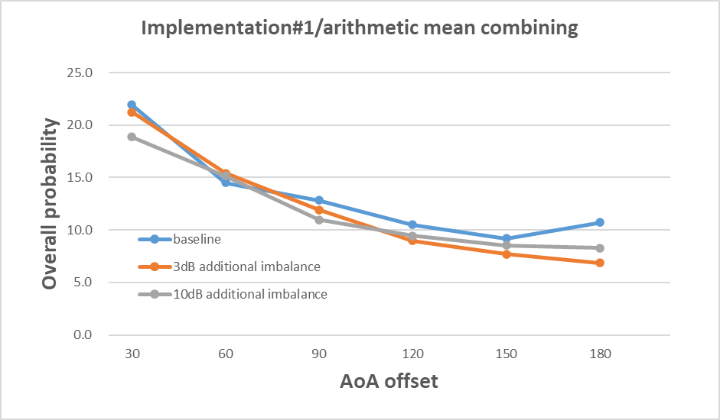
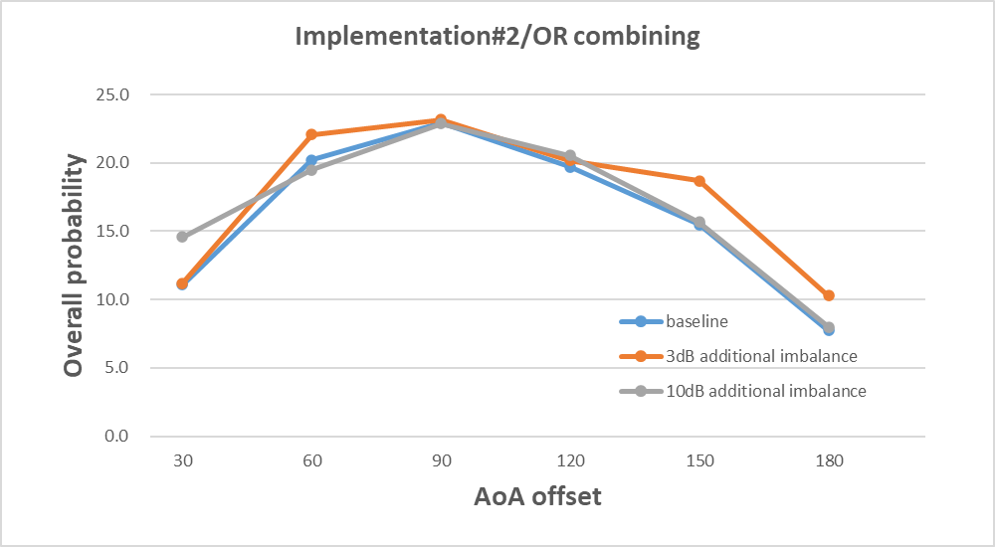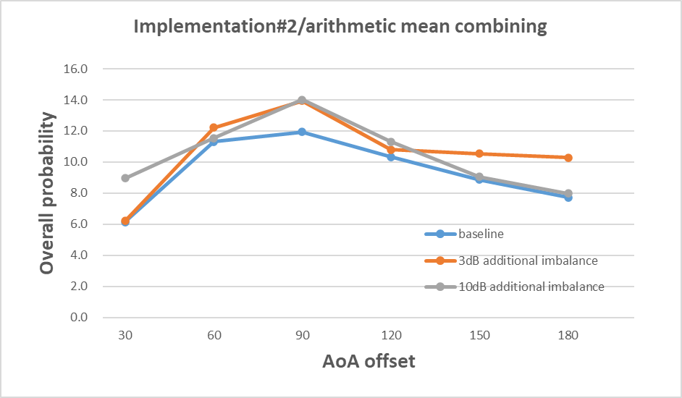
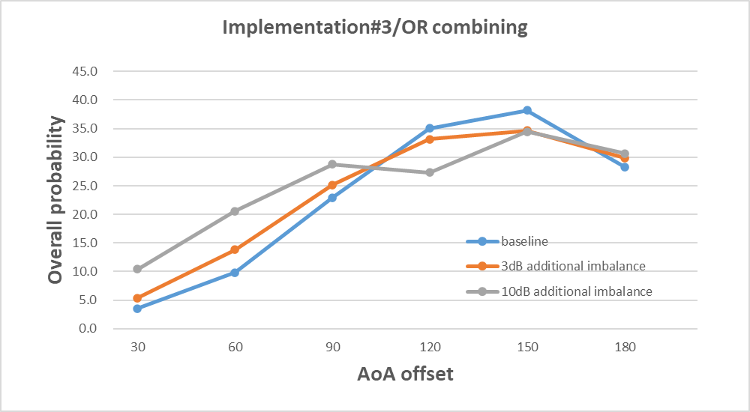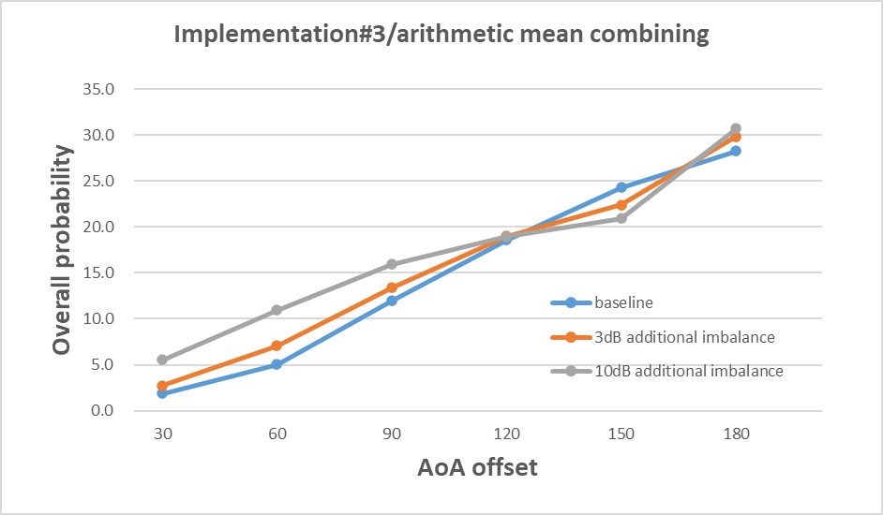
Figure 6.3.6-6 Overall probability under different gain imbalance after average
Compared to the performance gap between different DL polarizations, the performance change under different additional gain difference is smaller after average. We can also find that there is no conclusive relationship between gain imbalance and UE performance.
In the end, the UE RF requirement is defined as the average (arithmetic mean) of the metric values for two DL polarization test conditions: the first condition is when the DL polarizations at both TRPs are ‘θθ’ and the second condition is when they are ‘φφ’.
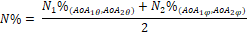
Where ‘N%_{(.,.)}’ is the metric value for the requirement for the DL pols specified in the subscripts.

6.3.7 NTC vs. ETC
During the Rel-15 discussion when the legacy single-AoA spherical coverage requirement was specified, the verification conditions were captured as part of the requirement in TS 38.101-2 as a note, i.e., Note 2 in Table 7.3.4.3-1.

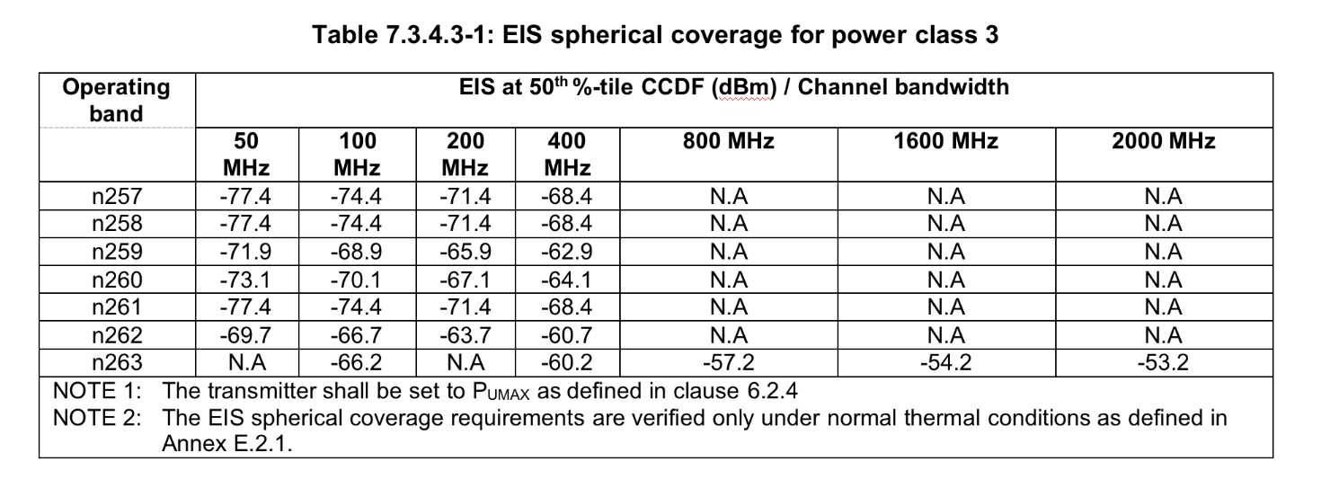
When it comes to the two-AoA spherical coverage requirement, the same issue emerged whether the requirement shall be verified under normal temperature conditions (NTC) but not under extreme temperature conditions (ETC).
As the legacy spherical coverage requirement are required to be verified under NTC only, and the DL fixed power level for the two-AoA requirement is directly reused from the legacy spherical coverage requirement, it is reasonable to consider only the NTC condition for verifying the two-AoA requirement. There are two options on how to specify the multi-RX spherical coverage requirement with respect to NTC vs. ETC:
- Option 1: Keep core requirement wording for the multi-RX spherical coverage requirement consistent with that of the legacy requirement, i.e., with a similar note as NOTE 2 in 38.101-2 Table 7.3.4.3-1, i.e., “The EIS spherical coverage requirements are verified only under normal thermal conditions as defined in Annex E.2.1.”
- Option 2: Do not use the note in the multi-RX spherical coverage requirement, and RAN4 agrees the requirement shall be verified under NTC only. Also, RAN4 ask RAN5 to verify it for NTC only.

The argument for Option 2 is usually RAN4 core requirements are specified independent of the verification conditions and such a convention should be preserved. The way the legacy requirement is specified is considered an exception, and there is a desire to avoid such exceptions. Furthermore, RAN4 has agreed to ask RAN5 to verify the requirement only under NTC. In this way, the RAN4 convention is kept, and no additional work is required to derive the appropriate core requirement for ETC.
In the end, Option 2 is agreed upon.

6.3.8 Consideration of AoA separation

6.3.8.1 Candidate AoA separation
To reveal whether, in real networks, a multi-Rx UE has a clear tendency for the angle between TRPs that can be accessed, system level simulation is performed and the results are recorded in Annex A.2. The conclusion is that UE can access to TRP pairs only if the channel conditions are good enough, and there are no obvious preferred AoA separation. For simplicity while taking into account the constraints of the test system, 30°, 60°, 90°, 120°, 150° are agreed as the candidate AoA separations for requirement design.

6.3.8.2 1AoA vs 2 AoA
How many AoA separations are needed to meet the requirement at the same time is the first problem to be solved. A popular option is to verify at least two AoA separations, one from [30°, 60°, 90°] and another one from [120°, 150°], and the intention is to get a full picture of UE performance.
As the simulation results shown in Annex A.8, when AoA separation changes, different UE implementation will show different trends, e.g., For the case that panels in opposite side, UE performance become better when the AoA separation is larger, but when panels in same side, UE performance will be worse with the increase of AoA separation. Due to the different trends, if two different AoA separations need to meet the requirements simultaneously, to accommodate different UE implementation, the requirement for each AoA separation will always be gated by the implementation that has the worst performance. To avoid such restriction, RAN4 agree that only 1AoA separation from all candidates need to be verified.

6.3.8.3 Specified vs declared
Another problem is that which AoA separation should be selected from the candidates and two options are raised during the discussion. One is to only specify one AoA separation in the specification, e.g., 90°, and with this approach, the worst performance across different placement of antenna modules should be used as requirement to accommodate different implementations. Another approach is to allow UE to declare its preferred AoA separation and the requirement for each AoA separation from candidates needs to be introduced in specification. Using this approach, the requirement will be linked to the UE implementation to show the best performance that one UE may achieved while avoiding put unnecessary restriction on UE implementation. The rules to construct the requirement is agreed as below:
- Three types of reference UE implementation (two panels on the same side, two panels on the adjacent side and two panels on the opposite side) will be used to determine the core requirement:
    - If the AoA offset would be declared by UE
    - If the AoA offset would be specified in the standard.
AoA offset (degrees) | 30° | 60° | 90° | 120° | 150°
Reference UE | same | same | adjacent | opposite | opposite
To better show UE performance under this feature, RAN4 agreed that the AoA separation to be verified can be declared by UE.
AoA offset (degrees) | 30° | 60° | 90° | 120° | 150°
Reference UE | Min (same, adjacent, opposite) | Min (same, adjacent, opposite ) | Min (same, adjacent, opposite ) | Min (same, adjacent, opposite ) | Min (same, adjacent, opposite )

7 Conclusion
Based on the results in A.8, the average value for each AoA separation after taking out outlier are shown in below:

Table 7-1 average value based on the simulation results across companies
 | 30° | 60° | 90° | 120° | 150°
Qualcomm Incorporated |  | 10.3 | 17.1 | 23.9 | 37.6
Apple |  |  | 12.3 | 25.6 | 36.0
LG Electronics | 9.4 | 6.5 | 12.5 | 19.2 | 20.0
Samsung | 17.0 | 12.0 | 11.0 | 17.0 | 23.0
Sony Ericsson | 26.9 | 21.6 | 16.2 | 24.8 | 33.0
vivo | 21.9 | 14.5 | 11.9 | 18.6 | 24.3
OPPO | 28.9 | 23.0 | 18.1 | 19.9 | 32.7
Huawei, HiSilicon | 20.0 | 14.4 | 14.9 | 17.4 | 21.7
Average | 20.7 | 14.6 | 14.3 | 20.8 | 28.5

For the small AoA separation, a few companies have concern on the higher interference power level which may burden on Rx chain performance. To accommodate this concern, some margins are reserved for 30°, 60°, 90°, and the following table is agreed as final requirements:

Table 7-2: Multi-Rx requirement for power class 3
AoA separation (degrees) | Probability (%)
30 | 18.5
60 | 13.5
90 | 12.5
120 | 20.5
150 | 28.5

Annex <A>:
Simulation results

A.1 General
This Annex intends to capture the simulation results and analysis during FR2 multi-Rx DL reception discussion that are helpful in understanding the development of the RF requirement.

A.2 AoA offset distribution with system simulation
Background
As the RF requirement serves as a metric for UE’s two-AoA spherical coverage performanceSince the AoA offset is varied in the real network, it is helpful to know how the AoA offset between two AoAs is distributed in real network in different scenarios, which can provide guidance on whether the range of AoA offset can be narrowed down and the requirement can be targeted for some common AoA offsets.
R4-2218166
To understand if the angular difference between the two AoAs observed in a typical multi-TRP deployment scenario exhibits any pattern, we conduct simulation based on the system simulation assumptions in A.2 in TR 38.802. We simulate the following mTRP scenario as shown below. In particular, the inter-macro TRP distance is 200m, in each cell (hexagon), three micro TRPs are randomly dropped within each dashed circle (i.e., cluster) around the center of the circle (within 20m), following some minimum distance rules (such as the minimum distance between two micro TRPs is 40m, the minimum distance between a micro TRP to a macro TRP is 10m, etc.). UEs are randomly dropped in the cluster (R = 50m). UE is assumed to have two back-to-back panels (pointing to opposite directions), with 4x1 antenna elements each.Details of other simulation parameters such as power can be found in Table A.2.1-1 in TR 38.802 corresponding to the Dense urban scenario.
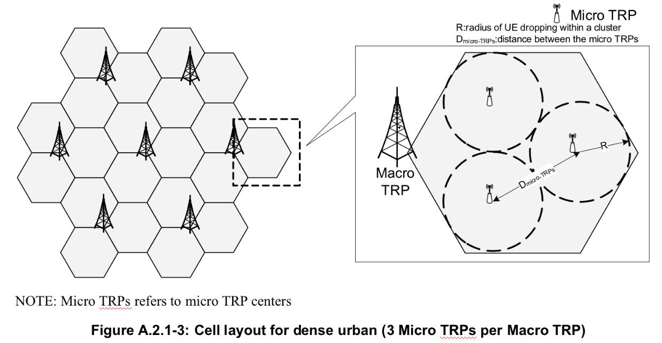
The analysis methodology for these simulations is as follows:
1. Assume each site (macro & micro TRP), in the modeled network is a potential point for the mTRP connection
2. Calculate RSRP between each site, taking into account BS gain in the link direction, UE gain in the link direction, and path loss
3. Associate TRP1 and TRP2 according to max. RSRP and also according to one of the following panel mapping assumptions:
- No restriction on panel mapping (i.e., two beams with best RSRP can be mapped to the same panel)
OR
- Best panel mapping (i.e., one AoA is mapped to the best beam/panel, and the other AoA is mapped to the best beam from the remaining panel)
4. Calculate AoA1 and AoA2 to these TRPs from the UE perspective
5. Evaluate the distribution of AoA1 - AoA2 (∆AoA)
Results are shown in Figures 1 and 2 below.
- It can be seen from Fig. A.2-1 that with unrestricted panel mapping, the distribution of ∆AoA is nearly uniform. In other words, it takes values from 0 to 180 degrees with equal probability.
- In Fig. A.2-2, with best panel mapping restriction, it can be observed that for 95% of the UEs, ∆AoA > 60 degrees.
- We note the results depend in general on the UE antenna panel assumptions as well as the power levels of the macro and micro nodes. We welcome other companies to share results for comparison.
Figure A.2-1: Distribution of ∆AoA with unrestricted panel mapping
Figure A.2-2: Distribution of ∆AoA with best panel mapping restriction
R4-2301573
To further figure out the AoA separation distribution in the dedicated deployment, we perform a simulation and 2 deployments are considered, as shown in Figure A.2-3:
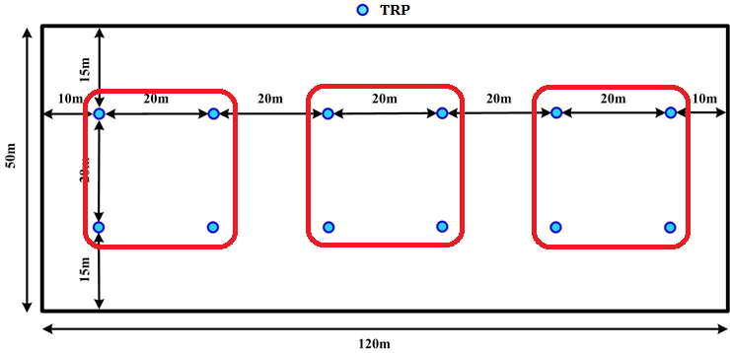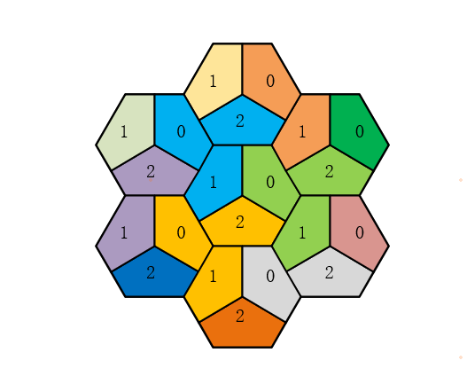
Figure A.2-3 Indoor and Dense Urban (Macro only) deployment

For indoor scenario, 4 TRPs within the red circle are combined as a cluster, and UE can access any two of them. For Dense Urban, the TRPs with the same color can collaborate. Other simulation assumptions are mainly from TR38.802, and the results are shown in Figure A.2-4.
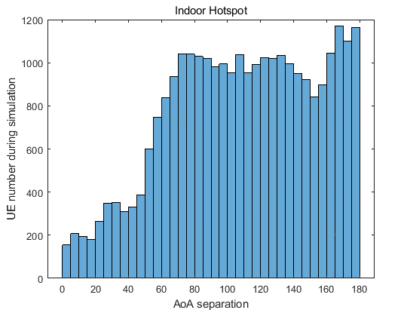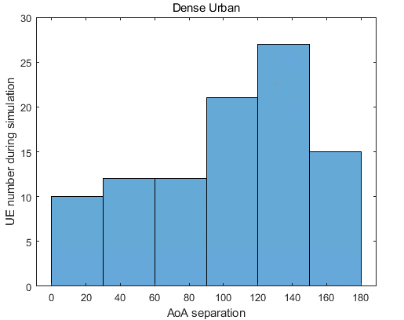
Figure A.2-4 AoA separation distribution in indoor and Dense urban

Unfortunately, it is hard to further narrow down the AoA separation range based on the results, as we have already mentioned in the previous meeting, UE can access the TRP if the channel condition is acceptable and the AoA separation varies due to the UE location, channel condition changes, and we cannot get a so-called minimum or maximum threshold based on the simulation results.

A.3 Requirement applicability for sDCI and mDCI
Background
It is preferrable to define a single set of requirements for both sDCI and mDCI, and the following part provides the analysis of whether it is feasible under functionality-based requirement.
R4-2308232
When both AoAs use the same fixed DL power level, due to the antenna gain and inter-beam interference being different for the signal from 2 AoA, the SINR at baseband for 2 layers are different, which means using the same fixed DL power will bring power imbalance artificially.

For multi-DCI UE, each layer can be decoded separately and we can get the throughput of each layer, so the power imbalance doesn’t matter and the -1 dB criterion above to judge each test point from a pair of AoA is still reasonable. However, things become different for sDCI UE because the 2 layers of sDCI UE share one transmission block and we can only get a total throughput of 2-layer MIMO, and there is no doubt that the power imbalance will affect this total throughput, and simply using -1dB as the criterion for each test point does not make sense anymore. Figure A.3-1 shows that how power imbalance will affect the throughput of sDCI UE.
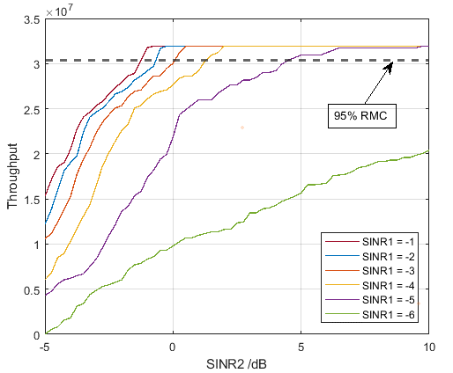
Figure A.3-1 impact of power imbalance for sDCI UE
In the simulation, the SINR1 and SINR2 represent the SINR value from 2AoA. Obviously, due to the power imbalance, even though one of SINRs is less than -1 dB, the total throughput still can achieve 95% RMC and pass the test.

Does raising or lowering the power of one of the AoA can help with this problem? The answer is NO. Simply changing the power level cannot remove the power imbalance, and the only way to solve this issue is for each test point, the DL power should be changed, but this scheme is too complicated from both the verification and evaluation perspectives.

As a compromise, we can only focus on that whether the sDCI UE can pass the same requirement as mDCI under power imbalance. In Figure A.3-1, the simulation shows that when both SINRs is larger than -1 dB, the total throughput still can be larger than 95% RMC, which means the -1 dB in simulation still can ensure the AoA pair can pass the test. The only omission here is that cases where either SINR1 or SINR2 is less than <-1 dB and UE can still pass the test are accounted for in the requirement. As we mention above, even though we realize this omission, it is hard to be verified or evaluated. So we think it is enough to confirm the same requirement can be applied to both sDCI and mDCI UEs under the current evaluation method.

A.4 Evaluation of EIS-based requirement
Background
A sensitivity-based requirement was a possible way during the discussion, but was eventually discarded due to its complexity. The related evaluation can be found in [11][12][13][14].

A.5 Impact of UE orientation
Background
As mentioned in Clause 6.3.4, it is identified that UE has different performance under different UE orientation due to the test system constrains, and the following part capture the evaluations.
R4-2304824
Our simulation results shown in section 2.1.3 gather simulation data for all angular separation values, for 3 typical UE orientations, for 3 different panel placement implementations, respectively. Those data are visualized in Figure A.6-1 for convenience of comparison. From the figure, it can be observed that different panel placement implementations show obvious different trend in angular separation preference, thus it is not proper to specify requirements for both small angular separation and large angular separation.
Different UE orientations also impact performance a lot. From Figure A.5-1 (a) and (c), it can be observed that there is even orientation showing bad performance for every angular separation from 30° to 180°, thus it is not proper to specify requirements for all UE orientations.
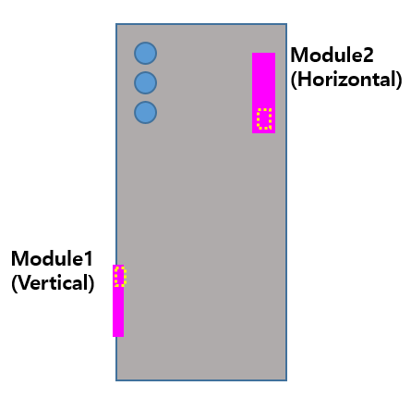
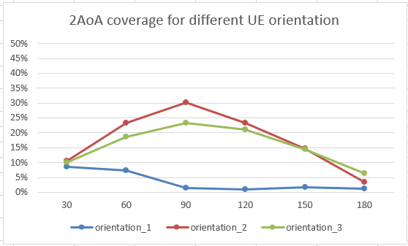
- simulation results of Right + Back panel placement
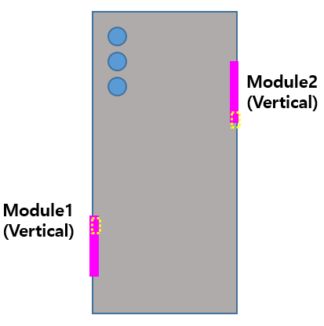
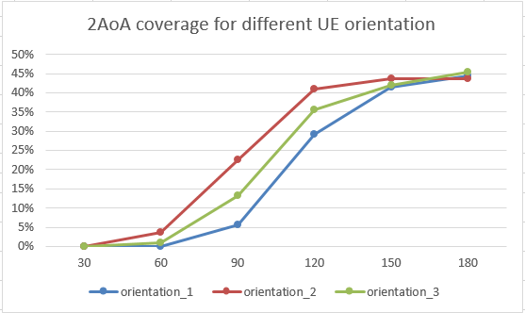
- simulation results of Left + Right panel placement
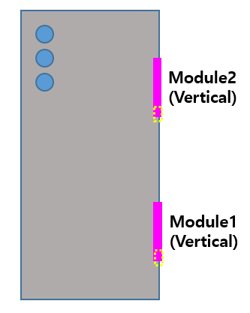
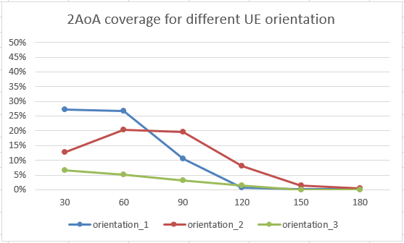
- simulation results of Left + Left panel placement
Figure A.5-1 Visualization of our simulation results
R4-2305098
The simulation results for different UE orientations are shown in Figure A.5-2 and the post-processing rules that mentioned in previous part are used.

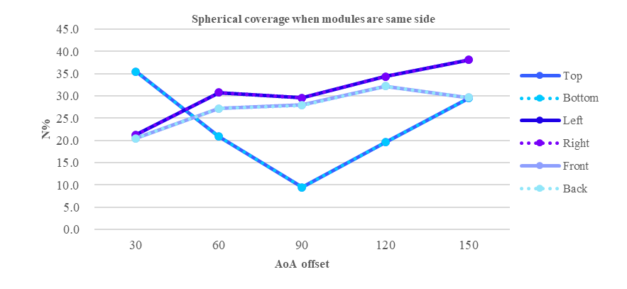
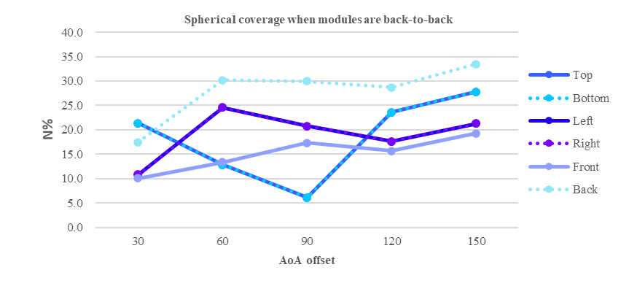
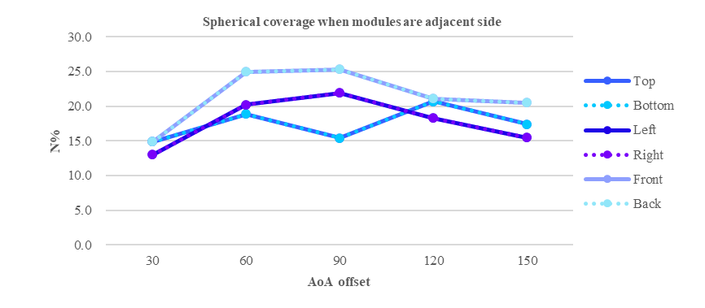
Figure A.5-2 N% for different orientations

Some curves are totally overlapped is because the model itself has symmetry. When metal blockage exists, the EM field will be scattered due to the reflection, and it is hard to summarize a rule between N% and AoA offset. The UE orientation also led to different results although the AoA offset is same, and the reason here is that the relative position between AoA pair and UE will be changed under different UE orientation.

R4-2304603
To evaluate the impact of different choices on module orientations relative to the UE reference coordinate system, a UE with 2 identical modules housed in adjacent faces was used. Each module comprised a 4x1 dual polarized element array. The coverage pattern is shown in figure A.5-3. Annex C has details on the module orientation in the UE reference coordinate system. Module locations were grouped into two categories.
- In the first category, one module pattern covered the polar region of the reference coordinate system. Examples: Front+Bottom, Front+Top, Front+Right
- In the second category, both modules cover equatorial regions (away from polar regions). Examples: Top+Left, Top+Right
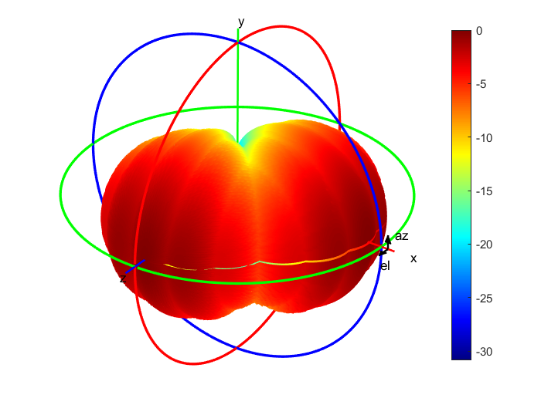
Figure A.5-3: Coverage pattern of example UE with modules on adjacent faces
The list in each category is not exhaustive but deemed sufficient to capture characteristic trends.
Figures A.5-4 and A.5-5 shows a comparison of overall probability to support 2TRP DL for the example UE chosen for the UE positioning study. Category 1 orientations are captured in cool colors (blues and greens), and category 2 orientations are captured in warm colors (reds).
Figure A.5-4: OR combining method comparison
Figure A.5-5: mean combining method comparison
Here too, the dashed and solid trends for any one color track closely. This suggests that module orientation (H-scanning or V-scanning) seems to make a relatively small difference in the projected overall probability result for a UE with modules on adjacent faces.

A.6 Impact of gain imbalance between antenna module
Background
For a real UE, the performance of panels may not be exactly same. The following part show how the gain imbalance impacts the functionality-based requirement.
R4-2307482
The simulation of the pass ratio over the whole sphere is performed by considering different antenna module performances, different UE orientations, and different antenna module combinations.
- Antenna module performance
  - Case 1: antenna module#1 and antenna module#2 are assumed to have the same performance gain
  - Case 2: antenna module#1 is assumed to have a 3dB lower performance gain than antenna module#2
  - Case 3: antenna module#2 is assumed to have a 3dB lower performance gain than antenna module#1
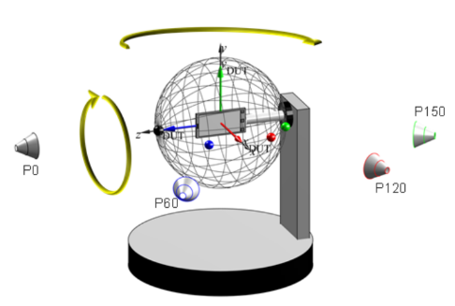
- UE orientation
  - Z-axis oriented
  - Y-axis oriented
  - X-axis oriented
    - Probes are located in the xz plane in [2]
- Antenna module combination
  - left-side & right-side combination
  - left-side & top-side combination
Figure A.6-1, Figure A.6-2, and Figure A.6-3 show the results of the pass ratio of both OR combining and averaging for Case1, Case2, and Case3, respectively.
(a). OR combining (b) Averaging
Figure A.6-1: Pass Ratio of both ‘OR combining’ and ‘averaging’ for Case 1.
(a). OR combining (b) Averaging
Figure A.6-2: Pass Ratio of both ‘OR combining’ and ‘averaging’ for Case 2.
(a). OR combining (b) Averaging
Figure A.6-3: Pass Ratio of both ‘OR combining’ and ‘averaging’ for Case 3.

R4-2309284
Sometimes it is preferable to use actual module coverage data, but in conjunction with the spherical coverage calibration condition, we may end up with an over-specified set of boundary conditions. (i.e cannot meet both REFSENS and spherical coverage gain drop at the same time.). In these cases, the baseline assumption in a previous WF suggests to ‘scale antenna gain’, see excerpt below (figure 2.4-1). 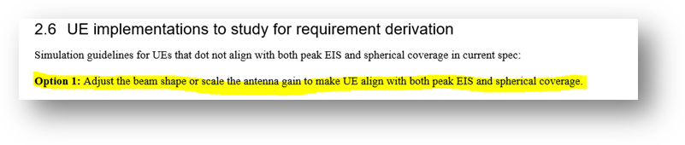
There are several ways to achieve this scaling: the first method would apply to both modules equally (symmetric scaling of gains in way to ‘tune’ the spherical coverage gain drop), and the second method would reduce the gain of one of the modules relative to the other (asymmetric scaling). Asymmetric scaling makes the sensitivity worse for one module over the other, so it can impact the probability metric significantly, see tables below.

Left and Right modules, legacy antenna gain | Module coverage relative to positioner centric grid (*) | Probability to support 2 TRP DL (option 1 metric [1]+ OR combining)
Equal modules  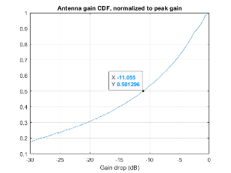 | 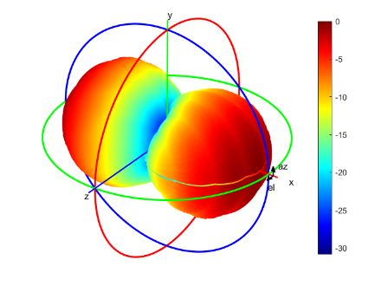 | 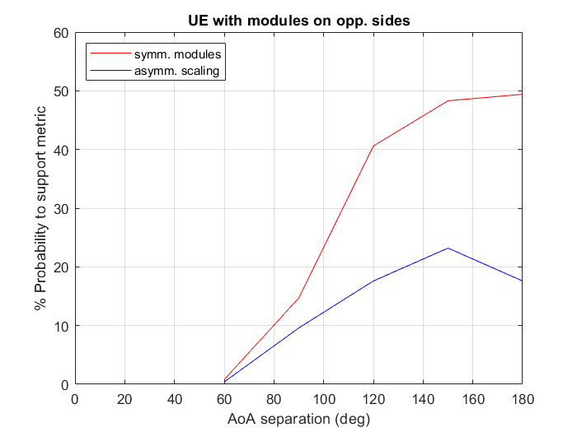
Asymm. scaled modules (9.0 dB reduction in one)  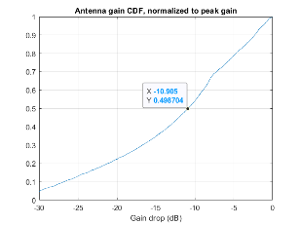 | 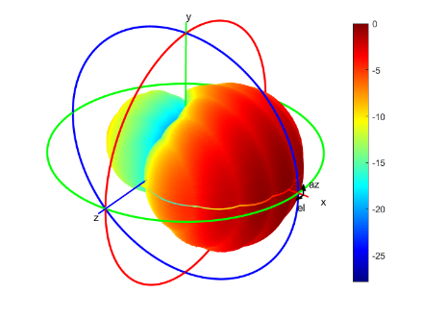

Left and Front modules, legacy antenna gain | Module coverage relative to positioner centric grid (*) | Probability to support 2 TRP DL (option 1 metric [1]+ OR combining)
Equal modules | 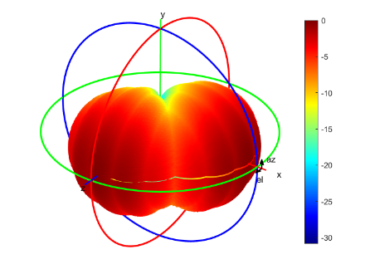 | 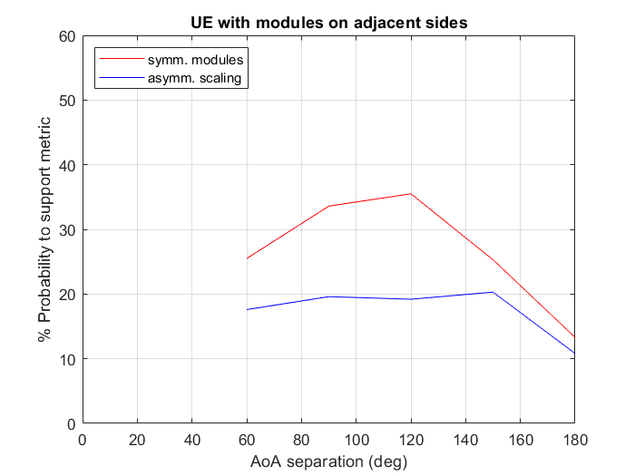
Asymm. scaled modules (7.5 dB reduction in one) | 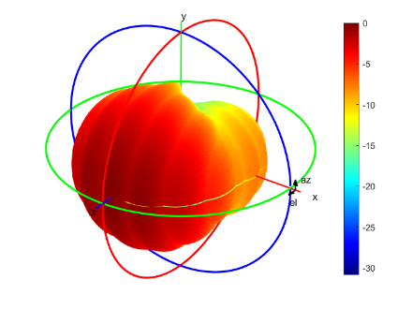

Note that all the UEs above are calibrated to legacy spherical coverage, but the probability metrics can be vastly different between UEs with equal modules and UEs with asymmetric modules. This difference may be tolerable for small differences (2 dB or less) across modules, but this type of implementation is not suitable for 2 TRP reception if the asymmetric gain split is larger across the modules. Larger gain splits become necessary if the individual module

A.7 Test time estimates
Background
Test time is an important aspect to be considered in search of the proper requirement concept. The following part provide the estimation for EIS-based requirement and functionality-based requirement.
R4-2302522
In the previous sections it was shown that the test time for the multi-AoA DL spherical test depends on various aspects, e.g.,
- number of AoA2 probes
- number of polarization combinations (AoA1_{q}, AoA2_{q}), (AoA1_{q}, AoA2_{f}), (AoA1_{f}, AoA2_{q}), (AoA1_{f}, AoA2_{f})
- single-DCI vs multi-DCI schemes
- parametric vs non-parametric test approach
The summary of test time estimates is tabulated in Table A.7-1. Big differences in terms of test time/test efforts can be observed; as expected, the non-parametric test approach yields the lowest test time.
Table A.7-1: Overview of Approximate Test Times
Power Class | Grid Type | Test Approach | Minimum Number of Spherical Coverage Test Points N | Number of Polarization Combinations P | Number of AoA2 Probes M | Effort/Test Time for multi-AoA DL spherical coverage test [min] |  | Notes
 |  |  |  |  |  | Min | Max | Notes
PC1/PC3 | constant-step size | Parametric single-DCI | 312 | 4 | 4 | 1331 | 1799 | Min/Max test time depends on Joint 2 AoA Sensitivity approach
 |  |  |  |  | 3 | 1248 | 1716
 |  |  |  |  | 2 | 1165 | 1633
 |  |  |  | 2 | 4 | 666 | 900
 |  |  |  |  | 3 | 624 | 858
 |  |  |  |  | 2 | 582 | 816
PC1/PC3 | constant-step size | Parametric multi-DCI | 312 | any | 4 | 666 |  | N/A
 |  |  |  |  | 3 | 624 |  | N/A
 |  |  |  |  | 2 | 582 |  | N/A
PC1/PC3 | constant-step size | Non-Parametric single-DCI or multi-DCI | 312 | 4 | 4 | 21 | 333 | Min/Max depends on early Pass
 |  |  |  |  | 3 | 21 | 250 | Min/Max depends on early Pass
 |  |  |  |  | 2 | 21 | 166 | Min/Max depends on early Pass
 |  |  |  | 2 | 4 | 21 | 166 | Min/Max depends on early Pass
 |  |  |  |  | 3 | 21 | 125 | Min/Max depends on early Pass
 |  |  |  |  | 2 | 21 | 83 | Min/Max depends on early Pass
Given the large difference in test time, feedback from industry is requested whether the test approach for multi-AoA spherical coverage should be based on a parametric test (as legacy spherical coverage test case) or on a non-parametric test.

A.8 Simulation campaign for requirement design
Background
This section summarizes the simulation results from companies for final RF requirement, and the results for 3 typical UE implementations and 2 candidate combining methods are provided.

Table A.8-1 Overall probability with OR combining
OR combining | Panels in adjacent faces
 | 30 | 60 | 90 | 120 | 150 | 180
Qualcomm Incorporated |  | 23.7 | 33.6 | 35.4 | 26.6
Apple | 13.7 | 22.5 | 24.4 | 21.7 | 16.6 | 12.0
LG Electronics | 8.2 | 16.3 | 24.9 | 24.5 | 28.2 | 28.6
Samsung-metal | 8.0 | 17.0 | 21.0 | 15.0 | 7.0 | 1.0
Samsung-plastic | 13.0 | 21.0 | 23.0 | 22.0 | 16.0 | 10.0
Sony, Ericsson | 11.6 | 23.2 | 33.0 | 32.0 | 27.0 | 13.6
vivo-metal | 12.3 | 17.6 | 18.5 | 17.2 | 16.2 | 8.8
vivo-plastic | 11.1 | 20.2 | 23.0 | 19.7 | 15.5 | 7.7
OPPO | 13.5 | 26.6 | 36.1 | 28.0 | 17.0 | 5.9
Huawei, HiSilicon | 18.0 | 30.6 | 35.7 | 30.9 | 17.3 | 6.3
Nokia

OR combining | Panels in opposite faces
 | 30 | 60 | 90 | 120 | 150 | 180
Qualcomm Incorporated |  | 7.0 | 22.0 | 40.9 | 48.4
Apple | 0.1 | 9.6 | 27.0 | 45.6 | 49.4 | 48.1
LG Electronics | 0.0 | 3.3 | 19.6 | 38.4 | 39.9 | 46.3
Samsung-metal | 0.0 | 4.0 | 19.0 | 35.0 | 37.0 | 29.0
Samsung-plastic | 0.0 | 4.0 | 22.0 | 41.0 | 44.0 | 44.0
Sony, Ericsson | 1.5 | 7.6 | 24.9 | 47.1 | 47.1 | 38.1
vivo-metal | 17.8 | 20.6 | 19.6 | 16.7 | 21.7 | 17.2
vivo-plastic | 3.6 | 9.8 | 23.0 | 35.0 | 38.2 | 28.3
OPPO | 14.2 | 13.4 | 20.5 | 36.3 | 46.1 | 39.4
Huawei, HiSilicon | 7.8 | 18.4 | 34.4 | 45.2 | 42.5 | 22.6
Nokia

OR combining | Panels in same faces
 | 30 | 60 | 90 | 120 | 150 | 180
Qualcomm Incorporated |  | 20.6 | 37.5 | 31.4 | 17.3
Apple
LG Electronics | 18.8 | 13.0 | 21.5 | 6.6 | 0.0 | 0.0
Samsung-metal | 23.0 | 23.0 | 9.0 | 1.0 | 0.0 | 0.0
Samsung-plastic | 28.0 | 26.0 | 18.0 | 8.0 | 6.0 | 2.0
Sony, Ericsson | 41.5 | 37.1 | 32.1 | 29.5 | 27.2 | 18.6
vivo-metal | 23.5 | 17.0 | 17.8 | 20.1 | 19.3 | 10.0
vivo-plastic | 32.6 | 27.1 | 25.2 | 20.6 | 16.1 | 10.7
OPPO | 41.2 | 39.4 | 31.2 | 21.5 | 16.2 | 11.8
Huawei, HiSilicon | 20.5 | 29.2 | 35.4 | 31.0 | 16.6 | 4.3
Nokia

Table A.8-2 Overall probability with arithmetic mean combining
Arithmetic mean | Panels in adjacent faces
 | 30 | 60 | 90 | 120 | 150 | 180
Qualcomm Incorporated |  | 12.8 | 17.1 | 17.8 | 15.9
Apple | 8.6 | 12.5 | 12.3 | 11.6 | 10.7 | 11.7
LG Electronics | 4.1 | 8.1 | 12.5 | 12.3 | 14.1 | 14.3
Samsung-metal | 4.0 | 9.0 | 11.0 | 7.0 | 4.0 | 1.0
Samsung-plastic | 7.0 | 11.0 | 12.0 | 11.0 | 9.0 | 10.0
Sony, Ericsson | 5.8 | 11.6 | 16.6 | 16.0 | 14.6 | 13.6
vivo-metal | 7.0 | 9.5 | 9.8 | 9.3 | 9.3 | 8.8
vivo-plastic | 6.1 | 11.3 | 11.9 | 10.3 | 8.9 | 7.7
OPPO | 6.8 | 13.5 | 18.1 | 14.0 | 8.6 | 5.9
Huawei, HiSilicon | 10.7 | 16.5 | 18.0 | 15.5 | 8.6 | 6.3
Nokia | 12.0 | 31.0 | 35.0 | 35.0 | 30.0

Arithmetic mean | Panels in opposite faces
 | 30 | 60 | 90 | 120 | 150 | 180
Qualcomm Incorporated |  | 3.5 | 11 | 23.9 | 37.6
Apple | 0.0 | 4.8 | 13.5 | 25.6 | 36.0 | 47.5
LG Electronics | 0.0 | 1.7 | 9.8 | 19.2 | 20.0 | 23.0
Samsung-metal | 0.0 | 2.0 | 10.0 | 17.0 | 23.0 | 29.0
Samsung-plastic | 0.0 | 2.0 | 11.0 | 21.0 | 27.0 | 44.0
Sony, Ericsson | 0.7 | 3.8 | 12.7 | 24.8 | 33.0 | 38.1
vivo-metal | 10.7 | 12.4 | 10.9 | 9.5 | 12.9 | 17.2
vivo-plastic | 1.9 | 5.0 | 12.0 | 18.6 | 24.3 | 28.3
OPPO | 7.1 | 6.7 | 10.3 | 19.9 | 32.7 | 39.3
Huawei, HiSilicon | 4.0 | 9.6 | 17.2 | 25.1 | 25.3 | 22.6
Nokia | 7.0 | 20.0 | 33.0 | 41.0 | 47.0

Arithmetic mean | Panels in same faces
 | 30 | 60 | 90 | 120 | 150 | 180
Qualcomm Incorporated |  | 10.3 | 18.8 | 15.7 | 8.7
Apple
LG Electronics | 9.4 | 6.5 | 10.7 | 3.3 | 0.0 | 0.0
Samsung-metal | 17.0 | 12.0 | 5.0 | 1.0 | 0.0 | 0.0
Samsung-plastic | 20.0 | 15.0 | 9.0 | 4.0 | 3.0 | 2.0
Sony, Ericsson | 26.9 | 21.6 | 17.6 | 16.0 | 17.6 | 18.6
vivo-metal | 14.5 | 9.3 | 10.0 | 12.2 | 11.2 | 10.0
vivo-plastic | 21.9 | 14.5 | 12.8 | 10.5 | 9.2 | 10.7
OPPO | 28.9 | 23.0 | 16.3 | 10.8 | 9.3 | 11.6
Huawei, HiSilicon | 12.4 | 15.8 | 17.8 | 15.5 | 8.3 | 4.3
Nokia | 10.0 | 28.0 | 37.0 | 28.0 | 30.0

Annex <B>:
Change history
Change history
Date | TSG # | TSG Doc. | CR | Rev | Subject/Comment | Old | New
08/2023 | RAN4#108 | R4-2311863 |  |  | TR skeleton for UE RF requirements for NR frequency range 2 multi-Rx chain DL reception | N/A | 0.0.1
08/2023 | RAN4#108 | R4-2314883 |  |  | R4-2311333 TP on DL power for TR 38.751  R4-2311334 TP on DL polarization combination for TR 38.751  R4-2314924 Text proposal to Multi-RX DL TR 38.751 on RMC and UE orientation  R4-2314667 TP to TR 38.751 on system assumption and UE RF requirement  R4-2314925 TP to TR 38.751 on inter-beam interference in multi-Rx DL reception | 0.0.1 | 0.1.0
09/2023 | RAN#101 | RP-231925 |  |  | For information | 0.1.0 | 1.0.0
10/2023 | RAN4#108bis | R4-2315086 |  |  | R4-2317592 TP to 38.751 on collection of simulation results | 1.0.0 | 1.1.0
11/2023 | RAN4#109 | R4-2318501 |  |  | R4-2321723 TP on NTC vs. ETC for TR 38.751  R4-2321724 TP on Annex <A>:Simulation results for TR 38.751  R4-2321725 TP to 38.751 on further evaluation of gain difference between V-pol and H-pol  R4-2321726 TP to 38.751 on RF requirement construction | 1.1.0 | 1.2.0

