|  |  |
| --- | --- |
| 3GPP TR 37.829 V0.8.0 (2023-011) | |
| Technical Report | |
| 3rd Generation Partnership Project;  Technical Specification Group Radio Access Network;  Evolved Universal Terrestrial Radio Access (E-UTRA) and NR;  High-power UE operation for fixed-wireless/vehicle-mounted use cases in LTE bands and NR bands for Rel-18  (Release 18) | |
|  | |
| *5G-logo_175px* | 3GPP-logo_web |
|  | |
| The present document has been developed within the 3rd Generation Partnership Project (3GPP TM) and may be further elaborated for the purposes of 3GPP. The present document has not been subject to any approval process by the 3GPPOrganizational Partners and shall not be implemented. This Specification is provided for future development work within 3GPPonly. The Organizational Partners accept no liability for any use of this Specification. Specifications and Reports for implementation of the 3GPP TM system should be obtained via the 3GPP Organizational Partners' Publications Offices. | |

|  |
| --- |
|  |
| ***3GPP***  Postal address  3GPP support office address  650 Route des Lucioles - Sophia Antipolis  Valbonne - FRANCE  Tel.: +33 4 92 94 42 00 Fax: +33 4 93 65 47 16  Internet  http://www.3gpp.org |
| ***Copyright Notification***  No part may be reproduced except as authorized by written permission. The copyright and the foregoing restriction extend to reproduction in all media.  © 2023, 3GPP Organizational Partners (ARIB, ATIS, CCSA, ETSI, TSDSI, TTA, TTC).  All rights reserved.  UMTS™ is a Trade Mark of ETSI registered for the benefit of its members  3GPP™ is a Trade Mark of ETSI registered for the benefit of its Members and of the 3GPP Organizational Partners LTE™ is a Trade Mark of ETSI registered for the benefit of its Members and of the 3GPP Organizational Partners  GSM® and the GSM logo are registered and owned by the GSM Association |

Contents

Foreword 5

1 Scope 7

2 References 7

3 Definitions of terms, symbols and abbreviations 7

3.1 Terms 7

3.2 Symbols 8

3.3 Abbreviations 8

4 Background 8

4.1 General 8

4.2 Justification of the work 8

4.3 Objectives of the work 9

5 Band specific requirements for a UE 9

5.1 Bands n71 and n85 9

5.1.1 REFSENS exception 9

5.1.2 A-MPR and MPR 9

5.1.2.1 A-MPR Simulation assumptions 9

5.1.2.2 A-MPR Simulation results 11

5.1.2.3 A-MPR 13

5.1.2.4 Edge allocations for PC2 and PC1.5 15

5.1.2.5 MPR Simulation results 17

5.1.2.6 MPR 19

5.1.3 Feasibility of the filter 20

5.1.4 Feasibility of the PA 20

5.1.5 Other 20

5.2 Bands n100 and n101 20

5.2.1 REFSENS exception 20

5.2.2 A-MPR and MPR 20

5.2.3 ECC requirements 20

5.2.3.1 n100 compliance 21

5.2.3.2 n101 compliance 21

5.3 Band 12 21

5.3.1 REFSENS exception 22

5.3.2 A-MPR and MPR 22

5.3.2.1 A-MPR Simulation assumptions 22

5.3.2.2 A-MPR Simulation results 23

5.3.2.3 A-MPR 25

5.3.3 Feasibility of the filter 25

5.3.4 Feasibility of the PA 25

5.3.5 Other 25

Annex A: Coexistence studies for 31 dBm UE Power Class for LTE Band 41 and NR Band n41 26

A.1 Simulation assumptions 26

A.1.1 Macro cell Propagation model 26

A.1.1.1 Macro cell Propagation model – Urban and Suburban Areas 26

A.1.1.2 Macro cell Propagation model – Rural Area 26

A.1.2 Power Control Simulation Parameters 26

A.1.3 Cell Layout 28

A.1.4 Other Simulation Assumptions 28

A.1.5 Simulation Procedure 30

A.2 Simulation results 30

A.2.1 0.75 km inter-site distance 30

A.2.2 2.8 km inter-site distance 34

A.2.3 6 km inter-site distance 37

A.2.4 8 km inter-site distance 40

A.2.5 BS received signal power 43

Annex B: 43

Coexistence studies for 31 dBm UE Power Class for NR Band n77 43

B.1 Simulation assumptions 43

B.1.1 Macro cell Propagation model 43

B.1.1.1 Macro cell Propagation model - Urban and Suburban Areas 43

B.1.1.2 Macro cell Propagation model - Rural Area 44

B.1.2 Power Control Simulation Parameters 44

B.1.3 Cell Layout 45

B.1.4 Other Simulation Assumptions 46

B.1.5 Simulation Procedure 47

B.2 Simulation results 48

B.2.1 0.5 km inter-site distance 48

B.2.2 1 km inter-site distance 51

B.2.3 2 km inter-site distance 53

B.2.4 5 km inter-site distance 55

B.2.5 BS received signal power 57

C.1 Simulation assumptions 58

C.1.1 Macro cell Propagation model 58

C.1.1.1 Macro cell Propagation model - Urban and Suburban Areas 58

C.1.1.2 Macro cell Propagation model - Rural Area 58

C.1.2 Power Control Simulation Parameters 59

C.1.3 Cell Layout 59

C.1.4 Other Simulation Assumptions 60

C.1.5 Simulation Procedure 61

D.1 Simulation assumptions 62

D.1.1 Macro cell Propagation model 62

D.1.1.1 Macro cell Propagation model - Urban and Suburban Areas 62

D.1.1.2 Macro cell Propagation model - Rural Area 62

D.1.2 Power Control Simulation Parameters 63

D.1.3 Cell Layout 64

D.1.4 Other Simulation Assumptions 64

D.1.5 Simulation Procedure 65

Annex E (informative): Change history 66

# Foreword

This Technical Report has been produced by the 3rd Generation Partnership Project (3GPP).

The contents of the present document are subject to continuing work within the TSG and may change following formal TSG approval. Should the TSG modify the contents of the present document, it will be re-released by the TSG with an identifying change of release date and an increase in version number as follows:

Version x.y.z

where:

x the first digit:

1 presented to TSG for information;

2 presented to TSG for approval;

3 or greater indicates TSG approved document under change control.

y the second digit is incremented for all changes of substance, i.e. technical enhancements, corrections, updates, etc.

z the third digit is incremented when editorial only changes have been incorporated in the document.

In the present document, modal verbs have the following meanings:

**shall** indicates a mandatory requirement to do something

**shall not** indicates an interdiction (prohibition) to do something

The constructions "shall" and "shall not" are confined to the context of normative provisions, and do not appear in Technical Reports.

The constructions "must" and "must not" are not used as substitutes for "shall" and "shall not". Their use is avoided insofar as possible, and they are not used in a normative context except in a direct citation from an external, referenced, non-3GPP document, or so as to maintain continuity of style when extending or modifying the provisions of such a referenced document.

**should** indicates a recommendation to do something

**should not** indicates a recommendation not to do something

**may** indicates permission to do something

**need not** indicates permission not to do something

The construction "may not" is ambiguous and is not used in normative elements. The unambiguous constructions "might not" or "shall not" are used instead, depending upon the meaning intended.

**can** indicates that something is possible

**cannot** indicates that something is impossible

The constructions "can" and "cannot" are not substitutes for "may" and "need not".

**will** indicates that something is certain or expected to happen as a result of action taken by an agency the behaviour of which is outside the scope of the present document

**will not** indicates that something is certain or expected not to happen as a result of action taken by an agency the behaviour of which is outside the scope of the present document

**might** indicates a likelihood that something will happen as a result of action taken by some agency the behaviour of which is outside the scope of the present document

**might not** indicates a likelihood that something will not happen as a result of action taken by some agency the behaviour of which is outside the scope of the present document

In addition:

**is** (or any other verb in the indicative mood) indicates a statement of fact

**is not** (or any other negative verb in the indicative mood) indicates a statement of fact

The constructions "is" and "is not" do not indicate requirements.

# 1 Scope

The present document is a technical report for release 17 basket WI High-power UE operation for fixed-wireless/vehicle-mounted use cases in LTE bands and NR bands.

# 2 References

The following documents contain provisions which, through reference in this text, constitute provisions of the present document.

- References are either specific (identified by date of publication, edition number, version number, etc.) or non‑specific.

- For a specific reference, subsequent revisions do not apply.

- For a non-specific reference, the latest version applies. In the case of a reference to a 3GPP document (including a GSM document), a non-specific reference implicitly refers to the latest version of that document *in the same Release as the present document*.

[1] 3GPP TR 21.905: "Vocabulary for 3GPP Specifications".

[2] ECC Decision (20)02, Harmonised use of the paired frequency bands 874.4-880.0 MHz and 919.4-925.0 MHz and of the unpaired frequency band 1900-1910 MHz for Railway Mobile Radio (RMR), updated 10 June 2022

[3] 3GPP TR 36.942: "Evolved Universal Terrestrial Radio Access (E-UTRA); Radio Frequency (RF) system scenarios".

[4] 3GPP TS 38.101-1: "NR; User Equipment (UE) radio transmission and reception; Part 1: Range 1 Standalone".

[5] 3GPP TS 36.101: "Evolved Universal Terrestrial Radio Access (E-UTRA); User Equipment (UE) radio transmission and reception".

# 3 Definitions of terms, symbols and abbreviations

## 3.1 Terms

For the purposes of the present document, the terms given in 3GPP TR 21.905 [1] and the following apply. A term defined in the present document takes precedence over the definition of the same term, if any, in 3GPP TR 21.905 [1].

## 3.2 Symbols

For the purposes of the present document, the following symbols apply:

## 3.3 Abbreviations

For the purposes of the present document, the abbreviations given in 3GPP TR 21.905 [1] and the following apply. An abbreviation defined in the present document takes precedence over the definition of the same abbreviation, if any, in 3GPP TR 21.905 [1].

3GPP 3rd Generation Partnership Project

A-MPR Additional Maximum Power Reduction

BB Baseband

CBW Channel Band Width

CIM Counter Inter Modulation

FDD Frequency Division Duplex

HPUE High Power User Equipment

IMD Inter Modulation Distortion

LTE Long Term Evolution

MBW Measurement Bandwidth

MPR Maximum Power Reduction

NR New Radio

NS Network Signalling

OFDM Orthogonal Frequency Division Multiplexing

OOB Out of Band

PA Power Amplifier

PC1 Power Class 1

RB Resource Block

SEM Spectrum Emission Mask

SCS Sub Carrier Spacing

TDD Time Division Duplex

TRX Transceiver

UE User Equipment

WI Work Item

# 4 Background

## 4.1 General

Rel-18 WI High-power UE operation for fixed-wireless/vehicle-mounted use cases in LTE bands and NR bands is a continuation for REL-17 basket WI High-power UE operation for fixed-wireless/vehicle-mounted use cases in LTE bands and NR bands.

## 4.2 Justification of the work

Support for fixed wireless and vehicle mounted user equipment usage scenarios, with broader rural coverage and higher data rates is envisioned as part of deployment configurations in LTE band 12, band 5 and band 13, and in NR band n5, n26, n13, n71 and n85. Improvements in coverage, availability, and throughput performance to meet the market demands associated with fixed wireless and vehicle mounted usage would be enabled with user equipment specified with a power class 1 (31dBm) up-link transmission capability.

The fixed wireless access scenario provides a variety of benefits consisting of rapid deployment, and a reduction of costs associated with the transport to a customer premise, relative to wireline types of transport. The enablement of fixed wireless user equipment provides backhauling services to an appropriate base station in a serving network, for any other equipment at the customer premise. Similarly, vehicle mounted access scenario provides both direct access to other devices and indirect access to other devices, via the network.

The REL17 WI on High-power UE operation for fixed-wireless/vehicle-mounted use cases in LTE bands and NR bands is completed with the approval of TR 37.828. REL17 completed all necessary core requirements, most of necessary co-existence studies and concluded release independence aspects.

Therefore, a REL18 WI can be started to further discuss and agree on the corresponding band specific HPUE requirements in the RAN4 specifications.

## 4.3 Objectives of the work

This is a basket WI including following E-UTRA and NR bands.

|  |  |  |  |  |
| --- | --- | --- | --- | --- |
| Band | contact company (email address) | other supporters (min. 3) | Status | Release independent from |
| 5 | sebastian.thalanany@uscellular.com | Nokia, Ericsson and Samsung | Ongoing | Rel-10 |
| 12 | sebastian.thalanany@uscellular.com | Nokia, Ericsson and Samsung | Ongoing | Rel-10 |
| 13 | zheng.zhao@VERIZONWIRELESS.COM | Nokia, Ericsson, Qualcomm and Samsung | Ongoing | Rel-10 |
| n5 | sebastian.thalanany@uscellular.com | Nokia, Ericsson and Samsung | Ongoing | Rel-15 |
| n13 | zheng.zhao@VERIZONWIRELESS.COM | Nokia,,Ericsson, Qualcomm and Samsung | Ongoing | Rel-15 |
| n26 | bill.shvodian@t-mobile.com | Nokia, Ericsson, Deutsche Telekom | Ongoing | Rel-15 |
| n71 | bill.shvodian@t-mobile.com | Nokia, Ericsson, Deutsche Telekom | Ongoing | Rel-15 |
| n85 | bill.shvodian@t-mobile.com | Nokia, Ericsson, Deutsche Telekom | Ongoing | Rel-15 |

**Band Specific objectives:**

- UE A-MPR, and impact of other related parameters.

- see, R4-2210569 WF on A-MPR for bands n71 and n85

- For other bands which have NS value do A-MPR for protection of other bands study

- Investigate the feasibility of filter with small duplex for B13 and n13.

The corresponding HPUE requirements for fixed wireless/vehicular-mounted use cases for each can be included in the RAN4 specifications independently when the work on this band is complete, i.e. no need to wait for the completion of other bands.

# 5 Band specific requirements for a UE

*Editor note: This section relates to the Band Specific objectives of the WI.*

## 5.1 Bands n71 and n85

*Editor note: All sub-clauses are not necessary for all bands.*

### 5.1.1 REFSENS exception

### 5.1.2 A-MPR and MPR

#### 5.1.2.1 A-MPR Simulation assumptions

The simulation assumptions are based on the WF [3]:

- PC1 PA linearity is assumed (37dB ACLR for DFT-s-OFDM QPSK 20MHZ 100RB0 waveform with 1dB MPR).

- Normal TRX impairments are assumed: 28dB carrier and image leakage, 60dB CIM3 and 70dB CIM5.

- BB WOLA windowing aspects are covered.

- At least QPSK DFT-s-OFDM full and edge allocations are evaluated for 5 and 20MHz CBW.

- Other CBW and allocations are not precluded.

Other assumptions:

- Channel bandwidths and subcarrier spacings according to TS 38.101-1 [4], Table 5.3.5-1:

Table 5.1.2-1: Additional requirements for "NS\_35"

|  |  |  |  |  |  |
| --- | --- | --- | --- | --- | --- |
| **NR band** | **SCS [kHz]** | **UE channel bandwidth [MHz]** | | | |
| **5** | **10** | **15** | **20** |
| **n71** | **15** | yes | yes | yes | yes |
| **30** | - | yes | yes | yes |
| **n85** | **15** | yes | yes | yes | - |
| **30** | - | yes | yes | - |

- Both OFDM and DFT-S-OFDM waveforms.

- All modulations: pi/2-BPSK, QPSK, 16-QAM, 64-QAM, 256-QAM.

- WOLA processing (window slope is 33 % of the short CP duration).

- SEM for n71 (NS\_35) according to TS 38.101-1 [4], Table 6.5.2.3.1-1:

Table 5.1.2-2: Additional requirements for "NS\_35"

|  |  |  |  |  |  |
| --- | --- | --- | --- | --- | --- |
| ΔfOOB (MHz) | Channel bandwidth (MHz) / Spectrum emission limit (dBm) | | | | Measurement bandwidth |
|  | 5 | 10 | 15 | 20 |  |
| ± 0-0.1 | -15 | -18 | -20 | -21 | 30 kHz |
| ± 0.1-6 | -13 | -13 | -13 | -13 | 100 kHz |
| ± 6-10 | -251 | -13 | -13 | -13 | 100 kHz |
| ± 10-15 |  | -251 | -13 | -13 | 100 kHz |
| ± 15-20 |  |  | -251 | -13 | 100 kHz |
| ± 20-25 |  |  |  | -25 | 1 MHz |
| NOTE 1: The measurement bandwidth shall be 1 MHz | | | | | |

- SEM for n85 (NS\_06) according to TS 38.101-1 [4], Table 6.5.2.3.4-1:

Table 5.1.2-3: Additional requirements for "NS\_06" or "NS\_07"

|  |  |  |  |  |
| --- | --- | --- | --- | --- |
| ΔfOOB (MHz) | Channel bandwidth (MHz) / Spectrum emission limit (dBm) | | | Measurement bandwidth |
|  | 5 | 10 | 15 |  |
| ± 0 – 0.1 | -15 | -18 | -20 | 30 kHz |
| ± 0.1 – 1 | -13 | -13 | -13 | 100 kHz |
| ± 1 – 6 | -13 | -13 | -13 | 1 MHz |
| ± 6 – 10 | -25 |  |  |  |
| ± 10 – 15 |  | -25 |  |  |
| ± 15 – 20 |  |  | -25 |  |

- General requirements as specified in TS 38.101-1 [4].

#### 5.1.2.2 A-MPR Simulation results

All valid channel bandwidth / SCS combinations for n71 and 85, both waveforms, all modulations, all contiguous RB allocations have been simulated. Results of the two bands were quite similar due to the similar SEMs. Examples of the results are shown in Figures 5.1.2-1 to 5.1.2-5.

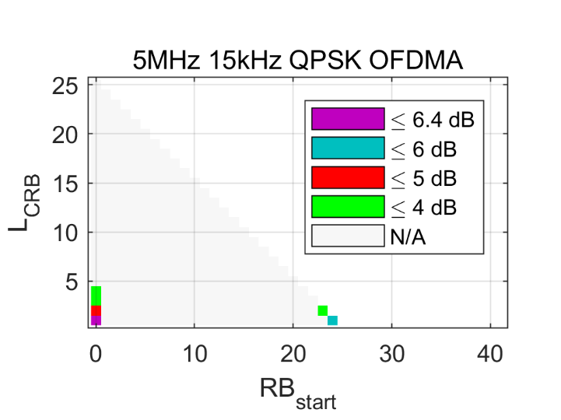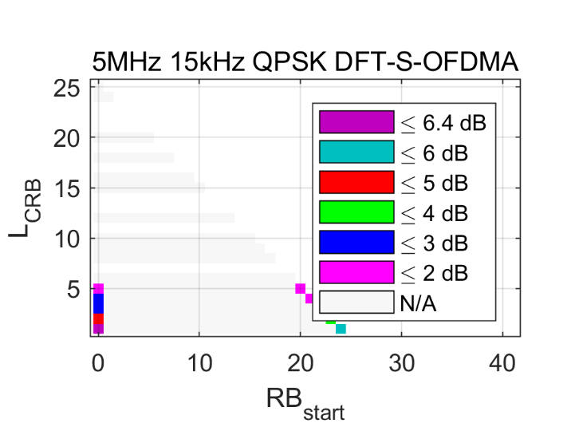

Figure 5.1.2-1. n71 back-off for 5 MHz, 15 kHz

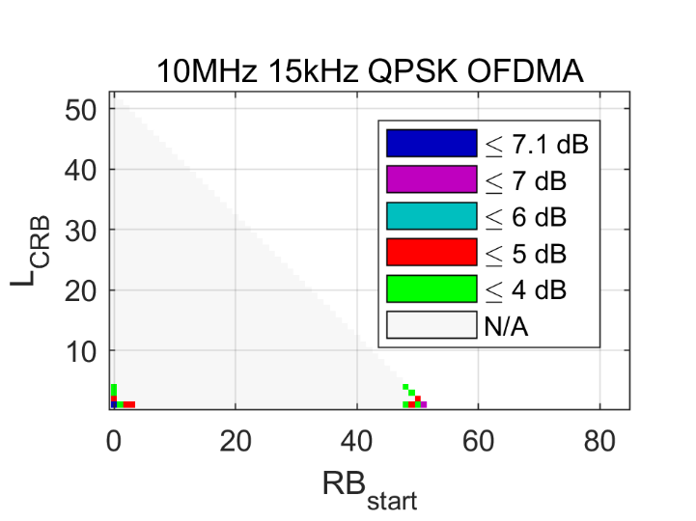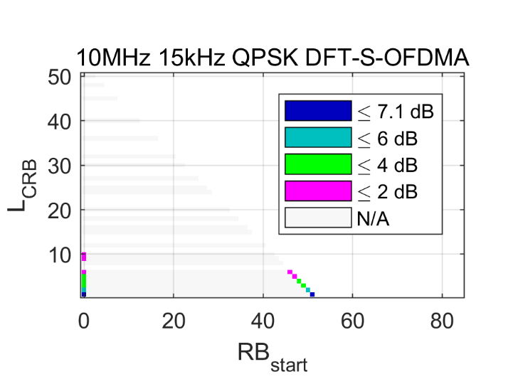

Figure 5.1.2-2. n71 back-off for 10 MHz, 15 kHz

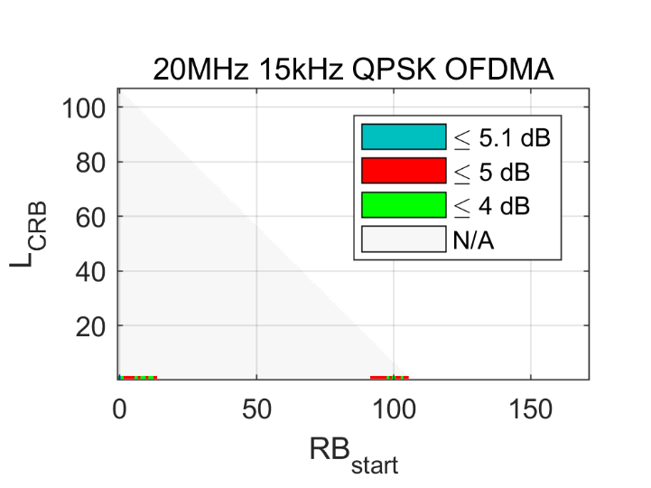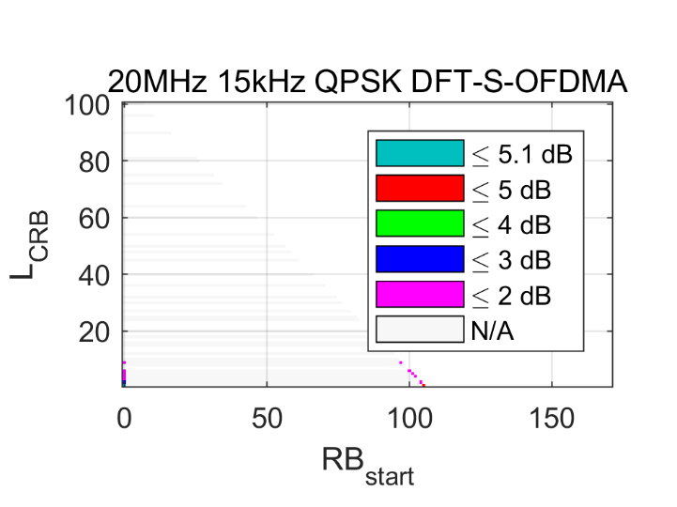

Figure 5.1.2-3. n71 back-off for 20 MHz, 15 kHz

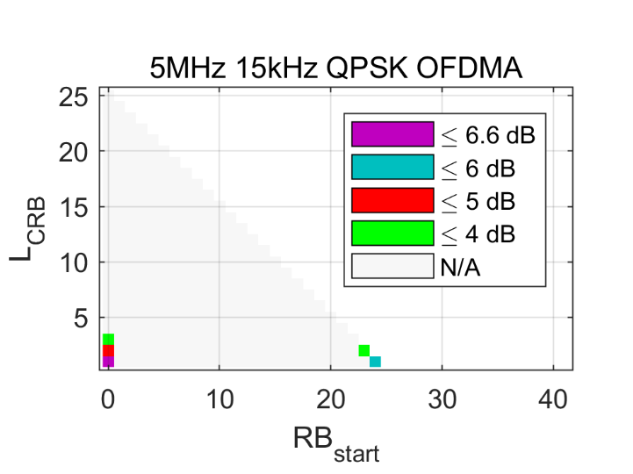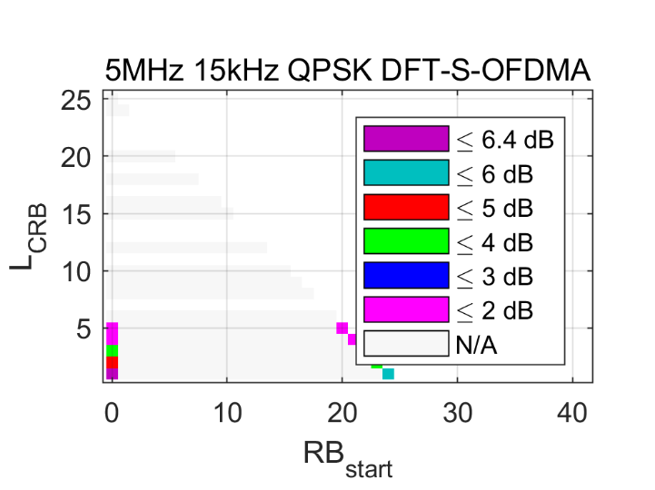

Figure 5.1.2-4. n85 back-off for 5 MHz, 15 kHz

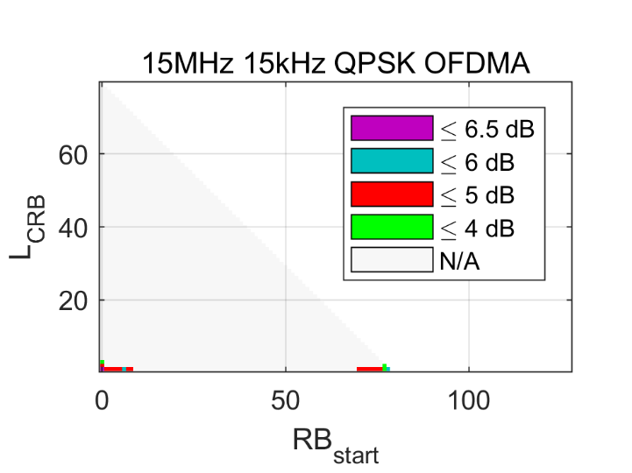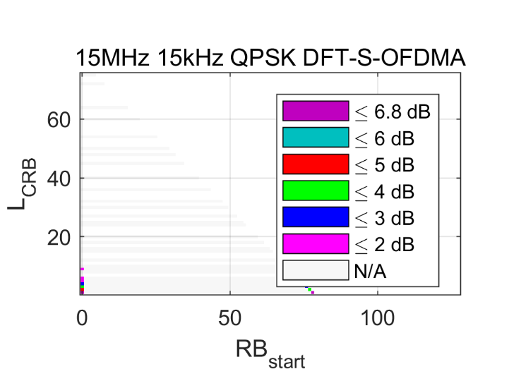

Figure 5.1.2.2-5. n85 back-off for 15 MHz, 15 kHz

In both n71 and n85, the allocations needing A-MPR are confined to narrow allocations close to either channel edge. Figures 5.1.2-6 and 5.1.2-7 depict two different cases. By coincident, both cases require a similar back-off.



Figure 5.1.2-6. Example spectrum: 10 MHz, OFDM, QPSK, 15 kHz, 1RB@0,  
gated by IMD5 hitting the spurious emission limit



Figure 5.1.2-7. Example spectrum: 10 MHz, DFT-S-OFDM, QPSK, 15 kHz, 1RB@0,  
gated by regrowth hitting the innermost SEM segment with 30 kHz MBW

#### 5.1.2.3 A-MPR

**It is agreed to specify the A-MPR for both n71 and n85 as follows:**

**If RB allocation is within Region A, apply the A-MPR given in Table 5.1.2-4. Otherwise, apply the MPR.**

Table 5.1.2-4. PC1 A-MPR for n71 and n85

|  |  |  |
| --- | --- | --- |
| **Waveform** | **Modulation** | **Region A** |
| **DFT-S-OFDM** | **pi/2-BPSK** | **8.5** |
| **QPSK** | **8.5** |
| **16-QAM** | **8.5** |
| **64-QAM** | **8.5** |
| **256-QAM** | **8.5** |
| **OFDM** | **QPSK** | **8.5** |
| **16-QAM** | **8.5** |
| **64-QAM** | **8.5** |
| **256-QAM** | **8.5** |

**An RB allocation is within Region A if  
( LCRB ≤ 0.20 ∙ NRB and ( RBstart = 0 or RBstart + LCRB = NRB ) )  
or  
( LCRB = 1 and 5 ∙ | RBstart + 0.5 – NRB / 2 | ∙ 12 ∙ SCS ≥ 1.5 ∙ CBW + 5 MHz ).**

Above, RBstart and LCRB are the lowest RB index and size of the RB allocation, NRB is the total number of RBs in the channel, and CBW is the channel bandwidth. The colors in the formula are used below when referring to subexpressions. Region A is illustrated in Figure 5.1.2-8.

The first condition covers narrow allocations at channel edge with spectral regrowth hitting the SEM (the vertical / slanted subregions in Figure 8). The second condition covers cases with IMD5 (of the allocation and its image, superpositioned with CIM5) hitting the spurious limit (the horizontal subregions in Figure 5.1.2-8). The expression  
| RBstart + 0.5 – NRB / 2 | ∙ 12 ∙ SCS gives the approximate distance of allocation center from channel center (given that LCRB=1). When multiplied with 5, we obtain the distance of the IMD5 component center from the channel center. The spurious region starts at the distance 1.5 ∙ CBW + 5 MHz from the channel center.The allocation ratio limit of 0.20 is required, e.g., in Figure 1 (DFT-S-OFDM) where the total RB count is NRB = 25 and the greatest allocation size requiring A-MPR is LCRB = 5.



Figure 5.1.2-8. The proposed Region A

#### 5.1.2.4 Edge allocations for PC2 and PC1.5

As previously discussed in WF [3], if PC1 PA are intrinsically more linear than PC2 and PC3 PAs with an ACLR requirement 37dB of versus 31dB and 30dB respectively, FWA and potentially vehicle mounted UEs may still reuse the BB IC and the RF transceiver from a smartphone platform. This means that both TRX carrier, image and CIM3/5 impairments apply but also the BB WOLA filtering will seek the same compromise that is found in smartphone platforms in terms of transient performance and margin to the channel guard-band on the waveform spectrum.

If there are agreed assumptions for carrier, image and CIM3/5 impairments, there is no agreed WOLA filtering. Still, some information is available through the PC2 and PC3 experience.

Edge allocations were first introduced for PC2 MPR for QPSK and higher order modulations. Only later this concept was reused for PC3 in the context of Pi/2 BPSK with power boosting.

If the different MPR tables for PC3, PC2, PC1.5 and PC1 extracted from 38.101-1 [4] and copied at the bottom are compared, and focus for QPSK modulation, it can be found that:

- PC3 does not have edge allocations and outer MPR is 1dB and 3dB for DFT and CP respectively.

- PC2 has edge allocation MPR of minimum 3.5dB across all modulations and outer MPR is 1dB and 3dB for DFT and CP respectively. Edge allocations are allocations within the two edge RBs on each side of the channel.

- For PC1.5 (using FWA case to neglect issues related to reverse IMD) has edge allocation MPR of minimum 6.5dB across all modulations and outer MPR is 2dB and 4dB for DFT and CP respectively. Edge allocations are allocations within the four edge RBs on each side of the channel.

- PC1 MPR does not have edge allocations but if the same transceiver and BB would be assumed than for PC2 and PC1.5, then it would be needed.

It can be observed that while outer MPR is relatively constant across PC3 to PC1.5, edge A-MPR is increased dB/dB with the power class level, it is constant across modulation orders and edge RB region doubles in size every 3dB of PCmax. This means that this is not related to the transmit path linearity, but the consequence of the input spectrum from the BB.

With the above observation and if the same BB WOLA filtering would be assumed, the PC1 MPR should also have an edge allocation type at 8.5dB minimum MPR (2dB above PC1.5) and cover the 7RB at both edge of the channel (4\*10^(2/10) is 6.4 and corresponds to a 2dB increase of the edge region).

Note that this edge allocation MPR is worst for channel bandwidths with lower guard-bands, but when considering A-MPR, one should further check these allocations as some NS have more stringent requirements in the OOB first 1MHz, either in terms of level or measurement bandwidth.

**Therefore, it is agreed on edge allocations:**

- If PC1 MPR needs to be representative of implementations using BB and RF transceivers from smartphone platforms, it should consider the addition of an edge allocation type with a minimum MPR of 8.5dB and an edge region of seven RBs.

- It may be feasible to agree a slightly better value of 8dB or add signaling for the UE to declare the need for this additional allocation type.

- Edge allocations with similar WOLA performance than evaluated for PC2 should be carefully checked for NS where the requirement in the first OOB MHz is more stringent or use smaller measurement bandwidth than NR SEM.; especially for channel bandwidths with small guard-bands.

Table 6.2.2-1 Maximum power reduction (MPR) for power class 3

|  |  |  |  |  |
| --- | --- | --- | --- | --- |
| Modulation | | MPR (dB) | | |
|  | | Edge RB allocations | Outer RB allocations | Inner RB allocations |
| DFT-s-OFDM | Pi/2 BPSK | ≤ 3.51 | ≤ 1.21 | ≤ 0.21 |
|  |  | ≤ 0.52 | ≤ 0.52 | 02 |
|  | Pi/2 BPSK w Pi/2 BPSK DMRS | ≤ 0.52 | 02 | 02 |
|  | QPSK | ≤ 1 | | 0 |
|  | 16 QAM | ≤ 2 | | ≤ 1 |
|  | 64 QAM | ≤ 2.5 | | |
|  | 256 QAM | ≤ 4.5 | | |
| CP-OFDM | QPSK | ≤ 3 | | ≤ 1.5 |
|  | 16 QAM | ≤ 3 | | ≤ 2 |
|  | 64 QAM | ≤ 3.5 | | |
|  | 256 QAM | ≤ 6.5 | | |
| NOTE 1: Applicable for UE operating in TDD mode with Pi/2 BPSK modulation and UE indicates support for UE capability *powerBoosting-pi2BPSK* and if the IE *powerBoostPi2BPSK* is set to 1 and 40 % or less slots in radio frame are used for UL transmission for bands n40, n41, n77, n78 and n79. The reference power of 0 dB MPR is 26 dBm.  NOTE 2: Applicable for UE operating in FDD mode, or in TDD mode in bands other than n40, n41, n77, n78 and n79 with Pi/2 BPSK modulation and if the IE *powerBoostPi2BPSK* is set to 0 and if more than 40 % of slots in radio frame are used for UL transmission for bands n40, n41, n77, n78 and n79. | | | | |

Table 6.2.2-2 Maximum power reduction (MPR) for power class 2

|  |  |  |  |  |
| --- | --- | --- | --- | --- |
| Modulation | | MPR (dB) | | |
|  | | Edge RB allocations | Outer RB allocations | Inner RB allocations |
| DFT-s-OFDM | Pi/2 BPSK | ≤ 3.5 | ≤ 0.5 | 0 |
|  | QPSK | ≤ 3.5 | ≤ 1 | 0 |
|  | 16 QAM | ≤ 3.5 | ≤ 2 | ≤ 1 |
|  | 64 QAM | ≤ 3.5 | ≤ 2.5 | |
|  | 256 QAM | ≤ 4.5 | | |
| CP-OFDM | QPSK | ≤ 3.5 | ≤ 3 | ≤ 1.5 |
|  | 16 QAM | ≤ 3.5 | ≤ 3 | ≤ 2 |
|  | 64 QAM | ≤ 3.5 | | |
|  | 256 QAM | ≤ 6.5 | | |

Table 6.2D.2-3 Maximum power reduction (MPR) for power class 1.5 with dual Tx

|  |  |  |  |  |
| --- | --- | --- | --- | --- |
| Modulation | | MPR (dB) | | |
|  | | Edge RB allocations | Outer RB allocations | Inner RB allocations |
| DFT-s-OFDM | Pi/2 BPSK | ≤ 6 | ≤ 1.5 | ≤ 0 |
|  | QPSK | ≤ 6.5 | ≤ 2 | ≤ 0 |
|  | 16 QAM | ≤ 6.5 | ≤ 3 | ≤ 1 |
|  | 64 QAM | ≤ 6.5 | ≤ 3.5 | ≤ 3 |
|  | 256 QAM | ≤ 6.5 | ≤ 5.5 | ≤ 5.5 |
| CP-OFDM | QPSK | ≤ 6.5 | ≤ 4 | ≤ 1.5 |
|  | 16 QAM | ≤ 6.5 | ≤ 4 | ≤ 2 |
|  | 64 QAM | ≤ 6.5 | ≤ 4.5 | ≤ 4 |
|  | 256 QAM | ≤ 7.5 | ≤ 7.5 | ≤ 7.5 |
| NOTE 1: This table is targeted to large FWA form factor with 20 dB or above antenna isolation. | | | | |

Table 6.2.2-5 Maximum power reduction (MPR) for power class 1

|  |  |  |  |  |
| --- | --- | --- | --- | --- |
| Modulation | | MPR (dB) | | |
|  | | Edge RB allocations | Outer RB allocations | Inner RB allocations |
| DFT-s-OFDM | Pi/2 BPSK | ≤ 0.5 | ≤ 0.5 | 0 |
|  | Pi/2 BPSK w Pi/2 BPSK DMRS | ≤ 0.5 | 0 | 0 |
|  | QPSK | ≤ 1 | | 0 |
|  | 16 QAM | ≤ 2 | | ≤ 1 |
|  | 64 QAM | ≤ 2.5 | | |
|  | 256 QAM | ≤ 4.5 | | |
| CP-OFDM | QPSK | ≤ 3 | | ≤ 1.5 |
|  | 16 QAM | ≤ 3 | | ≤ 2 |
|  | 64 QAM | ≤ 3.5 | | |
|  | 256 QAM | ≤ 6.5 | | |

#### 5.1.2.5 MPR Simulation results

Figure 5.1.2-9 shows the simulated power back-off for SEM-limited RB allocations at or close to channel edge, due to linear spectral regrowth caused by the windowing effect. Each marker represents a combination of CBW / waveform / modulation; its value is the maximum back-off among all combinations of SCS / RB allocation. Included are only parameter combinations that exceed the respective MPR of the given RB allocation.

Figure 5.1.2-9 shows a clear dependence between the back-off and CBW.



**Figure 5.1.2-9: Simulated back-off and allowed MPR**

For the SEM-limited RB allocations, the back-off is determined primarily by two factors:

- The emission limit in the first SEM segment at channel edge: The SEM limit is -13 dBm below 50 MHz CBW and -24 dBm from 50 MHz upwards (from Table 6.5.2.2-1 in TS 38.101-1 [4]). This can be seen as a sudden rise of back-off at 50 MHz CBW.

- The guard-to-SCS ratio, i.e, the ratio of minimum guard band width (from TS 38.101-1, Table 5.3.3-1) to the SCS: On the frequency axis, the linear spectral regrowth due to windowing scales with the SCS. The smaller the guard-to-SCS ratio, the higher emission and thus the higher required power back-off. Below 50 MHz CBW, the guard-to-SCS ratio mostly increases with increasing CBW, resulting in decreasing needed back-off. From 50 MHz upwards, the guard-to-SCS ratio mostly decreases with increasing CBW, resulting in increasing needed back-off.

From the simulation data, the allowed MPR can be defined as described in clause 5.1.2.6. This will avoid allowing MPR that is more than necessary. For example, adopting a proposal to define the allowed MPR with a common value for all CBW <50 MHz and a common value for all CBW ≥50 MHz will result in a 2dB power back-off more than necessary for 45 MHz and 50 MHz CBW which, in turn, would lead to 2dB UL coverage loss. This is illustrated as green lines in Figure 5.1.2-9.

The Edge RB allocations are narrow allocations at or close to channel edge, so that their linear spectral regrowth reaches beyond the channel edge and its PSD is sufficient to violate the SEM. The required maximum RB allocation size of Edge RB allcoations is illustrated in Figure 5.1.2-10.



**Figure 5.1.2-10: Maximum allocation size of Edge RB allocations as function of channel bandwidth**

From the simulation data, the set of Edge RB allocations can be specified separately for all CBW <50 MHz and for all CBW ≥50 MHz as described in clause 5.1.2.6.

#### 5.1.2.6 MPR

**It is agreed to specify the FR1 PC1 MPR for all operating bands as follows, except for band n14 MPR which is keep as it is:**

**Specify the MPR for Edge RB allocations as follows:**

**For PC1 UE supporting other bands than n14 the MPR for Edge RB allocation is defined as follows for two distinguished channel bandwidths groups as:**

**Within the <50MHz channel bandwidth group:**

$$MPR= CEIL(7.2 dB- 6 dB∙ \frac{CBW}{100 MHz}, 0.5 dB)$$

**Within the ≥50MHz channel bandwidth group:**

$$MPR= CEIL\left(5.35 dB+3.15 dB∙ \frac{CBW}{100 MHz}, 0.5 dB\right)$$

**where CEIL(*x*,0.5 dB) means rounding *x* upwards to the closest multiple of 0.5 dB.**

**Specify the set of Edge RB allocations as follows:**

**For PC1 UE supporting other bands than n14 RB allocation is an Edge RB allocation if**

$L_{CRB}≤L_{CRB,edge}$**AND ( ${RB}_{start}≤{RB}_{start,edge}$ OR ${RB}_{start}≥{N_{RB}-RB}_{start,edge}-L_{CRB}$),**

**where**

$$L_{CRB,edge}=\left\{\begin{matrix}6, CBW<50 MHz \\ 12, CBW≥50 MHz.\end{matrix}\right.$$

**For $CBW≥70 MHz$ with DFT-S-OFDM waveform and pi/2-BPSK, QPSK, or 16-QAM modulation, ${RB}_{start,edge}=1.$ Otherwise, ${RB}_{start,edge}=0.$**

### 5.1.3 Feasibility of the filter

### 5.1.4 Feasibility of the PA

### 5.1.5 Other

## 5.2 Bands n100 and n101

### 5.2.1 REFSENS exception

Not needed.

### 5.2.2 A-MPR and MPR

General MPR can be used and no A-MPR is necessary are there are not additional regional requirements which are more stringent than current 3GPP requirements.

### 5.2.3 ECC requirements

From ECC Decision (20)02 Harmonised use of the paired frequency bands 874.4-880.0 MHz and 919.4-925.0 MHz and of the unpaired frequency band 1900-1910 MHz for Railway Mobile Radio (RMR) [2] we can find relevant requirements for UE in Annex 2.2 for n100 and 3.2 for n101, see below.

**A 2.2 Technical conditions for RMR cab-radio using wideband technologies**

For radio access technologies other than GSM-R, the following parameters apply:

- Maximum output power: higher than 23 dBm and up to 31 dBm;

- ACLR[[1]](#footnote-2): 37 dB minimum;

- Uplink power control is mandatory and shall be activated.

**A 3.2 Technical conditions for RMR cab-radio using wideband technologies**

The following parameters apply:

- Maximum output power: 31 dBm;

- ACLR: 37 dB minimum;

- Unwanted output power in 1920-1980 MHz:

- -25 dBm/MHz maximum in 1920-1925 MHz;

- -30 dBm/MHz maximum in 1925-1980 MHz;

- Uplink power control is mandatory and shall be activated.

#### 5.2.3.1 n100 compliance

ECC Decision (20)02 mentions two technical conditions for RMR-HPUE- radio using wideband technologies and those are

- Maximum output power: higher than 23 dBm and up to 31 dBm

- ACLR : 37 dB minimum

which both are aligned with 3GPP specification therefore no additional requirements are needed for 3GPP specifications for PC1 operation on bands n100 and n101.

#### 5.2.3.2 n101 compliance

ECC Decision (20)02 mentions four technical conditions for RMR-HPUE - radio using wideband technologies and those are

- Maximum output power: 31 dBm;

- ACLR: 37 dB minimum;

- Unwanted output power in 1920-1980 MHz:

- -25 dBm/MHz maximum in 1920-1925 MHz;

- -30 dBm/MHz maximum in 1925-1980 MHz;

- Uplink power control is mandatory and shall be activated.

Maximum output power, ACLR and power control are all aligned with 3GPP specifications inherently but unwanted output power in 1920-1980 MHz needs some investigation.

In Figure 1 we compare ECC Decision (20)02 Unwanted output power in 1920-1980 MHz requirement to 3GPP general emission mask and can observe that bot 5 MHz and 10 MHz channel bandwidth 3GPP general emission mask inherently guarantees compliance to ECC Decision (20)02 requirement therefore no additional 3GPP requirements are needed for PC1 operation on bands n100 and n101.



Figure 5.25.1.3.2-1: comparison of ECC Decision (20)02 Unwanted output power requirement to 3GPP general emission mask

## 5.3 Band 12

*Editor note: All sub-clauses are not necessary for all bands.*

### 5.3.1 REFSENS exception

### 5.3.2 A-MPR and MPR

#### 5.3.2.1 A-MPR Simulation assumptions

The simulation assumptions are as follows:

- PC1 PA linearity is assumed (37dB ACLR for DFT-s-OFDM QPSK 20MHz 100RB0 waveform with 1dB MPR).

- Normal TRX impairments are assumed: 28dB carrier and image leakage, 60dB CIM3 and 70dB CIM5.

- BB filtering is assumed.

- At least QPSK DFT-s-OFDM full and edge allocations are evaluated for 1.4, 3, 5 and 10MHz CBW.

- Other CBW and allocations are not precluded.

Other assumptions:

- Channel bandwidths and subcarrier spacings according to TS 36.101-1 [4], Table 5.6.1-1:

Table 5.3.2-1: E-UTRA channel bandwidth

|  |  |  |  |  |  |  |
| --- | --- | --- | --- | --- | --- | --- |
| E-UTRA band / Channel bandwidth | | | | | | |
| E-UTRA Band | 1.4 MHz | 3 MHz | 5 MHz | 10 MHz | 15 MHz | 20 MHz |
| 12 | Yes | Yes | Yes | Yes |  |  |

- DFT-S-OFDM waveforms.

- All modulations: QPSK, 16-QAM, 64-QAM, 256-QAM.

- BB filtering.

- SEM for Band 12 (NS\_06) according to TS 36.101-1 [4], Table 6.6.2.2.3-1:

Table 5.3.2-2: Additional requirements

|  |  |  |  |  |  |
| --- | --- | --- | --- | --- | --- |
|  | Spectrum emission limit (dBm)/ Channel bandwidth | | | | |
| ΔfOOB  (MHz) | 1.4  MHz | 3.0  MHz | 5  MHz | 10  MHz | Measurement bandwidth |
| ± 0-0.1 | -13 | -13 | -15 | -18 | 30 kHz |
| ± 0.1-1 | -13 | -13 | -13 | -13 | 100 kHz |
| ± 1-2.5 | -13 | -13 | -13 | -13 | 1 MHz |
| ± 2.5-2.8 | -25 | -13 | -13 | -13 | 1 MHz |
| ± 2.8-5 |  | -13 | -13 | -13 | 1 MHz |
| ± 5-6 |  | -25 | -13 | -13 | 1 MHz |
| ± 6-10 |  |  | -25 | -13 | 1 MHz |
| ± 10-15 |  |  |  | -25 | 1 MHz |

* General requirements as specified in TS 36.101 [5].

#### 5.3.2.2 A-MPR Simulation results

All valid channel bandwidth / SCS combinations for Band 12, for DFT-s-OFDM, all modulations, all contiguous RB allocations have been simulated. The results are shown in Figures 5.3.2-1 to 5.3.2-4, which present the required total back-off (MPR + A-MPR) for allocations where MPR alone is insufficient.

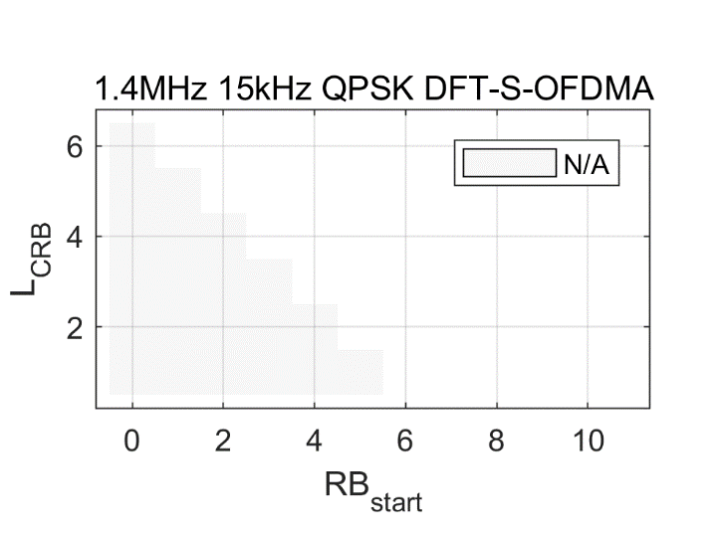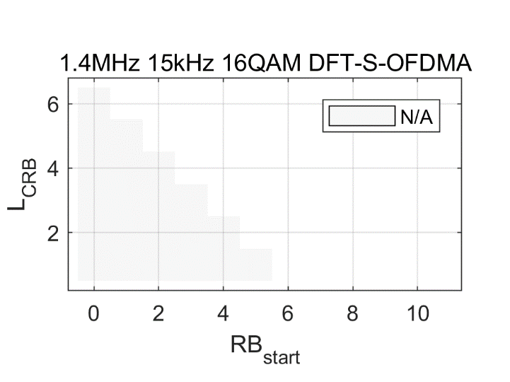

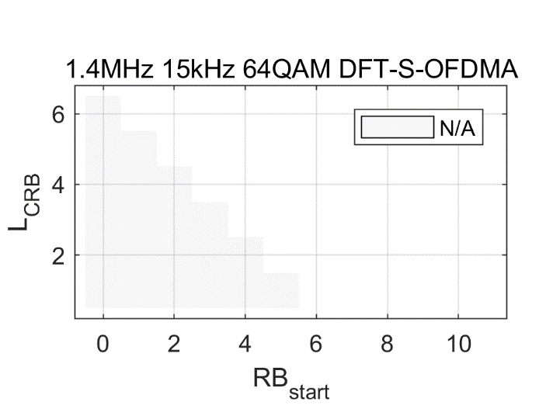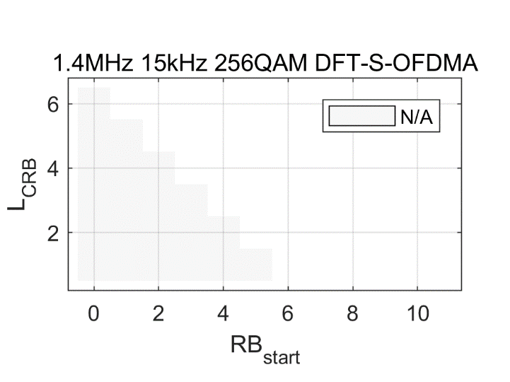

**Figure 5.3.2-1. Band 12 back-off for 1.4 MHz (shown only where exceeds the MPR)**

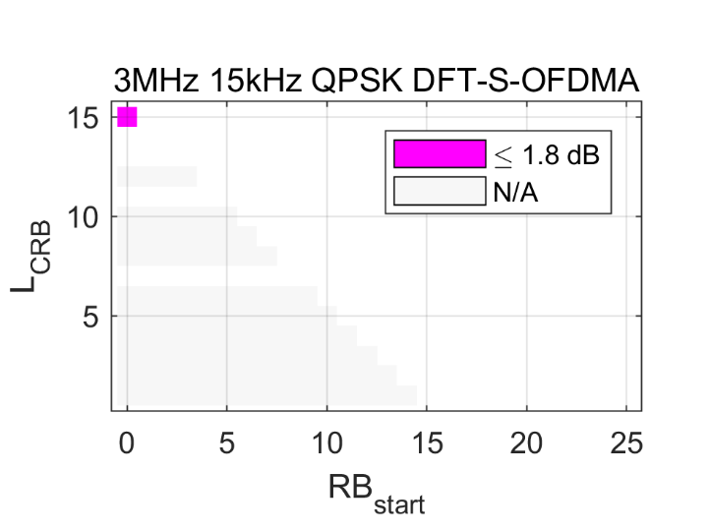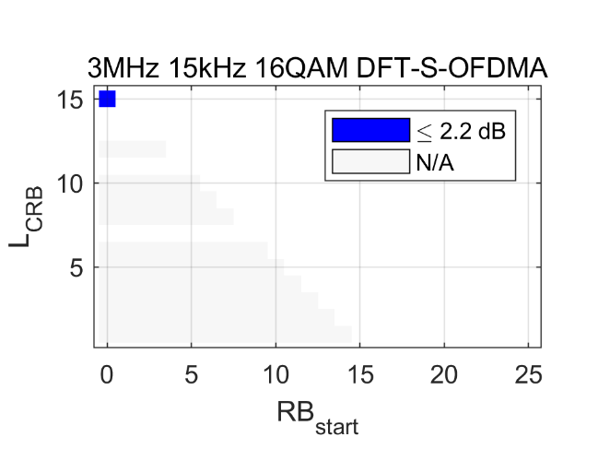

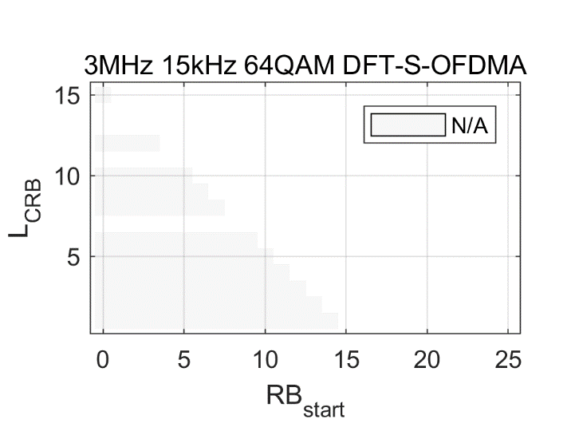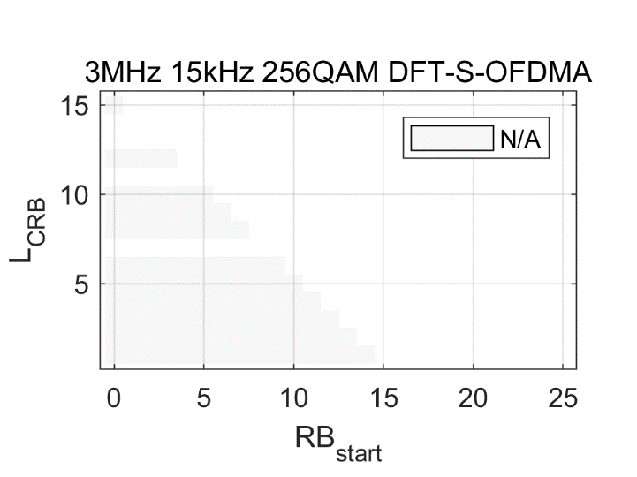

**Figure 5.3.2-2. Band 12 back-off for 3 MHz (shown only where exceeds the MPR)**

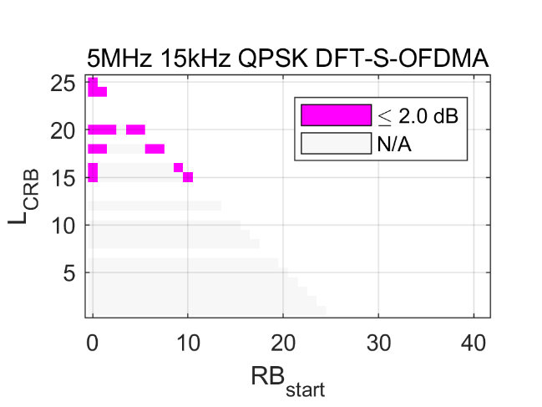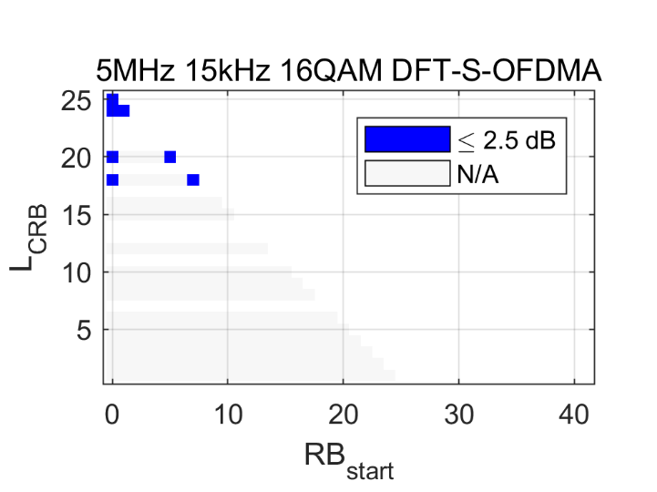

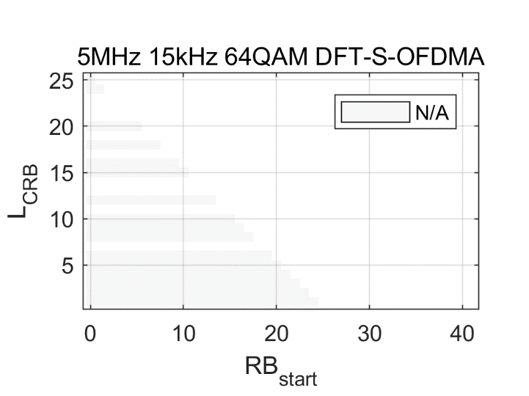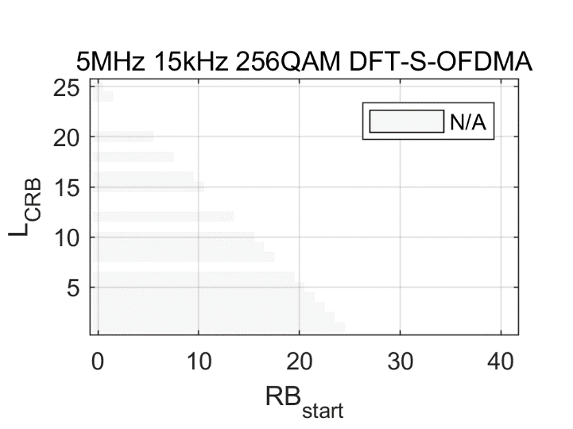

**Figure 5.3.2-3. Band 12 back-off for 5 MHz (shown only where exceeds the MPR)**

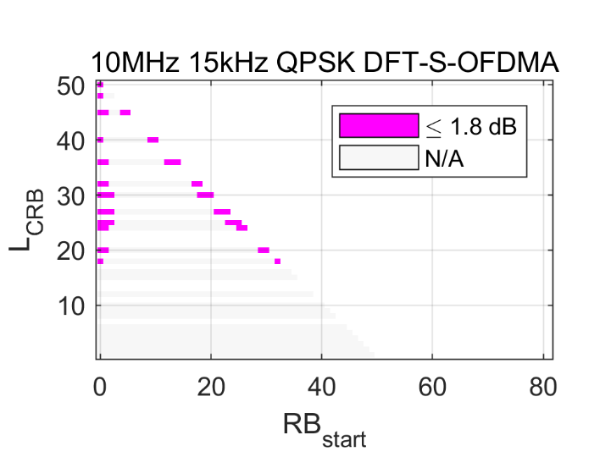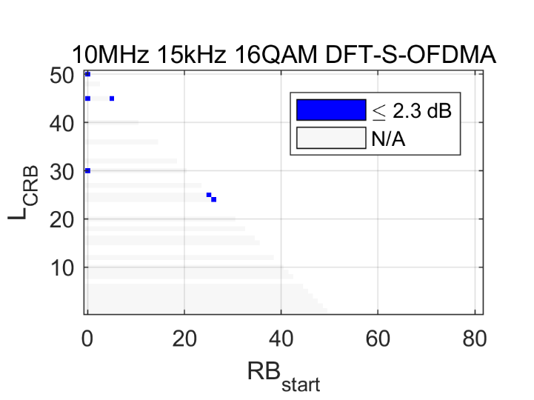

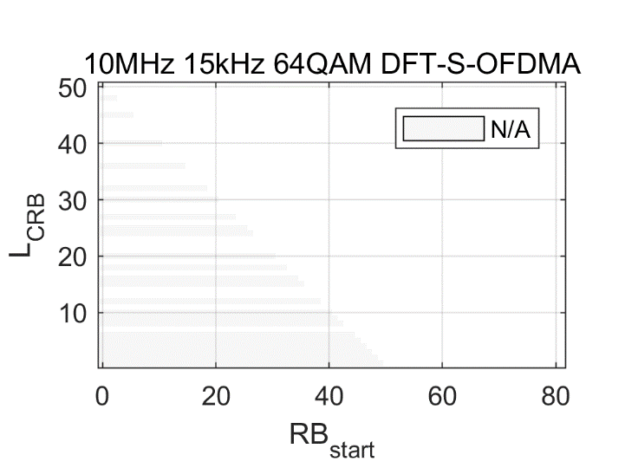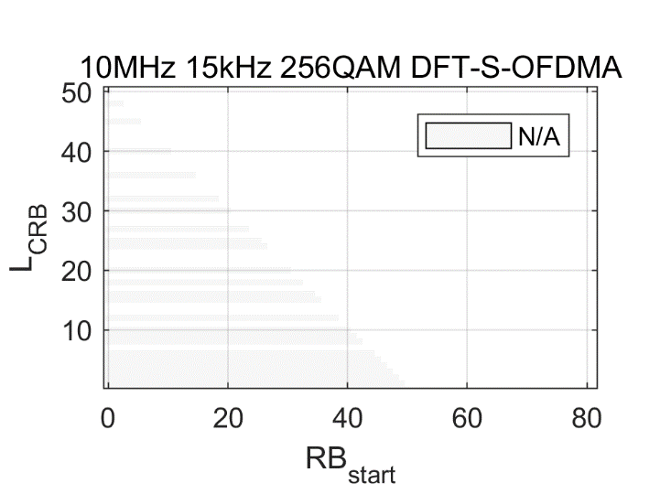

**Figure 5.3.2-4. Band 12 back-off for 10 MHz (shown only where exceeds the MPR)**

#### 5.3.2.3 A-MPR

It is agreed to specify the A-MPR for Band 12 as follows:

**Table 5.3.2-3: A-MPR for "NS\_06" for Power Class 1 UE**

|  |  |  |  |  |  |  |
| --- | --- | --- | --- | --- | --- | --- |
| **Channel bandwidth [MHz]** | **LCRB** | **Allocation positions** | **Modulation / A-MPR [dB]** | | | |
| **QPSK** | **16-QAM** | **64-QAM** | **256-QAM** |
| 1.4 | all | all | 0 | 0 | 0 | 0 |
| 3 | = 15 | RBstart = 0 | 1 | 0.5 | 0 | 0 |
| 5 | ≥ 15 | RBstart ≤ 2 or RBstart + LCRB ≥ 23 | 1 | 0.5 | 0 | 0 |
| 10 | ≥ 18 | RBstart ≤ 2 or RBstart + LCRB ≥ 48 | 1 | 0.5 | 0 | 0 |

### 5.3.3 Feasibility of the filter

### 5.3.4 Feasibility of the PA

### 5.3.5 Other

Annex A:  
Coexistence studies for 31 dBm UE Power Class for LTE Band 41 and NR Band n41

## A.1 Simulation assumptions

#### A.1.1 Macro cell Propagation model

##### A.1.1.1 Macro cell Propagation model – Urban and Suburban Areas

The propagation model is a derived from TR 36.942 [3].

Considering a carrier frequency of 2.6 GHz and a base station antenna height of 15 m above average rooftop level, the propagation model is given by the following equation:

$L=\text{130.5}+\text{37.6lo}{\text{g}}_{\text{10}}(R)$

where:

R is the base station-UE separation in kilometres

##### A.1.1.2 Macro cell Propagation model – Rural Area

The propagation model is a derived from TR 36.942.

For rural area, the Hata model is not applicable for a carrier frequency of 2.6 GHz, while the modified Hata model can be used:

*Case 1*: *d* ≤ 0.6 km

$L = 100.7 + 10 \log{(}d^{2} + 0.00189225)$*Case 2*: *d*  0.6 km

$L = 103.9 + 34.1 \log{(}d)$ where: d is the base station-UE separation in kilometres

#### A.1.2 Power Control Simulation Parameters

Table A.1.2-1 CLx-ile parameters for +23 dBm UE

(a) CLx-ile parameters for +23 dBm UE using 0.75 km inter-site distance and 2.6 GHz carrier frequency

|  |  |  |  |
| --- | --- | --- | --- |
| Parameter set | Gamma | CLx-ile | |
| 20 MHz bandwidth | 10 MHz bandwidth |
| Set 1 | 1 | 109 | 112 |
| Set 1’ | 1 | 117 | 120 |
| Set 2 | 0,8 | 133 | 137 |

(b) CLx-ile parameters for +23 dBm UE using 2.8 km inter-site distance and 2.6 GHz carrier frequency

|  |  |  |  |
| --- | --- | --- | --- |
| Parameter set | Gamma | CLx-ile | |
| 20 MHz bandwidth | 10 MHz bandwidth |
| Set 1 | 1 | 133 | 136 |
| Set 2 | 0,8 | 149 | 153 |

(c) CLx-ile parameters for +23 dBm UE using 6 km inter-site distance and 2.6 GHz carrier frequency

|  |  |  |  |
| --- | --- | --- | --- |
| Parameter set | Gamma | CLx-ile | |
| 20 MHz bandwidth | 10 MHz bandwidth |
| Set 1 | 1 | 117 | 120 |
| Set 2 | 0,8 | 132 | 136 |

(d) CLx-ile parameters for +23 dBm UE using 8 km inter-site distance and 2.6 GHz carrier frequency

|  |  |  |  |
| --- | --- | --- | --- |
| Parameter set | Gamma | CLx-ile | |
| 20 MHz bandwidth | 10 MHz bandwidth |
| Set 1 | 1 | 122 | 124 |
| Set 2 | 0,8 | 136 | 140 |

Table A.1.2-2 CLx-ile power control algorithm parameters for +31 dBm UE

(a) CLx-ile power control algorithm parameters for +31 dBm UE using 0.75 km inter-site distance and 2.6 GHz carrier frequency

|  |  |  |  |
| --- | --- | --- | --- |
| Parameter set | Gamma | CLx-ile | |
| 20 MHz bandwidth | 10 MHz bandwidth |
| Set 1 | 1 | 117 | 120 |
| Set 1’ | 1 | 125 | 128 |
| Set 2 | 0,8 | 143 | 147 |

(b) CLx-ile power control algorithm parameters for +31 dBm UE using 2.8 km inter-site distance and 2.6 GHz carrier frequency

|  |  |  |  |
| --- | --- | --- | --- |
| Parameter set | Gamma | Modified CLx-ile | |
| 20 MHz bandwidth | 10 MHz bandwidth |
| Set 1 | 1 | 141 | 144 |
| Set 2 | 0,8 | 159 | 163 |

(c)CLx-ile power control algorithm parameters for +31 dBm UE using 6 km inter-site distance and 2.6 GHz carrier frequency

|  |  |  |  |
| --- | --- | --- | --- |
| Parameter set | Gamma | Modified CLx-ile | |
| 20 MHz bandwidth | 10 MHz bandwidth |
| Set 1 | 1 | 125 | 128 |
| Set 2 | 0,8 | 142 | 146 |

(d) CLx-ile power control algorithm parameters for +31 dBm UE using 8 km inter-site distance and 2.6 GHz carrier frequency

|  |  |  |  |
| --- | --- | --- | --- |
| Parameter set | Gamma | Modified CLx-ile | |
| 20 MHz bandwidth | 10 MHz bandwidth |
| Set 1 | 1 | 130 | 132 |
| Set 2 | 0,8 | 146 | 150 |

#### A.1.3 Cell Layout

Base stations with 3 sectors per site are placed on a hexagonal grid with distance of 3\*R, where R is the cell radius (see Figure A.1.3-1), with wrap around. The number of sites shall be equal to or higher than 19. Uncoordinated macro cellular deployment is assumed, where interfering UE may be at cell edge of the serving base station but close to the victim base station (hence transmitting with highest power and causing highest interference).

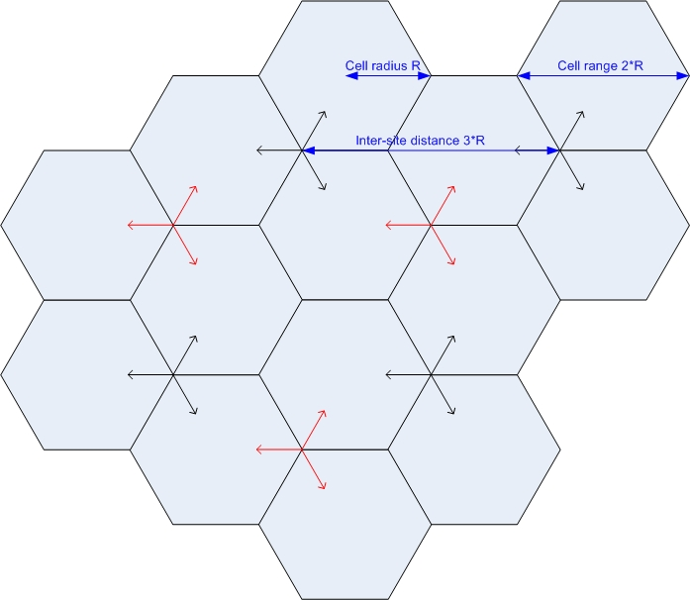

Figure A.1.3-1: Uncoordinated macro cellular deployment

The inter-site distances considered in the present document are provided in Table A.1.3-1 below.

Table A.1.3-1: Inter-site distances and Propagation model

|  |  |  |
| --- | --- | --- |
| Environment | ISD (km) | ISD (miles) |
| Urban | .75 | .47 |
| Suburban | 2.8 | 1.74 |
| Rural | 6 | 3.73 |
| Rural | 8 | 5 |

#### A.1.4 Other Simulation Assumptions

Other simulation assumptions are summarized in Table A.1.4-1 below:

Table A.1.4-1: Simulation parameters for Band 41 system

(a) With 23 dBm UE

|  |  |  |
| --- | --- | --- |
|  | Base Station | UE |
| Carrier frequency | 2600 MHz | |
| Channel bandwidth | 20 MHz, 10 MHz | |
| Inter-site distance | Use Table A.1.3-1 | |
| Cell layout | Wrap-around 19 tri-sector cells, uncoordinated | |
| Frequency reuse | 1x3x1 | |
| Lognormal fading | 10 dB | |
| Shadowing correlation | Between cells: 0.5, between sites: 1.0 | |
| MCL (including antenna gain) | 70 dB (urban and suburban areas)  80 dB (rural area) | |
| Antenna gain and horizontal antenna pattern | 17 dBi, = 65 degrees,  *Am* = 20 dB | Omni-directional antenna with -3.5 dBi. |
| Noise figure | 5 dB | 9 dB |
| Transmit power | 46 dBm | 23 dBm |
| Antenna height | 45 m | 1.5 m |
| ACLR | 45 dB | Use Table 5.2 in TR 36.942  ACLR1: 30+X, ACLR2: 43+X  Where X is 1 dB |
| ACS | 45 dB | 27 dB (20 MHz), 33 dB (10 MHz) |

(b) With 31 dBm UE

|  |  |  |
| --- | --- | --- |
|  | Base Station | HPUE |
| Carrier frequency | 2600 MHz | |
| Channel bandwidth | 20 MHz, 10 MHz | |
| Inter-site distance | Use Table A.1.3-1 | |
| Cell layout | Wrap-around 19 tri-sector cells, uncoordinated | |
| Frequency reuse | 1x3x1 | |
| Lognormal fading | 10 dB | |
| Shadowing correlation | Between cells: 0.5, between sites: 1.0 | |
| MCL (including antenna gain) | 70 dB (urban and suburban areas)  80 dB (rural area) | |
| Antenna gain and horizontal antenna pattern | 17 dBi, = 65 degrees, *Am* = 20 dB | Omni-directional antenna with -3.5 dBi. |
| Noise figure | 5 dB | 9 dB |
| Transmit power | 46 dBm | 31 dBm |
| Antenna height | 45 m | 1.5 m |
| ACLR | 45 dB | Use Table 5.2 in TR 36.942  ACLR1: 30+X, ACLR2: 43+X  Where X is 1 dB |
| ACS | 45 dB | 27 dB (20 MHz), 33 dB (10 MHz) |

Simulations should assume the worst case of 100 % HPUEs in the scenarios with HPUEs.

#### A.1.5 Simulation Procedure

For the co-existence study, the following procedure shall be performed:

1) Run the Band 41 UL to UL coexistence study, assuming parameters of both systems are according Table A.1.4-1 (a). Power control parameters in Table A.1.2-1 are used. This corresponds to the coexistence of two commercial networks operating in adjacent channel and with similar deployment parameters. This is used as the reference. Band 41 victim system performance degradation results in this scenario are used as the baseline. Provide a CDF plot of UE transmit power.

2) Run the Band 41 UL to UL coexistence study, assuming +31 dBm power class UE is deployed in Band 41 interfering system only, and obtain the victim system performance degradation results. The simulation parameters in Tables A.1.4-1 (a) and A.1.4-1 (b) are used for the victim and interfering system, respectively. And the power control parameters in Tables A.1.2-1 and A.1.2-2 are used for the victim and interfering system, respectively. Provide a CDF plot of UE transmit power.

3) Compare the Band 41 victim system performance degradation obtaining in steps 1) and 2), choose the 31 dBm UE ACLR value so that the victim system performance degradation due to 31 dBm UE in 2) is the same as 1).

## A.2 Simulation results

#### A.2.1 0.75 km inter-site distance

The CDFs of the UE transmit power as well as the victim system UL throughput loss Vs ACLR offset (with different power control parameter sets) for 0.75 km inter-site distance with 20 MHz channel bandwidth are shown in Figure A.2.1-1 below.

****

****

|  |  |  |
| --- | --- | --- |
| ACLR offset X [dB] | 0 | 7 |
| Average throughput loss (23 dBm interfering UE) | 2.99% |  |
| 5%-tile throughput loss (23 dBm interfering UE) | 3.02% |  |
| Average throughput loss (31 dBm interfering UE) | 3.35% | 1.68% |
| 5%-tile throughput loss (31 dBm interfering UE) | 4.30% | 1.48% |

**(a) With Power Control Parameter Set 1**

****

|  |  |  |
| --- | --- | --- |
| ACLR offset X [dB] | 0 | 7 |
| Average throughput loss (23 dBm interfering UE) | 2.66% |  |
| 5%-tile throughput loss (23 dBm interfering UE) | 3.21% |  |
| Average throughput loss (31 dBm interfering UE) | 2.70% | 1.31% |
| 5%-tile throughput loss (31 dBm interfering UE) | 3.25% | 1.27% |

**(b) With Power Control Parameter Set 1’**

****

|  |  |
| --- | --- |
| ACLR offset X [dB] | 0 |
| Average throughput loss (23 dBm interfering UE) | 1.07% |
| 5%-tile throughput loss (23 dBm interfering UE) | 1.49% |
| Average throughput loss (31 dBm interfering UE) | 1.07% |
| 5%-tile throughput loss (31 dBm interfering UE) | 1.49% |

**(c) With Power Control Parameter Set 2**

**Figure A.2.1-1: For 0.75 km inter-site distance** **with 20 MHz channel bandwidth**

It can be seen from the CDFs of the UE transmit power in Figure A.2.1-1 that the CDFs of the 23 dBm UE and the 31 dBm UE are identical until the UE reach their maximum output power. This is expected as the CLx-ile is adjusted according to the UE maximum output power. Comparing the CDFs of the UE transmit power with Set 1 and Set 1’, it can be seen that more (~10% of 23 dBm UE and ~1.5% of 31 dBm UE) of the UE population transmitted with their maximum output power with the more aggressive Set 1.

Moreover, it can be seen from the victim system UL throughput loss Vs ACLR offset results in Figure A.2.1-1 that with the more aggressive Set 1, the 37 dB ACLR of the 31 dBm UE (currently specified for power class 1 UE) will ensure that the victim system performance degradation due to 31 dBm interfering UE is not larger than that due to 23 dBm interfering UE.

#### A.2.2 2.8 km inter-site distance

The CDFs of the UE transmit power as well as the victim system UL throughput loss Vs ACLR offset (with different power control parameter sets) for 2.8 km inter-site distance with 20 MHz channel bandwidth are shown in Figure A.2.2-1 below.

** **

|  |  |  |
| --- | --- | --- |
| ACLR offset X [dB] | 0 | 7 |
| Average throughput loss (23 dBm interfering UE) | 1.35% |  |
| 5%-tile throughput loss (23 dBm interfering UE) | 12.21% |  |
| Average throughput loss (31 dBm interfering UE) | 1.43% | 0.83% |
| 5%-tile throughput loss (31 dBm interfering UE) | 13.03% | 6.81% |

**(a) With Power Control Parameter Set 1**

****

|  |  |
| --- | --- |
| ACLR offset X [dB] | 0 |
| Average throughput loss (23 dBm interfering UE) | 0.31% |
| 5%-tile throughput loss (23 dBm interfering UE) | 0.53% |
| Average throughput loss (31 dBm interfering UE) | 0.31% |
| 5%-tile throughput loss (31 dBm interfering UE) | 0.53% |

**(b) With Power Control Parameter Set 2**

**Figure A.2.2-1: For 2.8 km inter-site distance** **with 20 MHz channel bandwidth**

Similar observations can be made from the results in Figure A.2.2-1, namely that the CDFs of the 23 dBm UE and the 31 dBm UE are identical until the UE reach their maximum output power, more (~6% of 23 dBm UE and ~1% of 31 dBm UE) of the UE population transmitted with their maximum output power with the more aggressive Set 1, and the 37 dB ACLR of the 31 dBm UE (currently specified for power class 1 UE) will ensure that the victim system performance degradation due to 31 dBm interfering UE is not larger than that due to 23 dBm interfering UE.

#### A.2.3 6 km inter-site distance

The CDFs of the UE transmit power as well as the victim system UL throughput loss Vs ACLR offset (with different power control parameter sets) for 6 km inter-site distance with 20 MHz channel bandwidth are shown in Figure A.2.3-1 below.

****

****

|  |  |  |
| --- | --- | --- |
| ACLR offset X [dB] | 0 | 7 |
| Average throughput loss (23 dBm interfering UE) | 1.12% |  |
| 5%-tile throughput loss (23 dBm interfering UE) | 0.80% |  |
| Average throughput loss (31 dBm interfering UE) | 1.24% | 0.52% |
| 5%-tile throughput loss (31 dBm interfering UE) | 1.16% | 0.30% |

**(a) With Power Control Parameter Set 1**

****

|  |  |
| --- | --- |
| ACLR offset X [dB] | 0 |
| Average throughput loss (23 dBm interfering UE) | 0.42% |
| 5%-tile throughput loss (23 dBm interfering UE) | 0.62% |
| Average throughput loss (31 dBm interfering UE) | 0.42% |
| 5%-tile throughput loss (31 dBm interfering UE) | 0.62% |

**(b) With Power Control Parameter Set 2**

**Figure A.2.3-1: For 6 km inter-site distance** **with 20 MHz channel bandwidth**

Similar observations can be made from the results in Figure A.2.3-1, namely that the CDFs of the 23 dBm UE and the 31 dBm UE are identical until the UE reach their maximum output power, more (~6% of 23 dBm UE and ~1% of 31 dBm UE) of the UE population transmitted with their maximum output power with the more aggressive Set 1, and the 37 dB ACLR of the 31 dBm UE (currently specified for power class 1 UE) will ensure that the victim system performance degradation due to 31 dBm interfering UE is not larger than that due to 23 dBm interfering UE.

#### A.2.4 8 km inter-site distance

The CDFs of the UE transmit power as well as the victim system UL throughput loss Vs ACLR offset (with different power control parameter sets) for 8 km inter-site distance with 20 MHz channel bandwidth are shown in Figure A.2.4-1 below.

** **

|  |  |  |
| --- | --- | --- |
| ACLR offset X [dB] | 0 | 7 |
| Average throughput loss (23 dBm interfering UE) | 1.21% |  |
| 5%-tile throughput loss (23 dBm interfering UE) | 1.29% |  |
| Average throughput loss (31 dBm interfering UE) | 1.32% | 0.58% |
| 5%-tile throughput loss (31 dBm interfering UE) | 1.55% | 0.56% |

**(a) With Power Control Parameter Set 1**

****

|  |  |
| --- | --- |
| ACLR offset X [dB] | 0 |
| Average throughput loss (23 dBm interfering UE) | 0.37% |
| 5%-tile throughput loss (23 dBm interfering UE) | 0.49% |
| Average throughput loss (31 dBm interfering UE) | 0.37% |
| 5%-tile throughput loss (31 dBm interfering UE) | 0.49% |

**(b) With Power Control Parameter Set 2**

**Figure A.2.4: For 8 km inter-site distance** **with 20 MHz channel bandwidth**

Similar observations can be made from the results in Figure A.2.4-1, namely that the CDFs of the 23 dBm UE and the 31 dBm UE are identical until the UE reach their maximum output power, more (~5% of 23 dBm UE and ~1% of 31 dBm UE) of the UE population transmitted with their maximum output power with the more aggressive Set 1, and the 37 dB ACLR of the 31 dBm UE (currently specified for power class 1 UE) will ensure that the victim system performance degradation due to 31 dBm interfering UE is not larger than that due to 23 dBm interfering UE.

#### A.2.5 BS received signal power

The 99.99%-tile of the victim BS received signal power for the simulated 31 dBm UE cases with 20 MHz channel bandwidth are summarized in Table A.2.5-1 below. It can be seen that the 99.99%-tile received signal power in all simulated cases, except with the more aggressive Set 1 for 0.75 km inter-site distance, are lower than the current -43 dBm in-band blocking requirements specified in RAN4 specifications for wide-area BS. In the exception case, site engineering solutions (e.g., larger distance between victim BS and interfering FWA UE, better RF filtering in the victim BS receiver chain) will be required to ensure satisfactory coexistence between the victim BS and interfering 31 dBm UE.

**Table A.2.5-1: 99.99%-tile victim BS received signal power with 20 MHz channel bandwidth**

|  |  |  |  |  |
| --- | --- | --- | --- | --- |
| Power control parameters | 0.75 km inter-site distance | 2.8 km inter-site distance | 6 km inter-site distance | 8 km inter-site distance |
| Set 1 | -38.9983 | -47.0811 | -49.2813 | -50.0217 |
| Set 1’ | -43.7443 |  |  |  |
| Set 2 | -57.1937 | -60.0083 | -62.8238 | -62.6169 |

Annex B:

Coexistence studies for 31 dBm UE Power Class for NR Band n77

## B.1 Simulation assumptions

#### B.1.1 Macro cell Propagation model

##### B.1.1.1 Macro cell Propagation model - Urban and Suburban Areas

The propagation model is a derived from TR 36.942 [2].

Considering a carrier frequency of 3.5 GHz and a base station antenna height of 15 m above average rooftop level, the propagation model is given by the following equation:

$L=\text{133.2}+\text{37.6lo}{\text{g}}_{\text{10}}(R)$

where:

R is the base station-UE separation in kilometres

##### B.1.1.2 Macro cell Propagation model - Rural Area

The propagation model is a derived from TR 36.942.

For rural area, the Hata model is not applicable for a carrier frequency of 3.5 GHz, while the modified Hata model can be used:

*Case 1*: *d* ≤ 0.7 km

$$L = 103.3 + 10 \log{(}d^{2} + 0.00189225)$$

*Case 2*: *d*  0.7 km

$$L = 105.2 + 34.1 \log{(}d)$$

where: d is the base station-UE separation in kilometres

#### B.1.2 Power Control Simulation Parameters

Table B.1.2-1 CLx-ile parameters for +23 dBm UE

(a) CLx-ile parameters for +23 dBm UE using 0.5 km inter-site distance and 3.5 GHz carrier frequency

|  |  |  |  |
| --- | --- | --- | --- |
| Parameter set | Gamma | CLx-ile | |
| 20 MHz bandwidth | 10 MHz bandwidth |
| Set 1 | 1 | 109 | 112 |
| Set 1' | 1 | 108 | 111 |
| Set 2 | 0,8 | 124 | 128 |

(b) CLx-ile parameters for +23 dBm UE using 1 km inter-site distance and 3.5 GHz carrier frequency

|  |  |  |  |
| --- | --- | --- | --- |
| Parameter set | Gamma | CLx-ile | |
| 20 MHz bandwidth | 10 MHz bandwidth |
| Set 1 | 1 | 119 | 122 |
| Set 2 | 0,8 | 135 | 139 |

(c) CLx-ile parameters for +23 dBm UE using 2 km inter-site distance and 3.5 GHz carrier frequency

|  |  |  |  |
| --- | --- | --- | --- |
| Parameter set | Gamma | CLx-ile | |
| 20 MHz bandwidth | 10 MHz bandwidth |
| Set 1 | 1 | 130 | 133 |
| Set 2 | 0,8 | 146 | 150 |

(d) CLx-ile parameters for +23 dBm UE using 5 km inter-site distance and 3.5 GHz carrier frequency

|  |  |  |  |
| --- | --- | --- | --- |
| Parameter set | Gamma | CLx-ile | |
| 20 MHz bandwidth | 10 MHz bandwidth |
| Set 1 | 1 | 116 | 119 |
| Set 2 | 0,8 | 130 | 134 |

Table B.1.2-2 CLx-ile power control algorithm parameters for +31 dBm UE

(a) CLx-ile parameters for +31 dBm UE using 0.5 km inter-site distance and 3.5 GHz carrier frequency

|  |  |  |  |
| --- | --- | --- | --- |
| Parameter set | Gamma | CLx-ile | |
| 20 MHz bandwidth | 10 MHz bandwidth |
| Set 1 | 1 | 117 | 120 |
| Set 1' | 1 | 116 | 119 |
| Set 2 | 0,8 | 134 | 138 |

(b) CLx-ile parameters for +31 dBm UE using 1 km inter-site distance and 3.5 GHz carrier frequency

|  |  |  |  |
| --- | --- | --- | --- |
| Parameter set | Gamma | CLx-ile | |
| 20 MHz bandwidth | 10 MHz bandwidth |
| Set 1 | 1 | 127 | 130 |
| Set 2 | 0,8 | 145 | 149 |

(c) CLx-ile parameters for +31 dBm UE using 2 km inter-site distance and 3.5 GHz carrier frequency

|  |  |  |  |
| --- | --- | --- | --- |
| Parameter set | Gamma | CLx-ile | |
| 20 MHz bandwidth | 10 MHz bandwidth |
| Set 1 | 1 | 138 | 141 |
| Set 2 | 0,8 | 156 | 160 |

(d) CLx-ile parameters for +31 dBm UE using 5 km inter-site distance and 3.5 GHz carrier frequency

|  |  |  |  |
| --- | --- | --- | --- |
| Parameter set | Gamma | CLx-ile | |
| 20 MHz bandwidth | 10 MHz bandwidth |
| Set 1 | 1 | 124 | 127 |
| Set 2 | 0,8 | 140 | 144 |

#### B.1.3 Cell Layout

Base stations with 3 sectors per site are placed on a hexagonal grid with distance of 3\*R, where R is the cell radius (see Figure B.1.3-1), with wrap around. The number of sites shall be equal to or higher than 19. Uncoordinated macro cellular deployment is assumed, where interfering UE may be at cell edge of the serving base station but close to the victim base station (hence transmitting with highest power and causing highest interference).



Figure B.1.3-1: Uncoordinated macro cellular deployment

The inter-site distances considered in the present document are provided in Table B.1.3-1 below.

Table B.1.3-1: Inter-site distances and Propagation model

|  |  |  |
| --- | --- | --- |
| Environment | ISD (km) | ISD (miles) |
| Urban | .5 | .31 |
| Suburban | 1 | .62 |
| Rural | 2 | 1.24 |
| Rural | 5 | 3.11 |

#### B.1.4 Other Simulation Assumptions

Other simulation assumptions are summarized in Table B.1.4-1 below:

Table B.1.4-1: Simulation parameters for Band 77 system

(a) With 23 dBm UE

|  |  |  |
| --- | --- | --- |
|  | Base Station | UE |
| Carrier frequency | 3500 MHz | |
| Channel bandwidth | 20 MHz, 10 MHz | |
| Inter-site distance | Use Table B.1.3-1 | |
| Cell layout | Wrap-around 19 tri-sector cells, uncoordinated | |
| Frequency reuse | 1x3x1 | |
| Lognormal fading | 10 dB | |
| Shadowing correlation | Between cells: 0.5, between sites: 1.0 | |
| MCL (including antenna gain) | 70 dB (urban and suburban areas)  80 dB (rural area) | |
| Antenna gain and horizontal antenna pattern | 17 dBi, = 65 degrees,  *Am* = 20 dB | Omni-directional antenna with -3.5 dBi. |
| Noise figure | 5 dB | 9 dB |
| Transmit power | 46 dBm | 23 dBm |
| Antenna height | 45 m | 1.5 m |
| ACLR | 45 dB | Use Table 5.2 in TR 36.942  ACLR1: 30+X, ACLR2: 43+X  Where X is 1 dB |
| ACS | 45 dB | 27 dB (20 MHz), 33 dB (10 MHz) |

(b) With 31 dBm UE

|  |  |  |
| --- | --- | --- |
|  | Base Station | HPUE |
| Carrier frequency | 3500 MHz | |
| Channel bandwidth | 20 MHz, 10 MHz | |
| Inter-site distance | Use Table B.1.3-1 | |
| Cell layout | Wrap-around 19 tri-sector cells, uncoordinated | |
| Frequency reuse | 1x3x1 | |
| Lognormal fading | 10 dB | |
| Shadowing correlation | Between cells: 0.5, between sites: 1.0 | |
| MCL (including antenna gain) | 70 dB (urban and suburban areas)  80 dB (rural area) | |
| Antenna gain and horizontal antenna pattern | 17 dBi, = 65 degrees, *Am* = 20 dB | Omni-directional antenna with -3.5 dBi. |
| Noise figure | 5 dB | 9 dB |
| Transmit power | 46 dBm | 31 dBm |
| Antenna height | 45 m | 1.5 m |
| ACLR | 45 dB | Use Table 5.2 in TR 36.942  ACLR1: 30+X, ACLR2: 43+X  Where X is 1 dB |
| ACS | 45 dB | 27 dB (20 MHz), 33 dB (10 MHz) |

Simulations should assume the worst case of 100 % HPUEs in the scenarios with HPUEs.

#### B.1.5 Simulation Procedure

For the co-existence study, the following procedure shall be performed:

1) Run the Band 77 UL to UL coexistence study, assuming parameters of both systems are according Table B.1.4-1 (a). Power control parameters in Table B.1.2-1 are used. This corresponds to the coexistence of two commercial networks operating in adjacent channel and with similar deployment parameters. This is used as the reference. Band 77 victim system performance degradation results in this scenario are used as the baseline. Provide a CDF plot of UE transmit power.

2) Run the Band 77 UL to UL coexistence study, assuming +31 dBm power class UE is deployed in Band 77 interfering system only, and obtain the victim system performance degradation results. The simulation parameters in Tables B.1.4-1 (a) and B.1.4-1 (b) are used for the victim and interfering system, respectively. And the power control parameters in Tables B.1.2-1 and B.1.2-2 are used for the victim and interfering system, respectively. Provide a CDF plot of UE transmit power.

3) Compare the Band 77 victim system performance degradation obtaining in steps 1) and 2), choose the 31 dBm UE ACLR value so that the victim system performance degradation due to 31 dBm UE in 2) is the same as 1).

## B.2 Simulation results

#### B.2.1 0.5 km inter-site distance

The CDFs of the UE transmit power as well as the victim system UL throughput loss Vs ACLR offset (with different power control parameter sets) for 0.5 km inter-site distance are shown in Figure B.2.1-1 below.

****

****

|  |  |  |
| --- | --- | --- |
| ACLR offset X [dB] | 0 | 7 |
| Average throughput loss (23 dBm interfering UE) | 2.34% |  |
| 5%-tile throughput loss (23 dBm interfering UE) | 2.26% |  |
| Average throughput loss (31 dBm interfering UE) | 2.48% | 1.15% |
| 5%-tile throughput loss (31 dBm interfering UE) | 2.45% | 0.58% |

**(a) With Power Control Parameter Set 1**

****

|  |  |  |
| --- | --- | --- |
| ACLR offset X [dB] | 0 | 7 |
| Average throughput loss (23 dBm interfering UE) | 2.33% |  |
| 5%-tile throughput loss (23 dBm interfering UE) | 2.55% |  |
| Average throughput loss (31 dBm interfering UE) | 2.52% | 1.17% |
| 5%-tile throughput loss (31 dBm interfering UE) | 2.84% | 0.69% |

**(b) With Power Control Parameter Set 1’**

****

|  |  |
| --- | --- |
| ACLR offset X [dB] | 0 |
| Average throughput loss (23 dBm interfering UE) | 1.44% |
| 5%-tile throughput loss (23 dBm interfering UE) | 1.78% |
| Average throughput loss (31 dBm interfering UE) | 1.44% |
| 5%-tile throughput loss (31 dBm interfering UE) | 1.78% |

**(c) With Power Control Parameter Set 2**

**Figure B.2.1-1: For 0.5 km inter-site distance**

It can be seen from the CDFs of the UE transmit power in Figure B.2.1-1 that the CDFs of the 23 dBm UE and the 31 dBm UE are identical until the UE reach their maximum output power. This is expected as the CLx-ile is adjusted according to the UE maximum output power. Comparing the CDFs of the UE transmit power with Set 1/1’ and Set 2, it can be seen that more (~5% of 23 dBm UE and ~0.5% of 31 dBm UE) of the UE population transmitted with their maximum output power with the more aggressive Set 1/1’.

Moreover, it can be seen from the victim system UL throughput loss Vs ACLR offset results in Figure B.2.1-1 that with the more aggressive Set 1/1’, the 37 dB ACLR of the 31 dBm UE (currently specified for power class 1 UE) will ensure that the victim system performance degradation due to 31 dBm interfering UE is not larger than that due to 23 dBm interfering UE.

#### B.2.2 1 km inter-site distance

The CDFs of the UE transmit power as well as the victim system UL throughput loss Vs ACLR offset (with different power control parameter sets) for 1 km inter-site distance are shown in Figure B.2.2-1 below.

** **

|  |  |  |
| --- | --- | --- |
| ACLR offset X [dB] | 0 | 7 |
| Average throughput loss (23 dBm interfering UE) | 3.22% |  |
| 5%-tile throughput loss (23 dBm interfering UE) | 6.23% |  |
| Average throughput loss (31 dBm interfering UE) | 3.39% | 1.81% |
| 5%-tile throughput loss (31 dBm interfering UE) | 6.73% | 2.69% |

**(a) With Power Control Parameter Set 1**

****

|  |  |
| --- | --- |
| ACLR offset X [dB] | 0 |
| Average throughput loss (23 dBm interfering UE) | 1.19% |
| 5%-tile throughput loss (23 dBm interfering UE) | 2.16% |
| Average throughput loss (31 dBm interfering UE) | 1.19% |
| 5%-tile throughput loss (31 dBm interfering UE) | 2.16% |

**(b) With Power Control Parameter Set 2**

**Figure B.2.2-1: For 1 km inter-site distance**

Similar observations can be made from the results in Figure B.2.2-1, namely that the CDFs of the 23 dBm UE and the 31 dBm UE are identical until the UE reach their maximum output power, more (~6% of 23 dBm UE and ~1% of 31 dBm UE) of the UE population transmitted with their maximum output power with the more aggressive Set 1, and the 37 dB ACLR of the 31 dBm UE (currently specified for power class 1 UE) will ensure that the victim system performance degradation due to 31 dBm interfering UE is not larger than that due to 23 dBm interfering UE.

#### B.2.3 2 km inter-site distance

The CDFs of the UE transmit power as well as the victim system UL throughput loss Vs ACLR offset (with different power control parameter sets) for 2 km inter-site distance are shown in Figure B.2.3-1 below.

****

****

|  |  |  |
| --- | --- | --- |
| ACLR offset X [dB] | 0 | 1 |
| Average throughput loss (23 dBm interfering UE) | 1.76% |  |
| 5%-tile throughput loss (23 dBm interfering UE) | 11.09% |  |
| Average throughput loss (31 dBm interfering UE) | 1.87% | 1.08% |
| 5%-tile throughput loss (31 dBm interfering UE) | 11.93% | 6.14% |

**(a) With Power Control Parameter Set 1**

****

|  |  |
| --- | --- |
| ACLR offset X [dB] | 0 |
| Average throughput loss (23 dBm interfering UE) | 0.42% |
| 5%-tile throughput loss (23 dBm interfering UE) | 0.80% |
| Average throughput loss (31 dBm interfering UE) | 0.42% |
| 5%-tile throughput loss (31 dBm interfering UE) | 0.62% |

**(b) With Power Control Parameter Set 2**

**Figure B.2.3-1: For 2 km inter-site distance**

Similar observations can be made from the results in Figure B.2.3-1, namely that the CDFs of the 23 dBm UE and the 31 dBm UE are identical until the UE reach their maximum output power, more (~6% of 23 dBm UE and ~1% of 31 dBm UE) of the UE population transmitted with their maximum output power with the more aggressive Set 1, and the 37 dB ACLR of the 31 dBm UE (currently specified for power class 1 UE) will ensure that the victim system performance degradation due to 31 dBm interfering UE is not larger than that due to 23 dBm interfering UE.

#### B.2.4 5 km inter-site distance

The CDFs of the UE transmit power as well as the victim system UL throughput loss Vs ACLR offset (with different power control parameter sets) for 5 km inter-site distance are shown in Figure B.2.4-1 below.

** **

|  |  |  |
| --- | --- | --- |
| ACLR offset X [dB] | 0 | 1 |
| Average throughput loss (23 dBm interfering UE) | 1.06% |  |
| 5%-tile throughput loss (23 dBm interfering UE) | 0.77% |  |
| Average throughput loss (31 dBm interfering UE) | 1.16% | 0.48% |
| 5%-tile throughput loss (31 dBm interfering UE) | 0.97% | 0.22% |

**(a) With Power Control Parameter Set 1**

****

|  |  |
| --- | --- |
| ACLR offset X [dB] | 0 |
| Average throughput loss (23 dBm interfering UE) | 0.47% |
| 5%-tile throughput loss (23 dBm interfering UE) | 0.57% |
| Average throughput loss (31 dBm interfering UE) | 0.47% |
| 5%-tile throughput loss (31 dBm interfering UE) | 0.57% |

**(b) With Power Control Parameter Set 2**

**Figure B.2.4-1: For 5 km inter-site distance**

Similar observations can be made from the results in Figure B.2.4-1, namely that the CDFs of the 23 dBm UE and the 31 dBm UE are identical until the UE reach their maximum output power, more (~5.5% of 23 dBm UE and ~0.5% of 31 dBm UE) of the UE population transmitted with their maximum output power with the more aggressive Set 1, and the 37 dB ACLR of the 31 dBm UE (currently specified for power class 1 UE) will ensure that the victim system performance degradation due to 31 dBm interfering UE is not larger than that due to 23 dBm interfering UE.

#### B.2.5 BS received signal power

The 99.99%-tile of the victim BS received signal power for the simulated 31 dBm UE cases are summarized in Table B.2.5-1 below. It can be seen that the 99.99%-tile received signal power in all simulated cases, except with the more aggressive Set 1/1’ for 0.5/1 km inter-site distance, are lower than the current -43 dBm in-band blocking requirements specified in RAN4 specifications for wide-area BS. In the exception cases, site engineering solutions (e.g., larger distance between victim BS and interfering FWA UE, better RF filtering in the victim BS receiver chain) will be required to ensure satisfactory coexistence between the victim BS and interfering 31 dBm UE.

**Table B.2.5-1: 99.99%-tile victim BS received signal power**

|  |  |  |  |  |
| --- | --- | --- | --- | --- |
| Power control parameters | 0.5 km inter-site distance | 1 km inter-site distance | 2 km inter-site distance | 5 km inter-site distance |
| Set 1 | -42.7383 | -39.0000 | -46.1582 | -49.6809 |
| Set 1’ | -41.7383 |  |  |  |
| Set 2 | -55.4697 | -52.8777 | -62.8238 | -62.3430 |

Annex C:

Coexistence studies for 31 dBm UE Power Class for NR Band n25

# C.1 Simulation assumptions

#### C.1.1 Macro cell Propagation model

##### C.1.1.1 Macro cell Propagation model - Urban and Suburban Areas

The propagation model is a derived from TR 36.942 [2].

Considering a carrier frequency of 1.9 GHz and a base station antenna height of 15 m above average rooftop level, the propagation model is given by the following equation:

$L=\text{127.7}+\text{37.6lo}{\text{g}}_{\text{10}}(R)$

where:

R is the base station-UE separation in kilometres

##### C.1.1.2 Macro cell Propagation model - Rural Area

The propagation model is a derived from TR 36.942.

For rural area, the Hata model is not applicable for a carrier frequency above 1.5 GHz, while the modified Hata model can be used:

*Case 1*: *d* ≤ 0.45 km

$$L = 98.0 + 10 \log{(}d^{2} + 0.00189225)$$

*Case 2*: *d*  0.45 km

$$L = 102.9 + 34.1 \log{(}d)$$

where: d is the base station-UE separation in kilometres

#### C.1.2 Power Control Simulation Parameters

Table C.1.2-1 CLx-ile parameters for +23 dBm UE

(a) CLx-ile parameters for +23 dBm UE using 2 km inter-site distance and 1.9 GHz carrier frequency

|  |  |  |  |
| --- | --- | --- | --- |
| Parameter set | Gamma | CLx-ile | |
| 20 MHz bandwidth | 10 MHz bandwidth |
| Set 1 | 1 | 125 | 128 |
| Set 2 | 0,8 | 141 | 145 |

(b) CLx-ile parameters for +23 dBm UE using 5.1 km inter-site distance and 1.9 GHz carrier frequency

|  |  |  |  |
| --- | --- | --- | --- |
| Parameter set | Gamma | CLx-ile | |
| 20 MHz bandwidth | 10 MHz bandwidth |
| Set 1 | 1 | 140 | 143 |
| Set 2 | 0,8 | 156 | 160 |

(c) CLx-ile parameters for +23 dBm UE using 9.3 km inter-site distance and 1.9 GHz carrier frequency

|  |  |  |  |
| --- | --- | --- | --- |
| Parameter set | Gamma | CLx-ile | |
| 20 MHz bandwidth | 10 MHz bandwidth |
| Set 1 | 1 | 123 | 126 |
| Set 2 | 0,8 | 137 | 141 |

Table C.1.2-2 CLx-ile power control algorithm parameters for +31 dBm UE

(a) CLx-ile parameters for +31 dBm UE using 2 km inter-site distance and 1.9 GHz carrier frequency

|  |  |  |  |
| --- | --- | --- | --- |
| Parameter set | Gamma | CLx-ile | |
| 20 MHz bandwidth | 10 MHz bandwidth |
| Set 1 | 1 | 133 | 136 |
| Set 2 | 0,8 | 151 | 155 |

(b) CLx-ile parameters for +31 dBm UE using 5.1 km inter-site distance and 1.9 GHz carrier frequency

|  |  |  |  |
| --- | --- | --- | --- |
| Parameter set | Gamma | CLx-ile | |
| 20 MHz bandwidth | 10 MHz bandwidth |
| Set 1 | 1 | 148 | 151 |
| Set 2 | 0,8 | 166 | 170 |

(c) CLx-ile parameters for +31 dBm UE using 9.3 km inter-site distance and 1.9 GHz carrier frequency

|  |  |  |  |
| --- | --- | --- | --- |
| Parameter set | Gamma | CLx-ile | |
| 20 MHz bandwidth | 10 MHz bandwidth |
| Set 1 | 1 | 131 | 134 |
| Set 2 | 0,8 | 147 | 151 |

#### C.1.3 Cell Layout

Base stations with 3 sectors per site are placed on a hexagonal grid with distance of 3\*R, where R is the cell radius (see Figure C.1.3-1), with wrap around. The number of sites shall be equal to or higher than 19. Uncoordinated macro cellular deployment is assumed, where interfering UE may be at cell edge of the serving base station but close to the victim base station (hence transmitting with highest power and causing highest interference).



Figure C.1.3-1: Uncoordinated macro cellular deployment

The inter-site distances considered in the present document are provided in Table C.1.3-1 below.

Table C.1.3-1: Inter-site distances and Propagation model

|  |  |  |
| --- | --- | --- |
| Environment | ISD (km) | ISD (miles) |
| Urban | 2 | 1.24 |
| Suburban | 5.1 | 3.17 |
| Rural | 9.3 | 5.78 |

#### C.1.4 Other Simulation Assumptions

Other simulation assumptions are summarized in Table C.1.4-1 below:

Table C.1.4-1: Simulation parameters for Band 25 system

(a) With 23 dBm UE

|  |  |  |
| --- | --- | --- |
|  | Base Station | UE |
| Carrier frequency | 1900 MHz | |
| Channel bandwidth | 20 MHz, 10 MHz | |
| Inter-site distance | Use Table C.1.3-1 | |
| Cell layout | Wrap-around 19 tri-sector cells, uncoordinated | |
| Frequency reuse | 1x3x1 | |
| Lognormal fading | 10 dB | |
| Shadowing correlation | Between cells: 0.5, between sites: 1.0 | |
| MCL (including antenna gain) | 70 dB (urban and suburban areas)  80 dB (rural area) | |
| Antenna gain and horizontal antenna pattern | 17 dBi, = 65 degrees,  *Am* = 20 dB | Omni-directional antenna with -3.5 dBi. |
| Noise figure | 5 dB | 9 dB |
| Transmit power | 46 dBm | 23 dBm |
| Antenna height | 45 m | 1.5 m |
| ACLR | 45 dB | Use Table 5.2 in TR 36.942  ACLR1: 30+X, ACLR2: 43+X  Where X is 1 dB |
| ACS | 45 dB | 27 dB (20 MHz), 33 dB (10 MHz) |

(b) With 31 dBm UE

|  |  |  |
| --- | --- | --- |
|  | Base Station | HPUE |
| Carrier frequency | 1900 MHz | |
| Channel bandwidth | 20 MHz, 10 MHz | |
| Inter-site distance | Use Table C.1.3-1 | |
| Cell layout | Wrap-around 19 tri-sector cells, uncoordinated | |
| Frequency reuse | 1x3x1 | |
| Lognormal fading | 10 dB | |
| Shadowing correlation | Between cells: 0.5, between sites: 1.0 | |
| MCL (including antenna gain) | 70 dB (urban and suburban areas)  80 dB (rural area) | |
| Antenna gain and horizontal antenna pattern | 17 dBi, = 65 degrees, *Am* = 20 dB | Omni-directional antenna with -3.5 dBi. |
| Noise figure | 5 dB | 9 dB |
| Transmit power | 46 dBm | 31 dBm |
| Antenna height | 45 m | 1.5 m |
| ACLR | 45 dB | Use Table 5.2 in TR 36.942  ACLR1: 30+X, ACLR2: 43+X  Where X is 1 dB |
| ACS | 45 dB | 27 dB (20 MHz), 33 dB (10 MHz) |

Simulations should assume the worst case of 100 % HPUEs in the scenarios with HPUEs.

#### C.1.5 Simulation Procedure

For the co-existence study, the following procedure shall be performed:

1) Run the Band 25 UL to UL coexistence study, assuming parameters of both systems are according to Table C.1.4-1 (a). Power control parameters in Table C.1.2-1 are used. This corresponds to the coexistence of two commercial networks operating in adjacent channel and with similar deployment parameters. This is used as the reference. Band 25 victim system performance degradation results in this scenario are used as the baseline. Provide a CDF plot of UE transmit power.

2) Run the Band 25 UL to UL coexistence study, assuming +31 dBm power class UE is deployed in Band 25 interfering system only and obtain the victim system performance degradation results. The simulation parameters in Tables C.1.4-1 (a) and C.1.4-1 (b) are used for the victim and interfering system, respectively. And the power control parameters in Tables C.1.2-1 and C.1.2-2 are used for the victim and interfering system, respectively. Provide a CDF plot of UE transmit power.

3) Compare the Band 25 victim system performance degradation obtaining in steps 1) and 2), choose the 31 dBm UE ACLR value so that the victim system performance degradation due to 31 dBm UE in 2) is the same as 1).

## C.2 Simulation results

#### C.2.1 2 km inter-site distance

The CDFs of the UE transmit power as well as the victim system UL throughput loss Vs ACLR offset (with different power control parameter sets) for 2 km inter-site distance are shown in Figure C.2.1-1 below.

****

****

|  |  |  |
| --- | --- | --- |
| ACLR offset X [dB] | 0 | 7 |
| Average throughput loss (23 dBm interfering UE) | 2.53% |  |
| 5%-tile throughput loss (23 dBm interfering UE) | 8.83% |  |
| Average throughput loss (31 dBm interfering UE) | 2.65% | 1.5% |
| 5%-tile throughput loss (31 dBm interfering UE) | 9.32% | 4.66% |

**(a) With Power Control Parameter Set 1**

****

|  |  |
| --- | --- |
| ACLR offset X [dB] | 0 |
| Average throughput loss (23 dBm interfering UE) | 0.71% |
| 5%-tile throughput loss (23 dBm interfering UE) | 1.64% |
| Average throughput loss (31 dBm interfering UE) | 0.71% |
| 5%-tile throughput loss (31 dBm interfering UE) | 1.64% |

**(b) With Power Control Parameter Set 2**

**Figure C.2.1-1: For 2 km inter-site distance**

It can be seen from the CDFs of the UE transmit power in Figure C.2.1-1 that the CDFs of the 23 dBm UE and the 31 dBm UE are identical until the UE reach their maximum output power. This is expected as the CLx-ile is adjusted according to the UE maximum output power. Comparing the CDFs of the UE transmit power with Set 1 and Set 2, it can be seen that more (~5.5% of 23 dBm UE and ~0.7% of 31 dBm UE) of the UE population transmitted with their maximum output power with the more aggressive Set 1.

Moreover, it can be seen from the victim system UL throughput loss Vs ACLR offset results in Figure C.2.1-1 that with the more aggressive Set 1, the 37 dB ACLR of the 31 dBm UE (currently specified for power class 1 UE) will ensure that the victim system performance degradation due to 31 dBm interfering UE is not larger than that due to 23 dBm interfering UE.

#### C.2.2 5.1 km inter-site distance

The CDFs of the UE transmit power as well as the victim system UL throughput loss Vs ACLR offset (with different power control parameter sets) for 5.1 km inter-site distance are shown in Figure C.2.2-1 below.

** **

|  |  |  |
| --- | --- | --- |
| ACLR offset X [dB] | 0 | 7 |
| Average throughput loss (23 dBm interfering UE) | 0.63% |  |
| 5%-tile throughput loss (23 dBm interfering UE) | 13.92% |  |
| Average throughput loss (31 dBm interfering UE) | 0.68% | 0.39% |
| 5%-tile throughput loss (31 dBm interfering UE) | 14.3% | 9.69% |

**(a) With Power Control Parameter Set 1**

****

|  |  |
| --- | --- |
| ACLR offset X [dB] | 0 |
| Average throughput loss (23 dBm interfering UE) | 0.13% |
| 5%-tile throughput loss (23 dBm interfering UE) | 0.23% |
| Average throughput loss (31 dBm interfering UE) | 0.13% |
| 5%-tile throughput loss (31 dBm interfering UE) | 0.23% |

**(b) With Power Control Parameter Set 2**

**Figure C.2.2-1: For 1 km inter-site distance**

Similar observations can be made from the results in Figure C.2.2-1, namely that the CDFs of the 23 dBm UE and the 31 dBm UE are identical until the UE reach their maximum output power, more (~6% of 23 dBm UE and ~0.8% of 31 dBm UE) of the UE population transmitted with their maximum output power with the more aggressive Set 1, and the 37 dB ACLR of the 31 dBm UE (currently specified for power class 1 UE) will ensure that the victim system performance degradation due to 31 dBm interfering UE is not larger than that due to 23 dBm interfering UE.

#### C.2.3 9.3 km inter-site distance

The CDFs of the UE transmit power as well as the victim system UL throughput loss Vs ACLR offset (with different power control parameter sets) for 9.3 km inter-site distance are shown in Figure C.2.3-1 below.

****

****

|  |  |  |
| --- | --- | --- |
| ACLR offset X [dB] | 0 | 1 |
| Average throughput loss (23 dBm interfering UE) | 1.25% |  |
| 5%-tile throughput loss (23 dBm interfering UE) | 1.78% |  |
| Average throughput loss (31 dBm interfering UE) | 1.36% | 0.62% |
| 5%-tile throughput loss (31 dBm interfering UE) | 2.29% | 0.48% |

**(a) With Power Control Parameter Set 1**

****

|  |  |
| --- | --- |
| ACLR offset X [dB] | 0 |
| Average throughput loss (23 dBm interfering UE) | 0.37% |
| 5%-tile throughput loss (23 dBm interfering UE) | 0.59% |
| Average throughput loss (31 dBm interfering UE) | 0.37% |
| 5%-tile throughput loss (31 dBm interfering UE) | 0.59% |

**(b) With Power Control Parameter Set 2**

**Figure C.2.3-1: For 2 km inter-site distance**

Similar observations can be made from the results in Figure C.2.3-1, namely that the CDFs of the 23 dBm UE and the 31 dBm UE are identical until the UE reach their maximum output power, more (~5.5% of 23 dBm UE and ~0.7% of 31 dBm UE) of the UE population transmitted with their maximum output power with the more aggressive Set 1, and the 37 dB ACLR of the 31 dBm UE (currently specified for power class 1 UE) will ensure that the victim system performance degradation due to 31 dBm interfering UE is not larger than that due to 23 dBm interfering UE.

#### C.2.4 BS received signal power

The 99.99%-tile of the victim BS received signal power for the simulated 31 dBm UE cases are summarized in Table C.2.4-1 below. It can be seen that the 99.99%-tile received signal power in all simulated cases, except with the more aggressive Set 1 for 2 km inter-site distance, are lower than the current -43 dBm in-band blocking requirements specified in RAN4 specifications for wide-area BS. In the exception case, site engineering solutions (e.g., larger distance between victim BS and interfering FWA UE, better RF filtering in the victim BS receiver chain) will be required to ensure satisfactory coexistence between the victim BS and interfering 31 dBm UE.

**Table C.2.4-1: 99.99%-tile victim BS received signal power**

|  |  |  |  |
| --- | --- | --- | --- |
| Power control parameters | 2 km inter-site distance | 5.1 km inter-site distance | 9.3 km inter-site distance |
| Set 1 | -41.2777 | -50.1282 | -49.7917 |
| Set 2 | -55.3537 | -62.3026 | -62.4332 |

Annex D:

Coexistence studies for 31 dBm UE Power Class for NR Band n66

# D.1 Simulation assumptions

#### D.1.1 Macro cell Propagation model

##### D.1.1.1 Macro cell Propagation model - Urban and Suburban Areas

The propagation model is a derived from TR 36.942 [2].

Considering a carrier frequency of 1.75 GHz and a base station antenna height of 15 m above average rooftop level, the propagation model is given by the following equation:

$L=\text{126.9}+\text{37.6lo}{\text{g}}_{\text{10}}(R)$

where:

R is the base station-UE separation in kilometres

##### D.1.1.2 Macro cell Propagation model - Rural Area

The propagation model is a derived from TR 36.942.

For rural area, the Hata model is not applicable for a carrier frequency above 1.5 GHz, while the modified Hata model can be used:

*Case 1*: *d* ≤ 0.4 km

$$L = 97.3 + 10 \log{(}d^{2} + 0.00189225)$$

*Case 2*: *d*  0.4 km

$$L = 103.0 + 34.1 \log{(}d)$$

where: d is the base station-UE separation in kilometres

#### D.1.2 Power Control Simulation Parameters

Table D.1.2-1 CLx-ile parameters for +23 dBm UE

(a) CLx-ile parameters for +23 dBm UE using 2 km inter-site distance and 1.75 GHz carrier frequency

|  |  |  |  |
| --- | --- | --- | --- |
| Parameter set | Gamma | CLx-ile | |
| 20 MHz bandwidth | 10 MHz bandwidth |
| Set 1 | 1 | 124 | 127 |
| Set 2 | 0,8 | 140 | 144 |

(b) CLx-ile parameters for +23 dBm UE using 5.1 km inter-site distance and 1.75 GHz carrier frequency

|  |  |  |  |
| --- | --- | --- | --- |
| Parameter set | Gamma | CLx-ile | |
| 20 MHz bandwidth | 10 MHz bandwidth |
| Set 1 | 1 | 139 | 142 |
| Set 2 | 0,8 | 155 | 159 |

(c) CLx-ile parameters for +23 dBm UE using 9.3 km inter-site distance and 1.75 GHz carrier frequency

|  |  |  |  |
| --- | --- | --- | --- |
| Parameter set | Gamma | CLx-ile | |
| 20 MHz bandwidth | 10 MHz bandwidth |
| Set 1 | 1 | 123 | 126 |
| Set 2 | 0,8 | 137 | 141 |

Table D.1.2-2 CLx-ile power control algorithm parameters for +31 dBm UE

(a) CLx-ile parameters for +31 dBm UE using 2 km inter-site distance and 1.75 GHz carrier frequency

|  |  |  |  |
| --- | --- | --- | --- |
| Parameter set | Gamma | CLx-ile | |
| 20 MHz bandwidth | 10 MHz bandwidth |
| Set 1 | 1 | 132 | 135 |
| Set 2 | 0,8 | 150 | 154 |

(b) CLx-ile parameters for +31 dBm UE using 5.1 km inter-site distance and 1.75 GHz carrier frequency

|  |  |  |  |
| --- | --- | --- | --- |
| Parameter set | Gamma | CLx-ile | |
| 20 MHz bandwidth | 10 MHz bandwidth |
| Set 1 | 1 | 147 | 150 |
| Set 2 | 0,8 | 165 | 169 |

(c) CLx-ile parameters for +31 dBm UE using 9.3 km inter-site distance and 1.75 GHz carrier frequency

|  |  |  |  |
| --- | --- | --- | --- |
| Parameter set | Gamma | CLx-ile | |
| 20 MHz bandwidth | 10 MHz bandwidth |
| Set 1 | 1 | 131 | 134 |
| Set 2 | 0,8 | 147 | 151 |

#### D.1.3 Cell Layout

Base stations with 3 sectors per site are placed on a hexagonal grid with distance of 3\*R, where R is the cell radius (see Figure D.1.3-1), with wrap around. The number of sites shall be equal to or higher than 19. Uncoordinated macro cellular deployment is assumed, where interfering UE may be at cell edge of the serving base station but close to the victim base station (hence transmitting with highest power and causing highest interference).



Figure D.1.3-1: Uncoordinated macro cellular deployment

The inter-site distances considered in the present document are provided in Table D.1.3-1 below.

Table D.1.3-1: Inter-site distances and Propagation model

|  |  |  |
| --- | --- | --- |
| Environment | ISD (km) | ISD (miles) |
| Urban | 2 | 1.24 |
| Suburban | 5.1 | 3.17 |
| Rural | 9.3 | 5.78 |

#### D.1.4 Other Simulation Assumptions

Other simulation assumptions are summarized in Table D.1.4-1 below:

Table D.1.4-1: Simulation parameters for Band 66 system

(a) With 23 dBm UE

|  |  |  |
| --- | --- | --- |
|  | Base Station | UE |
| Carrier frequency | 1750 MHz | |
| Channel bandwidth | 20 MHz, 10 MHz | |
| Inter-site distance | Use Table D.1.3-1 | |
| Cell layout | Wrap-around 19 tri-sector cells, uncoordinated | |
| Frequency reuse | 1x3x1 | |
| Lognormal fading | 10 dB | |
| Shadowing correlation | Between cells: 0.5, between sites: 1.0 | |
| MCL (including antenna gain) | 70 dB (urban and suburban areas)  80 dB (rural area) | |
| Antenna gain and horizontal antenna pattern | 17 dBi, = 65 degrees,  *Am* = 20 dB | Omni-directional antenna with -3.5 dBi. |
| Noise figure | 5 dB | 9 dB |
| Transmit power | 46 dBm | 23 dBm |
| Antenna height | 45 m | 1.5 m |
| ACLR | 45 dB | Use Table 5.2 in TR 36.942  ACLR1: 30+X, ACLR2: 43+X  Where X is 1 dB |
| ACS | 45 dB | 27 dB (20 MHz), 33 dB (10 MHz) |

(b) With 31 dBm UE

|  |  |  |
| --- | --- | --- |
|  | Base Station | HPUE |
| Carrier frequency | 1750 MHz | |
| Channel bandwidth | 20 MHz, 10 MHz | |
| Inter-site distance | Use Table D.1.3-1 | |
| Cell layout | Wrap-around 19 tri-sector cells, uncoordinated | |
| Frequency reuse | 1x3x1 | |
| Lognormal fading | 10 dB | |
| Shadowing correlation | Between cells: 0.5, between sites: 1.0 | |
| MCL (including antenna gain) | 70 dB (urban and suburban areas)  80 dB (rural area) | |
| Antenna gain and horizontal antenna pattern | 17 dBi, = 65 degrees, *Am* = 20 dB | Omni-directional antenna with -3.5 dBi. |
| Noise figure | 5 dB | 9 dB |
| Transmit power | 46 dBm | 31 dBm |
| Antenna height | 45 m | 1.5 m |
| ACLR | 45 dB | Use Table 5.2 in TR 36.942  ACLR1: 30+X, ACLR2: 43+X  Where X is 1 dB |
| ACS | 45 dB | 27 dB (20 MHz), 33 dB (10 MHz) |

Simulations should assume the worst case of 100 % HPUEs in the scenarios with HPUEs.

#### D.1.5 Simulation Procedure

For the co-existence study, the following procedure shall be performed:

1) Run the Band 66 UL to UL coexistence study, assuming parameters of both systems are according to Table D.1.4-1 (a). Power control parameters in Table D.1.2-1 are used. This corresponds to the coexistence of two commercial networks operating in adjacent channel and with similar deployment parameters. This is used as the reference. Band 66 victim system performance degradation results in this scenario are used as the baseline. Provide a CDF plot of UE transmit power.

2) Run the Band 66 UL to UL coexistence study, assuming +31 dBm power class UE is deployed in Band 66 interfering system only and obtain the victim system performance degradation results. The simulation parameters in Tables D.1.4-1 (a) and D.1.4-1 (b) are used for the victim and interfering system, respectively. And the power control parameters in Tables D.1.2-1 and D.1.2-2 are used for the victim and interfering system, respectively. Provide a CDF plot of UE transmit power.

3) Compare the Band 66 victim system performance degradation obtaining in steps 1) and 2), choose the 31 dBm UE ACLR value so that the victim system performance degradation due to 31 dBm UE in 2) is the same as 1).

## D.2 Simulation results

#### D.2.1 2 km inter-site distance

The CDFs of the UE transmit power as well as the victim system UL throughput loss Vs ACLR offset (with different power control parameter sets) for 2 km inter-site distance are shown in Figure D.2.1-1 below.

****

****

|  |  |  |
| --- | --- | --- |
| ACLR offset X [dB] | 0 | 7 |
| Average throughput loss (23 dBm interfering UE) | 2.68% |  |
| 5%-tile throughput loss (23 dBm interfering UE) | 8.51% |  |
| Average throughput loss (31 dBm interfering UE) | 2.82% | 1.58% |
| 5%-tile throughput loss (31 dBm interfering UE) | 9.18% | 4.62% |

**(a) With Power Control Parameter Set 1**

****

|  |  |
| --- | --- |
| ACLR offset X [dB] | 0 |
| Average throughput loss (23 dBm interfering UE) | 0.80% |
| 5%-tile throughput loss (23 dBm interfering UE) | 1.67% |
| Average throughput loss (31 dBm interfering UE) | 0.80% |
| 5%-tile throughput loss (31 dBm interfering UE) | 1.67% |

**(b) With Power Control Parameter Set 2**

**Figure D.2.1-1: For 2 km inter-site distance**

It can be seen from the CDFs of the UE transmit power in Figure D.2.1-1 that the CDFs of the 23 dBm UE and the 31 dBm UE are identical until the UE reach their maximum output power. This is expected as the CLx-ile is adjusted according to the UE maximum output power. Comparing the CDFs of the UE transmit power with Set 1 and Set 2, it can be seen that more (~5.8% of 23 dBm UE and ~0.8% of 31 dBm UE) of the UE population transmitted with their maximum output power with the more aggressive Set 1.

Moreover, it can be seen from the victim system UL throughput loss Vs ACLR offset results in Figure D.2.1-1 that with the more aggressive Set 1, the 37 dB ACLR of the 31 dBm UE (currently specified for power class 1 UE) will ensure that the victim system performance degradation due to 31 dBm interfering UE is not larger than that due to 23 dBm interfering UE.

#### D.2.2 5.1 km inter-site distance

The CDFs of the UE transmit power as well as the victim system UL throughput loss Vs ACLR offset (with different power control parameter sets) for 5.1 km inter-site distance are shown in Figure D.2.2-1 below.

**** 

|  |  |  |
| --- | --- | --- |
| ACLR offset X [dB] | 0 | 7 |
| Average throughput loss (23 dBm interfering UE) | 0.71% |  |
| 5%-tile throughput loss (23 dBm interfering UE) | 14.49% |  |
| Average throughput loss (31 dBm interfering UE) | 0.75% | 0.44% |
| 5%-tile throughput loss (31 dBm interfering UE) | 14.89% | 9.89% |

**(a) With Power Control Parameter Set 1**

****

|  |  |
| --- | --- |
| ACLR offset X [dB] | 0 |
| Average throughput loss (23 dBm interfering UE) | 0.15% |
| 5%-tile throughput loss (23 dBm interfering UE) | 0.19% |
| Average throughput loss (31 dBm interfering UE) | 0.15% |
| 5%-tile throughput loss (31 dBm interfering UE) | 0.19% |

**(b) With Power Control Parameter Set 2**

**Figure D.2.2-1: For 1 km inter-site distance**

Similar observations can be made from the results in Figure D.2.2-1, namely that the CDFs of the 23 dBm UE and the 31 dBm UE are identical until the UE reach their maximum output power, more (~6.2% of 23 dBm UE and ~0.8% of 31 dBm UE) of the UE population transmitted with their maximum output power with the more aggressive Set 1, and the 37 dB ACLR of the 31 dBm UE (currently specified for power class 1 UE) will ensure that the victim system performance degradation due to 31 dBm interfering UE is not larger than that due to 23 dBm interfering UE.

#### D.2.3 9.3 km inter-site distance

The CDFs of the UE transmit power as well as the victim system UL throughput loss Vs ACLR offset (with different power control parameter sets) for 9.3 km inter-site distance are shown in Figure D.2.3-1 below.

****

****

|  |  |  |
| --- | --- | --- |
| ACLR offset X [dB] | 0 | 1 |
| Average throughput loss (23 dBm interfering UE) | 1.27% |  |
| 5%-tile throughput loss (23 dBm interfering UE) | 1.94% |  |
| Average throughput loss (31 dBm interfering UE) | 1.38% | 0.63% |
| 5%-tile throughput loss (31 dBm interfering UE) | 2.39% | 0.66% |

**(a) With Power Control Parameter Set 1**

****

|  |  |
| --- | --- |
| ACLR offset X [dB] | 0 |
| Average throughput loss (23 dBm interfering UE) | 0.38% |
| 5%-tile throughput loss (23 dBm interfering UE) | 0.77% |
| Average throughput loss (31 dBm interfering UE) | 0.38% |
| 5%-tile throughput loss (31 dBm interfering UE) | 0.77% |

**(b) With Power Control Parameter Set 2**

**Figure D.2.3-1: For 2 km inter-site distance**

Similar observations can be made from the results in Figure D.2.3-1, namely that the CDFs of the 23 dBm UE and the 31 dBm UE are identical until the UE reach their maximum output power, more (~5.5% of 23 dBm UE and ~0.7% of 31 dBm UE) of the UE population transmitted with their maximum output power with the more aggressive Set 1, and the 37 dB ACLR of the 31 dBm UE (currently specified for power class 1 UE) will ensure that the victim system performance degradation due to 31 dBm interfering UE is not larger than that due to 23 dBm interfering UE.

#### D.2.4 BS received signal power

The 99.99%-tile of the victim BS received signal power for the simulated 31 dBm UE cases are summarized in Table D.2.4-1 below. It can be seen that the 99.99%-tile received signal power in all simulated cases, except with the more aggressive Set 1 for 2 km inter-site distance, are lower than the current -43 dBm in-band blocking requirements specified in RAN4 specifications for wide-area BS. In the exception case, site engineering solutions (e.g., larger distance between victim BS and interfering FWA UE, better RF filtering in the victim BS receiver chain) will be required to ensure satisfactory coexistence between the victim BS and interfering 31 dBm UE.

**Table D.2.4-1: 99.99%-tile victim BS received signal power**

|  |  |  |  |
| --- | --- | --- | --- |
| Power control parameters | 2 km inter-site distance | 5.1 km inter-site distance | 9.3 km inter-site distance |
| Set 1 | -40.4777 | -49.9282 | -49.6919 |
| Set 2 | -54.3937 | -62.1426 | -62.3532 |

Annex E (informative):  
Change history

|  |  |  |  |  |  |  |  |
| --- | --- | --- | --- | --- | --- | --- | --- |
| **Change history** | | | | | | | |
| **Date** | **Meeting** | **Tdoc** | **CR** | **Rev** | **Cat** | **Subject/Comment** | **New version** |
| 2022-08 | RAN4#104-e | R4-2213758 |  |  |  | Skeleton TR | 0.0.1 |
| 2022-08 | RAN4#104-e | R4-2213759 |  |  |  | TP to TR 37.389: Background information. | 0.1.0 |
| 2022-08 | RAN4#104-e | R4-2214432 |  |  |  | TP to TR 37.829: PC1 A-MPR and MPR for bands n71 and n85 | 0.1.0 |
| 2022-10 | RAN4#104bis-e | R4-2215319 |  |  |  | TP for TR 37.389 to add abbreviations | 0.2.0 |
| 2022-11 | RAN4#105 | R4-2218323 |  |  |  | TP to TR 37.829: PC1 A-MPR and MPR for bands n71 and n85 | 0.3.0 |
| 2023-03 | RAN4#106 | R4-2300419 |  |  |  | TP to TR 37.829: ECC Decision (20)02 analysis for n100 and n101 for PC1 operation  TP to TR 37.829: System level simulation methodology and assumptions for coexistence study on 31dBm UE Power Class for LTE Band 41 and NR Band n41 | 0.4.0 |
| 2023-03 | RAN4#106bis-e | R4-2304112 |  |  |  | TP to TR 37.829: System level simulation results for coexistence study on 31dBm UE Power Class for LTE Band 41 and NR Band n41 | 0.5.0 |
| 2023-03 | RAN4#106bis-e | R4-2304113 |  |  |  | TP to TR 37.829: System level simulation methodology and assumptions for coexistence study on 31dBm UE Power Class for NR Band n77 | 0.5.0 |
| 2023-04 | RAN4#106bis-e | R4-2304115 |  |  |  | TP to TR 37.829: PC1 A-MPR for LTE band 12 | 0.5.0 |
| 2023-05 | RAN4#107 | R4-2307228 |  |  |  | TP to TR 37.829: System level simulation results for coexistence study on 31dBm UE Power Class for NR Band n77 | 0.6.0 |
| 2023-10 | RAN4#108bis | R4-2315258 |  |  |  | TP to TR 37.829: System level simulation methodology and assumptions for coexistence study on 31dBm UE Power Class for NR Band n25 | 0.7.0 |
| 2023-10 | RAN4#108bis | R4-2315259 |  |  |  | TP to TR 37.829: System level simulation methodology and assumptions for coexistence study on 31dBm UE Power Class for NR Band n66 | 0.7.0 |
| 2023-11 | RAN4#109 | R4-2318387 |  |  |  | TP to TR 37.829: System level simulation results for coexistence study on 31dBm UE Power Class for NR Band n25 | 0.8.0 |
| 2023-11 | RAN4#109 | R4-2318388 |  |  |  | TP to TR 37.829: System level simulation results for coexistence study on 31dBm UE Power Class for NR Band n66 | 0.8.0 |

1. [↑](#footnote-ref-2)