**3GPP TSG-RAN WG4 Meeting # 109 R4-2321137  
Chicago, US, November 13 – 17, 2023**

**Agenda item: 8.16.1**

**Source:** **CAICT**

**Title:** **Updated Framework and time plan for** **FR1 MIMO OTA performance requirements development (Nov 2023)**

**Document for: Approval**

# 1 Introduction

This contribution provides an updated framework and time plan based on the approved version in [1] and new agreements achieved in recent RAN4 meetings [2-5].

# 2 Discussion

In RAN4#108, the group agreed to adopt the same UE information collection approach for both Rel-18 TRP/TRS and Rel-18 MIMO OTA [2]:

|  |
| --- |
| **Issue 4-2-7: Adopting the same UE information collection approach for both Rel-18 TRP/TRS and Rel-18 MIMO OTA**   * **Agreements**   + The same UE information collection approach from Rel-18 TRP/TRS can be applied for FR1 MIMO OTA     - The threshold value can be discussed separately   + FFS for FR2 MIMO OTA |

In RAN4#108-bis, the working procedures for Rel-18 TRP/TRS measurement campaign were updated accordingly in [3].

In RAN4#108-bis, the time plan for FR1 MIMO OTA lab alignment activity was adjusted based on the real progress, and the issues on 2Rx/4Rx UEs at band n1 were discussed, in the agreements in WF[4]:

|  |
| --- |
| **Issue 1-4-2: Time plan**  **Agreement:**   * Adjust the time plan for FR1 MIMO OTA lab alignment activity as below:   + Collect all lab alignment measurement results from lab volunteers based on the contribution-driven manner at RAN4#109 (Nov 2024) and RAN4#110 (Feb 2024). Conclude the lab alignment outcome at RAN4#110 (Feb 2024).   **Issue 1-5-2: How to identify 2Rx UE and 4Rx UE**  **Agreement:**   * UEs will be classified based on the number of Rx antenna ports, regardless of the number of physical antennas.   + Note: The meaning of “antenna port” is the same as that in Clause 7.2 of 3GPP TS 38.101-1. |

In this meeting, RAN4 further achieved the following agreements [5]:

|  |
| --- |
| **Issue 1-2-2: Complete channel model validation**  **Agreement:**   * Volunteer labs should provide channel model validation results for bands n1/5/8 no later than RAN4 #110 (Feb. 2024), to ensure the Measurement Campaigns will not be delayed.   **Issue 1-3: Preliminary outcome of Rel-18 FR1 MIMO OTA lab alignment**   * Reuse the pass/fail limit of Rel-17 FR1 MIMO OTA lab alignment, i.e., +/- 0.75*preliminary MU (+/- 2.25 dB for bands < 3GHz). * Start the Measurement Campaign after RAN4#109 immediately, based on the preliminary outcome that ≥ 3 labs can be aligned. * The reference values of lab alignment will be derived by averaging the results from all 6 labs submitted in the 1st round. Then determine which labs are aligned; the potential failed labs can have the chance to retest the PAD(s). The reference values will not be changed, and the aligned labs will not be affected.   **Issue 1-4-1: Which MIMO OTA requirements should be defined for band n1**  **Agreement:**   * RAN4 should define 4x4 MIMO OTA requirements for 4Rx UE first in Rel-18, considering 4Rx UEs at band n1 is the majority on the market and mandatory in some countries/regions. * Not to define 2x2 MIMO OTA requirements for 4Rx UE. * Not to perform measurement campaign for 2Rx UE. * Study and investigate an offset between FR1 MIMO OTA performance for 4Rx and 2Rx UEs at band n1   **Issue 1-4-3: How to identify 2Rx UE and 4Rx UE**  **Agreement:**   * Labs can try to identify 4Rx UE by themselves in any methods listed below:   + Method 1: If a UE can be connected to call box with 4x4 MIMO, the UE can be confirmed as a 4Rx UE   + Method 2: Obtain the MIMO layer information from BS simulator, e.g., check the IE maxNumberMIMO-LayersPDSCH     - FFS IE srs-TxSwitch   + Method 3: Directly collect the information from OEMs.   + Other methods are not precluded * Any 3GPP member can work with the selected test labs to provide 4Rx UEs.   **Issue 1-4-5: Thresholds of data pool for specifying FR1 MIMO OTA requirements**  **Agreement:**   * Confirm the Minimum number of devices for defining FR1 MIMO OTA requirements for each band as 15. |

In this contribution, the working procedures and time plan are updated based on the agreements.



# 3 Framework for FR1 MIMO OTA performance requirements development (for approval)

## 3.1 Overall work flow

The overall work flow of FR1 MIMO OTA performance requirements development for bands <1GHz (n5/n8/n28) and bands >1GHz (n1/n77) are illustrated in Figs. 1 (a) and (b), respectively.

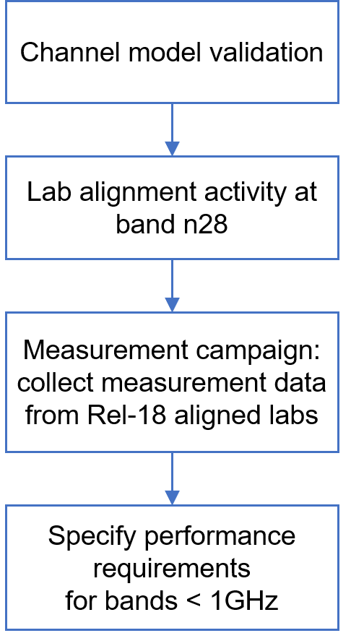 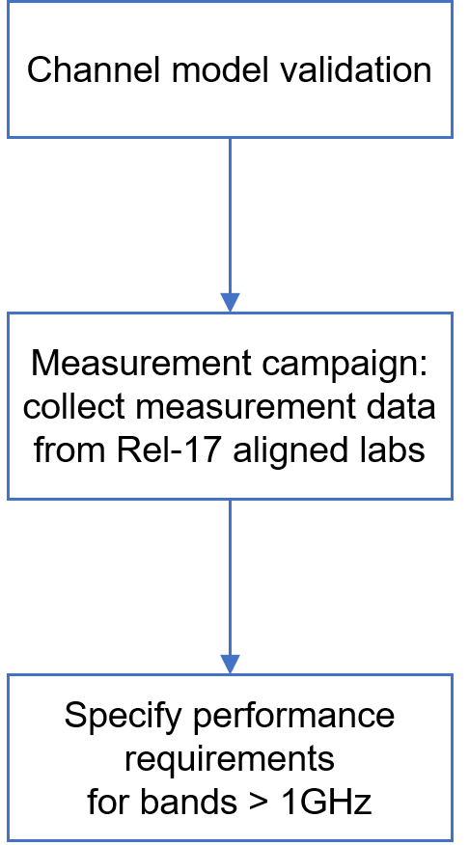

(a) for bands <1GHz (n5/n8/n28) (b) for bands >1GHz (n1/n77)

Fig. 1. Work flow of FR1 MIMO OTA performance requirements development

In general, FR1 MIMO OTA performance requirements will be derived based on a measurement data pool of commercial devices per band. To establish valid and trustable measurement data pools for defining FR1 MIMO OTA requirements, the following activities are required before measurement campaigns.

* + For bands <1GHz (n5/n8/n28)
    - Channel Model Validation: Companies shall complete channel model validation before submitting measurement results, validation results should be submitted to RAN4 for review. Details of the channel model validation is specified in Section 3.2.1.
    - Lab Alignment Activity: A new FR1 MIMO OTA lab alignment activity is required at band n28 in Rel-18. Only aligned labs can share measurement results into the data pool for defining FR1 MIMO OTA requirements for bands < 1GHz. Details of the lab alignment activity is specified in Section 3.2.3.
  + For bands >1GHz (n1/n77)
    - Channel Model Validation: Companies shall complete channel model validation before submitting measurement results, validation results should be submitted to RAN4 for review. Details of the channel model validation is specified in Section 3.2.1.
      * Note: Rel-17 aligned labs do not need to submit channel model validation results for band n77, because the channel model validation results for band n78 are applicable to band n77 due to the same channel model and validation frequency.
    - No new lab alignment activity is required. Only Rel-17 aligned labs (Apple, CAICT, CMCC&BUPT, Huawei, MediaTek, Xiaomi) can share measurement results into the data pool for defining FR1 MIMO OTA requirements for bands > 1GHz.

Detailed working procedures for FR1 MIMO OTA performance requirements development are described in Section 3.2.

## 3.2 Detailed working procedures

### 3.2.1 Channel Model Validation

1. The purpose of Channel Model Validation is to ensure that the channel models are correctly implemented and hence capable of generating the propagation environment, as described by the model, within the test zone of the MPAC system.
2. The channel model validation measurements shall be performed as described in Annex C.3 of TS 38.151, including:
   1. Power Delay Profile (PDP)
   2. Doppler/Temporal correlation
   3. Spatial correlation
   4. Cross-polarization
   5. Power validation
3. Test band: n1, n5/n8, n28; Test frequency: as specified in Tables C.3.1-1 and C.3.1-2 of TS 38.151

* Note: According to TS 38.151, n5 and n8 share the same channel model validation frequency, therefore, only one set of channel model validation results needs to be submitted for these two bands.

1. Channel model: as specified in Annex C.1 of TS 38.151
   1. For bands n28, n5/n8: FR1 UMi CDL-C (2x2 MIMO)
   2. For band n1: FR1 UMa CDL-C (4x4 MIMO)
2. Pass/fail limits: as defined in Annex C.4 of TS 38.151

### 3.2.2 Lab Alignment Activity

1. The purpose of Lab Alignment Activity is to ensure there is no unexpected lab deviation and establish full trust and confidence on the measurement results. At least 3 participating labs and [2-4] PADs are required.
2. Test labs are invited to participate in the lab alignment activity, the following conditions should be fulfilled:
   1. Participating labs shall complete channel model validation.
   2. Participating labs should have sufficient test resource to provide on-time measurement results without delay.
   3. Participating labs should first examine and exclude the impact of noise before submitting PAD measurement results.
3. Test methodology:
   1. Test plan: 3GPP TS 38.151
   2. Test system: MPAC
4. Test cases for Lab Alignment Activity:
   1. Test band: n28
   2. Number of test cases: 3 PADs
   3. Operation mode: NR Standalone (SA)
   4. Use scenario: Free space
5. Test results submission:
   1. Use the same worksheet template in R4-2316308 to submit the measurement results. Report any systematic offsets that have been applied to the TRMS results.
   2. The measurement results should be submitted to RAN4 by anonymous approach (the UE model shall not be disclosed publicly)
   3. Results shall not be shared between labs before submitting to RAN4 meetings or sharing in the RAN4 reflector. Comparison and lab alignment analysis should only be done in RAN4 meetings/discussions
6. Lab alignment criteria:
   1. The pass/fail criteria are defined as the maximum deviation between the measurement result and the reference value
   2. The reference value will be derived based on the averaging approach (linear average in dBm) of lab alignment data pool from ≥ 3 labs
   3. Apparent outliers (if identified) will not be considered in the average process for reference value. The PAD measurement result deviates over 1.5*preliminary MU (i.e., 4.55dB) from all the other labs’ results should be identified as apparent outlier.
   4. Pass/fail limit for lab alignment is defined as 0.75*preliminary MU (+/- 2.25 dB for band n28).
7. Volunteer lab procedures:
   1. PAD delivery scheme: Decide PAD delivery scheme after all the volunteer labs and PADs information being confirmed.
   2. PAD measurement time in each volunteer lab: finalize PAD measurement within [7] workdays, and deliver to the next lab ASAP with PAD delivery In/Out information shared in email-reflector.

### 3.2.3 Measurement Campaign

1. The purpose of Measurement Campaign is to collect measurement results of commercial devices from permitted labs for specifying FR1 MIMO OTA performance requirements.
2. Test cases for FR1 MIMO OTA Measurement Campaign:
   1. Test bands: all listed bands in WID [1], i.e., n1, n5, n8, n28, n77
      1. 1st priority: n1, n5, n28
      2. 2nd priority: n8, n77
   2. MIMO layer:
      1. For bands n28, n5, n8: 2x2 MIMO (with FR1 UMi CDL-C channel model)
      2. For bands n1, n77: 4x4 MIMO (with FR1 UMa CDL-C channel model)
   3. Use scenario: Free space
   4. Operation mode: SA (first stage)
   5. Power class: PC3 (first stage)
3. Commercial device (Smartphone) selection criteria for FR1 MIMO OTA Measurement Campaign:
   1. DUT capability: support for all the bands n1, n5, n8, n28, and n77 listed in the WID is preferred, but devices supporting only a subset of the above bands can equally be used in the measurement campaign for such supported bands
   2. DUT variety: the selection of commercial devices should cover various of devices in the market. The following selection criteria can also be considered:
      1. Year of production: 2021-2024
      2. Brand variety
      3. Price range (to cover different price ranges, including High/Mid/Low-end products)
      4. Popularity
      5. Number of bands supported
   3. For band n1, UEs equipped with 4 Rx antenna ports (4Rx UEs) shall be selected for the Measurement Campaign. Labs can try to identify 4Rx UEs by themselves in any methods listed below:
      1. Method 1: If a UE can be connected to call box with 4x4 MIMO, the UE can be confirmed as a 4Rx UE
      2. Method 2: Obtain the MIMO layer information from BS simulator, e.g., check the IE maxNumberMIMO-LayersPDSCH
         * FFS whther IE srs-TxSwitch can be used to identify 4Rx UE
      3. Method 3: Directly collect the information from OEMs.
      4. Other methods are not precluded
4. Commercial devices provision:
   1. Test labs can prepare and collect commercial devices by themselves based on the above selection criteria.
   2. Any 3GPP member can work with the selected test labs to provide devices
      1. A test lab shall measure only one UE model in case different samples are provided
      2. Same UE model supporting different sets of bands can be measured. For this case, the UE model should be marked as different model, e.g., model A-1, model A-2. (guidance on how to manage this case are provided in the spreadsheet in [TBD])
      3. For band n1, make sure the devices are 4Rx UEs
   3. The 3GPP member providing the DUTs should contact one of the selected labs to check their availability to receive the DUTs and define together the related provisioning aspects
      1. Any issue should be reported to the rapporteur in a timely manner to discuss for an alternative solution
      2. To plan properly the measurement campaign, the following actions are requested for the RAN4 Nov meeting:
         1. The rapporteur checks with the volunteer labs the number of DUTs (minimum 3, maximum 15) they expect to be able to measure AND how many DUTs they can accommodate from 3GPP members
         2. The 3GPP member providing the DUTs checks how many samples they intend to provide (in terms of maximum number)
         3. Planning of the measurement campaign could be reviewed based on the above points
5. Measurement results submission:
   1. RAN4 Secretary will cover the role of the trusted and neutral third party for the whole procedure
   2. UE information disclosure: labs use the spreadsheet in [TBD] to submit the device information. The UE information should NOT BE CORRELATED with the order in the measurement data submitted by the same lab for the respective list of devices in c, i.e., the UE mode order in the list should be randomly disrupted.
   3. Labs use the worksheet template in [TBD] to submit the measurement results for Rel-18 3GPP FR1 MIMO OTA performance data pool.
   4. The measurement results should be submitted to RAN4 by anonymous approach (the UE model should not be disclosed):
      1. The minimum number of submitted devices from each lab is 3, the maximum number is 15. Meanwhile, labs are encouraged to provide as much data as possible within 15
      2. Volunteer labs provide the device information sheet ONLY to the RAN4 Secretary and the sheet used to submit measurement results to 3GPP RAN4
   5. RAN4 Secretary ONLY publishes to 3GPP RAN4 the following summary of statistical information after anonymizing the sensitive UE information data, i.e., UE model name and vendor name:
      1. Total number of devices
      2. Total number of models
      3. Total number of devices vendors
      4. Percentage of devices per vendor
      5. Percentage of devices per Power Class
      6. Percentage of devices per each supported band
      7. Percentage of devices per year of production
      8. Percentage of the devices that are certified by at least one of certification bodies as following: PTCRB, GCF, NAL/CTA (Chinese network access licensed test)], FCC, CE
         * Once the device gets the above certification, for RAN4 discussion that means the device is not a prototype
6. Percentage of the devices that are certified for each certification body (for information only)

### 3.2.4 Specifying Performance Requirements

1. Only the results from aligned labs will be considered for specifying requirements, as described in Section 3.1.
2. Minimum number of devices for defining requirements for each band: 15
3. Method of requirements derivation: per-band Data driven approach
4. The value at [85%] percentile of the CDF curve can be selected as the starting point for requirement discussion
5. Performance part of the work will proceed in a contribution-driven manner.

## 3.3 Time plan

### 3.3.1 Time plan for bands < 1GHz

1. Finalize the working procedure and time plan for FR1 Lab Alignment Activity at RAN4 #106-bis-e (Apr 2023).

2. Lab volunteers and PADs announced at RAN4#106-bis-e or via email-reflector before the starting of RAN4#107 (22 May 2023) are considered.

3. Conclude lab volunteers, PADs’ information, and delivery scheme at RAN4#107. PAD providers are encouraged to prepare PADs as early as possible. Lab Alignment Activity can start with the labs that complete channel model validation, after RAN4#107 immediately, if ≥ 3 lab volunteers and 3 PADs are ready.

4. Lab volunteers shall complete channel model validation for band n28 before the starting of RAN4#108 (21 Aug 2023). The results shall be submitted to RAN4 by formal T-docs. Lab volunteer can also share the validation results via email-reflector before submitting to RAN4 meetings.

5. Collect all lab alignment measurement results from lab volunteers based on contribution-driven manner at RAN4#109 (Nov 2023) and RAN4#110 (Feb 2024). Conclude the lab alignment outcome at RAN4#110 (Feb 2024). Measurement Campaign can start after RAN4#109 immediately, if ≥ 3 labs are tentatively confirmed as aligned.

6. Conclude whether/how to down-select the bands in WID (n5/n8/n28) before the start of Measurement Campaign (RAN4#109).

7. Labs should provide channel model validation results for bands n5/8 no later than RAN4 #110 (Feb. 2024) to participate in the Measurement Campaigns at corresponding bands.

8. Collect measurement results of commercial devices from aligned labs based on contribution-driven manner in RAN4#110 (Feb 2024) and RAN4#110-bis (Apr 2024).

9. Conclude FR1 MIMO OTA performance requirements at or before RAN4#111 (May 2024).

### 3.3.2 Time plan for bands > 1GHz

1. Measurement Campaign for bands > 1GHz can start with the Rel-17 aligned labs that complete channel model validation at an early stage. The channel model validation results shall be submitted to RAN4 by formal T-docs.

2. Conclude whether/how to down-select the bands in WID (n1/n77) before the start of Measurement Campaign (RAN4#108 is suggested).

3. Labs should provide channel model validation results for band n1 no later than RAN4 #110 (Feb. 2024) to participate in the Measurement Campaign at that band.

4. Collect measurement results of commercial devices from the labs based on contribution-driven manner at RAN4#110 (Feb 2024) and RAN4#110-bis (Apr 2024).

5. Conclude FR1 MIMO OTA performance requirements no later than RAN4#111 (May 2024).

**Proposal 1: Approve the updated framework and time plan in Section 3 of this contribution for FR1 MIMO OTA performance requirements development.**

# 4 Conclusion

In this contribution, we propose an updated framework and time plan for FR1 MIMO OTA performance requirements development.

**Proposal 1: Approve the updated framework and time plan in Section 3 of this contribution for FR1 MIMO OTA performance requirements development.**

# References

1. R4-2305911, Framework and time plan for FR1 MIMO OTA performance requirements development, 3GPP RAN4#106-bis-e, Apr. 2023.
2. R4-2313891, WF for Rel-18 FR1 TRP TRS, vivo, 3GPP RAN4#108, Aug. 2023.
3. R4-2317004, WF on NR_FR1_TRP_TRS_enh, vivo, 3GPP RAN4#108-bis, Oct. 2023.
4. R4-2316945, WF on NR_MIMO_OTA_enh, CAICT, 3GPP RAN4#108-bis, Oct. 2023.
5. R4-2321085, WF on [109][336] NR_MIMO_OTA_enh, CAICT, 3GPP RAN4#109, Nov. 2023.