**3GPP TSG-RAN WG4 Meeting # 109 R4-2321085**

**Chicago, USA, November 13 – November 17, 2023**

**Title:** WF on [109][336] NR_MIMO_OTA_enh

**Agenda Item:** 8.16.6

**Source:** CAICT

**Document for:** Approval

# Topic #1: FR1 MIMO OTA

### Sub-topic 1-1 Test time reduction for FR1 MIMO OTA < 1GHz

**Issue 1-1: Reduce Minimum Number of Slots per Stream for bands <1GHz to 10k**

**Agreement:**

* Minimum Number of Slots per Stream can be reduced to 10k for FR1 MIMO OTA measurement campaign and conformance testing for bands < 1GHz.

### Sub-topic 1-2 Actions required before participating in Rel-18 FR1 Lab Alignment Activity/Measurement Campaign

**Issue 1-2-1: Exclude the impact of noise on MIMO OTA test results**

**Agreement:**

* RAN4 accepts the measurement results presented in R4-2319109 as an evidence of Apple’s FR1 MIMO OTA lab compliance on low frequency noise mitigation evaluation.

**Issue 1-2-2: Complete channel model validation**

**Agreement:**

* Volunteer labs should provide channel model validation results for bands n1/5/8 no later than RAN4 #110 (Feb. 2024), to ensure the Measurement Campaigns will not be delayed.

### Sub-topic 1-3 Rel-18 FR1 MIMO OTA lab alignment

**Issue 1-3: Preliminary outcome of Rel-18 FR1 MIMO OTA lab alignment**

*For information: The summary of current lab alignment results is shown in Table 1 and Figs. 1~2.*

Table 1. Summary of measurement results from 5 labs

|  |  |  |  |  |  |  |  |  |  |  |
| --- | --- | --- | --- | --- | --- | --- | --- | --- | --- | --- |
| **Device** | **Band** | **TRMS measurement result [dBm/15kHz]** | | | | | | **Average approach** | **Average value** | **Max-Min deviation** |
| **Lab 1** | **Lab 2** | **Lab 3** | **Lab 4** | **Lab 5** | **Lab 6** |
| PAD_1 | n28 | -89.34 | -90.58 | -89.95 | -88.26 | -89.22 |  | Linear average | -89.47 | 2.32 |
| PAD_2 | n28 | -86.46 | -88.39 | -88.61 | -85.50 | -85.86 |  | -86.96 | 3.12 |
| PAD_3 | n28 | -86.26 | -89.80 | -88.75 | -86.19 | -86.49 |  | -87.50 | 3.61 |
| **Device** | **Band** | **TRMS offset [dBm/15kHz]** | | | | | | **Pass/fail limit** | | |
| **Lab 1** | **Lab 2** | **Lab 3** | **Lab 4** | **Lab 5** | **Lab 6** |
| PAD_1 | n28 | 0.13 | -1.11 | -0.48 | 1.21 | 0.25 |  | [+/- 0.75 MU, i.e., +/- 2.25 dB] | | |
| PAD_2 | n28 | 0.50 | -1.42 | -1.65 | 1.47 | 1.10 |  |
| PAD_3 | n28 | 1.23 | -2.30 | -1.25 | 1.31 | 1.01 |  |

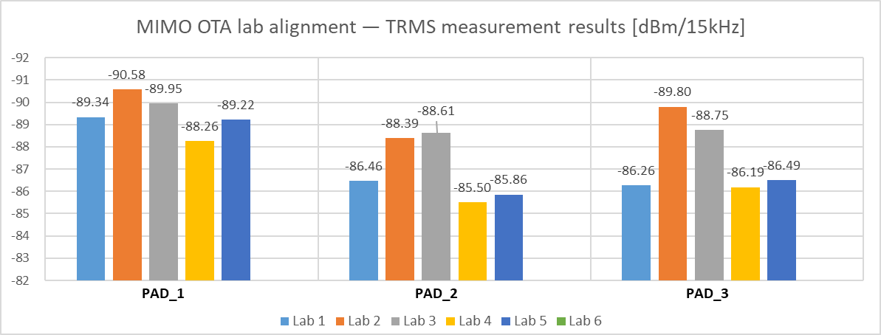

Fig. 1 Measurement results from 5 labs

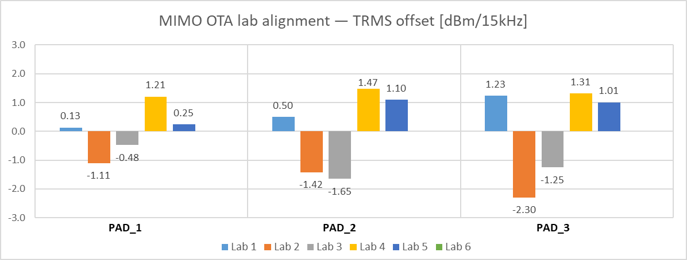

Fig. 2 Deviation between each measurement result and the average value

**Agreement:**

* Reuse the pass/fail limit of Rel-17 FR1 MIMO OTA lab alignment, i.e., +/- 0.75*preliminary MU (+/- 2.25 dB for bands < 3GHz).
* Start the Measurement Campaign after RAN4#109 immediately, based on the preliminary outcome that ≥ 3 labs can be aligned.
* The reference values of lab alignment will be derived by averaging the results from all 6 labs submitted in the 1st round. Then determine which labs are aligned; the potential failed labs can have the chance to retest the PAD(s). The reference values will not be changed, and the aligned labs will not be affected.

### Sub-topic 1-4 FR1 MIMO OTA requirements related work

**Issue 1-4-1: Which MIMO OTA requirements should be defined for band n1**

**Agreement:**

* RAN4 should define 4x4 MIMO OTA requirements for 4Rx UE first in Rel-18, considering 4Rx UEs at band n1 is the majority on the market and mandatory in some countries/regions.
* Not to define 2x2 MIMO OTA requirements for 4Rx UE.
* Not to perform measurement campaign for 2Rx UE.
* Study and investigate an offset between FR1 MIMO OTA performance for 4Rx and 2Rx UEs at band n1

**Issue 1-4-2: Whether IEs can be used to identify 2Rx UE and 4Rx UE**

**Agreement:**

* The IE of maxNumberMIMO-LayersPDSCH can be used to identify 4Rx UE
* Further check if the IE srs-TxSwitch can be used to identify 4Rx UE.

**Issue 1-4-3: How to identify 2Rx UE and 4Rx UE**

**Agreement:**

* Labs can try to identify 4Rx UE by themselves in any methods listed below:
  + Method 1: If a UE can be connected to call box with 4x4 MIMO, the UE can be confirmed as a 4Rx UE
  + Method 2: Obtain the MIMO layer information from BS simulator, e.g., check the IE maxNumberMIMO-LayersPDSCH
    - FFS IE srs-TxSwitch
  + Method 3: Directly collect the information from OEMs.
  + Other methods are not precluded
* Any 3GPP member can work with the selected test labs to provide 4Rx UEs.

**Issue 1-4-4: Updated working procedure for Measurement Campaign**

**Agreement:**

* The updated framework for FR1 MIMO OTA in R4-2321137 is agreed.

**Issue 1-4-5: Thresholds of data pool for specifying FR1 MIMO OTA requirements**

**Agreement:**

* Confirm the Minimum number of devices for defining FR1 MIMO OTA requirements for each band as 15

# Topic #2: FR2 MIMO OTA

### Sub-topic 2-1 FR2 MIMO OTA lab alignment

**Issue 2-1: FR2 PAD delivery scheme and time plan**

**Agreement:**

* Postpone the deadline of FR2 lab alignment activity to RAN4 110-bis meeting (Apr. 2024).

### Sub-topic 2-2 FR2 MIMO OTA Measurement Campaign

**Issue 2-2: Updated working procedures of FR2 MIMO OTA Measurement Campaign for specifying requirements**

**Agreement:**

* The updated framework for FR2 MIMO OTA in R4-2321138 is agreed.

# Topic #4: Rel-17 MIMO OTA maintenance

### Sub-topic 4-1 Channel Model Validation

**Issue 4-1-2: Doppler pass/fail limits for FR1 and FR2 channel model validation**

**Agreement:**

* Not to tighten the Doppler pass/fail limits for FR1 and FR2 channel model validation in Rel-18.

# References

1. R4-2318228, “Topic summary for [109][336] NR_MIMO_OTA_enh”, Moderator (CAICT), 3GPP TSG-RAN WG4 Meeting # 109, Nov. 2023.
2. R4-2321084, “Ad-hoc minutes for [109][336] NR_MIMO_OTA_enh”, Moderator (CAICT), 3GPP TSG-RAN WG4 Meeting # 109, Nov. 2023.