**3GPP TSG-RAN WG4 Meeting #109 R4-2318969  
Chicago, US, November 13 – 17, 2023**

**Agenda item: 8.15.2.2**

**Source: vivo**

**Title: Analysis of 3GPP TRP TRS AC lab alignment and RC harmonization measurement results**

**Document for: Approval**

# 1 Introduction

Based on the agreed working procedure [1], phase 1 AC lab alignment should be concluded in RAN4#109 meeting. 6 test labs have submitted LAD measurement results [2-12].

This contribution presents the analysis of phase 1 LAD1 and LAD2 measurement data and proposes the conclusions for the TRP TRS AC lab alignment activity for band n78 BHH.

# 2 Discussion

The reference value is derived based on linear average of all the labs results. The detailed analysis file is in the attached Excel worksheet of this contribution.

**BHH**: Beside Head and Hand, i.e., talk mode

**BH**: Beside Hand only, i.e., browsing mode

Figure 1 share the measured results of LAD1 and LAD2 for band n78, from each test lab. Figure 2 analyse the deviation between each test lab and reference value.

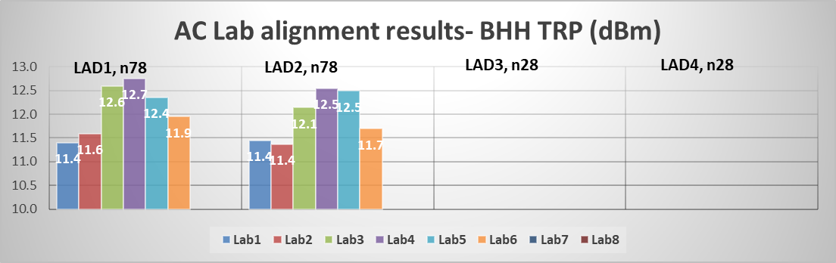

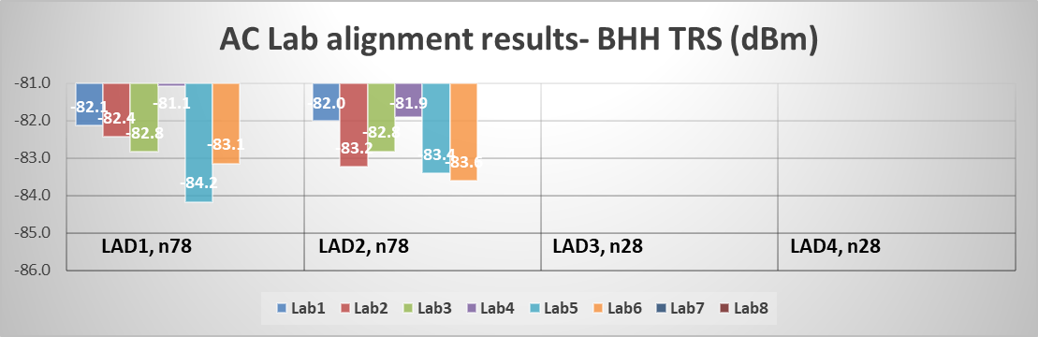

Figure 1: NR FR1 TRP and TRS AC lab alignment measurement results from each test lab

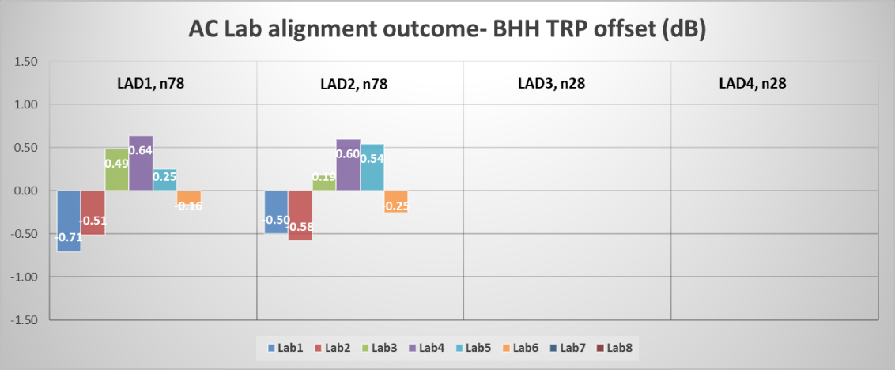

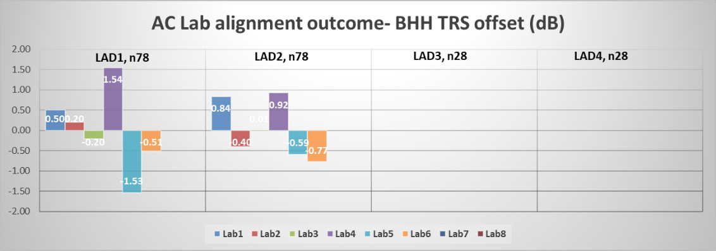

Figure 2: NR FR1 TRP and TRS AC lab alignment analysis, deviation between each test lab and reference value

**Observation 1:** The reference value is derived by the agreed linear average (with dBm) of all the 6 labs results, the maximum deviation between test labs and reference value is 0.71dB for TRP and 1.54dB for TRS.

**Observation 2:** The maximum deviation between test labs and reference value are within 0.75*MU, i.e., TRP 1.34dB, TRS 1.65dB.

With above analysis and observations, we can see that the performance deviation between lab and reference value is quite small, and the lab alignment activity presents a good harmonized performance of FR1 TRP TRS anechoic chamber systems for BHH usage scenario.

With above analysis, the following proposal can be made as the phase 1 3GPP FR1 TRP TRS AC lab alignment outcome:

**Proposal 1: 3GPP Rel-18 phase 1 FR1 TRP TRS AC lab alignment activity for BHH can be successfully concluded within the 6 labs with anechoic chamber system are well aligned.**

We also analyse the RC measured results, with the following summary.

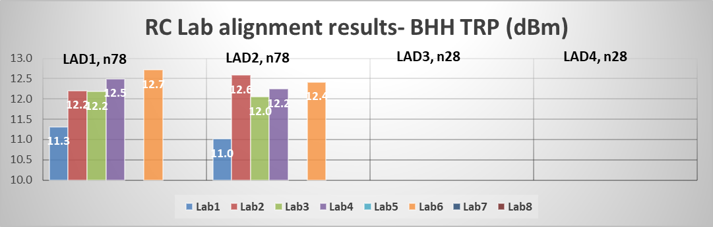

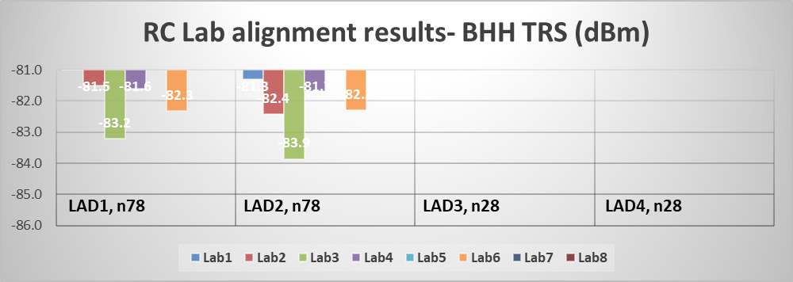

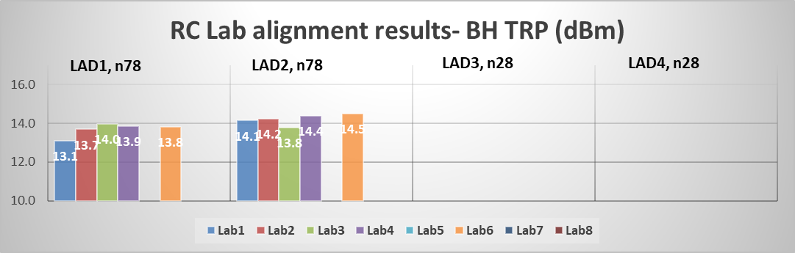

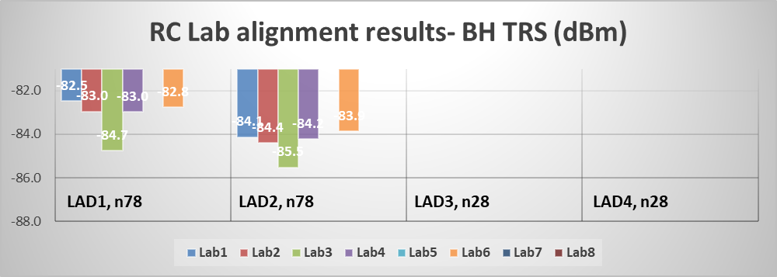

Figure 3: NR FR1 TRP and TRS RC lab alignment measurement results from each test lab (no RC results for Lab5 )

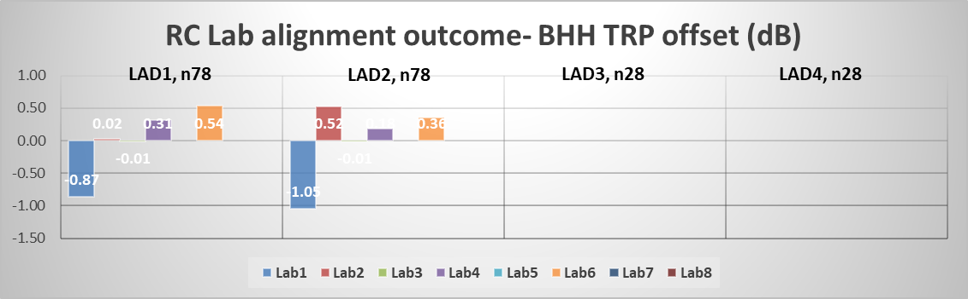

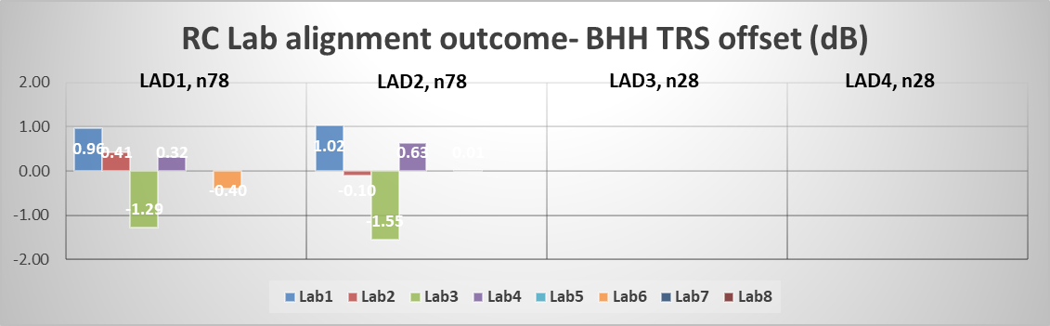

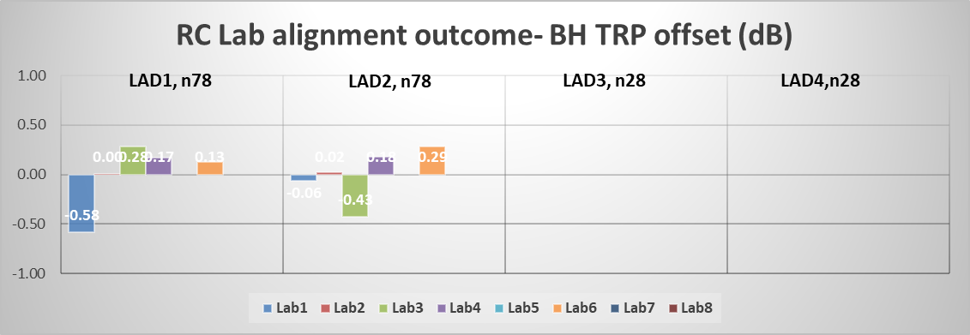

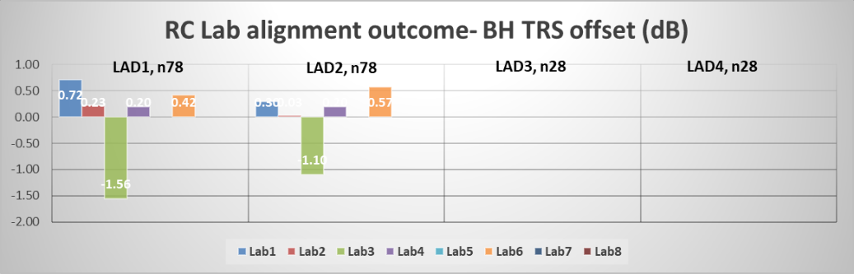

Figure 4: NR FR1 TRP and TRS RC lab alignment analysis, deviation between each test lab and reference value (no RC results for Lab5)

**Observation 3:** The reference value is derived by the agreed linear average (with dBm) of all the 5 labs results, the maximum deviation between test labs and reference value for BHH is 1.05dB for TRP and 1.55dB for TRS.

**Observation 4:** The reference value is derived by the agreed linear average (with dBm) of all the 5 labs results, the maximum deviation between test labs and reference value for BH is 0.58dB for TRP and 1.56dB for TRS.

**Observation 5:** The BH and BHH MU assessment for RC has not been finalized in TR 38.870.

In addition, we also analyse the RC vs AC gap of same device from each test lab, summarized as following:

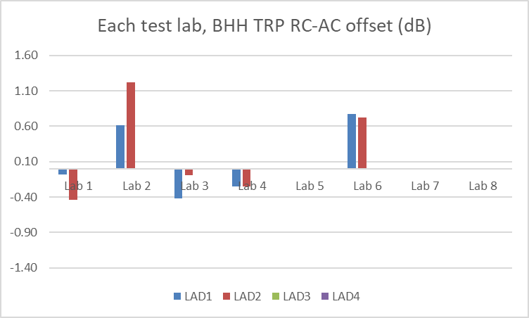

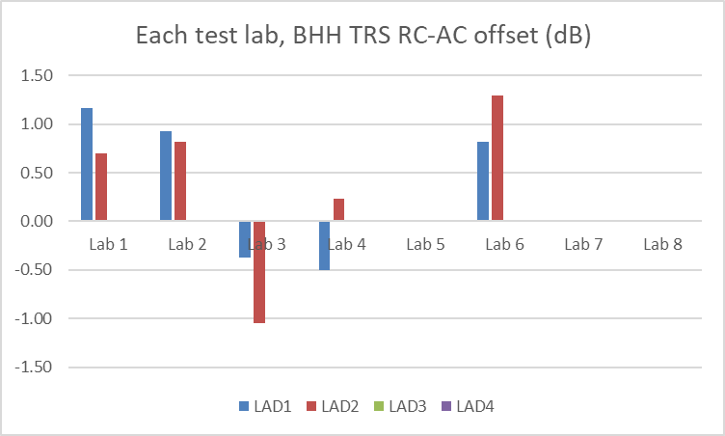

Figure 5: RC vs AC measurement results of same device in each test lab (no RC results for Lab5)

**Observation 6:** The RC vs AC gap of same UE in each test lab is Max 1.22dB for TRP and Max 1.30dB for TRS.

**Proposal 2: Given the missing of MU for RC, RC lab alignment and harmonization can be further discussed.**

# 3 Conclusion

Based on the above analysis in this paper, the following outcome of Rel-18 3GPP FR1 TRP TRS lab alignment activity (phase 1) is proposed:

**Observation 1:** The reference value is derived by the agreed linear average (with dBm) of all the 6 labs results, the maximum deviation between test labs and reference value is 0.71dB for TRP and 1.54dB for TRS.

**Observation 2:** The maximum deviation between test labs and reference value are within 0.75*MU, i.e., TRP 1.34dB, TRS 1.65dB.

**Proposal 1: 3GPP Rel-18 phase 1 FR1 TRP TRS AC lab alignment activity for BHH can be successfully concluded within the 6 labs with anechoic chamber system are well aligned.**

**Observation 3:** The reference value is derived by the agreed linear average (with dBm) of all the 5 labs results, the maximum deviation between test labs and reference value for BHH is 1.05dB for TRP and 1.55dB for TRS.

**Observation 4:** The reference value is derived by the agreed linear average (with dBm) of all the 5 labs results, the maximum deviation between test labs and reference value for BH is 0.58dB for TRP and 1.56dB for TRS.

**Observation 5:** The BH and BHH MU assessment for RC has not been finalized in TR 38.870.

**Observation 6:** The RC vs AC gap in each test lab is 1.22dB for TRP and 1.30dB for TRS.

**Proposal 2: Given the missing of MU for RC, RC lab alignment and harmonization can be further discussed.**

# 4 References

1. R4-2317004, WF on FR1 TRP TRS, vivo, RAN4#108bis
2. R4-2318970, Measurement results for 3GPP Rel-18 TRP TRS AC lab alignment activity, vivo, RAN4#109
3. R4-2319641, 3GPP Rel-18 TRP TRS AC lab alignment activity from SRTC, SRTC, RAN4#109
4. R4-2319288, Measurement results for 3GPP Rel-18 TRP TRS AC lab alignment activity, SGS Wireless, RAN4#109
5. R4-2318103, Measurement results for 3GPP Rel-18 TRP TRS AC lab alignment activity-Huawei, Huawei, RAN4#109
6. R4-2319920, 3GPP Rel-18 TRP TRS LAD measurement for AC lab alignment_n78, OPPO, RAN4#109.
7. R4-2320177, CAICT measurement results for 3GPP Rel-18 TRP TRS AC lab alignment activity, CAICT, RAN4#109
8. R4-2318104, Measurement results for 3GPP Rel-18 TRP TRS RC harmonization-Huawei, Huawei, RAN4#109
9. R4-2318971, Measurement results for 3GPP Rel-18 TRP TRS RC harmonization activity, vivo, RAN4#109
10. R4-2319635, 3GPP Rel-18 TRP TRS RC harmonization from SRTC, SRTC, RAN4#109
11. R4-2319921, 3GPP Rel-18 TRP TRS LAD measurement for RC harmonization_n78, OPPO, RAN4#109
12. R4-2320178, CAICT measurement results for 3GPP Rel-18 TRP TRS RC harmonization activity, CAICT, RAN4#109