**3GPP TSG-RAN WG4 Meeting # 109 R4-23xxxxx**

**Chicago, US, Nov. 13 – Nov. 17, 2023**

**Agenda item:** 8.28.7

**Source:** Moderator (CATT)

**Title:** Topic summary for [109][312] NR_netcon_repeater_RFConformance

**Document for:** Information

# Introduction

This contribution is the summary for the topic [312] NR_netcon_repeater_RFConformance. It covers the contributions in AI 8.28.4.

# Topic #1: General

## Companies’ contributions summary

|  |  |  |
| --- | --- | --- |
| **T-doc number** | **Company** | **Proposals / Observations** |
| R4-2319178 | Samsung | **Proposal 1**: We propose RAN4 to update previous wayforward to reflect and clarify the following:1) the simultaneous reception should be mandatory supported NOT declaration basis; 2) the simultaneous transmission can be declaration based but should align with its reported capacity.   * One possible updated wording from previous can be following:   + WhetherNCR should supporting NCR-Fwd and NCR-MT simultaneous transmission is manufacture declaration basis, and this should be aligned with its capability signaling.   + ~~Whether NCR supporting NCR-Fwd and NCR-MT simultaneous reception is manufacture declaration basis.~~ |
| R4-2319398 | Ericsson | **Observation 1:** The scenario where two base stations from different operator networks are located edge-by-edge seems not to be a typical scenario. In real situations the scenario used before Rel-15 seem to be dominant.  **Observation 2:** The current co-location concept assumes a base station co-location scenario considering an AAS BS mounted edge-to-edge with a BS with a passive single column antenna. This concept may not be representative for how many real networks now (end of Rel-18) are equipped.  **Observation 3:** The technical background assumptions for the co-location concept focus only on Wide Area base station, while co-location requirements also exist for Medium Range base station and Local Area base station.  **Observation 4:** When 30 dB was assumed, the isolation between a single column antenna and a AAS with few branches was considered. Now RAN4 consider higher frequencies and much larger array structures. The isolation value to assume above 2.5 GHz and more than 32 transceiver branches should be further studied.  **Observation 5:** To maintain degradation level used for non-AAS BS, RAN4 should reconsider for AAS BS co-location spurious emission not to include 9 dB relaxation part of requirement derivation background.  **Observation 6:** A band specific CLTA is required per declared supported co-location band. This will create a logistical problem during conformance testing since very many CLTAs are needed per tested product.  **Observation 7:** For bands defined above 2.5 GHz it is very difficult to find commercially available single column BS antennas or multi-columns with similar characteristics. Therefore, the availability and access to CLTA is limited for bands above 2.5 GHz.  **Observation 8:** By experience, it can be concluded that the test setup for transmitter intermodulation is very complex. A large PA capable of very high output power is required to generate the interfering signal clean enough and to be injected by the CLTA to test the AAS base station TRP unwanted emissions.  **Observation 9:** The CLTA puts additional requirements on the OTA test environments, such as volume and weight on the package including both test object and CLTA.  **Observation 10:** It’s not clear what deployment scenario that is relevant for an NCR node. The BS co-location scenario is relevant for a BS site deployment, while an NCR deployment may be very different.  **Observation 11:** Having multiple CLTA in the chamber at the same time was seen not feasible for base station testing. For NCR careful considerations of the CLTA definition is required to facilitate a test setup using multiple CLTAs.  **Observation 12:** As way-forward for NCR WI, based on previous observations the following should be considered.   1. If the concept of CLTA is re-used, careful considerations of the NCR CLTA definition is required. It is not obvious that the CLTA defined in current BS conformance test specification can be re-used without modifications. 2. When co-location requirements are defined issues and limitation observed in this contribution should be considered before the co-location concept is copied to other nodes (e.g., NCR). This means that a limit on highest supported frequency should be considered, only wide-area BS is considered, etc. 3. If issues observed in this contribution cannot be solved. The scope of the support of Rel-18 NCR needs to be re-evaluated. It could be said that for Rel-18 NCR, co-location requirements are not supported, since no test method have been defined. 4. If issues cannot be resolved, support for NCR type 1-O can be added in later release when test method have been defined.   RAN4 needs to revisit the technical background and feasibility for the co-location requirement and the fundamental concept used for the requirement before it is re-used for new types of network nodes to ensure that RAN4 requirements are relevant (spectrum compatibility, interoperability, efficiency, etc.) and testable.  **Proposal 1:** RAN4 should discuss and conclude on technical feasibility for co-location requirements before a concept is re-used for a new type of network node. |

## Open issues summary

**Issue 1-1: Simultaneously Tx/Rx declaration**

* Proposals
  + Option 1: Modify the simultaneously Tx/Rx declaration related agreements (From RAN4#108 meeting). For simultaneously Tx, supporting of simultaneous Tx is manufacture declaration basis, and this should be aligned with its capability signalling. For simultaneously Rx, there is no declaration because simultaneously Rx is mandatory. (R4-2318915, Samsung)
  + Option 2: Do not modify the existing agreements.
* Recommended WF
  + The declaration on simultaneously Rx can be removed.

**Issue 1-2: Reshaping the assumptions of Co-location requirements**

* Proposals
  + RAN4 should discuss and conclude on technical feasibility for co-location requirements before a concept is re-used for a new type of network node. (R4-2319398, Ericsson)
    - The assumptions of BS co-location requirement are out of fashion in the following aspects, including: unreasonable antenna configurations, inappropriate relaxations, awkward CLTA, and so on.
    - Evolved BS RF core requirements and corresponding BS conformance test requirements are proposed.
* Recommended WF
  + To be discussed.

# Topic #2: Measurement system set-up

## Companies’ contributions summary

|  |  |  |
| --- | --- | --- |
| **T-doc number** | **Company** | **Proposals / Observations** |
| R4-2320345 | ZTE Corporation | **Proposal 1**: for the measurement setup of Input IMD and output IMD of NCR-Fwd type 1-O, propose to consider the following measurement setup for it.  C:\Users\10164284\AppData\Local\Microsoft\Windows\INetCache\Content.MSO\CB820F8A.tmp  Figure 1. measurement setup for Input IMD requirement of FR1 NCR-Fwd type 1-O  C:\Users\10164284\AppData\Local\Microsoft\Windows\INetCache\Content.MSO\37870742.tmp  Figure 2. measurement setup for output IMD requirement of FR1 NCR-Fwd type 1-O |

## Open issues summary

**Issue 2-1: Measurement setup of Input IMD and output IMD of NCR-Fwd type 1-O**

* Proposals
  + Option 1: (ZTE)
    - For the measurement setup of Input IMD and output IMD of NCR-Fwd type 1-O, propose to consider the following measurement setup for it.

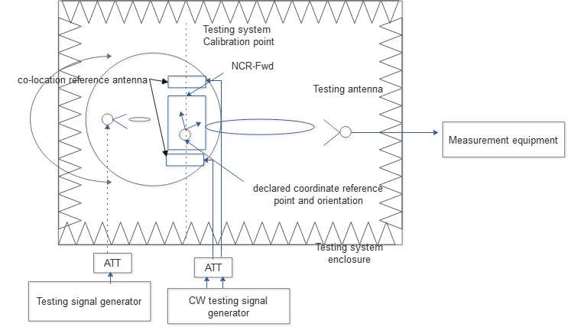

Figure 1. measurement setup for Input IMD requirement of FR1 NCR-Fwd type 1-O

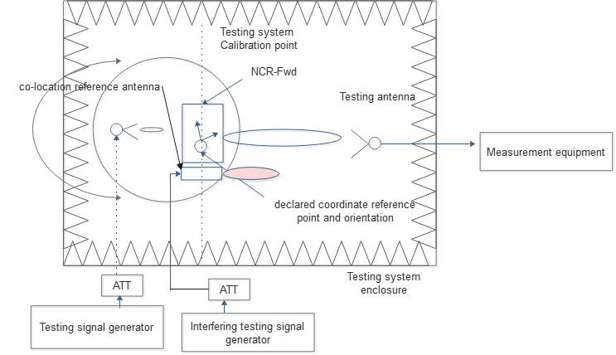

Figure 2. measurement setup for output IMD requirement of FR1 NCR-Fwd type 1-O Recommended WF

* Recommended WF
  + To be discussed.

# Topic #3: Test configuration and Test Model

## Companies’ contributions summary

|  |  |  |
| --- | --- | --- |
| **T-doc number** | **Company** | **Proposals / Observations** |
| R4-2318307 | CATT | **Proposal 1: The proposed RTC1 and RTC2 could be used for joint UL test configuration.** |
| R4-2318915 | CMCC | **Proposal 1: at least LA NCR-MT SEM requirements should also be tested under edge_1PRB_left and edge_1PRB_right RB allocations with max Tx power. Additional test mode beside IAB testing modes should be added.**  **Proposal 2: for the test modes when NCR-MT is configured within all RBs per carrier, option 1 in last meeting WF is OK to show the aggregate emission from MT and fwd-link UL.**  **Proposal 3: for the test modes when NCR-MT is configured at edge 1PRB(if specified), it’s suggested to further discuss the test configuration when MT occupies edge 1PRB and fwd-link occupies remaining PRB within the same carrier. Besides, another fwd-link carrier configured at the other side of pass-band edge. Detailed show as in above fig.** |
| R4-2320259 | Nokia | **Proposal 1: It is proposed to reused test signal used to build Test Configuration already specified in TS 38.115-1 and 38.115-2.**  **Proposal 2: It is proposed to add to TM1.1 for both FR1 and FR2 NCR-MT receiver sensitivity requirement.**  **Proposal 3: It is proposed for NCR-MT Rx intermodulation test configuration to modify position of f2 for CW interfering signal.** |
| R4-2320345 | ZTE Corporation | **Proposal 2:**.   * + - Place an NCR-MT carrier at the lower end of each passband. Generate an NR carrier using test equipment at the upper edge of each passband, and a second NR carrier adjacent to the NCR-MT carrier within each passband. For each passband, if there is insufficient space for the NR carriers then remove firstly the NR carrier adjacent to the NCR-MT carrier and then if needed the NR carrier at the upper end of the passband.     - Place an NCR-MT carrier at the upper end of each passband. Generate an NR carrier using test equipment at the lower edge of each passband, and a second NR carrier adjacent to the NCR-MT carrier within each passband. For each passband, if there is insufficient space for the NR carriers then remove firstly the NR carrier adjacent to the NCR-MT carrier and then if needed the NR carrier at the upper end of the passband.     - Place an NCR-MT carrier at the lower end of one passband and place an NCR-MT carrier at the upper end of another passband. Generate an NR carrier using test equipment at the opposite edge of each passband, and a second NR carrier adjacent to the NCR-MT carrier within each passband. For each passband, if there is insufficient space for the NR carriers then remove firstly the NR carrier adjacent to the NCR-MT carrier and then if needed the NR carrier at the opposite end of the passband.     - Place an NCR-MT carrier at the upper end of one passband and place an NCR-MT carrier at the lower end of another passband. Generate an NR carrier using test equipment at the opposite edge of each passband, and a second NR carrier adjacent to the NCR-MT carrier within each passband. For each passband, if there is insufficient space for the NR carriers then remove firstly the NR carrier adjacent to the NCR-MT carrier and then if needed the NR carrier at the opposite end of the passband. |

## Open issues summary

**Issue 3-1: Test configuration of simultaneously Tx**

* Option 1 (CATT&ZTE):
  + For RTC1 and RTC2, adopt following approach (CATT):
  + RTC1 (for Contiguous spectrum operation):

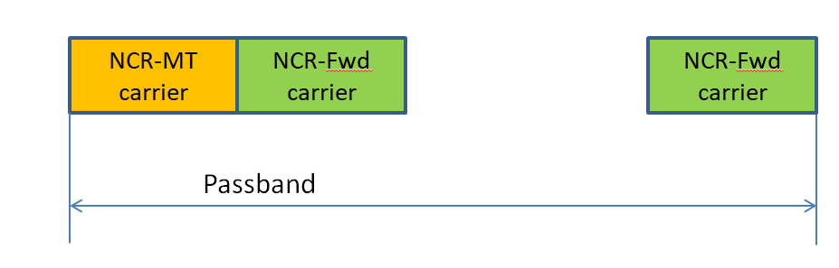

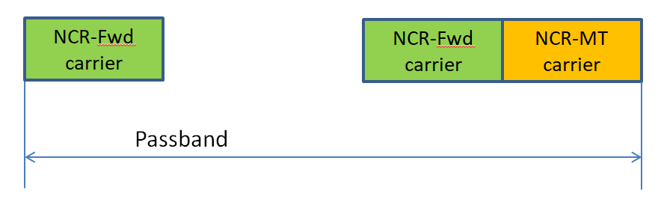

* + RTC2 (for Non-contiguous spectrum operation):

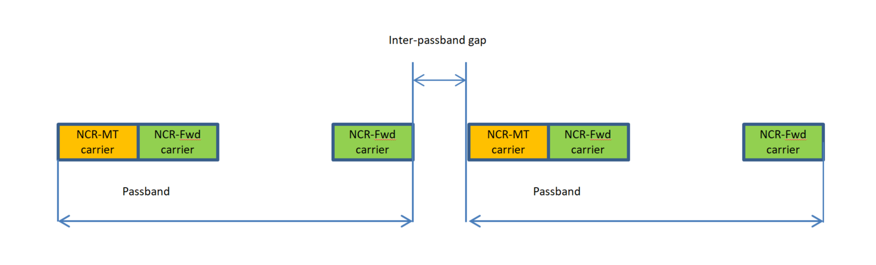

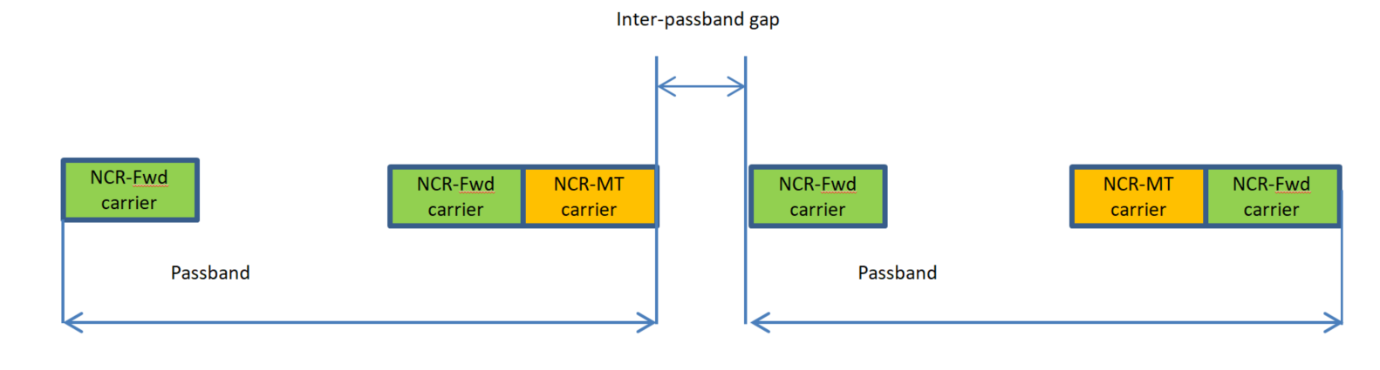

* + Improvement of RTC2 (ZTE):

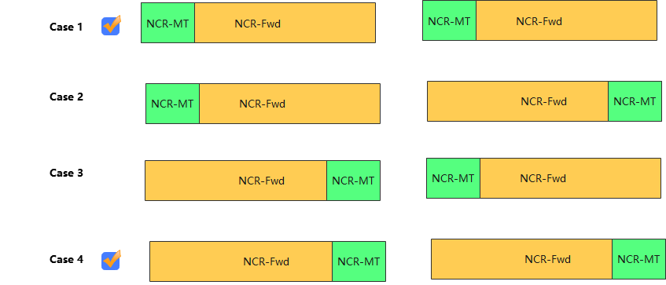

* Option 2 (CMCC):
  + Alternative RTC2:

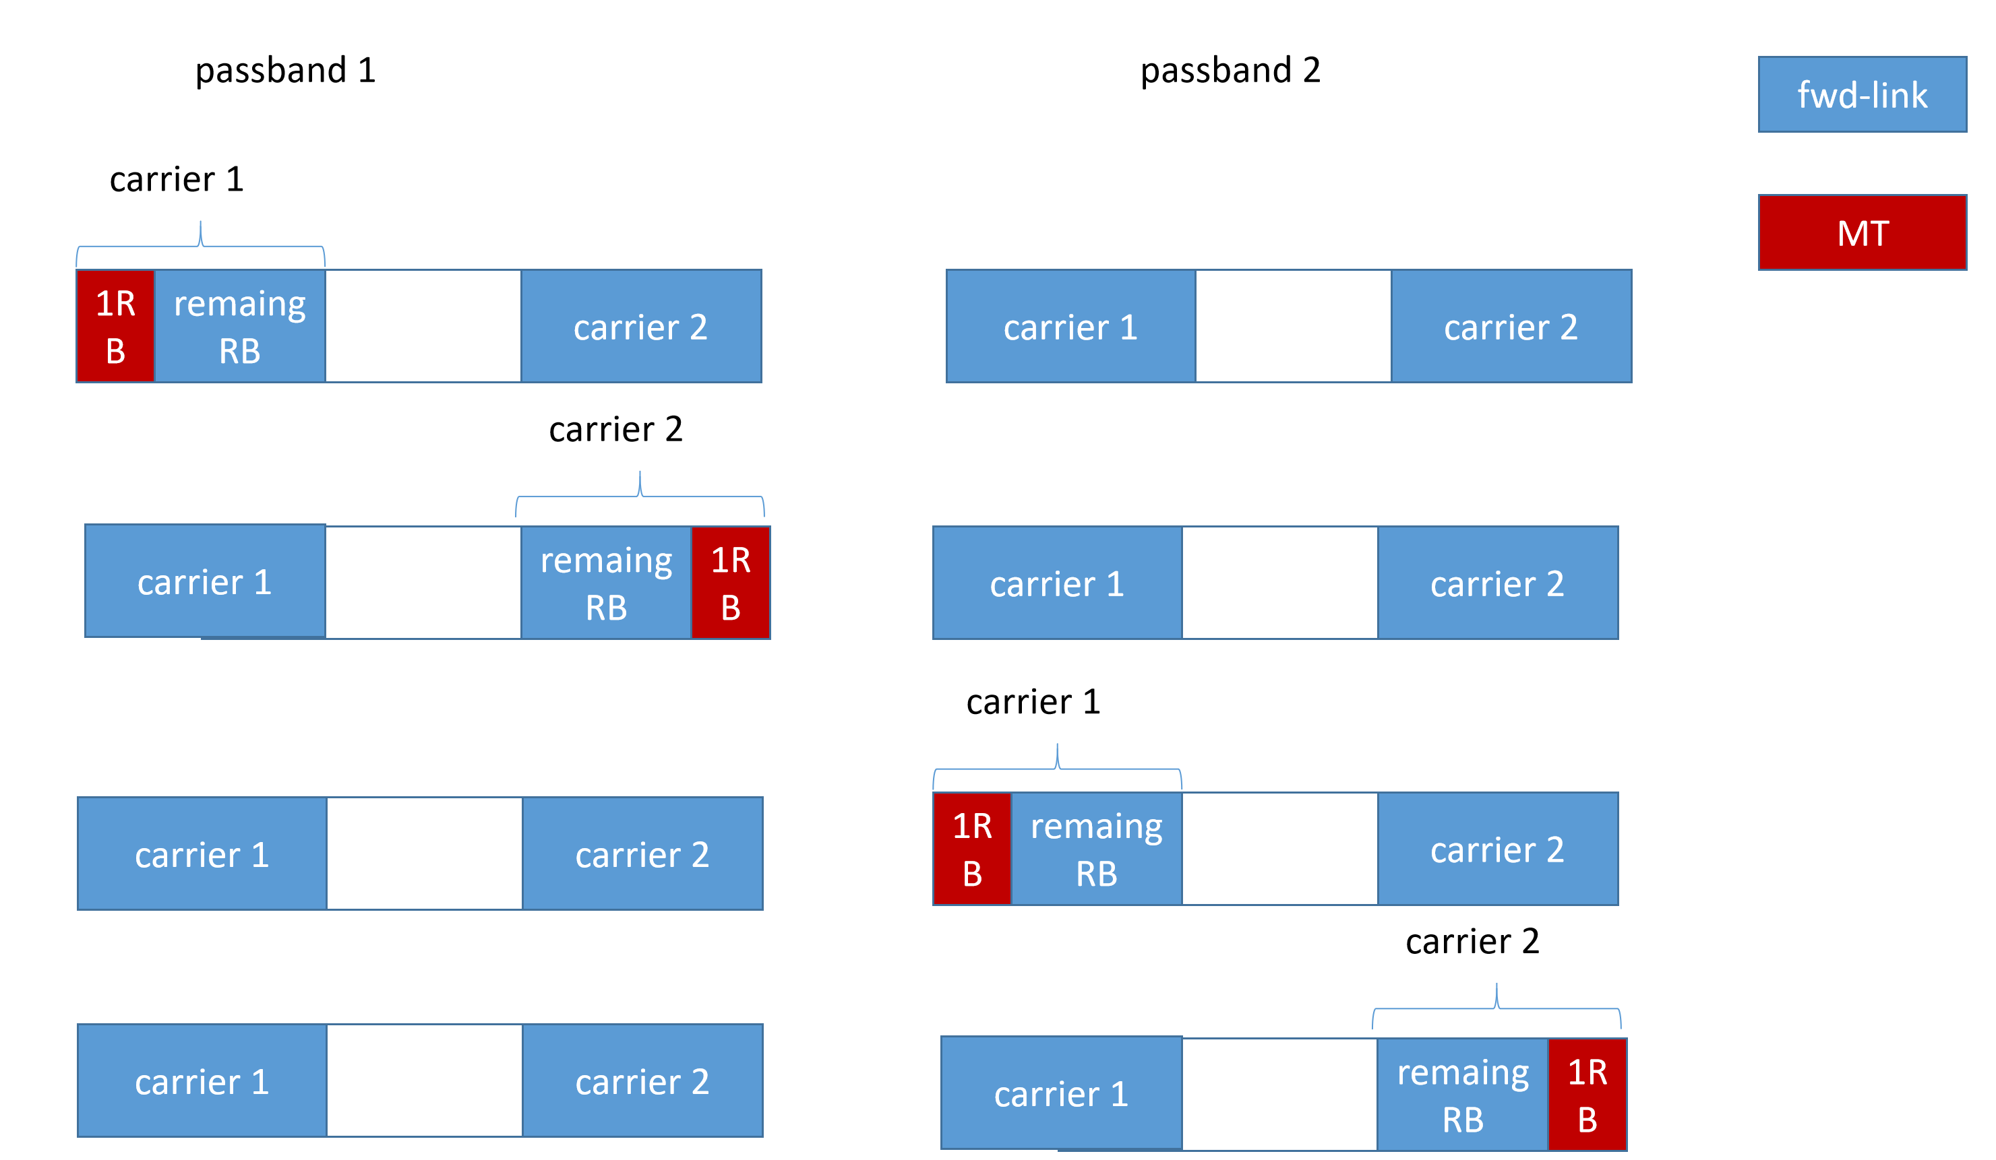

* Recommended WF
  + Option 1 can be agreed.

**Issue 3-2: Test signal**

* Proposals in R4-2320259 (Nokia):
  + Reuse test signal used to build Test Configuration already specified in TS 38.115-1 and 38.115-2.
  + For NCR-MT Rx intermodulation test configuration to modify position of f2 for CW interfering signal.

* Recommended WF
  + Discuss the above proposals in the meeting

**Issue 3-3: Test model**

* Proposal in R4-2320259 (Nokia)
  + Add TM1.1 for both FR1 and FR2 NCR-MT receiver sensitivity requirement.
* Proposal in R4-2318915 (CMCC)
  + At least LA NCR-MT SEM requirements should also be tested under edge_1PRB_left and edge_1PRB_right RB allocations with max Tx power. Additional test mode beside IAB testing modes should be added.
* Recommended WF
  + Discuss in the meeting

# Topic #4: Measurement Uncertainty and Test Tolerance

## Companies’ contributions summary

|  |  |  |
| --- | --- | --- |
| **T-doc number** | **Company** | **Proposals / Observations** |
| R4-2320345 | ZTE Corporation | **Proposal 3:** to use the MU and TT value defined in Rel-17 repeater as baseline for NCR-Fwd type 1-C and type 2-O |

## Open issues summary

**Issue 4-1: Measurement Uncertainty & Test Tolerance**

* Proposals
  + Option 1: (ZTE)
    - NCR-Fwd type 1-C and type 2-O: MU and TT use Rel-17 repeater as starting point
* Recommended WF

To be discussed.