**3GPP TSG-RAN WG4 Meeting # 109 R4-23xxxxx**

**Chicago, US, Nov. 13 – Nov. 17, 2023**

**Agenda item:** 8.28.7

**Source:** Moderator (CATT)

**Title:** Topic summary for [109][312] NR_netcon_repeater_RFConformance

**Document for:** Information

# Introduction

This contribution is the summary for the topic [312] NR_netcon_repeater_RFConformance. It covers the contributions in AI 8.28.4.

# Topic #1: General

## Companies’ contributions summary

|  |  |  |
| --- | --- | --- |
| **T-doc number** | **Company** | **Proposals / Observations** |
| R4-2319178 | Samsung | **Proposal 1**: We propose RAN4 to update previous wayforward to reflect and clarify the following:1) the simultaneous reception should be mandatory supported NOT declaration basis; 2) the simultaneous transmission can be declaration based but should align with its reported capacity.   * One possible updated wording from previous can be following:   + WhetherNCR should supporting NCR-Fwd and NCR-MT simultaneous transmission is manufacture declaration basis, and this should be aligned with its capability signaling.   + ~~Whether NCR supporting NCR-Fwd and NCR-MT simultaneous reception is manufacture declaration basis.~~ |
| R4-2319398 | Ericsson | **Proposal 1:** RAN4 should discuss and conclude on technical feasibility for co-location requirements before a concept is re-used for a new type of network node. |

## Open issues summary

**Issue 1-1: Simultaneously Tx/Rx declaration**

* Proposals
  + Option 1: Modify the simultaneously Tx/Rx declaration related agreements (From RAN4#108 meeting). For simultaneously Tx, supporting of simultaneous Tx is manufacture declaration basis, and this should be aligned with its capability signalling. For simultaneously Rx, there is no declaration because simultaneously Rx is mandatory. (R4-2318915, Samsung)
  + Option 2: Do not modify the existing agreements.
* Recommended WF
  + Discuss in the meeting

**Issue 1-2: Reshaping the assumptions of Co-location requirements**

* Proposals
  + RAN4 should discuss and conclude on technical feasibility for co-location requirements before a concept is re-used for a new type of network node. (R4-2319398, Ericsson)
    - The assumptions of BS co-location requirement are out of fashion in the following aspects, including: unreasonable antenna configurations, inappropriate relaxations, awkward CLTA, and so on.
    - Evolved BS RF core requirements and corresponding BS conformance test requirements are proposed.
* Recommended WF
  + Discuss in the meeting

# Topic #2: Measurement system set-up

## Companies’ contributions summary

|  |  |  |
| --- | --- | --- |
| **T-doc number** | **Company** | **Proposals / Observations** |
| R4-2320345 | ZTE Corporation | **Proposal 1**: for the measurement setup of Input IMD and output IMD of NCR-Fwd type 1-O, propose to consider the following measurement setup for it.  C:\Users\10164284\AppData\Local\Microsoft\Windows\INetCache\Content.MSO\CB820F8A.tmp  Figure 1. measurement setup for Input IMD requirement of FR1 NCR-Fwd type 1-O  C:\Users\10164284\AppData\Local\Microsoft\Windows\INetCache\Content.MSO\37870742.tmp  Figure 2. measurement setup for output IMD requirement of FR1 NCR-Fwd type 1-O |

## Open issues summary

**Issue 2-1: Measurement setup of Input IMD and output IMD of NCR-Fwd type 1-O**

* Proposals
  + Proposal in R4-2320345 (ZTE)
  + For the measurement setup of Input IMD and output IMD of NCR-Fwd type 1-O, propose to consider the following measurement setup for it.

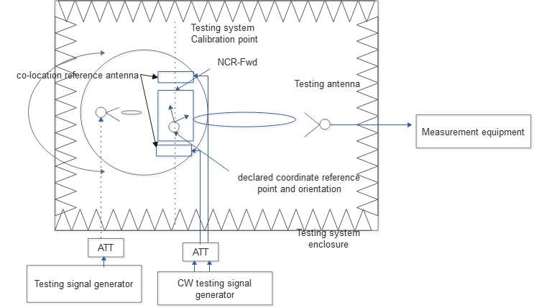

Figure 1. measurement setup for Input IMD requirement of FR1 NCR-Fwd type 1-O

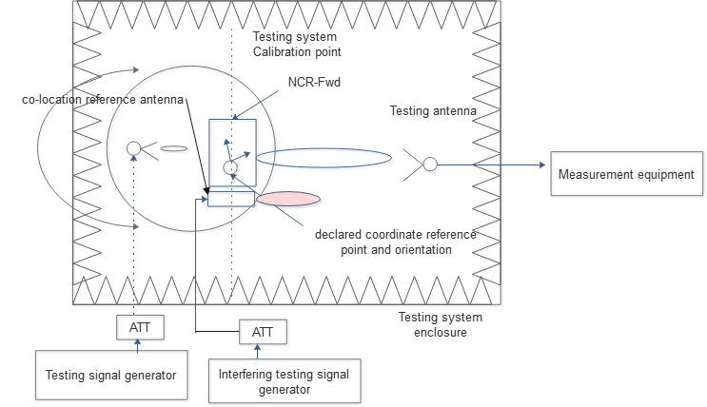

Figure 2. measurement setup for output IMD requirement of FR1 NCR-Fwd type 1-O Recommended WF

* + Discuss the above proposal in the meeting

# Topic #3: Test configuration and Test Model

## Companies’ contributions summary

|  |  |  |
| --- | --- | --- |
| **T-doc number** | **Company** | **Proposals / Observations** |
| R4-2318307 | CATT | **Proposal 1: The proposed RTC1 and RTC2 could be used for joint UL test configuration.** |
| R4-2318915 | CMCC | **Proposal 1: at least LA NCR-MT SEM requirements should also be tested under edge_1PRB_left and edge_1PRB_right RB allocations with max Tx power. Additional test mode beside IAB testing modes should be added.**  **Proposal 2: for the test modes when NCR-MT is configured within all RBs per carrier, option 1 in last meeting WF is OK to show the aggregate emission from MT and fwd-link UL.**  **Proposal 3: for the test modes when NCR-MT is configured at edge 1PRB(if specified), it’s suggested to further discuss the test configuration when MT occupies edge 1PRB and fwd-link occupies remaining PRB within the same carrier. Besides, another fwd-link carrier configured at the other side of pass-band edge. Detailed show as in above fig.** |
| R4-2320259 | Nokia | **Proposal 1: It is proposed to reused test signal used to build Test Configuration already specified in TS 38.115-1 and 38.115-2.**  **Proposal 2: It is proposed to add to TM1.1 for both FR1 and FR2 NCR-MT receiver sensitivity requirement.**  **Proposal 3: It is proposed for NCR-MT Rx intermodulation test configuration to modify position of f2 for CW interfering signal.** |
| R4-2320345 | ZTE Corporation | **Proposal 2:**.   * + - Place an NCR-MT carrier at the lower end of each passband. Generate an NR carrier using test equipment at the upper edge of each passband, and a second NR carrier adjacent to the NCR-MT carrier within each passband. For each passband, if there is insufficient space for the NR carriers then remove firstly the NR carrier adjacent to the NCR-MT carrier and then if needed the NR carrier at the upper end of the passband.     - Place an NCR-MT carrier at the upper end of each passband. Generate an NR carrier using test equipment at the lower edge of each passband, and a second NR carrier adjacent to the NCR-MT carrier within each passband. For each passband, if there is insufficient space for the NR carriers then remove firstly the NR carrier adjacent to the NCR-MT carrier and then if needed the NR carrier at the upper end of the passband.     - Place an NCR-MT carrier at the lower end of one passband and place an NCR-MT carrier at the upper end of another passband. Generate an NR carrier using test equipment at the opposite edge of each passband, and a second NR carrier adjacent to the NCR-MT carrier within each passband. For each passband, if there is insufficient space for the NR carriers then remove firstly the NR carrier adjacent to the NCR-MT carrier and then if needed the NR carrier at the opposite end of the passband.     - Place an NCR-MT carrier at the upper end of one passband and place an NCR-MT carrier at the lower end of another passband. Generate an NR carrier using test equipment at the opposite edge of each passband, and a second NR carrier adjacent to the NCR-MT carrier within each passband. For each passband, if there is insufficient space for the NR carriers then remove firstly the NR carrier adjacent to the NCR-MT carrier and then if needed the NR carrier at the opposite end of the passband. |

## Open issues summary

**Issue 3-1: Test configuration of simultaneously Tx**

* Option 1 (CATT&ZTE):
  + For RTC1 and RTC2, adopt following approach (CATT):
  + RTC1 (for Contiguous spectrum operation):

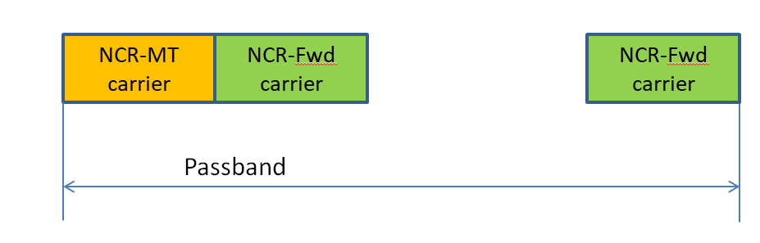

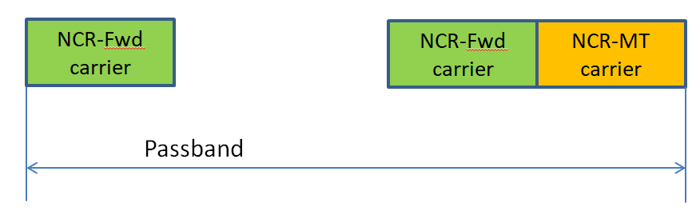

* + RTC2 (for Non-contiguous spectrum operation):

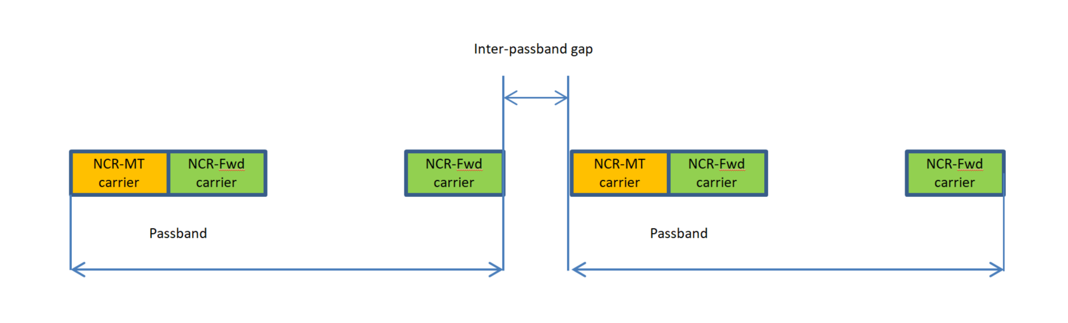

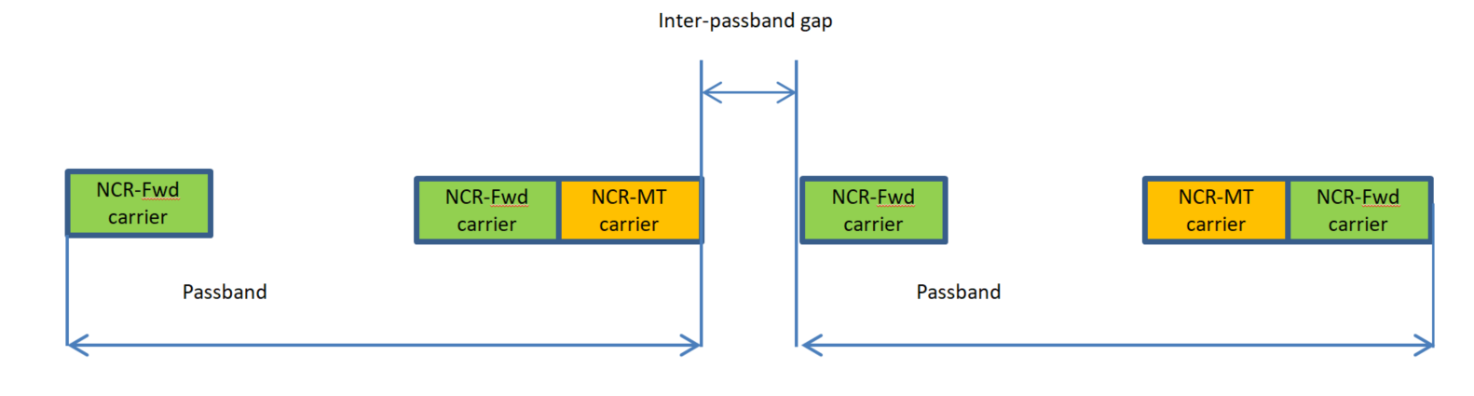

* + Improvement of RTC2 (ZTE):

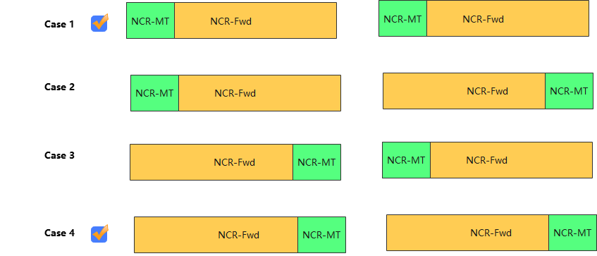

* Option 2 (CMCC):
  + Alternative RTC2:

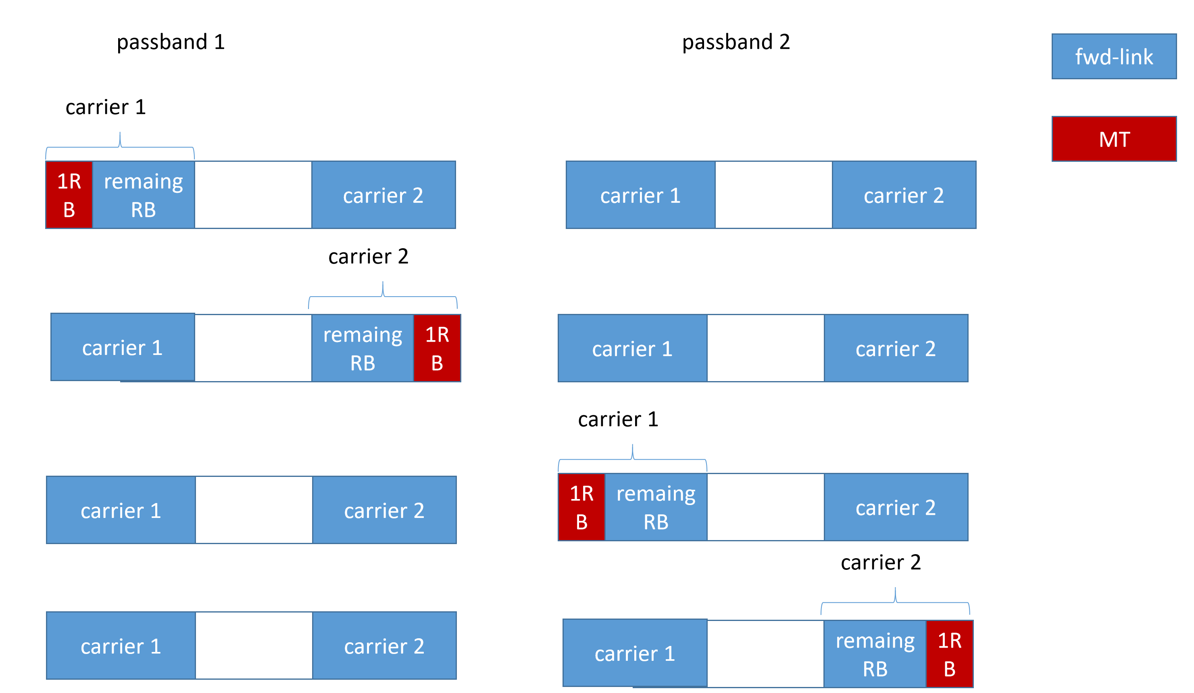

* Recommended WF
  + Discuss the above proposals in the meeting

**Issue 3-2: Test signal**

* Proposals in R4-2320259 (Nokia):
  + Reuse test signal used to build Test Configuration already specified in TS 38.115-1 and 38.115-2.
  + For NCR-MT Rx intermodulation test configuration to modify position of f2 for CW interfering signal.

* Recommended WF
  + Discuss the above proposals in the meeting

**Issue 3-3: Test model**

* Proposal in R4-2320259 (Nokia)
  + Add TM1.1 for both FR1 and FR2 NCR-MT receiver sensitivity requirement.
* Proposal in R4-2318915 (CMCC)
  + At least LA NCR-MT SEM requirements should also be tested under edge_1PRB_left and edge_1PRB_right RB allocations with max Tx power. Additional test mode beside IAB testing modes should be added.
* Recommended WF
  + Discuss in the meeting

# Topic #4: Measurement Uncertainty and Test Tolerance

## Companies’ contributions summary

|  |  |  |
| --- | --- | --- |
| **T-doc number** | **Company** | **Proposals / Observations** |
| R4-2320345 | ZTE Corporation | **Proposal 3:** to use the MU and TT value defined in Rel-17 repeater as baseline for NCR-Fwd type 1-C and type 2-O |

## Open issues summary

**Issue 4-1: Measurement Uncertainty & Test Tolerance**

* Proposals
  + Proposal in R4-2316543 (ZTE)
    - NCR-Fwd type 1-C and type 2-O: MU and TT use Rel-17 repeater as starting point
* Recommended WF
  + Discuss in the meeting