3GPP TSG-RAN WG4 Meeting # 109 R4-23XXXXX
Chicago, USA, November 13 – November 17, 2023

Agenda item: 8.19.4
Source: Moderator (Qualcomm Incorporated)
Title: Topic summary for [109][306] FS_NR_duplex_evo_Part2
Document for: Information

Introduction
This summary covers SBFD [FS_NR_duplex_evo] UE RF agendas 8.19.2.2.3 Feasibility of FR1 UE aspects, 8.19.2.2.4 Feasibility of FR2 UE aspects and 8.19.2.4 Impacts on UE RF requirements.

Topic #1: SBFD UE RF maintenance

Companies’ contributions summary
T-doc number | Company | Proposals / Observations
R4-2318683 | Apple | Title: On UE sub-band selectivity  Observation 1: In the revised UE sub-band selectivity definition, the reference point of this definition is left undefined.  Proposal 1: The reference point for in-channel adjacent subband selectivity is defined as:  • For FR1, UE antenna connector  • For FR2, the center of the quiet zone.  Proposal 2: Whether and how the UE sub-band selectivity requirement should be defined in R19, if a follow-on WI is to follow in R19, should be discussed later.
R4-2318684 | Apple | Title: TP on UE sub-band selectivity and impact on UE RF requirements  Changes according to the R4-2318683. Some of the changes below:  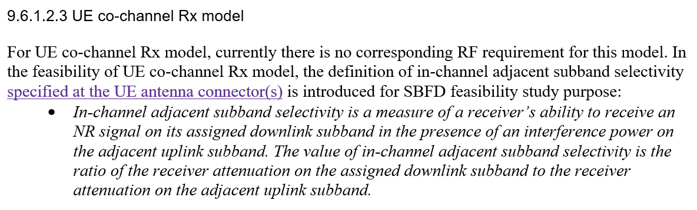  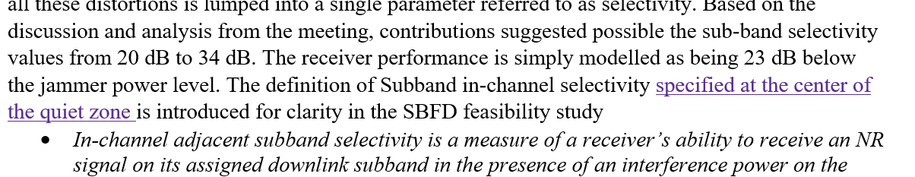
R4-2319002 | vivo | Title: Maintenance TP to TR 38.858 on UE aspects for FR1 in Full Duplex operation  One big change is for the Subband selectivity and it is further refined as follows:  - In-channel adjacent subband selectivity is a measure of a receiver’s ability to receive an NR signal on its assigned downlink subband in the presence of an interference power on the adjacent uplink subband. The value of in-channel adjacent subband selectivity is the ratio of the receiver attenuation on the assigned downlink subband to the receiver attenuation on the adjacent uplink subband.  For UE RF requirements impact, we reached the consensus that:  - Based on the study, existing UE RF requirements has been applied as default assumptions for study phase conclusion, since no issues related to existing UE RF requirements has been identified in the co-existence study.
R4-2319003 | vivo | Title: Maintenance TP to TR 38.858 on UE aspects for FR2-1 in Full Duplex operation  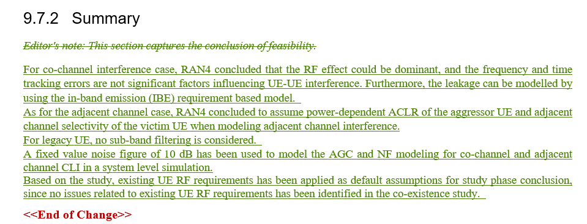

Open issues summary
Before Meeting, moderators shall summarize list of open issues, candidate options and possible WF (if applicable) based on companies’ contributions.

Sub-topic 1 Adjacent subband selectivity
Sub-topic description: What to do with adjacent sub band selectivity in the UE side
Open issues and candidate options before meeting:
Issue 1-1: Point of reference
- Proposals
  - Option 1: FR1 in Connector and FR2 center of QZ and approve TP R4-2318684 to add that in to TR
  - Option 2: Other
- Recommended WF
  - TBA

Issue 1-2: Need for R19 UE specification.
- Proposals
  - Option 1: Requirement for UE to be discussed later
  - Option 2: Other, such as discuss now?
- Recommended WF
  - To be discussed as part of the WI RAN4 objective discussion

Sub-topic 2 TR maintenance and conclusions
Sub-topic description
Open issues and candidate options before meeting:
Issue 2-1: Location of mentioning ”existing requirements can be applied as default assumptions”
- Proposals
  - Option 1: In “General” keep as is
  - Option 2: In Summary as proposed in R4-2319002
- Recommended WF
  - TBA
Issue 2-2: “Discussing requirements in WID phase”
- Proposals
  - Option 1: In Summary as it is now
  - Option 2: Remove as proposed in R4-2319002
- Recommended WF
  - TBA
Issue 2-3: FR2 summary as proposed in R4-2319003
- Proposals
  - Option 1: Leave summary for FR2 open, keep as is now
  - Option 2: Include summary as proposed in R4-2319003
- Recommended WF
  - Option 2, summary for FR2 seems to be missing otherwise

