3GPP TSG-RAN WG4 Meeting#109 R4-23XXXXX
Chicago, US, 13th – 17th November 2023

Agenda item: 11.4
Source: Moderator (Apple)
Title: Topic summary for [109][236] Reply_LS
Document for: Information

Introduction
This topic summary covers AI 11.1.1, 11.2.1, 11.2.2, 11.2.3, 11.2.4, 11.3.1, 11.3.2, 11.3.4, including the following LS discussion on RRM,
Rel-18 related:
- LS on combination of HST and RRM relaxation (R2-2311435)
Rel-17 related:
- Applicability of pre-configured measurement gaps for RedCap UE (R3-233478)
  - No contribution in this meeting
- Monitoring of paging occasions for CG-SDT with HD-FDD Redcap UEs (R2-2304562)
- LS on CG-SDT RRM test procedure (R5-235340)
- Reply LS on monitoring of paging occasions for CG-SDT with HD-FDD Redcap UEs (R2-2311424)
  - No contribution in this meeting
R15, R16 related:
- LS on RRM test cases with testability issues (R5-233782)
- LS on SRS antenna switching for TDD-FDD band combinations (R1-2308582)
  - No contribution in this meeting
- Reply LS on update for “interBandMRDC-WithOverlapDL-Bands-r16” in 38.306 (R2-2309218)

Topic #1: LS on combination of HST and RRM relaxation (R2-2311435)
Main technical topic overview. The structure can be done based on sub-agenda basis.

Companies’ contributions summary
T-doc number | Title | Company | Proposals / Observations
R4-2318621 | Discussion on RAN2 LS on combination of HST and RRM relaxation | Apple
R4-2318622 | Reply LS on combination of HST and RRM relaxation | Apple
R4-2320148 | CR on combination of HST and RRM relaxation - R16 | Apple
R4-2320149 | CR on combination of HST and RRM relaxation - R17 | Apple
R4-2320150 | CR on combination of HST and RRM relaxation - R18 | Apple

Open issues summary

Sub-topic 1-1
Issue 1-1-1: whether the UE behavior needs to be clarified when when both HST flag and power saving flag are configured?
- Proposals
  - Proposal 1: it is better to clarify UE measurement behavior when both HST flag and relaxed measurement flag are configured, especially at train station wherein there could be many UE on HST and also large number of UE not on HST.
  - Other, please specify.
- Recommended WF

Issue 1-1-2: if answer to 1-1-1 is yes, how to clarify the UE behavior?
- Proposals
  - Proposal 1: clarify that UE is allowed to enable relaxed measurement when both HST flag and low mobility evaluation are enabled. This has no negative impact on UE in high mobility mode, since the relaxed measurement criteria are unlikely to be met for them.
  - Other, please specify.
- Recommended WF

Issue 1-1-3: Please comment on the CR in R4-2320148/49/50. Agreeable or not?

Issue 1-1-4: is the LS in R4-2318622 agreeable?
- Proposals
  - Option 1: yes
  - Option 2, No. please give comments.

Topic#2: Monitoring of paging occasions for CG-SDT with HD-FDD Redcap UEs
Main technical topic overview. The structure can be done based on sub-agenda basis.

Companies’ contributions summary
T-doc number | Title | Company | Proposals / Observations
R4-2319385 | Modification on interruption in paging reception for HD-FDD RedCap UEs | Huawei, HiSilicon | For RedCap UE in HD-FDD mode, if paging occasions partially overlap with CG-SDT transmission, the UE is only required to monitor for SI change indication in any paging occasion at least once per modification period [2] during SDT if the initial downlink BWP on which the SDT procedure is ongoing is associated with a CD-SSB.
R4-2319386 | Modification on interruption in paging reception for HD-FDD RedCap UEs | Huawei, HiSilicon | Cat A
R4-2320069 | CR on interruption in paging reception for HD-FDD RedCap Ues | vivo | For RedCap UE in HD-FDD mode, the UE is only required to monitor for SI change indication in any paging occasion other than occasions overlap with CG-SDT at least once per modification period [2] during SDT if the initial downlink BWP on which the SDT procedure is ongoing is associated with a CD-SSB.
R4-2320070 | CR on interruption in paging reception for HD-FDD RedCap Ues R17 | vivo | Cat A

Open issues summary

Sub-topic 1-1
Issue 1-1-1: Which modification is acceptable？
- Proposals
  - Proposal 1:
For RedCap UE in HD-FDD mode, if paging occasions partially overlap with CG-SDT transmission, the UE is only required to monitor for SI change indication in any paging occasion at least once per modification period [2] during SDT if the initial downlink BWP on which the SDT procedure is ongoing is associated with a CD-SSB.
  - Proposal 2:
For RedCap UE in HD-FDD mode, the UE is only required to monitor for SI change indication in any paging occasion other than occasions overlap with CG-SDT at least once per modification period [2] during SDT if the initial downlink BWP on which the SDT procedure is ongoing is associated with a CD-SSB.
  - Other, please specify.
- Recommended WF

Topic #3: LS on CG-SDT RRM test procedure
Main technical topic overview. The structure can be done based on sub-agenda basis.

Companies’ contributions summary
T-doc number | Title | Company | Proposals / Observations
R4-2320476 | [NR_SmallData_INACTIVE-Perf] CR on CG-SDT RRM test procedure | Qualcomm Incorporated
R4-2320477 | [NR_SmallData_INACTIVE-Perf] CR on CG-SDT RRM test procedure | Qualcomm Incorporated
R4-2321012 | [NR_SmallData_INACTIVE-Perf] Formal CR to Rel-17 TS 38.133 on SDT test cases | MediaTek inc.
R4-2321013 | [NR_SmallData_INACTIVE-Perf] Formal CR to Rel-18 TS 38.133 on SDT test cases (Mirror) | MediaTek inc.
R4-2321014 | [NR_redcap-Perf] Formal CR to Rel-17 TS 38.133 on RedCap SDT test cases | MediaTek inc.
R4-2321015 | [NR_redcap-Perf] Formal CR to Rel-18 TS 38.133 on RedCap SDT test cases (Mirror) | MediaTek inc.

Open issues summary

Sub-topic 2-1
Issue 2-1-1: whether additional changes are needed for endorsed CR on CG-SDT RRM test case?
- Proposals
  - Option 1: Yes, Add 40MHz BW in test parameter for test configuration 3 and update Io in Table A.6.2.1.2-3 as proposed in R4-2320476.
  - Option 2: No, agree R4-2321012 which is based on the endorsed CR in RAN4#108bis.

- Recommended WF

Issue 2-1-2: Is CR in R4-2321014 (which is based on the endorsed CR in RAN4#108bis) agreeable or not?
- Proposals
  - Option 1: Yes
  - Option 2: No

- Recommended WF
  - Option 1

Topic #4: LS on RRM test cases with testability issues
Main technical topic overview. The structure can be done based on sub-agenda basis.

Companies’ contributions summary
T-doc number | Title | Company | Proposals / Observations
R4-2318623 | CR on RRM test cases with testability issues - R15 | Apple | Modification on test case list in R15
R4-2318624 | CR on RRM test cases with testability issues - R16 | Apple | Modification on test case list in R16
R4-2318625 | CR on RRM test cases with testability issues - R17 | Apple | Modification on test case list in R17
R4-2318626 | CR on RRM test cases with testability issues - R18 | Apple | Cat A

Open issues summary

Sub-topic 4-1
Issue 4-1-1: whether the R16 CR in R4-2318623/24/25 is agreeable or not?
- Proposals
  - Option 1: Yes
  - Option 2: No
- Recommended WF
  - These CRs are endorsed in the last meeting. Option 1 if no new comment in this meeting.

Topic #6: Reply LS on update for “interBandMRDC-WithOverlapDL-Bands-r16” in 38.306.

Companies’ contributions summary
T-doc number | Title | Company | Proposals / Observations
R4-2319497 | CR for MRTD/MTTD requirement for EN-DC/NE-DC (R16) | OPPO
R4-2319498 | Discussion on left issues for MRTD-MTTD requirements in ENDC and NEDC | OPPO
R4-2320496 | further discussion on MTTD/MRTD requirement for FDD-FDD inter-band EN-DC/NE-DC with overlapping DL frequency | Apple

Open issues summary

Sub-topic 5-1
Issue 5-1-1: RAN4 to discuss whether the 4th scenario in asyncIntraBandENDC is applicable also for FDD-FDD inter-band EN-DC?
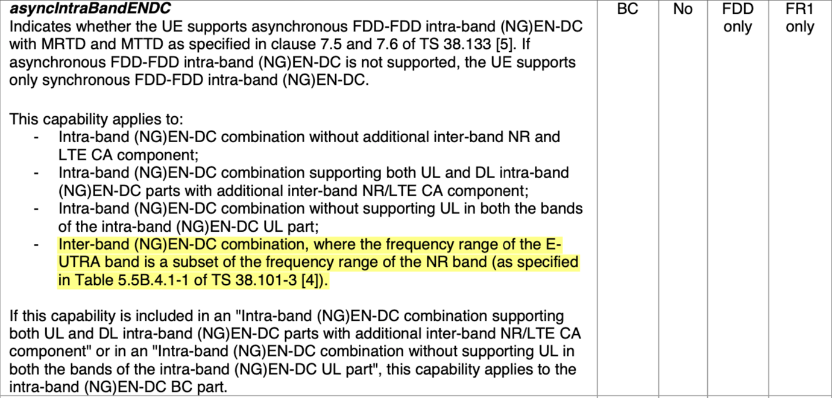

- Proposals
  - Option 1: yes
  - Option 2: no, FDD-FDD inter-band EN-DC with overlapping DL frequency apply asynchronous requirement mandatorily.
- Recommended WF

Issue 5-1-2: RAN4 to discuss whether the 4th scenario in asyncIntraBandENDC is applicable for TDD-TDD inter-band EN-DC with overlapping DL frequency?
- Proposals
  - Option 1: Yes
  - Option 2: no, TDD-TDD inter-band EN-DC with overlapping DL frequency is only limited to synchronous case.
- Recommended WF

Issue 5-1-3: RAN4 to discuss whether to define the requirements of MTTD/MRTD for TDD-TDD inter-band sync NE-DC with overlapping DL bands?
- Proposals
  - Option 1: Yes
  - Option 2: no, stick to previous agreement in RAN4#107 meeting. No such combination.
- Recommended WF

Issue 5-1-4: How to treat CR in R4-2318627 which is based on the endorsed CR in the last RAN4 meeting?
- Proposals
  - Option 1: approve CR in R4-2318627.
  - Option 2: update the CR in R4-2318627 according to discussion on Issue 5-1-1 and Issue 5-1-2.
    - Updated LS out may also be needed.
- Recommended WF

