**3GPP TSG-RAN WG4 Meeting # 109 R4-2321339**

**Chicago, US, November 13 – 17, 2023**

**Agenda item:** 9.6.7

**Source:** Moderator (MediaTek inc.)

**Title:** Ad-hoc minutes on IoT_NTN_enh WI

**Document for:** Approval

# Introduction

This is the ad-hoc minutes for [109][235] IoT_NTN_enh

* Topic #1: RRM core requirements (AI 9.6.4)

# Topic #1: RRM core requirements

Sub-Topic 1-2: CONN mode neighbour cell measurements

Issue 1-2-1: For NB-IoT NGSO, intra-frequency inter-satellite neighbour cell measurement

Agreement:

* Define requirements for NGSO intra-frequency inter-satellite neighbour cell measurement as “inter-frequency” case
* Add condition that requirements apply provided that cell is available as indicated by t-ServiceStartNeigh if indicated.

Issue 1-2-3: For eMTC, time-based triggering and MG perspectives

Agreement:

* For eMTC neighbour cell measurement, MG shall be configured as legacy TN case.
* RAN4 tentatively agree that the MG is suspended till the time t-serviceStartNeigh
  + Companies to check with RAN2 colleague with this RAN4 tentiave agreement in this week.
  + Detailed wording to be updated, to be aligned the wording of Issue 1-2-5.

Issue 1-2-5: For eMTC, suspend MG upon *t-ServiceStarNeigh*

Proposals:

* Proposal 1 (CMCC): Considering the network could set the ‘*t-ServiceStarNeigh*’ ideally or early than ideal timing, the measurement gap pattern(s) configured for neighbour cell measurements can be suspended until the earliest time *t-ServiceStartNeigh* among neighbour satellites.
* Proposal 2 (Huawei): Measurement gap pattern(s) configured for neighbour cell measurements are suspended when *t-ServiceStartNeigh* is configured for all satellite and the earliest *t-ServiceStartNeigh* has not started.
* Proposal 3 (Ericsson): If *t-ServiceStart* is provided, measurement gap pattern(s) configured for neighbour cell measurements are suspended until time *t-ServiceStart*.
* Proposal 4 (Nokia): If the UE is provided with MG for neighbor cell measurements, if t-serviceStartNeigh is provided for a given frequency, the UE is allowed to drop the MGs for that frequency. The MG might be used for measurements in different frequencies.
* Proposal 5 (new) (Qualcomm): add some more details for clarification
  + • If there is no other frequency/cells needing the MG
  + • There is no intra-frequency inter-satellite measurement needing the MG
  + • MG suspended until the earliest t-serviceStartNeigh of all satellites needing the MG.

Recommended WF:

* If *t-ServiceStartNeigh* is provided for all satellite for a given frequency, measurement gap pattern(s) configured for neighbour cell measurements are suspended until the earliest t-ServiceStartNeigh.

Discussion:

Tentative agreement in Ad-hoc:

Issue 1-2-6: For NB/eMTC NGSO, Ksatellite in Re-establishment delay requirement

Proposals:

* Proposal 1 (Ericsson): If the *carrierFreqList* in SIB32 indicates that current and target cells belong to the same carrier, then Ksatellite,I can be set to 1. Otherwise, Ksatellite,I shall correspond to the number of NGSO satellites the UE shall monitor.

Recommended WF:

* Discuss the proposal.

Discussion:

Tentative agreement in Ad-hoc:

Sub-Topic 1-3: eMTC, CHO

Issue 1-3-1: For eMTC, CHO requirements

Background: Agreement in RAN4 #108bis

*Agreement:*

* *Introduce CHO requirements for NTN eMTC with time and location-based trigger conditions. DCHO = TRRC + Tmeasure + TEvent_DU +Tinterrupt + TCHO_execution*

*Where:*

* + *TRRC is the RRC procedure delay*
  + *TEvent_DU is the delay uncertainty which is the time from when the UE successfully decodes a conditional handover command until the time/location condition fulfilled.*
  + *Tmeasure is the measurements time. Tmeasure=0 if only condEventD1 or condEventT1 is configured.*
  + *TCHO_execution is the conditional execution preparation time*
  + *Tinterrupt is the interruption time.*
  + *FFS Update Tinterrupt to include Tsearch, based on handover interruption requirement as in*
    - *5.5A.2.1.2 Interruption time for CEMode A*
    - *5.5A.3.1.2 Interruption time for CEMode A*

More information provided below:

5.5A.2.1.2 Interruption time

Tsearch is the time required to search the target cell when the handover command is received by the UE. If the target cell is known, then Tsearch = 0 ms. If the target cell is unknown and signal quality is sufficient for successful cell detection on the first attempt, then Tsearch = 80 ms. Otherwise, Tsearch shall be according to the non-DRX cell identification requirements specified in Clause 8.13A.2.1 for intra-frequency handover for a UE configured with CEModeA or Tsearch shall be according to the non-DRX cell identification requirements specified in Clause 8.13A.2.2 for inter-frequency handover for a UE configured with CEModeA. Regardless of whether DRX is in use by the UE, Tsearch shall still be based on non-DRX target cell search times.

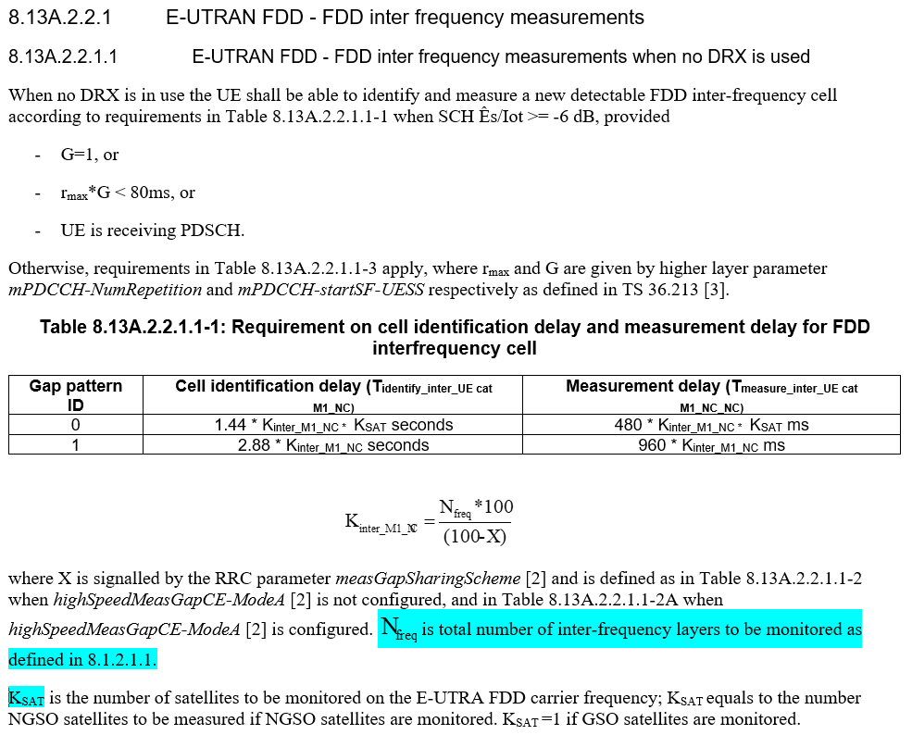

Proposals:

* Proposal 1 (CMCC):
  + *Update Tinterrupt to include Tsearch, based on handover interruption requirement as in*
    - *5.5A.2.1.2 Interruption time for CEMode A*
    - *5.5A.3.1.2 Interruption time for CEMode A*
* Proposal 2 (Ericsson): The interruption time in conditional handover requirements shall not include Tsearch.

*Moderators’ Note:*

* *condEventD1/T1 can be configured without signal quality criteria and thus UE may not have measured the target CHO cell. So it could be different from the legacy CHO.*
* *Please also check more information provided above.*

Recommended WF:

* Update Tinterrupt to include Tsearch, based on handover interruption requirementwith KSAT =1, and Nfreq=1

Discussion:

Tentative agreement in Ad-hoc:

Sub-Topic 1-4: GNSS re-acquisition gap in connected mode

Issue 1-4-1: GNSS-MG spec impact

Background: Agreement in RAN4 #108bis

*Discuss the following options until next meeting.*

* *Option 1: add generic description that the measurement delay could be longer if GNSS fix happens during measurement period.*
* *Option 2: The measurement delay requirements are extended by the duration of the GNSS-MG.* 
  + *When the UE triggers an early termination of the GNSS-MG, the measurement delay requirements are extended by the duration of the early-terminated GNSS-MG.*
* *Option 3: The measurement delay requirements are suspended until the termination of the GNSS-MG.*

Background: RAN2#123bis agreement

*Proposal 4: The following update in NOTE in Stage 2 running CR is agreed:*

*NOTE: The AS operations (e.g. RLM related timers, dataInactivityTimer, CHO execution, neighbour cell measurement, RACH, SR, and BSR) are* ***suspended*** *when UE is performing GNSS measurement during GNSS measurement gap and* ***resumed*** *when the GNSS measurement is finished*

**Agreed**

Proposals:

* Proposal 1: add generic description that the measurement delay requirements are suspended and resumed when the GNSS measurement is finished. (MTK)
  + When the UE triggers an early termination (i.e. MSG3) of the GNSS-MG, the measurement delay requirements are suspended by the duration of the early-terminated GNSS-MG.
  + The UE shall restart the cell detection/measurement when the interval between two samples are larger than 5000 ms.
* Proposal 2 (CMCC)
  + When the GNSS gap shorter than [5]s, the measurement delay requirements are extended by the duration of the GNSS-MG.
  + When the GNSS gap equal or longer than [5]s, UE should re-start the measurements after GNSS measurement gap. The requirements are not applicable when the UE is performing GNSS measurement using such gaps.
* Proposal 3 (Huawei): Add generic description that the measurement delay could be longer if GNSS fix happens during measurement period
* Proposal 4 (Ericsson): Measurements that occur during GNSS reacquisition time period using gaps are suspended.
* Proposal 5 (Nokia):
  + For the cases where the GNSS-MG is smaller than the eDRX cycle, the RLM requirements are still applicable.
  + When the GNSS-MG is shorter than the (e)DRX cycle and it collides with the on Duration part of one (e)DRX cycle, the time to evaluate requirements might be extended by one (e)DRX cycle.
  + When the UE is configured with eDRX cycle, and the GNSS-MG is larger than the eDRX cycle, the requirements applicable right after the GNSS-MG shall be corresponding to a DRX cycle of [1.28] s.

Moderator’s Note:

Recommended WF:

* Add generic description that the measurements are suspended when UE is performing GNSS measurement during GNSS measurement gap. Wording to be discussed directly in the CR.
* Discuss whether the UE shall restart the cell detection/measurement when the interval between two samples are larger than 5000 ms.
* Further discuss the following proposals for (e)DRX cycle during the meeting
  + For the cases where the GNSS-MG is smaller than the eDRX cycle, the RLM requirements are still applicable.
  + When the GNSS-MG is shorter than the (e)DRX cycle and it collides with the on Duration part of one (e)DRX cycle, the time to evaluate requirements might be extended by one (e)DRX cycle.
  + When the UE is configured with eDRX cycle, and the GNSS-MG is larger than the eDRX cycle, the requirements applicable right after the GNSS-MG shall be corresponding to a DRX cycle of [1.28] s.

Discussion:

Tentative agreement in Ad-hoc:

Issue 1-4-2: For eMTC, GNSS-MG overlapping with MG

Background: Agreement in RAN4 #108bis

*Agreement:*

* *If gaps configured for reacquiring GNSS and gaps configured for mobility measurements at least partially overlaps in time with other, then UE shall suspend the gaps configured for mobility measurements and instead prioritize the use of GNSS gaps*
  + *Note: it considers as no overlapping between GNSS-MG and gaps configured for mobility measurements after the UE has performed early termination of GNSS-MG.*

Proposals:

* Proposal 1: When GNSS gap overlaps with MG, MG is not suspended if GNSS-MG is terminated earlier than MG and UE does not sent CBRA or after CBRA if CBRA is sent. (Huawei)

Recommended WF:

* When GNSS gap overlaps with MG, MG applies if GNSS-MG is terminated earlier than MG and after CBRA if CBRA is sent.
  + Further discuss whether MG is applicable if GNSS-MG is terminated earlier than MG but the UE does not sent CBRA.

Discussion:

Tentative agreement in Ad-hoc:

TDoc recommendation

Below if for information purpose.

IoT

|  |  |  |  |  |
| --- | --- | --- | --- | --- |
| [**R4-2318074**](https://www.3gpp.org/ftp/TSG_RAN/WG4_Radio/TSGR4_109/Docs/R4-2318074.zip) | CR on cell re-selection requirement for IoT NTN enhancement for UE category NB-IoT | MediaTek inc. | draftCR | Agreeable? |
| [**R4-2320742**](https://www.3gpp.org/ftp/TSG_RAN/WG4_Radio/TSGR4_109/Docs/R4-2320742.zip) | DraftCR to 36.133 on Connected Mode Mobility for IoT NTN | Nokia, Nokia Shanghai Bell | draftCR | Revision  to apply inter-freq. meas. manner to inter-satellite measurement |
| [**R4-2319353**](https://www.3gpp.org/ftp/TSG_RAN/WG4_Radio/TSGR4_109/Docs/R4-2319353.zip) | Draft CR on RRM impact of GNSS re-acquisition for NB-IoT | Huawei, HiSilicon | draftCR | Revision?  to capture new Agreement |

eMTC

|  |  |  |  |  |
| --- | --- | --- | --- | --- |
| [**R4-2320015**](https://www.3gpp.org/ftp/TSG_RAN/WG4_Radio/TSGR4_109/Docs/R4-2320015.zip) | draftCR on IDLE mode requirements for eMTC over NTN | Huawei, HiSilicon | draftCR | Agreeable? |
| [**R4-2320743**](https://www.3gpp.org/ftp/TSG_RAN/WG4_Radio/TSGR4_109/Docs/R4-2320743.zip) | DraftCR to 36.133 on Connected Mode Mobility for Emtc NTN | Nokia, Nokia Shanghai Bell | draftCR | Revision  Remove FFSs |
| [**R4-2318913**](https://www.3gpp.org/ftp/TSG_RAN/WG4_Radio/TSGR4_109/Docs/R4-2318913.zip) | Draft CR to TS 36.133: Conditional HO for Cat-M1 for IOT-NTN | CMCC | draftCR | Revision?  to capture new Agreement |
| [**R4-2320141**](https://www.3gpp.org/ftp/TSG_RAN/WG4_Radio/TSGR4_109/Docs/R4-2320141.zip) | IoT NTN RRM requirements during GNSS reacquisition | Ericsson | draftCR | Revision |

For IoT/eMTC

|  |  |  |  |  |
| --- | --- | --- | --- | --- |
| [**R4-2320142**](https://www.3gpp.org/ftp/TSG_RAN/WG4_Radio/TSGR4_109/Docs/R4-2320142.zip) | IoT NTN RRC re-establishment requirements during discontinuous coverage | Ericsson | draftCR | Online discussion first |