**3GPP TSG-RAN WG4 Meeting # 109 [R4-2321969](http://10.10.10.10/ftp/RAN/RAN4/Inbox/R4-2321969.zip)**

**Chicago, USA, Nov 13 – Nov 17, 2023**

|  |  |  |  |  |  |  |  |  |
| --- | --- | --- | --- | --- | --- | --- | --- | --- |
| *CR-Form-v12.2* | | | | | | | | |
| **CHANGE REQUEST** | | | | | | | | |
|  | | | | | | | | |
|  | **38.101-5** | **CR** |  | **rev** | **1** | **Current version:** | **18.3.0** |  |
|  | | | | | | | | |
| *For* ***[HE](http://www.3gpp.org/3G_Specs/CRs.htm" \l "_blank)******[LP](http://www.3gpp.org/3G_Specs/CRs.htm" \l "_blank)*** *on using this form: comprehensive instructions can be found at  <http://www.3gpp.org/Change-Requests>.* | | | | | | | | |
|  | | | | | | | | |

|  |  |  |  |  |  |  |  |  |
| --- | --- | --- | --- | --- | --- | --- | --- | --- |
| ***Proposed change affects:*** | UICC apps |  | ME | **X** | Radio Access Network |  | Core Network |  |

|  |  |  |  |  |  |  |  |  |  |  |
| --- | --- | --- | --- | --- | --- | --- | --- | --- | --- | --- |
|  | | | | | | | | | | |
| ***Title:*** | Draft CR to TS 38.101-5 Clause 9.3 Output power dynamics | | | | | | | | | |
|  |  | | | | | | | | | |
| ***Source to WG:*** | ZTE Corporation | | | | | | | | | |
| ***Source to TSG:*** | R4 | | | | | | | | | |
|  |  | | | | | | | | | |
| ***Work item code:*** | NR\_NTN\_enh-Core | | | | |  | ***Date:*** | | | 2023-10-31 |
|  |  | | | |  | |  | | |  |
| ***Category:*** | **B** |  | | | | | ***Release:*** | | | Rel-18 |
|  | *Use one of the following categories:* ***F*** *(correction)* ***A*** *(mirror corresponding to a change in an earlier release)* ***B*** *(addition of feature),* ***C*** *(functional modification of feature)* ***D*** *(editorial modification)*  Detailed explanations of the above categories can be found in 3GPP [TR 21.900](http://www.3gpp.org/ftp/Specs/html-info/21900.htm). | | | | | | | | *Use one of the following releases: Rel-8 (Release 8) Rel-9 (Release 9) Rel-10 (Release 10) Rel-11 (Release 11) … Rel-16 (Release 16) Rel-17 (Release 17) Rel-18 (Release 18) Rel-19 (Release 19)* | |
|  |  | | | | | | | | | |
| ***Reason for change:*** | | This CR introduces VSAT requirements for NTN Ka bands according to the agreed work split. | | | | | | | | |
|  | |  | | | | | | | | |
| ***Summary of change:*** | | To introduce the NTN VSAT output dynamic requirements | | | | | | | | |
|  | |  | | | | | | | | |
| ***Consequences if not approved:*** | | The NTN ka-bands won’t be correctly supported | | | | | | | | |
|  | |  | | | | | | | | |
| ***Clauses affected:*** | | 9.3 | | | | | | | | |
|  | |  | | | | | | | | |
|  | | **Y** | **N** |  | | | |  | | |
| ***Other specs*** | |  | **X** | Other core specifications | | | | TS/TR ... CR ... | | |
| ***affected:*** | |  | **X** | Test specifications | | | | TS/TR ... CR ... | | |
| ***(show related CRs)*** | |  | **X** | O&M Specifications | | | | TS/TR ... CR ... | | |
|  | |  | | | | | | | | |
| ***Other comments:*** | |  | | | | | | | | |
|  | |  | | | | | | | | |
| ***This CR's revision history:*** | |  | | | | | | | | |

*<Start of the change>*

## 9.3 Output power dynamics

### 9.3.1 Minimum output power

#### 9.3.1.0 General

The minimum controlled output power of the VSAT is defined as the EIRP in the channel bandwidth for all transmit bandwidth configurations (resource blocks) when the power is set to a minimum value.

The minimum output power is defined as the mean power in at least one sub frame (1ms).

#### 9.3.1.1 Minimum output power for Mobile VSAT

For mobile VSAT, the minimum output power shall not exceed the values specified in Table 9.3.1.1-1 for each operating band supported. The minimum power is verified in beam locked mode with the test metric of EIRP (Link=TX beam peak direction, Meas=Link angle).

Table 9.3.1.1-1: Minimum output power for VAST type 4 and type 5

|  |  |  |  |
| --- | --- | --- | --- |
| Operating band | Channel bandwidth  (MHz) | Minimum output power  (dBm) | Measurement bandwidth  (MHz) |
| n512, n511 | 50 | [TBD] | 47.58 |
|  | 100 | [TBD] | 95.16 |
|  | 200 | [TBD] | 190.20 |
|  | 400 | [TBD] | 380.28 |

#### 9.3.1.2 Minimum output power for Fixed VSAT

For fixed VSAT, the minimum output power shall not exceed the values specified in Table 9.3.1.2-1 for each operating band supported. The minimum power is verified in beam locked mode with the test metric of EIRP (Link=TX beam peak direction, Meas=Link angle).

Table 9.3.1.2-1: Minimum output power for VAST type 1, type 2 and type 3

|  |  |  |  |
| --- | --- | --- | --- |
| Operating band | Channel bandwidth  (MHz) | Minimum output power  (dBm) | Measurement bandwidth  (MHz) |
| n512, n511, n510 | 50 | [TBD] | 47.58 |
|  | 100 | [TBD] | 95.16 |
|  | 200 | [TBD] | 190.20 |
|  | 400 | [TBD] | 380.28 |

### 9.3.2 Transmit OFF power

#### 9.3.2.1 General

The transmit OFF power is defined as the TRP in the channel bandwidth when the transmitter is OFF. The transmitter is considered OFF when the UE is not allowed to transmit on any of its ports.

#### 9.3.2.2 Minimum output power for Mobile VSAT

The transmit OFF power shall not exceed the values specified in Table 9.3.2.2-1 for each operating band supported. The requirement is verified with the test metric of TRP (Link=TX beam peak direction, Meas=TRP grid).

Table 9.3.2.2-1: Transmit OFF power for VAST type 4 and type 5

|  |  |  |  |  |
| --- | --- | --- | --- | --- |
| Operating band | Channel bandwidth / Transmit OFF power (dBm) / measurement bandwidth | | | |
|  | 50 MHz | 100 MHz | 200 MHz | 400 MHz |
| n512, n511 | [-35] | [-35] | [-35] | [-35] |
|  | 47.58 MHz | 95.16 MHz | 190.20 MHz | 380.28 MHz |

#### 9.3.2.3 Minimum output power for Fixed VSAT

The transmit OFF power shall not exceed the values specified in Table 9.3.2.2-1 for each operating band supported. The requirement is verified with the test metric of TRP (Link=TX beam peak direction, Meas=TRP grid).

Table 9.3.2.2-1: Transmit OFF power for VAST type 1, type 2 and type 3

|  |  |  |  |  |
| --- | --- | --- | --- | --- |
| Operating band | Channel bandwidth / Transmit OFF power (dBm) / measurement bandwidth | | | |
|  | 50 MHz | 100 MHz | 200 MHz | 400 MHz |
| n512, n511, n510 | [-35] | [-35] | [-35] | [-35] |
|  | 47.58 MHz | 95.16 MHz | 190.20 MHz | 380.28 MHz |

### 9.3.3 Transmit ON/OFF time mask

#### 9.3.3.1 General

The transmit ON/OFF time mask defines the transient period(s) allowed

- between transmit OFF power and transmit ON power symbols (transmit ON/OFF)

- between continuous ON-power transmissions when power change or RB hopping is applied.

In case of RB hopping, transition period is shared symmetrically.

Unless otherwise stated the minimum requirements in clause 9.5 apply also in transient periods.

The transmit ON/OFF time mask is defined as a directional requirement. The requirement is verified in beam locked mode at beam peak direction. The maximum allowed EIRP OFF power level is [-30dBm] at beam peak direction. The requirement is verified with the test metric of EIRP (Link=TX beam peak direction, Meas=Link angle).

In the following sub-clauses, following definitions apply:

- A slot transmission is a Type A transmission.

- A long subslot transmission is a Type B transmission with more than 2 symbols.

- A short subslot transmission is a Type B transmission with 1 or 2 symbols.

#### 9.3.3.2 General ON/OFF time mask

The general ON/OFF time mask defines the observation period allowed between transmit OFF and ON power. ON/OFF scenarios include: contiguous, and non-contiguous transmission, etc

The OFF power measurement period is defined in a duration of at least one slot excluding any transient periods. The ON power is defined as the mean power over one slot excluding any transient period.

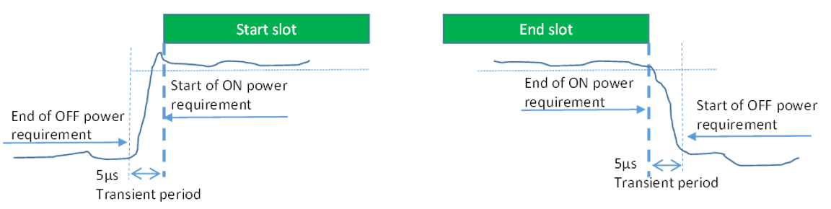

Figure 9.3.3.2-1: General ON/OFF time mask for NR UL transmission in FR2-NTN

#### 9.3.3.3 Transmit power time mask for slot and short or long subslot boundaries

The transmit power time mask for slot and a long subslot transmission boundaries defines the transient periods allowed between slot and long subslot PUSCH transmissions. For PUSCH-PUCCH and PUSCH-SRS transitions and multiplexing the time masks in sub-clause 9.3.3.7 apply.

The transmit power time mask for slot or long subslot and short subslot transmission boundaries defines the transient periods allowed between slot or long subslot and short subslot transmissions. The time masks in sub-clause 9.3.3.8 apply.

The transmit power time mask for short subslot transmissiona boundaries defines the transient periods allowed between short subslot transmissions. The time masks in sub-clause 9.3.3.9 apply.

#### 9.3.3.4 PRACH time mask

The PRACH ON power is specified as the mean power over the PRACH measurement period excluding any transient periods as shown in Figure 9.3.3.4-1. The measurement period for different PRACH preamble format is specified in Table 9.3.3.4-1.

Table 9.3.3.4-1: PRACH ON power measurement period

|  |  |  |
| --- | --- | --- |
| Format | SCS | Measurement period |
| A1 | 60 kHz | 0.035677 ms |
|  | 120 kHz | 0.017839 ms |
| A2 | 60 kHz | 0.071354 ms |
|  | 120 kHz | 0.035677 ms |
| A3 | 60 kHz | 0.107031 ms |
|  | 120 kHz | 0.053516 ms |
| B1 | 60 kHz | 0.035091 ms |
|  | 120 kHz | 0.0175455 ms |
| B4 | 60 kHz | 0.207617 ms |
|  | 120 kHz | 0.103809 ms |
| A1/B1 | 60 kHz | 0.035677 ms for front X1 occasion 0.035091 ms for last occasion  X1 = [2,5] |
|  | 120 kHz | 0.017839 ms for front X1occasion 0.017546 ms for last occasion  X1 = [2,5] |
| A2/B2 | 60 kHz | 0.071354 ms for front X2 occasion 0.069596 ms for last occasion  X2 = [1,2] |
|  | 120 kHz | 0.035677 ms for front X2 occasion 0.034798 ms for last occasion  X2 = [1,2] |
| A3/B3 | 60 kHz | 0.107031 ms for first occasion 0.104101 ms for second occasion |
|  | 120 kHz | 0.053515 ms for first occasion 0.052050 ms for second occasion |
| C0 | 60 kHz | 0.026758 ms |
|  | 120 kHz | 0.013379 ms |
| C2 | 60 kHz | 0.083333 ms |
|  | 120 kHz | 0.0416667 ms |
| NOTE: For PRACH on PRACH occasion start from begin of 0ms or 0.5 ms boundary, the measurement period will plus 0.032552 μs | | |



Figure 9.3.3.4-1: PRACH ON/OFF time mask

#### 9.3.3.5 Void

#### 9.3.3.6 SRS time mask

In the case a single SRS transmission, the ON power is defined as the mean power over the symbol duration excluding any transient period; Figure 9.3.3.6-1.



Figure 9.3.3.6-1: Single SRS time mask for NR UL transmission

In the case multiple consecutive SRS transmission, the ON power is defined as the mean power for each symbol duration excluding any transient period. See Figure 7.7.4-2



Figure 9.3.3.6-2: Consecutive SRS time mask for the case when no power change is required

When power change between consecutive SRS transmissions is required, then Figure 9.3.3.6-3 and Figure 9.3.3.6-4 apply.



Figure 9.3.3.6-3: Consecutive SRS time mask for the case when power change is required and when 60kHz SCS is used in FR2



Figure 9.3.3.6-4: Consecutive SRS time mask for the case when power change is required and when 120kHz SCS is used in FR2

#### 9.3.3.7 PUSCH-PUCCH and PUSCH-SRS time masks

The PUCCH/PUSCH/SRS time mask defines the observation period between sounding reference symbol (SRS) and an adjacent PUSCH/PUCCH symbol and subsequent UL transmissions. The time masks apply for all types of frame structures and their allowed PUCCH/PUSCH/SRS transmissions unless otherwise stated.



Figure 9.3.3.7-1: PUCCH/PUSCH/SRS time mask when there is a transmission before or after or both before and after SRS

When there is no transmission preceding SRS transmission or succeeding SRS transmission, then the same time mask applies as shown in Figure 9.3.3.7-1.

#### 9.3.3.8 Transmit power time mask for consecutive slot or long subslot transmission and short subslot transmission boundaries

The transmit power time mask for consecutive slot or long subslot transmission and short subslot transmission boundaries defines the transient periods allowed between such transmissions.

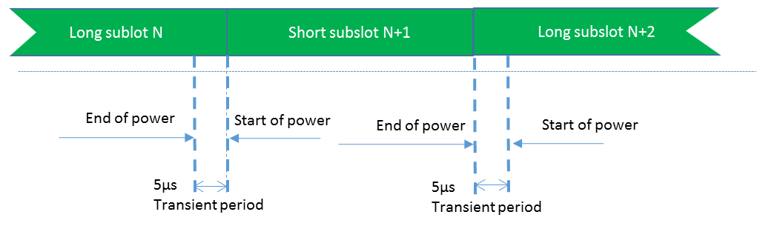

Figure 9.3.3.8-1: Consecutive slot or long subslot transmission and short subslot transmission time mask

#### 9.3.3.9 Transmit power time mask for consecutive short subslot transmissions boundaries

The transmit power time mask for consecutive short subslot transmission boundaries defines the transient periods allowed between short subslot transmissions.

The transient period shall be equally shared as shown on Figure 9.3.3.9-1.

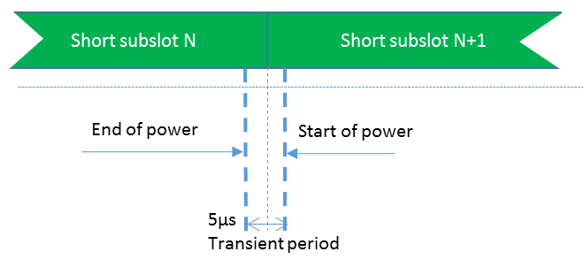

Figure 9.3.3.9-1: Consecutive short subslot transmissions time mask where DMRS is not the first symbol in the adjacent short subslot transmission

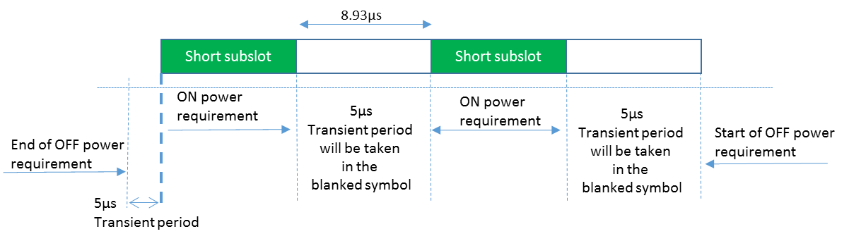

Figure 9.3.3.9-2: Consecutive short subslot (1 symbol gap) time mask for the case when transient period is required on both sides of the symbol and when 120 kHz SCS is used in FR2

### 9.3.4 Power control

#### 9.3.4.1 General

The requirements on power control accuracy apply under normal conditions and are defined as a directional requirement. The requirements are verified in beam locked mode on beam peak direction.

#### 9.3.4.2 Absolute power tolerance

The absolute power tolerance is the ability of the UE transmitter to set its initial output power to a specific value for the first sub-frame (1 ms) at the start of a contiguous transmission or non-contiguous transmission with a transmission gap larger than 20 ms. The tolerance includes the channel estimation error RSRP estimate.

The minimum requirements specified in Table 9.3.4.2-1 apply in the power range bounded by the minimum output power as specified in sub-clause 9.3.1 ('Pmin') and the maximum output power as specified in sub-clause 9.2.1 as minimum peak EIRP ('Pmax'). The intermediate power point 'Pint' is defined in table 9.3.4.2-2.

Table 9.3.4.2-1: Absolute power tolerance

|  |  |
| --- | --- |
| Power Range | Tolerance |
| Pint ≥ P ≥ Pmin | [± 14.0 dB] |
| Pmax ≥ P > Pint | [± 12.0 dB] |

Table 9.3.4.2-2: Intermediate power point

|  |  |
| --- | --- |
| Power Parameter | Value |
| Pint | [Pmax – 12.0 dB] |

#### 9.3.4.3 Relative power tolerance

The relative power tolerance is the ability of the UE transmitter to set its output power in a target sub-frame (1 ms) relatively to the power of the most recently transmitted reference sub-frame (1 ms) if the transmission gap between these sub-frames is less than or equal to 20 ms.

The minimum requirements specified in Table 9.3.4.3-1 apply when the power of the target and reference sub-frames are within the power range bounded by the minimum output power as defined in sub-clause 9.3.1 and Pint as defined in sub-clause 9.3.4.2. The minimum requirements specified in Table 9.3.4.3-2 apply when the power of the target and reference sub-frames are within the power range bounded by Pint as defined in sub-clause 9.3.4.2 and the measured PUMAX as defined in sub-clause 9.2.4.

For a test pattern that is either a monotonically increasing or monotonically decreasing power sweep over the range specified for Tables 9.3.4.3-1 and 9.3.4.3-2, 3 exceptions are allowed for each of the test patterns. For these exceptions, the power tolerance limit is a maximum of ±11.0 dB.

Table 9.3.4.3-1: Relative power tolerance, Pint ≥ P ≥ Pmin

|  |  |
| --- | --- |
| Power step ∆P (Up or down)  (dB) | All combinations of PUSCH and PUCCH, PUSCH/PUCCH and SRS transitions between sub-frames, PRACH (dB) |
| ΔP < 2 | [±5.0] |
| 2 ≤ ΔP < 3 | [±6.0] |
| 3 ≤ ΔP < 4 | [±7.0] |
| 4 ≤ ΔP < 10 | [±8.0] |
| 10 ≤ ΔP < 15 | [±10.0] |
| 15 ≤ ΔP | [±11.0] |
| NOTE: The requirements apply with *ue-BeamLockFunction* enabled. | |

Table 9.3.4.3-2: Relative power tolerance, PUMAX ≥ P > Pint

|  |  |
| --- | --- |
| Power step ∆P (Up or down)  (dB) | All combinations of PUSCH and PUCCH, PUSCH/PUCCH and SRS transitions between sub-frames, PRACH (dB) |
| ΔP < 2 | [± 3.0] |
| 2 ≤ ΔP < 3 | [± 4.0] |
| 3 ≤ ΔP < 4 | [± 5.0] |
| 4 ≤ ΔP < 10 | [± 6.0] |
| 10 ≤ ΔP < 15 | [± 8.0] |
| 15 ≤ ΔP | [± 9.0] |
| NOTE 1: The requirements apply with *ue-BeamLockFunction* enabled.  NOTE 2: For PUSCH to PUSCH transitions with the allocated resource blocks fixed in frequency and no transmission gaps other than those generated by downlink subframes, guard periods: for a power step ΔP = 1 dB, the relative power tolerance for transmission is ± 1.0 dB. | |

#### 9.3.4.4 Aggregate power tolerance

The aggregate power control tolerance is the ability of the UE transmitter to maintain its power in a sub-frame (1 ms) during non-contiguous transmissions within 21ms in response to 0 dB TPC commands with respect to the first UE transmission and all other power control parameters as specified in 38.213 kept constant.

The minimum requirements specified in Table 9.3.4.4-1 apply when the power of the target and reference sub-frames are within the power range bounded by the minimum output power as defined in sub-clause 9.3.1 and Pint as defined in sub-clause 9.3.4.2. The minimum requirements specified in Table 9.3.4.4-2 apply when the power of the target and reference sub-frames are within the power range bounded by Pint as defined in sub-clause 9.3.4.2 and the maximum output power as specified in sub-clause 9.2.1.

Table 9.3.4.4-1: Aggregate power tolerance, Pint ≥ P ≥ Pmin

|  |  |  |
| --- | --- | --- |
| TPC command | UL channel | Aggregate power tolerance within 21 ms |
| 0 dB | PUCCH | [± 5.5 dB] |
| 0 dB | PUSCH | [± 5.5 dB] |

Table 9.3.4.4-2: Aggregate power tolerance, Pmax ≥ P > Pint

|  |  |  |
| --- | --- | --- |
| TPC command | UL channel | Aggregate power tolerance within 21 ms |
| 0 dB | PUCCH | [± 3.5 dB] |
| 0 dB | PUSCH | [± 3.5 dB] |

*<End of the change>*