**3GPP TSG-RAN WG4 Meeting # 109 R4-2319572**

**Chicago, USA, November 13 – November 17, 2023**

|  |  |  |  |  |  |  |  |  |
| --- | --- | --- | --- | --- | --- | --- | --- | --- |
| *CR-Form-v12.2* | | | | | | | | |
| **CHANGE REQUEST** | | | | | | | | |
|  | | | | | | | | |
|  | **38.101-5** | **CR** |  | **rev** |  | **Current version:** | **18.3.0** |  |
|  | | | | | | | | |
| *For* ***[HE](http://www.3gpp.org/3G_Specs/CRs.htm" \l "_blank)******[LP](http://www.3gpp.org/3G_Specs/CRs.htm" \l "_blank)*** *on using this form: comprehensive instructions can be found at  <http://www.3gpp.org/Change-Requests>.* | | | | | | | | |
|  | | | | | | | | |

|  |  |  |  |  |  |  |  |  |
| --- | --- | --- | --- | --- | --- | --- | --- | --- |
| ***Proposed change affects:*** | UICC apps |  | ME | **X** | Radio Access Network |  | Core Network |  |

|  |  |  |  |  |  |  |  |  |  |  |
| --- | --- | --- | --- | --- | --- | --- | --- | --- | --- | --- |
|  | | | | | | | | | | |
| ***Title:*** | Draft CR to TS 38.101-5: NTN Ka-band introduction – Clause 5 | | | | | | | | | |
|  |  | | | | | | | | | |
| ***Source to WG:*** | Ericsson | | | | | | | | | |
| ***Source to TSG:*** | R4 | | | | | | | | | |
|  |  | | | | | | | | | |
| ***Work item code:*** | NR\_NTN\_enh-Core | | | | |  | ***Date:*** | | | 2023-11-13 |
|  |  | | | |  | |  | | |  |
| ***Category:*** | **B** |  | | | | | ***Release:*** | | | Rel-18 |
|  | *Use one of the following categories:* ***F*** *(correction)* ***A*** *(mirror corresponding to a change in an earlier release)* ***B*** *(addition of feature),* ***C*** *(functional modification of feature)* ***D*** *(editorial modification)*  Detailed explanations of the above categories can be found in 3GPP [TR 21.900](http://www.3gpp.org/ftp/Specs/html-info/21900.htm). | | | | | | | | *Use one of the following releases: Rel-8 (Release 8) Rel-9 (Release 9) Rel-10 (Release 10) Rel-11 (Release 11) … Rel-16 (Release 16) Rel-17 (Release 17) Rel-18 (Release 18) Rel-19 (Release 19)* | |
|  |  | | | | | | | | | |
| ***Reason for change:*** | | This CR introduces requirements for NTN Ka bands according to the agreed work split. Clause 5. | | | | | | | | |
|  | |  | | | | | | | | |
| ***Summary of change:*** | | Frequency range, Operating bands, channel bandwidth and channel arrangement clauses have been updated to consdier FR2-NTN. | | | | | | | | |
|  | |  | | | | | | | | |
| ***Consequences if not approved:*** | | The NTN ka-bands won’t be correctly supported | | | | | | | | |
|  | |  | | | | | | | | |
| ***Clauses affected:*** | | 2, 5.1, 5.2, 5.3, 5.4 | | | | | | | | |
|  | |  | | | | | | | | |
|  | | **Y** | **N** |  | | | |  | | |
| ***Other specs*** | |  | **X** | Other core specifications | | | | TS/TR ... CR ... | | |
| ***affected:*** | |  | **X** | Test specifications | | | | TS/TR ... CR ... | | |
| ***(show related CRs)*** | |  | **X** | O&M Specifications | | | | TS/TR ... CR ... | | |
|  | |  | | | | | | | | |
| ***Other comments:*** | |  | | | | | | | | |
|  | |  | | | | | | | | |
| ***This CR's revision history:*** | |  | | | | | | | | |

*<Start of the change>*

# 2 References

The following documents contain provisions which, through reference in this text, constitute provisions of the present document.

- References are either specific (identified by date of publication, edition number, version number, etc.) or non‑specific.

- For a specific reference, subsequent revisions do not apply.

- For a non-specific reference, the latest version applies. In the case of a reference to a 3GPP document (including a GSM document), a non-specific reference implicitly refers to the latest version of that document *in the same Release as the present document*.

[1] 3GPP TR 21.905: "Vocabulary for 3GPP Specifications".

[2] 3GPP TS 38.101-1: "NR; User Equipment (UE) radio transmission and reception; Part 1: Range 1 Standalone"

[3] 3GPP TS 38.101-3: "NR; User Equipment (UE) radio transmission and reception; Part 3: Range 1 and Range 2 Interworking operation with other radios"

[4] Void

[5] 3GPP TS 38.521-2: "NR; User Equipment (UE) conformance specification; Radio transmission and reception; Part 2: Range 2 Standalone"

[6] Recommendation ITU-R M.1545: "Measurement uncertainty as it applies to test limits for the terrestrial component of International Mobile Telecommunications-2000"

[7] ITU-R Recommendation SM.329-10, "Unwanted emissions in the spurious domain"

[8] 47 CFR Part 30, "UPPER MICROWAVE FLEXIBLE USE SERVICE, §30.202   Power limits", FCC.

[9] 3GPP TS 38.211: "NR; Physical channels and modulation".

[10] 3GPP TS 38.213: "NR; Physical layer procedures for control".

[11] 3GPP TS 38.215: "NR; Physical layer measurements".

[12] 3GPP TS 38.133: "NR; Requirements for support of radio resource management".

[13] 3GPP TS 38.331: "NR; Radio Resource Control (RRC); Protocol specification".

[14] 3GPP TS 38.306: "NR; User Equipment (UE) radio access capabilities".

[15] IEEE Std 149: "IEEE Standard Test Procedures for Antennas", IEEE.

[16] 3GPP TS 38.101-2: "NR; User Equipment (UE) radio transmission and reception; Part 2: Range 2 Standalone"

*<End of the change>*

*<Start of the change>*

# 5 Operating bands and channel arrangement

## 5.1 General

The channel arrangements presented in this clause are based on the operating bands and channel bandwidths defined in the present Release of specifications.

NOTE: Other operating bands and channel bandwidths may be considered in future Releases.

Requirements throughout the RF specifications are in many cases defined separately for different frequency ranges (FR). The frequency ranges in which NTN satellite can operate according to this version of the specification are identified as described in Table 5.1-1.

Table 5.1-1: Definition of NTN frequency ranges

|  |  |
| --- | --- |
| Frequency range designation | Corresponding frequency range |
| FR1-NTN1 | 410 MHz – 7125 MHz |
| FR2-NTN2 | 17300 MHz – 30000 MHz |
| NOTE 1: [NTN bands within this frequency range are regarded as a FR1 band when references from other specifications.]  NOTE 2: [NTN bands within this frequency range are regarded as a FR2 band when references from other specifications.] | |

## 5.2 Operating bands

### 5.2.1 General

NTN satellite covers FR1-NTN and FR2-NTN operating bands in the present specification.

### 5.2.2 Operating bands with conducted requirements

NTN satellite is designed to operate in the operating bands defined in Table 5.2.2-1.

Table 5.2.2-1: NTN satellite bands in FR1-NTN

|  |  |  |  |
| --- | --- | --- | --- |
| NTN satellite operating band | Uplink (UL) operating band Satellite Access Node receive / UE transmit  FUL,low – FUL,high | Downlink (DL) operating band Satellite Access Node transmit / UE receive  FDL,low – FDL,high | Duplex mode |
| n256 | 1980 MHz – 2010 MHz | 2170 MHz – 2200 MHz | FDD |
| n255 | 1626.5 MHz – 1660.5 MHz | 1525 MHz – 1559 MHz | FDD |
| NOTE: NTN satellite bands are numbered in descending order from n256. | | | |

### 5.2.3 Operating bands with radiated requirements

NTN satellite is designed to operate in the operating bands defined in Table 5.2.3-1.

Table 5.2.3-1: Satellite *operating bands* in FR2-NTN

|  |  |  |  |
| --- | --- | --- | --- |
| **Satellite *operating band*** | Uplink (UL) *operating band* SAN receive / UE transmit  **FUL,low – FUL,high** | Downlink (DL) *operating band* SAN transmit / UE receive  **FDL,low – FDL,high** | **Duplex mode** |
| n5121 | 27500 MHz - 30000 MHz | 17300 MHz - 20200 MHz | FDD |
| n5112 | 28350 MHz - 30000 MHz | 17300 MHz - 20200 MHz | FDD |
| n5103 | 27500 MHz - 28350 MHz | 17300 MHz - 20200 MHz | FDD |
| NOTE 1: This band is applicable in the countries subject to CEPT ECC Decision(05)01 and ECC Decision (13)01.  NOTE 2: This band is applicable in the USA subject to FCC 47 CFR part 25.  NOTE 3: This band is applicable for Earth Station operations in the USA subject to FCC 47 CFR part 25. FCC rules currently do not include ESIM operations in this band (47 CFR 25.202). | | | |

## 5.3 UE channel bandwidth

### 5.3.1 General

The UE channel bandwidth supports a single RF carrier in the uplink or downlink at the UE. From a SAN perspective, different UE channel bandwidths may be supported within the same spectrum for transmitting to and receiving from UEs connected to the SAN.

From a UE perspective, the UE is configured with one or more BWP / carriers, each with its own UE channel bandwidth. The UE does not need to be aware of the SAN channel bandwidth or how the SAN allocates bandwidth to different UEs.

The placement of the UE channel bandwidth for each UE carrier is flexible but can only be completely within the SAN channel bandwidth.

The relationship between the channel bandwidth, the guardband and the maximum transmission bandwidth configuration is shown in Figure 5.3.1-1.



Figure 5.3.1-1: Definition of the channel bandwidth and the maximum transmission bandwidth configuration for one channel

### 5.3.2 Maximum transmission bandwidth configuration

The maximum transmission bandwidth configuration NRB for each UE channel bandwidth and subcarrier spacing is specified in Table 5.3.2-1 for FR1-NTN and table 5.3.2-2 for FR2-NTN.

**Table 5.3.2-1: Maximum transmission bandwidth configuration NRB for FR1-NTN**

|  |  |  |  |  |  |
| --- | --- | --- | --- | --- | --- |
| SCS (kHz) | 5  MHz | 10  MHz | 15  MHz | 20  MHz | **30**  MHz |
| NRB | NRB | NRB | NRB | NRB |
| 15 | 25 | 52 | 79 | 106 | 160 |
| 30 | 11 | 24 | 38 | 51 | 78 |
| 60 | N/A | 11 | 18 | 24 | 38 |

Table 5.3.2-2: Maximum transmission bandwidth configuration NRB for FR2-NTN

|  |  |  |  |  |
| --- | --- | --- | --- | --- |
| SCS (kHz) | 50 MHz | 100 MHz | 200 MHz | 400 MHz |
|  | NRB | NRB | NRB | NRB |
| 60 | 66 | 132 | 264 | N/A |
| 120 | 32 | 66 | 132 | 264 |

### 5.3.3 Minimum guardband and transmission bandwidth configuration

The minimum guardband for each UE channel bandwidth and SCS is specified in Table 5.3.3-1 for FR1-NTN and in table 5.3.3-2 for FR2-NTN.

Table 5.3.3-1: Minimum guardband for each UE channel bandwidth and SCS (kHz) for FR1-NTN

|  |  |  |  |  |  |
| --- | --- | --- | --- | --- | --- |
| SCS (kHz) | 5  MHz | 10  MHz | 15  MHz | 20  MHz | **30**  MHz |
| 15 | 242.5 | 312.5 | 382.5 | 452.5 | 592.5 |
| 30 | 505 | 665 | 645 | 805 | 945 |
| 60 | N/A | 1010 | 990 | 1330 | 1290 |

Table 5.3.3-2: Minimum guardband for each UE channel bandwidth and SCS (kHz) (FR2-NTN)

|  |  |  |  |  |
| --- | --- | --- | --- | --- |
| SCS (kHz) | 50 MHz | 100 MHz | 200 MHz | 400 MHz |
| 60 | 1210 | 2450 | 4930 | N/A |
| 120 | 1900 | 2420 | 4900 | 9860 |

NOTE: The minimum guardbands have been calculated using the following equation: (BWChannel x 1000 (kHz) – NRB x SCS x 12) / 2 – SCS/2, where NRB are from Table 5.3.2-1 and Table 5.3.2-2.

Figure 5.3.3-1: Void

The number of RBs configured in any channel bandwidth shall ensure that the minimum guardband specified in this clause is met.

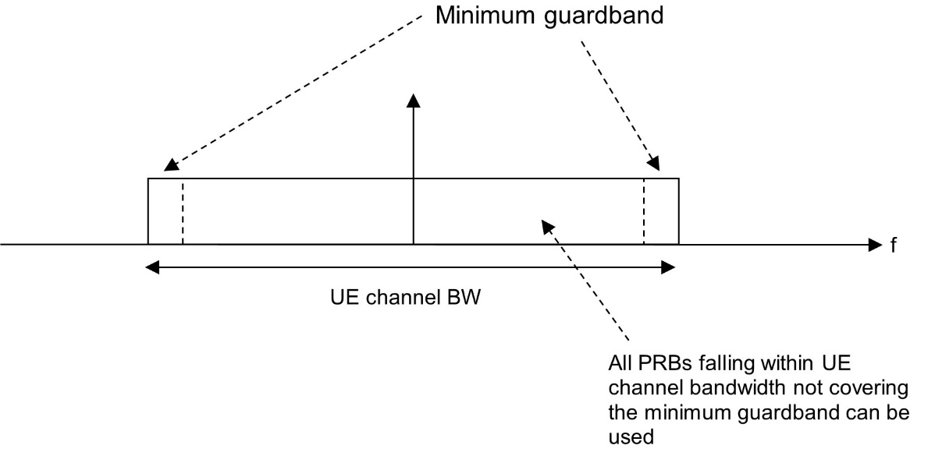

Figure 5.3.3-2: UE PRB utilization

In the case that multiple numerologies are multiplexed in the same symbol, the minimum guard band on each side of the carrier is the guard band applied at the configured UE channel bandwidth for the numerology that is transmitted/received immediately adjacent to the guard band.

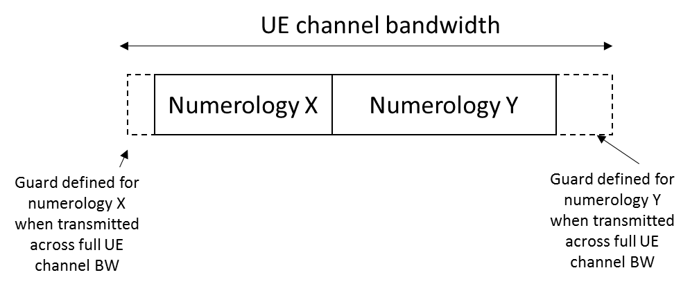

Figure 5.3.3-3: Guard band definition when transmitting multiple numerologies

NOTE: Figure 5.3.3-2 is not intended to imply the size of any guard between the two numerologies. Inter-numerology guard band within the carrier is implementation dependent.

### 5.3.4 RB alignment

The RB alignment for FR1-NTN refers to NR RB alignments as specified in 3GPP TS 38.101-1 [5] clause 5.3.4.

The RB alignment for FR2-NTN refers to NR RB alignments as specified in 3GPP TS 38.101-2 [15] clause 5.3.4.

### 5.3.5 UE channel bandwidth per operating band

The requirements in this specification apply to the combination of channel bandwidths, SCS and operating bands shown in Table 5.3.5-1 for FR1-NTN and table 5.3.5-2 for FR2-NTN. The transmission bandwidth configuration in Table 5.3.2-1 and Table 5.3.2-2 shall be supported for each of the specified channel bandwidths. The channel bandwidths are specified for both the Tx and Rx path.

Table 5.3.5-1: Channel bandwidths for each NTN satellite band in FR1-NTN

| NTN satellite band | SCS  kHz | UE Channel bandwidth (MHz) | | | | |
| --- | --- | --- | --- | --- | --- | --- |
| 5 | 10 | 15 | 20 | **30**  **(NOTE)** |
|  | 15 | 5 | 10 | 15 | 20 |  |
| n256 | 30 |  | 10 | 15 | 20 |  |
|  | 60 |  | 10 | 15 | 20 |  |
|  | 15 | 5 | 10 | 15 | 20 |  |
| n255 | 30 |  | 10 | 15 | 20 |  |
|  | 60 |  | 10 | 15 | 20 |  |
| NOTE: Deployment of 30 MHz channel bandwidth for NTN SAN needs to be preceded by introduction of all applicable Tx RF, Rx RF, and demodulation requirements. | | | | | | |

Table 5.3.5-2: Channel bandwidths for each NTN satellite band FR2-NTN

|  |  |  |  |  |  |
| --- | --- | --- | --- | --- | --- |
| SAN Operating Band | SCS (kHz) | *SAN channel bandwidth* (MHz) | | | |
| 50 | 100 | 200 | 400 |
| n512 | 60 | 50 | 100 | 200 |  |
|  | 120 | 50 | 100 | 200 | 400 |
| n511 | 60 | 50 | 100 | 200 |  |
|  | 120 | 50 | 100 | 200 | 400 |
| n510 | 60 | 50 | 100 | 200 |  |
|  | 120 | 50 | 100 | 200 | 400 |

## 5.4 Channel arrangement

### 5.4.1 Channel spacing

#### 5.4.1.1 Channel spacing for adjacent NTN satellite carriers

The channel spacing for adjacent NTN satellite carriers in FR1-NTN refers to the NR channel spacing as specified in 3GPP TS 38.101-1 [5] clause 5.4.1.1.

The channel spacing for adjacent NTN satellite carriers in FR2-NTN refers to the NR channel spacing as specified in 3GPP TS 38.101-2 [16] clause 5.4.1.1.

### 5.4.2 Channel raster

#### 5.4.2.1 NR-ARFCN and channel raster

The global frequency channel raster defines a set of RF reference frequencies FREF. The RF reference frequency is used in signalling to identify the position of RF channels, SS blocks and other elements.

The global frequency raster is defined for all frequencies from 0 to 100 GHz. The granularity of the global frequency raster is ΔFGlobal.

RF reference frequencies are designated by an NR Absolute Radio Frequency Channel Number (NR-ARFCN) in the range (0…2016666) on the global frequency raster. The relation between the NR-ARFCN and the RF reference frequency FREF in MHz is given by the following equation, where FREF-Offs and NREF-Offs are given in Table 5.4.2.1-1 and NREF is the NR-ARFCN.

FREF = FREF-Offs + ΔFGlobal (NREF – NREF-Offs)

Table 5.4.2.1-1: NR-ARFCN parameters for the global frequency raster

|  |  |  |  |  |
| --- | --- | --- | --- | --- |
| Frequency range (MHz) | ΔFGlobal (kHz) | FREF-Offs (MHz) | NREF-Offs | Range of NREF |
| 0 – 3000 | 5 | 0 | 0 | 0 – 599999 |
| 3000 – 24250 | 15 | 3000 | 600000 | 600000 – 2016666 |
| 24250 – 100000 | 60 | 24250.08 | 2016667 | 2016667 – 3279165 |

The channel raster defines a subset of RF reference frequencies that can be used to identify the RF channel position in the uplink and downlink. The RF reference frequency for an RF channel maps to a resource element on the carrier. For each operating band, a subset of frequencies from the global frequency raster are applicable for that band and forms a channel raster with a granularity ΔFRaster, which may be equal to or larger than ΔFGlobal.

The mapping between the channel raster and corresponding resource element is given in clause 5.4.2.2. The applicable entries for each operating band are defined in clause 5.4.2.3.

#### 5.4.2.2 Channel raster to resource element mapping

The mapping between the RF reference frequency on the channel raster and the corresponding resource element for FR1-NTN refers to the NR requirements specified in 3GPP TS 38.101-1 [5] clause 5.4.2.2.

The mapping between the RF reference frequency on the channel raster and the corresponding resource element for FR2-NTN refers to the NR requirements specified in 3GPP TS 38.101-2 [16] clause 5.4.2.2.

#### 5.4.2.3 Channel raster entries for each operating band

The RF channel positions on the channel raster in each NTN satellite operating band are given through the applicable NR-ARFCN in Table 5.4.2.3‑1 for FR1-NTN and table 5.4.2.3-2 for FR2-NTN, using the channel raster to resource element mapping in clause 5.4.2.2.

For NTN satellite operating bands with 100 kHz channel raster, ΔFRaster = 20 × ΔFGlobal. In this case every 20th NR-ARFCN within the operating band are applicable for the channel raster within the operating band and the step size for the channel raster in Table 5.4.2.3‑1 is given as <20>.

For NTN satellite operating bands with 60 kHz channel raster above 3 GHz, ΔFRaster = *I* ×ΔFGlobal, where *I* ϵ {4, 8}. In this case, every *Ith* NR‑ARFCN within the *operating band* are applicable for the channel raster within the *operating band* and the step size for the channel raster in table 5.4.2.3-2 is given as <*I*>.

Table 5.4.2.3-1: Applicable NR-ARFCN per operating band in FR1-NTN

|  |  |  |  |
| --- | --- | --- | --- |
| NTN satellite operating band | ΔFRaster  (kHz) | Uplink  Range of NREF  (First – <Step size> – Last) | Downlink  Range of NREF  (First – <Step size> – Last) |
| n256 | 100 | 396000 – <20> – 402000 | 434000 – <20> – 440000 |
| n255 | 100 | 325300 – <20> – 332100 | 305000 – <20> – 311800 |
| NOTE : The channel numbers that designate carrier frequencies so close to the operating band edges that the carrier extends beyond the operating band edge shall not be used. | | | |

Table 5.4.2.3-2: Applicable NR-ARFCN per operating band in FR2-NTN

|  |  |  |  |
| --- | --- | --- | --- |
| SAN operating band | ΔFRaster  (kHz) | Uplink  range of NREF  (First – <Step size> – Last) | Downlink  range of NREF  (First – <Step size> – Last) |
| n512 | 60 | 2070833 – <1> – 2112499 | 1553336 – <4> – 1746664 |
| 120 | 2070833 – <2> – 2112499 | 1553336 – <8> – 1746664 |
| n511 | 60 | 2084999 – <1> –2112499 | 1553336 – <4> – 1746664 |
| 120 | 2084999 – <2> –2112499 | 1553336 – <8> – 1746664 |
| n510 | 60 | 2070833 – <1> – 2084999 | 1553336 – <4> – 1746664 |
| 120 | 2070833 – <2> – 2084999 | 1553336 – <8> – 1746664 |

### 5.4.3 Synchronization raster

#### 5.4.3.1 Synchronization raster and numbering

The synchronization raster indicates the frequency positions of the synchronization block that can be used by the UE for system acquisition when explicit signalling of the synchronization block position is not present.

A global synchronization raster is defined for all frequencies. The frequency position of the SS block is defined as SSREF with corresponding number GSCN. The parameters defining the SSREF and GSCN for all the frequency ranges are in Table 5.4.3.1-1.

The resource element corresponding to the SS block reference frequency SSREF is given in clause 5.4.3.2. The synchronization raster and the subcarrier spacing of the synchronization block is defined separately for each band.

Table 5.4.3.1-1: GSCN parameters for the global frequency raster

|  |  |  |  |
| --- | --- | --- | --- |
| Frequency range | SS Block frequency position SSREF | GSCN | Range of GSCN |
| 0 – 3000 MHz | N \* 1200kHz + M \* 50 kHz,  N=1:2499, M ϵ {1,3,5}1 | 3N + (M-3)/2 | 2 – 7498 |
| 3000 – 24250 | 3000 MHz + N \* 1.44 MHz,  N = 0:14756 | 7499 + N | 7499 – 22255 |
| NOTE: The default value for operating bands with which only support SCS spaced channel raster(s) is M=3. | | | |

#### 5.4.3.2 Synchronization raster to synchronization block resource element mapping

The mapping between the synchronization raster and the corresponding resource element of the SS block in FR1-NTN refers to 3GPP TS 38.101-1 [5] clause 5.4.3.2.

The mapping between the synchronization raster and the corresponding resource element of the SS block in FR2-NTN refers to 3GPP TS 38.101-2 [16] clause 5.4.3.2.

#### 5.4.3.3 Synchronization raster entries for each operating band

The synchronization raster for each band is give in Table 5.4.3.3-1 and table 5.4.3.3-2. The distance between applicable GSCN entries is given by the <Step size> indicated in Table 5.4.3.3-1 for FR1-NTN and table 5.4.3.3-2 for FR2-NTN.

Table 5.4.3.3-1: Applicable SS raster entries per operating band (FR1-NTN)

|  |  |  |  |
| --- | --- | --- | --- |
| NTN satellite operating band | SS Block SCS | SS Block pattern1 | Range of GSCN  (First – <Step size> – Last) |
| n256 | 15 kHz | Case A | 5429 – <1> – 5494 |
| n255 | 15 kHz | Case A | 3818 – <1> – 3892 |
|  | 30 kHz | Case B | 3824 – <1> – 3886 |
| NOTE : SS Block pattern is defined in clause 4.1 in 3GPP TS 38.213 [7]. | | | |

Table 5.4.3.3-2: Applicable SS raster entries per operating band (FR2-NTN)

|  |  |  |  |
| --- | --- | --- | --- |
| **SAN operating band** | **SS Block SCS** | **SS Block pattern (NOTE)** | Range of GSCN  **(First – <Step size> – Last)** |
| n512 | 120 kHz | Case D | 17448 – <12> – 19428 |
|  | 240 kHz | Case E | 17472 – <24> – 19416 |
| n511 | 120 kHz | Case D | 17448 – <12> – 19428 |
|  | 240 kHz | Case E | 17472 – <24> – 19416 |
| n510 | 120 kHz | Case D | 17448 – <12> – 19428 |
|  | 240 kHz | Case E | 17472 – <24> – 19416 |
| NOTE: SS Block pattern is defined in section 4.1 in TS 38.213 [7]. | | | |

### 5.4.4 TX–RX frequency separation

The default TX channel (carrier centre frequency) to RX channel (carrier centre frequency) separation for operating bands is specified in Table 5.4.4-1 for FR1-NTN.

Table 5.4.4-1: UE TX-RX frequency separation (FR1-NTN)

| NTN Satellite Operating Band | TX – RX  carrier centre frequency separation |
| --- | --- |
| n256 | 190 MHz |
| n255 | -101.5 MHz |

*<End of the change>*