3GPP TSG-RAN WG4 Meeting #109 R4-2321821
Chicago, USA, November 13 – 17, 2023

Title: [Draft] LS reply on further clarifications on enhancements to realize increasing UE power high limit for CA and DC
Response to: R4-2318078 (R2-2311611)
Release: Rel-18
Work Item: NR_cov_enh2

Source: TSG RAN WG4
To: TSG RAN WG2
Cc: TSG RAN WG1

Contact person:

Name: Xiang Gao

E-mail Address: gaoxiang74@huawei.com

Attachments: None

1 Overall description
RAN4 thanks RAN2 for the LS on further clarifications on enhancements to realize increasing UE power high limit for CA and DC in R2-2311611.
Regarding the questions from RAN2, RAN4 would like to share the following answers.
- Q1: What exact information is required to be reported by the UE (i.e., how many bits are required to support the reporting of this information)?

Answer: 2 bit

Answer from RAN4:
Both ΔP_{PowerClass}, ΔP_{PowerClass, CA}/ΔP_{PowerClass, EN-DC}/ΔP_{PowerClass, NR-DC} should be considered, in addition to ulFullPower parameters.
- For single band operation, signalling is needed to cover 0, 3 and 6 dB for ΔP_{PowerClass}.
- For CA operation, signalling is needed to cover 0, 3 and 6 dB for ΔP_{PowerClass, CA}. The reporting is related to the total aggregated power of the band combination (P_{CMAX}) rather than ΔP_{PowerClass} for each serving cell.
  - ΔP_{PowerClass} for each serving cell is not reported.
  - RAN4 defers to RAN2 choice on how to populate the unused bits in the PHR report if the existing PHR framework is used.
- For EN-DC operation, signalling is needed to cover 0, 3 and 6 dB for ΔP_{PowerClass, EN-DC}. The reporting is related to the total aggregated power of the band combination (P_{CMAX, f, c, NR}) rather than ΔP_{PowerClass} for each serving cell.
  - ΔP_{PowerClass} for each serving cell is not reported.
  - RAN4 defers to RAN2 choice on how to populate the unused bits in the PHR report if the existing PHR framework is used.
- For NR-DC operation, signalling is needed to cover 0, 3 and 6 dB for ΔP_{PowerClass, NR-DC}. The reporting is related to the total aggregated power of the band combination (P_{CMAX, f, c, MCG} and P_{CMAX, f, c, SCG}, respectively) rather than ΔP_{PowerClass} for each serving cell.
  - ΔP_{PowerClass} for each serving cell is not reported.
  - RAN4 defers to RAN2 choice on how to populate the unused bits in the PHR report if the existing PHR framework is used.
In addition to the parameters above, a suggested method for the UE to convey the applicable ulFullPower mode is below:

For each fallback level (or positive value of the parameter ΔP_{PowerClass} or ΔP_{PowerClass, CA}/ΔP_{PowerClass, EN-DC}/ΔP_{PowerClass, NR-DC}), the UE needs to optionally convey to the network an applicable ul-FullPower capability. The choices correspond to ul-FullPower, ul-FullPowerMode1 and ul-FullPowerMode2 [38.306]. Not reporting an ul-FullPower capability for a new fallback level implies no change from declared ULFPTx mode for the declared power class. See figure below:

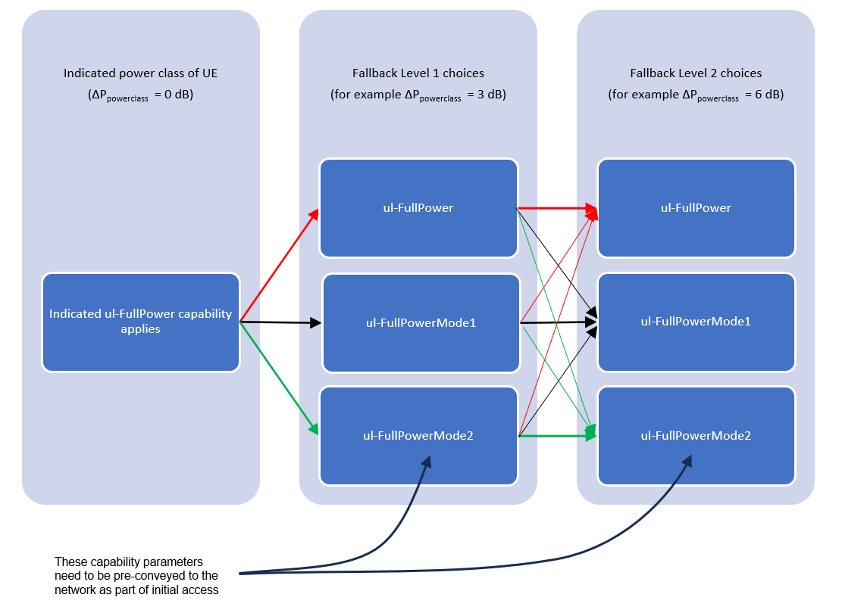

RAN4 is aware that the first two options (ul-FullPower, ul-FullPowerMode1) only require a bit each, so special care is needed only for ul-FullPowerMode2 parameters. To support this goal in an efficient way, the signaling can be divided into a static ‘pre-conveyed’ part and a dynamic pointing via MAC-CE or similar. Specifically, the UE would additionally report as part of initial access, sets of ul-FullPowerMode2 parameters for each foreseen fallback level. The UE is then only required to dynamically point to one of the three options for each fallback level. When the new parameter value is 0, the original capability set for the declared power class applies.

In summary, 7 possible states need to be conveyed by MAC-CE. These states correspond to the 7 blue boxes in the figure above. 3 bits would therefore suffice.

EAB preferred answer:

Agreement: Use the following bullets as the baseline
- For ΔP_{PowerClass}
- Both ΔP_{PowerClass} for a serving cell (the reduction of the maximum output power per serving cell) and ΔP_{PowerClass, CA}/ΔP_{PowerClass, EN-DC}/ΔP_{PowerClass, NR-DC} for a band combination (reduction of the maximum total output power per band combination) should be considered.
  - For a serving cell, 2 bits are needed to cover 0, 3 and 6 dB for ΔP_{PowerClass}.
  - For a band combination a granularity of 1 bit for ΔP_{PowerClass}, ΔP_{PowerClass, CA}/ΔP_{PowerClass, EN-DC}/ΔP_{PowerClass, NR-DC}: then 0 dB and ≥[3] dB.
- ΔP_{PowerClass} for a serving cells of a band combination should also be reported with a 2 bit granularity.
Conclusions: RAN4 has no consensus on the full power transmission mode capability reporting in Rel-18

[Moderator: One possible compromise solution for full power transmission mode capability reporting:]
- Semi-static indication should be considered, which means the UE indicated the full power transmission mode capability {ul-FullPower, ul-FullPowerMode1, ul-FullPowerMode2} for each ΔP_{Powerclass} value {0, 3 and 6dB}.

- Q2: What is the granularity of the information to be reported (e.g., per UE / per cell / other option)?
Answer from RAN4:
Based on the answers to the previous question, RAN4 provide the following information.
- ΔP_{PowerClass} reported per serving cell
- ΔP_{PowerClass, CA}/ΔP_{PowerClass, EN-DC}/ΔP_{PowerClass, NR-DC} per band combination

- If UE only supports the single CC, the capability of reporting the above per UE (same for all serving cells and BC) but with two options for a band combination:
  - Reporting of ΔP_{PowerClass, CA}/ΔP_{PowerClass, EN-DC}/ΔP_{PowerClass, NR-DC} only
  - Reporting of both ΔP_{PowerClass, CA}/ΔP_{PowerClass, EN-DC}/ΔP_{PowerClass, NR-DC} and ΔP_{PowerClass} for configured serving cells

Agreement:
- The capability of reporting is per UE
  - [ΔP_{PowerClass} reported per serving cell
  - ΔP_{PowerClass, CA}/ΔP_{PowerClass, EN-DC}/ΔP_{PowerClass, NR-DC} per band combination
  - For a band combination, UE can choose the two options below:
    - Reporting of ΔP_{PowerClass, CA}/ΔP_{PowerClass, EN-DC}/ΔP_{PowerClass, NR-DC} only
    - Reporting of ΔP_{PowerClass, CA}/ΔP_{PowerClass, EN-DC}/ΔP_{PowerClass, NR-DC} per band combination and ΔP_{PowerClass} per serving cell of band combination configured]
- Network configures the reporting of ΔP_{PowerClass} and/or ΔP_{PowerClass, CA}/ΔP_{PowerClass, EN-DC}/ΔP_{PowerClass, NR-DC} for the overhead reduction purpose

- Q3: Will RAN4 specification(s) specify the triggering condition(s) when this reporting should be performed by the UE, to which RAN2 specification(s) could then refer to when writing the reporting procedure?
Answer from RAN4:
Option 1:

RAN4 will specify the triggering conditions for UE report on ∆P_{PowerClass} and ∆P_{PowerClass,CA} and associated information in TS 38.101-1, and those for UE report on ∆P_{PowerClass, EN-DC} and ∆P_{PowerClass,NR-DC} and associated information in TS 38.101-3, respectively.

The triggering of a power capability change ΔP_{PowerClass}, the corresponding for the BC and duty-cycle management are up to UE implementation and will therefore not be specified by RAN4.

Option 2:
RAN4 provide following clarifications with the understanding that no dedicated RAN4 specification impacts would be needed to reflect triggering conditions:
- The ΔP_{PowerClass} and associated reporting is triggered by a change in the value of the ΔP_{PowerClass} parameter and when the parameter value is non-negative. The condition that triggers a parameter value change as described above and the relation among ΔP_{PowerClass}, scheduled duty cycle and maximum duty cycle capabilities are defined in clause 6.2.4 of 38.101-1 for single band, clause 6.2A.4 of 38.101-1 for CA, 6.2B.4 of 38.101-1 for NR-DC, and 6.2B.4 of 38.101-3 for EN-DC in these cases.
Ericsson preferred answer:

The ΔP_{PowerClass} reduces the configured maximum power (Pcmax,f,c) of the UL power control and the corresponding for the BC the maximum power at which the UE prioritizes transmissions. RAN4 assumes that these changes of the maximum output power can trigger an aperiodic report similarly to DL PL changes for the existing PHR (the DL PL also part of the UL power control). The triggering of a power capability change ΔP_{PowerClass}, the corresponding for the BC and duty-cycle management are up to UE implementation and will therefore not be specified by RAN4.

2 Actions
To RAN2
ACTION: RAN4 respectfully ask RAN2 to consider above information for their future work on the implementation of ΔP_{PowerClass} reporting and full-power MIMO transmission capability reporting.

3 Dates of next TSG RAN WG4 meetings
TSG RAN WG4 Meeting #110 February 26 – March 1, 2024 Athens, Greek

