3GPP TSG-RAN WG4 Meeting #107 R4-2310267
Incheon, KR, May 22 – May 26, 2023

Title: WF on UE RF requirements for FR2_multiRx_UERF
Agenda Item: 8.8.5
Source: Apple
Document for: Approval

Topic #1: WI planning

1.1 TR
Agreement:
- RAN4 agrees to request a new TR for FR2 multi-Rx DL reception.
  - RAN4 will avoid overlapping of the new TR with the existing TR.
  - The new TR will capture the UE RF discussions only.

Topic #2: System parameter assumption, UE architecture and conditions of UE RF requirement

2.1 RF requirement for the UEs only supporting “multiDCI-MultiTRP-r16”
Option 1: No new requirements needed to be defined and the legacy requirements will be individually applied for testing AoA1 and AoA2
Option 2: No RF requirements at all will be applicable for this scenario meaning this case will not be tested.
Agreement:
The two-AoA spherical coverage requirement defined under this WI does not apply to UEs only supporting “multiDCI-MultiTRP-r16”

  - Fixed DL power level
Agreement:
- For multi-Rx DL reception of PC3, confirm that the legacy spherical power level is used as the fixed DL power.

  - Wether sDCI and mDCI can share exactly the same requirement under the current fixed DL power scheme
Agreement:
sDCI and mDCI can share the same requirement under the current fixed DL power scheme, and no need to define specific requirements for sDCI UE.

Topic #3: UE RF requirements

3.1 Requirement metric
Agreement:
- For the requirement metric for 2 AoA
  - For a specific angular separation between 2 TRPs and a specific UE orientation under standardized DL power level which is equal between 2 TRPs, the result at each test point is constructed based on two AoA pairs containing that test point, i.e., AoA+ pair and AoA- pair. Overall result (probability to support 2TRP DL) is by averaging regional results.

3.2 ’Combining method’ to compute P_{directional} in metric
For UEs required to fulfil a requirement on the probability for 2AoA reception, the metric for a given AoA separation is the spatial average:
$$P_{overall}= \sum_{θ_{1}}{\sum_{φ_{1}}{\left\{P_{directional }(θ_{1},φ_{1}).AW(θ_{1})\right\}}}$$
P_{directional}(θ₁,φ₁) is given by:
Option 1 – arithmetic mean combining | $$P_{directional}(θ_{1},φ_{1})= \{\frac{PF\left(AoApair\#1\right)+PF\left(AoApair\#2\right)}{2}\}$$
Option 2 – OR combining | $$P_{directional}(θ_{1},φ_{1})= OR\{PF\left(AoApair\#1\right),PF\left(AoApair\#2\right)\}$$
Agreement:

3.3 Area weights accompany P_{directional} in metric
For UEs required to fulfil a requirement on the probability for 2AoA reception, the metric for a given AoA separation is the spatial average:
$$P_{overall}= \sum_{θ_{1}}{\sum_{φ_{1}}{\left\{P_{directional }(θ_{1},φ_{1}).AW(θ_{1})\right\}}}$$

Proposals:
- Option 1: Use Clenshaw-Curtis weights for spatial averaging instead of sinϴ.Δϴ weights.
- Option 2: Clenshaw Curtis weighting and sinθ weighting should show almost the same simulation results in simulation for requirements derivation

Agreement:
- The issues for weights will be handled in OTA SI. If the impact on core requirement is identified, RAN4 will further discuss it in the multi-Rx DL reception WI.

3.4 DL polarizations for requirement
Agreement:
The UE RF requirement is defined as the average (arithmetic mean) of the metric values for two DL polarization test conditions: the first condition is when the DL polarizations at both TRPs are ‘θθ’ and the second condition is when they are ‘φφ’.
$$N\%= \frac{{N\%}_{{(AoA}_{1θ}, {AoA}_{2θ})}+{N\%}_{{(AoA}_{1φ}, {AoA}_{2φ})}}{2}$$
Where ‘N%_{(.,.)}’ is the metric value for the requirement for the DL pols specified in the subscripts.

3.5 UE capability for different performance levels
Proposal:
Introduce UE capability if the different requirements are specified according to the antenna modules’ performance.
Agreement:
- No UE capability will be specified
- The implementations of two equally and unequally capable antenna modules could be considered when specifying the requirements

3.6 UE orientation for requirement derivation
Proposals:
- Option 1: Define the requirement by averaging the Pass Ratios of 3 UE-oriented axes, and worst Pass Ratio between antenna module combinations.
- Option 2: Define one or more standard-specified UE orientations in the positioner
- Option 3: UE requirements apply to UE declared orientation.
  - Option 3a: The UE RF requirement is derived assuming the UE orientation that yields the best metric value.

Agreement:
- The following aspects apply:
  - 1. UE requirement applies to UE declared orientation(s).
  - 2. The UE RF requirement is derived assuming each UE is evaluated in the orientation that yields the best metric value.
  - 3. Candidate orientations for UE to choose from are all the ‘Alignment Options’ in Annex J (J.2) of 38.101-2.

3.7 AoA offsets to be specified for the UE RF requirement
Proposals:
- Option 1: During the test, the UE will choose test 2 AoA offsets, one from {30⁰, 60⁰, 90⁰} and one from{120⁰, 150⁰, 180⁰} respectively
- Option 2: 2 AoA offsets are specified in the standard as test conditions, ex; 60⁰ and 150⁰ respectively.
- Option 3: During the test, the UE will choose test 1 AoA offset from {30⁰, 60⁰, 90⁰, 120⁰, 150⁰, 180⁰}

Agreement:

3.8 Requirement value if requirement applies only to one AoA offset
Proposals:
- Option 1: just one requirement applies to whatever AoA offset is chosen by UE.
- Option 2: RAN4 to define separate RF requirements for each AoA offset. The requirement that eventually applies to the UE depends on whatever AoA offset is chosen by it.

Discussion:

3.9 Requirement value if requirement applies to two AoA offsets
Proposals:
- Option 1: whether the same requirements should be applied to both offsets can be studied further
- Option 2: RAN4 to define separate RF requirements for different AoA offsets (one requirement for each AoA offset). (R4-2307233, R4-2307482, R4-2308233).

Proposed WF for discussion:
RAN4 to define separate RF requirements for different AoA offsets (one requirement for each AoA offset)

Discussion:

3.10 NTC vs ETC
Motivation:
2AoA spherical coverage requirements shall be verified under normal temperature condition. When coming to spherical coverage requirement of multiple AoAs, due to more complicated test system, it is not only difficult but also not necessary to verify the 2AoA spherical coverage requirements with ETC conditions. (R4-2307932).
Proposal is slightly modified for further discussion because:
- The wording referenced in the proposal (R4-2307932) has been controversial in RAN4 due to different interpretations. Proponent has clarified that the intent here is not to limit applicability of requirement to NTC.
- The agreed UE RF requirement concept is a probability.

Proposed WF for discussion:
The UE RF core requirement for the 2AoA Rx feature applies over ETC. Options for verification (conformance test):
- Capture as agreement in RAN4 that verification shall be limited to NTC.
- Leave this decision up to RAN5.

Discussion:

3.11 CR wording
Motivation:
There are multiple proposals on details that are best captured in the draft CR.
Proposals to check against CR wording:
P1: If more than one AoA separation need to be verified, the UE orientation that declared by UE for each AoA separation can be different. (R4-2308233)
P2: The test outcome corresponding to +AoA offset and -AoA offset should be treated independently to generate the result. (R4-2307233)
P3: the clear mathematical and physical explanation of evaluating the probability of multi-Rx UE under two AoA conditions shall be captured in 3GPP specification so that readers outside the RAN4 forum can well understand the final test methods. (R4-2309031)
P4: The final requirement includes a description of the TE constraints assumed during the requirement derivation process to reflect their interdependence. (R4-2309284)
P5: equal DL power shall be applied to both TRPs. (R4-2307932)
P6: It is proposed to specify 2AoA spherical coverage requirements per power classes. (R4-2307932)
P7: The UE RF requirement (metric value) for 2AoA Rx feature is specified to be the same for all channel bandwidths for a given AoA offset. (R4-2309284)

Proposed WF for discussion:
Discuss and improve wording in draft CR directly (R4-2309823).

Discussion:

3.12 CR clause
Motivation:
(R4-2307932) there might be 3 options for multi-RX DL requirements to be captured as following
- Option 1: existing single carrier clause 7.3
- Option 2: new clause with dedicated suffix 7.3E
- Option 3: new sub-clause 7.11. (draft CR uses this option)

Y/N Proposal:
Create new suffix E for reception from multiple angles of arrival

Discussion:

3.13 Simulation detail: how to tackle ’declared orientation’ of UE
Y/N Proposal: The simulation phase must include multiple different UE orientations, so the optimal orientation is self-evident and data pertaining to that orientation can be chosen for the requirement specification process (R4-2309823)
Discussion:

3.14 Simulation detail: Scaling module gains for legacy spherical coverage calibration
Motivation:
Analysis in R4-2309284 shows that asymmetric scaling across otherwise identical modules in a UE causes disproportionate degradation in 2AoA reception performance.
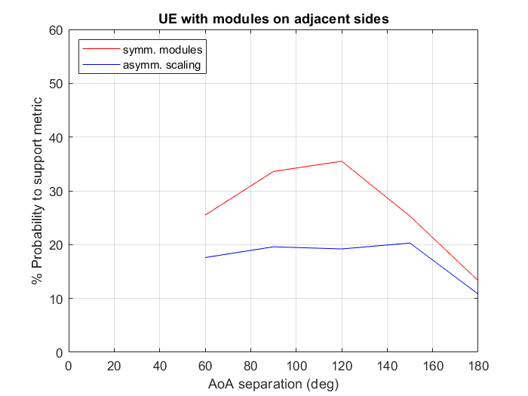 | 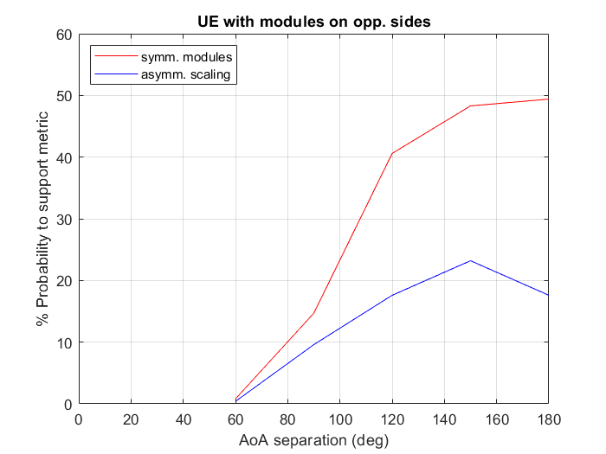

Y/N Proposal:
‘Scale the antenna gain’ method to make UE align with both peak EIS and spherical coverage applies only to schemes that degrade all modules equally. (R4-2309824)

Discussion:

3.15 Simulation detail: Alternative calibration for legacy spherical coverage
Motivation:
Sometimes ... cannot meet both REFSENS and spherical coverage gain drop at the same time. (R4-2309284. R4-2309031)
Proposals
- Option 1: Only perform the calibration on the peak EIS direction according to the Refsens level. (R4-2309031)
- Option 2: Meet one calibration condition as long as the other is met or exceeded (R4-2309284)

Option 1 is equivalent to option 2 when gain drop to 50th %ile is smaller than standards expectation (~ 11 dB for n257). Option 2 additionally covers the situation if REFSENS is much better than standard but gain drop is much larger than standard expectation. Since option 2 is more general:
Proposed WF for discussion:
In case it is not feasible to simultaneously achieve calibration on both peak and spherical coverage levels, UE meets one calibration condition as long as the other is met or exceeded (R4-2309284)

Discussion:

3.16 Simulation detail: other impairments
Motivation:
The following factors may require consideration.
- (R4-2307345) With at least two panels required to support two AoA reception, UE implementation impairments should be re-discussed. They may include physical limitations and constraints, such as thermal noise effects, routing losses, and panel interaction (as both are active at the same time), etc.
- (R4-2307345) As discussed before, besides the AoA mutual interference, if there is power imbalance between AoA1 and AoA2, its impact on AGC performance of each Rx chain needs to be considered.
- (R4-2307345) The antenna performance difference between UE’s V/H element need to be considered in requirement design, as captured in the WF [1].
- (R4-2307482) How to specify the difference in Pass Ratio according to antenna modules’ performance should be considered.

Proposal for discussion:
RAN4 further discusses what additional RF impairments/implementation constraints are to be considered in addition to spherical coverage calibration while defining the final RF requirement. (R4-2307345).

Discussion:

