3GPP TSG-RAN WG4 Meeting # 104-bis-e R4-22XXXXX
Electronic Meeting, 10– 19 October 2022

Agenda item: 4.6.2
Source: Moderator (Ericsson)
Title: Email discussion summary for [104-bis-e][104] NR_RedCap
Document for: Information

Introduction
Briefly introduce background, the scope of this email discussion (e.g. list of treated agenda items) and provide some guidelines for email discussion if necessary.
List of candidate target of email discussion for 1st round and 2nd round
- 1st round: TBA
- 2nd round: TBA
Topic for 1st round:
1: CR for Corrections on the definition of RedCap UE

Topic #1: CR for FR1
Main technical topic overview. The structure can be done based on sub-agenda basis.

Companies’ contributions summary
T-doc number | Company | Proposals / Observations
R4-2215908 | ZTE Corporation | In current TS38.101-1, the definition for Redcap UE is:  RedCap UE: A UE capable of supporting RedCap [IE].  Obviously, the definition is unclear. In terms of the RAN2 spec, there was no specific IE defined for Redcap UE.  Actually, the definition for RedCap UE is elaborated in TS38.306, which is:  RedCap UE: The UE with reduced capabilities as specified in clause 4.2.21.1.  The contents in clause 4.2.21.1 in TS38.306 are captured below:  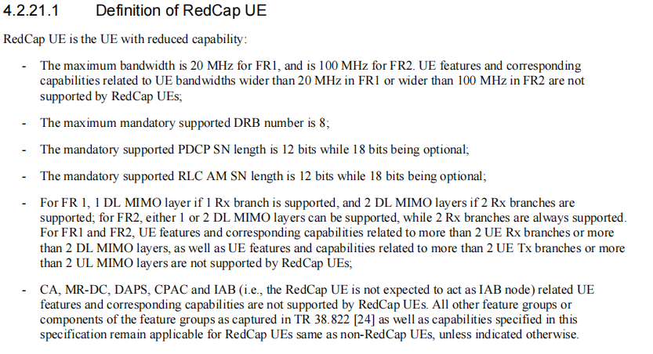  Therefore, the RedCap UE definition in TS38.101-1 should be corrected.  It is proposed to refer the reduced capabilities as specified in TS38.306.
R4-2215941 | ZTE Corporation | There is definition for RedCap UE in TS38.101-1, however, there is no definition for Redcap UE in TS38.101-2.  To align with the corrections in R4-2215908 for TS38.101-1, it is proposed to introduced RedCap UE definition in TS38.101-2.

Open issues summary
Before e-Meeting, moderators shall summarize list of open issues, candidate options and possible WF (if applicable) based on companies’ contributions.

Sub-topic 1-1
Sub-topic description:
Open issues and candidate options before e-meeting:
Issue 1-1: RedCap UE definition updates
- Proposals
  - Option 1: RedCap UE: The UE with reduced capabilities as specified in TS38.306 [14]
  - Option 2: others
- Recommended WF
  - TBA

Companies views’ collection for 1st round

Open issues
One of the two formats, i.e. either example 1 or 2 can be used by moderators.
Sub topic 1-1
Company | Comments
XXX
Huawei | It’s better to align with TS 38.306. We can specify it as below to capture the specific clause for both 38.101-1 and 38.101-3.  RedCap UE: The UE with reduced capabilities as specified in clause 4.2.21.1 from TS38.306 [XX].
ZTE | Thanks Huawei for the comments.  We are open to the wordings. We can revise the CRs.
Apple | We are okay with Huawei’s proposal to align the definition with TS 38.306 for both TS 38.101-1 and TS 38.101-2.  One clarification to the statement in R4-2215908 cover sheet: “In terms of the RAN2 spec, there was no specific IE defined for Redcap UE.”  There is actually an IE specified in TS 38.306 to indicate the support of RedCap UE which is supportOfRedCap-r17. We wonder if the above statement in the cover sheet is correct or not.
ZTE | To Apple:  You are right, thanks for pointing out the mistakes. supportOfRedCap-r17 indicates that the UE is a RedCap UE with comprised of at least the following functional components....  We can remove it in the revision. Our intention is to for RedCap UE definition, which aims to align the definition among RAN2/4 specs.
MediaTek | As there seems to be a definition in 38.306, it seems more appropriate to refer to that definition rather than a specific capability? i.e. “Please see definition in TS38.306”
vivo | Agree with Apple comments, it is for 101-1 and 101-2.
Ericsson | Current definition is missing the specific IE so adding the IE and the reference is one option:  RedCap UE: A UE capable of supporting RedCap IE [supportOfRedCap-r17] [15].  Another option is to refer to 38.306 for such definition, there is RedCap UE definition in 3.1 definition in 38.306.  RedCap UE: The UE with reduced capabilities as defined in TS38.306 [15].  Either option is fine with us.
Sony | As Ericsson points out there are two options and we are fine with either or, even though we slightly prefer the first one (RedCap UE: A UE capable of supporting RedCap IE [supportOfRedCap-r17] [15])..
Meta | We are similar view with Huawei and Apple comments to align the RAN2/RAN4 specification. The detail wording for the definition can be discussed in 2nd round. Currently, we support the wording as follow  RedCap UE: The UE with reduced capabilities as defined in TS38.306 [15].
CHTTL | We share the similar view as MTK and prefer the second one proposed by Ericsson.

CRs/TPs comments collection
For close-to-finalize WIs and maintenance work, comments collections can be arranged for TPs and CRs. For ongoing WIs, suggest to focus on open issues discussion on 1st round.
Please companies add additional comments if it is not covered in the sub-topic discussion points.
CR/TP number | Comments collection
R4-2215908 | Huawei: See comments above.
 | Ericsson: need some rewording based on 1st round /2nd round discussion.
R4-2215941 | Huawei: See comments above.
 | ericsson: need some rewording based on 1st round /2nd round discussion.

Summary for 1st round

Open issues
Moderator tries to summarize discussion status for 1st round, list all the identified open issues and tentative agreements or candidate options and suggestion for 2nd round i.e. WF assignment.
 | Status summary
Sub-topic #1 | Tentative agreements:  Candidate options:  Recommendations for 2nd round:

CRs/TPs
Moderator tries to summarize discussion status for 1st round and provides recommendation on CRs/TPs Status update
Note: The tdoc decisions shall be provided in Section 3 and this table is optional in case moderators would like to provide additional information.
CR/TP number | CRs/TPs Status update recommendation
XXX | Based on 1st round of comments collection, moderator can recommend the next steps such as “agreeable”, “to be revised”

Discussion on 2nd round (if applicable)

Recommendations for Tdocs

1st round
New tdocs
New Tdoc number | Title | Source | Comments
 | WF on … | YYY
 | LS on … | ZZZ | To: RAN_X; Cc: RAN_Y

Existing tdocs
Tdoc number | Revised to | Title | Source | Recommendation | Comments
R4-22xxxxx |  | CR on … | XXX | Agreeable, Revised, Merged, Postponed, Not Pursued
R4-2215908 |  | Corrections on the definition of RedCap UE | ZTE Corporation
R4-2215941 |  | definition on RedCap | ZTE Corporation

Notes:
- Please include the summary of recommendations for all tdocs across all sub-topics incl. existing and new tdocs.
- For the Recommendation column please include one of the following:
  - CRs/TPs: Agreeable, Revised, Merged, Postponed, Not Pursued
  - Other documents: Agreeable, Revised, Noted
- For new LS documents, please include information on To/Cc WGs in the comments column
- Do not include hyper-links in the documents

2nd round

Tdoc number | Revised to | Title | Source | Recommendation | Comments
R4-22xxxxx |  | CR on … | XXX | Agreeable, Revised, Merged, Postponed, Not Pursued
R4-22xxxxx |  | WF on … | YYY | Agreeable, Revised, Noted
R4-22xxxxx |  | LS on … | ZZZ | Agreeable, Revised, Noted

Notes:
- Please include the summary of recommendations for all tdocs across all sub-topics.
- For the Recommendation column please include one of the following:
  - CRs/TPs: Agreeable, Revised, Merged, Postponed, Not Pursued
  - Other documents: Agreeable, Revised, Noted
- Do not include hyper-links in the documents

Annex
Contact information
Company | Name | Email address
Ericsson | Chunhui Zhang | Chunhui.Zhang@ericsson.com
Huawei | Peng (Henry), Zhang | zhangpeng169@huawei.com
ZTE | Wubin Zhou | Zhou.wubin@zte.com.cn
vivo | Ruixin | ruixin.wang@vivo.com
Sony | Olof Zander | Olof.zander@sony.com
Meta | Suhwan Lim | suhlim@meta.com

Note:
- Please add your contact information in above table once you make comments on this email thread.
- If multiple delegates from the same company make comments on single email thread, please add you name as suffix after company name when make comments i.e. Company A (XX, XX)

