3GPP TSG-RAN WG4 Meeting # 104-bis-e R4-22XXXXX
Electronic Meeting, 10– 19 October 2022

Agenda item: 4.6.2
Source: Moderator (Ericsson)
Title: Email discussion summary for [104-e][104] NR_RedCap
Document for: Information

Introduction
Briefly introduce background, the scope of this email discussion (e.g. list of treated agenda items) and provide some guidelines for email discussion if necessary.
List of candidate target of email discussion for 1st round and 2nd round
- 1st round: TBA
- 2nd round: TBA
Topic for 1st round:
1: CR for Corrections on the definition of RedCap UE

Topic #1: CR for FR1
Main technical topic overview. The structure can be done based on sub-agenda basis.

Companies’ contributions summary
T-doc number | Company | Proposals / Observations
R4-2215908 | ZTE Corporation | In current TS38.101-1, the definition for Redcap UE is:  RedCap UE: A UE capable of supporting RedCap [IE].  Obviously, the definition is unclear. In terms of the RAN2 spec, there was no specific IE defined for Redcap UE.  Actually, the definition for RedCap UE is elaborated in TS38.306, which is:  RedCap UE: The UE with reduced capabilities as specified in clause 4.2.21.1.  The contents in clause 4.2.21.1 in TS38.306 are captured below:  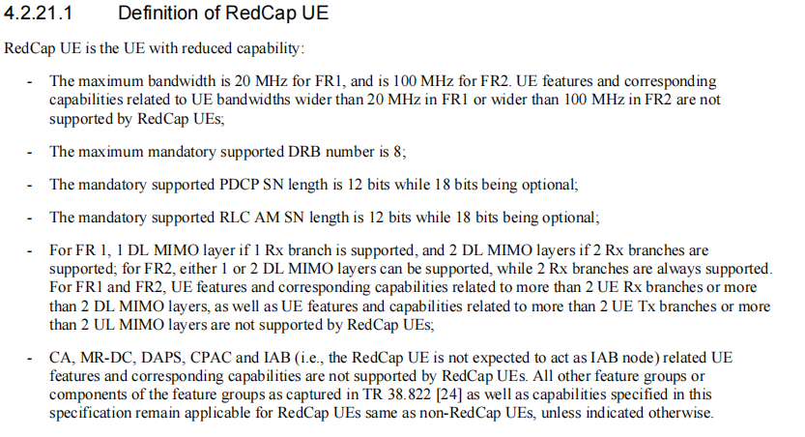  Therefore, the RedCap UE definition in TS38.101-1 should be corrected.  It is proposed to refer the reduced capabilities as specified in TS38.306.
R4-2215941 | ZTE Corporation | There is definition for RedCap UE in TS38.101-1, however, there is no definition for Redcap UE in TS38.101-2.  To align with the corrections in R4-2215908 for TS38.101-1, it is proposed to introduced RedCap UE definition in TS38.101-2.

Open issues summary
Before e-Meeting, moderators shall summarize list of open issues, candidate options and possible WF (if applicable) based on companies’ contributions.

Sub-topic 1-1
Sub-topic description:
Open issues and candidate options before e-meeting:
Issue 1-1: RedCap UE definition updates
- Proposals
  - Option 1: RedCap UE: The UE with reduced capabilities as specified in TS38.306 [14]
  - Option 2: others
- Recommended WF
  - TBA

Companies views’ collection for 1st round

Open issues
One of the two formats, i.e. either example 1 or 2 can be used by moderators.
Sub topic 1-1
Company | Comments
XXX

CRs/TPs comments collection
For close-to-finalize WIs and maintenance work, comments collections can be arranged for TPs and CRs. For ongoing WIs, suggest to focus on open issues discussion on 1st round.
Please companies add additional comments if it is not covered in the sub-topic discussion points.
CR/TP number | Comments collection
R4-2215908 | Company A
 | Company B
R4-2215941 | Company A
 | Company B

Summary for 1st round

Open issues
Moderator tries to summarize discussion status for 1st round, list all the identified open issues and tentative agreements or candidate options and suggestion for 2nd round i.e. WF assignment.
 | Status summary
Sub-topic #1 | Tentative agreements:  Candidate options:  Recommendations for 2nd round:

CRs/TPs
Moderator tries to summarize discussion status for 1st round and provides recommendation on CRs/TPs Status update
Note: The tdoc decisions shall be provided in Section 3 and this table is optional in case moderators would like to provide additional information.
CR/TP number | CRs/TPs Status update recommendation
XXX | Based on 1st round of comments collection, moderator can recommend the next steps such as “agreeable”, “to be revised”

Discussion on 2nd round (if applicable)

Recommendations for Tdocs

1st round
New tdocs
New Tdoc number | Title | Source | Comments
 | WF on … | YYY
 | LS on … | ZZZ | To: RAN_X; Cc: RAN_Y

Existing tdocs
Tdoc number | Revised to | Title | Source | Recommendation | Comments
R4-22xxxxx |  | CR on … | XXX | Agreeable, Revised, Merged, Postponed, Not Pursued
R4-2215908 |  | Corrections on the definition of RedCap UE | ZTE Corporation
R4-2215941 |  | definition on RedCap | ZTE Corporation

Notes:
- Please include the summary of recommendations for all tdocs across all sub-topics incl. existing and new tdocs.
- For the Recommendation column please include one of the following:
  - CRs/TPs: Agreeable, Revised, Merged, Postponed, Not Pursued
  - Other documents: Agreeable, Revised, Noted
- For new LS documents, please include information on To/Cc WGs in the comments column
- Do not include hyper-links in the documents

2nd round

Tdoc number | Revised to | Title | Source | Recommendation | Comments
R4-22xxxxx |  | CR on … | XXX | Agreeable, Revised, Merged, Postponed, Not Pursued
R4-22xxxxx |  | WF on … | YYY | Agreeable, Revised, Noted
R4-22xxxxx |  | LS on … | ZZZ | Agreeable, Revised, Noted

Notes:
- Please include the summary of recommendations for all tdocs across all sub-topics.
- For the Recommendation column please include one of the following:
  - CRs/TPs: Agreeable, Revised, Merged, Postponed, Not Pursued
  - Other documents: Agreeable, Revised, Noted
- Do not include hyper-links in the documents

Annex
Contact information
Company | Name | Email address
Ericsson | Chunhui Zhang | Chunhui.Zhang@ericsson.com

Note:
- Please add your contact information in above table once you make comments on this email thread.
- If multiple delegates from the same company make comments on single email thread, please add you name as suffix after company name when make comments i.e. Company A (XX, XX)

