**3GPP TSG-RAN WG4 Meeting # 104-e R4-22xxxxx**

**Electronic Meeting, 15– 26 August 2022**

**Agenda item:** 11.5.1, 11.5.2, 11.5.3, 11

**Source:** Qualcomm Incorporated

**Title:** WF on NR FR2 OTA testing enhancements

**Document for:** Approval

# Introduction

According to the email discussion summary in [1], this document is to capture the WF on NR FR2 OTA testing enhancement.

# WF on general and workplan

### Sub-topic 1-1

**Issue 1-1: Work plan**

* Proposals
  + Option 1: To adopt the workplan Rel-18 FR2 OTA testing enhancements study item in the revision of R4-2213181
  + Option 2: Provide the comments if any
* Agreement: Endorse the latest draft work plan
  + RAN4 aims to further discuss and document the feasibility of supporting the full degree of rotation freedom with 2AoA and check the status by RAN4 #106 meeting.

### Sub-topic 1-2

**Issue 1-2: Extend the scoping to also consider multi-panel transmission**

* Proposals
  + Option 1: RAN4 to recommend extending the scope to include the multi-Tx from testability point of view considering the forward compatibility. The study on the multi-Tx is with 2nd priority. The final decision will be made in RAN level.
  + Option 2: RAN4 not to recommend extending the scope to include the multi-Tx from testability point. The final decision will be made in RAN level.
* Agreement: No consensus in RAN4 for the extending the scope to include the multi-Tx from testability point. Whether this can be included subject to further guidance from RAN-P if any.

### Sub-topic 1-3

**Issue 1-3: Dependence between core requirements and test method**

* Proposals
  + Option 1: Study the test method considering both the test system capability as well as the core requirement definition. The test method and core requirements will be discussing in parallel. Study on detailed test methods enhancement ensuring a close connection between progress in requirements.
  + Option 2: specify other option if any
* Agreement:
  + Study the test method considering both the test system capability as well as the core requirement definition. Study on detailed test methods enhancement ensuring a close connection between progress in requirements

### Sub-topic 1-4

**Issue 1-3: Skeleton for TR 38.871**

* Proposals
  + Option 1: Agree on TR skeleton in revision of R4-2213182
  + Option 2: Provide the comments if any
* Agreement: Proceed the skeleton with [ ] on title and/or editor note to clarify the title maybe updated in future.

# WF on test methods for RF/RRM/Demodulation requirements

### Sub-topic 2-1

**Issue 2-1-1: Quiet zone size and validation procedure**

* Proposals
  + Option 1: Study the quiet zone size, MU definition and validation procedure for multi-Rx ~~and multi-Tx if applicable~~. The same list of QZ sizes defined so far (i.e., 20cm, 30cm, 40cm, and 55cm) is starting point and 30cm QZ is with high priority.
  + Option 2: specify other option if any
* Agreement:
  + Study the quiet zone size, MU definition and validation procedure for multi-Rx. The same list of QZ sizes defined so far (i.e., 20cm, 30cm, 40cm, and 55cm) is starting point and 30cm QZ is with high priority.

**Issue 2-1-2: Baseline measurement setup for RF testing**

* Proposals: companies are encouraged to provide your view for the following options from considerations of reusing legacy system and feasibility of test setup aspects.
  + Option 1: Reuse legacy IFF/DFF system as much as possible and further study how to introduce additional DL antenna to support the 2AoA spherical coverage measurement. Whether to support 2 simultaneously active AoAs is FFS
  + Option 2: Enhanced IFF is selected as the baseline methodology for further study and definition of multi AoA methodology for multi-panel reception UEs. Reuse legacy RRM test setup, i.e., angular relationships between simultaneously active AoAs is 30°, 60°, 90°, 120° and 150°. Whether the list can be further reduced is FFS.
  + Option 3: Study new multi-probe test system targeted to enable the condition that the simultaneous reception/transmission paths to and from UE can be configured as any directions permutations by proper rotation system design
  + Option 4: The test method setup for FR2 MIMO OTA in TR 38.827 can be considered as the baseline together with those in TR 38.810 and TR 38.884.
  + Option 5: Current study on inter-band CA of FR2+FR2 with offset antenna can be the starting point of the new test methodology.
* Agreements:
  + To further discuss above potential baseline measurement setups for RF testing. Other options are not precluded.
  + To evaluate and decide how many simultaneously active AoAs are needed.
  + Reusing legacy IFF/DFF system as much as possible is preferred.

**Issue 2-1-3: The feasibility of supporting full rotational degrees of freedom for simultaneously two active AoAs in RF testing**

* Proposals: companies are encouraged to share the views on the potential feasibility issues to support full rotational degrees of freedom for simultaneously two active AoAs
  + Option 1: It is feasible.
  + Option 2: It is not feasible. Specify the issues if any.
* Agreements:
  + To further study in next meeting

**Issue 2-1-4: Potential test methods for RF testing**

* Proposals: companies are encouraged to share the views on pros and cons for each option
  + Option 1(R4-2211549): IFF+IFF with moving reflectors, Test 2 AoAs simultaneously with 2 IFF (see example illustration below)

* + Option 2 (R4-2211549): IFF+DFF, DFF antennae as the second AoA NR anchor (see example illustration below)

* + Option 3 (R4-2211549): IFF+DFF, fixed DFF antennae as NR anchor (see example illustration below)

* + Option 4 (R4-2211549): Sequential tests by introducing a new test command to fix an active antenna in the DUT (see example illustration below)

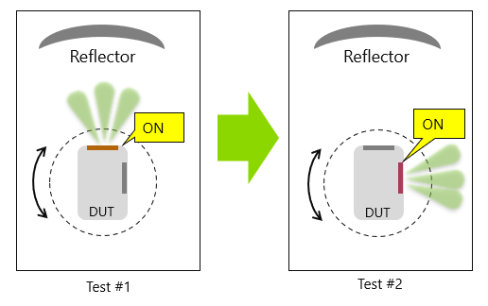

* + Option 5 (R4-2211991): IFF+ rotating UE and anchor probe as a whole, the probes are divided into test probe and anchor probe (see example illustration below)

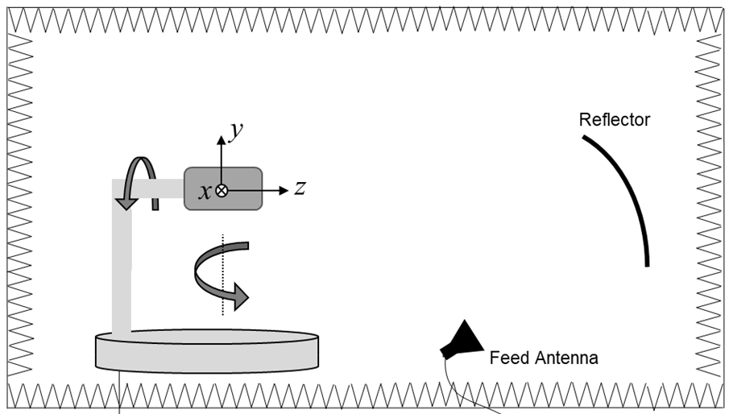

rotate UE and anchor probe as a whole

anchor probe

test probe

* + Option 6 (R4-2213627): Enhanced IFF method utilizing multiple compact antenna test ranges as per TS 38.508-1, i.e., reuse the legacy RRM test setup (see example illustration below)



* Agreements:
  + To investigate pros and cons for each option in next meeting.
  + Other options are not precluded.

### Sub-topic 2-2

**Issue 2-2: Baseline measurement setup for RRM testing**

* Proposals: companies are encouraged to share the views on pros and cons for each option
  + Option 1 (Apple): Further discuss applicability of the legacy FR2 RRM test setup to the multi-panel reception RRM requirements
  + Option 2 (Qualcomm): Legacy RRM test setup could be baseline and to further consider more flexibility on the angular offset for multiple panels for UE RRM requirements testing.
  + Option 3 (R&S): Enhanced IFF is selected as the baseline methodology for further study and definition of multi AoA methodology for multi-panel reception UEs. Reuse legacy RRM test setup, i.e., angular relationships between simultaneously active AoAs is 30°, 60°, 90°, 120° and 150°. Whether the list can be further reduced is FFS.
  + Option 4 (vivo): Wait for the clear feedback from RRM session on which requirement will be specified and how the capability of test system should be.
* Agreements
  + To investigate pros and cons for each option in next meeting.
  + Other options are not precluded.

### Sub-topic 2-3

**Issue 2-3-1: Approach for multi-panel reception demodulation testing**

* Proposals
  + Option 1: The virtual cable approach should be the baseline for multiple panels UE demodulation testing and only pure baseband performance shall be tested.
  + Option 2: Specify other option if any
* Agreement:
  + Option 1

**Issue 2-3-2: Baseline measurement setup for demodulation testing**

* Proposals: companies are encouraged to share the views on pros and cons for each option
  + Option 1 (vivo): The Rel-15 measurement setup for UE demodulation should be baseline for further enhancement to support 4-layer MIMO. To discuss how to introduce additional DL antenna with reasonable angular separation.
  + Option 2 (Qualcomm): RAN4 to further study how to support the selection of beam pair (two AoAs) for UE demodulation requirements testing.
  + Option 3 (R&S): Enhanced IFF is selected as the baseline methodology for further study and definition of multi AoA methodology for multi-panel reception UEs. Reuse legacy RRM test setup, i.e., angular relationships between simultaneously active AoAs is 30°, 60°, 90°, 120° and 150°. Whether the list can be further reduced is FFS.
* Agreements:
  + To investigate pros and cons for each option in next meeting.
  + Other options are not precluded

**Issue 2-3-3: The feasibility of supporting full rotational degrees of freedom for simultaneously two active AoAs in demodulation testing**

* Proposals: continue to discuss the necessity and feasibility of supporting full rotational degrees of freedom for simultaneously two active AoAs in demodulation testing
  + Option 1: It is necessary and feasible to support full rotational degrees of freedom for simultaneously two active AoAs in demodulation testing
  + Option 2: It is not necessary. Please specify the reasons and the feasibility issues if Option 2 is selected.
* Agreements:
  + To further study in next meeting

# WF on test uncertainty assessments

### Sub-topic 3-1

**Issue 3-1: MU impacts for Multi-Rx test system**

* Proposals
  + Option 1: RAN4 to study the impact on MU element of Quality of Quiet Zone and positioner blocking.
  + Option 2: specify other option if any
* Agreement:
  + RAN4 to study the impact of positioner blocking on MU element of Quality of Quiet Zone

# WF on maximum DL testable SNR for band n263

### Sub-topic 4-1

**Issue 4-1-1: Is it possible to enhance the antenna gain for n263 in IFF compared to 12dBi used for FR2-1?**

* Proposals
  + Option 1: The probe antenna gain of 12dBi should be kept for IFF for FR2-2.
* Agreements:
  + Option 1

**Issue 4-1-2: Maximum DL testable SNR for 8RBs with 480kHz SCS for band n263**

* Proposals
  + Option 1: Introducing the maximum DL testable SNR for 8RBs in TR38884. The conclusion to be reflected in R4-2214539.
* Agreements

Hold on introducing the maximum DL testable SNR for 8RBs in TR38884.

**Issue 4-1-3: Maximum DL testable SNR for 800MHz CBW SCS for band n263**

* Proposals
  + Option 1: To correct maximum DL testable SNR from [-14.5]dB to [-2.3]dB for 800MHz CBW in TR38.884. The conclusion to be reflected in R4-2214539.
  + Agreements:
  + Option 1

**Issue 4-1-4: Is it possible to enhance transmit power from TE?**

* Proposals
  + Option 1: Keep the original parameters for transmit power of TE at this stage.
* Agreements:
  + Option 1

**Issue 4-1-5: Is it possible to enhance the parameter of backoff from P1?**

* Proposals
  + Option 1: update the SNR in TR38884 based on the latest agreements in RAN5 on backoff from P1. The updates to be reflected in R4-2214539
* Agreements:
  + Option 1

**Issue 4-1-6: Is it possible to use DNF method for demodulation OTA testing for band n263?**

* Proposals:
  + Option 1: Yes, please specify the details on the feasibility of testing REFSENSE, RSRPB, etc by DNF.
  + Option 2: No, please specify the reasons
* Agreements:
  + To further discuss the feasibly of using DNF method for demodulation OTA testing for band n263

# Reference

[1] R4-2214323, Email Discussion Summary for [104-e][334] FS_NR_FR2_OTA_enh, Moderator (Qualcomm)