**3GPP TSG-RAN WG4 Meeting # 104-e R4-2212642  
Electronic Meeting, 15 – 26 August 2022**

**Agenda item: 9.1.2.1**

**Source:** **CAICT**

**Title: Summary of** **FR1 MIMO OTA lab alignment results**

**Document for: Discussion**

# 1 Introduction

In RAN4#103-e meeting, FR1 MIMO OTA lab alignment has been confirmed among 5 labs including CAICT, CMCC&BUPT, Huawei, MediaTek, and Xiaomi [1]-[6]. Due to the delay caused by COVID lockdown, the last lab (Apple) is allowed to submit PAD measurement results at this meeting [6]. In this meeting, Apple submitted PAD measurement results in [7].

This contribution presents a summary and analysis of the PAD measurement data from all the 6 labs.

# 2 Discussion

The FR1 MIMO OTA lab alignment results from the 6 labs are summarized and analysed as shown in Table 1. The reference value of each PAD at each band is the linear average (in dB) of the PAD measurement results submitted by all the labs. The detailed analysis file is in the Excel worksheet of this contribution.

**Table 1. Summary of the FR1 MIMO OTA lab alignment results**

|  |  |  |  |  |  |  |  |  |  |  |
| --- | --- | --- | --- | --- | --- | --- | --- | --- | --- | --- |
| **Device** | **Band** | **TRMS measurement result [dBm/30kHz]** | | | | | | **Average approach** | **Reference value** | **Max-Min deviation** |
| **Lab 1** | **Lab 2** | **Lab 3** | **Lab 4** | **Lab 5** | **Lab 6** |
| PAD_n41_1 | n41 | -96.43 | -97.61 | -98.20 | -97.45 | -96.88 | -99.10 | Linear average | -97.61 | 2.67 |
| PAD_n41_2 | n41 | -99.30 | -97.80 | -100.02 | -99.96 | -99.62 | -101.43 | -99.69 | 3.63 |
| PAD_n41_3 | n41 | -96.31 | -97.39 | -97.81 | -96.53 | -96.74 | -98.59 | -97.23 | 2.28 |
| PAD_n78_1 | n78 | -96.02 | -96.54 | -96.44 | -96.10 | -96.53 | -98.38 | -96.67 | 2.36 |
| PAD_n78_2 | n78 | -95.42 | -95.95 | -96.11 | -96.48 | -96.66 | -98.97 | -96.60 | 3.55 |
| PAD_n78_3 | n78 | -99.06 | -97.42 | -99.53 | -99.08 | -99.54 | NA1 | -98.93 | 2.12 |
| **Device** | **Band** | **TRMS offset [dBm/30kHz]** | | | | | | **Pass/fail limit** | | |
| **Lab 1** | **Lab 2** | **Lab 3** | **Lab 4** | **Lab 5** | **Lab 6** |
| PAD_n41_1 | n41 | 1.18 | 0.00 | -0.59 | 0.16 | 0.73 | -1.49 | +/- 0.75 MU, i.e., +/- 2.25 dB | | |
| PAD_n41_2 | n41 | 0.39 | 1.89 | -0.33 | -0.27 | 0.07 | -1.74 |
| PAD_n41_3 | n41 | 0.92 | -0.16 | -0.58 | 0.70 | 0.49 | -1.36 |
| PAD_n78_1 | n78 | 0.65 | 0.13 | 0.22 | 0.57 | 0.14 | -1.71 | +/- 0.75 MU, i.e., +/- 2.55 dB | | |
| PAD_n78_2 | n78 | 1.18 | 0.65 | 0.48 | 0.12 | -0.06 | -2.37 |
| PAD_n78_3 | n78 | -0.13 | 1.51 | -0.60 | -0.15 | -0.61 | NA1 |
| **Lab alignment conclusion** | | **Pass** | **Pass** | **Pass** | **Pass** | **Pass** | **Pass** |  |  |  |

Note 1: The PAD_n78_3 was delivered to Apple on 08/09/2022, one day before the contribution submission deadline; the measurement results of PAD_n78_3 are not available in [7].

Figure 1 presents the TRMS measurement results, and Figure 2 illustrates the deviations between TRMS measurement values and reference values.

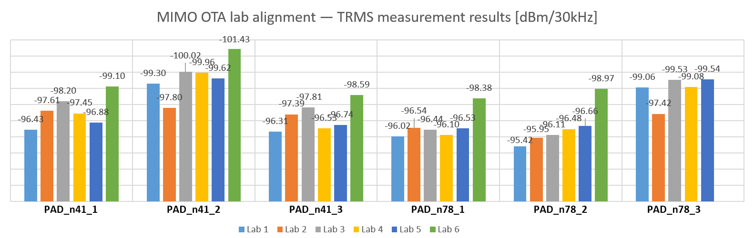

**Figure 1. TRMS measurement results submitted by 5 labs**

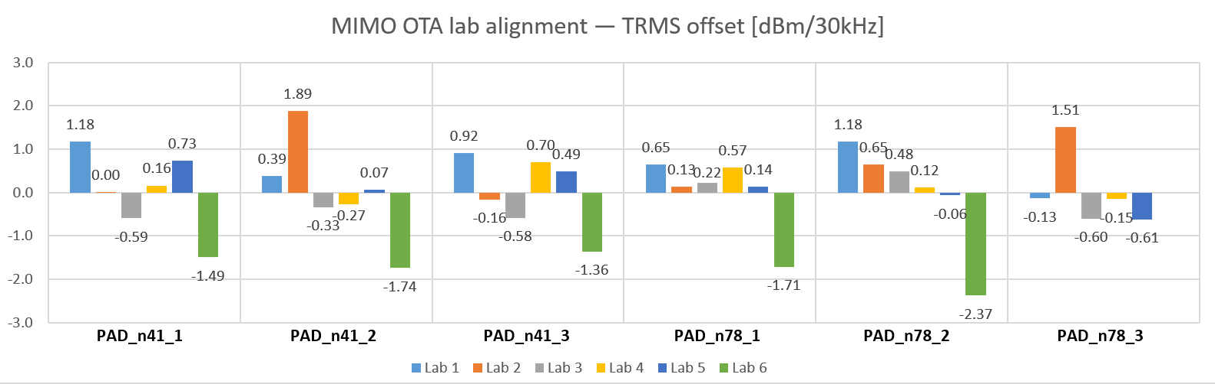

**Figure 2. Deviations between TRMS measurement values and reference values**

The alignment among the 6 labs is confirmed in RAN4#104-e meeting [8].

**Observation 1: 3GPP FR1 MIMO OTA lab alignment among the 6 labs, i.e., CAICT, CMCC&BUPT, Huawei, MediaTek, Xiaomi, and Apple is confirmed [8].**

# 3 Conclusion

This contribution presents a summary and analysis of the PAD measurement data from all the 6 labs.

**Observation 1: 3GPP FR1 MIMO OTA lab alignment among the 6 labs, i.e., CAICT, CMCC&BUPT, Huawei, MediaTek, Xiaomi, and Apple is confirmed [8].**

# References

1. R4-2208320, “CAICT FR1 MIMO OTA lab alignment results”, CAICT, 3GPP RAN4#103e, May 2022.
2. R4-2208412, “PAD testing results of CMCC & BUPT joint lab”, CMCC, BUPT, 3GPP RAN4#103e, May 2022.
3. R4-2207654, “MIMO OTA lab alignment results”, Huawei, 3GPP RAN4#103e, May 2022.
4. R4-2208319, “PAD test results for NR FR1 MIMO OTA lab alignment”, MediaTek, 3GPP RAN4#103e, May 2022.
5. R4-2209514, “3GPP NR FR1 MIMO OTA Lab Alignment Result”, Xiaomi, 3GPP RAN4#103e, May 2022.
6. R4-2210675, “WF on NR MIMO OTA”, vivo, CAICT, 3GPP RAN4#103-e, May 2022.
7. Rev. of R4-2212406, “MIMO OTA lab alignment results”, Apple, 3GPP RAN4#104-e, Aug. 2022.
8. R4-2214360, “WF on NR MIMO OTA”, CAICT, vivo, 3GPP RAN4#104-e, Aug. 2022.