3GPP TSG-RAN4 WG4 Meeting #104-e R4-2213190

Electronic Meeting, August 15 – August 26, 2022
CR-Form-v12.2
CHANGE REQUEST
 | 38.151 | CR | XXXX | rev | - | Current version: | 17.1.0
For HELP on using this form: comprehensive instructions can be found at
http://www.3gpp.org/Change-Requests.

Proposed change affects: | UICC apps |  | ME | x | Radio Access Network |  | Core Network

Title: | Draft CR to 38.151 on Channel model validation
Source to WG: | Huawei, HiSilicon
Source to TSG: | R4
Work item code: | NR_MIMO_OTA |  |  |  |  |  | Date: |  |  | 2022-08-10
Category: | F |  |  |  |  |  | Release: |  |  | Rel-17
 | Use one of the following categories:  F (correction)  A (mirror corresponding to a change in an earlier release)  B (addition of feature),  C (functional modification of feature)  D (editorial modification)  Detailed explanations of the above categories can  be found in 3GPP TR 21.900. |  |  |  |  |  |  |  | Use one of the following releases:  Rel-8 (Release 8)  Rel-9 (Release 9)  Rel-10 (Release 10)  Rel-11 (Release 11)  …  Rel-16 (Release 16)  Rel-17 (Release 17)  Rel-18 (Release 18)  Rel-19 (Release 19)
Reason for change: |  | Spec context inconsistency may lead to confusion.
Summary of change: |  | Regarding Doppler/Temporal correlation, absolute values are applied for normalization instead of real numbers.  Regarding FR1 Spatial correlation, span is consistent with number of points in VNA settings. Add note: Span and number of points may be increased to estimate reliably.  Regarding FR2 PSP, H(m∆f,n∆t) is consistent with VNA settings. Add note: Span and number of points may be increased to estimate reliably.
Consequences if not approved: |  | Spec context inconsistency.
Clauses affected: |  | C.3.3, D.3.4, D.3.3, D.3.4
 |  | Y | N
Other specs |  |  | x | Other core specifications |  |  |  | TS/TR … CR …
affected: |  | x |  | Test specifications |  |  |  | TS 38.521-2
(show related CRs) |  |  | x | O&M Specifications |  |  |  | TS/TR … CR …
Other comments:

This CR’s revision history:

<<< START OF CHANGE >>>

C.3.3 Doppler/Temporal correlation
This measurement checks the Doppler/temporal correlation. For Doppler/Temporal correlation validation measurement, only Vertical validation is required.
The Doppler spectrum is measured with a spectrum analyser as shown in Figure C.3.3-1. In this case a signal generator transmits CW signal through the NR MIMO OTA test system. The signal is received by a test antenna within the test area. Finally, the signal is analysed by a spectrum analyser and the measured spectrum is compared to the target spectrum. This setup can be used to measure Doppler Spectrum of the Channel models defined in Annex C.1.
Method of measurement:
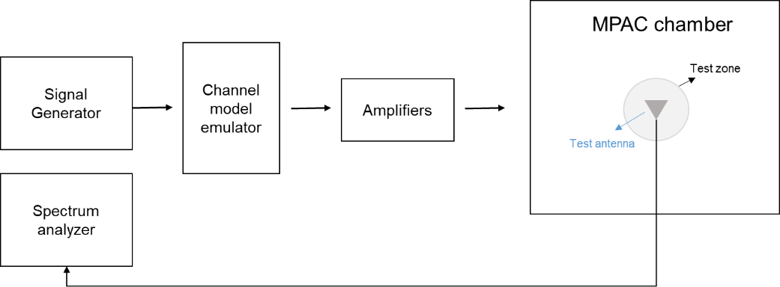
Figure C.3.3-1: Setup for Doppler measurements
Sine wave (CW, carrier wave) signal is transmitted from the signal generator. The signal is connected from the signal generator to fading emulator via cables. The fading emulator output signals are connected to power amplifier boxes via cables. The amplified signals are then transferred via cables to the probe antennas. The probe antennas radiate the signals over the air to the test antenna. The Doppler spectrum is measured by the spectrum analyser and the trace is saved.
Signal generator settings:
Table C.3.3-1: Signal generator settings for Doppler/Temporal correlation measurements
Item | Unit | Value
Centre frequency | MHz | Downlink centre frequency  in Table C.3.1-1
Modulation |  | OFF

Spectrum analyser settings:
Table C.3.3-2: Spectrum analyser settings for Doppler/Temporal correlation measurements
Item | Unit | Value
Centre frequency | MHz | Downlink centre frequency  in Table C.3.1-1
Minimum Span | Hz | 4 kHz
RBW | Hz | 1
VBW | Hz | 1
Number of points |  | 16002
Averaging |  | 100

Channel model specification:
Table C.3.3-3: Channel model specification for Doppler/Temporal correlation measurements
Item | Unit | Value
Centre frequency | MHz | Downlink centre frequency  in Table C.3.1-1
Channel model |  | As specified in Annex C.1
Mobile speed | km/h | 100

Method of measurement result analysis: Measurement data file (Doppler power spectrum) is saved into hard drive. The data is read into, e.g., Matlab. The analysis is performed by taking the Fourier transformation of the Doppler spectrum. The resulting temporal correlation function $R_{t}\left(Δt\right)$ is normalized such that max(abs(R_{t}(∆t)))=1$\text{max}\left(\text{Re}\left(R_{t}\left(Δt\right)\right)\right)=1$. Then the function values left from the maximum i.e., the negative lags are cut out. Further on the function values after five periods are cut out.
Time Domain Alternate Method
Time domain techniques can also be used to validate the tempoal correlation. The temporal correlation validation measurement setup is illustrated in Figure C.3.3-2. In this case a Signal generator transmits a CW signal through the MIMO test system. The signal is received by a test antenna within the test area. Finally, the signal is collected by a signal analyser and the measured signal is stored as IQ data format for postprocessing.
Signal
Analyzer
Trigger

Figure C.3.3-2: Setup for Doppler measurements based on time domain technique
The time domain doppler spectrum is measured by the signal analyzer and the trace in IQ format is saved. Follow the same procedure to post process the data and calculate the temporal correlation curve. Data recording is synchronized with the channel emulator trigger.
The settings for the signal analyzer are in Table C.3.3-4:
Table C.3.3-4: Signal Analyser Settings
Item | Unit | Value
Centre frequency | MHz | Downlink centre frequency in Table C.3.1-1
Sampling | Hz | At least 15 times bigger than the max Doppler spread (f_{d}=v/λ)
Observation time | s | At least 16s. Channel Model length should be the same or greater than the observation time.

Beam-Specific Block Diagram
It is assumed that the beams are mapped to the inputs of the channel emulator as follows:
- Beam 1: Input 1 and Input 2
- Beam 2: Input 3 and Input 4 (CDL-C UMa only)
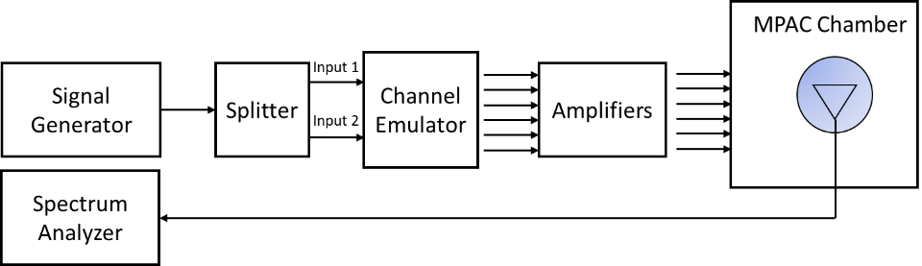
Figure C.3.3-3: Setup for Beam-Specific Doppler measurements (Beam 1)
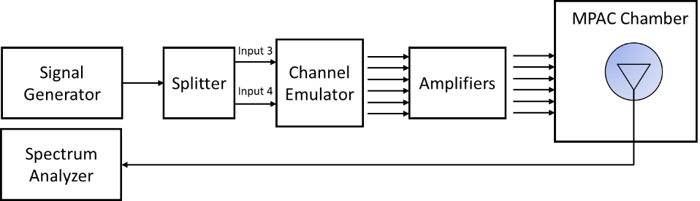
Figure C.3.3-4: Setup for Beam-Specific Doppler measurements (Beam 2 CDL-C UMa only)
The detailed Temporal correlation reference value for CDL-C UMa and CDL-C UMi channel model validation is defined is table C.3.3-5.
Table C.3.3-5: Autocorrelation Targets
Lambda Separation | CDL-C UMa beam 1 at  ≤ 2.5 GHz | CDL-C UMa beam 2 at ≤ 2.5 GHz | CDL-C UMa beam 1 at > 2.5 GHz | CDL-C UMa beam 2 at > 2.5 GHz | CDL-C UMi beam 1 at  ≤ 2.5 GHz | CDL-C UMi beam 1 at > 2.5 GHz
0.0 | 1.000 | 1.000 | 1.000 | 1.000 | 1.000 | 1.000
0.1 | 0.986 | 0.974 | 0.985 | 0.973 | 0.995 | 0.995
0.2 | 0.945 | 0.907 | 0.942 | 0.904 | 0.982 | 0.982
0.3 | 0.882 | 0.832 | 0.874 | 0.825 | 0.962 | 0.961
0.4 | 0.801 | 0.776 | 0.787 | 0.765 | 0.936 | 0.935
0.5 | 0.709 | 0.738 | 0.689 | 0.723 | 0.906 | 0.905
0.6 | 0.613 | 0.695 | 0.586 | 0.675 | 0.872 | 0.871
0.7 | 0.518 | 0.623 | 0.486 | 0.599 | 0.834 | 0.834
0.8 | 0.430 | 0.525 | 0.394 | 0.496 | 0.793 | 0.793
0.9 | 0.353 | 0.426 | 0.315 | 0.391 | 0.750 | 0.749
1.0 | 0.289 | 0.360 | 0.252 | 0.319 | 0.705 | 0.704
1.1 | 0.240 | 0.335 | 0.206 | 0.290 | 0.659 | 0.658
1.2 | 0.204 | 0.320 | 0.174 | 0.273 | 0.614 | 0.612
1.3 | 0.181 | 0.287 | 0.154 | 0.239 | 0.569 | 0.568
1.4 | 0.167 | 0.233 | 0.143 | 0.185 | 0.527 | 0.525
1.5 | 0.159 | 0.176 | 0.137 | 0.129 | 0.487 | 0.485
1.6 | 0.155 | 0.141 | 0.135 | 0.096 | 0.450 | 0.448
1.7 | 0.153 | 0.135 | 0.134 | 0.092 | 0.417 | 0.415
1.8 | 0.150 | 0.137 | 0.134 | 0.095 | 0.387 | 0.385
1.9 | 0.144 | 0.132 | 0.130 | 0.093 | 0.361 | 0.358
2.0 | 0.135 | 0.117 | 0.122 | 0.089 | 0.337 | 0.335
2.1 | 0.121 | 0.097 | 0.109 | 0.086 | 0.316 | 0.313
2.2 | 0.105 | 0.076 | 0.090 | 0.076 | 0.296 | 0.293
2.3 | 0.085 | 0.062 | 0.069 | 0.064 | 0.277 | 0.274
2.4 | 0.065 | 0.071 | 0.047 | 0.067 | 0.258 | 0.255
2.5 | 0.048 | 0.090 | 0.031 | 0.088 | 0.239 | 0.236
2.6 | 0.039 | 0.099 | 0.033 | 0.103 | 0.219 | 0.216
2.7 | 0.038 | 0.088 | 0.046 | 0.099 | 0.198 | 0.195
2.8 | 0.042 | 0.058 | 0.057 | 0.073 | 0.178 | 0.175
2.9 | 0.043 | 0.037 | 0.062 | 0.038 | 0.158 | 0.154
3.0 | 0.041 | 0.067 | 0.060 | 0.045 | 0.138 | 0.135
3.1 | 0.037 | 0.103 | 0.050 | 0.080 | 0.120 | 0.116
3.2 | 0.036 | 0.120 | 0.036 | 0.100 | 0.103 | 0.100
3.3 | 0.044 | 0.115 | 0.019 | 0.099 | 0.089 | 0.085
3.4 | 0.056 | 0.097 | 0.010 | 0.081 | 0.076 | 0.073
3.5 | 0.068 | 0.082 | 0.019 | 0.061 | 0.066 | 0.063
3.6 | 0.075 | 0.083 | 0.029 | 0.053 | 0.057 | 0.055
3.7 | 0.076 | 0.090 | 0.034 | 0.060 | 0.051 | 0.049
3.8 | 0.068 | 0.089 | 0.036 | 0.073 | 0.046 | 0.044
3.9 | 0.051 | 0.079 | 0.044 | 0.091 | 0.042 | 0.041
4.0 | 0.027 | 0.068 | 0.062 | 0.111 | 0.039 | 0.038
4.1 | 0.007 | 0.063 | 0.090 | 0.127 | 0.037 | 0.035
4.2 | 0.036 | 0.062 | 0.123 | 0.133 | 0.036 | 0.034
4.3 | 0.067 | 0.057 | 0.155 | 0.129 | 0.038 | 0.036
4.4 | 0.093 | 0.052 | 0.182 | 0.126 | 0.043 | 0.040
4.5 | 0.111 | 0.055 | 0.200 | 0.131 | 0.051 | 0.048
4.6 | 0.119 | 0.063 | 0.207 | 0.139 | 0.061 | 0.058
4.7 | 0.116 | 0.066 | 0.200 | 0.138 | 0.073 | 0.070
4.8 | 0.101 | 0.058 | 0.180 | 0.117 | 0.085 | 0.082
4.9 | 0.078 | 0.047 | 0.149 | 0.079 | 0.096 | 0.093
5.0 | 0.051 | 0.048 | 0.110 | 0.034 | 0.107 | 0.104

C.3.4 Spatial correlation
This measurement checks whether the measured correlation curve follows the theoretical curve. For spatial correlation validation measurement, only Vertical validation measurement is required. Spatial correlation validation is only adopted for FR1 MIMO OTA.
The spatial correlation validation measurement setup is illustrated in Figure C.3.4-1. The network analyser transmits signals through the fading emulator and probes. The 16 probes radiate the signals within the anechoic chamber and a receiving test antenna is placed within the test zone. The test antenna is attached to a positioner that can move the antenna to pre-defined spatial locations on a fixed radius from the centre of the quiet zone. The received signal is measured with the network analyser.
The measurement and analysis procedure are as follows:
Set the target channel model to fading emulator.
1. For each position of the test antenna in the test zone, step & pause the emulator to different time instances. Measure the frequency responses for all stepped channel snapshots 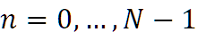, where the interval between frequency and time samples is 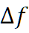 and 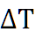, respectively. The number of channel snapshots and frequency samples should be sufficiently high so that the matrix can be estimated reliably.
2. Move the measurement antenna with a positioner to another location and repeat step 2 to record frequency responses 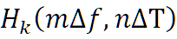 of all stepped channel snapshots.
3. Repeat step 3 to record frequency responses at all 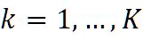 spatial sample points.
4. Stack measured time and frequency samples to a vector and calculate correlation between the first spatial sample point (i.e. ) and other spatial points 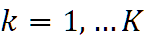
5.
6. Take the theoretical reference spatial correlation of the corresponding spatial sample points. Plot both the measured and theoretical curves.
7. Calculate the weighted RMS correlation error between the measured and the reference.
Figure C.3.4-1: Configuration for spatial correlation validation
Beam-Specific Block Diagram
It is assumed that the beams are mapped to the inputs of the channel emulator as follows:
- Beam 1: Input 1 and Input 2
- Beam 2: Input 3 and Input 4 (CDL-C UMa only)
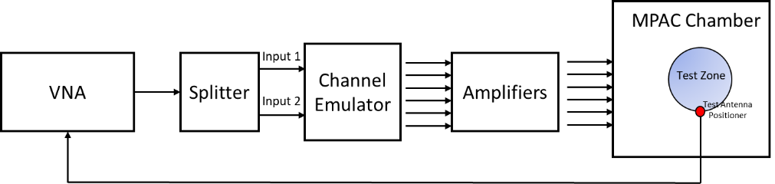
Figure C.3.4-2: Configuration for spatial correlation validation (CDL-C UMi)
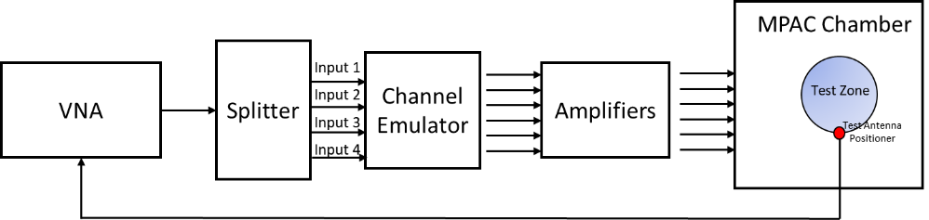
Figure C.3.4-3: Configuration for spatial correlation validation (CDL-C UMa)
Time and frequency samples
The number of temporal snapshots N and frequency samples M is shown in Table C.3.4-1. The channel model specification is presented in Table C.3.4-2.
Table C.3.4-1: VNA settings for spatial correlation
Item | Unit | Value
Center frequency | MHz | Downlink centre frequency  in Table C.3.1-1
Span | MHz | 0²
RF output level | dBm | -15
Number of traces |  | 1000
Distance between traces in channel model | Wavelength¹ | > 2
Number of points |  | 1 (or the smallest possible)²
Averaging |  | 1
NOTE1: Time in seconds = distance [λ] / MS speed [λ/s]
MS speed [λ/s] = MS speed [m /s] / Speed of light [m/s] * Center frequency [Hz]
NOTE2: Span and number of points may be increased to estimate reliably.

Table C.3.4-2: Channel model specification
Item | Unit | Value
Center frequency | MHz | Downlink centre frequency  in Table C.3.1-1
Channel model samples | Wavelength | > 2000
Channel model |  | As specified in Annex C.1
Mobile speed | km/h | 30

Spatial samples
The spatial samples for the correlation validation measurement are on the circumference of the quiet zone, as illustrated in Figure C.3.4-2. The test zone is a circle with 20 cm diameter in the horizontal plane. The reference point (denoted by a red marker) is in AoA 270°. The mean AoAs of the CDL-C UMi and CDL-C UMa models are slightly different, but the underlying geometry for the CDL model indicates that the mean AoA (or assumed LoS direction) of the model is 180°. The reference point orientation of the validation measurement is proposed to be with 90° offset to the channel model reference AoA to enable accurate sampling of the main lobe of the spatial correlation curve. The reference point orientation must be defined in the channel model coordinate system instead of the chamber/probe coordinate system to enable optimization of OTA model implementation to achieve better alignment with the cluster AoAs and probe directions. In order to have spatial samples that yield reasonable measurement times and adequately capture the main lobe of the correlation curve, a non-uniform sampling is used where the first quadrant i.e., 270°-180°, is sampled with dense sampling compared to the rest of the circle. The spacing of the spatial samples is summarized in Table C.3.4-1 for test frequencies less than 1800 MHz and equal to or greater than 1800 MHz.
Table C.3.4-1: Spacing of Spatial Samples
Test Frequencies [MHz] | First quadrant of test zone circumference (270º-180º) | Remaining quadrants
617, 722, 836.5 1575.42 | λ/15 | λ/4
1800, 2132.50, 2450, 3600, 4700 | λ/10 | λ/2

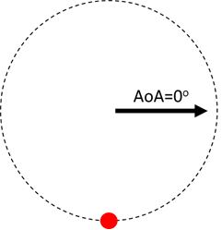
Figure C.3.4-2: Spatial sampling for spatial correlation validation measurement for test frequencies less than and equal to or greater than 1800 MHz: 617 MHz spatial sampling (left) and 4700 MHz spatial sampling (right).
Reference Spatial Correlation Curves
The spatial correlation validation reference curves are tabulated in Tables C.3.4-2 and C.3.4-3 for CDL-C UMi and CDL-C UMa, respectively, for a vertically polarized MPAC OTA setup with 16 uniformly spaced probes.
Table C.3.4-2: Spatial correlation reference curves for CDL-C UMi model for a vertically polarized MPAC OTA setup with 16 uniformly spaced probes at FR1 test frequencies
617 MHz |  | 722 MHz |  | 836.5 MHz |  | 1575.42 MHz |  | 1800 MHz
Azim [°] | |ρ| beam 1 | Azim [°] | |ρ| beam 1 | Azim [°] | |ρ| beam 1 | Azim [°] | |ρ| beam 1 | Azim [°] | |ρ| beam 1
270.0 | 1.00 | 270.0 | 1.00 | 270.0 | 1.00 | 270.0 | 1.00 | 270.0 | 1.00
251.4 | 1.00 | 254.1 | 1.00 | 256.3 | 1.00 | 262.7 | 1.00 | 260.9 | 1.00
232.9 | 1.00 | 238.3 | 1.00 | 242.6 | 1.00 | 255.5 | 1.00 | 251.7 | 1.00
214.3 | 0.99 | 222.4 | 1.00 | 228.9 | 1.00 | 248.2 | 1.00 | 242.6 | 0.99
195.8 | 0.99 | 206.6 | 0.99 | 215.2 | 0.99 | 240.9 | 0.99 | 233.5 | 0.99
110.4 | 0.87 | 190.7 | 0.98 | 201.6 | 0.98 | 233.7 | 0.99 | 224.3 | 0.98
40.8 | 0.87 | 120.5 | 0.84 | 187.9 | 0.96 | 226.4 | 0.99 | 215.2 | 0.97
331.2 | 0.98 | 61.1 | 0.80 | 128.7 | 0.82 | 219.1 | 0.98 | 206.0 | 0.95
 |  | 1.6 | 0.91 | 77.3 | 0.73 | 211.9 | 0.97 | 196.9 | 0.92
 |  | 302.1 | 0.99 | 26.0 | 0.81 | 204.6 | 0.96 | 187.8 | 0.87
 |  |  |  | 334.7 | 0.95 | 197.3 | 0.94 | 134.3 | 0.39
 |  |  |  | 283.3 | 1.00 | 190.0 | 0.91 | 88.6 | 0.15
 |  |  |  |  |  | 182.8 | 0.87 | 43.0 | 0.24
 |  |  |  |  |  | 152.7 | 0.66 | 357.3 | 0.62
 |  |  |  |  |  | 125.5 | 0.44 | 311.6 | 0.94
 |  |  |  |  |  | 98.2 | 0.30
 |  |  |  |  |  | 71.0 | 0.28
 |  |  |  |  |  | 43.7 | 0.37
 |  |  |  |  |  | 16.5 | 0.54
 |  |  |  |  |  | 349.2 | 0.75
 |  |  |  |  |  | 321.9 | 0.91
 |  |  |  |  |  | 294.7 | 0.99
2132.5 MHz |  | 2450 MHz |  | 3600 MHz |  | 4700 MHz
Azim [°] | |ρ| beam 1 | Azim [°] | |ρ| beam 1 | Azim [°] | |ρ| beam 1 | Azim [°] | |ρ| beam 1
270.0 | 1.00 | 270.0 | 1.00 | 270.0 | 1.00 | 270.0 | 1.00
261.9 | 1.00 | 263.0 | 1.00 | 265.2 | 1.00 | 266.3 | 1.00
253.9 | 1.00 | 256.0 | 1.00 | 260.5 | 1.00 | 262.7 | 1.00
245.8 | 0.99 | 249.0 | 0.99 | 255.7 | 0.99 | 259.0 | 0.99
237.8 | 0.99 | 242.0 | 0.99 | 250.9 | 0.99 | 255.4 | 0.99
229.7 | 0.98 | 234.9 | 0.99 | 246.1 | 0.99 | 251.7 | 0.99
221.7 | 0.97 | 227.9 | 0.98 | 241.4 | 0.98 | 248.1 | 0.98
213.6 | 0.96 | 220.9 | 0.97 | 236.6 | 0.98 | 244.4 | 0.98
205.6 | 0.93 | 213.9 | 0.95 | 231.8 | 0.97 | 240.8 | 0.98
197.5 | 0.89 | 206.9 | 0.92 | 227.1 | 0.97 | 237.1 | 0.97
189.5 | 0.84 | 199.9 | 0.88 | 222.3 | 0.95 | 233.5 | 0.97
181.4 | 0.77 | 192.9 | 0.83 | 217.5 | 0.93 | 229.8 | 0.96
139.7 | 0.27 | 185.9 | 0.76 | 212.7 | 0.90 | 226.1 | 0.95
99.5 | 0.14 | 144.9 | 0.19 | 208.0 | 0.86 | 222.5 | 0.93
59.2 | 0.14 | 109.9 | 0.26 | 203.2 | 0.81 | 218.8 | 0.91
18.9 | 0.26 | 74.8 | 0.37 | 198.4 | 0.75 | 215.2 | 0.87
338.6 | 0.71 | 39.8 | 0.19 | 193.7 | 0.68 | 211.5 | 0.83
298.4 | 0.97 | 4.7 | 0.29 | 188.9 | 0.59 | 207.9 | 0.78
 |  | 329.7 | 0.74 | 184.1 | 0.49 | 204.2 | 0.72
 |  | 294.6 | 0.97 | 156.1 | 0.23 | 200.6 | 0.64
 |  |  |  | 132.3 | 0.62 | 196.9 | 0.56
 |  |  |  | 108.4 | 0.85 | 193.3 | 0.47
 |  |  |  | 84.6 | 0.93 | 189.6 | 0.37
 |  |  |  | 60.7 | 0.92 | 185.9 | 0.27
 |  |  |  | 36.9 | 0.79 | 182.3 | 0.18
 |  |  |  | 13.0 | 0.42 | 161.7 | 0.51
 |  |  |  | 349.1 | 0.15 | 143.5 | 0.83
 |  |  |  | 325.3 | 0.60 | 125.2 | 0.95
 |  |  |  | 301.4 | 0.90 | 106.9 | 0.89
 |  |  |  | 277.6 | 1.00 | 88.6 | 0.80
 |  |  |  |  |  | 70.4 | 0.78
 |  |  |  |  |  | 52.1 | 0.88
 |  |  |  |  |  | 33.8 | 0.98
 |  |  |  |  |  | 15.5 | 0.91
 |  |  |  |  |  | 357.3 | 0.53
 |  |  |  |  |  | 339.0 | 0.09
 |  |  |  |  |  | 320.7 | 0.50
 |  |  |  |  |  | 302.4 | 0.82
 |  |  |  |  |  | 284.2 | 0.97

Table C.3.4-3: Spatial correlation reference curves for CDL-C UMa model for a vertically polarized MPAC OTA setup with 16 uniformly spaced probes at FR1 test frequencies
617 MHz |  | 722 MHz |  | 836.5 MHz |  | 1575.42 MHz |  | 1800 MHz
Azim [°] | |ρ| comb | Azim [°] | |ρ| comb | Azim [°] | |ρ| comb | Azim [°] | |ρ| comb | Azim [°] | |ρ| comb
270.0 | 1.00 | 270.0 | 1.00 | 270.0 | 1.00 | 270.0 | 1.00 | 270.0 | 1.00
251.4 | 0.99 | 254.1 | 0.99 | 256.3 | 0.99 | 262.7 | 0.99 | 260.9 | 0.99
232.9 | 0.99 | 238.3 | 0.98 | 242.6 | 0.98 | 255.5 | 0.98 | 251.7 | 0.96
214.3 | 0.98 | 222.4 | 0.97 | 228.9 | 0.97 | 248.2 | 0.96 | 242.6 | 0.93
195.8 | 0.96 | 206.6 | 0.96 | 215.2 | 0.96 | 240.9 | 0.94 | 233.5 | 0.90
110.4 | 0.61 | 190.7 | 0.94 | 201.6 | 0.95 | 233.7 | 0.92 | 224.3 | 0.89
40.8 | 0.47 | 120.5 | 0.58 | 187.9 | 0.92 | 226.4 | 0.91 | 215.2 | 0.88
331.2 | 0.85 | 61.1 | 0.30 | 128.7 | 0.56 | 219.1 | 0.90 | 206.0 | 0.87
 |  | 1.6 | 0.56 | 77.3 | 0.19 | 211.9 | 0.89 | 196.9 | 0.84
 |  | 302.1 | 0.95 | 26.0 | 0.27 | 204.6 | 0.88 | 187.8 | 0.79
 |  |  |  | 334.7 | 0.70 | 197.3 | 0.87 | 134.3 | 0.16
 |  |  |  | 283.3 | 0.99 | 190.0 | 0.84 | 88.6 | 0.30
 |  |  |  |  |  | 182.8 | 0.79 | 43.0 | 0.22
 |  |  |  |  |  | 152.7 | 0.42 | 357.3 | 0.36
 |  |  |  |  |  | 125.5 | 0.13 | 311.6 | 0.57
 |  |  |  |  |  | 98.2 | 0.30
 |  |  |  |  |  | 71.0 | 0.31
 |  |  |  |  |  | 43.7 | 0.29
 |  |  |  |  |  | 16.5 | 0.33
 |  |  |  |  |  | 349.2 | 0.29
 |  |  |  |  |  | 321.9 | 0.48
 |  |  |  |  |  | 294.7 | 0.88

2132.5 MHz |  | 2450 MHz |  | 3600 MHz |  | 4700 MHz
Azim [°] | |ρ| comb | Azim [°] | |ρ| comb | Azim [°] | |ρ| comb | Azim [°] | |ρ| comb
270.0 | 1.00 | 270.0 | 1.00 | 270.0 | 1.00 | 270.0 | 1.00
261.9 | 0.99 | 263.0 | 0.99 | 265.2 | 0.98 | 266.3 | 0.98
253.9 | 0.95 | 256.0 | 0.95 | 260.5 | 0.95 | 262.7 | 0.94
245.8 | 0.92 | 249.0 | 0.91 | 255.7 | 0.90 | 259.0 | 0.89
237.8 | 0.89 | 242.0 | 0.87 | 250.9 | 0.84 | 255.4 | 0.83
229.7 | 0.86 | 234.9 | 0.85 | 246.1 | 0.80 | 251.7 | 0.78
221.7 | 0.85 | 227.9 | 0.83 | 241.4 | 0.77 | 248.1 | 0.73
213.6 | 0.85 | 220.9 | 0.82 | 236.6 | 0.75 | 244.4 | 0.70
205.6 | 0.83 | 213.9 | 0.82 | 231.8 | 0.73 | 240.8 | 0.68
197.5 | 0.80 | 206.9 | 0.80 | 227.1 | 0.72 | 237.1 | 0.66
189.5 | 0.75 | 199.9 | 0.77 | 222.3 | 0.71 | 233.5 | 0.65
181.4 | 0.67 | 192.9 | 0.73 | 217.5 | 0.70 | 229.8 | 0.64
139.7 | 0.22 | 185.9 | 0.66 | 212.7 | 0.69 | 226.1 | 0.63
99.5 | 0.24 | 144.9 | 0.26 | 208.0 | 0.67 | 222.5 | 0.62
59.2 | 0.03 | 109.9 | 0.23 | 203.2 | 0.64 | 218.8 | 0.61
18.9 | 0.16 | 74.8 | 0.19 | 198.4 | 0.61 | 215.2 | 0.60
338.6 | 0.37 | 39.8 | 0.13 | 193.7 | 0.56 | 211.5 | 0.59
298.4 | 0.73 | 4.7 | 0.15 | 188.9 | 0.49 | 207.9 | 0.57
 |  | 329.7 | 0.38 | 184.1 | 0.41 | 204.2 | 0.55
 |  | 294.6 | 0.74 | 156.1 | 0.42 | 200.6 | 0.52
 |  |  |  | 132.3 | 0.19 | 196.9 | 0.48
 |  |  |  | 108.4 | 0.64 | 193.3 | 0.42
 |  |  |  | 84.6 | 0.47 | 189.6 | 0.35
 |  |  |  | 60.7 | 0.44 | 185.9 | 0.26
 |  |  |  | 36.9 | 0.28 | 182.3 | 0.18
 |  |  |  | 13.0 | 0.16 | 161.7 | 0.59
 |  |  |  | 349.1 | 0.16 | 143.5 | 0.26
 |  |  |  | 325.3 | 0.41 | 125.2 | 0.79
 |  |  |  | 301.4 | 0.40 | 106.9 | 0.43
 |  |  |  | 277.6 | 0.95 | 88.6 | 0.68
 |  |  |  |  |  | 70.4 | 0.63
 |  |  |  |  |  | 52.1 | 0.75
 |  |  |  |  |  | 33.8 | 0.87
 |  |  |  |  |  | 15.5 | 0.67
 |  |  |  |  |  | 357.3 | 0.09
 |  |  |  |  |  | 339.0 | 0.25
 |  |  |  |  |  | 320.7 | 0.32
 |  |  |  |  |  | 302.4 | 0.42
 |  |  |  |  |  | 284.2 | 0.73

Time Domain Alternative Method:
Time domain techniques can also be used to validate the spatial correlation. The spatial correlation validation measurement setup is illustrated in Figure C.3.4-3. In this case a Signal generator transmits a CW signal through the MIMO test system. The signal is received by a test antenna within the test area. Finally, the signal is collected by a signal analyser and the measured signal is stored for postprocessing.
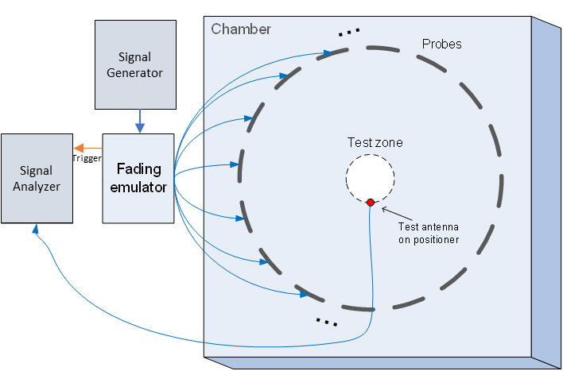
Figure C.3.4-3: Configuration for spatial correlation validation based on time domain techniques
For each spatial point, the channel emulator should issue a trigger signal each time fading is started. For each point collect a time domain trace with the signal analyser, when done, stop fading. Data recording is synchronized with the channel emulator trigger.
Follow the same procedure to postprocess the data and calcalate the spatial correlation by setting m to 1. The settings for the Signal Generator and Signal Analyser are in Table C.3.4-6 and C.3.4-7 respectively.
Table C.3.4-6: Signal Generator Settings
Item | Unit | Value
Centre frequency | MHz | Downlink centre frequency in Table C.3.1-1
Output power | dBm | Function of the CE. Sufficiently above Noise Floor

Table C.3.4-7: Signal Analyser Settings
Item | Unit | Value
Centre frequency | MHz | Downlink centre frequency in Table C.3.1-1
Sampling | Hz | At least 15 times bigger than the max Doppler spread (f_{d}=v/λ)
Observation time | s | At least 16s. Channel Model length should be the same or greater than the observation time.

Beam-Simultaneous Block Diagram
It is assumed that the beams are mapped to the inputs of the channel emulator as follows:
- Beam 1: Input 1 and Input 2
- Beam 2: Input 3 and Input 4 (CDL-C UMa only)
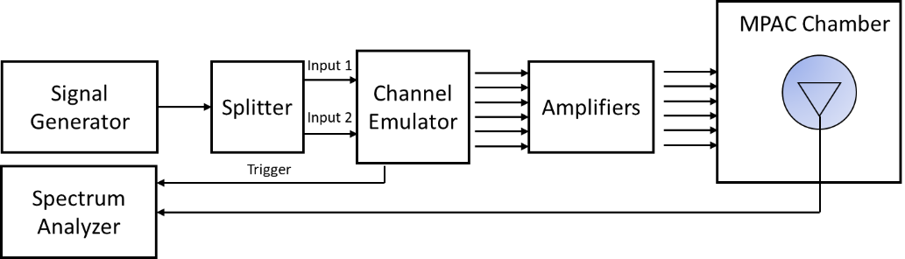
Figure C.3.4-4: Configuration for spatial correlation validation based on time domain techniques (CDL-C UMi)

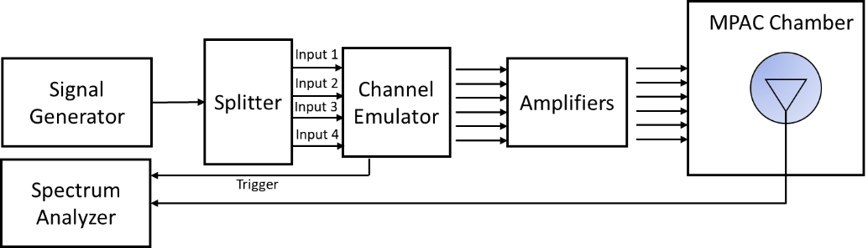
Figure C.3.4-5: Configuration for spatial correlation validation based on time domain techniques (CDL-C UMa)

<<< Skip unchanged sections >>>
<<< START OF CHANGE >>>

D.3.3 FR2 Doppler/Temporal correlation
This measurement checks the Doppler/temporal correlation. For Doppler/Temporal correlation validation measurement, only Vertical validation is required.
The Doppler spectrum is measured with a spectrum analyser as shown in Figure D.3.3-1. In this case a signal generator transmits CW signal through the NR MIMO OTA test system. The signal is received by a test antenna within the test area. Finally, the signal is analysed by a spectrum analyser and the measured spectrum is compared to the target spectrum. This setup can be used to measure Doppler Spectrum of the Channel models defined in Annex D.2.
Method of measurement:
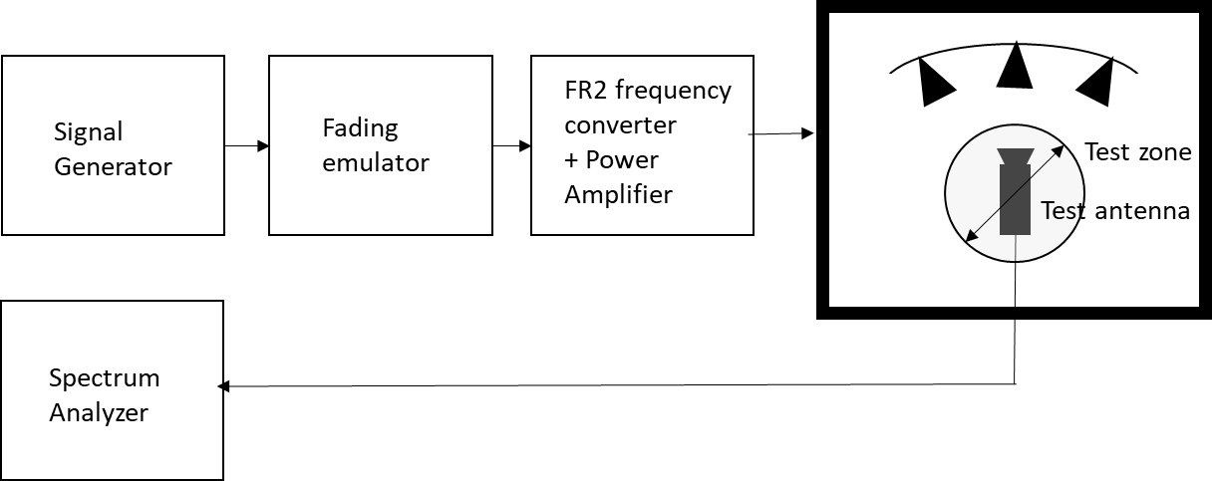
Figure D.3.3-1: Setup for FR2 Doppler measurements
Sine wave (CW, carrier wave) signal is transmitted from the signal generator. The signal is connected from the signal generator to fading emulator via cables. The fading emulator output signals are connected to frequency converter and power amplifier boxes via cables. The amplified signals are then transferred via cables to the probe antennas. The probe antennas radiate the signals over the air to the test antenna The Doppler spectrum is measured by the spectrum analyser and the trace is saved.
Signal generator settings:
Table D.3.3-1: Signal generator settings for FR2 Doppler/Temporal correlation measurements
Item | Unit | Value
Centre frequency | MHz | Downlink centre frequency  in Table D.3.1-1
Modulation |  | OFF

Spectrum analyser settings:
Table D.3.3-2: Spectrum analyser settings for FR2 Doppler/Temporal correlation measurements
Item | Unit | Value
Centre frequency | MHz | Downlink centre frequency  in Table D.3.1-1
Minimum Span | Hz | 4 kHz
RBW | Hz | 1
VBW | Hz | 1
Number of points |  | 16002
Averaging |  | 100

Channel model specification:
Table D.3.3-3: Channel model specification for FR2 Doppler/Temporal correlation measurements
Item | Unit | Value
Centre frequency | MHz | Downlink centre frequency  in Table D.3.1-1
Channel model |  | As specified in Annex D.1
Mobile speed | km/h | 3

Method of measurement result analysis: Measurement data file (Doppler power spectrum) is saved into hard drive. The data is read into, e.g., Matlab. The analysis is performed by taking the Fourier transformation of the Doppler spectrum. The resulting temporal correlation function $R_{t}\left(Δt\right)$ is normalized such that max(abs(R_{t}(∆t)))=1$\text{max}\left(\text{Re}\left(R_{t}\left(Δt\right)\right)\right)=1$. Then the function values left from the maximum is cut out. Further on the function values after, e.g. seven periods is cut out.
The detailed Temporal correlation reference value for FR2 CDL-C UMi channel model validation is defined is table D.3.3-4.
Table D.3.3-4: Temporal correlation Targets
Distance [λ] | X2V Corr. | Distance [λ] | X2V Corr.
0 | 1.0000 | 2.5 | 0.1769
0.1 | 0.9929 | 2.6 | 0.1717
0.2 | 0.9717 | 2.7 | 0.1649
0.3 | 0.9379 | 2.8 | 0.1564
0.4 | 0.8937 | 2.9 | 0.1456
0.5 | 0.8414 | 3 | 0.1327
0.6 | 0.7834 | 3.1 | 0.1177
0.7 | 0.7223 | 3.2 | 0.1011
0.8 | 0.6601 | 3.3 | 0.0829
0.9 | 0.5986 | 3.4 | 0.0638
1 | 0.5387 | 3.5 | 0.0449
1.1 | 0.4817 | 3.6 | 0.0272
1.2 | 0.4284 | 3.7 | 0.0121
1.3 | 0.3796 | 3.8 | 0.0023
1.4 | 0.3362 | 3.9 | 0.0079
1.5 | 0.2984 | 4 | 0.0104
1.6 | 0.2667 | 4.1 | 0.0083
1.7 | 0.2416 | 4.2 | 0.0026
1.8 | 0.2221 | 4.3 | 0.0095
1.9 | 0.2081 | 4.4 | 0.0235
2 | 0.1987 | 4.5 | 0.0397
2.1 | 0.1921 | 4.6 | 0.0572
2.2 | 0.1879 | 4.7 | 0.0738
2.3 | 0.1844 | 4.8 | 0.0890
2.4 | 0.1812 | 4.9 | 0.1018
 |  | 5 | 0.1109

D.3.4 FR2 PAS similarity percentage (PSP)
The PSP validation measurements aim at evaluating PAS similarity percentage (PSP), which is one of the validation metrics for characterizing FR2 channel model under test in the quite zone of 3D-MPAC. For PSP validation measurement, only vertical polarization validation is required.
The measurement array is essentially a virtual array configuration realized in 3D-MPAC through a φ-θ positioning system. The measurement array is a semi-circle and sectored array configuration illustrated in Figure D.3.4-1 where complex channel frequency response is measured at each antenna location 0.5 λ apart using a vector network analyser (VNA) setup. The vertical sectors of the measurement array are limited to 60° (±30°) and the horizontal sector to 180° (±90°) with the broad side direction points towards the probes. Depending of the turntable architecture/implementation, the virtual array configuration for the PSP validation is composed of two alternative semi-circle arrangements (1 x horizontal and either 2 x crossed vertical or 2 x parallel vertical). The radius of the array element locations with respect to the centre of the test zone is 5 cm, which is equivalent to the half of the test zone radius at 28 GHz. For different frequency bands, the radius of the measurement array sectored semi-circles remains fixed at 5 cm while the spatial sampling of the array varies. This measurement validates the proper angular behaviour in the test zone.
Figure D.3.4-1: Semi-circle measurement array configurations with K = 37 elements (at 28 GHz). On the left with two crossed vertical sectors, on the right with two parallel vertical sectors.

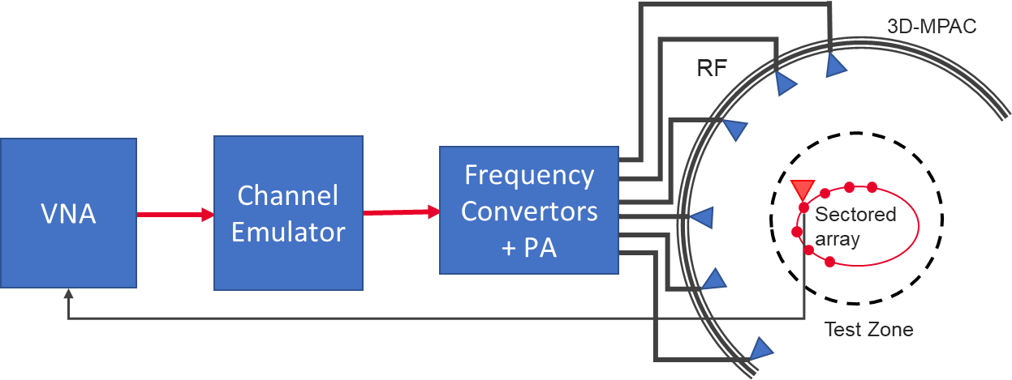
Figure D.3.4-2: Setup for FR2 PSP validation measurements
The PSP validation is measured with a vector network analyser as shown in Figure D.3.4-2 illustrating the PSP measurement setup. Port 1 of the VNA transmits signals through the fading emulator and radiate them through L probes within the anechoic chamber. The radiated signals are then received at the test antenna that is positioned inside the test zone. The test antenna is mounted on a φ-θ positioner which is capable of moving the antenna to pre-defined spatial locations on a fixed radius from the centre of the quiet zone according the measurement array configuration. Finally, the signal is received at port 2 of the VNA. The most suitable approach for the PSP validation is based on an omnidirectional antenna (omnidirectional pattern in AZ and wide BW in EL) as the test can be automated easily. Alternatively, a directional antenna could be used but requires frequent re-positioning.
The measurement and analysis procedure are given as follows:
1. Set the target channel model in the Channel Emulator.
2. For each position of the test antenna on the measurement array configuration in the test zone, step & pause the emulator to different time instances. Measure the complex frequency responses for all stepped channel snapshots , where the interval between frequency and time samples is and, respectively. The number of channel snapshots and frequency samples .
3. Move the measurement antenna with a positioner to another location and repeat step 2 to record frequency responses of all stepped channel snapshots.
4. Repeat step 3 to record frequency responses at all spatial sample points.
5. Estimate the measured PAS through the following two- stage processing:
a. In the first stage, calculate the discrete azimuth and elevation angles (DoA) for the measurement array configuration by applying the MUSIC algorithm. Estimate the powers from the DoA and auto-covariance matrix of the received signal acquired through VNA complex frequency response data.
i) Compose an estimate of the covariance matrix . The entry on the th row and th column of is
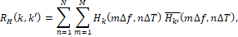
where is the complex conjugate operator.
ii) Compose pseudo-PAS of the chamber environment and channel model using the MUSIC algorithm. The intention of this step is to estimate DoAs of signals radiated by probes. Perform first the eigen decomposition of and pick the noise-subspace matrix . The matrix is obtained from the eigen decomposition by removing eigenvectors, i.e. columns, that correspond to X strongest eigenvalues, where X is the number of active probes in the MPAC setup. The pseudo-PAS is Error: Reference source not found
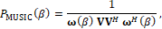
where is the matrix Hermitean operator and the near-field array factor of the virtual array composed by K spatial measurement antenna locations is
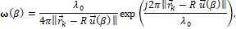
where is the wavelength at the carrier centre frequency, is the norm of a vector, is a location vector of the kth virtual array element, is the unit vector to direction , and R is the a priori known approximate range length Error: Reference source not found. Both vectors and are defined with respect to same origin, which is the centre of the test zone.
iii) Find local maxima of and pick directions , of the X highest peaks.
iv) Perform Bartlett beamforming as defined in step 6 with the steering vector (instead of ) to the X directions identified in iii). The output is X power estimates .

b. In the second stage, use the angle and power estimates, i.e. the discrete PAS of X azimuth and elevation directions and power values in conjunction with a 4x4 DUT sampling array for beamforming with the conventional Bartlett beamformer to estimate the “measured PAS seen by DUT” for PSP calculation. This is
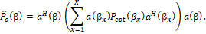
where is the array steering vector of the 4x4 DUT array.

6. Evaluate the reference OTA PAS for the 4x4 DUT array by applying the conventional Bartlett beamformer. The theoretical PAS as reference is calculated for the ideal channel model as
where is the array steering vector of the 4x4 DUT array and is the PAS of the reference channel model.

7. Calculate total variation distance (D_{p}) from the reference and measured PAS. Mathematically,
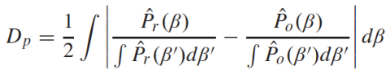
8. Calculate PSP values as PSP = (1-D_{p}) x 100%.

VNA settings:
Table D.3.4-1: VNA settings for FR2 PSP measurements
Item | Unit | Value
Centre frequency | MHz | Downlink centre frequency  in Table D.3.1-1
Span | MHz | 0 (or the minimum)₁
Number of traces |  | 1000
Number of points |  | 1¹
NOTE1: Span and number of points may be increased to estimate reliably.

Channel model specification:
Table D.3.4-2: Channel model specification for FR2 PSP measurements
Item | Unit | Value
Centre frequency | MHz | Downlink centre frequency  in Table D.3.1-1
Distance between traces in channel model | wavelength (Note) | > 2
Channel model |  | As specified in Annex D.1
NOTE: Time [s] = distance [λ] / MS speed [λ/s]
MS speed [λ/s] = MS speed [m/s] / Speed of light [m/s] * Centre frequency [Hz]

Time Domain Alternative Method:
PSP validation can also be implemented using time-domain techniques using the testing setup presented in Figure D.3.4-3. The VNA is substituted by a signal generator, and a signal analyser.
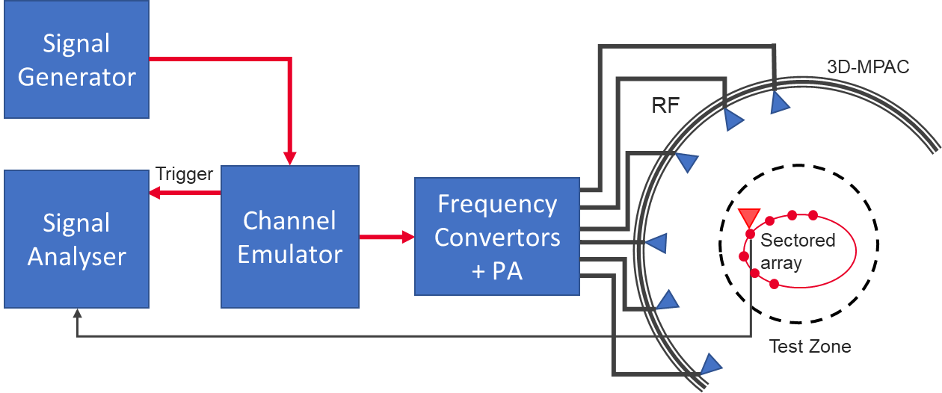
Figure D.3.4-3: Setup for FR2 PSP validation measurements based on time domain
Table D.3.4-3: Signal Generator Settings for FR2 PSP measurements based on time domain
Item | Unit | Value
Centre frequency | MHz | Downlink centre frequency in Table D.3.1-1
Output power | dBm | Function of the CE. Sufficiently above Noise Floor

Table D.3.4-4: Signal Analyser Settings for FR2 PSP measurements based on time domain
Item | Unit | Value
Centre frequency | MHz | Downlink centre frequency in Table D.3.1-1
Sampling | Hz | At least 10 times bigger than the max Doppler spread (f_{d}=v/λ)
Observation time | s | At least 32s
The measurement and analysis procedure are given as follows:
Follow the same procedure as before, but M is set to 1. The Channel Emulator is not stepped, but it is allowed to play in free run mode for each of the K spatial points.

<<< Skip unchanged sections >>>

<<< END OF CHANGES >>>

