3GPP TSG-RAN WG4 Meeting # 104e R4-2213189

Electronic Meeting, August 15 – August 26, 2022

Agenda item: 9.1.3.3
Source: Huawei, HiSilicon
Title: Discussion on FR2 MIMO OTA channel model validation
Document for: Approval

1 Introduction
In RAN4#103 meeting, some agreements on FR2 MIMO OTA channel model validation in the WF [1] have been made in order to close core part in June RAN meeting. In general, we are still discussing in the same way as FR1. In this contribution, we provide initial measurement results and further discuss pass/fail limits for FR2 channel model validation.
Issue 1-3-1: PDP pass/fail limits for FR2 channel model validation
Agreements:
  - Define PDP pass/fail limits as follows, further refine the limits when more practical/empirical data is available.
 | Power Tolerance | Delay Tolerance
Paths from 0 dB to 10 dB below the peak | [±1 dB] | [±6 ns]
Paths from 10 dB to 30 dB below the peak | [±5 dB] | [±6 ns]
Paths from 30dB to 40dB | [±10 dB] | [±6 ns]
Issue 1-3-2: Temporal Correlation pass/fail limits for FR2 channel model validation
Agreements:
  - Define Temporal Correlation pass/fail limits as follows, further refine the limits when more practical/empirical data is available.
    - Pass/Fail limits for theoretical TCF above [0.3] are formed as bands of [±10]% of correlation capped at 1 at the high end. Additionally, when the theoretical TCF drops below [0.3], the limits are formed at bands of [±30]% of correlation capped at 0 at the low end.
Issue 1-3-3: Cross-polarization (V/H) pass/fail limits for FR2 channel model validation
Agreements:
  - Define V/H pass/fail limits as [±1.5dB], further refine the limits when more practical/empirical data is available.
Issue 1-3-4: PSP pass/fail limits for FR2 channel model validation
Agreements:
  - Define PSP pass/fail limit as [84%], further refine the limit when more practical/empirical data is available.

2. Discussion
PDP pass/fail limits for FR2 channel model validation
The PDP validation results for FR2 are as follow, and the gap of delay and power between the measurement results and reference results are listed in Table1. It can be seen from Figure1 that the equipment generates some power leakage due to high frequency, which allows the current large margin reasonable.
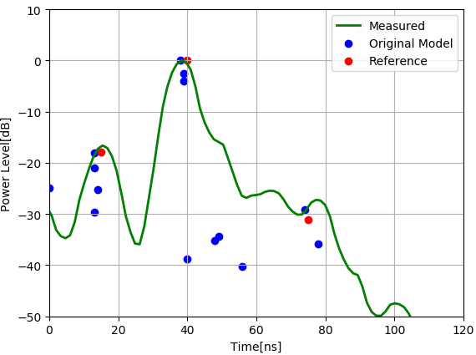
Figure 1 Measured PDP of CDL-C UMi.
Table 1. Measured PDP of CDL-C UMi
Combined Clusters index | Target  Delay(ns) | Measured Delay(ns) | Delay gap(ns) | Target  Power(dB) | Measured  Power(dB) | Power gap(dB)
1-5 | 15 | 15 | 0 | -17.9 | -16.6 | -1.3
6-11 | 40 | 40 | 0 | 0.0 | 0.0 | 0.0
13-14 | 75 | 80 | 5 | -31.2 | -27.2 | -4.0

Proposal 1: RAN4 agrees the square bracket should be removed.
Table D.4.2-1: PDP pass/fail limits for FR2 CDL-C UMi channel model validation
 | Power Tolerance | Delay Tolerance
Paths from 0dB to 10dB | ±1dB | ±6ns
Paths from 10dB to 30dB | ±5dB | ±6ns
Paths from 30dB to 40dB | ±10dB | ±6ns

Temporal Correlation pass/fail limits for FR2 channel model validation
In [2], two proposals shown below were mainly discussed, and companies think Proposals 1 and 2 are basically the same but worded differently. However, the different wordings between FR1 and FR2 may cause confusion.
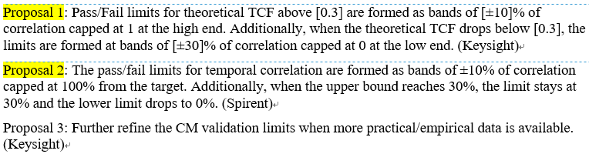
Therefore, we proposal the same wording as agreed for FR1 and a draft CR to revise the current wording.
Proposal 2: Adopt the same wording for Temporal Correlation pass/fail limits as agreed for FR1.
Figure 2 shows the pass/fail, target and measured curve of temporal correlation. The green curve presents the pass/fail of the current spec, which is same as FR1. FR1 has many target curves to measure in Table C.4.3-1 [3], which drives loose restrictions, yet FR2 only has one target curve. It may be necessary to tighten the pass/fail limit appropriately.
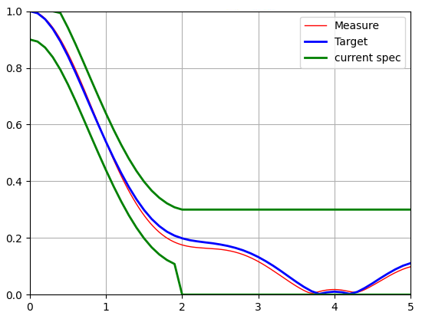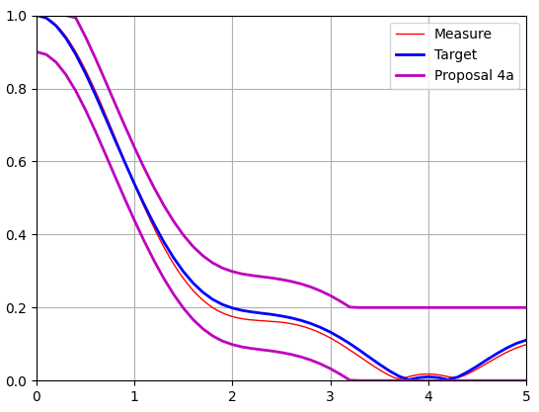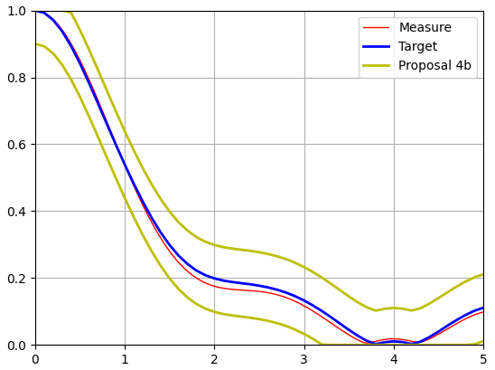
Figure 2 Pass/fail, target and measured curve of temporal correlation
Proposal 3: Considering only one target curve for FR2, tighten the pass/fail limit appropriately.
We provied two tightened pass/fial limits:
Proposal 4a: The pass/fail limits for temporal correlation are formed as bands of ±10% of correlation capped at 100% from the target defined in clause D.3.3. Additionally, when the upper bound reaches 20%, the limit stays at 20% and the lower limit drops to 0%. The values defined in Table 2 are introduced into the spec.
Proposal 4b: The pass/fail limits for temporal correlation are formed as bands of ±10% of correlation capped at 100% from the target defined in clause D.3.3, and the lower limit drops to 0%. The values defined in Table 3 are introduced into the spec.
Table 2 pass/fail limits for temporal correlation based on Proposal 4a
Distance [λ] | X2V Corr. |  | Distance [λ] | X2V Corr.
Distance [λ] | Lower | Upper | Distance [λ] | Lower | Upper
0 | 0.9000 | 1.0000 | 2.5 | 0.0769 | 0.2769
0.1 | 0.8929 | 1.0000 | 2.6 | 0.0717 | 0.2717
0.2 | 0.8717 | 1.0000 | 2.7 | 0.0649 | 0.2649
0.3 | 0.8379 | 1.0000 | 2.8 | 0.0564 | 0.2564
0.4 | 0.7937 | 0.9937 | 2.9 | 0.0456 | 0.2456
0.5 | 0.7414 | 0.9414 | 3 | 0.0327 | 0.2327
0.6 | 0.6834 | 0.8834 | 3.1 | 0.0177 | 0.2177
0.7 | 0.6223 | 0.8223 | 3.2 | 0.0011 | 0.2011
0.8 | 0.5601 | 0.7601 | 3.3 | 0.0000 | 0.2000
0.9 | 0.4986 | 0.6986 | 3.4 | 0.0000 | 0.2000
1 | 0.4387 | 0.6387 | 3.5 | 0.0000 | 0.2000
1.1 | 0.3817 | 0.5817 | 3.6 | 0.0000 | 0.2000
1.2 | 0.3284 | 0.5284 | 3.7 | 0.0000 | 0.2000
1.3 | 0.2796 | 0.4796 | 3.8 | 0.0000 | 0.2000
1.4 | 0.2362 | 0.4362 | 3.9 | 0.0000 | 0.2000
1.5 | 0.1984 | 0.3984 | 4 | 0.0000 | 0.2000
1.6 | 0.1667 | 0.3667 | 4.1 | 0.0000 | 0.2000
1.7 | 0.1416 | 0.3416 | 4.2 | 0.0000 | 0.2000
1.8 | 0.1221 | 0.3221 | 4.3 | 0.0000 | 0.2000
1.9 | 0.1081 | 0.3081 | 4.4 | 0.0000 | 0.2000
2 | 0.0987 | 0.2987 | 4.5 | 0.0000 | 0.2000
2.1 | 0.0921 | 0.2921 | 4.6 | 0.0000 | 0.2000
2.2 | 0.0879 | 0.2879 | 4.7 | 0.0000 | 0.2000
2.3 | 0.0844 | 0.2844 | 4.8 | 0.0000 | 0.2000
2.4 | 0.0812 | 0.2812 | 4.9 | 0.0000 | 0.2000
 |  |  | 5 | 0.0000 | 0.2000

Table 3 pass/fail limits for temporal correlation based on Proposal 4a
Distance [λ] | X2V Corr. |  | Distance [λ] | X2V Corr.
Distance [λ] | Lower | Upper | Distance [λ] | Lower | Upper
0 | 0.9000 | 1.0000 | 2.5 | 0.0769 | 0.2769
0.1 | 0.8929 | 1.0000 | 2.6 | 0.0717 | 0.2717
0.2 | 0.8717 | 1.0000 | 2.7 | 0.0649 | 0.2649
0.3 | 0.8379 | 1.0000 | 2.8 | 0.0564 | 0.2564
0.4 | 0.7937 | 0.9937 | 2.9 | 0.0456 | 0.2456
0.5 | 0.7414 | 0.9414 | 3 | 0.0327 | 0.2327
0.6 | 0.6834 | 0.8834 | 3.1 | 0.0177 | 0.2177
0.7 | 0.6223 | 0.8223 | 3.2 | 0.0011 | 0.2011
0.8 | 0.5601 | 0.7601 | 3.3 | 0.0000 | 0.1829
0.9 | 0.4986 | 0.6986 | 3.4 | 0.0000 | 0.1638
1 | 0.4387 | 0.6387 | 3.5 | 0.0000 | 0.1449
1.1 | 0.3817 | 0.5817 | 3.6 | 0.0000 | 0.1272
1.2 | 0.3284 | 0.5284 | 3.7 | 0.0000 | 0.1121
1.3 | 0.2796 | 0.4796 | 3.8 | 0.0000 | 0.1023
1.4 | 0.2362 | 0.4362 | 3.9 | 0.0000 | 0.1079
1.5 | 0.1984 | 0.3984 | 4 | 0.0000 | 0.1104
1.6 | 0.1667 | 0.3667 | 4.1 | 0.0000 | 0.1083
1.7 | 0.1416 | 0.3416 | 4.2 | 0.0000 | 0.1026
1.8 | 0.1221 | 0.3221 | 4.3 | 0.0000 | 0.1095
1.9 | 0.1081 | 0.3081 | 4.4 | 0.0000 | 0.1235
2 | 0.0987 | 0.2987 | 4.5 | 0.0000 | 0.1397
2.1 | 0.0921 | 0.2921 | 4.6 | 0.0000 | 0.1572
2.2 | 0.0879 | 0.2879 | 4.7 | 0.0000 | 0.1738
2.3 | 0.0844 | 0.2844 | 4.8 | 0.0000 | 0.1890
2.4 | 0.0812 | 0.2812 | 4.9 | 0.0018 | 0.2018
 |  |  | 5 | 0.0109 | 0.2019

Cross-polarization (V/H) pass/fail limits for FR2 channel model validation
By simulation, the reference values are obtained and consistent with agreements in last meeting, and the measured V/H for FR2 CDL-C UMi is shown in Table 4.
Table 4. Measured V/H of FR2 CDL-C UMi
 | Simulation  Result(dB) | Target  V/H(dB) | Measured V/H(dB) | V/H gap(dB)
Beam 1, Input 1 | -0.454 | -0.45 | -0.80 | 0.35
Beam 1, Input 2 | 0.491 | 0.49 | 1.01 | -0.52
Beam 1, Input 1+2 | 0 | 0 | 0.76 | -0.76

Proposal 5: RAN4 agrees the square bracket should be removed: The cross-polarization ratio pass/fail limit is specified as ±1.5 dB.

PSP pass/fail limits for FR2 channel model validation
The measurement PAS for FR2 CDL-C UMi is shown in Figure 2 and 91.3 % PSP can be achieved.
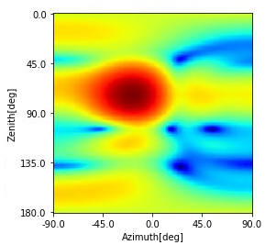
Figure 3 Measured PAS for FR2 CDL-C UMi

Proposal 6: RAN4 agrees the square bracket should be removed: The PSP pass/fail limit is specified as 84%.
Observation 1: Huawei, Hisilicon measurement results for FR2 CDL-C UMi channel model matches with the reference values.

3 Conclusions.
In the contribution, we show the initial measurement result for PDP,TCF,V/H and PAS.
Proposal 1: RAN4 agrees the square bracket should be removed.
Table D.4.2-1: PDP pass/fail limits for FR2 CDL-C UMi channel model validation
 | Power Tolerance | Delay Tolerance
Paths from 0dB to 10dB | ±1dB | ±6ns
Paths from 10dB to 30dB | ±5dB | ±6ns
Paths from 30dB to 40dB | ±10dB | ±6ns

Proposal 2: Adopt the same wording for Temporal Correlation pass/fail limits as agreed for FR1.
Proposal 3: Considering only one target curve for FR2, tighten the pass/fail limit appropriately.
We provied two tightened pass/fial limits:
Proposal 4a: The pass/fail limits for temporal correlation are formed as bands of ±10% of correlation capped at 100% from the target defined in clause D.3.3. Additionally, when the upper bound reaches 20%, the limit stays at 20% and the lower limit drops to 0%. The values defined in Table 2 are introduced into the spec.
Table 2 pass/fail limits for temporal correlation based on Proposal 4a
Distance [λ] | X2V Corr. |  | Distance [λ] | X2V Corr.
Distance [λ] | Lower | Upper | Distance [λ] | Lower | Upper
0 | 0.9000 | 1.0000 | 2.5 | 0.0769 | 0.2769
0.1 | 0.8929 | 1.0000 | 2.6 | 0.0717 | 0.2717
0.2 | 0.8717 | 1.0000 | 2.7 | 0.0649 | 0.2649
0.3 | 0.8379 | 1.0000 | 2.8 | 0.0564 | 0.2564
0.4 | 0.7937 | 0.9937 | 2.9 | 0.0456 | 0.2456
0.5 | 0.7414 | 0.9414 | 3 | 0.0327 | 0.2327
0.6 | 0.6834 | 0.8834 | 3.1 | 0.0177 | 0.2177
0.7 | 0.6223 | 0.8223 | 3.2 | 0.0011 | 0.2011
0.8 | 0.5601 | 0.7601 | 3.3 | 0.0000 | 0.2000
0.9 | 0.4986 | 0.6986 | 3.4 | 0.0000 | 0.2000
1 | 0.4387 | 0.6387 | 3.5 | 0.0000 | 0.2000
1.1 | 0.3817 | 0.5817 | 3.6 | 0.0000 | 0.2000
1.2 | 0.3284 | 0.5284 | 3.7 | 0.0000 | 0.2000
1.3 | 0.2796 | 0.4796 | 3.8 | 0.0000 | 0.2000
1.4 | 0.2362 | 0.4362 | 3.9 | 0.0000 | 0.2000
1.5 | 0.1984 | 0.3984 | 4 | 0.0000 | 0.2000
1.6 | 0.1667 | 0.3667 | 4.1 | 0.0000 | 0.2000
1.7 | 0.1416 | 0.3416 | 4.2 | 0.0000 | 0.2000
1.8 | 0.1221 | 0.3221 | 4.3 | 0.0000 | 0.2000
1.9 | 0.1081 | 0.3081 | 4.4 | 0.0000 | 0.2000
2 | 0.0987 | 0.2987 | 4.5 | 0.0000 | 0.2000
2.1 | 0.0921 | 0.2921 | 4.6 | 0.0000 | 0.2000
2.2 | 0.0879 | 0.2879 | 4.7 | 0.0000 | 0.2000
2.3 | 0.0844 | 0.2844 | 4.8 | 0.0000 | 0.2000
2.4 | 0.0812 | 0.2812 | 4.9 | 0.0000 | 0.2000
 |  |  | 5 | 0.0000 | 0.2000

Proposal 4b: The pass/fail limits for temporal correlation are formed as bands of ±10% of correlation capped at 100% from the target defined in clause D.3.3, and the lower limit drops to 0%. The values defined in Table 3 are introduced into the spec.
Table 3 pass/fail limits for temporal correlation based on Proposal 4a
Distance [λ] | X2V Corr. |  | Distance [λ] | X2V Corr.
Distance [λ] | Lower | Upper | Distance [λ] | Lower | Upper
0 | 0.9000 | 1.0000 | 2.5 | 0.0769 | 0.2769
0.1 | 0.8929 | 1.0000 | 2.6 | 0.0717 | 0.2717
0.2 | 0.8717 | 1.0000 | 2.7 | 0.0649 | 0.2649
0.3 | 0.8379 | 1.0000 | 2.8 | 0.0564 | 0.2564
0.4 | 0.7937 | 0.9937 | 2.9 | 0.0456 | 0.2456
0.5 | 0.7414 | 0.9414 | 3 | 0.0327 | 0.2327
0.6 | 0.6834 | 0.8834 | 3.1 | 0.0177 | 0.2177
0.7 | 0.6223 | 0.8223 | 3.2 | 0.0011 | 0.2011
0.8 | 0.5601 | 0.7601 | 3.3 | 0.0000 | 0.1829
0.9 | 0.4986 | 0.6986 | 3.4 | 0.0000 | 0.1638
1 | 0.4387 | 0.6387 | 3.5 | 0.0000 | 0.1449
1.1 | 0.3817 | 0.5817 | 3.6 | 0.0000 | 0.1272
1.2 | 0.3284 | 0.5284 | 3.7 | 0.0000 | 0.1121
1.3 | 0.2796 | 0.4796 | 3.8 | 0.0000 | 0.1023
1.4 | 0.2362 | 0.4362 | 3.9 | 0.0000 | 0.1079
1.5 | 0.1984 | 0.3984 | 4 | 0.0000 | 0.1104
1.6 | 0.1667 | 0.3667 | 4.1 | 0.0000 | 0.1083
1.7 | 0.1416 | 0.3416 | 4.2 | 0.0000 | 0.1026
1.8 | 0.1221 | 0.3221 | 4.3 | 0.0000 | 0.1095
1.9 | 0.1081 | 0.3081 | 4.4 | 0.0000 | 0.1235
2 | 0.0987 | 0.2987 | 4.5 | 0.0000 | 0.1397
2.1 | 0.0921 | 0.2921 | 4.6 | 0.0000 | 0.1572
2.2 | 0.0879 | 0.2879 | 4.7 | 0.0000 | 0.1738
2.3 | 0.0844 | 0.2844 | 4.8 | 0.0000 | 0.1890
2.4 | 0.0812 | 0.2812 | 4.9 | 0.0018 | 0.2018
 |  |  | 5 | 0.0109 | 0.2019

Proposal 5: RAN4 agrees the square bracket should be removed: The cross-polarization ratio pass/fail limit is specified as ±1.5 dB.
Proposal 6: RAN4 agrees the square bracket should be removed: The PSP pass/fail limit is specified as 84%.
Observation 1: Huawei, Hisilicon measurement results for FR2 CDL-C UMi channel model matches with the reference values.

4 References
- R4-2210675, WF on NR MIMO OTA, vivo, CAICT, 3GPP TSG-RAN WG4 Meeting # 103, May, 2022.
- R4-2210535, Email discussion summary for [103-e][332] NR_MIMO_OTA, CAICT, 3GPP TSG-RAN WG4 Meeting # 103, May, 2022.
- TS38.151. v17.1.0.

