3GPP TSG-RAN WG4 Meeting #104-e R4-2214426
Electronic Meeting, 15– 26 August 2022
Title: WF on triple beat MSD of UL DC_3C_n28A
Agenda Item: 10.1.2
Source: Huawei, HiSilicon
Document for: Approval

Background
Based on the WID RP-191568 [1], DC_3C_n28A was requested and completed in Rel-16. However, since the triple beat MSD was missing, some band combinations related to UL configuration DC_3C_n28A were removed in RAN4#103 meeting referring to draft CR R4-2211214 [2]. Based on the WF [3], some criteria and assumptions were captured to encourage companies for further study. In this meeting, one company provided some studies and analysis [4] on triple beat MSD of DC_3C_n28A.

MSD test configuration
Referring to clause 7.3.3.2 from TR 38.862 [5], it’s known how to detect a triple beat issue in the FDD band DL or a third band DL.
● Mainly consider the 1st order triple beat α (TX₂²TX₁) of 3rd order non-linearity -> this is shown in the table as triple beat order 1.
- Detection ->
For 20MHz+20MHz band 3C, the LTE nominal channel spacing is 19.8MHz and the UL CA aggregated channel bandwidth is 39.8MHz.
Since UL configuration of band n28 was restricted as 25RB for each DL bandwidth REFSENS requirement, the UL RB allocation for band n28 can be 25RB, but closet to DL Rx band. As discussed in the 1st round, it seems that most companies think 25MHz channel bandwidth for band n28 can be assumed. Thus, the following MSD test configuration is proposed.

<Way forward >: The triple beat MSD test configuration for DC_3C_n28A as below
Band / Channel bandwidth / N_{RB} / Duplex mode |  |  |  |  |  |  |  | Source of IMD
ENDC band combination | NR/LTE band | UL F_{c}  (MHz) | UL/DL BW  (MHz) | UL  L_{CRB} | DL F_{c} (MHz) | MSD  (dB) | Duplex mode
 | n28 | 715.5 | 25 | 25(RB_{START}=108) | 770.5 | FFS | FDD | 1st order triple beat α (TX₂²TX₁)  i.e. IMD3
DC_3C_n28A | 3 | 1720 | 20 | 1 (RB_{START}=0) | 1815 | N/A | FDD | N/A
 |  | 1739.8 | 20 | 1 (RB_{START}=99) | 1834.8

RF architecture and parameters assumption
<Way forward>: RF architecture for DC_3C_n28A is assumed as below
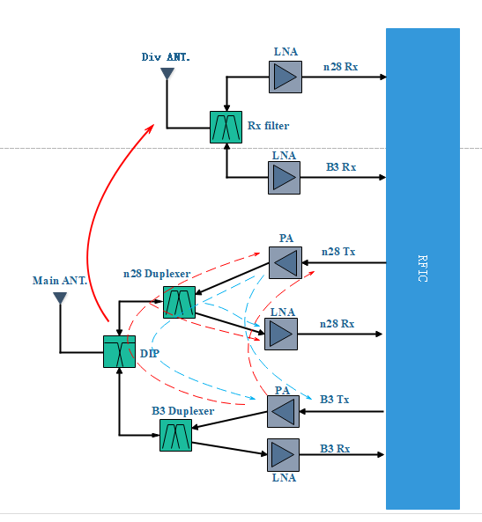

<Way forward>: RF parameters assumption

Attenuation and Isolation Parameter | Value (dB) | Comment
Antenna ISO | 10 | Main antenna to diversity antenna
Diplexer ISO | 10
PCB ISO | 60
PA gain | 25
PCB isolation Paout-Pain | 60 | PCB isolation (PA forward mixing)
Band n28 Duplexer Tx rejection at B3 Tx | 30
Band n28 Duplexer Tx rejection at n28 Rx | 43
Band B3 Duplexer Tx rejection at n28 Tx | 32
Band B3 Duplexer Tx rejection at n28 Rx | 32
Band n28 filter/Duplexer Rx rejection at n28 Tx | 50
Band n28 filter/Duplexer Rx rejection at B3 Tx | 33
LNA IIP3 assumption | -6 | dBm

<Way forward>: MSD evaluation
For the proposed MSD test point, interested companies are invited to evaluate the band n28 MSD using the proposed RF parameter assumptions. Evaluations with other assumptions are not precluded, e.g. MSD evaluation using PA and/or LNA measurements.

Reference
[1] RP-191568, Revised WID on EN-DC for 2 bands DL with 2 bands UL (1 LTE band + 1 NR band), NTT DOCOMO INC.
[2] R4-2211214, Draft CR to TS 38.101-3 V17.5.0 on intra-band ULCA UL configurations, Skyworks Solutions Inc.
[3] R4-2210557, WF on criteria for triple beat MSD analysis, Qualcomm Incorporated, Skyworks Solutions, Inc., ZTE Corporation
[4] R4-2213132, Discussion on triple beat MSD of UL DC_3C_n28A, Huawei, HiSilicon
[5] TR 38.862, Study on band combination handling in RAN4, v17.0.0

