3GPP TSG-RAN WG4 Meeting #104-e R4-220xxx
Electronic Meeting, Aug. 15th – 26th, 2022 (rev of R4-2214418)

Title: WF on DC location signalling applicability
Agenda Item: 9.4.3
Source: Qualcomm Incorporated
Document for: Approval

1-2-1: Discuss which feature variants which method for DC location signalling is applicable.
The intention is to get common understanding what methods can be used to signal DC location for which features. The intent is to enable reporting the location of the carrier leakage.

Issue 1-2-1-1 Treatment of signalling 3300/3301 vs not supporting applicable signalling method
Two possibilities how to treat the 3300/3301 case in the Ran4 specification:
<Way forward/Agreement during discussion phase>:
- Option 1: Even if the signalling method does not support reporting DC location, mention in the specification the method as one option since 3300/3301 can be used to indicate DC location is outside carrier or in an unknown place in carrier.
- Option 2: Do not consider signalling method a possible method for a feature if it can only be used to signal an unknown location.
- Option 3 (possible compromise): Do not consider signalling method a possible method for a feature if it can only be used to signal an unknown location. No change to existing possibilities to signal 3300/3301 for the UE.

<Proposed Agreement from moderator after discussions (Seems controversial)>:
- Do not consider signalling method a possible method for a feature if it can only be used to signal an unknown location. No change to existing possibilities to signal 3300/3301 for the UE.

Company | Comments
Nokia | Option 2: Specifically, 3301, i.e., Undetermined position within the carrier, is a very unfortunate option. It’s useless. Even if a UE always report 3301, the UE is considered as supporting this UL DC location signaling feature… Perhaps, during the test, TE can use this as a criteria to decide to try to find out where the UL DC location is by sweeping the frequency…since at least we know UL DC location somewhere in the carrier..But in the field, it must be useless.  3300 is not the best option since operators may have more than one spectrum blocks. In this case, even if an UL DC of a UE in a spectrum block “A” doesn’t exist, but if it exists in the other spectrum block “B” belonging to the same operator, it’s worth reporting the exact position since other UEs in the other sub-block “B” may avoid impact of the DC from the UE in the block “A” on their UL performance. But still 3300 has some benefit while 3301 doesn’t.
OPPO2 | From RAN2 signalling point of view, 3300/3301 is supported, and be considered as the valid DC location though not meaningful to gNB maybe. If RAN4 going to exclude 3300/3301 from some cases, maybe RAN2 need to be informed and checked the impacts.  Comparing Option 1 and 2, we may slightly prefer Option1, since UE reporting are based on NW request. As long as RAN4 get some conclusion on the applicability of each DC reporting scheme in the scenarios, and NW knows the restrictions then it depends on NW choice which scheme is used.  Besides, for Rel-17, whether the “unknown” is still needed for the signalling haven’t been fully discussed in RAN4 but there are some discussion in the dualPA-Architecture and DC location report topic in this meeting. For UE with two LO implemented and report dualPA-Architecture, it is agreed that UE can choose to report only one DC location in Rel-17, then to NW whether this means the not reported DC is the default DC location or this DC is unknown to NW. From the discussion, it is clear that this not reported DC should be considered as “unknown” rather than default DC location. Therefore, in our view, the “unknown” reporting value should be also supported by Rel-17 scheme, corresponding to “3300 or 3301” in Rel-15/16.  Therefore, the “unknown” position should also be supported in Rel-17.
Vivo | Option 2. The 3300/3301 may still useful in the field, e.g., DC location changed when BWP activated/deactivated for R15 scheme, but the form RAN4 spec perspective, the 3300/3301 is useless because we still cannot give the exact exception location.
Huawei | Option 1. For Rel-15/16, the definition of 3300/3301 is well defined in both RAN2 and RAN4, and it is part of the signalling design for sure.  Regarding of the Rel-17 issue mentioned in OPPO’s comments, we also think “unknown” flag is still needed, but it should be noted that such two values, i.e. 3300&3301, have been considered as valid value in RAN2 since RAN4 already approved a large offset range.
Qualcomm | Intention here is not to remove the “unknown” signalling but to decide what to do in ran4 requirements with it. Not reporting or reporting “unknown” leads to the same end result in terms of ran4 requirements. So if we go with option 1 in ran4 specs, then how do we word the CR? For example NC UL CA:  UE reports carrier leakage location with [R17-method IE] and RF correction is performed and exceptions to IBE are granted that reported frequency. Or in case UE does not report carrier leakage location or reports 3300/3301, with the [IE Rel-15] or with [IE rel-16] then RF correction is not performed or exception is not granted.  To us, the last part seems unnecessary complicated and needless to carry this 3300/3301 possibility since it has no effect in ran4. We are also little puzzled about why proponents who want to keep the 3300/3301 option feel the need to refer ran2 definitions of it, seems it is not ran4 technical reason.  Edit: Apple’s comment below condenses this issue well, it is also unnecessary burden to the UE to report information it does not benefit of.
Apple | Our preference is not to report anything if UE does not need help from gNB for DC removal nor require IBE exceptions.
Nokia | With the current spec, it’s not possible to go with a following text since it’s not clear how to interpret this as requirements. In any case, nothing to do is OK?  Or in case UE does not report carrier leakage location or reports 3300/3301, with the [IE Rel-15] or with [IE rel-16] then RF correction is not performed or exception is not granted.  For instance, the below NOTE 5 says applicable frequencies are needed to be identified via signaling. Hence, reporting 3301 is meaningless. And the fundamental problem is that the spec allows a UE not reporting accurate location to have advantage, i.e., allowance of skipping requirements, over a UE reporting accurate location. So, if we go with the last WF in this document, we simply need to say that UE shall report DC location or 3300.  NOTE 5: The applicable frequencies for this limit depend on the parameter txDirectCurrentLocation in UplinkTxDirectCurrent IE, and are those that are enclosed either in the RB containing the carrier leakage frequency, or in the two RBs immediately adjacent to the carrier leakage frequency but excluding any allocated RB.

Issue 1-2-1-2 Applicable signalling methods
The table from Oppo in the comments as starting point with edits to categorize the issues to help alignment:
Case 1: -> No (Rel-16 scheme only apply to 2UL CA case)
According to the Oppos comments, the method is only when two uplink carriers are configured.
Case 2: -> Yes (3300 reported) and -> Yes (3300 reported for the outside UL CC)
This case depends on issue 1-2-1-1. If it considered 2eporting an unknow location is meaningful to mention in ran4 specification then this is yes. If it is considered that 2eporting unknown location results in to the same outcome from ran4 spec, then this is no.
Case 3: -> No (R15 DC location indicated in CA case may be incorrect)
This case the reporting is possible but with restrictions such that there has to be DC on UL carrier.

Feature/Reporting method |  | R15 | R16 | R17
Single CC |  | Yes | No  *Case 1 | Yes
DL CA, single UL CC | UL DC on UL CC | Yes | No  *Case 1 | Yes
DL CA, single UL CC | UL DC on DL CC | No  Case 2 | No | Yes
Contiguous UL CA up to 2 UL CCs | Single LO on UL CC | No  *Case 3 | Yes | Yes
Contiguous UL CA up to 2 UL CCs | Single LO outside UL CC | No  *Case 3 | No  *Case 2 | Yes
Contiguous UL CA up to 2 UL CCs | Dual LO on UL CC | No  *Case 3 | Yes | Yes
Contiguous UL CA up to 2 UL CCs | Dual LO on DL CC  (N/A in RAN4 specs) | No  *Case 3 | No  *Case 2 | Yes
Contiguous UL CA > 2 UL CCs | Single LO, all cases | No  *Case 3 | No | Yes
Non-contiguous UL CA | Single LO on UL CC | No  *Case 3 | Yes | Yes
Non-contiguous UL CA | Single LO outside UL CC | No  *Case 3 | No  *Case 2 | Yes
Non-contiguous UL CA | Dual LO on UL CC | No  *Case 3 | Yes | Yes
Non-contiguous UL CA | Dual LO, at least one outside UL CC | No  *Case 3 | No  *Case 2 | Yes

- <Proposed Way forward/Agreement before discussions>: All the case above will set to “No” (changes to the original in R4-2214039 are in red) since they either can not be used to declare DC location or they can only support limited cases where it can be reported. Further discuss exact spec wording in next meeting.

- Proposed Way forward after discussions: All the cases (case 1, 2 and 3) listed above the table will be set to “No” in to the table meaning specification will not included wording for this method since they either can not be used to declare DC location or they can only support limited cases where it can be reported. Further discuss exact spec wording in next meeting.
Companies are encouraged to provide comments on the above cases and if there are comments or concerns on non highlighted cases, the please indicate where.
Company | Comments
Nokia | We support this clarification activity. But we think that it’s more appropriate to ask RAN2 for what each release UL DC location method can do via LS or we capture the table in the WF and collect each company’s view in the next meeting.  Because it is likely that RAN4 delegates consult with RAN2 delegates internally and check what is feasible. We don’t think it is the right way for RAN4 to speculate what is feasible in terms of signaling.  If we send an LS to RAN2, the questions and associated languages must be clarified. For instance,  - What is the exact criteria of “Yes” and “No”? 3300 and/or 3301 counted as Yes?  - Single CC on the 2nd row is an appropriate expression? May be replaced with Non-CA state, etc…Since up to Rel-16, the report is conducted per cell basis, but from Rel-17, it must not be the case because the number of CCs can be larger than the number of UL DC. So this must not be interpreted as reporting per CC basis, though we may be overthinking…  - Etc…
OPPO | The clarification is useful in general to align the understandings among companies. And the applicability of each scheme can communicate with RAN2 once RAN4 have conclusions. The DC location reporting schemes are defined by RAN4, and RAN4 have the final judgement of how the schemes should work, but of course signalling impacts should discuss with RAN2 and if necessary to clarify in the specs no matter RAN2 or RAN4.  And the table changes are aligned with our understanding.
Vivo | The current table is fine to us and we agree with Nokia and OPPO, it is better to align the understanding between RAN4 and RAN2 to avoid potential signalling impact because RAN2 may have a flexible framework to accommodate more cases.
Huawei | First, we think such clarification is RAN4 activity, since anyway RAN2 is mainly responsible for signalling design rather.  Second, we think any potential RAN4 spec change related to Rel-15/16 DC report should not be introduced after such clarification.
Qualcomm | To clarify, this is just for Rel-17 ran4 requirement facing discussion. And the Yes/No is the intended applicability in the specifications.
Apple | We also support the clarification. For Rel-16 handling non-contiguous UL CA, the number of CCs should be limited to 2.
Nokia | To Qualcomm  Thank you for the clarification. In order to discuss applicability of RAN4 requirements, we need to correctly understand what RAN2 signaling can provide in each condition. If Rel-15 signaling cannot provide accurate UL DC location in CA mode, the applicability must be NO. So, we think we need to think about both signaling and applicability of the requirements.

Issue 1-2-2: Whether change RAN4 specifications to allow exceptions for carrier leakage and IQ image only if UE declares support for an appropriate method for signalling the DC location?
Issue comments had some questions and as proponent, we clarify that the intention from Rel-17 onwards is that the exception for emission requirements such as SEM in FR2 case and IBE in both FR1 and FR2 case would be granted only if UE reports the DC location by using one of the possible methods. For example table Table 6.4A.2.1.2-2 text right most column would say:
“The frequencies of the up to 2 non-allocated RBs are indicated by the UE with IE [uplinkTxDirectCurrent…. -r17] unknown. The frequency raster of the RBs is derived when this component carrier is allocated with RBs”
It may further make sense to clean up the whole treatment and concentrate the carrier leakage indications to the section 6.4A.2.1.3.
<proposed Way forward before discussions>:
- From Rel-17 onwards, any RF correction or exception to emission or such IBE for carrier leakage and IQ image will be granted only if UE supports signalling method that enables signalling the carrier leakage for the applicable feature. UE can still signal “unknown”.
Proposed way forward after discussions (seems stable):
Way forward: From Rel-17 onwards, any RF correction or exception to emission or such IBE for carrier leakage and IQ image will be granted only if UE supports signalling method that enables signalling the carrier leakage for the applicable feature. UE can still signal “unknown” for applicable cases with R15 or R16 signaling method.

Company | Comments
Nokia | For the first exception mentioned by the proponent, there was a discussion on if we allow this exception only for FR2 or not. If the same requirement in FR1 applies to FR2, we don’t need to discuss this exception anymore…  In any case, the concept that exceptions are allowed for only UEs that indicate where UL DC location(s) is are very reasonable approach. But there are following texts. 3300 or 3301 is reported, requirements are waived since the position is unknown…So, the proponent are thinking that some specific requirements should allow some exceptions for UEs to indicate UL DC location while some other specific requirements should allow some exceptions for UEs not to indicate UL DC location?  In case the parameter 3300 or 3301 is reported from UE via txDirectCurrentLocation-r16 or txDirectCurrentLocation (as defined in TS 38.331 [7]) or UE does not indicate the DC location parameters, carrier leakage measurement requirement in clause 6.4A.2.4.2 shall be waived, and the RF correction with regard to the carrier leakage and IQ image shall be omitted during the calculation of transmit modulation quality.
OPPO2 | For clarification what is the difference from current spec description below?  “In case the parameter 3300 or 3301 is reported from UE via txDirectCurrentLocation-r16 or txDirectCurrentLocation (as defined in TS 38.331 [7]) or UE does not indicate the DC location parameters, carrier leakage measurement requirement in clause 6.4A.2.4.2 shall be waived, and the RF correction with regard to the carrier leakage and IQ image shall be omitted during the calculation of transmit modulation quality.”  In the header it refers to Table 6.4A.2.1.2-2 which is for the carrier that not allocated, then in Rel-15/16 the DC location will be 3300 (outside of the carrier), it seems current spec is correct?  Though generally ok with the principle, it seems this proposed WF is unnecessary.
Vivo | We are ok with the WF and how to revise the spec can be further discussed based on the applicability discussion.
Huawei | We think this proposal with the spec change is unnecessary. The “unknown” is a possible situation which is covered by Rel-15/16 DC report framework, and there is no need to preclude that with Rel-17 approach.
Qualcomm | Our intent is to change that ambiguity since now we have a method to signal the DC in every place so UE has no reason not to signal it. It would little unfortunate to allow spec relaxations/exceptions to the UE even if does not bother to tell where this DC location is. In our proposal, reporting the “unknown” leads to the same situation, the DC location is not known and the relaxation is not granted.  For the unallocated component carrier, IBE requirement is valid, same situation in FR2. Currently RAN5 does not test any emission or IBE requirement for the un allocated component carrier because of this unknown location of the carrier leakage. And even in the case of single DC location, the carrier leakage maybe in the unallocated component carrier, for example if the location in the in the middle, an the allocated component carrier is narrower in bandwidth. Or very common case in FR2 where there are more than two component carriers configured.  Edit: Huawei could clarify, the UE can still report unknown but then it means carrier leakage is untestable as it is in current specification, as it is now. The specification for this part would not change and requirements otherwise still apply. Maybe we clarify that UE can still signal “unknown”. To Oppo, that part is aligned with our understanding.
Apple | We think the principle of this way forward is reasonable as the same principle has already been applied to single carrier and UL CA with allocated carrier.
Nokia | If the intention doesn’t allow exceptions for a UE which doesn’t report DC from Rel17 onwards, we support it. But again, how to amend the current specification needs to be discussed…

Appendix (no agreements in this section, just information)

Motivation for mandating UE to report DC location
Without knowledge of the carrier leakage location, the requirement where it is needed is not testable or the removal of the carrier leakage and IQ image is not possible.

EVM
The RF correction removes carrier leakage before EVM is tested. From TS 38.101-1 appendix F
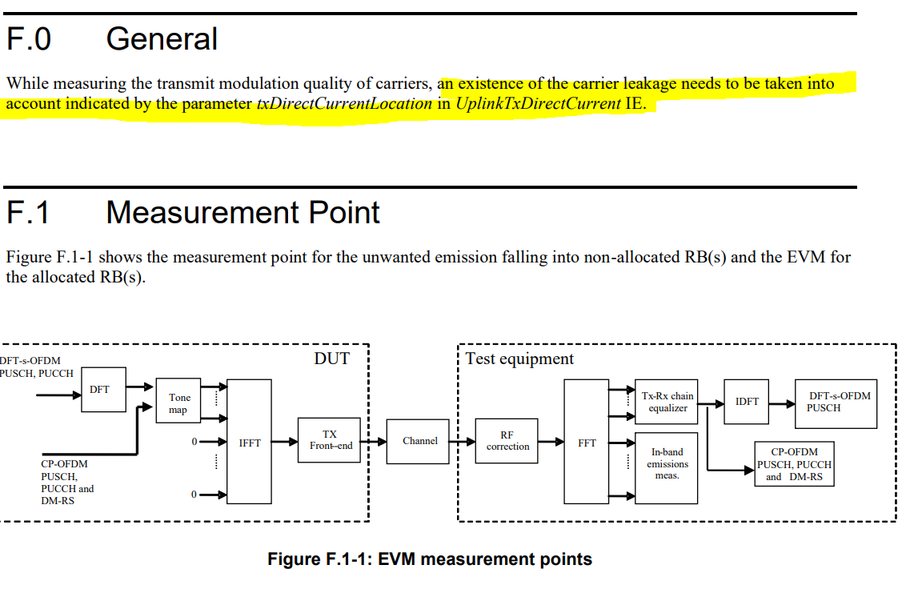
If the carrier leakage location is unknown, the RF correction is applied for it. It does not matter if the location is unknown by signalling ”unknown”, or by not signalling it by choise of UE or by appropriate method not being available to signalling it.

IBE requiruements on non-allocated component carrier
In band emission requirements apply over the non-allocated UL component carrier on FR1 and on DL component carrier on FR2. The picture shows the situation with requirements. The carrier leakage exception can be many dB’s above the IBVE requirement. The levels are discussed in R4-2107281.

Unless the carrier leakage frequency (= DC location) is not known, the emissions on those component carrier frequencies for this configuration can not be tested since the requirements is per RB and tester would not know if the corresponding RB included the relaxation for carrier leakage or did the UE fail it because of too large emisions: CC2 for FR1 and CC2, CC3 and CC4 for FR2. Only theoretical possibility to test is for TE to perform a scan and somehow find the carrier leakage but it is hard and especially if the carrier leakage is close to the emission level, it maybe even impossible. Currently, RAN5 specifications are unfinished for this

The options for going forward
Currently RAN5 does not have intra-band UL CA IBE test description for this reason on FR1 or FR2.
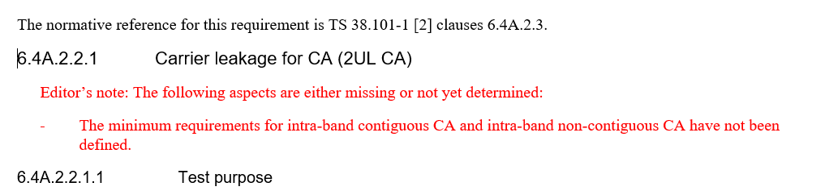
Two approaches with DC location can be takes by RAN4:
- Define that for UE to get the relaxation/RF correction/exception, UE must declare the carrier leakage position. If UE does not declare, then it has to meet the corresponding emission/EVM etc requirement
- Define that UE can declare the position but also allow UE not to declare it or declare “unknown” and keep the specification unchanged, i.e. acknowledge in the RF requirements that the carrier leakage frequency maybe unknown
The important note with the option 2 is that if UE for reason does not meet the requirement, UE can choose to declare “unknown” or not signal carrier leakage and therefore be exempted from the testing, as it is written in 6.4A.2:
“In case the parameter 3300 or 3301 is reported from UE via the parameter txDirectCurrentLocation in UplinkTxDirectCurrentList IE (as defined in TS 38.331 [7]), carrier leakage measurement requirement in clause 6.4D.2.2 and 6.4D.2.3 shall be waived,”
So in practice, this will be used to relaxation to some emission requirements.
Both options will enable ran5 to create test description for missing cases but if option 2 is chosen, it is unlikely those will be used. It would also make the whole big effort in RAN4 and RAN2 to create this signalling method to enable all the cases wasted. .

