**3GPP TSG-RAN WG4 Meeting #102-e draft R4-2207325**

**Electronic Meeting, February 21st – March 3rd, 2022**

**Source:** Rohde & Schwarz, vivo, Keysight Technologies

**Title:** TP to TR 38.834 on Measurement distance

**Agenda Item:** 10.2.2.1

**Document for:** Approval

# **Introduction**

This paper provides changes to the TRP and TRS test setup description in TR 38.834 [1] to define the minimum range length based on the approach agreed for RTS in clause 6.6.2 of TR 38.827 [2].

Proposal 1: Approve the text proposal below.

# **Conclusion**

The following proposal is made in this contribution:

Proposal 1: Approve the text proposal below.

# **References**

1. 3GPP TR 38.834 v0.3.0 (2022-01)
2. 3GPP TR 38.827 v16.5.0 (2022-01)

# **Appendix – Text Proposal to TR 38.834 v0.3.0**

**< Unchanged Text Deleted >**

**< Beginning of Changes >**

## 7.1 General

### 7.1.1 Minimum Range Length

This sub-section specifies the minimum range lengths for NR FR1 TRP-TRS OTA systems. The range length is defined as the distance from the centre of the quiet zone to the aperture of the measurement probes/antennas, as illustrated in Figure 7.1.1-1.

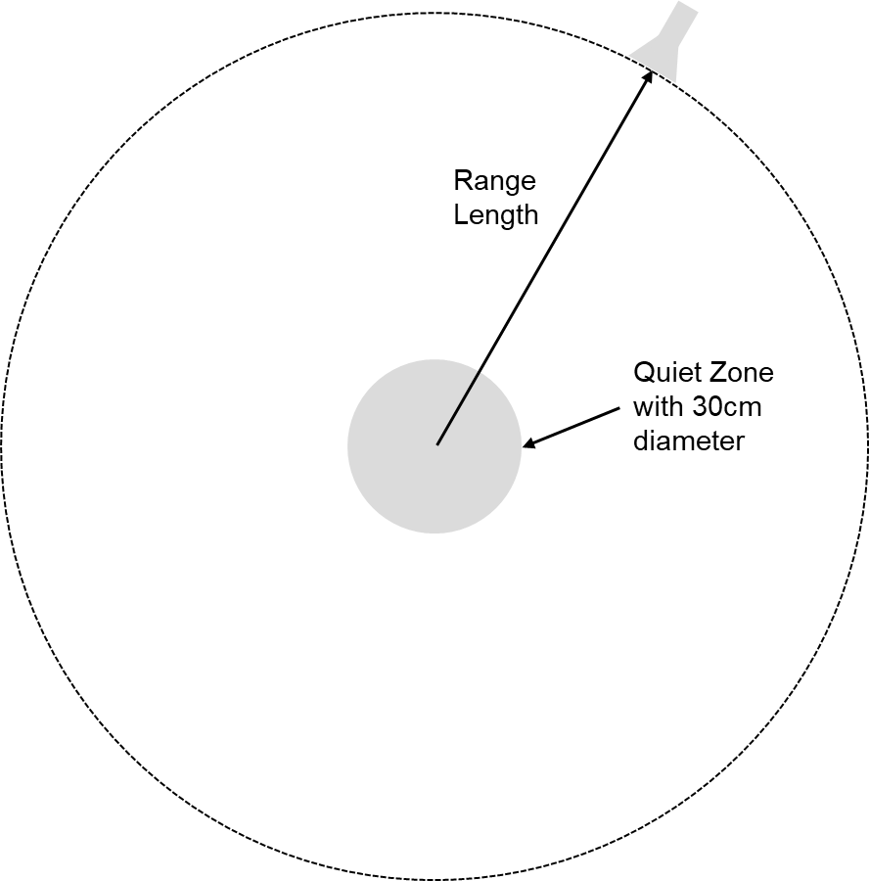

Figure 7.1.1-1: Illustration of range length definition

The minimum range length shall be the maximum of the following three limits

- The phase uncertainty limit: *R*QZ+2*D*rad2/

- The amplitude uncertainty limit: 3*D*

- The reactive Near-Field limit: *R*QZ+2

where *R*QZ is defined as the radius of the quiet zone, i.e., *R*QZ=*D*/2, and *D*rad is the diameter of the effective radiating aperture. The minimum range length calculations for *D*=30cm quiet zone size TRP-TRS OTA test systems shall assume that *D*rad is 30cm below 1GHz and decrease linearly from 30cm to 5cm from 1GHz to 7.125GHz, respectively. The last column of Table 7.1.1-1 shall be considered the minimum range length for NR FR1 TRP-TRS OTA systems with 30cm quiet zone size.

Table 7.1.1-1: Minimum Range Length for NR FR1 TRP-TRS OTA systems with 30cm quiet zone size.

|  |  |  |  |  |  |
| --- | --- | --- | --- | --- | --- |
| *f* [GHz] | Drad [m] | RQZ+2*Drad*²/λ | 3*D* = 6*R*QZ | RQZ+2λ | max(RQZ+2λ,3*D*,RQZ+2*D*²/λ) |
| 0.41 | 0.30 | 0.40 | 0.9 | 1.61 | 1.61 |
| 0.6 | 0.30 | 0.51 | 0.9 | 1.15 | 1.15 |
| 0.7 | 0.30 | 0.57 | 0.9 | 1.01 | 1.01 |
| 0.8 | 0.30 | 0.63 | 0.9 | 0.90 | 0.90 |
| 1 | 0.30 | 0.75 | 0.9 | 0.75 | 0.90 |
| 1.2 | 0.29 | 0.83 | 0.9 | 0.65 | 0.90 |
| 1.4 | 0.28 | 0.90 | 0.9 | 0.58 | 0.90 |
| 1.6 | 0.28 | 0.96 | 0.9 | 0.52 | 0.96 |
| 1.8 | 0.27 | 1.01 | 0.9 | 0.48 | 1.01 |
| 2 | 0.26 | 1.05 | 0.9 | 0.45 | 1.05 |
| 2.2 | 0.25 | 1.07 | 0.9 | 0.42 | 1.07 |
| 2.4 | 0.24 | 1.09 | 0.9 | 0.40 | 1.09 |
| 2.6 | 0.23 | 1.11 | 0.9 | 0.38 | 1.11 |
| 2.8 | 0.23 | 1.11 | 0.9 | 0.36 | 1.11 |
| 3 | 0.22 | 1.10 | 0.9 | 0.35 | 1.10 |
| 4 | 0.18 | 0.99 | 0.9 | 0.30 | 0.99 |
| 5 | 0.14 | 0.77 | 0.9 | 0.27 | 0.90 |
| 6 | 0.10 | 0.52 | 0.9 | 0.25 | 0.90 |
| 7 | 0.06 | 0.29 | 0.9 | 0.24 | 0.90 |
| 7.125 | 0.05 | 0.27 | 0.9 | 0.23 | 0.90 |

**< End of Changes >**