3GPP TSG-RAN WG4 Meeting #102-e R4-2204988
Electronic Meeting, 21st Feb. – 03rd Mar., 2022
Agenda item: 10.2.1
Source: OPPO
Title: Discussion and TP on performance metrics
Document for: Approval

1 Introduction
This paper presents further refinement on the performance metrics, i.e. TRP and TRS, based on the lasted version of TR 38.834, and provides the text proposal accordingly.

2 Discussion
The initial text proposal on performance metrics is provided in R4-2120691 [1], and merged to the version 0.2.0 of TR 38.834. The definitions of TRP and TRS are given in form of mathematical integration as below.
$$TRP= \frac{1}{4π}\int_{θ=0}^{π}{\int_{ϕ=0}^{2π}{EIRP\left(θ,ϕ\right)}\sin\left(θ\right)dϕdθ}$$
$$TRS=\frac{4π}{\oint{[\frac{1}{{EIS}_{θ}(Ω;f)}+\frac{1}{{EIS}_{ϕ}(Ω;f)}]dΩ}}$$
Considering the EIRP is actually the sum of transmitted power on two orthogonal linear polarizations, i.e. EIRP_{θ} and EIRP_{ϕ}, in anechoic chamber, it is proposed to express EIRP in the form of EIRP_{θ} and EIRP_{ϕ} as below.
$$TRP= \frac{1}{4π}\int_{θ=0}^{π}{\int_{ϕ=0}^{2π}{\left[{EIRP}_{θ}\left(θ,ϕ\right)+{EIRP}_{ϕ}\left(θ,ϕ\right)\right]}\sin\left(θ\right)dϕdθ}$$
Where EIRP_{θ} and EIRP_{ϕ} are the actually transmitted power-levels in corresponding polarizations.
Proposal 1: Express EIRP in the form of EIRP_{θ} and EIRP_{ϕ} as above.

Regarding TRP is defined with θ and ϕ, while TRS with Ω, it is proposed to express TRS with θ and ϕ as below for consistency.
$$TRS=\frac{4π}{\int_{θ=0}^{π}{\int_{ϕ=0}^{2π}{\left[\frac{1}{{EIS}_{θ}\left(θ,ϕ\right)}+\frac{1}{{EIS}_{ϕ}\left(θ,ϕ\right)}\right]\sin{θ}dϕdθ}}}$$
Where EIS_{θ} and EIS_{ϕ} are the effective isotropic sensitivities (EIS) in corresponding polarizations.
Proposal 2: Define the expression of TRS with θ and ϕ, rather than with Ω, as above.

In the last RAN4 #101-bis-e meeting, the sample steps in both θ and ϕ axes are defined in R4-2203071 [2]. The constant sampling step is 15 degrees for TRP measurement, and that for TRS measurement is 30 degrees. To facilitate the calculation of TRP and TRS with the measured data of EIRP and EIS, the summation form of the definition of TRP and TRS is needed. Similar approach is also implemented in TS 37.544 [3].
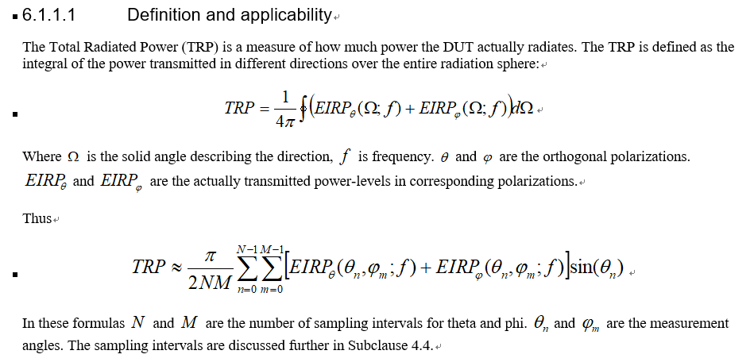
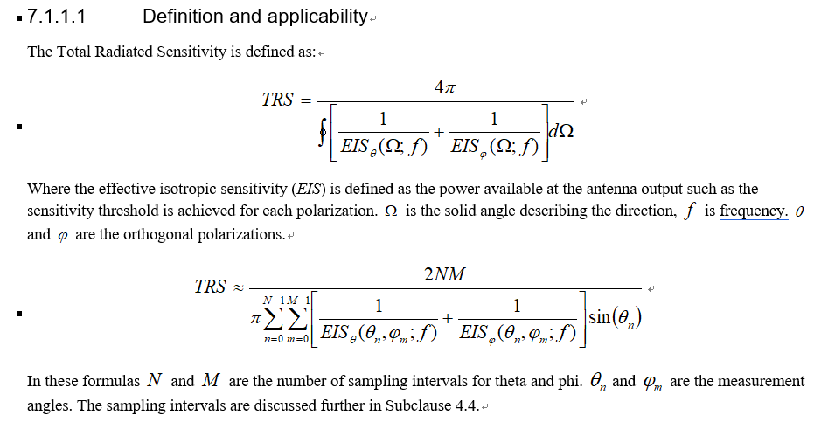
Proposal 3: Add the summation form of the definition of TRP and TRS as below to TR 38.834.
$$TRP≈ \frac{π}{2NM}\sum_{n=0}^{N-1}{\sum_{m=0}^{M-1}{\left[{EIRP}_{θ}\left(θ_{n},ϕ_{m}\right)+{EIRP}_{ϕ}\left(θ_{n},ϕ_{m}\right)\right]\sin{θ_{n}}}}$$
$$TRS≈\frac{2NM}{π\sum_{n=0}^{N-1}{\sum_{m=0}^{M-1}{\left[\frac{1}{{EIS}_{θ}\left(θ_{n},ϕ_{m}\right)}+\frac{1}{{EIS}_{ϕ}\left(θ_{n},ϕ_{m}\right)}\right]\sin{θ_{n}}}}}$$
In these formulas, N and M are the number of sampling intervals for θ and ϕ. θ_{n} and ϕ_{m} are the measurement angles.

3 Conclusion
Proposal 1: Express EIRP in the form of EIRP_{θ} and EIRP_{ϕ} as below.
$$TRP= \frac{1}{4π}\int_{θ=0}^{π}{\int_{ϕ=0}^{2π}{\left[{EIRP}_{θ}\left(θ,ϕ\right)+{EIRP}_{ϕ}\left(θ,ϕ\right)\right]}\sin\left(θ\right)dϕdθ}$$
Where EIRP_{θ} and EIRP_{ϕ} are the actually transmitted power-levels in the corresponding polarizations.

Proposal 2: Define the expression of TRS with θ and ϕ, rather than with Ω, as below.
$$TRS=\frac{4π}{\int_{θ=0}^{π}{\int_{ϕ=0}^{2π}{\left[\frac{1}{{EIS}_{θ}\left(θ,ϕ\right)}+\frac{1}{{EIS}_{ϕ}\left(θ,ϕ\right)}\right]\sin{θ}dϕdθ}}}$$
Where EIS_{θ} and EIS_{ϕ} are the effective isotropic sensitivities (EIS) in the corresponding polarizations.

Proposal 3: Add the summation form of the definition of TRP and TRS to TR 38.834.
$$TRP≈ \frac{π}{2NM}\sum_{n=0}^{N-1}{\sum_{m=0}^{M-1}{\left[{EIRP}_{θ}\left(θ_{n},ϕ_{m}\right)+{EIRP}_{ϕ}\left(θ_{n},ϕ_{m}\right)\right]\sin{θ_{n}}}}$$
$$TRS≈\frac{2NM}{π\sum_{n=0}^{N-1}{\sum_{m=0}^{M-1}{\left[\frac{1}{{EIS}_{θ}\left(θ_{n},ϕ_{m}\right)}+\frac{1}{{EIS}_{ϕ}\left(θ_{n},ϕ_{m}\right)}\right]\sin{θ_{n}}}}}$$
In these formulas, N and M are the number of sampling intervals for θ and ϕ. θ_{n} and ϕ_{m} are the measurement angles.

References
[1] R4-2120691 TP to TR 38.834 on performance metrics
[2] R4-2203071 TP to TR 38.834 on SA TRP TRS test procedure
[3] 3GPP TS 37.544 Universal Terrestrial Radio Access (UTRA) and Evolved Universal Terrestrial Radio Access (E-UTRA), User Equipment (UE) Over The Air (OTA) performance, Conformance testing (Release 16)

Text Proposal
<TP for TR 38.834>

5 Performance metrics

5.1 Definition of the Total Radiated Power (TRP)
Transmitter power measurements shall be performed using the Total Radiated Power (TRP) as the measurement metric.
This definition will be used to calculate the Total Radiated Power (TRP) value of NR FR1 DUT.
The TRP with Anechoic Chamber method is defined as:
TRP= 14πθ=0πϕ=02πEIRPθ,ϕsin(θ)dϕdθ TRP= 14πθ=0πϕ=02πEIRPθθ,ϕ+EIRPϕθ,ϕsinθdϕdθ (5.1)
Where the effective isotropic radiated power (EIRP) is defined as
$EIRP\left(θ,ϕ\right)=P_{T}G_{T}\left(θ,ϕ\right)$ (5.2)
Where $P_{T}G_{T}$ is the product of the power delivered to the antenna and the antenna’s power gain.
Where EIRP_{θ} and EIRP_{ϕ} are the EIRP in the corresponding θ and ϕ polarizations.
The summation form based on the sinθ⋅Δθ weights of TRP with Anechoic Chamber method is defined as:
TRP≈ π2NMn=0N-1m=0M-1EIRPθθn,ϕm+EIRPϕθn,ϕmsinθn (5.3)
Where N and M are the number of sampling intervals for θ and ϕ. θ_{n} and ϕ_{m} are the measurement angles.
The summatttion form based on the Clenshaw-Curtis quadrature integral approximation of TRP with Anechoic Chamber method is defined as:
TRP≈ 12Mn=0Nm=0M-1EIRPθθn,ϕm+EIRPϕθn,ϕmWθn (5.4)
Where the value of W(θ_{n}) follows Table 5.1-1.
Table 5.1-1 Weights for Clenshaw-Curtis Quadratures with Δθ=15º
Clenshaw-Curtis
θ [deg] | Weights
0 | 0.007
15 | 0.0661
30 | 0.1315
45 | 0.1848
60 | 0.227
75 | 0.2527
90 | 0.262
105 | 0.2527
120 | 0.227
135 | 0.1848
150 | 0.1315
165 | 0.0661
180 | 0.007

5.2 Definition of Total Radiated Sensitivity (TRS)
Receiver sensitivity measurements shall be performed using data throughput as the measurement metric. The DUT’s receiver sensitivity corresponds to the minimum downlink signal power required to provide a data throughput rate greater than or equal to 95% of the maximum throughput of the reference measurement channel (RMC).
This definition will be used to calculate the Total Radiated Sensitivity (TRS) value of NR FR1 DUT.
The TRS with Anechoic Chamber method is defined as:
TRS=4π[1EISθ(Ω;f)+1EISϕ(Ω;f)]dΩ TRS=4πθ=0πϕ=02π1EISθθ,ϕ+1EISϕθ,ϕsinθdϕdθ (5.4)
Where the effective isotropic sensitivity (EIS) is defined as the minimum power level at which the throughput exceeds or equal to 95% of the maximum throughput of the specified RMC, at each sampling point.
Where EIS_{θ} and EIS_{ϕ} are the EIS in the corresponding θ and ϕ polarizations.
The summation form based on the sinθ⋅Δθ weights of TRS with Anechoic Chamber method defined as:
TRS≈2NMπn=0N-1m=0M-11EISθθn,ϕm+1EISϕθn,ϕmsinθn (5.5)
Where N and M are the number of sampling intervals for θ and ϕ. θ_{n} and ϕ_{m} are the measurement angles.
The summatttion form based on the Clenshaw-Curtis quadrature integral approximation of TRS with Anechoic Chamber method is defined as:

TRS≈2Mn=0Nm=0M-11EISθθn,ϕm+1EISϕθn,ϕmWθn (5.5)
Where the value of W(θ_{n}) follows Table 5.2-1.
Table 5.2-1 Weights for Clenshaw-Curtis Quadratures with Δθ=30º
Clenshaw-Curtis
θ [deg] | Weights
0 | 0.007
30 | 0.1315
60 | 0.227
90 | 0.262
120 | 0.227
150 | 0.1315
180 | 0.007

<End of TP >

