**3GPP TSG-RAN WG4 Meeting #102-e R4-22xxxxx  
Electronic Meeting, February 21th – March 3rd, 2022**

**Agenda item: 10.1.3.3**

**Source: MVG Industries**

**Title: TP to TS38.151 on FR1 Temporal Correlation Validation – Time domain technique**

**Document for: Approval**

# 1 Introduction

This contribution does provide the text for including in [1] the time domain technique when testing temporal correlation – doppler spectrum

# 2 References

1. 3GPP TS 38.151 v0.7.0, January 2022

# 3 Text Proposal to TS 38.151

**--------------Start of text proposal 1 -------------**

## C.3.3 Doppler/Temporal correlation

This measurement checks the Doppler/temporal correlation. For Doppler/Temporal correlation validation measurement, only Vertical validation is required.

The Doppler spectrum is measured with a spectrum analyser as shown in Figure C.3.3-1. In this case a signal generator transmits CW signal through the NR MIMO OTA test system. The signal is received by a test antenna within the test area. Finally, the signal is analysed by a spectrum analyser and the measured spectrum is compared to the target spectrum. This setup can be used to measure Doppler Spectrum of the Channel models defined in Annex C.1.

**Method of measurement:**

Figure C.3.3-1: Setup for Doppler measurements

Sine wave (CW, carrier wave) signal is transmitted from the signal generator. The signal is connected from the signal generator to fading emulator via cables. The fading emulator output signals are connected to power amplifier boxes via cables. The amplified signals are then transferred via cables to the probe antennas. The probe antennas radiate the signals over the air to the test antenna. The Doppler spectrum is measured by the spectrum analyser and the trace is saved.

**Signal generator settings:**

Table C.3.3-1: Signal generator settings for Doppler/Temporal correlation measurements

| Item | Unit | Value |
| --- | --- | --- |
| Centre frequency | MHz | Downlink centre frequency  in Table C.3.1-1 |
| Modulation |  | OFF |

**Spectrum analyser settings:**

Table C.3.3-2: Spectrum analyser settings for Doppler/Temporal correlation measurements

| Item | Unit | Value |
| --- | --- | --- |
| Centre frequency | MHz | Downlink centre frequency  in Table C.3.1-1 |
| Minimum Span | Hz | 4 kHz |
| RBW | Hz | 1 |
| VBW | Hz | 1 |
| Number of points |  | 16002 |
| Averaging |  | 100 |

**Channel model specification:**

Table C.3.3-3: Channel model specification for Doppler/Temporal correlation measurements

| Item | Unit | Value |
| --- | --- | --- |
| Centre frequency | MHz | Downlink centre frequency  in Table C.3.1-1 |
| Channel model |  | As specified in Annex C.1 |
| Mobile speed | km/h | 100 |

Method of measurement result analysis: Measurement data file (Doppler power spectrum) is saved into hard drive. The data is read into, e.g., Matlab. The analysis is performed by taking the Fourier transformation of the Doppler spectrum. The resulting temporal correlation function  is normalized such that . Then the function values left from the maximum i.e., the negative lags are cut out. Further on the function values after five periods are cut out.**Time Domain Alternate Method**

Time domain techniques can also be used to validate the tempoal correlation. The temporal correlation validation measurement setup is illustrated in Figure C.3.3-2. In this case a Signal generator transmits a CW signal through the MIMO test system. The signal is received by a test antenna within the test area. Finally, the signal is collected by a signal analyser and the measured signal is stored as IQ data format for postprocessing.

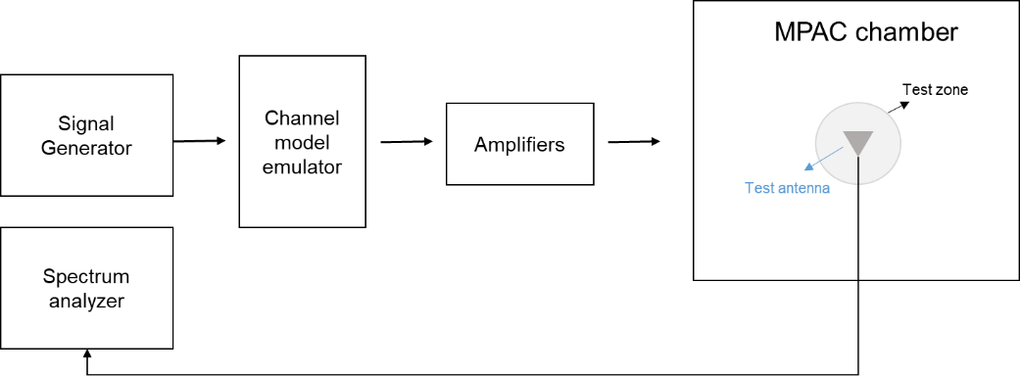

Signal

Analyzer

Trigger

Figure C.3.3-2: Setup for Doppler measurements based on time domain technique

The time domain doppler spectrum is measured by the signal analyzer and the trace in IQ format is saved. Follow the same procedure to post process the data and calculate the temporal correlation curve. Data recording is synchronized with the channel emulator trigger.

The settings for the signal analyzer are in Table C.3.3-4:

Table C.3.3-4: Signal Analyser Settings

|  |  |  |
| --- | --- | --- |
| Item | Unit | Value |
| Centre frequency | MHz | Downlink centre frequency in Table C.3.1-1 |
| Sampling | Hz | At least 15 times bigger than the max Doppler spread (*fd=v/λ)* |
| Observation time | s | At least 16s. Channel Model length should be the same or greater than the observation time. |

**Beam-Specific Block Diagram**

It is assumed that the beams are mapped to the inputs of the channel emulator as follows:

- Beam 1: Input 1 and Input 2

- Beam 2: Input 3 and Input 4 (CDL-C UMa only)

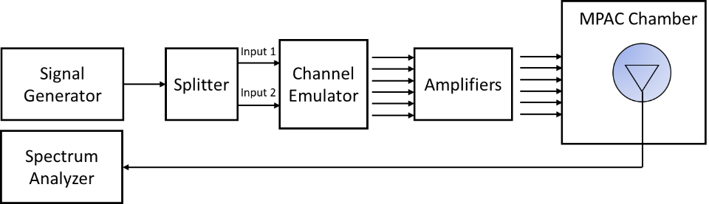

Figure C.3.3-3: Setup for Beam-Specific Doppler measurements (Beam 1)

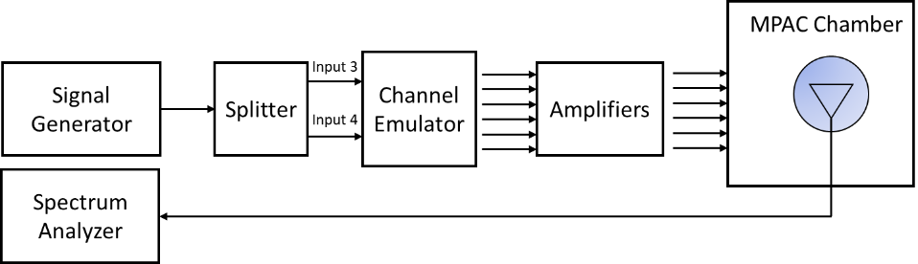

Figure C.3.3-4: Setup for Beam-Specific Doppler measurements (Beam 2 CDL-C UMa only)

Table C.3.3-5: Autocorrelation Targets

|  |  |  |  |  |  |  |
| --- | --- | --- | --- | --- | --- | --- |
| Lambda Separation | CDL-C UMa beam 1 at  ≤ 2.5 GHz | CDL-C UMa beam 2 at ≤ 2.5 GHz | CDL-C UMa beam 1 at > 2.5 GHz | CDL-C UMa beam 2 at > 2.5 GHz | CDL-C UMi beam 1 at  ≤ 2.5 GHz | CDL-C UMi beam 1 at > 2.5 GHz |
| 0.0 | 1.000 | 1.000 | 1.000 | 1.000 | 1.000 | 1.000 |
| 0.1 | 0.986 | 0.974 | 0.985 | 0.973 | 0.995 | 0.995 |
| 0.2 | 0.945 | 0.907 | 0.942 | 0.904 | 0.982 | 0.982 |
| 0.3 | 0.882 | 0.832 | 0.874 | 0.825 | 0.962 | 0.961 |
| 0.4 | 0.801 | 0.776 | 0.787 | 0.765 | 0.936 | 0.935 |
| 0.5 | 0.709 | 0.738 | 0.689 | 0.723 | 0.906 | 0.905 |
| 0.6 | 0.613 | 0.695 | 0.586 | 0.675 | 0.872 | 0.871 |
| 0.7 | 0.518 | 0.623 | 0.486 | 0.599 | 0.834 | 0.834 |
| 0.8 | 0.430 | 0.525 | 0.394 | 0.496 | 0.793 | 0.793 |
| 0.9 | 0.353 | 0.426 | 0.315 | 0.391 | 0.750 | 0.749 |
| 1.0 | 0.289 | 0.360 | 0.252 | 0.319 | 0.705 | 0.704 |
| 1.1 | 0.240 | 0.335 | 0.206 | 0.290 | 0.659 | 0.658 |
| 1.2 | 0.204 | 0.320 | 0.174 | 0.273 | 0.614 | 0.612 |
| 1.3 | 0.181 | 0.287 | 0.154 | 0.239 | 0.569 | 0.568 |
| 1.4 | 0.167 | 0.233 | 0.143 | 0.185 | 0.527 | 0.525 |
| 1.5 | 0.159 | 0.176 | 0.137 | 0.129 | 0.487 | 0.485 |
| 1.6 | 0.155 | 0.141 | 0.135 | 0.096 | 0.450 | 0.448 |
| 1.7 | 0.153 | 0.135 | 0.134 | 0.092 | 0.417 | 0.415 |
| 1.8 | 0.150 | 0.137 | 0.134 | 0.095 | 0.387 | 0.385 |
| 1.9 | 0.144 | 0.132 | 0.130 | 0.093 | 0.361 | 0.358 |
| 2.0 | 0.135 | 0.117 | 0.122 | 0.089 | 0.337 | 0.335 |
| 2.1 | 0.121 | 0.097 | 0.109 | 0.086 | 0.316 | 0.313 |
| 2.2 | 0.105 | 0.076 | 0.090 | 0.076 | 0.296 | 0.293 |
| 2.3 | 0.085 | 0.062 | 0.069 | 0.064 | 0.277 | 0.274 |
| 2.4 | 0.065 | 0.071 | 0.047 | 0.067 | 0.258 | 0.255 |
| 2.5 | 0.048 | 0.090 | 0.031 | 0.088 | 0.239 | 0.236 |
| 2.6 | 0.039 | 0.099 | 0.033 | 0.103 | 0.219 | 0.216 |
| 2.7 | 0.038 | 0.088 | 0.046 | 0.099 | 0.198 | 0.195 |
| 2.8 | 0.042 | 0.058 | 0.057 | 0.073 | 0.178 | 0.175 |
| 2.9 | 0.043 | 0.037 | 0.062 | 0.038 | 0.158 | 0.154 |
| 3.0 | 0.041 | 0.067 | 0.060 | 0.045 | 0.138 | 0.135 |
| 3.1 | 0.037 | 0.103 | 0.050 | 0.080 | 0.120 | 0.116 |
| 3.2 | 0.036 | 0.120 | 0.036 | 0.100 | 0.103 | 0.100 |
| 3.3 | 0.044 | 0.115 | 0.019 | 0.099 | 0.089 | 0.085 |
| 3.4 | 0.056 | 0.097 | 0.010 | 0.081 | 0.076 | 0.073 |
| 3.5 | 0.068 | 0.082 | 0.019 | 0.061 | 0.066 | 0.063 |
| 3.6 | 0.075 | 0.083 | 0.029 | 0.053 | 0.057 | 0.055 |
| 3.7 | 0.076 | 0.090 | 0.034 | 0.060 | 0.051 | 0.049 |
| 3.8 | 0.068 | 0.089 | 0.036 | 0.073 | 0.046 | 0.044 |
| 3.9 | 0.051 | 0.079 | 0.044 | 0.091 | 0.042 | 0.041 |
| 4.0 | 0.027 | 0.068 | 0.062 | 0.111 | 0.039 | 0.038 |
| 4.1 | 0.007 | 0.063 | 0.090 | 0.127 | 0.037 | 0.035 |
| 4.2 | 0.036 | 0.062 | 0.123 | 0.133 | 0.036 | 0.034 |
| 4.3 | 0.067 | 0.057 | 0.155 | 0.129 | 0.038 | 0.036 |
| 4.4 | 0.093 | 0.052 | 0.182 | 0.126 | 0.043 | 0.040 |
| 4.5 | 0.111 | 0.055 | 0.200 | 0.131 | 0.051 | 0.048 |
| 4.6 | 0.119 | 0.063 | 0.207 | 0.139 | 0.061 | 0.058 |
| 4.7 | 0.116 | 0.066 | 0.200 | 0.138 | 0.073 | 0.070 |
| 4.8 | 0.101 | 0.058 | 0.180 | 0.117 | 0.085 | 0.082 |
| 4.9 | 0.078 | 0.047 | 0.149 | 0.079 | 0.096 | 0.093 |
| 5.0 | 0.051 | 0.048 | 0.110 | 0.034 | 0.107 | 0.104 |

**--------------End of text proposal 1 -------------**