**TSG-RAN Working Group 4 (Radio) meeting #102-eR4-22xxxxxx**

**Electronic Meeting, Feb 21st - March 3rd 2022** Revision of R4-2205926

**Source:** T-Mobile USA

**Title:** TP for TR 37.828: Filter and PA data for n71, n26 and n12

**Agenda item:** 9.29.2.3

**Document for:** Approval

1 Introduction

The WID includes the following objective: Investigate the feasibility of filter with small duplex for B13, n13 and n71. This Text Proposal provides filter and PA data for n71, n26 and n12

This is a revision of R4-2119882 from RAN4#101e.

This revision fixed a typo, and split the filter tables up so they fit on the page. It also deleted some “add then delete” instances.

2 Text Proposal

<First changed section>

# 7 Band specific requirements for a UE

*Editor note: This section relates to the Band Specific objectives of the WI.*

## 7.x Band n71

*Editor note: All sub-clauses are not necessary for all bands.*

### 7.x.1 REFSENS exception

### 7.x.2 A-MPR

### 7.x.3 Feasibility of the filter

Since the PC1 FWA market does not yet exist, it is unlikely that there are off the shelf components optimized for such a device. This data is being provided for information and is not intended to demonstrate that off the shelf hardware exists for the FWA devices.

A filter example is presented below with input power capabilities of 43 dBm which obviously is more than needed for PC1 operation even considering the post PA-losses, but this demonstrates that capable technology is available.

Band 71/n71 duplex-filter [UMD071A (ctscorp.com)](https://www.ctscorp.com/wp-content/uploads/UMD071A.pdf)

In addition to the above filter with 43 dBm capability, there are also filters with input power capabilities of 38 dBm, which is also more power than is needed for PC1 FWA. Nonetheless, the filters are still very large and may not be suitable even for large form factor FWA. Further size reduction will likely be required even for filters for larger FWA devices.

Band 71/n71 and Band 85 UL duplex-filter [USD7185A (ctscorp.com)](https://www.ctscorp.com/wp-content/uploads/USD7185A.pdf)

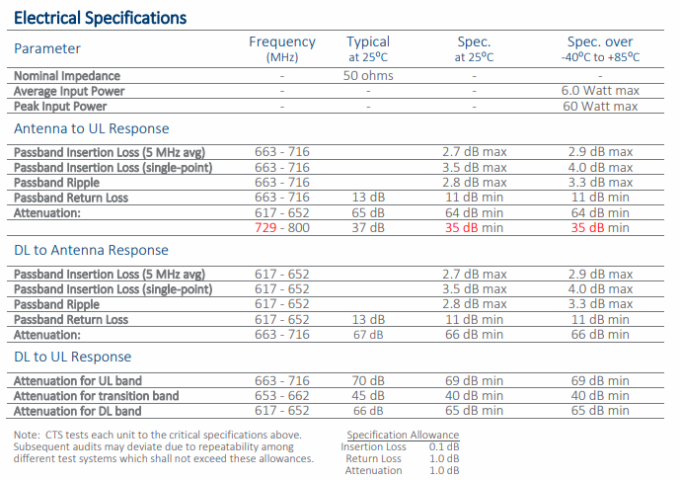

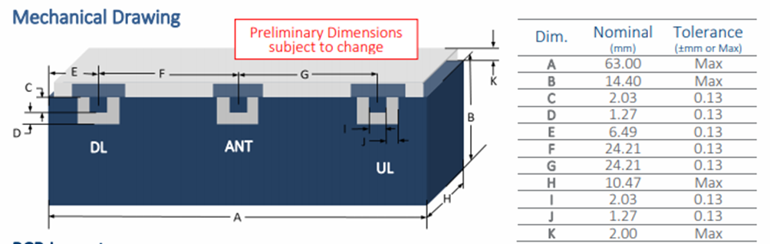

### 7.x.4 Feasibility of the PA

Here are some commercial data sheets for Pas that appear to be compatible with n71 PC1 FWA devices, although the voltage levels are too high for FWA devices. The table was split into two rows to fit on the page.

|  |  |  |  |  |  |  |  |  |  |  |  |
| --- | --- | --- | --- | --- | --- | --- | --- | --- | --- | --- | --- |
| Device | Fmin  (MHz) | Fmax  (MHz) | Avg. power | | OBO | Peak power | | Voltage | Technology | Device type | Gain |
| [A3G26D055N](https://www.nxp.com/docs/en/data-sheet/A3G26D055N.pdf) | 100 | 2690 | 8 W | 39.0 dBm | 8.2 dB | 53 W | 47.2 dBm | 48 V | GaN | Discrete | 18 dB |
| [A2I09VD030N](https://www.nxp.com/docs/en/data-sheet/A2I09VD030N.pdf) | 575 | 960 | 4 W | 36.0 dBm | 10.1 dB | 41 W | 46.1 dBm | 48 V | LDMOS | IC | 34 dB |
| [MW7IC915N](https://www.nxp.com/docs/en/data-sheet/MW7IC915N.pdf) | 600 | 900 | 2 W | 32.0 dBm | 9.9 dB | 16 W | 41.9 dBm | 28 V | LDMOS | IC | 38 dB |
| [A2T27S020N](https://www.nxp.com/docs/en/data-sheet/A2T27S020N.pdf) | 400 | 2700 | 3 W | 34.0 dBm | 9.0 dB | 20 W | 43.0 dBm | 28 V | LDMOS | Discrete | 21 dB |
| [AFT09MS031N](https://www.nxp.com/docs/en/data-sheet/AFT09MS031N.pdf) | 1.8 | 941 | 4 W | 36.4 dBm | 8.5 dB | 31 W | 44.9 dBm | 12.5 V | LDMOS | Discrete | 17 dB |

|  |  |  |  |  |  |  |  |
| --- | --- | --- | --- | --- | --- | --- | --- |
| Device | Key parameter | Parameter description | Package | Package type | Matching | Configuration | Recommended driver |
| [A3G26D055N](https://www.nxp.com/docs/en/data-sheet/A3G26D055N.pdf) | 54% | drain efficiency (Doherty) at 8.2 dB OBO | DFN 7 x 6.5 | over-molded plastic | Input pre-matched, output unmatched | Dual path | A3V26S004N |
| [A2I09VD030N](https://www.nxp.com/docs/en/data-sheet/A2I09VD030N.pdf) | 20% | PAE (Class AB) at 10.1 dB OBO | TO-270WB-15 | over-molded plastic | 50-ohm input, output pre-matched | Dual path | MMG38151B |
| [MW7IC915N](https://www.nxp.com/docs/en/data-sheet/MW7IC915N.pdf) | 17% | PAE (Class AB) at 9.9 dB OBO | PQFN 8 x 8 | over-molded plastic | Input pre-matched, output unmatched | Single path | MMG3014N |
| [A2T27S020N](https://www.nxp.com/docs/en/data-sheet/A2T27S020N.pdf) | 21% | drain efficiency (Class AB) at 9.0 dB OBO | TO-270-2 | over-molded plastic | Unmatched | Single path | A3M40PD012 |
| [AFT09MS031N](https://www.nxp.com/docs/en/data-sheet/AFT09MS031N.pdf) | 71% | drain efficiency (CW) | TO-270-2 | over-molded plastic | Unmatched | Single path | AFT05MS004N |

### 7.x.4 Other

## 7.y Band n26

### 7.y.1 REFSENS exception

### 7.y.2 A-MPR

### 7.y.3 Feasibility of the filter

Since the PC1 FWA market does not yet exist, it is unlikely that there are off the shelf components optimized for such a device. This data is being provided for information and is not intended to demonstrate that off the shelf hardware exists for the FWA devices.

A filter example is presented below with input power capabilities of 43 dBm which obviously is more than needed for PC1 operation even considering the post PA-losses, but this demonstrates that capable technology is available.

Band 26/n26 duplex-filter (subset of n26 for the US market) [UMD026B (ctscorp.com)](https://www.ctscorp.com/wp-content/uploads/UMD026B.pdf)

In addition to the above filter with 43 dBm capability, there are also filters with input power capabilities of 38 dBm which is also more power than is needed for PC1 FWA.. Nonetheless, the filters are still very large and may not be suitable even for large form factor FWA. Further size reduction will likely be required even for filters for larger FWA devices.

Band 26/n26 duplex-filter [USD005A (ctscorp.com)](https://www.ctscorp.com/wp-content/uploads/USD026A.pdf)

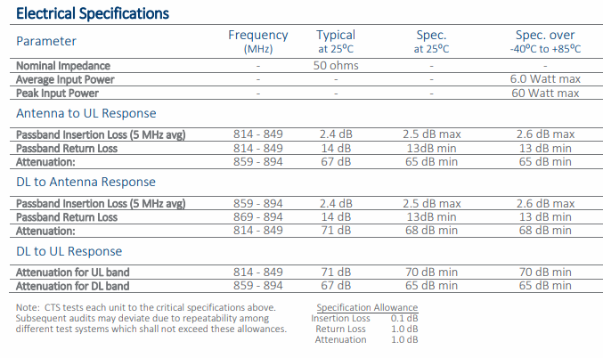

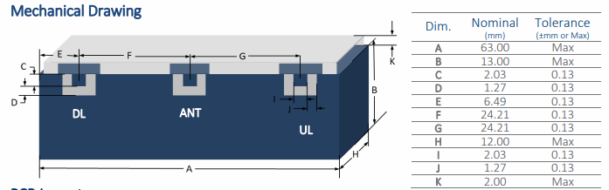

### 7.y.4 Feasibility of the PA

Here are some commercial data sheets for PAs that appear to be compatible with n26 PC1 FWA devices, although the voltage levels are too high for FWA devices. The table was split into two rows to fit on the page.

|  |  |  |  |  |  |  |  |  |  |  |  |
| --- | --- | --- | --- | --- | --- | --- | --- | --- | --- | --- | --- |
| Device | Fmin  (MHz) | Fmax  (MHz) | Avg. power | | OBO | Peak power | | Voltage | Technology | Device type | Gain |
| [A3G26D055N](https://www.nxp.com/docs/en/data-sheet/A3G26D055N.pdf) | 100 | 2690 | 8 W | 39.0 dBm | 8.2 dB | 53 W | 47.2 dBm | 48 V | GaN | Discrete | 18 dB |
| [A2I09VD030N](https://www.nxp.com/docs/en/data-sheet/A2I09VD030N.pdf) | 575 | 960 | 4 W | 36.0 dBm | 10.1 dB | 41 W | 46.1 dBm | 48 V | LDMOS | IC | 34 dB |
| [MW7IC915N](https://www.nxp.com/docs/en/data-sheet/MW7IC915N.pdf) | 600 | 900 | 2 W | 32.0 dBm | 9.9 dB | 16 W | 41.9 dBm | 28 V | LDMOS | IC | 38 dB |
| [A2T27S020N](https://www.nxp.com/docs/en/data-sheet/A2T27S020N.pdf) | 400 | 2700 | 3 W | 34.0 dBm | 9.0 dB | 20 W | 43.0 dBm | 28 V | LDMOS | Discrete | 21 dB |
| [AFT09MS031N](https://www.nxp.com/docs/en/data-sheet/AFT09MS031N.pdf) | 1.8 | 941 | 4 W | 36.4 dBm | 8.5 dB | 31 W | 44.9 dBm | 12.5 V | LDMOS | Discrete | 17 dB |

|  |  |  |  |  |  |  |  |
| --- | --- | --- | --- | --- | --- | --- | --- |
| Device | Key parameter | Parameter description | Package | Package type | Matching | Configuration | Recommended driver |
| [A3G26D055N](https://www.nxp.com/docs/en/data-sheet/A3G26D055N.pdf) | 54% | drain efficiency (Doherty) at 8.2 dB OBO | DFN 7 x 6.5 | over-molded plastic | Input pre-matched, output unmatched | Dual path | A3V26S004N |
| [A2I09VD030N](https://www.nxp.com/docs/en/data-sheet/A2I09VD030N.pdf) | 20% | PAE (Class AB) at 10.1 dB OBO | TO-270WB-15 | over-molded plastic | 50-ohm input, output pre-matched | Dual path | MMG38151B |
| [MW7IC915N](https://www.nxp.com/docs/en/data-sheet/MW7IC915N.pdf) | 17% | PAE (Class AB) at 9.9 dB OBO | PQFN 8 x 8 | over-molded plastic | Input pre-matched, output unmatched | Single path | MMG3014N |
| [A2T27S020N](https://www.nxp.com/docs/en/data-sheet/A2T27S020N.pdf) | 21% | drain efficiency (Class AB) at 9.0 dB OBO | TO-270-2 | over-molded plastic | Unmatched | Single path | A3M40PD012 |
| [AFT09MS031N](https://www.nxp.com/docs/en/data-sheet/AFT09MS031N.pdf) | 71% | drain efficiency (CW) | TO-270-2 | over-molded plastic | Unmatched | Single path | AFT05MS004N |

### 7.y.4 Other

### 7.x.4 Other

## 7.z Band n12

### 7.z.1 REFSENS exception

### 7.z.2 A-MPR

### 7.z.3 Feasibility of the filter

Since the PC1 FWA market does not yet exist, it is unlikely that there are off the shelf components optimized for such a device. This data is being provided for information and is not intended to demonstrate that off the shelf hardware exists for the FWA devices.

A filter example is presented below with input power capabilities of 43 dBm which obviously is more than needed for PC1 operation even considering the post PA-losses, but this demonstrates that capable technology is available.

Band 12 duplex-filter [UMD012A (ctscorp.com)](https://www.ctscorp.com/wp-content/uploads/UMD012A.pdf)

In addition to the above filter with 43 dBm capability, there are also filters with input power capabilities of 38 dBm, which is also more power than is needed for PC1 FWA Nonetheless, the filters are still very large and may not be suitable even for large form factor FWA. Further size reduction will likely be required even for filters for larger FWA devices.

Band 12 duplex-filter [USD012A (ctscorp.com)](https://www.ctscorp.com/wp-content/uploads/USD012A.pdf)

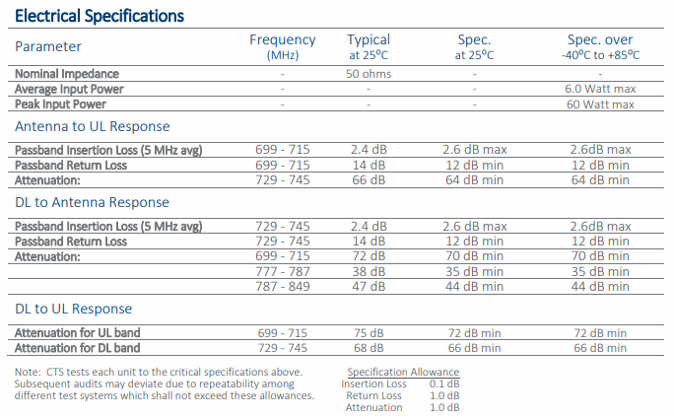

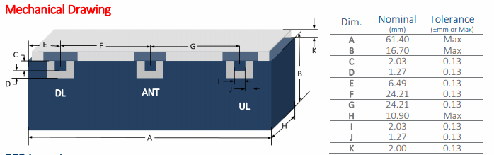

### 7.z.4 Feasibility of the PA

Here are some commercial data sheets for PAs that appear to be compatible with n12 PC1 FWA devices, although the voltage levels are too high for FWA devices. The table was split into two rows to fit on the page.

|  |  |  |  |  |  |  |  |  |  |  |  |
| --- | --- | --- | --- | --- | --- | --- | --- | --- | --- | --- | --- |
| Device | Fmin  (MHz) | Fmax  (MHz) | Avg. power | | OBO | Peak power | | Voltage | Technology | Device type | Gain |
| [A3G26D055N](https://www.nxp.com/docs/en/data-sheet/A3G26D055N.pdf) | 100 | 2690 | 8 W | 39.0 dBm | 8.2 dB | 53 W | 47.2 dBm | 48 V | GaN | Discrete | 18 dB |
| [A2I09VD030N](https://www.nxp.com/docs/en/data-sheet/A2I09VD030N.pdf) | 575 | 960 | 4 W | 36.0 dBm | 10.1 dB | 41 W | 46.1 dBm | 48 V | LDMOS | IC | 34 dB |
| [MW7IC915N](https://www.nxp.com/docs/en/data-sheet/MW7IC915N.pdf) | 600 | 900 | 2 W | 32.0 dBm | 9.9 dB | 16 W | 41.9 dBm | 28 V | LDMOS | IC | 38 dB |
| [A2T27S020N](https://www.nxp.com/docs/en/data-sheet/A2T27S020N.pdf) | 400 | 2700 | 3 W | 34.0 dBm | 9.0 dB | 20 W | 43.0 dBm | 28 V | LDMOS | Discrete | 21 dB |
| [AFT09MS031N](https://www.nxp.com/docs/en/data-sheet/AFT09MS031N.pdf) | 1.8 | 941 | 4 W | 36.4 dBm | 8.5 dB | 31 W | 44.9 dBm | 12.5 V | LDMOS | Discrete | 17 dB |

|  |  |  |  |  |  |  |  |
| --- | --- | --- | --- | --- | --- | --- | --- |
| Device | Key parameter | Parameter description | Package | Package type | Matching | Configuration | Recommended driver |
| [A3G26D055N](https://www.nxp.com/docs/en/data-sheet/A3G26D055N.pdf) | 54% | drain efficiency (Doherty) at 8.2 dB OBO | DFN 7 x 6.5 | over-molded plastic | Input pre-matched, output unmatched | Dual path | A3V26S004N |
| [A2I09VD030N](https://www.nxp.com/docs/en/data-sheet/A2I09VD030N.pdf) | 20% | PAE (Class AB) at 10.1 dB OBO | TO-270WB-15 | over-molded plastic | 50-ohm input, output pre-matched | Dual path | MMG38151B |
| [MW7IC915N](https://www.nxp.com/docs/en/data-sheet/MW7IC915N.pdf) | 17% | PAE (Class AB) at 9.9 dB OBO | PQFN 8 x 8 | over-molded plastic | Input pre-matched, output unmatched | Single path | MMG3014N |
| [A2T27S020N](https://www.nxp.com/docs/en/data-sheet/A2T27S020N.pdf) | 21% | drain efficiency (Class AB) at 9.0 dB OBO | TO-270-2 | over-molded plastic | Unmatched | Single path | A3M40PD012 |
| [AFT09MS031N](https://www.nxp.com/docs/en/data-sheet/AFT09MS031N.pdf) | 71% | drain efficiency (CW) | TO-270-2 | over-molded plastic | Unmatched | Single path | AFT05MS004N |

### 7.z.4 Other

<End of changes>