3GPP TSG-RAN WG4 Meeting #102-e R4-22xxxxx
Electronic Meeting, 21 Feb - 3 Mar, 2022

Title: [Draft] Further Reply LS on power control for NR-DC
Response to: (R1-2104018) Further Reply LS on power control for NR-DC
Release: Rel-16
Work Item: LTE_NR_DC_CA_enh-Core

Source: RAN4
To: RAN1
Cc: RAN2

Contact Person:
Name: Jinqiang Xing
E-mail Address: xingjinqiang@OPPO.com

Name: Sanjun Feng
E-mail Address: fengsanjun@vivo.com

Send any reply LS to: 3GPP Liaisons Coordinator, mailto:3GPPLiaison@etsi.org

Attachments: -

Agreement: the content in this document is agreeable.

1. Overall Description:
RAN4 would like to thank RAN1 for the Further Reply LS on power control for NR-DC.
Regarding the feasibility of independent power control for the mentioned two cases:
1) uplink CCs of MCG and uplink CCs of SCG are in different frequency bands in FR2.
2) uplink CCs of MCG and uplink CCs of SCG are in the same frequency band in FR2.

RAN4 has discussed the definition of independent power control, and the understanding is that it means power control is per CG, and there is no total power limitation.
Up to now RAN4 hasn’t introduce NR-DC band combination for FR2, therefore UL CA is referred here and it is RAN4 understanding that same conclusion can be applied to NR-DC.
For intra-band UL CA, total max TRP and max EIRP limitation are defined in section 6.2A.4 of TS 38.101-2, thus power sharing is needed when the maximum power limitation was reached. Therefore, it is not independent power control.

For inter-band UL CA:
RAN4 has discussed two kinds of UEs to support inter-band CA, one is called CBM (Common Beam Management), and the other is called IBM (Independent Beam Management), and in Rel-17 RAN4 only defined requirements for IBM in inter-band UL CA. It is agreed that independent power control might be possible in some case for IBM but is not guaranteed UE behavior. RAN4 hasn’t discussed CBM for inter-band UL CA up to Rel-17.

In addition, RAN4 do not plan to discuss p-NR-FR2 or p-UE-FR2 in Rel-17.

2. Actions:
To RAN1:
ACTION: RAN4 respectfully asks RAN1 to take the above information into account.

3. Date of Next TSG WG RAN4 Meetings:
TSG-RAN WG4 Meeting #103-e 16 - 27 Fri 2022 E-meeting

LS contents | Company comments
For the intra-band UL CA | Company 1:  Company 2:  Qualcomm: Conclusions from intra-band ULCA cannot be used for intra-band NR-DC.  Intra-band ULCA presumes a common QCL-D source for all cells, in addition to strict timing requirements. On the other hand, NR-DC is not feasible without IBM: NR-DC cannot be configured with BM resource sharing across cell groups (RAN2 limitation), so UE BM for each cell-group (MCG and SCG respectively) must be independent. So intra-band ULCA (CBM) is not relevant for intra-band NR-DC (IBM only).  The need for IBM and other practical considerations are reflected in RAN4’s own 38.133, which does not recognize or treat intra-band NR-DC, it only has requirements for inter-band NR-DC.  OPPO: Reply to QC comments  1. Currently CBM/IBM is only defined for inter-band as below UE capability, what is intra-band CBM/IBM?  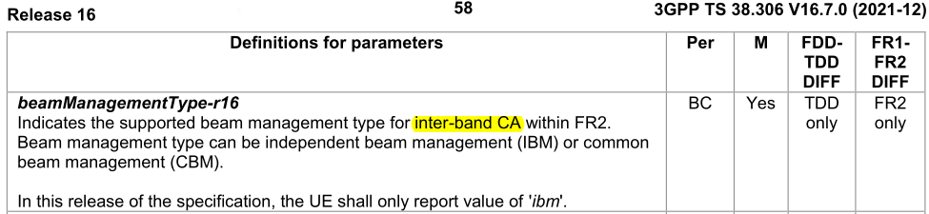  2. For the NR-DC BM resource limitation, could you please share the RAN2 limitation reference?  3. The independent power control concept has been agreed meetings ago, i.e. per CG power control and there is no total power limitation. The discussion can focus on whether there is total power limitation in intra-band case. In intra-band UL CA, clearly it has total max TRP and max EIRP limitation which are coming from regulations and it is per-band defined. These limitations are applied to intra-band DC regardless of BM types.  Vivo: Intra-band case would be anyway limited by per-band regulatory requirements, and not need to make too much detailed discussion. Keep it as it is should be fine.
For the inter-band UL CA | Company 1:  Company 2:  Qualcomm: CBM discussion should be removed from LS:  RAN4 has not discussed CBM UEs for ULCA, so this statement is not true for RAN4: ‘For inter-band UL CA, RAN4 has discussed two kinds of UEs, one is called CBM (Common Beam Management), and the other is called IBM (Independent Beam Management)’.  RAN4 has only discussed IBM inter-band ULCA, but this discussion is sufficient to extrapolate to NR-DC because the parallels are not controversial. Without a detailed study we cannot allude to suitability of CBM for ULCA. NR-DC is a further stretch.  OPPO: Reply to QC comments  - Yes, CBM hasn’t been discussed in RAN4 requirements, and the description of CBM/IBM is for introduction of UE types. Some updating can be as below:  For inter-band UL CA:  Two kinds of UEs have been considered to support inter-band CA, one is called CBM (Common Beam Management), and the other is called IBM (Independent Beam Management), and in Rel-17 RAN4 only defined requirements for IBM in inter-band UL CA.  - For the CBM UE, RAN4 hasn’t discuss details up to Rel-17 and cannot give conclusions whether they are independent power control or not.  - For the IBM UE, typically separate Tx hardware are used for the two bands. There are different views in RAN4 about whether this kind of UE is independent power control.  Vivo: Agree that CBM does not need to be mentioned here, and the background part can use Qualcomm’s suggestion in next issue. Then this part can be greatly simplified, e.g.  For inter-band UL CA, though typically separate Tx hardware are used for the two bands, independent power control is feasible but is not guaranteed behaviour with IBM UL CA.
For other parts | Company 1:  Company 2:  Qualcomm: We recommend the following changes.  RAN4 has not yet discussed NR-DC band combination for FR2, therefore UL CA with IBM (independent beam management) is referred here and it is RAN4 understanding that same conclusion can be applied to NR-DC. IBM is defined as the ability of a UE to selects its beam(s) for all CCs in each configured band based on DL reference signals measurements made in that band.  Also, after further analysis and thanks to counter arguments by other companies, we have revised our stand on feasibility of independent power control. We now think that independent power control cannot be guaranteed by the standard even for IBM inter-band ULCA. It can be considered up to UE implementation, however.  We take independent power control as ‘UE complies with TS38.213 section 7.1 through 7.5 independently for each band.’. Our explanation is below.  A typical power control equation is shown below (taken from 7.1):  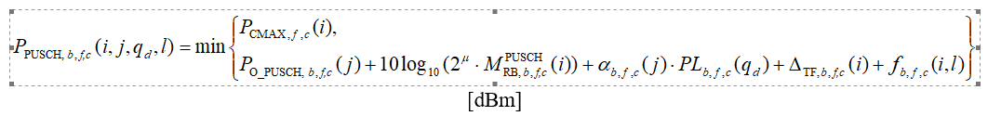  To check for independence of power control, it is sufficient to check if PCmaxf,c in one band changes due to scheduling or other changes in the other band, during inter-band operation after RRC configuration. If change is possible, power control cannot be independent.  A practical configured power requirement would offer 3 possible inter-band link paths: delta(TIB), CAMPR and P-MPR.  Delta(TIB) is static for a power class and band combination, so PCmaxf,c in one band is not affected by MCS, allocation changes and TPC in the other band. So delta(TIB) does not break independence.  MPR_PAPA (while not yet agreed) however does seem to depend on the allocation in both bands, so we agree there could be inter-band linkage in corner cases where single band MPR is less than MPR_PAPA, and the UE chooses to take all the MPR available to it. So cross-band dependence due to MPR_PAPA is not precluded by the standard, but it is up to UE implementation whether to allow or avoid cross-band dependence.  P-MPR on the other hand is not regulated and up to UE implementation, so the standard cannot guarantee preclusion of cross-band linkage of PCmax,f,c.  In conclusion, two out of the three parameters can allow cross-band dependence of PCmax,f,c. Independent power control is feasible but is not guaranteed behaviour with IBM UL CA.  OPPO: Reply to QC comments:  - With the updates in previous comment, i.e. saying RAN4 only defined IBM for inter-band UL CA in Rel-17 and no discussion of CBM then the changes below is no need anymore.  “…therefore UL CA with IBM (independent beam management) is referred here…”  - Though we have different understanding on the impact of P-MPR, and delta Tib, the conclusion is same from specification perspective it shouldn’t assume UEs are independent power control for inter-band UL CA IBM.  Vivo: Support Qualcomm’s latest comment: “Independent power control is feasible but is not guaranteed behaviour with IBM UL CA.” and propose to send this back via LS;  In addition, the recommendation from Qualcomm “RAN4 has not yet discussed NR-DC band combination for FR2, therefore UL CA with IBM (independent beam management) is referred here…” seems good.

