**3GPP TSG-RAN WG4 Meeting #102-e R4-22xxxxx**

**Electronic Meeting, February 21 – March 3, 2022**

**Title: [LS] On Canada band n77**

**Reply To:**

**Release:** Rel-17

**Work Item:** ??

**Source:** RAN WG4

**To:** RAN WG2

**Cc:** RAN

**Contact Person:**

**Name: Ivo Maljevic**

**E-mail Address: ivo.maljevic@telus.com**

**Attachments:**

**1. Background information:**

The issue is related to phased introduction of n77 spectrum in Canada and has similarities to the US band n77 that was originally introduced to cover the frequency range 3700-3980 MHz, and later extended to include 3450-3550 MHz frequency range.

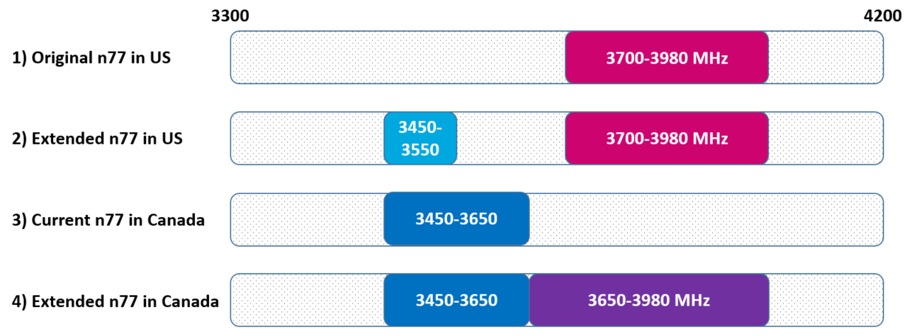

Canadian operators require a mechanism to differentiate current n77 UEs that support frequency range from 3450-3650 MHz (2022 devices) and extended n77 devices (3450-3980 MHz range, 2023+ devices).

1. **Summary**

Agreements:

RAN4 has discussed the above issue [1] and recommended a solution similar to that for US n77 band for enabling the signaling indication in Rel-17.

* A capability bit- to indicate that a UE is capable of operating in the full range 3450-3980 MHz in Canada.
* New NS value:  is only applicable in the range 3650-3980 MHz in Canada and used for barring existing devices not indicating capability bit from accessing a cell in 3650-3980 MHz from IDLE mode. The NS value will be defined in RAN4 when RAN2 decides to define the signaling bit.

RAN4 also welcomes RAN2 to find more general solution in this regards.

1. **Actions:**

**To RAN WG2 group.**

**ACTION:** RAN4 kindly asks RAN2 to introduce a new IE for the extendedBandCanada-n77-r17 capability in Canada and a new NS_XX value to address the issue.

1. **Date of Next TSG-RAN WG4 Meetings:**

TSG-RAN4 #104 22-26 August 2022 Toulouse, France

TSG-RAN4 #104-bis 10-14 October 2022 TBD, India

1. **References**

|  |  |
| --- | --- |
| **1** | R4-2203554 - Discussion on devices certified in a subset of a 3GPP band, Electronic Meeting, February 21 – March 3, 2022 |
|  |  |