**3GPP TSG-RAN WG4 Meeting # 100-e [draft]R4-2115750**

**Electronic Meeting, 19th – 27th May, 2021**

**Agenda item: 9.13.2**

**Source:** Samsung, CATT

**Title:** Simulation assumptions for NTN co-existence study

**Document for:** Information

# Introduction

This document captures initial simulation assumptions for the NTN coexistence study in frequency bands around 2GHz.

Remaining issues for further discussion are with [] and highlighted in yellow mark.

# Discussion

## Co-existence simulation scenarios

It is proposed to have a phase-by-phase approach to conduct co-existence study considering scenarios.

The proposed scenarios for coexistence study are in the following table.

Table 2.1-1 Scenarios for NTN-NTN/TN co-existence

|  |  |  |  |  |  |  |  |  |  |
| --- | --- | --- | --- | --- | --- | --- | --- | --- | --- |
| **FR1: 2GHz** | | | **Set 1** | | | **Set 22** | | | **HAPS** |
| **GEO** | **LEO 600km** | **LEO 1200km** | **GEO** | **LEO 600km** | **LEO 1200km** |  |
| **NR / NB-IoT** | **Rural** | | X | X | X | X | X | X | FFS |
| **Urban macro** | | X | X | X | X | X | X | FFS |
| **~~Dense Urban~~** | | ~~X~~ | ~~X~~ | ~~X~~ | ~~X~~ | ~~X~~ | ~~X~~ | FFS |
|  | |  |  |  |  |  |  |  |
| **NTN1** | **GEO3** | **Set 1** | X | X | X | N/A | N/A | N/A | FFS |
| **LEO 1200km** | X | X | X | N/A | N/A | N/A | FFS |
| **LEO 600km** | X | X | X | N/A | N/A | N/A | FFS |
| **GEO** | **Set 22** | N/A | N/A | N/A | X | X | X | FFS |
| **LEO 1200km** | N/A | N/A | N/A | X | X | X | FFS |
| **LEO 600km** | N/A | N/A | N/A | X | X | X | FFS |
| Note 1: Start with Earth Fixed beam first, Earth Moving Beams could be further discussed  Note 2: Use Set 1 satellite antenna as the starting point for co-existence study. Set 2 might be used if any worst case in associate with Set 2 is found.  Note 3: GEO and LEO only operate at adjacent channel.  Note 4: Use GEO and LEO@600km when TN is victim.  Note 5: Further check the possibility to remove LEO 1200km cases in future RAN4 meetings. | | | | | | | | | |

The aggressor and victim combination is list in Table 2.1-2.

Table 2.1-2 Aggressor and victim

|  |  |  |  |  |  |
| --- | --- | --- | --- | --- | --- |
| No. | Combination | **Aggressor** | **Victim** | Notes | Study Phase |
| 1 | TN with NTN | TN DL | NTN DL |  | Phase 1 |
| 2 | TN with NTN | TN UL | NTN UL |  | Phase 1 |
| 3 | TN with NTN | NTN DL | TN DL |  | Phase 1 |
| 4 | TN with NTN | NTN UL | TN UL |  | Phase 1 |
| 5 | TN with NTN | NTN UL | TN DL | Applicable for satellite operating in S band, e.g. coexistence with Band 34 TDD. | Phase 1 |
| 6 | TN with NTN | TN DL | NTN UL | Applicable for satellite operating in S band, e.g. coexistence with Band 34 TDD. | Phase 1 |
| 7 | NTN with NTN | NTN DL | NTN DL | LEO-LEO | Phase 2 |
| GEO-GEO | Phase 2 |
| GEO-LEO@600 or  HAPS-HAPS | Phase 2 |
| NTN UL | NTN UL | LEO-LEO | Phase 2 |
| GEO-GEO | Phase 2 |
| GEO-LEO@600 or  HAPS-HAPS | Phase 2 |

The proposed frequency and bandwidth are listed as table 2.1-3.

Table 2.1-3. Proposed frequency and bandwidth for co-existence study

|  |  |  |  |  |
| --- | --- | --- | --- | --- |
|  | **Frequency** | **Bandwidth** | **Duplex mode** | **Frequency reuse factor** |
| TN Rural | 2 GHz | 20MHz | FDD, TDD | 1 |
| TN Urban macro | 2 GHz | 20MHz | FDD, TDD | 1 |
|  |  |  |  |  |
| GEO | 2 GHz | 5/10/15/20 MHz for FR1 | FDD | 1, 31 |
| LEO | 2 GHz | 5/10/15/20 MHz for FR1 | FDD | 1, 31 |
| HAPS | 2 GHz | TBD | FDD | [1] |
| Note 1: 2 phases will be considered for FRF: FRF=1 in phase 1 for simplification; FRF=3 in phase 2 or it is found FRF=1 is too stringent. | | | | |

## Network layout model

### Co-existence between NTN and TN

Cellular cell structure is considered for both NTN and TN network layout.

**Coordination System**

Referring to TR 38.811 Section 6.3 and Annex A, a 3D global coordinate system is considered (Earth-Centred Earth Fixed) for simulating NTN beams direction and location on the earth surface. It means the NTN beam location, TN randomly dropping location are generated with a set of three parameters (x,y,z).

**Simulation Methodology**

Following simulation steps can be used for NTN-TN co-existence study.

1. Generate aggressor and victim networks.

* NTN central beam is at satellite nadir, surrounded with 6 co-frequency beams. NTN FRFs higher than 1 need to be considered. Assume one NTN aggressor as default.
* Deployment of TN network (19 cells with wraparound) refers to Annex 2.

1. UE associations

* TN UE are generated randomly inside the TN network, make sure enough TN UEs are associated to each TN sectors based on coupling loss.
* Deployment of NTN UE refers to Annex 2.

1. Once association is done, round robin scheduling is used. BF weights are adjusted to point to the LOS direction between BS-UE. This is done for both victim and aggressor networks.
2. Throughput is computed in the victim systems without considering ACI as below:

- , where $I_{ICI}$ is the inter-cell interference.

For TN-NTN SINR calculation, the satellite receiver off angle should be considered in the satellite receiver gain calculation when calculating SINR. Note that such angle is not considered in TR 38.821 section 6.1.3 equations. Thus those equations should be used for SINR calculation.

1. Throughput is computed considering ACI as below:

- , where $I_{ACI}$ is the adjacent channel interference.

1. RF parameters are determined based on the degradation cause by ACI as below:

- .

### Co-existence between NTN and NTN

[The following 2 cases are considered as candidate options and to be further discussed.

* One satellite carries two neighbour carriers, where the footprints of the 2 carriers are the same and coordinated see Figure 2.2-1.
* Two satellites (GEO and LEO) operate on two neighbour carriers but at different height, see Figure 2.2-2. The number of LEO satellite and footprints are FFS.

Figure 2.2-1 Layout for coexistence between NTN systems

Figure 2.2-2 Layout for coexistence between NTN systems (different height satellites)

]

## Simulation parameters

### NTN parameters

**Satellite parameters**

Two sets of satellite parameters are shown in Table 2.3-2 and Table 2.3-3 according to TR 38.821.

The satellite max Tx power can be calculated by the equation as below:

$$\max{Tx power\left[dBm\right]=}EIRP density\left[\frac{dBW}{MHz}\right]+30+10 \log_{10}\left(N_{RB}*SCS\left[MHz\right]*12\right)-Max Gain\left[dBi\right]$$

**Table 2.3-1 NRB configuration per BandWidth size and SCS**

|  |  |  |  |  |
| --- | --- | --- | --- | --- |
| **Configuration FR1 S-band** | **NRB** (**5MHz BW)** | **NRB** (**10MHz BW)** | **NRB** (1**5MHz BW)** | **NRB** (**20MHz BW)** |
| SCS 15 kHz | 25 | 52 | 79 | 106 |
| SCS 30 kHz | 11 | 24 | 38 | 106 |

Table 2.3-2 Set-1 satellite parameters for co-existence study

|  |  |  |  |  |  |  |  |  |  |  |  |  |  |  |
| --- | --- | --- | --- | --- | --- | --- | --- | --- | --- | --- | --- | --- | --- | --- |
| Satellite orbit | | | GEO | | | | LEO-1200 | | | | LEO-600 | | | |
| Satellite altitude | | | 35786 km | | | | 1200 km | | | | 600 km | | | |
| Payload characteristics for DL transmissions | | | | | | | | | | | | | | |
| Satellite EIRP density | | 2GHz | 59 dBW/MHz | | | | 40 dBW/MHz | | | | 34 dBW/MHz | | | |
| Satellite max TX power in dBm | BW (MHz) | 5 | 10 | 15 | 20 | 5 | 10 | 15 | 20 | 5 | 10 | 15 | 20 |
| SCS 15kHz | 44.53 | 47.71 | 49.53 | 50.81 | 46.53 | 49.71 | 51.53 | 52.81 | 40.53 | 43.71 | 45.53 | 46.81 |
| SCS 30kHz | 43.98 | 47.37 | 49.36 | 50.64 | 45.98 | 49.37 | 51.36 | 52.64 | 39.98 | 43.37 | 45.36 | 46.64 |
| Satellite Tx max Gain | | 51 dBi | | | | 30 dBi | | | | 30 dBi | | | |
| Channel bandwidth | | 5/10/15/20MHz | | | | 5/10/15/20MHz | | | | 5/10/15/20MHz | | | |
| 3dB beamwidth or HPBW (Half-Power BandWidth) of main central beam | | 0.4011 deg | | | | 4.4127 deg | | | | 4.4127 deg | | | |
| ABS (Adjacent Beam Spacing) of adjacent beams from the central beam | | 0.3474 deg | | | | 3.8206 deg | | | | 3.8206 deg | | | |
| Satellite beam diameter | | 250 km | | | | 90 km | | | | 50 m | | | |
| Payload characteristics for UL transmissions | | | | | | | | | | | | | | |
| G/T | | 2 GHz | 19 dB K-1 | | | | 1.1 dB K-1 | | | | 1.1 dB K-1 | | | |
| Satellite Rx max Gain | | 51 dBi | | | | 30 dBi | | | | 30 dBi | | | |

Table 2.3-2 Set-2 satellite parameters for co-existence study

|  |  |  |  |  |
| --- | --- | --- | --- | --- |
| Satellite orbit | | GEO | LEO-1200 | LEO-600 |
| Satellite altitude | | 35786 km | 1200 km | 600 km |
| Payload characteristics for DL transmissions | | | |  |
| Satellite EIRP density | 2GHz | 53.5 dBW/MHz | 34 dBW/MHz | 28 dBW/MHz |
| Satellite Tx max Gain | 45.5 dBi | 24 dBi | 24 |
| Channel bandwidth | 5/10/15/20MHz | 5/10/15/20MHz | 5/10/15/20MHz |
| 3dB beamwidth | 0.7353 deg | 8.8320 deg | 8.8320 deg |
| Satellite beam diameter | 450 km | 190 km | 90 km |
| Payload characteristics for UL transmissions | | | |  |
| G/T | 2 GHz | 14 dB K-1 | -4.9 dB K-1 | -4.9 dB K-1 |
| Satellite Rx max Gain | 45.5 dBi | 24 dBi | 24 dBi |

Table 2.3-3 Other parameters for NTN

|  |  |  |
| --- | --- | --- |
| **Parameters** | **NTN** | **Remark** |
| Carrier frequency | 2GHz |  |
| The number of active UE (UL) | 9 UEs and 2RBs per UE for GEO and LEO1 |  |
| The number of active UE (DL) | 1 | Same with TN |
| Traffic model | Full buffer |  |
| DL power control | NO |  |
| UL power control | See Session 2.6.2 |  |
| NTN satellite Noise figure in dB | See Table 2.3-3-1 |  |
| Handover margin | 3dB |  |
| Note 1: UEs are equally splitted inside the channel bandwidth into ACIR 3 regions. [Scheduled PRB position for UE1 per satellite beam should be also fully aligned to simulate the worst case for co-channel interference and this is also aligned with full bufffer case.  http://kr5.samsung.net/mail/rest/v1/files/image/download/202108260042453_CZHWKC3T.png?1=1&filepath=/LOCAL/ML/CACHE/image/y/20210825/110_31_JZ9R2KEKVGKD@namo.co.kr_4_yiran.jin&user=yiran.jin&partno=4&folderId=110&seqid=31&contentType=image%2Fpng  ] | | |

Table 2.3-3-1 NTN satellite Noise figure in dB

|  |  |  |  |
| --- | --- | --- | --- |
| **Satellite** | **GEO** | **LEO 600** | **LEO 1200** |
| **G/T (dB K-1)** | 19 | 1.1 | 1.1 |
| **G_Rx (dBi)** | 51 | 30 | 30 |
| **NF (dB)** | **7.4** | **4.3** | **4.3** |

**UE parameters**

UE parameters are shown in Table 2.3-4

Table 2.3-4 UE characteristics for system level simulations

|  |  |
| --- | --- |
| Characteristics | Handheld |
| Frequency band | S band (i.e. 2 GHz) |
| Antenna type and configuration | (1, 1, 2) with omni-directional antenna element |
| Polarisation | Linear: +/-45°X-pol |
| Rx Antenna gain | 0 dBi per element |
| Antenna temperature | 290 K |
| Noise figure | 9 dB |
| Tx transmit power | 200 mW (23 dBm) |
| Tx antenna gain | 0 dBi per element |

**HAPS parameters**

Refer to R4-2115751.

### TN parameters

Table 2.3-5 Simulation assumptions of TN respectively based on NB-IoT and NR

|  | NB-IoT  standalone | NR |
| --- | --- | --- |
| Carrier frequency in GHz | 2 | 2 |
| Size of each nominal channel BW in MHz | 0.2 | 20 |
| Transmission bandwidth in MHz | 0.18 | N/A |
| Environment | Urban macro  Rural | Deployment scenario related, check Table 2.3-6. |
| Network layout | 19-sites [57 sectors] with wrap-around | 19-sites 57 sectors with wrap-around |
| Inter-site distance in meter | 500 for 2GHz band for UMA  [TBD For Rural] | Deployment scenario related, see Table 2.3-6 |
| System loading and activity | Full buffer 100% | See Annex 2 |
| Network location | FFS | See Annex 2 |
| DL subcarrier spacing | 15kHz | 15kHz |
| UL | See RP-152284 | OFDMA |
| DL power control | No | No |
| UL power control | 36.942 section 5.1.1.6 (set 1) by bandwidth scale, target SNR at BS is 15 dB | 36.942 |
| Frequency reuse | 1 | 1 |
| Number of scheduled UE per cell (DL) | 1 | 1 |
| Number of scheduled UE per cell (UL) | 3 for multi-tone (60kHz per UE),  12 for 15kHz single-tone,  48 for 3.75kHz single-tone | 3 |
| UE antenna height in meter | 1.5 | 1.5m |
| UE TX power in dBm | -40 to 23 | -40 to 23 |
| UE antenna gain in dBi | 0 | 0 |
| Building penetration loss | 45.820 Annex D.1 | In pathloss model, TR 38.901 |
| Cell selection margin in dB | 3 | 3 |
| BS-MS min distance in meters | 35 | 35 |
| BS noise figure in dB | 5 | 5 |
| UE noise figure in dB | 9 | 9 |
| BS-UE path-loss model | TR36.942 macro urban | TR 38.901 |
| Standard deviation of BS-UE log-normal shadow fading in dB | 10 | Deployment scenario related, referring to TR 38.901. |
| Shadowing correlation | Inter-cell 0.5  Intra-cell 1 | Inter-cell 0.5  Intra-cell 1 |
| Link-level performance model |  | See Section 2.9  Throughtput-SINR mapping |
| UE distribution |  | Uniform |
| Evaluation metrics | SINR vs ACS (as victim) | See Section 2.9  Throughtput or SNR loss criteria |

Table 2.3-6 Deployment-related parameters of TN (2 GHz)

|  |  |  |  |
| --- | --- | --- | --- |
|  | Urban Macro | Rural Macro | Remarks |
| ISD in meters | 750 | 7500 | ITU-R Report M.2292 |
| BS Antenna height in meters | 25 | 30 |
| UE Outdoor/indoor | 100% Outdoor | |  |
| UE height in meter | 1.5 | 1.5 | 3GPP LS to ITU-R WP5D RP-200559  and  ITU-R WP5D  [IMT_Parameters] |

Table 2.3-7 ACLR/ACS for TN (2GHz)

|  |  |  |  |
| --- | --- | --- | --- |
|  | | **NR** | **NB-IOT** |
| BS | ACLR | 45 dB | 40 dB |
| ACS | 46 dB | 46 dB |
| UE | ACLR | 30dB (ACLR1)  43dB (ACLR2) | 37 |
| ACS | 33 | 28 |

## Antenna and beam forming pattern modelling

### Satellite and UE Antenna and beam forming pattern modelling

Satellite and UE Antenna and beam forming pattern modelling of satellite could be referred to section 6.4.1 in TR 38.811.

**Satellite antenna pattern**

The following normalized antenna gain pattern, corresponding to a typical reflector antenna with a circular aperture, is considered

1 

 

where J1(x) is the Bessel function of the first kind and first order with argument x, $a$ is the radius of the antenna's circular aperture, k = 2f/c is the wave number, f is the frequency of operation, c is the speed of light in a vacuum and  is the angle measured from the bore sight of the antenna's main beam. Note that *ka* equals to the number of wavelengths on the circumference of the aperture and is independent of the operating frequency.

The antenna patterns for LEO 600km, 1200km and GEO are show in Figure 2.4.1-1 and 2.4.1-2.



**Figure 2.4.1-1: Antenna pattern for LEO 600KM and 1200KM (4.4127 deg for 3dB beamwidth)**



**Figure 2.4.1-2 Antenna pattern for antenna aperture of GEO (0.4011 deg for 3dB beamwidth]**

**Satellite and UE beam forming pattern**

The following table is agreed for the beam layout definition for a single satellite simulation in S-Band.

**Table 2.4.1-1: Beam layout definition for single satellite simulation**

|  |  |  |  |
| --- | --- | --- | --- |
| Beam layout definition | Baseline: Hexagonal mapping of the beam bore sight directions on UV plane defined in the satellite reference frame.  Only the 3dB beam width parameters should be used. The beam diameter and beam spacing values can be computed directly from the 3 dB beam width assumptions and should be considered as informative. | | |
| Number of beams | Baseline: 7-beam layout (i.e. 6 co-frequency beams surrounding the central beam) | | |
| UV plane illustration (extracted from [19]) |  | | |
| UV plane convention | U axis is defined as the perpendicular line to the satellite-earth line on the orbital plane as illustrated here after:    The straight line being orthogonal to UV plane is pointing towards the Earth centre.  UV coordinates of the nadir of the reference satellite is (0,0) | | |
| Adjacent beam spacing on UV plane | Baseline: Adjacent beam spacing computation based on 3dB beam width of the satellite antenna pattern:  ABS[rad] = sqrt(3) x sin(HPBW[degrees]/2) or ABS[rad] = sqrt(3) x sinr(HPBW[rad]/2)  with ABS [degree]=180/pi x ABS[rad] and  with HPBW the Half-Power BandWidth of the main lobe from the satellite antenna pattern. | | |
| Central beam bore sight direction definition | Baseline:  Case 1: Central beam center is considered at nadir point  Case 2: 45° for GEO and LEO  Interested companies can bring analysis and results for other values. | | |
|  | Option 1: FRF=1 | Option 2: FRF=3 | Option 3: FRF=2 |
| Polarization re-use | Option 1: Disable  Option 2: Enable  Note: Polarization re-use should apply only if circular polarization for terminal antenna is considered | | |
| UEs outdoor/indoor distribution | 100% outdoor distribution for UEs | | |
| UE distribution | The cell area associated to a given beam is defined as the Voronoi cell associated with the corresponding beam centers. | | |
| UE configuration | S-band: Handheld | | |
| UE orientation | Handheld: Random | | |
| UE attachment | RSRP | | |
| NOTE 1: Typical impairment values (additional frequency error, SNR loss) due to the feeder link except for delay can be considered to be negligible. When available, specific values can be considered in the evaluation and should be reported.  NOTE 2: For the calibration purpose, the ionospheric scintillation loss shall be considered equal to zero (i.e., the UEs are located between 20 and 60 degrees of latitude). | | | |

### TN BS and UE antenna and beam forming pattern modelling

**BS antenna**

For AAS antenna, it refers to TR 38.921 pattern.

**Table 2.4.2-1 AAS antenna parameters for 2GHz**

|  |  |  |  |
| --- | --- | --- | --- |
|  |  | **Rural** | **Macro urban** |
| **1** | **Base Station Antenna Characteristics** | | |
| 1.1 | Antenna pattern | TR 38.921 | |
| 1.2 | Element gain (dBi) (Note 2) | 7.1 | 6.4 |
| 1.3 | Horizontal/vertical 3 dB beam width of single element (degree) | 90º for H  54º for V | 90º for H  65º for V |
| 1.4 | Horizontal/vertical front‑to‑back ratio (dB) | 30 for both H/V | 30 for both H/V |
| 1.5 | Antenna polarization | Linear ±45º | Linear ±45º |
| 1.6 | Antenna array configuration (Row × Column)  (Note 4) | 8 × 8 elements | 8 × 8 elements |
| 1.7 | Horizontal/Vertical radiating element spacing | 0.5 of wavelength for H, 0.9 of wavelength for V | 0.5 of wavelength for H, 0.7 of wavelength for V |
| 1.8 | Array Ohmic loss (dB) (Note 2) | 2 | 2 |
| 1.9 | Conducted power (before Ohmic loss) per antenna element (dBm) (Note 3) | 25 | 25 |
| 1.10 | Base station maximum coverage angle in the horizontal plane (degrees) | 120 | 120 |
| 1.11 | Base station vertical coverage range (degrees) (Note 1) | 90-100 | 90-120 |
| 1.12 | Mechanical downtilt (degrees) | 3 | 10 |

For non-AAS antenna, the parameter in Table 2.4.2-1 is used for 2GHz BS antenna pattern in the NTN system simulation.

**Table 2.4.2-1 FR1 BS Non-AAS antenna pattern for 2GHz**

|  |  |  |
| --- | --- | --- |
| Parameter for BS | Values | |
| Antenna vertical radiation pattern (dB) | $$A_{E,V}(θ^{″})=-\min\left\{12{\left(\frac{θ^{″}-90°}{θ_{\text{3dB}}}\right)}^{2},SLA_{V}\right\},θ_{\text{3dB}}=10°,SLA_{V}=20\text{dB}$$ | |
| Antenna horizontal radiation pattern (dB) | $$A_{E,H}(ϕ^{″})=-\min\left\{12{\left(\frac{ϕ^{″}}{ϕ_{\text{3dB}}}\right)}^{2},A_{m}\right\},ϕ_{\text{3dB}}=65°,A_{m}=20\text{dB}$$ | |
| Combining method for 3D antenna pattern (dB) |  | |
| Maximum directional gain of an antenna *GE,max* | 17 dBi | |
| Conducted power | 46 dBm | |
| Mechanical downtilt in degrees | Rural | 3 |
| Urban | 10 |

Only Non-AAS antenna can be used for NB-IoT.

**UE antenna**

For UE antennas, an omni-directional radiation pattern with antenna gain 0dBi is assumed.

## ACIR model

The following ACIR model is agreed to be used to derive ACIR values for co-ex study between NTN and TN.

The number of RBs in Table 2.5-1 should be updated and aligned with the agreed number of UL UE in NTN and TN assumptions.



**Figure 2.5-1. ACIR model**

**Table 2.5-1. Uplink ACIR value**

|  |  |
| --- | --- |
| Frequency offset between aggressor (105 RBs) and victim (105 RBs) | ACIR value |
| 0-[34] RBs | 30 + X |
| [35-69] RBs | 43 + X |
| >[69] RBs | 43+ X |

## Propagation model

Editor’s note: RAN4 confirms using the agreed NTN propagation model from TR 38.811 as starting point for NTN coexistence work with respect to both calibration and simulation purpose. New proposals for NTN propagation model optimizations are potentially acceptable, but only if they would change the result to an extent where that work is justified.

### Propagation model between NTN and UE

Propagation model between NTN and UE could be referred to section 6.6 in TR 38.811.

### Propagation model between TN BS and UE

Propagation model between TN BS and UE could be referred to section 7.4 in TR 38.901.

### Propagation model between NTN BS and TN BS

Propagation model between NTN BS and TN BS should reference to TS 38.811 which is used for DL-UL cross link interference for S band.

## Transmission power control model

### TN UL TPC

For uplink scenario, TPC model specified in Section 9.1 TR 36.942 could be applied for TN with following parameters.



Where, Pmax = 23dBm, Rmin = TBD dB, CLx-ile and γ are set as following:

- CLx-ile = 88 + 10*log10 (200/X) + 11 – Y,

where X is UL transmission BW (MHz) and Y is the BS noise figure

- γ = 1For uplink scenario,

### NTN UL TPC

For calibration purpose, reuse the same TN TPC for NTN with SNR target 15dB.

For the coexistence study, the same TPC model of TN for NTN UL scenarios is adopted but needs to revise CLx-ile to align with UE UL power control parameters used in TR38.821. The CLx-ile value should be adapted for rural scenario.

### DL TPC

For downlink scenario, no power control scheme is applied.

## Received power model

The received power in downlink and uplink scenarios is defined as below:

*RX_PWR = TX_PWR – Path loss + G_TX + G_RX*

Where,

RX_PWR is the received power

TX_PWR is the transmitted power

G_TX is the transmitter antenna gain (directional array gain)

G_RX is the receiver antenna gain (directional array gain).

## Performance metric

**For NR,**

The average throughput loss and 5%-ile throughput loss should be less than 5%.

**For NB-IOT,**

The SNR loss, SNR loss should be according to 36.802.

**For NTN,**

The average throughput loss and 5%-ile throughput loss should be less than 5%.

## Throughput ~ SNR mapping

Adopt Section 5.2.7 of TR 38.803 as the SINR-Throughput performance metrics, but α, SNIRMIN, and SNIRMAXneed to be further studied and decided for NR NTN.

[Parameters below can be a starting point for **α**, SNIRMIN, and SNIRMAX, but other options are not precluded.

|  |  |  |  |
| --- | --- | --- | --- |
| **Parameter** | **DL** | **UL** | **Notes** |
| **α, attenuation** | [0.6] | [0.4] | Represents implementation losses |
| **SNIRMIN, dB** | [-10] | [-10] | Based on QPSK, 1/8 rate (DL) & 1/5 rate (UL) |
| **SNIRMAX, dB** | [30] | [22] | Based on 256QAM 0.93(DL) & 64QAM 0.93 (UL) |

It’s infeasible to achieve 30dB/22dB DL/UL maximum SNIR for NR NTN, so the following parameters need to be further studied and RAN4 need to check them with RAN1.]

# Conclusion

It is proposed to use the simulation assumptions in this paper as the starting point for NTN co-existence study.

# Reference

[1] R4-2115785_Summary_313_2nd round

# Annex 1. Interference Chart

Coexistence scenarios for NTN-TN scenarios are shown in Figure A.1, A.2 and A.3 below.

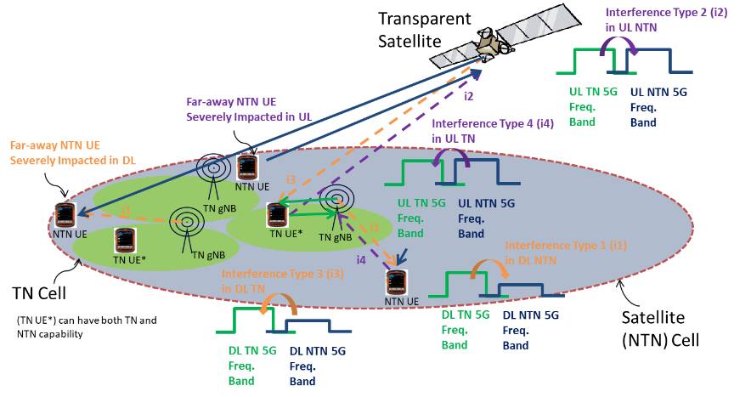

Figure A.1: S-band NTN-TN adjacent band coexistence scenarios with TN in FDD mode

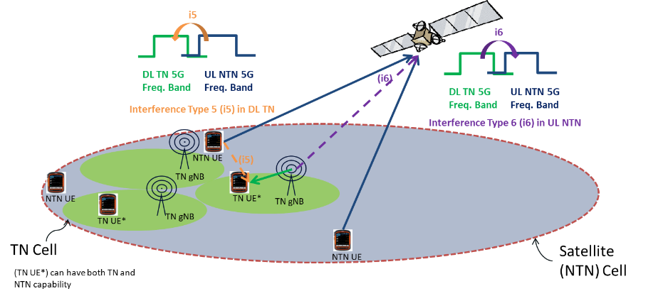

Figure A.2: S-band NTN-TN adjacent band coexistence scenarios with TN in TDD mode (e.g. n34)

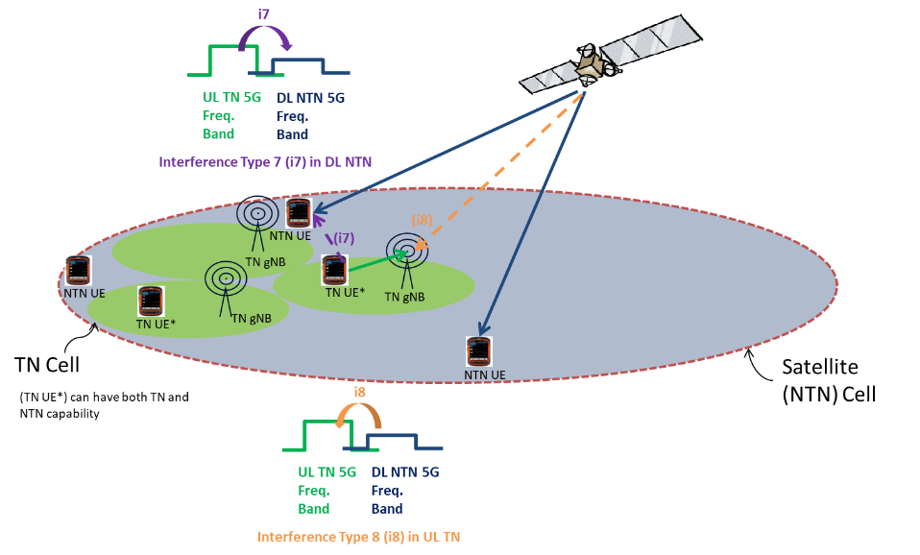

**Figure A.3: S-band NTN-TN adjacent band coexistence scenarios with TN in TDD mode (e.g. n41)**

# Annex 2. Consideration of Network and UE depolyment

**[Options with Bold fonts and marked in green are those Agreed in 1st round and GTW session on Aug. 25.**

Options marked in yellow with square brackets are those concluded based on 2nd round discussion.]

|  |  |  |  |  |  |  |
| --- | --- | --- | --- | --- | --- | --- |
| **No.** | **Combination** | **Aggressor** | **Victim** | **Which NTN cell/UE to observe?** | **Which TN/UE to observe?** | **Which TN cells in a TN to observe?** |
| 1 | TN with NTN | TN DL | NTN DL | **NTN cell:**  **Observe NTN central beam for SINR, 6 adjacent beams for inter-beam interference.**  **NTN UE:**  **NTN UEs dropped at the edge of TN clusters** | ***[Tentative agreement:***  **One cluster with 19 TN cells (57 sectors) randomly placed in the central NTN beam]** | **All active TN cells which host NTN UEs** |
| 2 | TN with NTN | TN UL | NTN UL | **NTN cell:**  **Observe NTN central beam for SINR, 6 adjacent beams for inter-beam interference.**  **NTN UE:**  ***[Suggestion: To align with #1***  **NTN UEs dropped at the edge of TN clusters]** | **Consider an active rate of 20% for Rural and Urban of TN.** | ***[Suggestion: To align with #1.***  **All active TN cells which host NTN UEs]** |

|  |  |  |  |  |  |  |
| --- | --- | --- | --- | --- | --- | --- |
| 3 | TN with NTN | NTN DL | TN DL | **NTN cell:**  **Nadir point.**  **NTN UE:**  **NTN UEs dropped outside or at the edge of TN clusters** | **TN clusters randomly placed in this NTN beam** | **All in central NTN beam** |
| **NTN cell:**  **NTN cell with satellite at low elevation (45° for GEO and LEO，Interested companies can bring analysis and results for other values)**  **NTN UE:**  **NTN UEs dropped outside or at the edge of TN clusters** | **TN clusters randomly placed in this NTN beam** |

|  |  |  |  |  |  |  |
| --- | --- | --- | --- | --- | --- | --- |
| 4 | TN with NTN | NTN UL | TN UL | **NTN cell:**  **Nadir point.**  **NTN UE:**  ***[Suggestion: To align with #1***  **NTN UEs dropped at the edge of TN clusters]** | **TN randomly placed in this NTN beam** | ***[Tentative agreement:***  **Only the TN cells (sectors) hosting NTN UE(s)]** |

|  |  |  |  |  |  |  |
| --- | --- | --- | --- | --- | --- | --- |
| 5 | TN with NTN | NTN UL | TN DL | **NTN cell:**  **Nadir point**  **NTN UE:**  ***[Suggestion: To align with #1***  **NTN UEs dropped at the edge of TN clusters]** | **TN clusters randomly placed in this NTN beam** | ***[Tentative agreement:***  **All TN cells which host NTN UEs.]** |
| **NTN cell:**  **NTN cell with satellite at low elevation** (**45° for GEO and LEO，Interested companies can bring analysis and results for other values**).  **NTN UE:**  ***[Suggestion: To align with #1***  **NTN UEs dropped at the edge of TN clusters]** | ***[Suggestion: To align with above.***  **TN clusters randomly placed in this NTN beam**] | ***[Tentative agreement:***  **All TN cells which host NTN UEs]** |

|  |  |  |  |  |  |  |
| --- | --- | --- | --- | --- | --- | --- |
| 6 | TN with NTN | TN DL | NTN UL | **NTN cell:**  **Observe NTN central beam for SINR, 6 adjacent beams for inter-beam interference.**  **NTN UE:**  **NTN UEs dropped outside or at the edge of TN clusters** | **Consider the active rate of 20% for Rural and Urban of TN.** | ***[Tentative agreement:***  **All active TN cells in central NTN beam]** |

|  |  |  |  |  |  |  |  |  |  |
| --- | --- | --- | --- | --- | --- | --- | --- | --- | --- |
| 7 | TN with NTN | TN UL | NTN DL |  |  |  |  |  |  |
| ***Summary:***  ***Given the tentative agreement of Issue 1-4, do not consider this scenario at this stage*** | | | | | | | | | |

|  |  |  |  |  |  |  |  |  |  |
| --- | --- | --- | --- | --- | --- | --- | --- | --- | --- |
| 8 | TN with NTN | NTN DL | TN UL |  |  |  |  |  |  |
| ***Summary:***  ***Given the tentative agreement of Issue 1-4, do not consider this scenario at this stage*** | | | | | | | | | |

|  |  |  |  |  |  |  |  |  |  |
| --- | --- | --- | --- | --- | --- | --- | --- | --- | --- |
| 9 | NTN with NTN | NTN DL | NTN DL | TBD |  | TBD |  | NA |  |
| NTN UL | NTN UL | TBD |  | TBD |  | NA |  |