3GPP TSG-RAN WG4 Meeting #100-e R4-2115627
Electronic Meeting, August 16 - 27, 2021

Source: CATT
Title: Link level simulation results for 1024QAM for NR FR1
Agenda item: 9.6.2.1
Document for: Approval

Introduction
In RAN4 #99-e, a WF [1] on Link level simulation assumptions was approved. In this contribution, we provide link simulation for 1024QAM for NR FR1.

Discussion
Summary of link simulation assumptions in WF [1] are listed in Table A.1-1 in Annex.

Simulation results for Rank 1
The rank 1 throughput simulation results for txEVM 2%, 2.5% and 3% in TDL-A are shown in Figure 2-1, Figure 2-2, and Figure 2-3 respectively. And the rank 1 throughput simulation results for txEVM 2%, 2.5% and 3% in TDL-D are shown in Figure 2-4, Figure 2-5, and Figure 2-6 respectively.

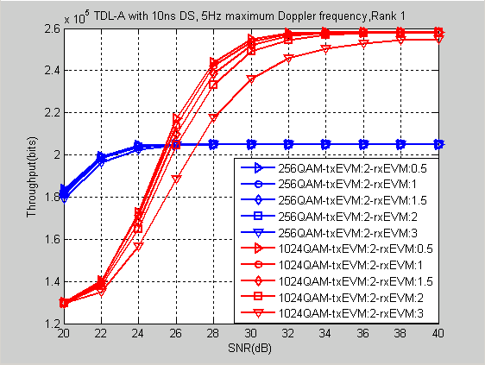  Figure 2-1 Throughput simulation result for rank 1 for txEVM 2% in TDL-A | 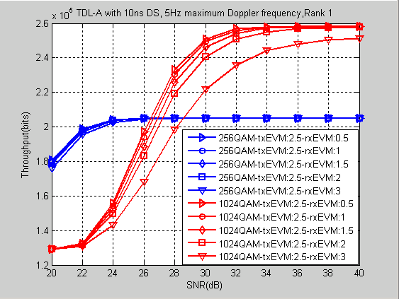  Figure 2-2 Throughput simulation result for rank 1 for txEVM 2.5% in TDL-A
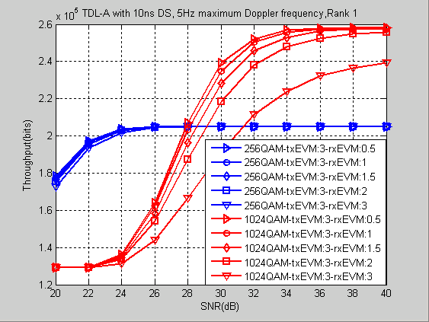
Figure 2-3 Throughput simulation result for rank 1 for txEVM 3% in TDL-A
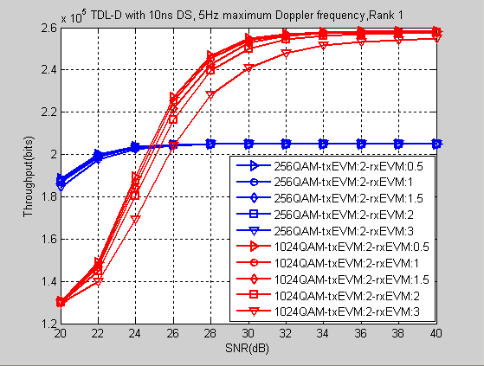  Figure 2-4 Throughput simulation result for rank 1 for txEVM 2% in TDL-D | 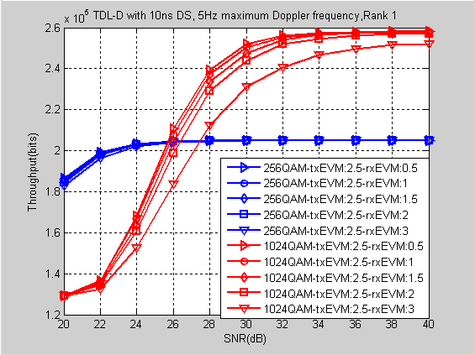  Figure 2-5 Throughput simulation result for rank 1 for txEVM 2.5% in TDL-D
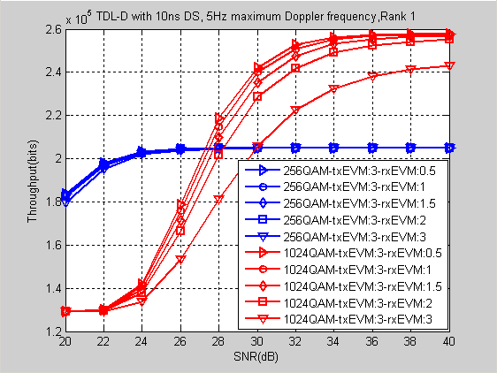
Figure 2-6 Throughput simulation result for rank 1 for txEVM 3% in TDL-D

We summarize the crossover SNR between 256QAM and 1024QAM for rank 1 as shown in Table 2.1-1. From the Table 2.1-1, it is observed that
  - The crossover SNR with 3%/3% TX/RX EVM in TDL-A is ~31.35dB.
  - The crossover SNR with 2.5%/3% TX/RX EVM in TDL-A is ~28.54dB.
  - As TX/RX EVM decreases, crossover SNR also decreases
  - For the same TX/RX EVM, the crossover SNR in TDL-D is lower than that in TDL-A.
Observation 1: The crossover SNR for rank 1 with 3% TX EVM and 2.5 TX EVM in TDL-A is 31.35dB and 28.54dB respectively.

Table 2.1-1 Summary of crossover SNR between 256QAM and 1024QAM in TDL-A and TDL-D, Rank 1
Channel | txEVM rxEVM | 0.5% | 1% | 1.5% | 2% | 3%
TDL-A, 1T4R | 2% | 25.45 | 25.57 | 25.76 | 26.02 | 27.12
TDL-A, 1T4R | 2.5% | 26.43 | 26.6 | 26.88 | 27.2 | 28.54
TDL-A, 1T4R | 3% | 27.91 | 28.11 | 28.53 | 29.14 | 31.35
TDL-D, 1T4R | 2% | 24.78 | 24，89 | 25.05 | 25.32 | 26.01
TDL-D, 1T4R | 2.5% | 25.71 | 25.84 | 26.03 | 26.39 | 27.46
TDL-D, 1T4R | 3% | 27.3 | 27.49 | 27.74 | 28.23 | 29.93

The throughput gain of 1024QAM compared to 256QAM for rank 1 is shown in Table 2.1-2. From table 2.1-2, the following is observed,
  - The throughput gain of 1024QAM compared to 256QAM with 3%/3% TX/RX EVM in TDL-A is increased by ~16.8%.
  - The throughput gain of 1024QAM compared to 256QAM with 2.5%/3% TX/RX EVM in TDL-A is increased by ~22.6%.
  - As TX/RX EVM decreases, throughput gain of 1024QAM compared to 256QAM increases.
  - For the same TX/RX EVM, the throughput gain of 1024QAM compared to 256QAM in TDL-D is larger than that in TDL-A.
Observation 2: The throughput gain of 1024QAM compared to 256QAM for rank 1 with 3% TX EVM and 2.5% TX EVM in TDL-A is 16.8% and 22.6% respectively.

Table 2.1-2 Summary of throughput gain of 1024QAM compared to 256QAM (percentage@40dB)
in TDL-A and TDL-D, Rank1
Channel | txEVM rxEVM | 0.5% | 1% | 1.5% | 2% | 3%
TDL-A, 1T4R | 2% | 25.9% | 25.9% | 25.9% | 25.9% | 24.3%
TDL-A, 1T4R | 2.5% | 25.7% | 25.7% | 25.7% | 25.7% | 22.6%
TDL-A, 1T4R | 3% | 25.7% | 25.7% | 25.7% | 24.7% | 16.8%
TDL-D, 1T4R | 2% | 25.9% | 25.9% | 25.9% | 25.9% | 24.3%
TDL-D, 1T4R | 2.5% | 25.9% | 25.9% | 25.9% | 25.4% | 23.0%
TDL-D, 1T4R | 3% | 25.9% | 25.9% | 25.4% | 24.5% | 18.5%

From simulation results analysis, the 2.5% TX EVM compared to 3% TX EVM can achieve 3dB SNR gain and 6% throughput gain, so we propose BS TX EVM requirement for 1024QAM is 2.5%.
Observation 3: The 2.5% TX EVM compared to 3% TX EVM can achieve 3dB SNR gain and 6% throughput gain.
Proposal 1: To define BS TX EVM requirement for 1024QAM as 2.5~3%.

Simulation results for Rank 2
The rank 2 throughput simulation results for txEVM 2%, 2.5% and 3% in TDL-A are shown in Figure 2-7, Figure 2-8, and Figure 2-9 respectively. And the rank 2 throughput simulation results for txEVM 2%, 2.5% and 3% in TDL-D are shown in Figure 2-10, Figure 2-11, and Figure 2-12 respectively.

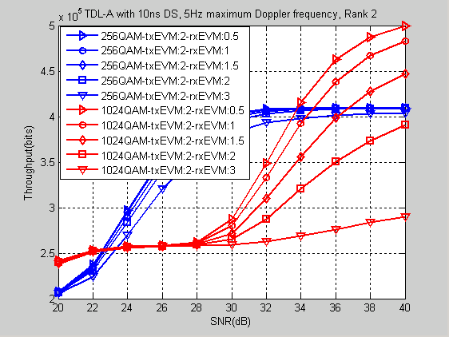  Figure 2-7 Throughput simulation result for rank 2 for txEVM 2% in TDL-A | 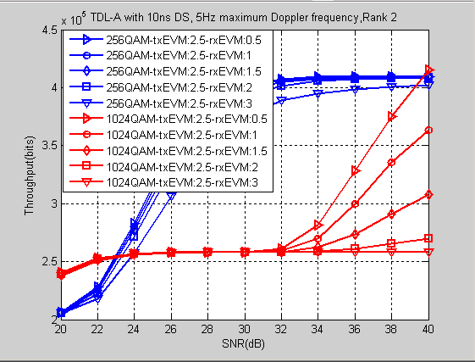  Figure 2-8 Throughput simulation result for rank 2 for txEVM 2.5% in TDL-A
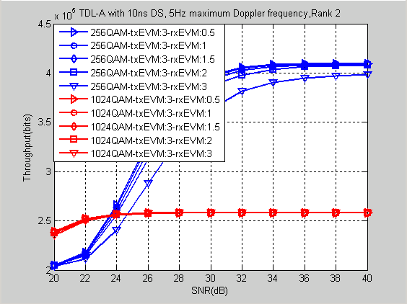
Figure 2-9 Throughput simulation result for rank 2 for txEVM 3% in TDL-A
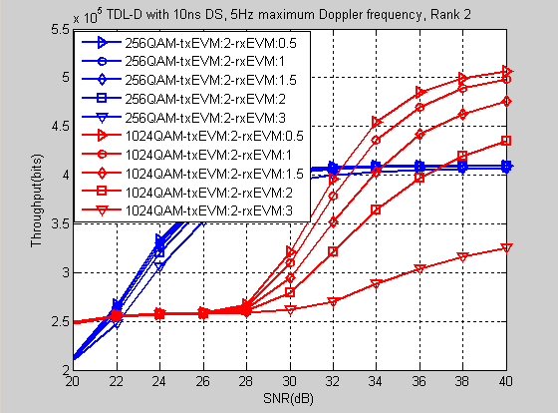  Figure 2-10 Throughput simulation result for rank 2 for txEVM 2% in TDL-D | 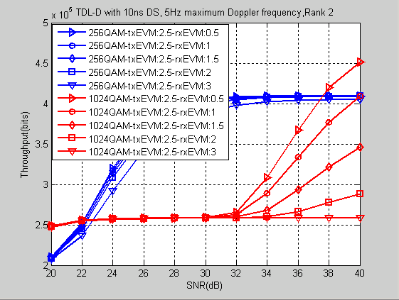  Figure 2-11 Throughput simulation result for rank 2 for txEVM 2.5% in TDL-D
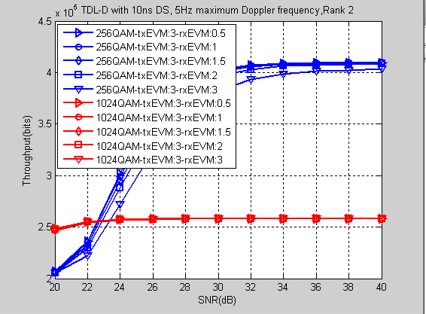
Figure 2-12 Throughput simulation result for rank 2 for txEVM 3% in TDL-D

We summarize the crossover SNR between 256QAM and 1024QAM for rank 2 as shown in Table 2.1-4. From the Table 2.1-4, it is observed that
  - There is no crossover SNR with 3%/3% TX/RX EVM in TDL-A when SNR is less than 40dB.
  - There is no crossover SNR with 2.5%/3% TX/RX EVM in TDL-A when SNR is less than 40dB.
  - The crossover SNR with 2%/1% TX/RX EVM in TDL-A when SNR is ~34.75dB.
  - As TX/RX EVM decreases, crossover SNR also decreases
  - For the same TX/RX EVM, the crossover SNR in TDL-D is lower than that in TDL-A.

Table 2.1-3 Summary of crossover SNR between 256QAM and 1024QAM in TDL-A and TDL-D, Rank 2
Channel | txEVM rxEVM | 0.5% | 1% | 1.5% | 2% | 3%
TDL-A, 1T4R | 2% | 33.83 | 34.75 | 36.72 | N/A | N/A
TDL-A, 1T4R | 2.5% | 39.72 | N/A | N/A | N/A | N/A
TDL-A, 1T4R | 3% | N/A | N/A | N/A | N/A | N/A
TDL-D, 1T4R | 2% | 32.44 | 33.04 | 34.27 | 37.06 | N/A
TDL-D, 1T4R | 2.5% | 37.63 | 40 | N/A | N/A | N/A
TDL-D, 1T4R | 3% | N/A | N/A | N/A | N/A | N/A
Note: N/A means that there is not crossover SNR when SNR is less than 40dB.

The throughput gain of 1024QAM compared to 256QAM for rank 2 is shown in Table 2.1-4 From table 2.1-4, the following is observed,
  - There is no throughput gain of 1024QAM compared to 256QAM with 3%/3% TX/RX EVM in TDL-A.
  - There is throughput gain of 1024QAM compared to 256QAM with 2.5%/3% TX/RX EVM in TDL-A.
  - The throughput gain of 1024QAM compared to 256QAM with 2 %/1% TX/RX EVM in TDL-A is ~18.1%.
  - As TX/RX EVM decreases, throughput gain of 1024QAM compared to 256QAM increases.
  - For the same TX/RX EVM, the throughput gain of 1024QAM compared to 256QAM in TDL-D is larger than that in TDL-A.

Table 2.1-4 Summary of throughput gain of 1024QAM compared to 256QAM (percentage@40dB)
in TDL-A and TDL-D, Rank 2
Channel | txEVM rxEVM | 0.5% | 1% | 1.5% | 2% | 3%
TDL-A, 1T4R | 2% | 22.1% | 18.1% | 9.3% | N/A | N/A
TDL-A, 1T4R | 2.5% | 1.6% | N/A | N/A | N/A | N/A
TDL-A, 1T4R | 3% | N/A | N/A | N/A | N/A | N/A
TDL-D, 1T4R | 2% | 23.9% | 21.8% | 16.3% | 6.3% | N/A
TDL-D, 1T4R | 2.5% | 10.3% | 0% | N/A | N/A | N/A
TDL-D, 1T4R | 3% | N/A | N/A | N/A | N/A | N/A
Note: N/A means that there is not throughput gain when SNR is less than 40dB.
Observation 4: For rank 2, there is no obvious throughput gain of 1024QAM compared to 256QAM with 3% TX EVM and 2.5% TX EVM in TDL-A.

Conclusions
This contribution provides link level simulation results for NR FR1 1024QAM. The following observations and proposals are concluded.
Observation 1: The crossover SNR for rank 1 with 3% TX EVM and 2.5 TX EVM in TDL-A is 31.35dB and 28.54dB respectively.
Observation 2: The throughput gain of 1024QAM compared to 256QAM for rank 1 with 3% TX EVM and 2.5% TX EVM in TDL-A is 16.8% and 22.6% respectively.
Observation 3: The 2.5% TX EVM compared to 3% TX EVM can achieve 3dB SNR gain and 6% throughput gain.
Observation 4: For rank 2, there is no obvious throughput gain of 1024QAM compared to 256QAM with 3% TX EVM and 2.5% TX EVM in TDL-A.
Proposal 1: To define BS TX EVM requirement for 1024QAM as 2.5~3%.

References
- R4-2108077，WF on Link level simulation assumptions，CATT, RAN4#99-e

Annex
Table A.1-1 Summary of link simulation assumptions
Parameter | Value
Carrier frequency | 2 GHz
CBW | 40MHz
SCS | 15kHz
Allocated RBs | Full allocation
Propagation | TDL-A 10ns delay spread, Maximum Doppler frequency: 5Hz (used as Baseline)  TDL-D 10ns delay spread, Maximum Doppler frequency: 5Hz
MCS | 256QAM: MCS 24 in TS 38.214 Table 5.1.3.1-2: MCS index table 2 for PDSCH, and other MCSs are not precluded  1024QAM: MCS 24 in the following Table according to the agreement in RAN1 #104, and other MCSs are not precluded
Precoding | Precoding configuration defined in 38.101-4 Section 7.2 for fading channels; follow PMI
Symbol type | CP-OFDM
Number of HARQ transmission | 8 HARQ processes, maximum 4 transmissions
RV sequence | {0,2,3,1}
RANK | One and Two
BS antenna configuration | Take 1 and 2 Tx antenna as baseline. Companies also welcome to bring 8TX results if they demonstrate differing trends
UE antenna configuration | 4
Antenna correlation (Tx and Rx) | Low correlation
Channel estimation | Practical
Receiver type | MMSE-IRC
PDSCH configuration | Type A mapping, Start symbol 1, Duration 13 (for D slots)
DMRS configuration | DMRS type : Type 1, Single symbol, additional DM-RS (dmrsAdditionalPosition): pos1
txEVM | 2%, 2.5%, 3%
rxEVM | 0.5%, 1%, 1.5%, 2%, 3%.

