**3GPP TSG-RAN4 Meeting #101-eR4-2119881**

**Electronic Meeting, 1– 12 November, 2021**

|  |  |  |  |  |  |  |  |  |
| --- | --- | --- | --- | --- | --- | --- | --- | --- |
| *CR-Form-v12.1* | | | | | | | | |
| **CHANGE REQUEST** | | | | | | | | |
|  | | | | | | | | |
|  | **37.880** | **CR** | **0002** | **rev** | **1** | **Current version:** | **17.1.0** |  |
|  | | | | | | | | |
| *For* [***HE******LP***](http://www.3gpp.org/3G_Specs/CRs.htm#_blank)*on using this form: comprehensive instructions can be found at* [*http://www.3gpp.org/Change-Requests*](http://www.3gpp.org/Change-Requests)*.* | | | | | | | | |
|  | | | | | | | | |

|  |  |  |  |  |  |  |  |  |
| --- | --- | --- | --- | --- | --- | --- | --- | --- |
| ***Proposed change affects:*** | UICC apps |  | ME | **x** | Radio Access Network |  | Core Network |  |

|  |  |  |  |  |  |  |  |  |  |  |
| --- | --- | --- | --- | --- | --- | --- | --- | --- | --- | --- |
|  | | | | | | | | | | |
| ***Title:*** | CR for 37.880: ACS of PSNB handset receivers | | | | | | | | | |
|  |  | | | | | | | | | |
| ***Source to WG:*** | Huawei, HiSilicon | | | | | | | | | |
| ***Source to TSG:*** | R-4 | | | | | | | | | |
|  |  | | | | | | | | | |
| ***Work item code:*** | LTE_NR_HPUE_FWVM-Core | | | | |  | ***Date:*** | | | 2021-10-19 |
|  |  | | | |  | |  | | |  |
| ***Category:*** | **F** |  | | | | | ***Release:*** | | | Rel-17 |
|  | *Use one of the following categories:* ***F*** *(correction)* ***A*** *(mirror corresponding to a change in an earlier release)* ***B*** *(addition of feature),* ***C*** *(functional modification of feature)* ***D*** *(editorial modification)*  Detailed explanations of the above categories can be found in 3GPP [TR 21.900](http://www.3gpp.org/ftp/Specs/html-info/21900.htm). | | | | | | | | *Use one of the following releases: Rel-8 (Release 8) Rel-9 (Release 9) Rel-10 (Release 10) Rel-11 (Release 11) … Rel-15 (Release 15) Rel-16 (Release 16) Rel-17 (Release 17) Rel-18 (Release 18)* | |
|  |  | | | | | | | | | |
| ***Reason for change:*** | | ACS for PSNB handsets are needed as per the WID. | | | | | | | | |
|  | |  | | | | | | | | |
| ***Summary of change:*** | | Adds data for PSNB handsets based on the market available PSNB handsets | | | | | | | | |
|  | |  | | | | | | | | |
| ***Consequences if not approved:*** | | ACS value of the PSNB handsets will be missing from the TR. | | | | | | | | |
|  | |  | | | | | | | | |
| ***Clauses affected:*** | |  | | | | | | | | |
|  | |  | | | | | | | | |
|  | | **Y** | **N** |  | | | |  | | |
| ***Other specs*** | |  | **x** | Other core specifications | | | | TS/TR ... CR ... | | |
| ***affected:*** | |  | **x** | Test specifications | | | | TS/TR ... CR ... | | |
| ***(show related CRs)*** | |  | **x** | O&M Specifications | | | | TS/TR ... CR ... | | |
|  | |  | | | | | | | | |
| ***Other comments:*** | |  | | | | | | | | |
|  | |  | | | | | | | | |
| ***This CR's revision history:*** | |  | | | | | | | | |

<First Changed Section>

## 3.3 Abbreviations

For the purposes of the present document, the abbreviations given in 3GPP TR 21.905 [1] and the following apply. An abbreviation defined in the present document takes precedence over the definition of the same abbreviation, if any, in 3GPP TR 21.905 [1].

3GPP 3rd Generation Partnership Project

ACLR Adjacent Channel Leakage Ratio

A-MPR Additional Maximum Power Reduction

ACS Adjacent Channel Selectivity

BB Base Band

BS Base Station

BW Bandwidth

CL Coupling Loss

DL Downlink

FWA Fixed Wireless Access

HPUE High Power User Equipment

IF Intermediate Frequency

ITU International Telecommunication Union

LTE Long Term Evolution

MOP Maximum Output Power

MPR Allowed Maximum Power Reduction

MTC Machine-Type Communications

NB-IoT Narrowband – Internet of Things

NB Narrowband

NR New Radio

OOBE Out Of Band Emissions

PA Power Amplifier

PC Power Class

PRB Physical Resource Block

PSNB Public Safety Narrowband

RAN4 Radio Access Network Working Group 4

REFSENS Reference Sensitivity

RF Radio Frequency

Rx Receiver

SW Software

TR Technical Report

Tx Transmitter

UE User Equipment

<Next Changed Section>

5.3 Coexistence with Public Safety

Satisfactory coexistence between two communication systems in the same geographical area normally depends on two main criteria:

1) The interfering transmitter out of band emission (OOBE) received by the affected receiver is sufficiently below this affected receiver noise floor.

2) The total interfering carrier power attenuated by the affected receiver radio frequency (RF), intermediate frequency (IF), and base band (BB) filters is sufficiently below the affected receiver noise floor.

System simulation is required for coexistence studies on the interference cases involving UE. This is because the UE positions are not fixed, and they are not expected to transmit with full power most of the time due to power control. Hence using deterministic analysis could result in findings that are too conservative, which in turn lead to unnecessary tight coexistence requirements. System simulation need to be performed based on agreed methodology and parameters, so that results from different companies can be compared directly to draw the conclusions from the studies.

The public safety narrowband (PSNB) system parameters used for Band 26 and PSNB coexistence studies in TR 37.806 [14] are shown in table 5.3-1, and some simulation results can be found in clause 7.2 of TR 37.806. These parameters can be considered together with the assumptions provided in clause 5.1 of this TR for the system simulation between HPUE and public safety operation.

**Table 5.3-1: PSNB system parameters**

|  |  |  |
| --- | --- | --- |
|  | **Base Station** | **Portable** |
| **Carrier frequency** | 850 MHz | |
| **Channel bandwidth** | 6.25 kHz | |
| **Cell radius** | 12 km | |
| **Antenna height** | 100 m from ground | 1.5m |
| **Lognormal fading** | 10 dB | |
| **Antenna gain and antenna pattern** | 11 dBi omni-directional | Antenna gain + body loss =-6 dBi |
| **Noise figure** | 5.7 dB | 9.75 dB |
| **Transmit power** | 45 dBm (after combiner loss) | 36 dBm |
| **SNR Threshold** | 16.5 dB | 16.5 dB |
| **Effective Noise Bandwidth (ENBW)** | 6.25 kHz | 6.25 kHz |
| **Noise Floor** | -130.3dBm / 6.25 kHz | -126.3dBm / 6.25 kHz |
| **Sensitivity** | -113.8dBm / 6.25 kHz | -109.8dBm / 6.25 kHz |
| **ACS** |  | 72 dB |

Based on datasheet of “APX™ 8000 ALL-BAND P25 PORTABLE RADIO” the ACS of PSNB handset can be considered as 72dB

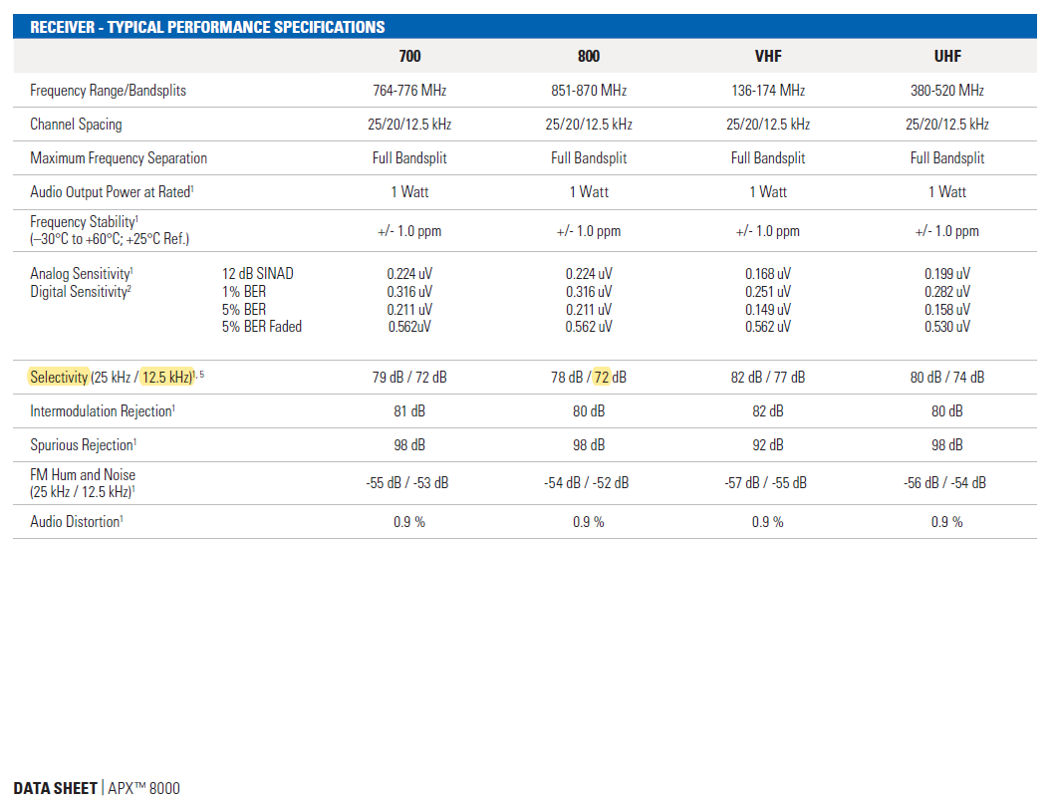

Note that the target OOBE from a Band 5 HPUE to the public safety downlink and uplink frequency ranges (for criterion 1), as well as the achievable attenuation on the Band 5 HPUE carrier power at the public safety downlink and uplink receiver filters (for criterion 2), need to be agreed on to evaluate the impact from a Band 5 HPUE on the public safety downlink in 851-861 MHz and the public safety uplink in 806-816 MHz. The simulation methodology and parameters for the system simulation should be further discussed and agreed during the work item (WI) phase.

<End of changes>