**3GPP TSG- RAN WG#4 Meeting #100-e *R4-2115076***

**Electronic Meeting, 16-27 August 2021 Revision of R4-2114236**

|  |  |  |  |  |  |  |  |  |
| --- | --- | --- | --- | --- | --- | --- | --- | --- |
| *CR-Form-v11.4* | | | | | | | | |
| **CHANGE REQUEST** | | | | | | | | |
|  | | | | | | | | |
|  | **37.880** | **CR** | **0001** | **rev** | 1 | **Current version:** | **17.0.0** |  |
|  | | | | | | | | |
| *For* [***HE******LP***](http://www.3gpp.org/3G_Specs/CRs.htm#_blank)*on using this form: comprehensive instructions can be found at* [*http://www.3gpp.org/Change-Requests*](http://www.3gpp.org/Change-Requests)*.* | | | | | | | | |
|  | | | | | | | | |

|  |  |  |  |  |  |  |  |  |
| --- | --- | --- | --- | --- | --- | --- | --- | --- |
| ***Proposed change affects:*** | UICC apps |  | ME | **X** | Radio Access Network |  | Core Network |  |

|  |  |  |  |  |  |  |  |  |  |  |
| --- | --- | --- | --- | --- | --- | --- | --- | --- | --- | --- |
|  | | | | | | | | | | |
| ***Title:*** | Cr for 37.880: n71 filter data | | | | | | | | | |
|  |  | | | | | | | | | |
| ***Source to WG:*** | T-Mobile USA | | | | | | | | | |
| ***Source to TSG:*** | R-4 | | | | | | | | | |
|  |  | | | | | | | | | |
| ***Work item code:*** | LTE_NR_HPUE_FWVM-Core | | | | |  | ***Date:*** | | | 2021-08-06 |
|  |  | | | |  | |  | | |  |
| ***Category:*** | **B** |  | | | | | ***Release:*** | | | Rel-17 |
|  | *Use one of the following categories:* ***F*** *(correction)* ***A*** *(mirror corresponding to a change in an earlier release)* ***B*** *(addition of feature),* ***C*** *(functional modification of feature)* ***D*** *(editorial modification)*  Detailed explanations of the above categories can be found in 3GPP [TR 21.900](http://www.3gpp.org/ftp/Specs/html-info/21900.htm). | | | | | | | | *Use one of the following releases: Rel-8 (Release 8) Rel-9 (Release 9) Rel-10 (Release 10) Rel-11 (Release 11) Rel-12 (Release 12)* *Rel-13 (Release 13) Rel-14 (Release 14) Rel-15 (Release 15) Rel-16 (Release 16)* | |
|  |  | | | | | | | | | |
| ***Reason for change:*** | | Filter data for n71 needed as per the WID. | | | | | | | | |
|  | |  | | | | | | | | |
| ***Summary of change:*** | | Adds data for n71 filters, as well as updated and additional specs for other filters. Also added the definition of FWA and additional filter data for B5 and B12. | | | | | | | | |
|  | |  | | | | | | | | |
| ***Consequences if not approved:*** | | n71 filter data, definition of FWA and low power filter data for B5 and B12 will be missing from the TR. | | | | | | | | |
|  | |  | | | | | | | | |
| ***Clauses affected:*** | | 3.3, 7.1 | | | | | | | | |
|  | |  | | | | | | | | |
|  | | **Y** | **N** |  | | | |  | | |
| ***Other specs*** | |  | **X** | Other core specifications | | | | TS/TR ... CR ... | | |
| ***affected:*** | |  | **X** | Test specifications | | | | TS/TR ... CR ... | | |
| ***(show related CRs)*** | |  | **X** | O&M Specifications | | | | TS/TR ... CR ... | | |
|  | |  | | | | | | | | |
| ***Other comments:*** | | Rev1 inserts images of the data from the filter data sheets. Also added comments on the filter size and the one filter was only n85 UL. | | | | | | | | |

<First Changed Section>

## 3.3 Abbreviations

For the purposes of the present document, the abbreviations given in 3GPP TR 21.905 [1] and the following apply. An abbreviation defined in the present document takes precedence over the definition of the same abbreviation, if any, in 3GPP TR 21.905 [1].

3GPP 3rd Generation Partnership Project

ACLR Adjacent Channel Leakage Ratio

A-MPR Additional Maximum Power Reduction

BB Base Band

BS Base Station

BW Bandwidth

CL Coupling Loss

DL Downlink

FWA Fixed Wireless Access

HPUE High Power User Equipment

IF Intermediate Frequency

ITU International Telecommunication Union

LTE Long Term Evolution

MOP Maximum Output Power

MPR Allowed Maximum Power Reduction

MTC Machine-Type Communications

NB-IoT Narrowband – Internet of Things

NB Narrowband

NR New Radio

OOBE Out Of Band Emissions

PA Power Amplifier

PC Power Class

PRB Physical Resource Block

PSNB Public Safety Narrowband

RAN4 Radio Access Network Working Group 4

REFSENS Reference Sensitivity

RF Radio Frequency

Rx Receiver

SW Software

TR Technical Report

Tx Transmitter

UE User Equipment

<Next Changed Section>

# 7 UE hardware

Editor note: This clause the third objective of the study item.

## 7.1 New RF components

During Rel-11 when band 14 PC1 requirements were developed Technical report Public safety broadband high power User Equipment (UE) for band 14 [3] and a contribution [11] discussed necessary hardware changes to realize PC1 vehicular mobile form factor compared to PC3 normal handheld formfactor. These studies in [3][11] are considered to be relevant also to this WI targeting high-power UE operation for fixed-wireless/vehicle-mounted use cases in LTE bands 5 and 12 and NR band n71.

Main take away from [3][11] is that in order to minimize implementation complexity and utilize the Power Class 3 eco-system it was considered that changes to the baseband IC and RF IC should be avoided and only changes to the discrete RF combining front end elements are considered. This manifests mainly to need of frontend filters with better power handling capabilities. Suitable technologies mentioned were ceramic-filters and cavity-filters. Furthermore power amplifiers that are capable for PC1 operation are obviously necessity. A few filter examples are presented below with input power capabilities of 43 dBm which obviously in more than needed for PC1 operation even considering the post PA-losses but this demonstrates that capable technology is available.

Band 5 duplex-filter [UMD005A (ctscorp.com)](https://www.ctscorp.com/wp-content/uploads/UMD005A.pdf)

Band 5/partial Band 26 duplex-filter [UMD026B (ctscorp.com)](https://www.ctscorp.com/wp-content/uploads/UMD026B.pdf)

Band 12 duplex-filter [UMD012A (ctscorp.com)](https://www.ctscorp.com/wp-content/uploads/UMD012A.pdf)

Band 71/n71 duplex-filter [UMD071A (ctscorp.com)](https://www.ctscorp.com/wp-content/uploads/UMD071A.pdf)

In addition to the above filters with 43 dBm capability, there are also filters with input power capabilities of 38 dBm, that are smaller and may be more appropriate for FWA devices. Nonetheless, the filters are still very large and may only be suitable for large form factor FWA. Not all FWA devices may be able to accommodate these filters.

Band 5 duplex-filter [USD005A (ctscorp.com)](https://www.ctscorp.com/wp-content/uploads/USD005A.pdf)

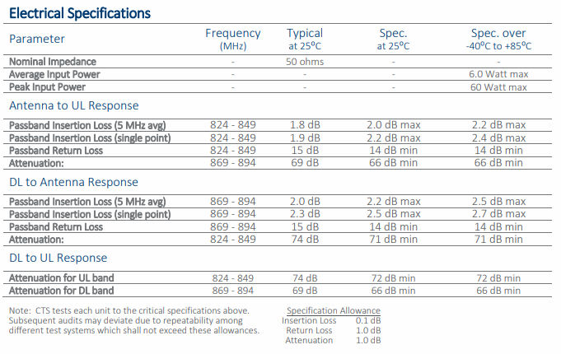

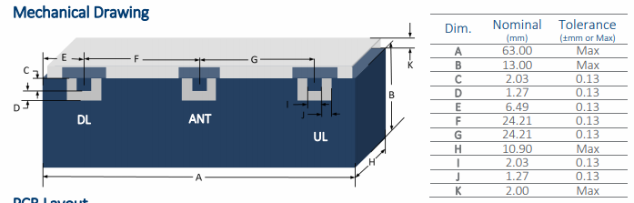

Band 5/full Band 26 duplex-filter [USD026A (ctscorp.com)](https://www.ctscorp.com/wp-content/uploads/USD026A.pdf)

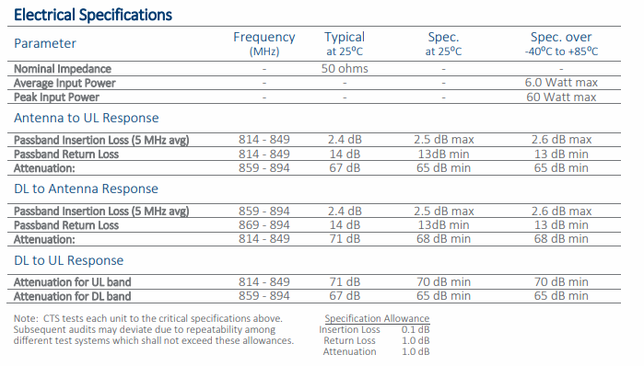

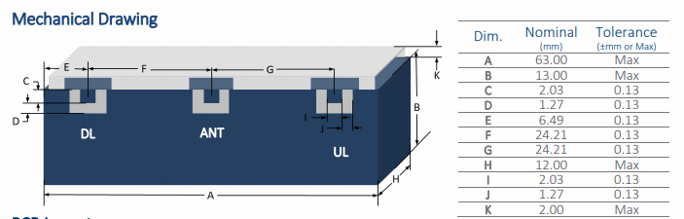

Band 12 duplex-filter [USD012A (ctscorp.com)](https://www.ctscorp.com/wp-content/uploads/USD012A.pdf)

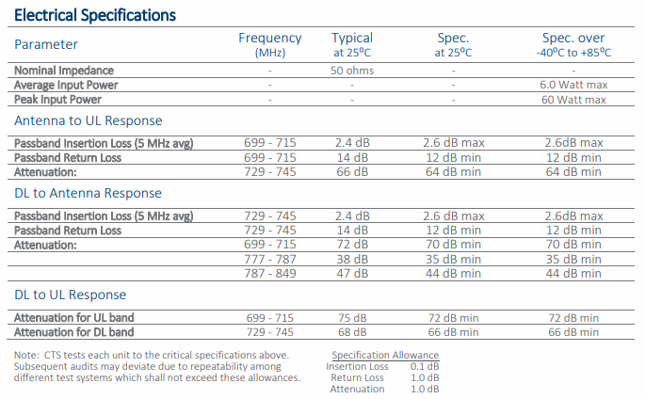

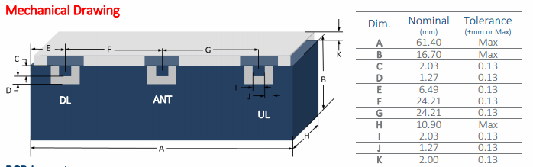

Band 71/n71 and Band 85 UL duplex-filter [USD7185A (ctscorp.com)](https://www.ctscorp.com/wp-content/uploads/USD7185A.pdf)

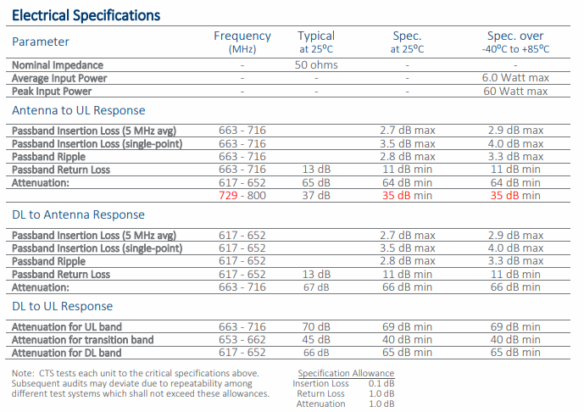

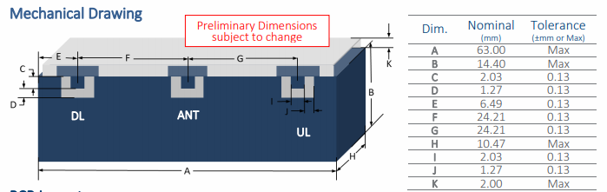

<End of changes>