3GPP TSG-RAN WG4 #100-e R4-211xxxx

August 16th ‒ 27th, 2021

Electronic Meeting

**Agenda item:** 10.4.3

**Source:** Qualcomm Incorporated

**Title:** TP for 38.860: Further B1 filter optimization

**Document for:** Approval

# Introduction

The filter for option B1 has been further optimized since [1] with respect to the Rx attenuation of the blocker in Ch 36. Other filter performance requirements are maintained relative to Band n71 design. Other minor editorial changes are also included in this TP.

# Reference

1. R4-2107348, “Filtering for extended 600 MHz band,” Qualcomm Incorporated

**<<< Start of TP >>>**

6.4.1 Option B1

Editor’s note; The text below is from R4-2108000.

* + - 1. Full band filter

Option B1 is based on spectrum allocation of 663-703 MHz for TX and 612-652 MHz for RXThe first considered approach is to use a full band filter option B1 as illustrated below.

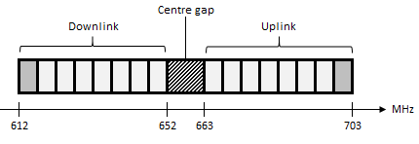

**Figure 6.4.1.1-0‑1. Option B1**

One advantage of option B1 compared to other filtering options is that B1 is conducive to a single full-band filter implementation. The potential advantage of single filter is reduced size and bill-of-materials of the required front-end and reduced complexity for intra-band carrier aggregation across the filters and inter-band carrier aggregation with another band in close frequency proximity when quadplexing is needed are limited. On the other hand, the performance of a dual filter solution in insertion loss and stop band attenuation may be superior to a single filter.

For option B1, extending the 35 MHz filter passband to 40 MHz increases the relative bandwidth from 5.5% to 6.3% at 600 MHz. At the time that Band 28 was defined, such relative bandwidths were not feasible. However, since that time with technological advances in filter design and materials, wider relative bandwidths have now become available. Therefore, from a relative bandwidth perspective option B1 is regarded as feasible. Considering out-of-band rejection, the blocking requirement of Band 71/n71 at 12 MHz offset is considered below when the passband increases to 40 MHz. The filter rejection is checked at 9 MHz offset since the DTV channel is centered at 12 MHz offset so its edge is expected at 9 MHz offset. A reduction in filter rejection due to widening of the passband reduces tolerance to DTV jamming unless the linearity of the Rx path post filtering is improved to compensate. Tx and Rx isolation as well as passband insertion loss are also relevant in comparing the widened filter against the Band 71/n71 filter.

A second level filter simulation implementing design rules and including packaging parasitic effects but without optimization was conducted and provided in [8]. The filter technology used is a conventional, mass produced TC SAW filter technology rather than a more advanced technology and represents typical performance at this point. The focus of the design effort was on the transmit side to ensure that emissions and coexistence requirements could be met, while less effort was placed on the receiver side. The study below specifically evaluates the ability of the wide B1 filter to meet existing Band 71 filter requirements where the existing Band 71 filter requirements are those that are listed on the data sheet from the same filter vendor. Although the Band 71 filter requirements are largely met, there may be a loss in performance compared to a narrower Band 71 filter using the same generation of filter technology and the same constraints.

The Tx and Rx insertion loss is first shown.

|  |  |
| --- | --- |
|  |  |

**Figure 6.4.1.1-2. Tx and Rx insertion losses**

On the transmit side, the insertion loss is approaching 3 dB but still meets the Band 71 filter specification. In comparison to a narrower Band 71 filter using the same generation of filter technology and the same constraints, an increase in Tx insertion loss towards the band edge may be expected. Moreover, the maximum output power for Band n71 provides a lower tolerance of 2.5 dB so the insertion loss of the Tx filter is not expected to be a problem.

On the receiver side, the insertion loss is approaching 2 dB. The steep drop-off of the filter at the upper edge of the band at 652 MHz is likely due to the relatively narrow duplex gap and the need to provide sufficient Tx isolation. In comparison to a narrower Band 71 filter using the same generation of filter technology and the same constraints, an increase in Rx insertion loss may be expected. But since the reference sensitivity requirement for Band 71 is relatively relaxed to accommodate the noise and spurious products from the transmitter, it is not expected that the increase in Rx IL will hinder a device implementing the B1 filter from meeting Band 71 receiver requirements. Moreover, while the duplex gap is relatively narrow for Band 71 at 11 MHz, the Tx-Rx separation is 46 MHz so the Tx isolation at 11 MHz offset may be slightly compromised if band edge Rx insertion loss needs to be improved.

The Tx-Rx filter performance is studied next.

|  |  |
| --- | --- |
|  |  |

**Figure 6.4.1.1-3. Tx and Rx narrowband filter response**

On the transmit side, all requirements in the Band 71 Rx band are met. On the receiver side, all requirements in the Band 71 Tx band are met, although the rejection is marginal at the 663 MHz edge. Slight filter tuning or shifting should improve the Tx rejection at the band edge.

Coexistence with Band 29 is also critical for the Band 71 UE. The [6] specification imposes a requirement of -38 dBm/MHz into the receive band of Band 29, 717 – 728 MHz. The Band 71 filter rejection requirement over this frequency range is met by the wider filter, although the transition band is steep.

The next aspect to consider is the ability of the filter to reject blockers. An in-band blocking requirement, as shown below, has been defined for Band n71 to reject interference from a nearby DTV transmission.

**Table 6.4.1.1: In-band blocking for NR bands with FDL_high < 2700 MHz and FUL_high < 2700 MHz (Table 7.6.2-2 of TS 38.101-1 [6])**

|  |  |  |  |  |  |  |
| --- | --- | --- | --- | --- | --- | --- |
| **NR band** | **Parameter** | **Unit** | **Case 1** | **Case 2** | **Case 3** | **Case 4** |
| Pinterferer | dBm | -56 | -44 | -15 | -38 |
| Finterferer (offset) | MHz | -BWChannel/2 –  FIoffset, case 1  and  BWChannel/2 +  FIoffset, case 1 | ≤ -BWChannel/2 –  FIoffset, case 2  and  ≥ BWChannel/2 +  FIoffset, case 2 |  | -BWChannel/2-11 |
| n71 | Finterferer | MHz | NOTE 2 | FDL_low – 12 to FDL_high + 15 | FDL_low – 12 |  |
| NOTE 1: The absolute value of the interferer offset Finterferer (offset) shall be further adjusted to MHz with SCS the sub-carrier spacing of the wanted signal in MHz. The interferer is an NR signal with 15 kHz SCS.  NOTE 2: For each carrier frequency, the requirement applies for two interferer carrier frequencies: a: -BWChannel/2 – FIoffset, case 1; b: BWChannel/2 + FIoffset, case 1  NOTE 3: n48 follows the requirement in this frequency range according to the general requirement defined in Clause 7.1. | | | | | | |

In the absence of this requirement, the case 3 blocking requirement would not have been present and the case 2 blocking requirement at -44 dBm would have extended to FDL_low – 15. Instead, the case 3 in-band blocker models a Channel 36 DTV transmission centered at approximately 605 MHz, extending from 602 to 608 MHz and received at -15 dBm. With the passband of the Rx filter extended down to 612 MHz, it was initially considered that there is no opportunity to provide meaningful filter rejection to a Ch 36 blocker as shown in Figure 6.4.1.1-3. Updated simulations with further optimization under typical conditions, however, do reveal that rejection of Ch 36 is possible with this design. The attenuation within Ch 36 is above -30dB … at 608 MHz was found to be 31 dB with 2.5 dB at the Rx passband edge of 612 MHz as shown in Figure 6.4.1.1-4. The ability of the filter to rejection Ch 36 is also consistent with a separate finding reported in [10] and shown below in Figure 6.4.1.1-5. A channel 35 blocker at -15 dBm being one channel further away can be rejected. For other filter designs not fully optimized to reject Ch 36, some rejection to Ch 36 can be still achieved at the possible expense of increased Rx IL over the lowermost 5 MHz of the Rx band.

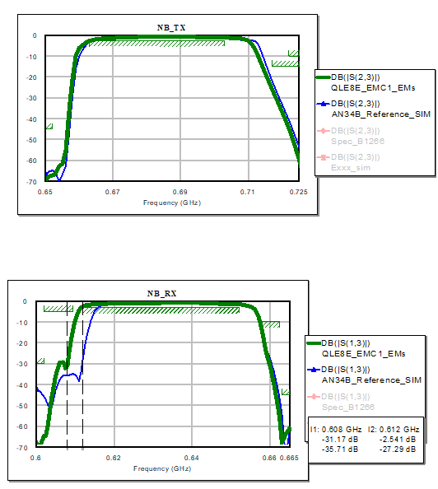

Figure 6.4.1.1-4: Further optimized B1 filter option to include Ch 36 Rx rejection. Green trace is the optimized design.

*The simulation results indicate that the B1 filter is technically feasible* and despite the potential increase in IL is expected to fulfil Band 71 requirements including rejection of the Ch 36 blocker- The results provided are not exhaustive and not yet optimized and only for the typical condition, so it is expected that worst case over process and temperature will be worse. On the other hand, the results are for a design that has not yet been optimized and is based on conventional technology in wide use today and are provided with the intention to investigate the filter option feasibility.

Table 6.4.1.1-5 below lists another set of filter results reported in [9] from three vendors; it is likely that they will improve over time due to optimization:

**Table 6.4.1.1-5: Performance Characteristics of a Single Duplexer for Option B1**

|  |  |  |  |
| --- | --- | --- | --- |
| Vendor | Vendor A | Vendor B | Vendor C |
| Frequency range (TX) | 663-703 MHz | 663-703 MHz | 663-703 MHz |
| TX Insertion loss relative to n71 duplexer (dB) | +0.4 | +0.0 | <3dB absolute |
| Rejection for n29 | >20 | >20 | ~30 |
| Frequency range (RX) | 612-652 MHz | 612-652 MHz | 612-652 MHz |
| RX Insertion loss relative to n71 duplexer (dB) | +0.5 | +0.6dB, expected to come close to n71 duplexer with optimization | <4dB absolute |
| Rejection for Ch 36 band edge | <15dB | <20dB | ~20dB |

Although these initial values are difficult to compare, it can generally be seen that the insertion loss for these filters will increase with the increasing bandwidth, especially at the band edges. For example, the loss of the RX filter at the upper edge can be degraded because the filter curve is shifted to lower frequencies. Generally, the loss in the middle of the passband is relatively constant, while at the band edges the insertion loss is increased compared to the n71 duplexer. With the exception of Vendor C which offers higher stop band rejection and whose insertion loss is reported as absolute, the Tx and Rx insertion loss increase relative to n71 is reported to be on the order of 0.5 dB.

If design optimization and employing more advanced filter technologies can become more prevalent for the extended 600 MHz band, it is expected that the results will improve.

Yet another full band filter evaluation was provided in [10]. During the preliminary analyses it was identified that full band duplexer for option B1 is considered to be implementation feasible, while keeping enough Tx/Rx attenuation, as well as the rejection at Band 29. However, it was identified that the blocking to DTV channel 36 may be worse than that of band n71. Further evaluations were required to verify if the newly designed duplexer for B1 can provide enough rejection as that of band n71 duplexer. Although the study did not specifically evaluate the ability of the wide B1 filter to meet existing Band 71 filter requirements, where the existing Band 71 filter requirements are those that are listed on the data sheet from the same filter vendor, they are reasonably aligned with the studies provided above.

Based on further evaluation results with an optimized design, the full band duplexer for option B1 was recognized as being able to provide equivalent rejection capability as that of commercially available band n71 duplexer for DTV CH36.

With this, option B1 was confirmed to be technically feasible based on simulations for the available requirements.



**Figure 6.1.1-5: Duplexer evaluation for option B1 [10]**

**<<< End of TP >>>**