**3GPP TSG-RAN2 Meeting 119bis-e** **R2-2210931**

**Online, 10th – 19th October, 2022**

**Agenda item: 6.15.2**

**Source: Huawei, HiSilicon**

**Title: Summary of [AT119bis-e][501][V2X/SL] 38.331 corrections (Huawei)**

**Document for: Discussion and Decision**

1. Introduction

This is the summary of below offline discussion.

* [AT119bis-e][501][V2X/SL] 38.331 corrections (Huawei)

**Scope:** Discuss proposed corrections in R2-2210373, R2-2209739, R2-2209740, R2-2210542, R2-2209878, R2-2209772, R2-2209857, R2-22010555, R2-2209463, R2-2209674, and P4 and P5 in R2-2210779 (corresponding CR in R2-2209379). Merge agreeable corrections in a CR as much as possible (we may have separate CR if required, it’s up to rapporteur).

**Intended outcome:** 38.331 CR in R2-2210930 and discussion summary in R2-2210931 (if needed). Email approval.

**Deadline:** 10/17 12:00 (UTC)

Contact list

|  |  |  |  |
| --- | --- | --- | --- |
| Name | | Company | Email |
| Tao Cai | | Huawei, HiSilicon | tao.cai@huawei.com |
| Zhibin Wu | | Apple | zhibin_wu@apple.com |
| Xiao Xiao | vivo | | xiao.xiao@vivo.com |
| Jie Shi | | CATT | Shijie@catt.cn |
| Ansab Ali | | Intel Corporation | ansab.ali@intel.com |
| Qing Li | | Qualcomm | [qinli@qti.qualcomm.com](mailto:qinli@qti.qualcomm.com) |
|  | |  |  |
|  | |  |  |
|  | |  |  |
|  | |  |  |

1. Discussion

## 2.1 For changes in R2-2210373

### 2.1.1 First change in clause 5.8.8:

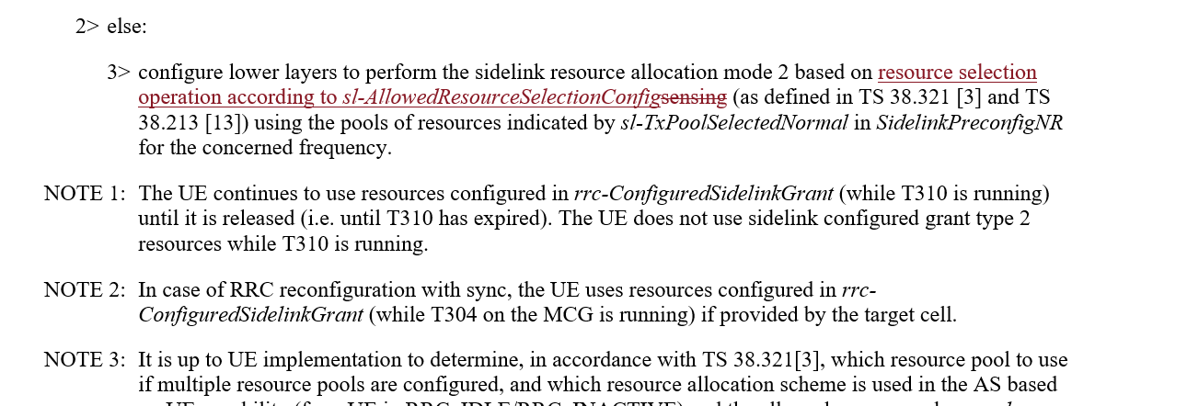

This change should be discussed together with change proposed in R2-2209772:

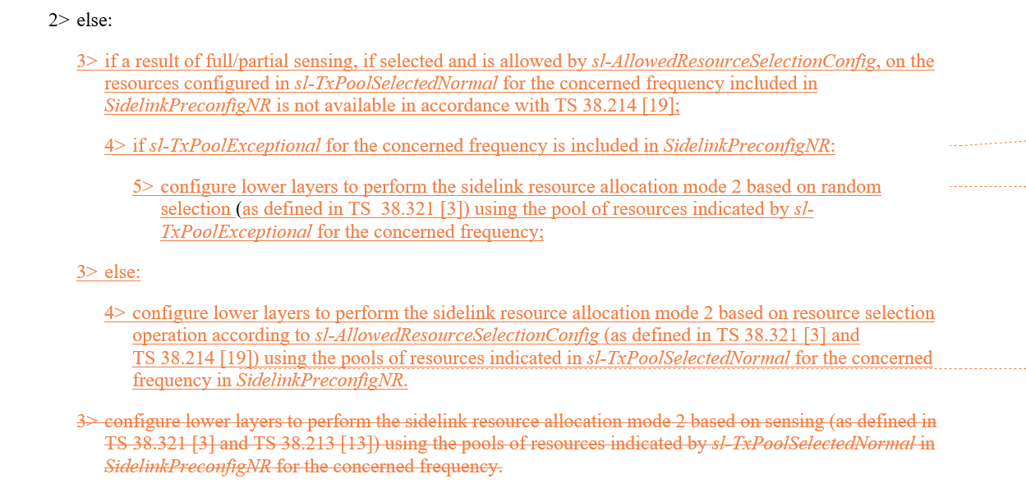

Rapporteur thinks the agreed changes will be applied also for clause 5.8.13.3 "NR sidelink discovery transmission", the other editorial changes proposed in R2-2209772 will be adopted.

**Q1: Would you company agree the UE actions shall be separately specified for the cases where the sensing results available or not available for OOC scenario?**

|  |  |  |
| --- | --- | --- |
| Company | Agree/Disagree | Further comments |
| Huawei, HiSilicon | Agree |  |
| Apple | Agree | Yes, since the RRC spec indicates that there is an exceptional pool in pre-configuration. The same UE behaviour can be adopted for OOC UE. |
| OPPO | Disagree | We checked the R14 agreement, where it clarified e-pool is only used for In-coverage scenario, so tend to stick to that. |
| Xiaomi | Comment | We understand current UE behaviour is inherited from legacy. If this change is agreed, we wonder whether this change should also apply to R16 and earlier spec? |
| vivo | Disagree | We also understand that the usage of NR SL exceptional pool is inherited from LTE V2X, and is mainly used for the RRC IDLE/INACTIVE/CONNECTED UE with exceptional cases during handover, RLF, during RLF, during transition from RRC IDLE/INACTIVE to RRC CONNECTED or during change of dedicated V2X sidelink resource pools within a cell, and during cell reselection. Therefore, these changes are not preferred as it will have impact on legacy UE behaviour to extend the exceptional case to OOC case. |
| CATT | Agree |  |
| Ericsson | disagree | Share the concern as OPPO and xiaomi, we also tend to stick to the legacy |
| Intel | Disagree | We also share the concern with other companies on changing legacy behavior |
| ZTE | Disagree | Agree with vivo. |
| Qualcomm | Disagree | It’s better to follow Rel 16 structure. |

**[Summary]**

**[Proposals]**

**Q2: If RAN2 agree to specify UE behaviour where the sensing results are not available for OOC scenario, do your company agree the corresponding changes proposed in R2-2209772?**

|  |  |  |
| --- | --- | --- |
| Company | Agree/Disagree | Further comments |
| Huawei, HiSilicon | Agree |  |
| Apple | Agree |  |
| OPPO | Disagree | See our reply to Q1. |
| CATT | Disagree | If random selection is allowed in the normal resource pool, UE can perform random selection using the pool of resources indicated by *sl-TxPoolSelectedNormal* in this case. |
| Ericsson | disagree |  |
| Intel | Disagree |  |
| Qualcomm | Disagree |  |

**Q3: If RAN2 agree to specify UE behaviour where the sensing results are available for OOC scenario, do your company agree the corresponding changes proposed in R2-2210373/R2-2209772 (bar editorial difference)?**

|  |  |  |
| --- | --- | --- |
| Company | Agree/Disagree | Further comments |
| Huawei, HiSilicon | Agree |  |
| Apple | Agree |  |
| OPPO | Agree | We are fine with Change-1 in 10373. |
| vivo | Agree | Agree with first change in R2-2210373. |
| CATT | Agree |  |

### 2.1.2 2nd change of R2-2210373:

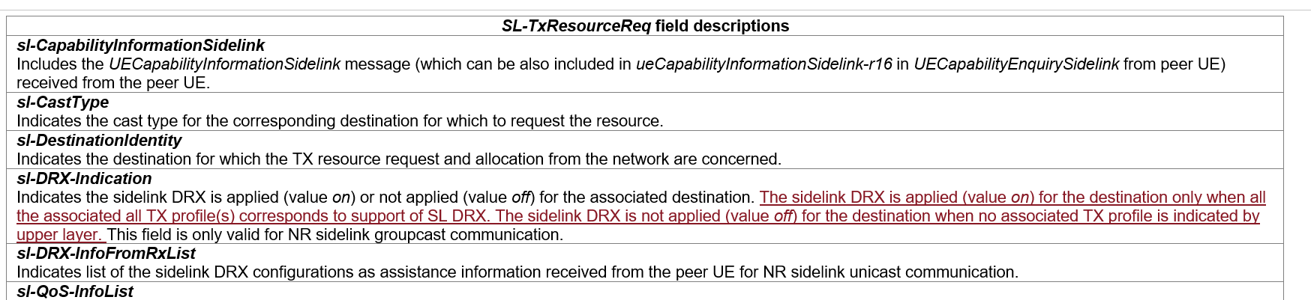

**Q4: Would you company agree the 2nd change proposed in R2-2210373?**

|  |  |  |
| --- | --- | --- |
| Company | Agree/Disagree | Further comments |
| Huawei, HiSilicon | Agree (proponent) |  |
| Apple | See comment | We agree with the intention, but wonder if it is to be captured in the field description of “***sl-TxProfileList “*** |
| OPPO | Missing cases? | Intention fine, yet we wonder for the off case, do we miss the case where associated Tx profile are indicated, but indicated as no-DRX?  [additional comment] the MAC CR is being discussed in 502, no need to touch that here. |
| Xiaomi | Disagree | We understand similar description is already captured in stage 2 spec. |
| vivo | Agree with comments | Suggest the re-wording to description the two different cases for SL DRX off indication. For example:  ***sl-DRX-Indication***  Indicates the sidelink DRX is applied (value *on*) or not applied (value *off*) for the associated destination. The sidelink DRX is applied (value *on*) for the destination only when all the associated all TX profile(s) corresponds to support of SL DRX. The sidelink DRX is not applied (value *off*) for the destination when at least one TX profile corresponds to no support of SL DRX or no associated TX profile(s) is indicated by upper layer. This field is only valid for NR sidelink groupcast communication. |
| CATT | See comment | UE may not request DRX on for the destination that associated all TX profile(s) corresponds to support of SL DRX. Therefore, it is preferred to “The sidelink DRX can be applied (value on) for the destination only when all the associated all TX profile(s) corresponds to support of SL DRX. The sidelink DRX is not applied (value off) for the destination when no associated TX profile is indicated by upper layer.” |
| Ericsson | disagree | We prefer to capturing this in the MAC spec instead, we have a MAC CR [R2-2209859](https://www.3gpp.org/ftp/tsg_ran/WG2_RL2/TSGR2_119bis-e/Docs/R2-2209859.zip) |
| Intel | Agree | We are fine with the intention |
| ZTE | Disagree | 300 already captured this intention, do not need to duplicate it here. |
| Qualcomm | Comment | In MAC is OK. |

### 2.1.3 3rd change of R2-2210373:



This change can be discussed together with change proposed in R2-2209878:

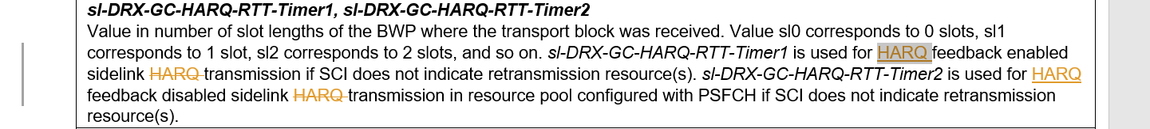



Rapporteur' d point out that:

1. After-change FD will be applied for both UC case and GC/BC case.

2. While FD for *HARQ-RTT-Timer* in Uu and SL seems not "sufficient" in 38.331 while in 38.321 HARQ-RTT-Timer is defined as:

- drx-HARQ-RTT-TimerSL (per SL HARQ process): the minimum duration before an SL retransmission grant is expected by the MAC entity;

Rapporteur understand the confusion might be caused by the original wording "sidelink transmission" or "sidelink HARQ transmission", as this RTT timer is the "sleep time" while UE is expecting the sidelink retransmission grant. This timer is not exactly for "a transmission" or "a HARQ transmission". Rapporteur thus suggests one option (option 1) as below for the FD, to be aligned with definition in 38.321.

**Q5: Which option would your company agree regarding the FD for sl-drx-HARQ-RTT-Timer1 and sl-drx-HARQ-RTT-Timer2?**

**Option 1: *sl-DRX-GC-HARQ-RTT-Timer1* is the minimum duration before an SL retransmission grant is expected by the MAC entity and used for HARQ feedback enabled case, if SCI does not indicate retransmission resource(s). *sl-DRX-GC-HARQ-RTT-Timer2* is the minimum duration before an SL retransmission grant is expected by the MAC entity and used for HARQ feedback disabled case in resource pool configured with PSFCH, if SCI does not indicate retransmission resource(s).**

**Option 2: No change for UC, 3rd change of R2-2210373 for GC/BC.**

**Option 3: change proposed in R2-2209878: *sl-DRX-GC-HARQ-RTT-Timer1* is used for HARQ feedback enabled sidelink ~~HARQ~~ transmission if SCI does not indicate retransmission resource(s). *sl-DRX-GC-HARQ-RTT-Timer2* is used for HARQ feedback disabled sidelink ~~HARQ~~ transmission in resource pool configured with PSFCH if SCI does not indicate retransmission resource(s).**

**Option 4: Others, please elaborate.**

|  |  |  |
| --- | --- | --- |
| Company | Option | Further comments |
| Huawei, HiSilicon | 1 |  |
| Apple | 3 | We feel the change in 3 is most straight-forward. |
| OPPO | 4 | By reading the 17.2.0 version      We understand the thing to correct is the UC case (since GC has been corrected last time), so that original change in 10373 is enough    [To the proponent of 3] what is the critical point to change from ‘feedback enabled sidelink HARQ transmission’ to ‘HARQ feedback enabled sidelink transmission’?  I am not totally against it, but isn’t the change to UC, from ‘HARQ enabled sidelink transmission’ to ‘feedback enabled HARQ transmission’ more critical as an correction? Does option-3 = no change to the UC case? |
| Xiaomi | 3 | Proponent  We understand how to use the timer is defined in MAC. RRC can simply specify how to select the timer based on HARQ feedback enable/disable. |
| vivo | 1 |  |
| CATT | 3 |  |
| Ericsson | 3 |  |
| Intel | 3 |  |
| ZTE | 3 |  |
| Qualcomm | 3 comment | Option 3: change proposed in R2-2209878: *sl-DRX-GC-HARQ-RTT-Timer1* is used for HARQ feedback enabled sidelink ~~HARQ~~ retransmission if SCI does not indicate retransmission resource(s). *sl-DRX-GC-HARQ-RTT-Timer2* is used for HARQ feedback disabled sidelink ~~HARQ~~ retransmission in resource pool configured with PSFCH if SCI does not indicate retransmission resource(s). |

### 2.1.4 Change on OLPC parameters:

This change is discussed together with change proposed in R2-2209858.

The online agreement on OLPC parameters is:

* A Rel-17 OLPC capable UE will ignore the legacy Rel-16 OLPC parameters for NR SL with suffix “-r16” if Rel-17 OLPC parameters are configured for NR SL with suffix “-r17”. FFS whether UE capability aspect need to be specified in FD.

R2-2209858 Corrections to 38331 on OLPC parameters Ericsson CR Rel-17 38.331 17.2.0 3514 - F NR_SL_enh-Core

* Will be handled in email discussion [501].

The below question is for deciding having/not having UE capability aspect in FD, companies can propose the actual FD wording for the OLPC parameters.

**Q6: Regarding FD for OLPC parameters, which option would you company agree?**

**Option 1: UE capability aspect need to be specified.**

**Option 2: UE capability aspect need NOT to be specified.**

|  |  |  |
| --- | --- | --- |
| Company | Option | Further comments |
| Apple | 1 | We support to clarify the UE capability aspect. |
| OPPO | See comment | We would like to suggest only for SIB case, the UE related capability needs to specified. I.e., we do not think / accept the UE to further check capability when dedicated signaling is received. Which is the basic principle for dedicated configuration design. |
| Xiaomi | Comments | We suggest to discuss based on explicit change. |
| vivo | 1 | This is necessary when the OLPC parameters are configured via SIB, and we are OK with the OPPO’s proposed way forward (i.e. limiting capability description only to SIB).  Reason for mentioning the capability is that, if it directly specifies that “if the ‘-r17’ parameters are configured, then…”, it means that even the UE incapable of the R17 OLPC is required to check this “if” condition on whether the “-r17” parameters are configured or not. But this is basically impossible, since for the UE not capable of this R17 feature, it cannot read the “-r17” fields at all, and thus cannot do this “if” condition check. |
| CATT | Option 2 |  |
| Ericsson | Option 2 | No need to specify the UE capability check in the FD. |
| Intel | Option 2 |  |
| ZTE | Option2 |  |
| Qualcomm | Option2 |  |

### 2.1.5 Editorial changes in R2-2210373:











**Q7: Would you company Disagree the editorial change above?**

|  |  |  |
| --- | --- | --- |
| Company | Disagree | Further comments |
| Apple | Yes |  |
| Xiaomi | Yes |  |
| CATT | Yes |  |
| Intel | Yes |  |
| ZTE | Yes |  |
| Qualcomm | Yes |  |

## 2.2 For other changes in R2-2209878

### 2.2.1 For the case gNB does not support SL DRX:

It is argued that "The UE behaviour is missing when sl-DRX-ConfigCommon-GC-BC is not present in SIB12." and the below change is proposed in clause 5.2.2.4.13 "Actions upon reception of SIB12":

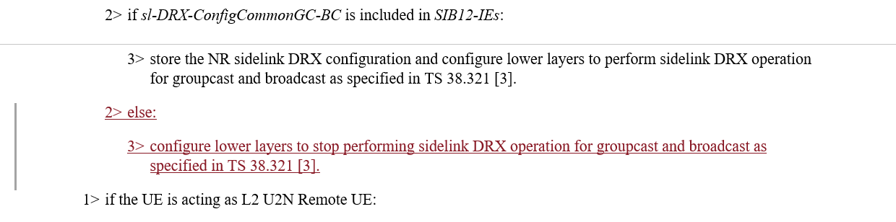

**Q8: Would you company agree the above change proposed in R2-2209878?**

|  |  |  |
| --- | --- | --- |
| Company | Agree/Disagree | Further comments |
| Apple | No strong view | The ASN.1 indicates that IE “sl-DRX-ConfigCommonGC-BC”in SIB 12 is NEED R.  So, if the UE release the DRX configuration when this IE is absent, the UE cannot perform SL DRX operation anyway. |
| OPPO | Disagree | Checked with Xiaomi, intention is to prevent DRX if it is not supported by NW based on SIB flag, it is fine.  But no specification needed since:   * If we do this, we can/need do similar change for all SIB based NW capability indication * The change limits to GC/BC, yet we understand it is applicable to all cast types.   [additional comment] this issue has been discussed in AT-119 [509], did not reach a clear agreement on what to do if NW is DRX incapable. We are fine to clarify it in the Chairman note, which should be sufficient. |
| Xiaomi | Agree | Answer to Apple and OPPO’s fist question,  According to last meeting discussion, we observed there is diverse understanding about whether SL DRX is enabled if UE is under SL DRX incapable gNB. Some companies understand SL DRX shall be enabled based on preconfiguration, while some don’t. If UE behaviour regarding enabling/disable SL DRX is not consistent, data loss may occur between UEs. So, we suggest to make it clear.  For the other SIB based NW capability indication, there is no such diverse understanding.  Answer to OPPO’s second question,  We are fine if this change is also applicable to UC. But we understand UC SL DRX is negotiated between peer UEs, so peer UEs can be synchronized. But for GC/BC, TX and RX UE should be clear SL DRX is disabled in this case. |
| vivo | See comments | We think the key point here is that the UE’s behaviour is not clear according to xiaomi’s explanation. If there are different UE implementations, then we agree that the problem raise by xiaomi is valid. With or without this change in 9878, it should be discussed to help to understand the UE’s behaviour.  After that discussion, then we can also choose to specify the UE’s behaviour in e.g. a NOTE or even in chairman minutes. |
| CATT | Disagree | It is not needed to describe the UE behaviour of the feature not indicated by NW. If we agree this, more similar changes are needed. |
| Ericsson | disagree | if SL DRX is not present, meaning UE doesn’t apply SL DRX, the UE does not need to stop. Since whether the gNB support SL DRX, is semi-static, the gNB has no reason to change its capability of SL DRX |
| Intel | Agree with comment | We have sympathy with Xiaomi’s intention to clarify the UE behavior and can support the intention. If needed, we can compromise by adding a note |
| ZTE | Disagree | SIB12 only shows whether network support SL DRX or NOT. The UE can still DRX configuration from pre-configuration. And whether UE start the SL DRX for GC or BC is controlled by tx profile. If stopping the SL DRX, for GC and BC, packet loss will happen since peer UE does not stop the SL DRX. |
| Qualcomm | Disagree | For groupcast or broadcast, some UEs may be in coverage, and others may be not (e.g., cell edge). In this case, how to ensure consistent UE behaviors? |

**Q9: If RAN2 agree the above change proposed in clause 5.2.2.4.13, would you company agree to add the "no longer used/interested" message in clause 5.8.3.3 as below:**

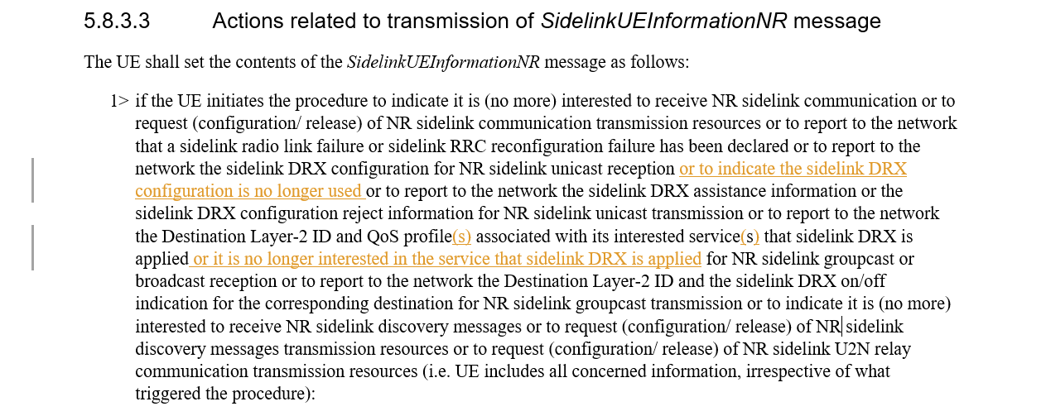

|  |  |  |
| --- | --- | --- |
| Company | Agree/Disagree | Further comments |
| Apple | No strong view | Can we just say “report to the network (any change of) the sidelink DRX configuration….which is similar to the text “is (no more) interested” used in the same paragraph ? |
| Xiaomi | Yes |  |
| vivo | Agree |  |
| CATT | See comments | Agree with Apple. |
| Intel | Agree |  |

### 2.2.2 For the conditions of SUI

This change can be discussed together with changes proposed for clause 5.8.3.1 in R2-2209739.

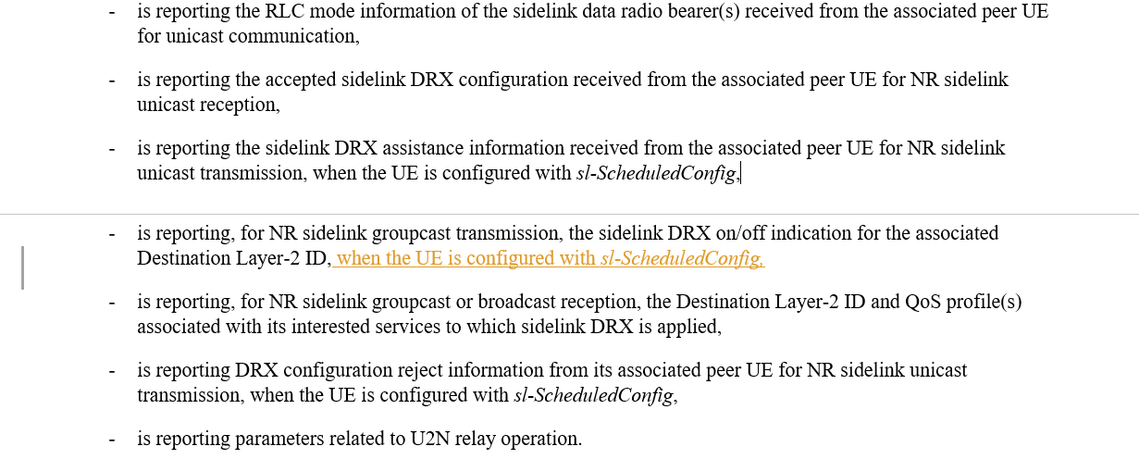

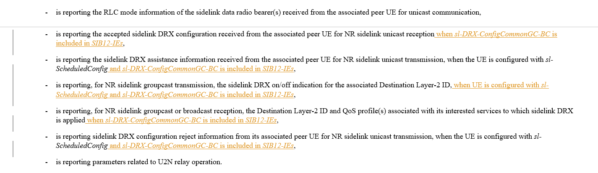

Rapporteur understands that the conditions for "Mode1/Mode2" and/or the conditions for "gNB supporting SL DRX" are agreed to be included in both 5.8.3.2 "Initiation" and 5.8.3.3 "Actions". For clause 5.8.3.1 though, it is "General", the above conditions might not need to be mentioned if they are anyway specified in 5.8.3.2 and 5.8.3.3. The sentences can become longer and longer and it is preferred not to have those conditions if they are not deemed as critically necessary. We can discuss even on whether to remove the Mode 1 conditions for assistance information and reject information.

**Q10: Would you company agree to have Mode 1 condition in clause 5.8.3.1 "General": Agree means to accept change for clause 5.8.3.1 in R2-2209878, Disagree means to even remove the current Mode 1 conditions for assistance information and reject information?**

|  |  |  |
| --- | --- | --- |
| Company | Agree/Disagree | Further comments |
| Apple | No | RAN2 has not agreed that GC/BC reporting Tx profile is limit to mode 1.  Based on RAN2#118 agreement,  For GC, UE reports L2 id and SL DRX on/off indication to the gNB.  We understand this applicable to all CONNECTED UEs. |
| OPPO | See comment | Different view from Apple, we understand it is limited to mode-1, as captured in spec already, and we see no reason to differ between GC/BC and UC/  W.r.t whether to do the change, no strong view though. |
| Xiaomi | Yes | Proponent |
| vivo | Disagree | Tend to agree with Rapporteur that the specific conditions might not need to be exhausted if they are anyway specified in 5.8.3.2 and 5.8.3.3. It is better to not make the “General” sentences become longer and longer. |
| CATT | Agree | In clause 5.8.3.1, the conditions should be unequivocal. |
| Ericsson | Yes | We are fine to the change, to be aligned with other conditions in Mode 1 |
| Intel | Disagree | We share rapporteur’s view |
| ZTE | Disagree | Ageree with Rapporteur. |
| Qualcomm | Comment | No strong view on this. |

**Q11: Would you company agree to have “gNB supporting SL DRX” condition, as proposed for clause 5.8.3.1 “General” in R2-2209379?**

|  |  |  |
| --- | --- | --- |
| Company | Agree/Disagree | Further comments |
| Apple | No | Agree with the rapporteur that there is no need to explicitly listing all the conditions |
| vivo | Disagree | Same view as in Q10. |
| CATT | Agree |  |
| Ericsson | No strong view |  |
| Intel |  | Fine to go with majority |
| ZTE | Disagree | Same view as in Q10. |
| Qualcomm | Comment | No strong view on it. |

One more change is proposed on the conditions for clause 5.8.3.2 “Initiation”:

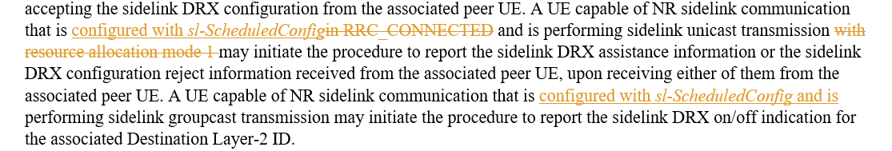

**Q12: Would you company agree to have “Mode 1” condition for GC, as proposed for clause 5.8.3.2 “** **Initiation” in R2-2209379?**

|  |  |  |
| --- | --- | --- |
| Company | Agree/Disagree | Further comments |
| Apple | No | We do not recall there is a agreement to limit this to mode 1. |
| OPPO | See comment | See our reply to Q10 |
| Xiaomi | Yes | Proponent |
| vivo | Agree | Even though no RAN2 agreement to limit the GC/BC reporting Tx profile to only mode 1, technically we believe that mode 1 is a common restriction for GC/BC and UC as long as it’s the gNB that is responsible for SL DRX configuration. |
| CATT | Agree |  |
| Ericsson | yes |  |
| Intel | Yes |  |
| ZYE | Agree |  |
| Qualcomm | Agree |  |

**Q13: Would you company agree to remove "RRC_CONNECTED" condition for UC, as proposed for clause 5.8.3.2 "** **Initiation" in R2-2209379?**

|  |  |  |
| --- | --- | --- |
| Company | Agree/Disagree | Further comments |
| Apple | No | The current text is fine. No need to change. |
| Xiaomi | Yes | Proponent |
| vivo |  | No strong view. The proposed change is more like wording improvement. |
| CATT | Agree | Only RRC_CONNECTED UE can be in mode 1. |
| Ericsson | yes |  |
| Intel |  | No strong view |
| ZTE | Agree |  |

### 2.2.3 Other minor changes proposed in R2-2209878

For other minor changes proposed in R2-2209878, Rapporteur lists recommendation as below, companies can comment if you Disagree with Rapporteur recommendation:

|  |  |  |
| --- | --- | --- |
| Changes proposed | Rapp Recommendation | Company comments if disagree with Rapp |
|  | The term "operation" is used to cover the relay case. Rapp suggests to keep "operation" and adopt both (s) and another (s) in the first paragraph. |  |
|  | Rapp agree to replace the Mode 1 condition with configured with sl-ScheduledConfig. |  |
|  | Rapp agree to add two (s) here. |  |
|  | Rapp agree to add two (s) here. |  |
|  | Rapp think the title of field is clear already so no need for one more sentence. Recommend to change as "Indicates a sidelink DRX configuration for groupcast communication, which is applicable to any QoS profile or any Destination Layer-2 ID." |  |
|  | Rapp see no need for this change. These three sentences are indeed complex. We may further fine-tune them in Rapp CR review. |  |
|  | Rapp agree to add "and" |  |

## 2.3 For other changes in R2-2209739

For change in clause 5.3.5.14 as,

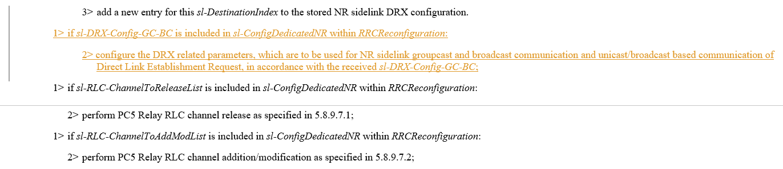

**Q14: Would you company agree the above change?**

|  |  |  |
| --- | --- | --- |
| Company | Agree/Disagree | Further comments |
| OPPO |  | sl-DRX-Config-GC-BC => sl-DRX-ConfigGC-BC |
| Xiaomi | Disagree | We understand *sl-DRX-Config-GC-BC* is always included in SIB12, if gNB supports SL DRX. Therefore, seems gNB would not configure this by dedicated signalling. |
| vivo | See comments | According to below RAN2 agreement, we think the dedicated singnalling cases for *sl-DRX-ConfigGC-BC* will only be SIB contained within dedicated singnalling, thus the changes are not correctly captured.  Agreements on SL DRX configuration for GC/BC:  1: For SL BC and GC, for in-coverage case, RRC_CONNECTED TX-UE/RX-UE can obtain DRX configuration from 1) SIB which is delivered via dedicated RRC signalling as in legacy, and from 2) from dedicated RRC signalling during handover, i.e., in an RRCReconfiguration message including reconfigurationWithSyn. Otherwise, RRC_CONNECTED TX-UE/RX-UE does not expect DRX configuration from dedicated RRC signalling. |
| Ericsson | disagree | Agree with xiaomi |
| Intel | Disagree | Similar view as Xiaomi |
| Apple | disagree |  |
| ZTE | Disagree | Similar view as Xiaomi |
| Qualcomm | Disagree | Share Xiaomi’s view |
| CATT | Agree | In RAN2#115 meeting, the following agreement were reached:  Proposal 1          For SL BC and GC, for in-coverage case, RRC_CONNECTED TX-UE/RX-UE can obtain DRX configuration from 1) SIB which is delivered via dedicated RRC signalling as in legacy [16/17], and from 2) from dedicated RRC signalling during handover, i.e., in an RRCReconfiguration message including reconfigurationWithSyn [16/17]. Otherwise, RRC_CONNECTED TX-UE/RX-UE does not expect DRX configuration from dedicated RRC signalling [15/17].   * Agreed.   At least in HO case, according to the ASN.1 structure, the BC/GC SL DRX configuration can be included in *SL-ConfigDedicatedNR* which is used for HO case, it is listed below:  SL-ConfigDedicatedNR –> SL-PHY-MAC-RLC-Config –> sl-DRX-Config-r17 -> sl-DRX-Config-GC-BC-r17  So, it can be concluded that sl-DRX-Config-GC-BC-r17 will be included in the dedicated RRC signalling *SL-ConfigDedicatedNR* during handover, the description on sl-DRX-Config-GC-BC-r17 in 5.3.5.14 for SL-ConfigDedicatedNR is needed. |

The below change is understood as postponed from last meeting:

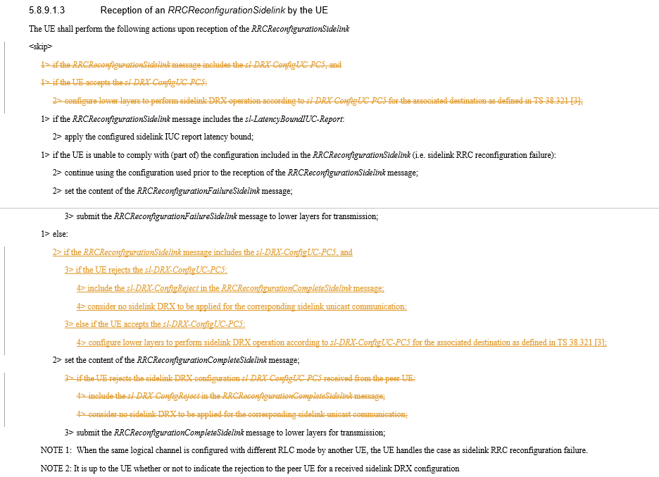

**Q15: Would you company agree the above change?**

|  |  |  |
| --- | --- | --- |
| Company | Agree/Disagree | Further comments |
| OPPO | Disagree | We fail to identify a critical issue to perform such change. |
| Xiaomi | Agree | We understand UE should perform compliance check before applying SL DRX configuration. |
| vivo | Disagree | We think this issue has been discussed at previous meeting and agreed that no spec change needed. |
| CATT | Agree(proponent) | For legacy procedure, it is wield for UE to determine to accept or reject SL DRX and associated actions in two different steps. In our view, UE needs to make a decision of either accepting or rejecting the SL DRX at the same point, which is better to be after the compliance check. |
| Ericsson | Disagree. | The issue was already discussed last time. |
| Intel | Disagree | Does not seem like this is an essential correction |
| Apple | Disagree | Not essential |
| ZTE | Disagree |  |
| Qualcomm | Disagree | Note 2. It’s up to the UE whether or not to indicate the rejection… |

## 2.4 For changes in R2-2209740



Rapporteur understands the other sidelink MAC CE shall reuse the same SR configuration.

**Q16: Would you company agree the above change?**

|  |  |  |
| --- | --- | --- |
| Company | Agree/Disagree | Further comments |
| Xiaomi | Agree |  |
| vivo |  | No strong view, can follow the majorities. |
| CATT | Agree | In 38.321, the name is “Sidelink CSI reporting MAC CE”. Furthermore, “sl-CSI-SchedulingRequestId” is reused for Inter-UE Coordination Information MAC CE and Inter-UE Coordination request MAC CE. |
| Ericsson | disagree | IUC MAC CE is only applicable to Mode 2, therefore, IUC MAC CE needs to be removed from the FD. |
| Intel | Agree |  |
| Apple | Disagree | Same view as Ericsson |
| ZTE | Partially Agree | Agree the change proposed by Ericsson. |
| Qualcomm | Disagree | Same view as Ericsson, IUC in Mode 2 only. |



For this change, Rapporteur propose one alternative as Option 1 below.

**Q17: Which option would you company support regarding above change?**

**Option 1: Indicates whether inter-UE coordination information triggered by a condition, other than explicit request reception, is enabled or not.**

**Option 2: Indicates whether inter-UE coordination information triggered by a condition is enabled or not. (as in R2-2209740)**

**Option 3: no change needed.**

**Option 4: others, please elaborate.**

|  |  |  |
| --- | --- | --- |
| Company | Option | Further comments |
| OPPO | 3 | With ‘by a condition’, it is clear already? |
| Xiaomi | 2 | Option 2 is cleaner. |
| vivo | 3 |  |
| CATT | Option 2 | Condition-based IUC is separately from request-based IUC. |
| Ericsson | 3 | The existing text is already clear. |
| Intel | 2 |  |
| Apple | 2 | We think the two IEs are independently configured. |
| ZTE | 3 |  |
| Qualcomm | 3 |  |

## 2.5 For changes in R2-2210542

Regarding changes of adding reference for discovery message, Rapporteur agrees and will add into the merged CR directly.

For the change proposed as below:

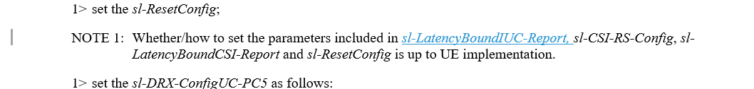

**Q18: Would you company agree the above change?**

|  |  |  |
| --- | --- | --- |
| Company | Agree/Disagree | Further comments |
| Xiaomi | Agree |  |
| vivo | Agree | Proponent. |
| CATT | Agree |  |
| Ericsson | agree |  |
| Intel | Agree |  |
| Apple | Agree |  |
| ZTE | Agree |  |
| Qualcomm | Agree |  |

## 2.6 For changes regarding resource selection config in R2-2209463, R2-2209674

The following changes are proposed following RAN1 LS and Rapporteur understand they could be adopted. Companies can propose alternative wording for the FD.

In R2-2209463:

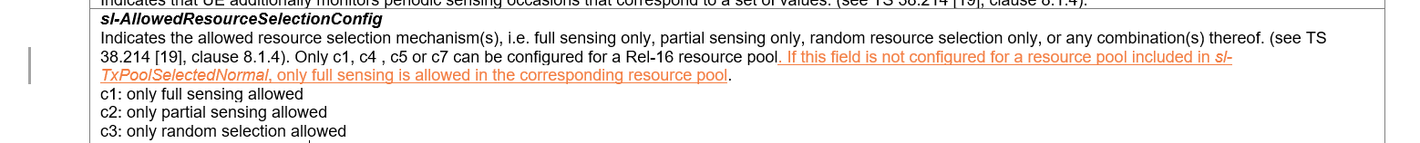

In R2-2209674:

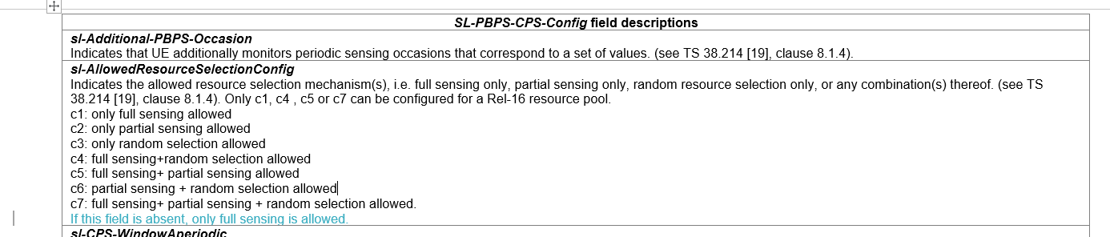

**Q19: Would you company agree the above changes?**

|  |  |  |
| --- | --- | --- |
| Company | Agree/Disagree | Further comments |
| OPPO | Agree | [additional comment] we are fine to use ‘not configured’ as suggested by vivo. Yet it may not be necessarily that ‘**the NW has not ever configured this field earlier**’, since we can use setupRelease for the parent IE SL-PBPS-CPS-Config-r17. |
| Xiaomi | Agree |  |
| vivo | Agree with comment | Basically, for the dedicated signalling case, the added sentence is to define a specified default behaviour, so ideally speaking *sl-AllowedResourceSelectionConfig* should have been specified as an “Need S” field. However, now that it’s already (unfortunately) been specified as “Need M”, to avoid changing Need Code, it seems that this default behaviour can only be limited to the case that \***the NW has not ever configured this field earlier\***, because if this field was once configured, the UE must follow the current stored value but not a default behaviour, even if the field is absent in later reconfiguration signalling. Perhaps the above \***case**\* can only be described as “if this field is not **configured**…”, instead of saying “if this field is **absent**” in an RRC message. Also, another finding from us (though perhaps not exhaustively…) is that for “NEED M” fields, usually the description of “if not *configured*” is used  We are open to hear companies’ views on how to understand this issue and what the best wording is. |
| CATT | Agree |  |
| Ericsson | agree |  |
| Intel | Agree |  |
| Apple | Agree |  |
| ZTE | Agree | Detailed wording can be up to rapper. |
| Qualcomm | Agree |  |

## 2.7 For changes related to default CBR parameters

Based on RAN1 LS R1-2208090, different implementations are proposed in R2-2209857:

 in R2-2210555:

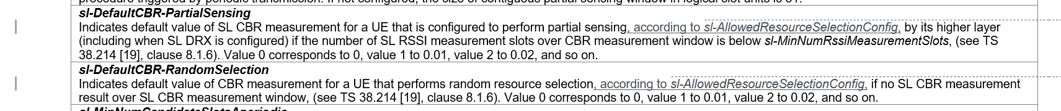



in R2-2209674:



**Q20: Would you company agree to add restriction in FD for partial sensing and random selection cases, as changes in R2-2210555?**

|  |  |  |
| --- | --- | --- |
| Company | Agree/Disagree | Further comments |
| OPPO | Disagree | If this Q is to ask for    We do not see this helps to solve the issue actually. |
| vivo | Agree | This change helps to clarify that the UE is configured to perform partial sensing and random resource selection according to *sl-AllowedResourceSelectionConfig.* |
| CATT | Disagree | Agree with OPPO. |
| Ericsson | agree | The changes seems helpful to improve the wording for the FD |
| Intel | Agree | The intention seems ok, but instead of writing three separate sentences, we can rephrase to say “This field is used if full sensing is used, or when *defaultCbrPartialSensing* ….” for better readability. |
| Apple | Disagree | Same view as OPPO |
| ZTE | Disagree | The change does not influence anything. |
| Qualcomm | Disagree | Don’t need the changes proposed in **R2-2210555.** |

Rapporteur understand changes for FD of sl-DefaultTxConfigIndex by R2-2209857 and R2-2209674 are almost equivalent as R2-2209857 propose "This field is applicable only when the UE performs full sensing. " meaning for all other cases this field is not applicable. Actual wording can be done during CR review.

**Q21: Would you company agree to add restriction in FD for full sensing case, as changes in R2-2209857, R2-2210555 and R2-2209674?**

|  |  |  |
| --- | --- | --- |
| Company | Agree/Disagree | Further comments |
| OPPO | Disagree | It is wrong!  For full sensing, it can be done in normal pool, if sensing result is available, and in this case, CBR result is also available, so no need to use default CBR value.  Or if sensing result is not available, UE switch to e-pool, using **random-selection, in that case,** sl-DefaultTxConfigIndex, is used. So it is actually the random-selection, caused by no-sensing-result for full-sensing in normal pool, makes use of the sl-DefaultTxConfigIndex  [Additional comment] the following comment is a bit confusing.. anyway, we do not see a chance to use this in the normal pool, where full sensing can be used only if there is sensing result, and that means the CBR result is also available. |
| vivo | See comments | We understand the CR intention, and suggest to simply add the corresponding reference to TS 38.321 since the usage of default CBR value is specified there. Moreover, the ongoing offline email in [AT119bis-e][502][V2X/SL] 38.321 corrections (LG) is also discussing the same issue (i.e., Q34), duplicated discussion need be avoided here. |
| CATT | Disagree | sl-DefaultTxConfigIndex is used for the case that CBR result is also available for full sensing-based resource selection. Then UE performs random selection. Therefore, it is needed to discuss how to describe it correctly. |
| Ericsson | Agree (Propnent) |  |
| Apple | See comment | We need to coordinate the RRC and MAC discussion on this issue. Maybe we can postpone this to Nov meeting. |
| ZTE | Agree | (Propnent):  To OPPO’s comments, original text shows that this parameter is used when CBR measurement is not available. |
| Qualcomm | Comment | Need to coordinate the RRC and MAC discussion on this issue. |

## 2.8 Changes related to P4 and P5 in R2-2210779 (corresponding CR in R2-2209379)

Rapporteur understand it is related to P3 and P4 (as there is no P5) in R2-2210779.

P3 and related TP in R2-2210779 propose to add procedure texts to clarify the usage of R16/R17 default CBR values which is related to the discussion in above section where only changes on FD are discussed.

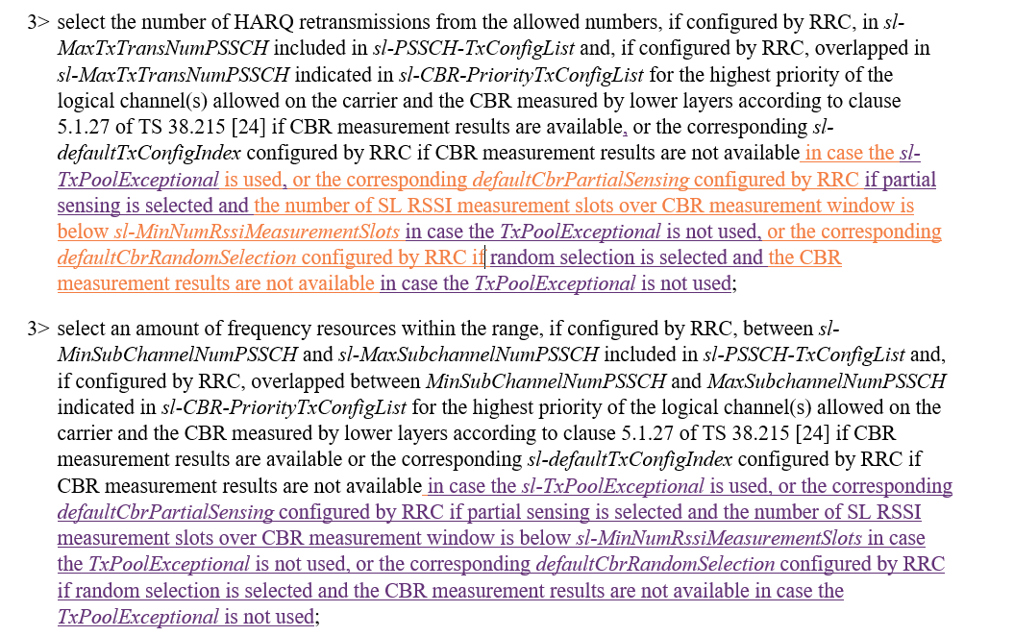

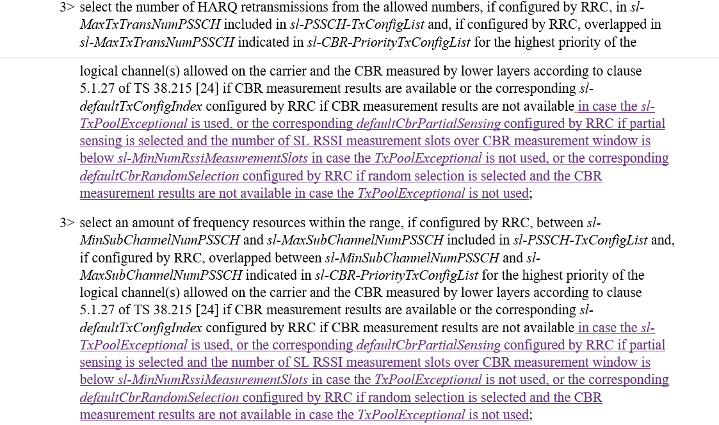

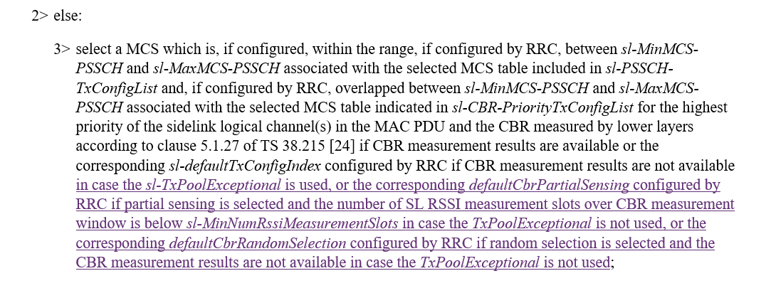

**Q22: Would your company agree the procedure changes proposed in R2-2210779, to clarify the usage of R16/R17 default CBR values?**

|  |  |  |
| --- | --- | --- |
| Company | Agree/Disagree | Further comments |
| OPPO | Agree | Yet we see this issue is being checked in MAC offline. Good to align between each other. |
| Xiaomi | Disagree | Proposed change is not aligned with RAN1 LS. Seems proponent believes for normal pool, R16 default CBR setting is not applicable. We can first send LS to RAN1 to check whether this is the correct understanding. |
| vivo | See comments | As replied in Q21, the proposed changes mainly impact MAC and duplicated discussion can be avoided here. |
| CATT | Agree |  |
| Ericsson | disagree | Share the same view as xiaomi, we need to check with RAN1. |
| Intel |  | We support the change, but if companies want to confirm intention with RAN1, we are also fine |
| Apple |  | Postpone to Nov meeting. |
| ZTE | Disagree | Partially agree with Xiaomi, for the LS, we think this is not necessary. Fornormal poll, R16 default CBR is applicable when defaultRandomSelection or defaultPartialSensingCBR is not configured. |
| Qualcomm | Comment | Mostly impacts MAC. Keep in MAC is good enough. |

**One NOTE is proposed via P4 in R2-2210779 and related TP as:**

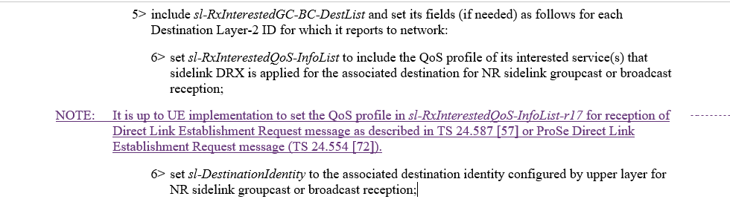

Rapporteur remind that 38.331-h20 has included one NOTE as below, so the actual change, if agreed, could be adjusted:

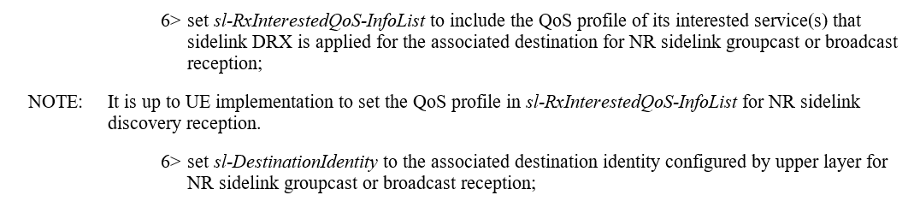

**Q23: Would your company agree the NOTE proposed via P4 in R2-2210779?**

|  |  |  |
| --- | --- | --- |
| Company | Agree/Disagree | Further comments |
| OPPO | Agree |  |
| Xiaomi | Disagree | It’s up to UE implementation. We don’t see the need for the NOTE. |
| vivo | Agree |  |
| CATT | Agree | Merge to the NOTE. |
| Ericsson | agree |  |
| Intel | Agree |  |
| Apple | Agree |  |
| ZYE | Agree |  |
| Qualcomm | Agree |  |

Also, change is proposed on related FD as:



**Q24: Would your company agree the change on FD of *sl-RxInterestedGC-BC-DestList***

**as proposed via P4 in R2-2210779?**

|  |  |  |
| --- | --- | --- |
| Company | Agree/Disagree | Further comments |
| OPPO | Agree |  |
| Xiaomi | Disagree | Similar as previous question. |
| vivo | Agree |  |
| CATT | Agree |  |
| Ericsson | agree |  |
| Intel | Agree |  |
| ZYE | Agree |  |
| Qualcomm | Agree |  |

## 2.9 Other changes in R2-2209674

Extra conditions for UE reporting assistance information or DRX on/off indication: 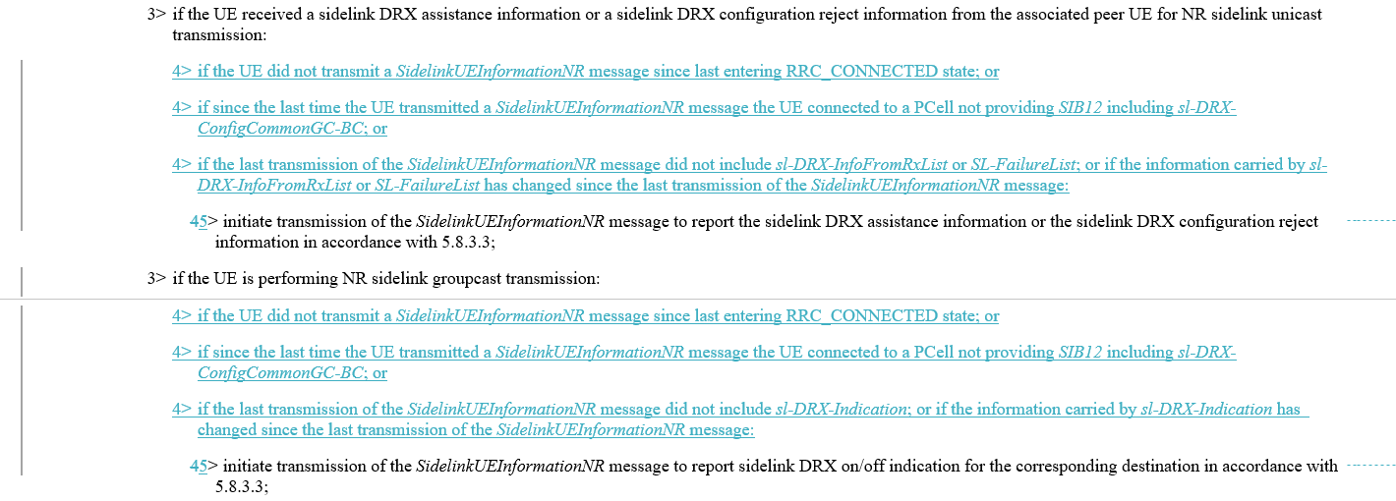

**Q25: Would your company agree the above changes on the additional conditions for UE to report assistance information and DRX on/off indication?**

|  |  |  |
| --- | --- | --- |
| Company | Agree/Disagree | Further comments |
| OPPO |  | OK although initiation condition of sl-TxResourceReqList has been covered by the existing text above |
| Xiaomi | Disagree | It’s discussed in last meeting and agreed without spec impact as below,  Proposal 5 (14/16) TX-UE store and report the related information (assistance information, DRX on-off indication) upon changing from mode-2 to mode-1. No spec impact. |
| vivo | Agree |  |
| CATT | Disagree | 2> if configured by upper layers to perform NR sidelink transmission on the frequency included in *sl-FreqInfoList* in *SIB12* of the PCell and *if sl-DRX-ConfigCommonGC-BC* is included in *SIB12-IEs* andif the UE is configured with *sl-ScheduledConfig*:  3> if the UE received a sidelink DRX assistance information or a sidelink DRX configuration reject information from the associated peer UE for NR sidelink unicast transmission:  4> initiate transmission of the *SidelinkUEInformationNR* message to report the sidelink DRX assistance information or the sidelink DRX configuration reject information in accordance with 5.8.3.3;  3> if the UE is performing NR sidelink groupcast transmission:  4> initiate transmission of the *SidelinkUEInformationNR* message to report sidelink DRX on/off indication for the corresponding destination in accordance with 5.8.3.3;  No additional condition is added for both cases. |
| Ericsson | disagree | Agree with xiaomi |
| Apple | Disagree | Same view as Xiaomi |
| ZTE | Disagree | Agree with xiaomi |
| Qualcomm | Disagree | Share Xiaomi’s view |

## 2.10 Change related to Q1 of RAN1 LS R2-2209310/R1-2208090

One action is agreed regarding Q1 of RAN1 LS R2-2209310/R1-2208090:

[Apple]: For R2-2209310, we need correction for the corresponding field description for the first RAN1 response. [Session chair]: Let’s discuss as part of email discussion [501]. Apple will contact RRC CR rapporteur with suggested change.

Apple provided change as below, in order to "to align the description to the language used in "sl-TriggerConditionCoordInfo” to be clear about this is for “piggyback” behaviour.":

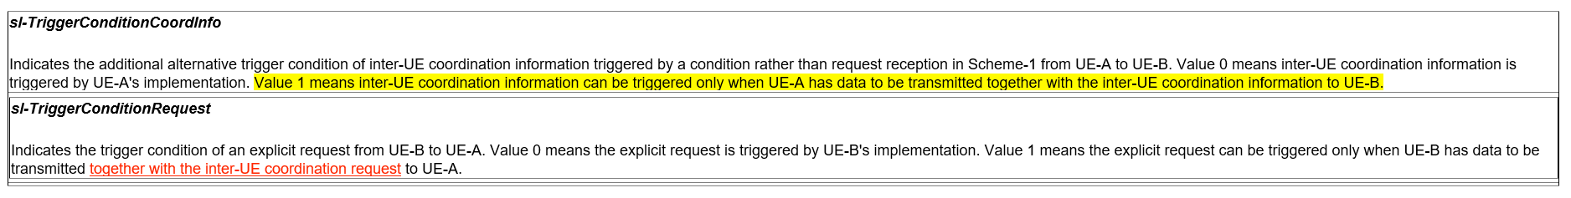

**Q26: Would your company agree the above change regarding RAN1 response for Q1 in R2-2209310?**

|  |  |  |
| --- | --- | --- |
| Company | Agree/Disagree | Further comments |
| Apple (Proponent) | Agree | The original description “UE-B has data to be transmitted to UE-A” can be misunderstood in different meaning (e.g, UE-B need trigger IUC to get resource for this data to be transmitted based on IUC response)  That is why we send a LS to RAN1. After reading the Q1 response, we get RAN1 confirmation as this is only for “piggybacking”. So, it is proper to align the text used in both "sl-TriggerConditionCoordInfo” & “"sl-TriggerConditionRequest” as both are containing conditions for “Piggyback”.. |
| OPPO | Disagree | ~~We fail to follow~~    ~~Did not R1 answer NOT always to piggyback?~~  ~~And the Q was for~~ *~~sl-TriggerConditionRequest~~*~~, why it leads to a change to~~ *~~sl-TriggerConditionCoordInfo~~*~~?~~  [Apple: It is not always piggybacked because there are two alternatives as shown in RAN1 agreements. We do not change the FD of “*TriggerConditionCoordInfo ]*  *[updated comment] now we get the point, and fine with this change.* |
| Xiaomi | Agree | According to RAN1 LS as below, if alt2 is configured, only piggyback is allowed.   * A resource pool level (pre-)configuration can enable one of the following alternatives:   + Alt 1: it is up to UE-B’s implementation whether or not to trigger the request generation   + Alt 2: the request generation can be triggered only when UE-B has data to be transmitted to UE-A |
| vivo | Prefer NO | We don’t see current texts lead to such misunderstanding e.g, UE-B need trigger IUC to get resource for this data to be transmitted based on IUC response. |
| CATT | Agree |  |
| Ericsson | disagree | RAN1 LS is stating that, IUC request is not always piggybacked with SL data.  Whether to allow piggyback is up to the MAC layer LCP and the grant.  [Apple: It is triggered only if MAC Layer LCP procedure ensures the SL DATA is transmitted together with the IUC REQ MAC CE in the same TB, we think the field description change is correctly capture this MAC layer behaviour] |
| Intel | Disagree | Based on RAN1 response, whether UE-B piggybacks the IUC Request with SL data transmission is as per TS 38.321, therefore, the change is not needed  [Apple: It is triggered only if MAC Layer LCP procedure ensures the SL DATA is transmitted together with the IUC REQ MAC CE in the same TB, we think the field description change is correctly matching the intended behaviour in MAC. If we do not capture this in FD in 38.331, it is not captured in MAC spec either. Then the value 1 setting is meaningless.] |
| ZTE | Disagree | We think current text is fine. Actually, RAN2 spec does not use this parameter, the usage of this parameter is in PHY layer and RAN1 has captured the meaning in RAN1. We do not see the necessary to modify this. |
| Qualcomm | Agree | It’s for Alt 2. |

## Conclusion

# Reference:

R2-2210373 Rapporteur CR on TS 38.331 for SL enhancements Huawei, HiSilicon CR Rel-17 38.331 17.2.0 3541 - F NR_SL_enh-Core Late

R2-2209739 Miscellaneous corrections on TS 38.331 for SL DRX CATT CR Rel-17 38.331 17.2.0 3502 - F NR_SL_enh-Core

R2-2209740 Miscellaneous corrections on TS 38.331 for SL enhancement CATT CR Rel-17 38.331 17.2.0 3503 - F NR_SL_enh-Core

R2-2210542 Miscellaneous corrections on 38.331 vivo CR Rel-17 38.331 17.2.0 3551 - F NR_SL_enh-Core

R2-2209878 Correction on 38.331 Xiaomi draftCR Rel-17 38.331 17.2.0 F NR_SL_enh-Core

R2-2209772 Correction on SL transmission by OOC UE for SL communication and SL discovery Apple CR Rel-17 38.331 17.2.0 3505 - F NR_SL_enh-Core

R2-2209857 Discussion on RAN1 LS R1-2208090 Ericsson discussion Rel-17 NR_SL_enh-Core

R2-2210555 Clarification of default CBR parameters Samsung Research America CR Rel-17 38.331 17.2.0 3553 - F NR_SL_enh-Core

R2-2209463 Discussion on the LS in R2-2209311 for default resource selection scheme vivo discussion

R2-2209379 Correction for SL DRX OPPO draftCR Rel-17 38.331 17.2.0 F NR_SL_enh-Core

R2-2209674 correction on RRC spec for SUI initiation and IUC parameter ZTE Corporation, Sanechips draftCR Rel-17 38.331 17.2.0 F NR_SL_enh-Core