**3GPP TSG-RAN2 Meeting 119bis-e** **R2-2210931**

**Online, 10th – 19th October, 2022**

**Agenda item: 6.15.2**

**Source: Huawei, HiSilicon**

**Title: Summary of [AT119bis-e][501][V2X/SL] 38.331 corrections (Huawei)**

**Document for: Discussion and Decision**

1. Introduction

This is the summary of below offline discussion.

* [AT119bis-e][501][V2X/SL] 38.331 corrections (Huawei)

**Scope:** Discuss proposed corrections in R2-2210373, R2-2209739, R2-2209740, R2-2210542, R2-2209878, R2-2209772, R2-2209857, R2-22010555, R2-2209463, R2-2209674, and P4 and P5 in R2-2210779 (corresponding CR in R2-2209379). Merge agreeable corrections in a CR as much as possible (we may have separate CR if required, it’s up to rapporteur).

**Intended outcome:** 38.331 CR in R2-2210930 and discussion summary in R2-2210931 (if needed). Email approval.

**Deadline:** 10/17 12:00 (UTC)

Contact list

|  |  |  |  |
| --- | --- | --- | --- |
| Name | | Company | Email |
| Tao Cai | | Huawei, HiSilicon | tao.cai@huawei.com |
| Zhibin Wu | | Apple | zhibin_wu@apple.com |
|  |  | |  |
|  | |  |  |
|  | |  |  |
|  | |  |  |
|  | |  |  |
|  | |  |  |
|  | |  |  |
|  | |  |  |

1. Discussion

## 2.1 For changes in R2-2210373

### 2.1.1 First change in clause 5.8.8:

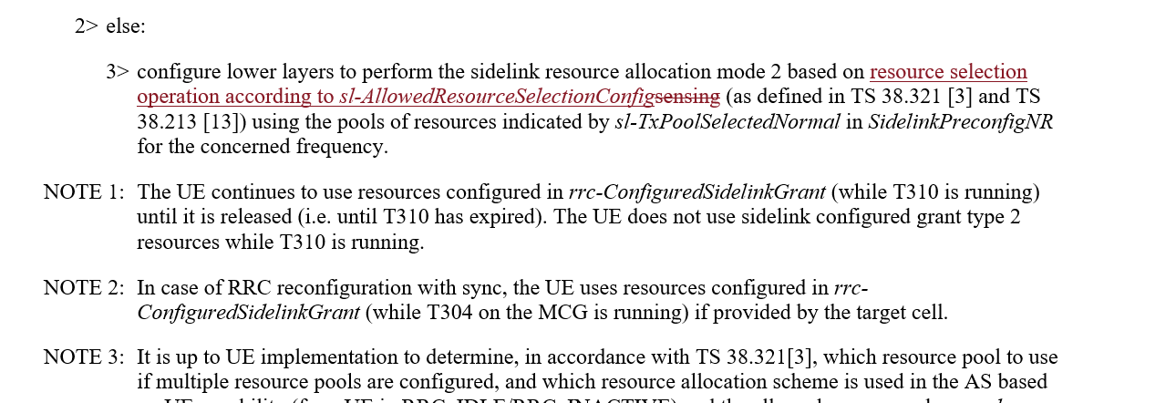

This change should be discussed together with change proposed in R2-2209772:

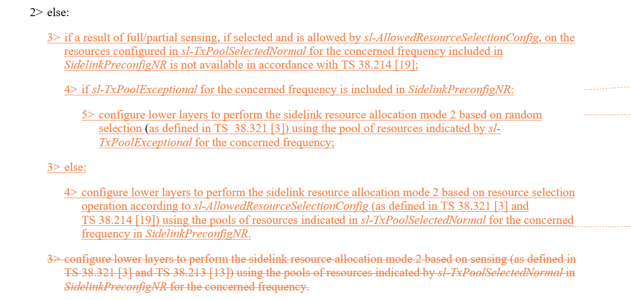

Rapporteur thinks the agreed changes will be applied also for clause 5.8.13.3 "NR sidelink discovery transmission", the other editorial changes proposed in R2-2209772 will be adopted.

**Q1: Would you company agree the UE actions shall be separately specified for the cases where the sensing results available or not available for OOC scenario?**

|  |  |  |
| --- | --- | --- |
| Company | Agree/Disagree | Further comments |
| Huawei, HiSilicon | Agree |  |
| Apple | Agree | Yes, since the RRC spec indicates that there is an exceptional pool in pre-configuration. The same UE behaviour can be adopted for OOC UE. |
| OPPO | Disagree | We checked the R14 agreement, where it clarified e-pool is only used for In-coverage scenario, so tend to stick to that. |
| Xiaomi | Comment | We understand current UE behaviour is inherited from legacy. If this change is agreed, we wonder whether this change should also apply to R16 and earlier spec? |

**[Summary]**

**[Proposals]**

**Q2: If RAN2 agree to specify UE behaviour where the sensing results are not available for OOC scenario, do your company agree the corresponding changes proposed in R2-2209772?**

|  |  |  |
| --- | --- | --- |
| Company | Agree/Disagree | Further comments |
| Huawei, HiSilicon | Agree |  |
| Apple | Agree |  |
| OPPO | Disagree | See our reply to Q1. |

**Q3: If RAN2 agree to specify UE behaviour where the sensing results are available for OOC scenario, do your company agree the corresponding changes proposed in R2-2210373/R2-2209772 (bar editorial difference)?**

|  |  |  |
| --- | --- | --- |
| Company | Agree/Disagree | Further comments |
| Huawei, HiSilicon | Agree |  |
| Apple | Agree |  |
| OPPO | Agree | We are fine with Change-1 in 10373. |

### 2.1.2 2nd change of R2-2210373:

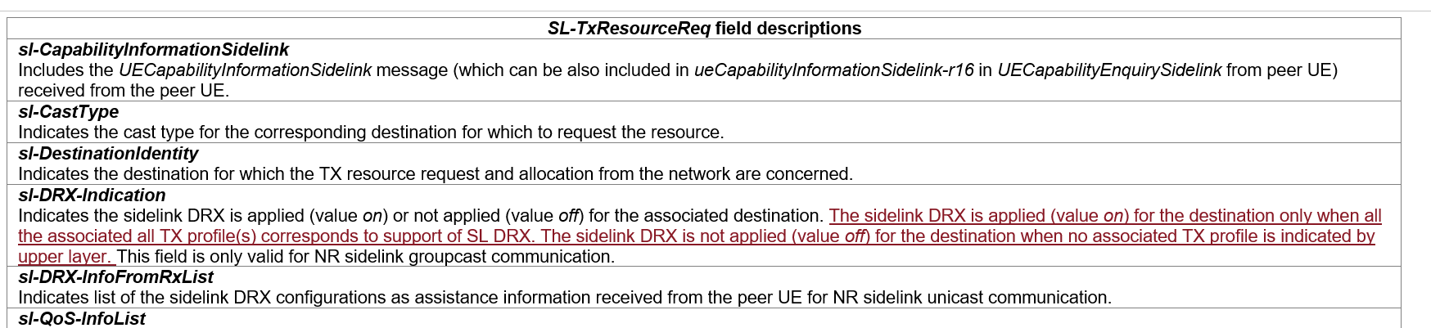

**Q4: Would you company agree the 2nd change proposed in R2-2210373?**

|  |  |  |
| --- | --- | --- |
| Company | Agree/Disagree | Further comments |
| Huawei, HiSilicon | Agree (proponent) |  |
| Apple | See comment | We agree with the intention, but wonder if it is to be captured in the field description of “***sl-TxProfileList “*** |
| OPPO | Missing cases? | Intention fine, yet we wonder for the off case, do we miss the case where associated Tx profile are indicated, but indicated as no-DRX? |
| Xiaomi | Disagree | We understand similar description is already captured in stage 2 spec. |

### 2.1.3 3rd change of R2-2210373:



This change can be discussed together with change proposed in R2-2209878:

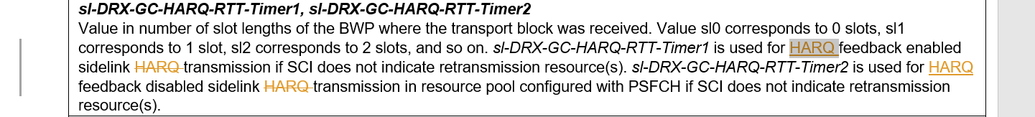



Rapporteur' d point out that:

1. After-change FD will be applied for both UC case and GC/BC case.

2. While FD for *HARQ-RTT-Timer* in Uu and SL seems not "sufficient" in 38.331 while in 38.321 HARQ-RTT-Timer is defined as:

- drx-HARQ-RTT-TimerSL (per SL HARQ process): the minimum duration before an SL retransmission grant is expected by the MAC entity;

Rapporteur understand the confusion might be caused by the original wording "sidelink transmission" or "sidelink HARQ transmission", as this RTT timer is the "sleep time" while UE is expecting the sidelink retransmission grant. This timer is not exactly for "a transmission" or "a HARQ transmission". Rapporteur thus suggests one option (option 1) as below for the FD, to be aligned with definition in 38.321.

**Q5: Which option would your company agree regarding the FD for sl-drx-HARQ-RTT-Timer1 and sl-drx-HARQ-RTT-Timer2?**

**Option 1: *sl-DRX-GC-HARQ-RTT-Timer1* is the minimum duration before an SL retransmission grant is expected by the MAC entity and used for HARQ feedback enabled case, if SCI does not indicate retransmission resource(s). *sl-DRX-GC-HARQ-RTT-Timer2* is the minimum duration before an SL retransmission grant is expected by the MAC entity and used for HARQ feedback disabled case in resource pool configured with PSFCH, if SCI does not indicate retransmission resource(s).**

**Option 2: No change for UC, 3rd change of R2-2210373 for GC/BC.**

**Option 3: change proposed in R2-2209878: *sl-DRX-GC-HARQ-RTT-Timer1* is used for HARQ feedback enabled sidelink ~~HARQ~~ transmission if SCI does not indicate retransmission resource(s). *sl-DRX-GC-HARQ-RTT-Timer2* is used for HARQ feedback disabled sidelink ~~HARQ~~ transmission in resource pool configured with PSFCH if SCI does not indicate retransmission resource(s).**

**Option 4: Others, please elaborate.**

|  |  |  |
| --- | --- | --- |
| Company | Option | Further comments |
| Huawei, HiSilicon | 1 |  |
| Apple | 3 | We feel the change in 3 is most straight-forward. |
| OPPO | 4 | By reading the 17.2.0 version      We understand the thing to correct is the UC case (since GC has been corrected last time), so that original change in 10373 is enough |
| Xiaomi | 3 | Proponent  We understand how to use the timer is defined in MAC. RRC can simply specify how to select the timer based on HARQ feedback enable/disable. |
|  |  |  |
|  |  |  |
|  |  |  |
|  |  |  |

### 2.1.4 Change on OLPC parameters:

This change is discussed together with change proposed in R2-2209858.

The online agreement on OLPC parameters is:

* A Rel-17 OLPC capable UE will ignore the legacy Rel-16 OLPC parameters for NR SL with suffix “-r16” if Rel-17 OLPC parameters are configured for NR SL with suffix “-r17”. FFS whether UE capability aspect need to be specified in FD.

R2-2209858 Corrections to 38331 on OLPC parameters Ericsson CR Rel-17 38.331 17.2.0 3514 - F NR_SL_enh-Core

* Will be handled in email discussion [501].

The below question is for deciding having/not having UE capability aspect in FD, companies can propose the actual FD wording for the OLPC parameters.

**Q6: Regarding FD for OLPC parameters, which option would you company agree?**

**Option 1: UE capability aspect need to be specified.**

**Option 2: UE capability aspect need NOT to be specified.**

|  |  |  |
| --- | --- | --- |
| Company | Option | Further comments |
| Apple | 1 | We support to clarify the UE capability aspect. |
| OPPO | See comment | We would like to suggest only for SIB case, the UE related capability needs to specified. I.e., we do not think / accept the UE to further check capability when dedicated signaling is received. Which is the basic principle for dedicated configuration design. |
| Xiaomi | Comments | We suggest to discuss based on explicit change. |

### 2.1.5 Editorial changes in R2-2210373:











**Q7: Would you company Disagree the editorial change above?**

|  |  |  |
| --- | --- | --- |
| Company | Disagree | Further comments |
| Apple | Yes |  |
| Xiaomi | Yes |  |

## 2.2 For other changes in R2-2209878

### 2.2.1 For the case gNB does not support SL DRX:

It is argued that "The UE behaviour is missing when sl-DRX-ConfigCommon-GC-BC is not present in SIB12." and the below change is proposed in clause 5.2.2.4.13 "Actions upon reception of SIB12":

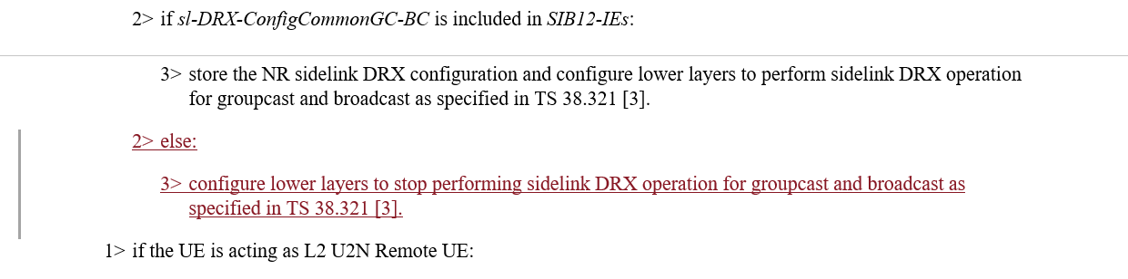

**Q8: Would you company agree the above change proposed in R2-2209878?**

|  |  |  |
| --- | --- | --- |
| Company | Agree/Disagree | Further comments |
| Apple | No strong view | The ASN.1 indicates that IE “sl-DRX-ConfigCommonGC-BC”in SIB 12 is NEED R.  So, if the UE release the DRX configuration when this IE is absent, the UE cannot perform SL DRX operation anyway. |
| OPPO | Disagree | Checked with Xiaomi, intention is to prevent DRX if it is not supported by NW based on SIB flag, it is fine.  But no specification needed since:   * If we do this, we can/need do similar change for all SIB based NW capability indication * The change limits to GC/BC, yet we understand it is applicable to all cast types. |
| Xiaomi | Agree | Answer to Apple and OPPO’s fist question,  According to last meeting discussion, we observed there is diverse understanding about whether SL DRX is enabled if UE is under SL DRX incapable gNB. Some companies understand SL DRX shall be enabled based on preconfiguration, while some don’t. If UE behaviour regarding enabling/disable SL DRX is not consistent, data loss may occur between UEs. So, we suggest to make it clear.  For the other SIB based NW capability indication, there is no such diverse understanding.  Answer to OPPO’s second question,  We are fine if this change is also applicable to UC. But we understand UC SL DRX is negotiated between peer UEs, so peer UEs can be synchronized. But for GC/BC, TX and RX UE should be clear SL DRX is disabled in this case. |

**Q9: If RAN2 agree the above change proposed in clause 5.2.2.4.13, would you company agree to add the "no longer used/interested" message in clause 5.8.3.3 as below:**

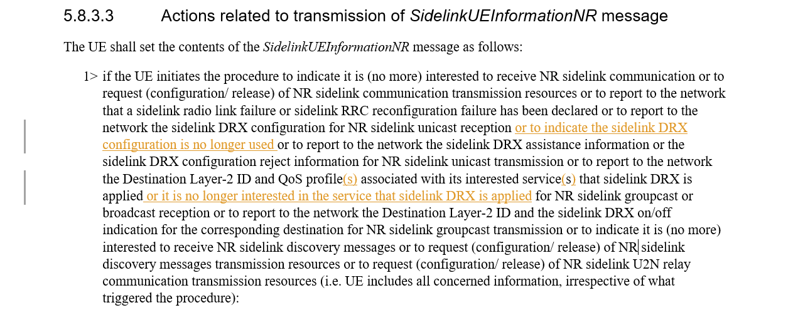

|  |  |  |
| --- | --- | --- |
| Company | Agree/Disagree | Further comments |
| Apple | No strong view | Can we just say “report to the network (any change of) the sidelink DRX configuration….which is similar to the text “is (no more) interested” used in the same paragraph ? |
| Xiaomi | Yes |  |
|  |  |  |

### 2.2.2 For the conditions of SUI

This change can be discussed together with changes proposed for clause 5.8.3.1 in R2-2209739.

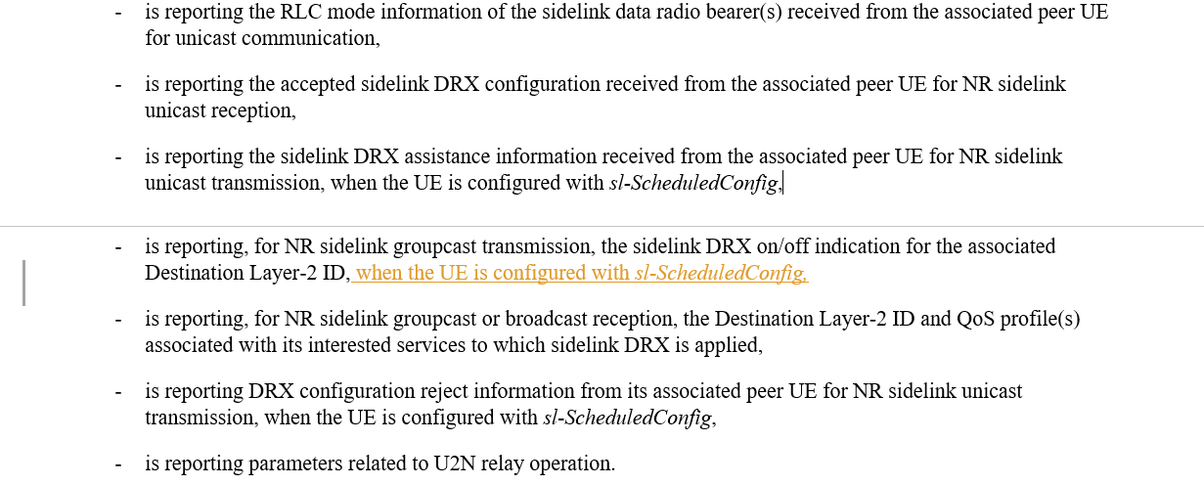

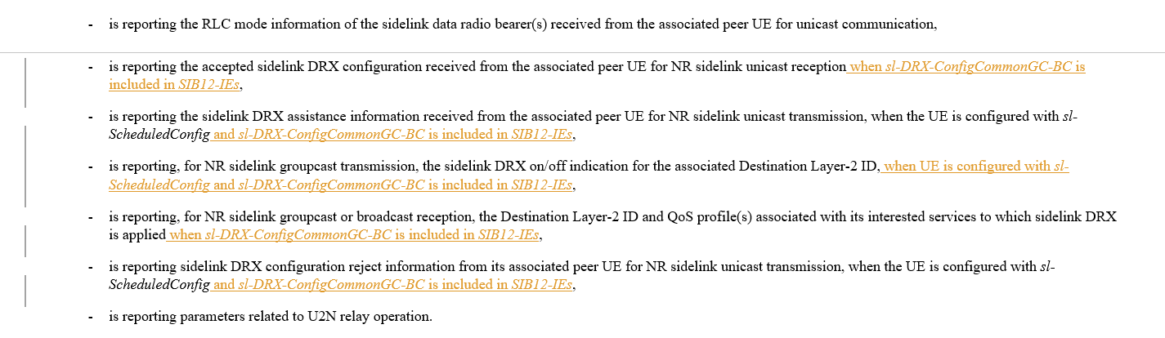

Rapporteur understands that the conditions for "Mode1/Mode2" and/or the conditions for "gNB supporting SL DRX" are agreed to be included in both 5.8.3.2 "Initiation" and 5.8.3.3 "Actions". For clause 5.8.3.1 though, it is "General", the above conditions might not need to be mentioned if they are anyway specified in 5.8.3.2 and 5.8.3.3. The sentences can become longer and longer and it is preferred not to have those conditions if they are not deemed as critically necessary. We can discuss even on whether to remove the Mode 1 conditions for assistance information and reject information.

**Q10: Would you company agree to have Mode 1 condition in clause 5.8.3.1 "General": Agree means to accept change for clause 5.8.3.1 in R2-2209878, Disagree means to even remove the current Mode 1 conditions for assistance information and reject information?**

|  |  |  |
| --- | --- | --- |
| Company | Agree/Disagree | Further comments |
| Apple | No | RAN2 has not agreed that GC/BC reporting Tx profile is limit to mode 1.  Based on RAN2#118 agreement,  For GC, UE reports L2 id and SL DRX on/off indication to the gNB.  We understand this applicable to all CONNECTED UEs. |
| OPPO | See comment | Different view from Apple, we understand it is limited to mode-1, as captured in spec already, and we see no reason to differ between GC/BC and UC/  W.r.t whether to do the change, no strong view though. |
| Xiaomi | Yes | Proponent |

**Q11: Would you company agree to have “gNB supporting SL DRX” condition, as proposed for clause 5.8.3.1 “General” in R2-2209379?**

|  |  |  |
| --- | --- | --- |
| Company | Agree/Disagree | Further comments |
| Apple | No | Agree with the rapporteur that there is no need to explicitly listing all the conditions |

One more change is proposed on the conditions for clause 5.8.3.2 “Initiation”:

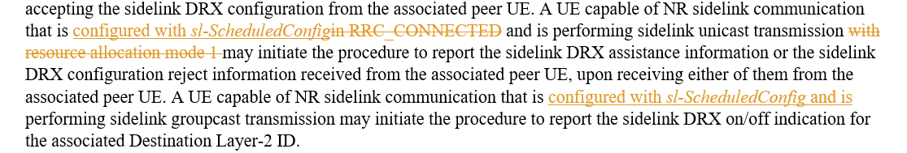

**Q12: Would you company agree to have “Mode 1” condition for GC, as proposed for clause 5.8.3.2 “** **Initiation” in R2-2209379?**

|  |  |  |
| --- | --- | --- |
| Company | Agree/Disagree | Further comments |
| Apple | No | We do not recall there is a agreement to limit this to mode 1. |
| OPPO | See comment | See our reply to Q10 |
| Xiaomi | Yes | Proponent |

**Q13: Would you company agree to remove "RRC_CONNECTED" condition for UC, as proposed for clause 5.8.3.2 "** **Initiation" in R2-2209379?**

|  |  |  |
| --- | --- | --- |
| Company | Agree/Disagree | Further comments |
| Apple | No | The current text is fine. No need to change. |
| Xiaomi | Yes | Proponent |

### 2.2.3 Other minor changes proposed in R2-2209878

For other minor changes proposed in R2-2209878, Rapporteur lists recommendation as below, companies can comment if you Disagree with Rapporteur recommendation:

|  |  |  |
| --- | --- | --- |
| Changes proposed | Rapp Recommendation | Company comments if disagree with Rapp |
|  | The term "operation" is used to cover the relay case. Rapp suggests to keep "operation" and adopt both (s) and another (s) in the first paragraph. |  |
|  | Rapp agree to replace the Mode 1 condition with configured with sl-ScheduledConfig. |  |
|  | Rapp agree to add two (s) here. |  |
|  | Rapp agree to add two (s) here. |  |
|  | Rapp think the title of field is clear already so no need for one more sentence. Recommend to change as "Indicates a sidelink DRX configuration for groupcast communication, which is applicable to any QoS profile or any Destination Layer-2 ID." |  |
|  | Rapp see no need for this change. These three sentences are indeed complex. We may further fine-tune them in Rapp CR review. |  |
|  | Rapp agree to add "and" |  |

## 2.3 For other changes in R2-2209739

For change in clause 5.3.5.14 as,

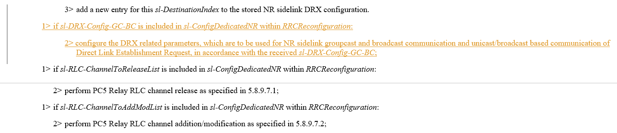

**Q14: Would you company agree the above change?**

|  |  |  |
| --- | --- | --- |
| Company | Agree/Disagree | Further comments |
| OPPO |  | sl-DRX-Config-GC-BC => sl-DRX-ConfigGC-BC |
| Xiaomi | Disagree | We understand *sl-DRX-Config-GC-BC* is always included in SIB12, if gNB supports SL DRX. Therefore, seems gNB would not configure this by dedicated signalling. |

The below change is understood as postponed from last meeting:

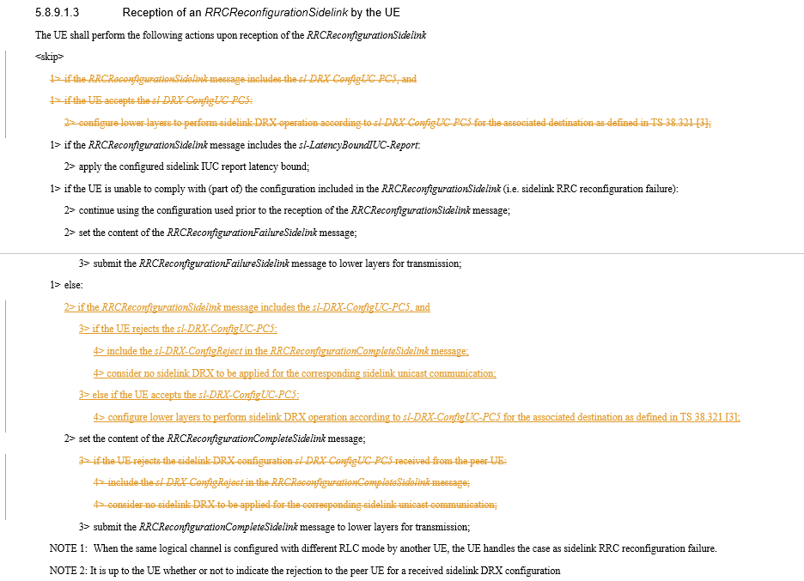

**Q15: Would you company agree the above change?**

|  |  |  |
| --- | --- | --- |
| Company | Agree/Disagree | Further comments |
| OPPO | Disagree | We fail to identify a critical issue to perform such change. |
| Xiaomi | Agree | We understand UE should perform compliance check before applying SL DRX configuration. |

## 2.4 For changes in R2-2209740



Rapporteur understands the other sidelink MAC CE shall reuse the same SR configuration.

**Q16: Would you company agree the above change?**

|  |  |  |
| --- | --- | --- |
| Company | Agree/Disagree | Further comments |
| Xiaomi | Agree |  |



For this change, Rapporteur propose one alternative as Option 1 below.

**Q17: Which option would you company support regarding above change?**

**Option 1: Indicates whether inter-UE coordination information triggered by a condition, other than explicit request reception, is enabled or not.**

**Option 2: Indicates whether inter-UE coordination information triggered by a condition is enabled or not. (as in R2-2209740)**

**Option 3: no change needed.**

**Option 4: others, please elaborate.**

|  |  |  |
| --- | --- | --- |
| Company | Option | Further comments |
| OPPO | 3 | With ‘by a condition’, it is clear already? |
| Xiaomi | 2 | Option 2 is cleaner. |

## 2.5 For changes in R2-2210542

Regarding changes of adding reference for discovery message, Rapporteur agrees and will add into the merged CR directly.

For the change proposed as below:

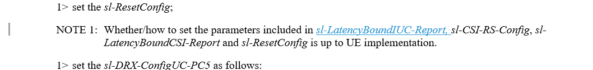

**Q18: Would you company agree the above change?**

|  |  |  |
| --- | --- | --- |
| Company | Agree/Disagree | Further comments |
| Xiaomi | Agree |  |

## 2.6 For changes regarding resource selection config in R2-2209463, R2-2209674

The following changes are proposed following RAN1 LS and Rapporteur understand they could be adopted. Companies can propose alternative wording for the FD.

In R2-2209463:

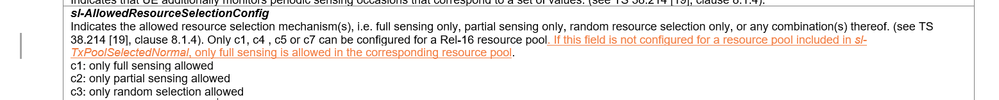

In R2-2209674:

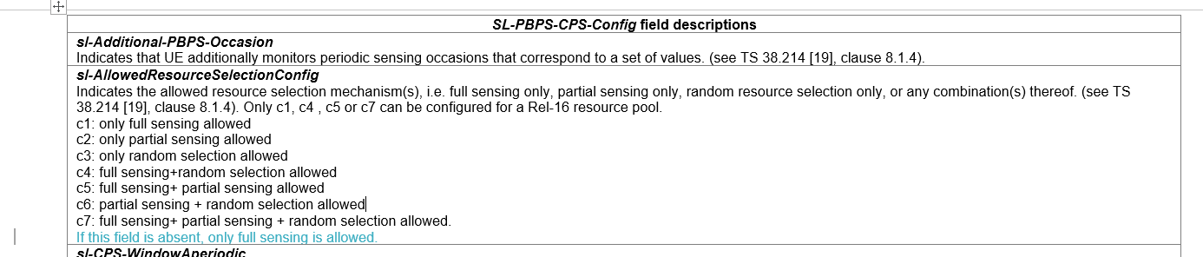

**Q19: Would you company agree the above changes?**

|  |  |  |
| --- | --- | --- |
| Company | Agree/Disagree | Further comments |
| OPPO | Agree |  |
| Xiaomi | Agree |  |

## 2.7 For changes related to default CBR parameters

Based on RAN1 LS R1-2208090, different implementations are proposed in R2-2209857:

 in R2-2210555:

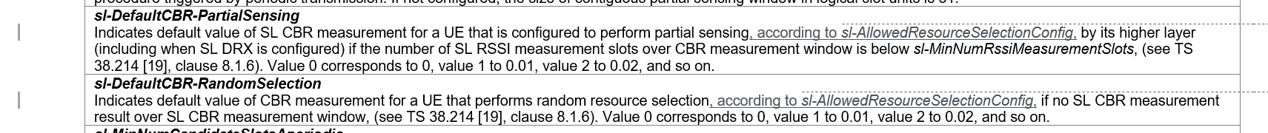



in R2-2209674:



**Q20: Would you company agree to add restriction in FD for partial sensing and random selection cases, as changes in R2-2210555?**

|  |  |  |
| --- | --- | --- |
| Company | Agree/Disagree | Further comments |
| OPPO | Disagree | If this Q is to ask for    We do not see this helps to solve the issue actually. |
|  |  |  |

Rapporteur understand changes for FD of sl-DefaultTxConfigIndex by R2-2209857 and R2-2209674 are almost equivalent as R2-2209857 propose "This field is applicable only when the UE performs full sensing. " meaning for all other cases this field is not applicable. Actual wording can be done during CR review.

**Q21: Would you company agree to add restriction in FD for full sensing case, as changes in R2-2209857, R2-2210555 and R2-2209674?**

|  |  |  |
| --- | --- | --- |
| Company | Agree/Disagree | Further comments |
| OPPO | Disagree | It is wrong!  For full sensing, it can be done in normal pool, if sensing result is available, and in this case, CBR result is also available, so no need to use default CBR value.  Or if sensing result is not available, UE switch to e-pool, using **random-selection, in that case,** sl-DefaultTxConfigIndex, is used. So it is actually the random-selection, caused by no-sensing-result for full-sensing in normal pool, makes use of the sl-DefaultTxConfigIndex |
|  |  |  |

## 2.8 Changes related to P4 and P5 in R2-2210779 (corresponding CR in R2-2209379)

Rapporteur understand it is related to P3 and P4 (as there is no P5) in R2-2210779.

P3 and related TP in R2-2210779 propose to add procedure texts to clarify the usage of R16/R17 default CBR values which is related to the discussion in above section where only changes on FD are discussed.

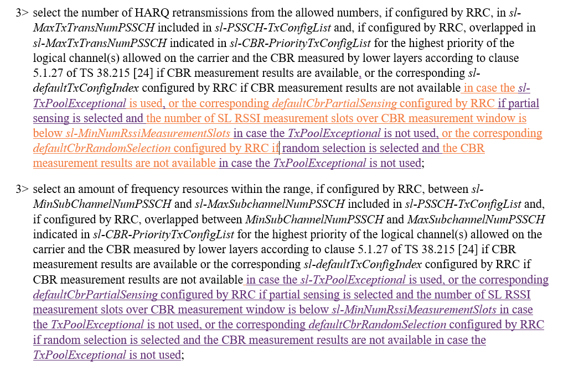

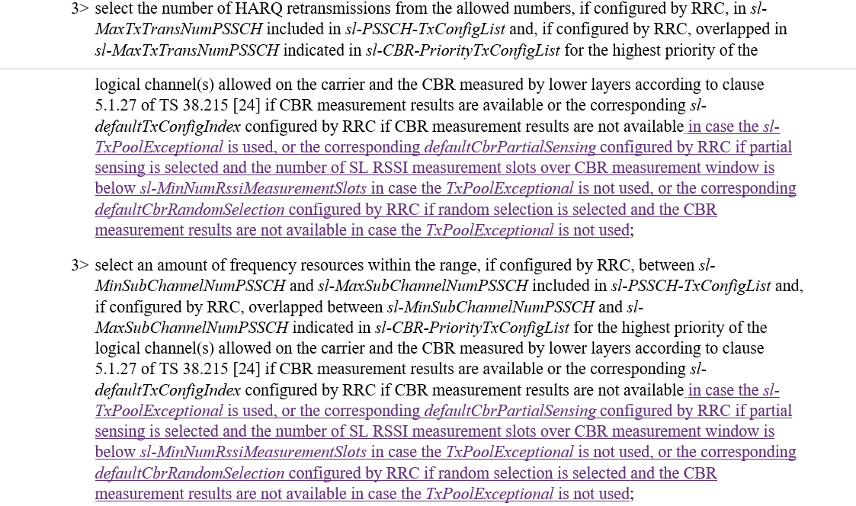

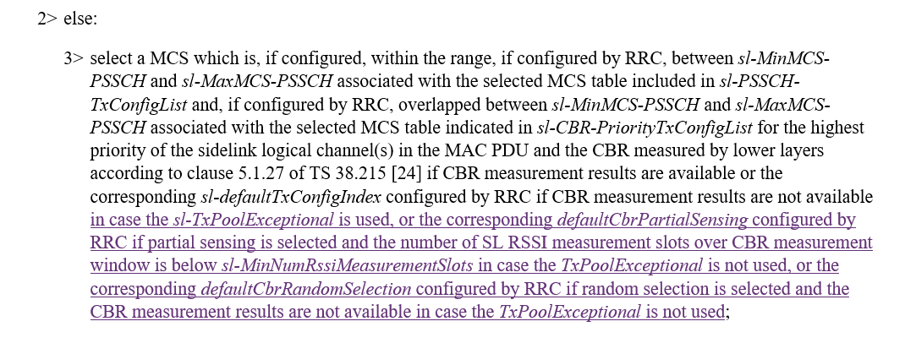

**Q22: Would your company agree the procedure changes proposed in R2-2210779, to clarify the usage of R16/R17 default CBR values?**

|  |  |  |
| --- | --- | --- |
| Company | Agree/Disagree | Further comments |
| OPPO | Agree | Yet we see this issue is being checked in MAC offline. Good to align between each other. |
| Xiaomi | Disagree | Proposed change is not aligned with RAN1 LS. Seems proponent believes for normal pool, R16 default CBR setting is not applicable. We can first send LS to RAN1 to check whether this is the correct understanding. |

**One NOTE is proposed via P4 in R2-2210779 and related TP as:**

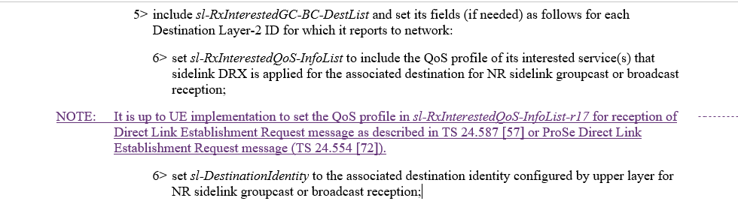

Rapporteur remind that 38.331-h20 has included one NOTE as below, so the actual change, if agreed, could be adjusted:

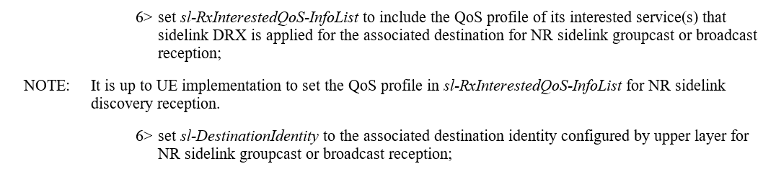

**Q23: Would your company agree the NOTE proposed via P4 in R2-2210779?**

|  |  |  |
| --- | --- | --- |
| Company | Agree/Disagree | Further comments |
| OPPO | Agree |  |
| Xiaomi | Disagree | It’s up to UE implementation. We don’t see the need for the NOTE. |

Also, change is proposed on related FD as:



**Q24: Would your company agree the change on FD of *sl-RxInterestedGC-BC-DestList***

**as proposed via P4 in R2-2210779?**

|  |  |  |
| --- | --- | --- |
| Company | Agree/Disagree | Further comments |
| OPPO | Agree |  |
| Xiaomi | Disagree | Similar as previous question. |

## 2.9 Other changes in R2-2209674

Extra conditions for UE reporting assistance information or DRX on/off indication: 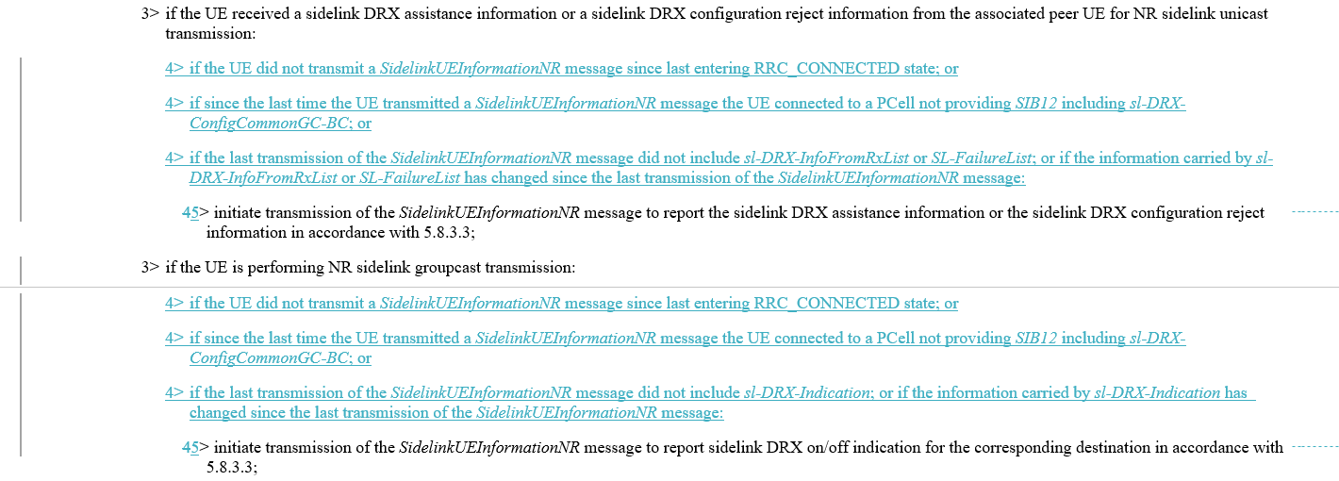

**Q25: Would your company agree the above changes on the additional conditions for UE to report assistance information and DRX on/off indication?**

|  |  |  |
| --- | --- | --- |
| Company | Agree/Disagree | Further comments |
| OPPO |  | OK although initiation condition of sl-TxResourceReqList has been covered by the existing text above |
| Xiaomi | Disagree | It’s discussed in last meeting and agreed without spec impact as below,  Proposal 5 (14/16) TX-UE store and report the related information (assistance information, DRX on-off indication) upon changing from mode-2 to mode-1. No spec impact. |
|  |  |  |

## 2.10 Change related to Q1 of RAN1 LS R2-2209310/R1-2208090

One action is agreed regarding Q1 of RAN1 LS R2-2209310/R1-2208090:

[Apple]: For R2-2209310, we need correction for the corresponding field description for the first RAN1 response. [Session chair]: Let’s discuss as part of email discussion [501]. Apple will contact RRC CR rapporteur with suggested change.

Apple provided change as below, in order to "to align the description to the language used in "sl-TriggerConditionCoordInfo” to be clear about this is for “piggyback” behaviour.":

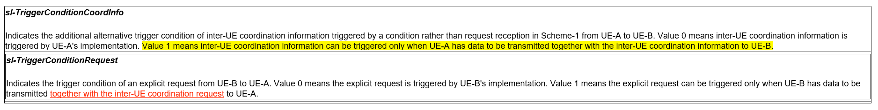

**Q26: Would your company agree the above change regarding RAN1 response for Q1 in R2-2209310?**

|  |  |  |
| --- | --- | --- |
| Company | Agree/Disagree | Further comments |
| Apple (Proponent) | Agree | The original description “UE-B has data to be transmitted to UE-A” can be misunderstood in different meaning (e.g, UE-B need trigger IUC to get resource for this data to be transmitted based on IUC response)  That is why we send a LS to RAN1. After reading the Q1 response, we get RAN1 confirmation as this is only for “piggybacking”. So, it is proper to align the text used in both "sl-TriggerConditionCoordInfo” & “"sl-TriggerConditionRequest” as both are containing conditions for “Piggyback”.. |
| OPPO | Disagree | We fail to follow    Did not R1 answer NOT always to piggyback?  And the Q was for *sl-TriggerConditionRequest*, why it leads to a change to *sl-TriggerConditionCoordInfo*? |
| Xiaomi | Agree | According to RAN1 LS as below, if alt2 is configured, only piggyback is allowed.   * A resource pool level (pre-)configuration can enable one of the following alternatives:   + Alt 1: it is up to UE-B’s implementation whether or not to trigger the request generation   + Alt 2: the request generation can be triggered only when UE-B has data to be transmitted to UE-A |

## Conclusion

# Reference:

R2-2210373 Rapporteur CR on TS 38.331 for SL enhancements Huawei, HiSilicon CR Rel-17 38.331 17.2.0 3541 - F NR_SL_enh-Core Late

R2-2209739 Miscellaneous corrections on TS 38.331 for SL DRX CATT CR Rel-17 38.331 17.2.0 3502 - F NR_SL_enh-Core

R2-2209740 Miscellaneous corrections on TS 38.331 for SL enhancement CATT CR Rel-17 38.331 17.2.0 3503 - F NR_SL_enh-Core

R2-2210542 Miscellaneous corrections on 38.331 vivo CR Rel-17 38.331 17.2.0 3551 - F NR_SL_enh-Core

R2-2209878 Correction on 38.331 Xiaomi draftCR Rel-17 38.331 17.2.0 F NR_SL_enh-Core

R2-2209772 Correction on SL transmission by OOC UE for SL communication and SL discovery Apple CR Rel-17 38.331 17.2.0 3505 - F NR_SL_enh-Core

R2-2209857 Discussion on RAN1 LS R1-2208090 Ericsson discussion Rel-17 NR_SL_enh-Core

R2-2210555 Clarification of default CBR parameters Samsung Research America CR Rel-17 38.331 17.2.0 3553 - F NR_SL_enh-Core

R2-2209463 Discussion on the LS in R2-2209311 for default resource selection scheme vivo discussion

R2-2209379 Correction for SL DRX OPPO draftCR Rel-17 38.331 17.2.0 F NR_SL_enh-Core

R2-2209674 correction on RRC spec for SUI initiation and IUC parameter ZTE Corporation, Sanechips draftCR Rel-17 38.331 17.2.0 F NR_SL_enh-Core