**3GPP TSG-RAN2 Meeting 119bis-e** **R2-2210931**

**Online, 10th – 19th October, 2022**

**Agenda item: 6.15.2**

**Source: Huawei, HiSilicon**

**Title: Summary of [AT119bis-e][501][V2X/SL] 38.331 corrections (Huawei)**

**Document for: Discussion and Decision**

1. Introduction

This is the summary of below offline discussion.

* [AT119bis-e][501][V2X/SL] 38.331 corrections (Huawei)

**Scope:** Discuss proposed corrections in R2-2210373, R2-2209739, R2-2209740, R2-2210542, R2-2209878, R2-2209772, R2-2209857, R2-22010555, R2-2209463, R2-2209674, and P4 and P5 in R2-2210779 (corresponding CR in R2-2209379). Merge agreeable corrections in a CR as much as possible (we may have separate CR if required, it’s up to rapporteur).

**Intended outcome:** 38.331 CR in R2-2210930 and discussion summary in R2-2210931 (if needed). Email approval.

**Deadline:** 10/17 12:00 (UTC)

Contact list

|  |  |  |  |
| --- | --- | --- | --- |
| Name | | Company | Email |
| Tao Cai | | Huawei, HiSilicon | tao.cai@huawei.com |
|  | |  |  |
|  |  | |  |
|  | |  |  |
|  | |  |  |
|  | |  |  |
|  | |  |  |
|  | |  |  |
|  | |  |  |
|  | |  |  |

1. Discussion

## 2.1 For changes in R2-2210373

### 2.1.1 First change in clause 5.8.8:

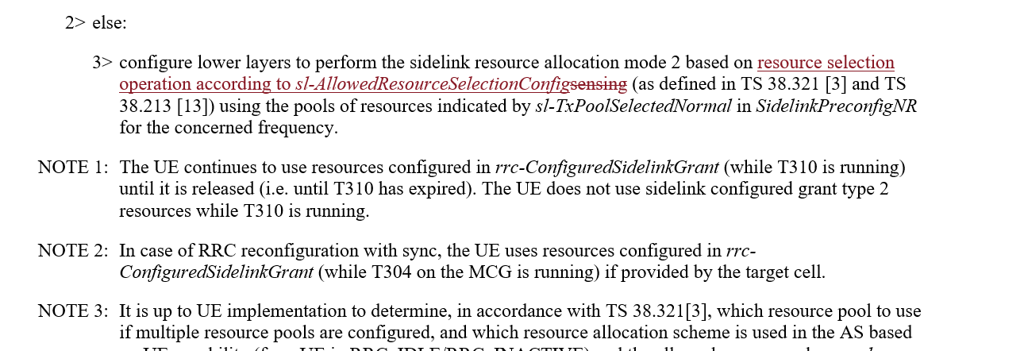

This change should be discussed together with change proposed in R2-2209772:

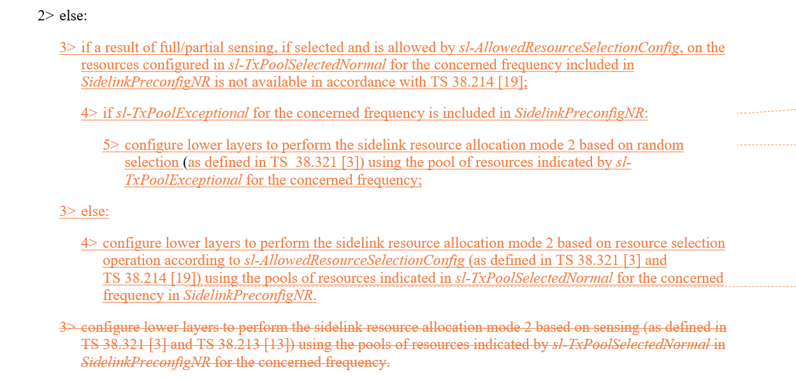

Rapporteur thinks the agreed changes will be applied also for clause 5.8.13.3 "NR sidelink discovery transmission", the other editorial changes proposed in R2-2209772 will be adopted.

**Q1: Would you company agree the UE actions shall be separately specified for the cases where the sensing results available or not available for OOC scenario?**

|  |  |  |
| --- | --- | --- |
| Company | Agree/Disagree | Further comments |
| Huawei, HiSilicon | Agree |  |

**[Summary]**

**[Proposals]**

**Q2: If RAN2 agree to specify UE behaviour where the sensing results are not available for OOC scenario, do your company agree the corresponding changes proposed in R2-2209772?**

|  |  |  |
| --- | --- | --- |
| Company | Agree/Disagree | Further comments |
| Huawei, HiSilicon | Agree |  |

**Q3: If RAN2 agree to specify UE behaviour where the sensing results are available for OOC scenario, do your company agree the corresponding changes proposed in R2-2210373/R2-2209772 (bar editorial difference)?**

|  |  |  |
| --- | --- | --- |
| Company | Agree/Disagree | Further comments |
| Huawei, HiSilicon | Agree |  |

### 2.1.2 2nd change of R2-2210373:

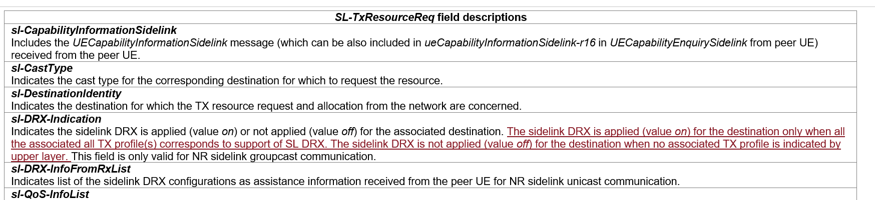

**Q4: Would you company agree the 2nd change proposed in R2-2210373?**

|  |  |  |
| --- | --- | --- |
| Company | Agree/Disagree | Further comments |
| Huawei, HiSilicon | Agree (proponent) |  |

### 2.1.3 3rd change of R2-2210373:



This change can be discussed together with change proposed in R2-2209878:

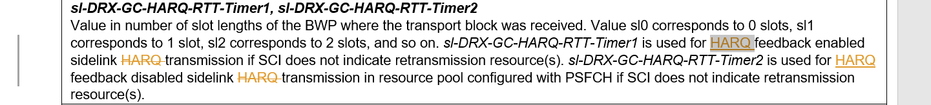



Rapporteur' d point out that:

1. After-change FD will be applied for both UC case and GC/BC case.

2. While FD for *HARQ-RTT-Timer* in Uu and SL seems not "sufficient" in 38.331 while in 38.321 HARQ-RTT-Timer is defined as:

- drx-HARQ-RTT-TimerSL (per SL HARQ process): the minimum duration before an SL retransmission grant is expected by the MAC entity;

Rapporteur understand the confusion might be caused by the original wording "sidelink transmission" or "sidelink HARQ transmission", as this RTT timer is the "sleep time" while UE is expecting the sidelink retransmission grant. This timer is not exactly for "a transmission" or "a HARQ transmission". Rapporteur thus suggests one option (option 1) as below for the FD, to be aligned with definition in 38.321.

**Q5: Which option would your company agree regarding the FD for sl-drx-HARQ-RTT-Timer1 and sl-drx-HARQ-RTT-Timer2?**

**Option 1: *sl-DRX-GC-HARQ-RTT-Timer1* is the minimum duration before an SL retransmission grant is expected by the MAC entity and used for HARQ feedback enabled case, if SCI does not indicate retransmission resource(s). *sl-DRX-GC-HARQ-RTT-Timer2* is the minimum duration before an SL retransmission grant is expected by the MAC entity and used for HARQ feedback disabled case in resource pool configured with PSFCH, if SCI does not indicate retransmission resource(s).**

**Option 2: No change for UC, 3rd change of R2-2210373 for GC/BC.**

**Option 3: change proposed in R2-2209878: *sl-DRX-GC-HARQ-RTT-Timer1* is used for HARQ feedback enabled sidelink ~~HARQ~~ transmission if SCI does not indicate retransmission resource(s). *sl-DRX-GC-HARQ-RTT-Timer2* is used for HARQ feedback disabled sidelink ~~HARQ~~ transmission in resource pool configured with PSFCH if SCI does not indicate retransmission resource(s).**

**Option 4: Others, please elaborate.**

|  |  |  |
| --- | --- | --- |
| Company | Option | Further comments |
| Huawei, HiSilicon | 1 |  |
|  |  |  |
|  |  |  |
|  |  |  |
|  |  |  |
|  |  |  |
|  |  |  |
|  |  |  |

### 2.1.4 Change on OLPC parameters:

This change is discussed together with change proposed in R2-2209858.

The online agreement on OLPC parameters is:

* A Rel-17 OLPC capable UE will ignore the legacy Rel-16 OLPC parameters for NR SL with suffix “-r16” if Rel-17 OLPC parameters are configured for NR SL with suffix “-r17”. FFS whether UE capability aspect need to be specified in FD.

R2-2209858 Corrections to 38331 on OLPC parameters Ericsson CR Rel-17 38.331 17.2.0 3514 - F NR_SL_enh-Core

* Will be handled in email discussion [501].

The below question is for deciding having/not having UE capability aspect in FD, companies can propose the actual FD wording for the OLPC parameters.

**Q6: Regarding FD for OLPC parameters, which option would you company agree?**

**Option 1: UE capability aspect need to be specified.**

**Option 2: UE capability aspect need NOT to be specified.**

|  |  |  |
| --- | --- | --- |
| Company | Option | Further comments |
|  |  |  |

### 2.1.5 Editorial changes in R2-2210373:











**Q7: Would you company Disagree the editorial change above?**

|  |  |  |
| --- | --- | --- |
| Company | Disagree | Further comments |
|  |  |  |
|  |  |  |

## 2.2 For other changes in R2-2209878

### 2.2.1 For the case gNB does not support SL DRX:

It is argued that "The UE behaviour is missing when sl-DRX-ConfigCommon-GC-BC is not present in SIB12." and the below change is proposed in clause 5.2.2.4.13 "Actions upon reception of SIB12":

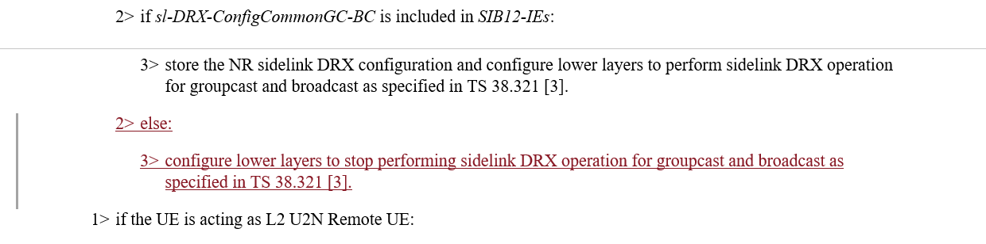

**Q8: Would you company agree the above change proposed in R2-2209878?**

|  |  |  |
| --- | --- | --- |
| Company | Agree/Disagree | Further comments |
|  |  |  |

**Q9: If RAN2 agree the above change proposed in clause 5.2.2.4.13, would you company agree to add the "no longer used/interested" message in clause 5.8.3.3 as below:**

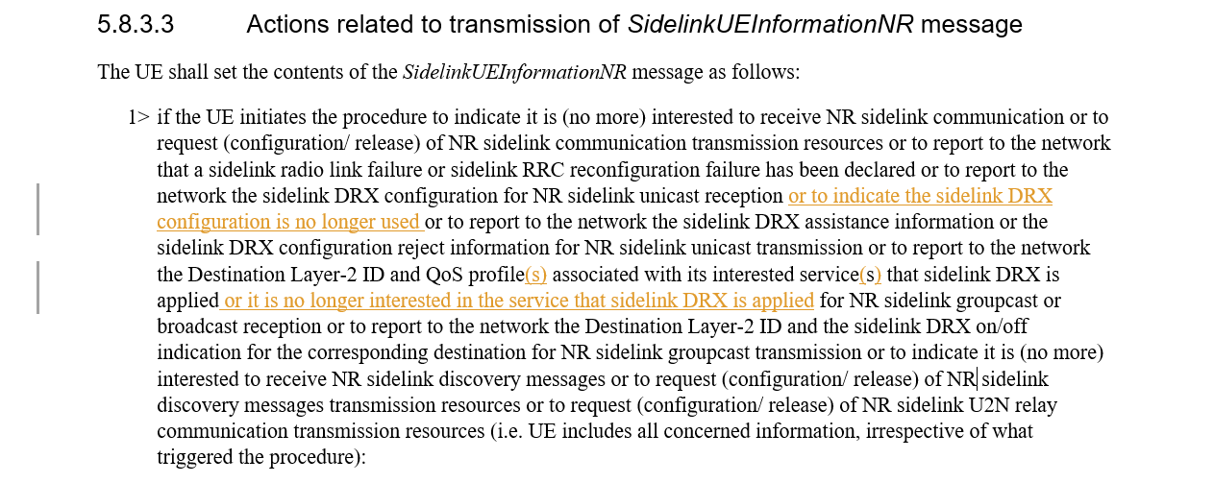

|  |  |  |
| --- | --- | --- |
| Company | Agree/Disagree | Further comments |
|  |  |  |

### 2.2.2 For the conditions of SUI

This change can be discussed together with changes proposed for clause 5.8.3.1 in R2-2209739.

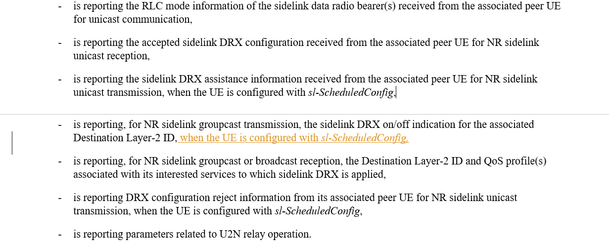

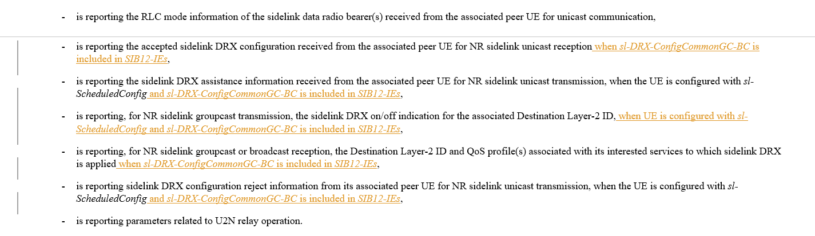

Rapporteur understands that the conditions for "Mode1/Mode2" and/or the conditions for "gNB supporting SL DRX" are agreed to be included in both 5.8.3.2 "Initiation" and 5.8.3.3 "Actions". For clause 5.8.3.1 though, it is "General", the above conditions might not need to be mentioned if they are anyway specified in 5.8.3.2 and 5.8.3.3. The sentences can become longer and longer and it is preferred not to have those conditions if they are not deemed as critically necessary. We can discuss even on whether to remove the Mode 1 conditions for assistance information and reject information.

**Q10: Would you company agree to have Mode 1 condition in clause 5.8.3.1 "General": Agree means to accept change for clause 5.8.3.1 in R2-2209878, Disagree means to even remove the current Mode 1 conditions for assistance information and reject information?**

|  |  |  |
| --- | --- | --- |
| Company | Agree/Disagree | Further comments |
|  |  |  |

**Q11: Would you company agree to have "gNB supporting SL DRX" condition, as proposed for clause 5.8.3.1 "General" in R2-2209379?**

|  |  |  |
| --- | --- | --- |
| Company | Agree/Disagree | Further comments |
|  |  |  |

One more change is proposed on the conditions for clause 5.8.3.2 "Initiation":

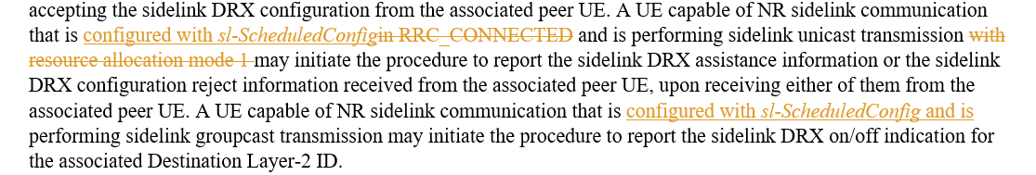

**Q12: Would you company agree to have "Mode 1" condition for GC, as proposed for clause 5.8.3.2 "** **Initiation" in R2-2209379?**

|  |  |  |
| --- | --- | --- |
| Company | Agree/Disagree | Further comments |
|  |  |  |

**Q13: Would you company agree to remove "RRC_CONNECTED" condition for UC, as proposed for clause 5.8.3.2 "** **Initiation" in R2-2209379?**

|  |  |  |
| --- | --- | --- |
| Company | Agree/Disagree | Further comments |
|  |  |  |

### 2.2.3 Other minor changes proposed in R2-2209878

For other minor changes proposed in R2-2209878, Rapporteur lists recommendation as below, companies can comment if you Disagree with Rapporteur recommendation:

|  |  |  |
| --- | --- | --- |
| Changes proposed | Rapp Recommendation | Company comments if disagree with Rapp |
|  | The term "operation" is used to cover the relay case. Rapp suggests to keep "operation" and adopt both (s) and another (s) in the first paragraph. |  |
|  | Rapp agree to replace the Mode 1 condition with configured with sl-ScheduledConfig. |  |
|  | Rapp agree to add two (s) here. |  |
|  | Rapp agree to add two (s) here. |  |
|  | Rapp think the title of field is clear already so no need for one more sentence. Recommend to change as "Indicates a sidelink DRX configuration for groupcast communication, which is applicable to any QoS profile or any Destination Layer-2 ID." |  |
|  | Rapp see no need for this change. These three sentences are indeed complex. We may further fine-tune them in Rapp CR review. |  |
|  | Rapp agree to add "and" |  |

## 2.3 For other changes in R2-2209739

For change in clause 5.3.5.14 as,

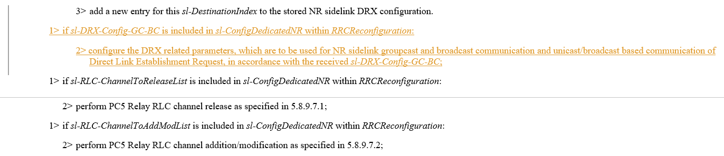

**Q14: Would you company agree the above change?**

|  |  |  |
| --- | --- | --- |
| Company | Agree/Disagree | Further comments |
|  |  |  |

The below change is understood as postponed from last meeting:

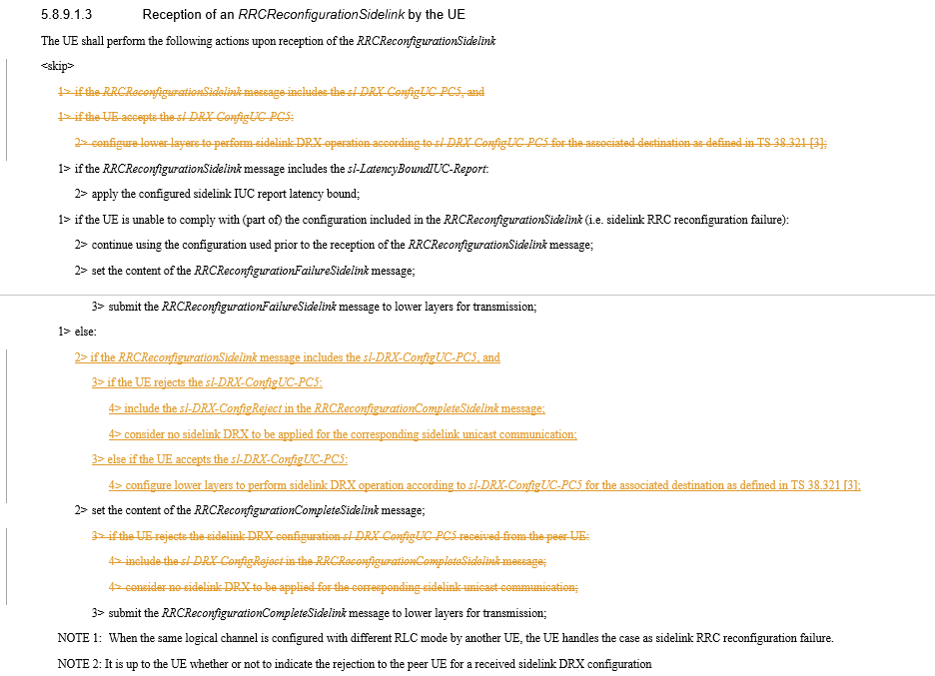

**Q15: Would you company agree the above change?**

|  |  |  |
| --- | --- | --- |
| Company | Agree/Disagree | Further comments |
|  |  |  |

## 2.4 For changes in R2-2209740



Rapporteur understands the other sidelink MAC CE shall reuse the same SR configuration.

**Q16: Would you company agree the above change?**

|  |  |  |
| --- | --- | --- |
| Company | Agree/Disagree | Further comments |
|  |  |  |



For this change, Rapporteur propose one alternative as Option 1 below.

**Q17: Which option would you company support regarding above change?**

**Option 1: Indicates whether inter-UE coordination information triggered by a condition, other than explicit request reception, is enabled or not.**

**Option 2: Indicates whether inter-UE coordination information triggered by a condition is enabled or not. (as in R2-2209740)**

**Option 3: no change needed.**

**Option 4: others, please elaborate.**

|  |  |  |
| --- | --- | --- |
| Company | Option | Further comments |
|  |  |  |

## 2.5 For changes in R2-2210542

Regarding changes of adding reference for discovery message, Rapporteur agrees and will add into the merged CR directly.

For the change proposed as below:

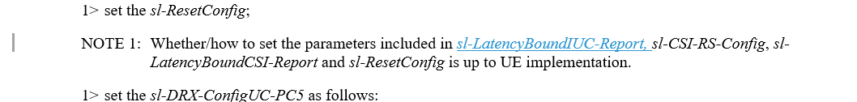

**Q18: Would you company agree the above change?**

|  |  |  |
| --- | --- | --- |
| Company | Agree/Disagree | Further comments |
|  |  |  |

## 2.6 For changes regarding resource selection config in R2-2209463, R2-2209674

The following changes are proposed following RAN1 LS and Rapporteur understand they could be adopted. Companies can propose alternative wording for the FD.

In R2-2209463:

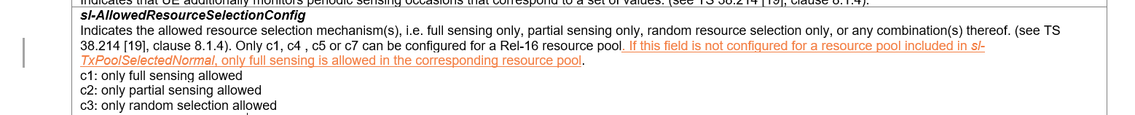

In R2-2209674:

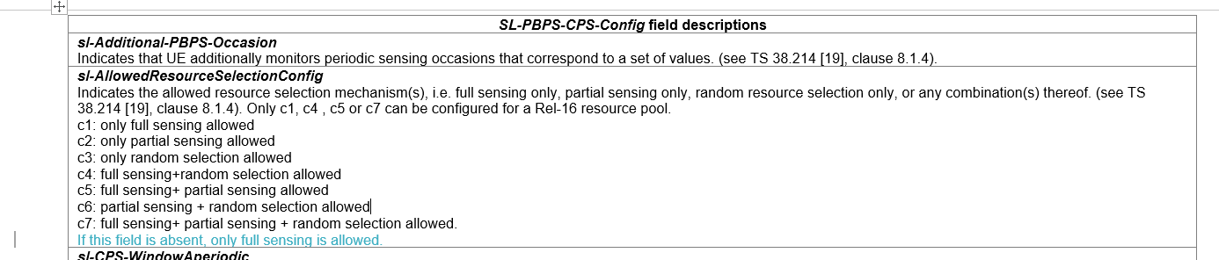

**Q19: Would you company agree the above changes?**

|  |  |  |
| --- | --- | --- |
| Company | Agree/Disagree | Further comments |
|  |  |  |

## 2.7 For changes related to default CBR parameters

Based on RAN1 LS R1-2208090, different implementations are proposed in R2-2209857:

 in R2-2210555:

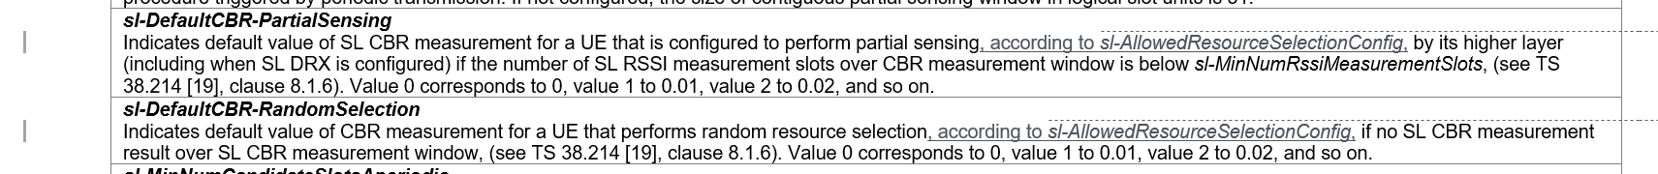



in R2-2209674:



**Q20: Would you company agree to add restriction in FD for partial sensing and random selection cases, as changes in R2-2210555?**

|  |  |  |
| --- | --- | --- |
| Company | Agree/Disagree | Further comments |
|  |  |  |
|  |  |  |

Rapporteur understand changes for FD of sl-DefaultTxConfigIndex by R2-2209857 and R2-2209674 are almost equivalent as R2-2209857 propose "This field is applicable only when the UE performs full sensing. " meaning for all other cases this field is not applicable. Actual wording can be done during CR review.

**Q21: Would you company agree to add restriction in FD for full sensing case, as changes in R2-2209857, R2-2210555 and R2-2209674?**

|  |  |  |
| --- | --- | --- |
| Company | Agree/Disagree | Further comments |
|  |  |  |
|  |  |  |

## 2.8 Changes related to P4 and P5 in R2-2210779 (corresponding CR in R2-2209379)

Rapporteur understand it is related to P3 and P4 (as there is no P5) in R2-2210779.

P3 and related TP in R2-2210779 propose to add procedure texts to clarify the usage of R16/R17 default CBR values which is related to the discussion in above section where only changes on FD are discussed.

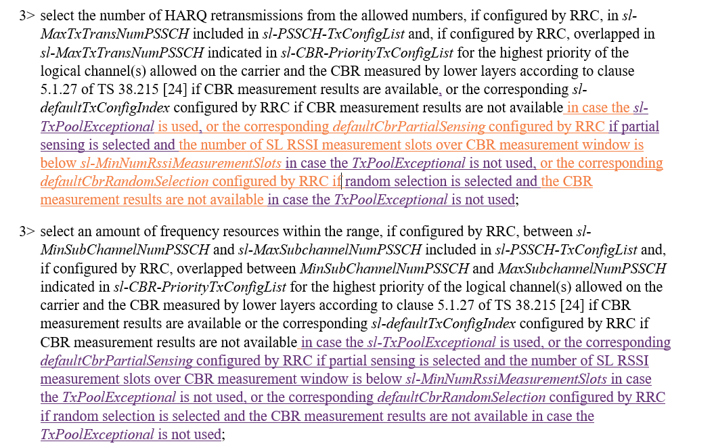

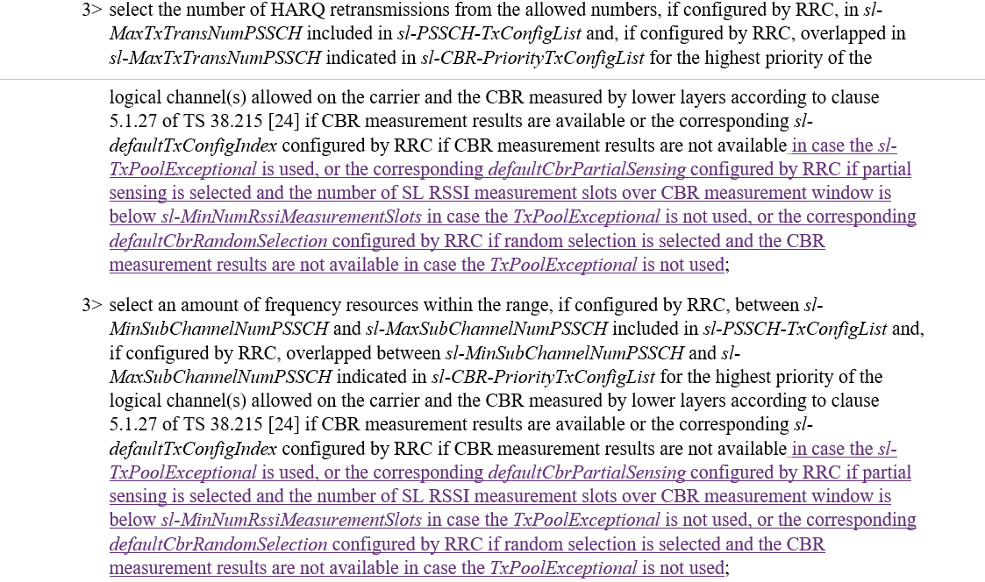

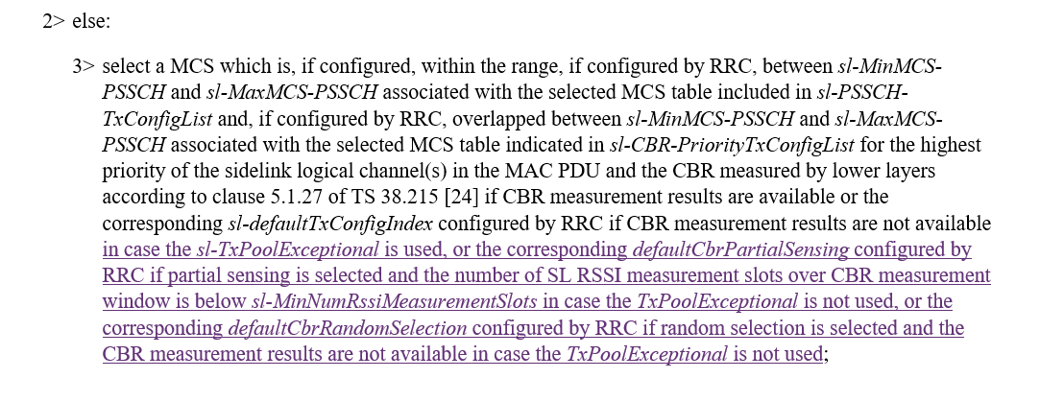

**Q22: Would your company agree the procedure changes proposed in R2-2210779, to clarify the usage of R16/R17 default CBR values?**

|  |  |  |
| --- | --- | --- |
| Company | Agree/Disagree | Further comments |
|  |  |  |
|  |  |  |

**One NOTE is proposed via P4 in R2-2210779 and related TP as:**

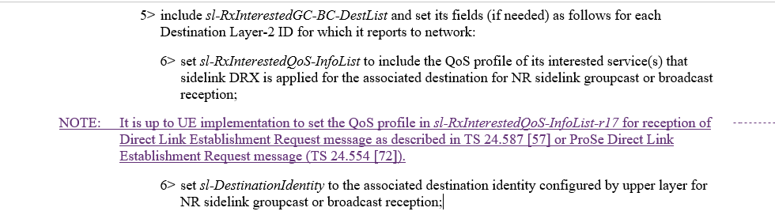

Rapporteur remind that 38.331-h20 has included one NOTE as below, so the actual change, if agreed, could be adjusted:

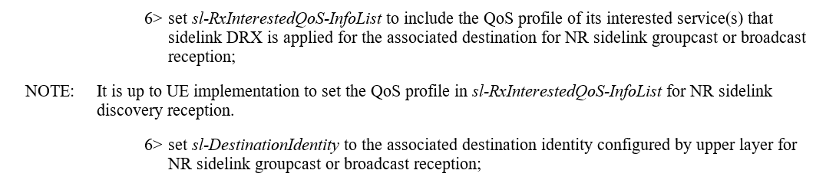

**Q23: Would your company agree the NOTE proposed via P4 in R2-2210779?**

|  |  |  |
| --- | --- | --- |
| Company | Agree/Disagree | Further comments |
|  |  |  |
|  |  |  |

Also, change is proposed on related FD as:



**Q24: Would your company agree the change on FD of *sl-RxInterestedGC-BC-DestList***

**as proposed via P4 in R2-2210779?**

|  |  |  |
| --- | --- | --- |
| Company | Agree/Disagree | Further comments |
|  |  |  |
|  |  |  |

## 2.9 Other changes in R2-2209674

Extra conditions for UE reporting assistance information or DRX on/off indication: 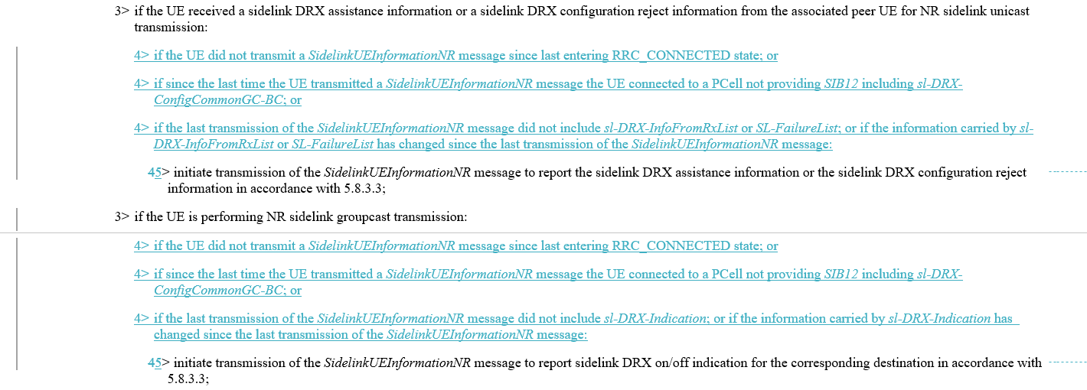

**Q25: Would your company agree the above changes on the additional conditions for UE to report assistance information and DRX on/off indication?**

|  |  |  |
| --- | --- | --- |
| Company | Agree/Disagree | Further comments |
|  |  |  |
|  |  |  |
|  |  |  |

## 2.10 Change related to Q1 of RAN1 LS R2-2209310/R1-2208090

One action is agreed regarding Q1 of RAN1 LS R2-2209310/R1-2208090:

[Apple]: For R2-2209310, we need correction for the corresponding field description for the first RAN1 response. [Session chair]: Let’s discuss as part of email discussion [501]. Apple will contact RRC CR rapporteur with suggested change.

Apple provided change as below, in order to "to align the description to the language used in "sl-TriggerConditionCoordInfo” to be clear about this is for “piggyback” behaviour.":

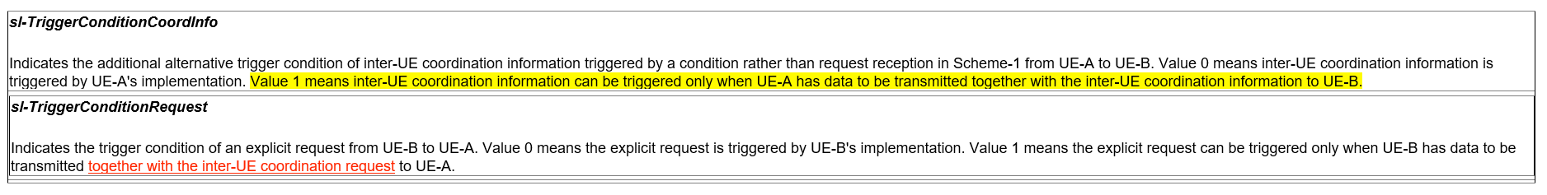

**Q26: Would your company agree the above change regarding RAN1 response for Q1 in R2-2209310?**

|  |  |  |
| --- | --- | --- |
| Company | Agree/Disagree | Further comments |
|  |  |  |
|  |  |  |
|  |  |  |

## Conclusion

# Reference:

R2-2210373 Rapporteur CR on TS 38.331 for SL enhancements Huawei, HiSilicon CR Rel-17 38.331 17.2.0 3541 - F NR_SL_enh-Core Late

R2-2209739 Miscellaneous corrections on TS 38.331 for SL DRX CATT CR Rel-17 38.331 17.2.0 3502 - F NR_SL_enh-Core

R2-2209740 Miscellaneous corrections on TS 38.331 for SL enhancement CATT CR Rel-17 38.331 17.2.0 3503 - F NR_SL_enh-Core

R2-2210542 Miscellaneous corrections on 38.331 vivo CR Rel-17 38.331 17.2.0 3551 - F NR_SL_enh-Core

R2-2209878 Correction on 38.331 Xiaomi draftCR Rel-17 38.331 17.2.0 F NR_SL_enh-Core

R2-2209772 Correction on SL transmission by OOC UE for SL communication and SL discovery Apple CR Rel-17 38.331 17.2.0 3505 - F NR_SL_enh-Core

R2-2209857 Discussion on RAN1 LS R1-2208090 Ericsson discussion Rel-17 NR_SL_enh-Core

R2-2210555 Clarification of default CBR parameters Samsung Research America CR Rel-17 38.331 17.2.0 3553 - F NR_SL_enh-Core

R2-2209463 Discussion on the LS in R2-2209311 for default resource selection scheme vivo discussion

R2-2209379 Correction for SL DRX OPPO draftCR Rel-17 38.331 17.2.0 F NR_SL_enh-Core

R2-2209674 correction on RRC spec for SUI initiation and IUC parameter ZTE Corporation, Sanechips draftCR Rel-17 38.331 17.2.0 F NR_SL_enh-Core