3GPP TSG-RAN WG2 #119bis-e R2-xxxxxxx

Online Meeting, Oct 10th – 19th, 2022

**Agenda item:** 8.2.2

**Source:** Qualcomm Incorporated

**Title:** Summary of [AT119bis-e][424][POS] SLPP/RSPP protocol design (Qualcomm)

Document for:  Discussion

# Introduction

This document summarizes the following email discussion:

* [AT119bis-e][424][POS] SLPP/RSPP protocol design (Qualcomm)

Scope: Continue discussion of P5/P6 of R2-2210363 and attempt to converge. Focus on what the use cases are and the functionalities that need to be supported by the protocol design.

Intended outcome: Report to CB session

Deadline: Friday 2022-10-14 1000 UTC

# Contact Information

|  |  |  |
| --- | --- | --- |
| Name | Company | E-mail Contact |
| Dan Vassilovski | Qualcomm | dvassilo@qti.qualcomm.com |
| Sasha Sirotkin | Apple | ssirotkin@apple.com |
| Jonggil Nam | LG | jonggil.nam@lge.com |
| Xuelong Wang | MediaTek | xuelong.wang@mediatek.com |
| Jinhui Wen | NEC | wenjinhui@labs.nec.cn |
| Ansab Ali | Intel Corporation | ansab.ali@intel.com |
|  |  |  |
|  |  |  |
|  |  |  |
|  |  |  |
|  |  |  |

# Background

RAN2 has reached the following agreements regarding Sidelink Positioning protocol in RAN2 #119-e [1] and RAN2 #119bis-e [2].

In RAN2 #119-e, RAN2 agreed to introduce a new protocol for sidelink positioning procedures between UEs

|  |
| --- |
| Agreements:  Proposal 1 (modified): Confirm that for sidelink positioning in-coverage, partial coverage and out-of-coverage scenarios shall be supported. FFS if partial coverage case assumes anything about which UEs are in coverage.  Proposal 2: Study the architecture and signaling procedures to enable at least the following two operation scenarios:   * Operation Scenario 1: PC5-only-based positioning. * Operation Scenario 2: Combination of Uu- and PC5-based positioning. |

|  |
| --- |
| Agreement:  RAN2 follow SA2 on the architecture, including the possibility of a UE as a location server. FFS from RAN2 perspective if there are cases without a UE in the location server role. |

|  |
| --- |
| Agreement:  Proposal 4 (modified): Align with SA2/RAN1 on the terms for sidelink positioning, and introduce the following terms of UE role as the baseline for further discussion:   * Target UE: UE to be positioned * Anchor UE: UE supporting positioning of target UE, e.g., by transmitting and/or receiving reference signals for positioning, providing positioning-related information, etc., over the SL interface. FFS: clarification of the knowledge of the anchor UE.   Additional roles can be considered. |

|  |
| --- |
| Agreements:  Introduce a new protocol for sidelink positioning procedures between UEs (name FFS, e.g., RSPP, SLPP). FFS where it is specified.  The new protocol is a separate ASN.1 module from LPP (this does not necessarily imply whether it is included in 37.355). |

|  |
| --- |
| Agreement:  Study the potential impact to LPP for support of sidelink positioning procedures between UE and LMF. FFS how much impact (if any), e.g., only to carry the new protocol, and if the PC5-only and hybrid PC5+Uu cases are the same or different. |

In RAN2 #119bis-e, RAN2 agreed to introduce a new protocol for sidelink positioning procedures between UEs

|  |
| --- |
| Agreement:  Proposal 3 (modified): In order to enable sidelink positioning, SLPP/RSPP shall support at least the following functionalities:   1. SL Positioning Capability Transfer 2. SL Positioning Assistance Data exchange 3. SL Location Information Transfer 4. Error handling 5. Abort   This agreement does not imply any specific signalling structure. |

|  |
| --- |
| Agreements:  Proposal 5: Unicast/one-to-one operation is assumed as baseline for exchange of sidelink positioning signaling.  Proposal 6 (modified): RAN2 shall study applicability of at least the following positioning signaling for groupcast/broadcast (in addition to unicast), including addressing any security aspects (involving SA3 where needed). FFS the specific use case:   * SL positioning capability transfer * SL positioning assistance data * FFS SL location information transfer |

# Discussion

## SLPP/RSPP Session-Based and Session-less Operation

Sidelink positioning enables absolute position, relative position and range determination to be performed over sidelink communication. Sidelink positioning may be conducted between a pair of UEs, between a group of UEs and may involve a network component such as an LMF. To support sidelink positioning between UEs, RAN2 has agreed to introduce a new protocol (SLPP/RSPP), with the new protocol supporting at least the following functionality [1]:

* Sidelink Positioning Capability Transfer
* Sidelink Positioning Assistance Data exchange
* Sidelink Location Information Transfer
* Error handling
* Abort

Sidelink positioning will support numerous use cases, including V2X, public safety, commercial, and IIOT [4]. These use cases may involve stationary UEs, moving UEs or a combination of stationary and moving UEs. An individual UE in one of these use cases may wish to initiate sidelink positioning with one or more UEs in its vicinity (UEs with which it can establish sidelink communication). Those UEs may constitute all the UEs in the initiating UE’s vicinity, a subset of the UEs in the initiating UE’s its vicinity or only a single UE in the initiating UE’s vicinity. A possible example for a V2X scenario is illustrated in Figure 1. In this example UE1 initiates sidelink positioning with the single UE in its vicinity in Figure 1(A), with all UEs in its vicinity in Figure 1(B) and with a subset of three of the UEs in its vicinity in Figure 1(C). Note that although the example in the figure is for a V2X use case, the three scenarios illustrated are equally applicable to public safety, commercial and IIOT use cases as well.

**Observation 1**: A UE may initiate sidelink positioning with one of the UEs in its vicinity, or a group of UEs in its vicinity. When initiating with a group of UEs, the group could constitute all or a subset of the UEs in the initiating UE’s vicinity.

As evident from Figure 1, sidelink positioning use cases include scenarios where an initiating UE determines which of the UEs in its vicinity it will conduct sidelink positioning with (which UEs in its vicinity to engage in SLPP/RSPP capability transfer, assistance data exchange and location information transfer). While UE Discovery facilitates knowledge of the UEs in the vicinity, Discovery by itself does not enable a UE to inform or notify other UEs they are participants in an sidelink positioning transaction. Enabling a UE with a mechanism to establish a sidelink positioning session (an SLPP/RSPP session) with one or more UEs from among all the UEs in its vicinity is a useful and enabling feature for sidelink positioning, and a capability that should be part of SLPP/RSPP.

**Observation 2**: Enabling a UE to notify one or more of the UEs in its vicinity as participants in a sidelink positioning session is a useful and enabling feature for SLPP/RSPP.

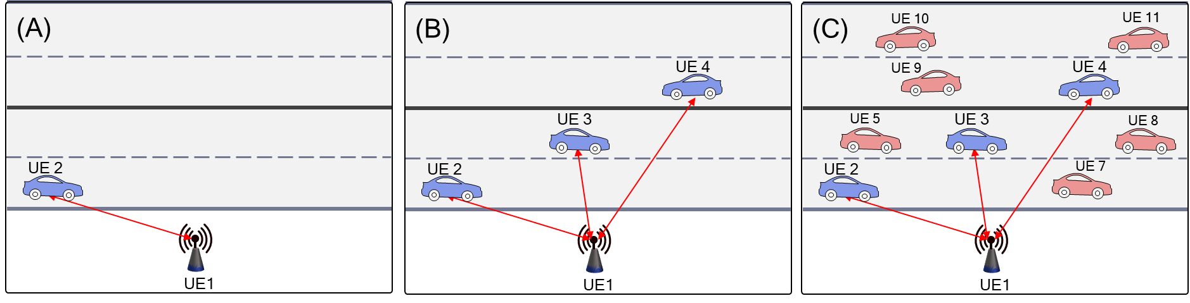

Figure 1: Sidelink Positioning for a group of vehicle UEs

Example procedural flows for SLPP/RSPP session establishment among UEs are illustrated in Figure 3, Figure 4 and Figure 4.

An example high-level overall procedure for establishing an SLPP/RSPP session for sidelink positioning is shown in Figure 3. Following UE discovery in Step 1, an SLPP/RSPP session is established in Step 2 (via a request-response described further in Figure 4 and Figure 4). In Step 3, sidelink ranging/positioning is conducted using the SLPP/RSPP functions for Capability transfer, Assistance Data exchange and Location Information transfer. In Step 4 the SLPP/RSPP session may be modified through the addition or removal of UEs. Session modification is particularly relevant to sidelink positioning given the dynamic nature of sidelink use cases introduced by UE mobility. It is quite likely UE accessibility within any initial set of UEs in a sidelink positioning session will change. It may also be noted UE identification at the SLPP/RSPP level is required for sidelink positioning, and as such SLPP/RSPP lends itself well to session participant management. However, even in a rather stationary scenario, any initial set of UEs in a SLPP/RSRP session may change. For example, once a SLPP/RSRP session has been established and capabilities have been exchanged, it seems likely that UEs may need to be removed/added from/to the SLPP/RSPP session, since not all UEs from the initial set may support the desired capability (e.g., may not support the desired SL positioning method, may not be able to act as an anchor UE, etc.).

Further illustration of how the SLPP/RSPP session establishment of Step 2 in Figure 3 may be conducted by SLPP/RSPP is provided in Figure 4 and Figure 4 for the case of a sidelink positioning SLPP/RSPP session between two UEs and a group of UEs, respectively. In the example of SLPP/RSPP between two UEs (Figure 4), following UE discovery in Step 1, the initiating UE (UE1) invites UE2 to become part of an SLPP session. Upon receiving a response from UE2, UE1 transmits an SLPP/RSPP message to initiate the sidelink positioning session, which UE2 acknowledges in Step 4. Subsequently UE1 and UE2 conduct sidelink positioning using the SLPP/RSPP functions described in Figure 3, Step 3 through Step 6 (Capability/Assistance/Location Info, Session Modification, Session Termination). The example of SLPP/RSPP between a group of UEs (Figure 4) may follow the same steps as illustrated for the SLPP/RSPP session between two UEs in Figure 4, extended to include SLPP/RSPP session invitation and SLPP/RSPP session initiation to multiple UEs.



Figure 2: Sidelink positioning based on SLPP/RSPP session establishment



Figure 3: Sidelink positioning based on SLPP/RSPP Session Establishment between two UEs



Figure 4: Sidelink positioning based on SLPP/RSPP Session Establishment among a group of UEs

The moderator’s view is the preceding description provides additional clarification for the use cases and protocol function motivating SLPP/RSPP session-based operation, and that SLPP/RSPP should support session-based operation, which may comprise one more of:

* Session establishment among a group of UEs
* Session modification among a group of UEs to add a UE to an SLPP/RSPP session
* Session modification among a group of UEs to remove a UE from an SLPP/RSPP session
* Session termination to end an SLPP/RSPP session

**Question 1**: Do companies agree SLPP/RSPP should support session-based operation (Y/N):

|  |  |  |
| --- | --- | --- |
| **Company** | **Yes/No** | **Comments** |
| Apple | Yes |  |
| LG | Yes, see comments | We think session-based SL positioning can be used in conjunction with Unicast type of SL positioning service. For example, it is necessary for ranging between two UEs, as in Figure 1 (A).  But for Groupcast or Broadcast type of SL positioning service, as in Figure 1 (B) and (C), we need further study whether session-based SL positioning is more efficient than session-less SL positioning. In those cases, the session-based one requires the establishment of the session with the individual UEs, as illustrated in Figure 4. We think it’s quite complex and may cause a long latency.  So we think that the session-based SL positioning is more suitable for SL positioning between two UEs.  In addition, considering hybrid (i.e. Uu- and PC5-based) positioning in in-coverage, SLPP session can work jointly with LPP session. Furthermore, SLPP session-based operation would be supported for exchanging SL positioning-related information between UEs due to it is hard to be covered by only with low layer signaling. |
| MediaTek | Yes and see comments | With reference to network involved position session management, session-based operation for SLPP/RSPP can be supported among the UEs. Meanwhile it is a bit unclear which layer will handle the session management between a pair of UEs. If it is to be supported by PC5-S layer, the session management signalling would be outside RAN2 scope and the main RAN2 impact would be to document it in the protocol design (analogous to LPP). |
| vivo | In SA2 scope | To our understanding, the existing session establishment is between AMF and LMF, which is in the scope of SA2. Thus, we think the similar procedure between UEs shall be discussed by SA2 as well. |
| NEC | Yes with comments | We agree to support session-based operation, but SLPP/RSPP session among a group of UEs may not be needed. For Figure 4, initiating UE still needs to initiate session (step 4) and start session (step 5) with each UE in the group, which is similar to multiple separate 1:1 sessions illustrated in Figure 3. And if needed, the group info can be sent or maintained on top of the sessions. So we don’t see any benefit for session among a group of UE (no procedure-related optimization). |
| Intel | Yes with comment | We assume the session based operation is derived from LPP and essentially involves signaling among anchor UE(s) and target UE in order to obtain location related measurements or a location estimate or to transfer assistance data over sidelink. So, it seems natural to extend this to SLPP. However, it needs to be discussed whether this has any impact on the supported cast types. From the preceding examples, it seems that some kind of groupcast/broadcast operation is assumed for the sidelink positioning signaling between UEs, but this is dependent on the support of groupcast/broadcast discussion which is still ongoing in RAN2.  Since it was agreed that unicast operation is taken as baseline for sidelink positioning signaling, RAN2 should discuss whether the session-based operation implies the need for unicast connection setup between involved UEs to perform SL positioning procedure from RAN2 point of view. |
|  |  |  |
|  |  |  |

**Summary**:

**Question 2**: If your response to Question 1 was at least partly positive, which functions should be supported by SLPP/RSPP session-based operation?

1. Session establishment among a group of UEs
2. Session modification among a group of UEs to add a UE to an SLPP/RSPP session
3. Session modification among a group of UEs to remove a UE from an SLPP/RSPP session
4. Session termination to end an SLPP/RSPP session
5. Other functions (please specify)

|  |  |  |  |  |  |  |
| --- | --- | --- | --- | --- | --- | --- |
| **Company** | **(A)**  **(Y/N)** | **(B)**  **(Y/N)** | **(C )**  **(Y/N)** | **(D)**  **(Y/N)** | **(E)**  **(Y/N)** | **Comments** |
| Apple | Y | Y | Y | Y | Y | We may also consider session modification for other reasons (other than adding/removing UEs) |
| LG | N, see comment | N, see comment | N, see comment | Y |  | As we commented in Question 1, we think the session-based operation is suitable for two-UE case. We need further study if it can also be used for group of UEs more than 2.  We suggest to replace “a group of UEs” with “a pair of UEs” in (A), (B), and (C)  We think anchor UE selection procedure (for selecting proper anchor UE) can be performed anytime during the SL positioning procedure. |
| MediaTek | Y | Maybe | Maybe | Y |  | As commented to Q1, the management of the group of the UEs may be supported at PC5-S layer, which is in SA2 regime.  Session modification adds some complexity, and it is not clear if there is a requirement for it. If the session management is determined to be in RAN2 scope, we think some more discussion on this aspect is needed to understand what doesn’t work if we don’t have it. |
| NEC | N | N | N | Y |  | We think that using separate 1:1 session will also work well. See Q1 for the reasons. |
| Intel |  |  |  |  |  | While all the proposed functionalities may be useful to consider, we wonder if session management in general would be handled by the upper layer and what is RAN2 scope |
|  |  |  |  |  |  |  |
|  |  |  |  |  |  |  |
|  |  |  |  |  |  |  |

**Summary**:

In addition to session-based operation, some scenarios may benefit from session-less operation. This may include scenarios with highly dynamic UEs where minimizing the signaling overhead for group maintenance associated with session-based operation is desirable. Such a scenario could be similar to Figure 5, in the case of a high-speed freeway where the set of UEs proximate for sidelink positioning changes rapidly.

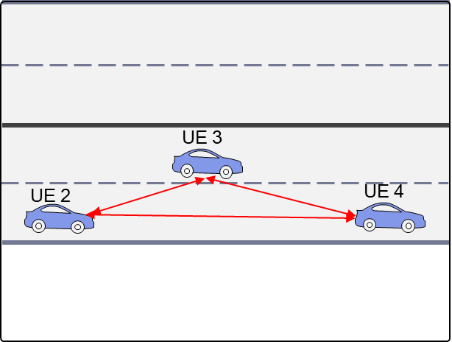

Figure 5: Sidelink positioning session-less scenario

Figure 6 provides an example of session-less operation. In Step 1 each UE transmits its Assistance data, comprising the SL-PRS configuration. In Step 2 UEs transmit their respective SL-PRS signals and conduct sidelink positioning measurements of received SL-PRS signals. In Step 3, UEs exchange location information and may subsequently use the exchanged information to determine range/position.



Figure 6: Sidelink positioning based on SLPP/RSPP Session-less operation among a group of 3 UEs

In the moderator’s view SLPP/RSPP session-less operation may provide a mechanism for sidelink positioning transactions which may be suitable in scenarios involving highly dynamic UE associations where the signaling overhead of session-based group management is less desired.

**Question 3**: Do companies agree SLPP/RSPP should support session-less operation (Y/N):

|  |  |  |
| --- | --- | --- |
| **Company** | **Yes/No** | **Comments** |
| Apple | Yes | In many use cases where SL positioning may be beneficial (e.g. V2X), where timing is critical, there may not be enough time to establish a session. Therefore, we think that session-less operation is at least as important, if not more, then session-based. |
| LG | Yes, see comment | As we commented in Question 1, we think that the session-less operation is more suitable than the session-based one for Groupcast or Broadcast type of SL positioning, as shown in Figure 1 (B) and (C) as well as Figure 5. In those cases, the session-based operation may cause a heavy signalling overhead and a long latency.  In the session-less Groupcast or Broadcast type of SL positioning as in Figure 1 (B) and (C), it may not be needed to exchange the assistance data between UEs. For example, the necessary SL positioning configurations can be (pre-)configured e.g. per resource pool or per region around RSU. Every UE is aware of the (pre-)configuration in advance. For example, RSU can periodically broadcast SL PRS based on the (pre-)configuration, and UE passing by the RSU can receive the SL PRS and measure it for its location calculation. It’s quite efficient in both signalling overhead and latency perspective. |
| MediaTek | No | As with the previous question, we are not sure this is in RAN2 scope anyway, but we tend to think a dynamic session can be established between UEs with a light signalling exchange.  The example seems a little incomplete to us, because it isn’t clear what UEs should be listening to what signalling. Does every UE monitor constantly for positioning signalling from every UE in range? If not, some handshake seems necessary to establish which UEs are involved in the positioning activity.  We have a question on the applicability of session less operation. If the target scenarios are involving highly dynamic UE associations, is it really possible to make SLPP/RSPP based positioning/ranging. In addition, if it is possible to do so, we do not think it is useful for the ranging, since the involving UE is not there anymore due to high movement. |
| vivo |  | The term session-less operation seems to be a similar concept with the broadcast-/ groupcast-based SL positioning without unicast interaction? If so, we shall focus on the solution for different cast types instead of introducing another new term. |
| NEC | Yes with comments | Fine with session-less operation. But security issues may need to be considered as any UE can send or receive positioning related information (e.g., some UE may send faked location information). |
| Intel | No | The use cases discussed for motivation of the session-less operation all assume groupcast/broadcast of sidelink positioning signaling, which is still under discussion. We also agree with MediaTek that the motivation of supporting highly dynamic UEs is not very clear. As per our comments in Q1, we think a more pertinent question for RAN2 to ask is whether SLPP/RSPP should be supported without the need for setting up dedicated unicast link(s) between peer UEs? |
|  |  |  |
|  |  |  |

**Summary**:

## SLPP/RSPP Centralized and Distributed Operation

Sidelink positioning use cases lend themselves to calculation of range and/or position either by one of the UEs participating in a sidelink positioning session or by multiple participating UEs participating in the session. the two examples for the V2X use case are illustrated in Figure 7. In Figure 7 (A), UE1 (an RSU) determines range/position for UE2, UE3 and UE4. In some operational scenarios UE1 may consume the resulting range/position calculation, and other operational scenarios UE1 may disseminate the results to one or more of the participating UEs (for example if it is important for UE2, UE3, UE4 to know their relative and/or absolute positions). Alternatively, as shown in Figure 7 (B), those UEs requiring relative and/or absolute position information may perform position/range calculations on their own based on the SLPP/RSPP session Location Information exchange. Note that while these examples are for the V2X use case, the example of a centralized and distributed sidelink positioning session is generally applicable to other sidelink positioning use cases, including public safety, commercial and IIOT.

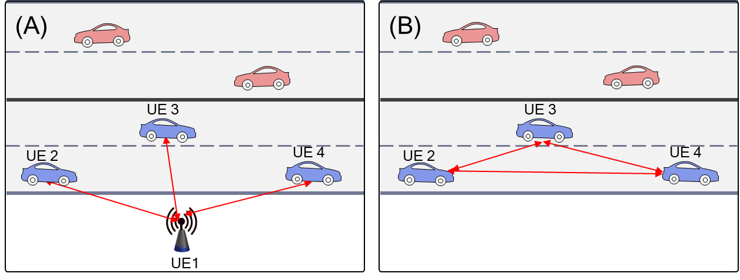

Figure 7: Centralized (A) and Distributed (B) Sidelink Positioning/Ranging

Example procedural flows for SLPP/RSPP centralized and distributed operation are illustrated in Figure 8 and Figure 9, respectively. Both centralized (Figure 8) and distributed (Figure 9) modes of operation follow the same first six steps (discovery, session establishment, Capability Transfer, and Assistance Data exchange). However, by enabling participating UEs to perform range/position calculations, the distributed mode of operation requires one less step than the centralized mode of operation (distribution of range/position by an SLPP/RSPP Provide Location Information is not required), resulting in a more expedient sidelink positioning session, potentially a significant benefit for UEs with dynamically changing position.



Figure 8: Sidelink positioning – Centralized position/range calculation



Figure 9: Sidelink positioning – Distributed position/range calculation

The moderator’s view is that sidelink positioning use cases motivate support for centralized and distributed SLPP/RSPP operation and as such that SLPP/RSPP should be made to enable these two modes of operation.

**Question 4**: Do companies agree SLPP/RSPP should support centralized operation where one UE performs range and/or position calculations on behalf of other UEs based on shared measurement/location information (Y/N):

|  |  |  |
| --- | --- | --- |
| **Company** | **Yes/No** | **Comments** |
| Apple |  | We prefer to defer this issue to a later stage when the overall solution is more clear |
| LG | Yes and No. See comments. | We need clarification on the centralized operation between the following two operations.   1. A specific UE (e.g. RSU) will always control or schedule the SL positioning of other UEs. That is, the role is fixed for the specific UE, and no other UE can do the role, as in LMF case in Uu link positioning. 2. Whenever a group of UEs participates in SL positioning of a target UE, one of the member UE (either target or anchor UE) can take the role of managing the SL positioning procedure. That is, forming a group, initiating the procedure, exchange the assistance data, etc.   If the proposed centralized operation refers to the first operation above, it is similar to SL positioning server UE beyond location calculation, as discussed in SA2. If it’s the case, we don’t support it.  Otherwise, if the proposal refers to the second operation, we support it. The role can be taken by either target or anchor UE within the group. |
| MediaTek | Yes | We think that centralized operation should be the baseline, which means the centralized UE uses multiple input to calculate the location (i.e., position/range). |
| vivo | Yes | The centralized operation is beneficial for some V2X use cases, e.g., platooning. |
| NEC | Yes | Agree to support centralized operation. |
| Intel |  | Agree with Apple that this has dependence on the overall architecture for SL positioning as well as the support of different cast types. For instance, Figure 9 seems to suggest that UE2 sends the provide location request in a groupcast/broadcast way and other UEs respond by providing location information in a groupcast/broadcast fashion. Based on what we discussed in this meeting, the benefit and feasibility of sending SL location info in groupcast/broadcast is still FFS; hence we think this discussion can be postponed. |
|  |  |  |
|  |  |  |

**Summary**:

**Question 5**: Do companies agree SLPP/RSPP should support distributed operation where each UE participating in an SLPP/RSPP sidelink positioning session may perform range and/or position calculations based on shared measurement/location information (Y/N):

|  |  |  |
| --- | --- | --- |
| **Company** | **Yes/No** | **Comments** |
| Apple |  | See answer to Q4 |
| LG | Yes, see the comment | Our understanding of the distributed operation proposed is that every UE within a group transmits and receives SL PRS each other, and calculates its own location by UE. So it is basically simultaneous UE-based positioning.  We support the proposal only for SL RTT-type positioning, where anyway both UEs associated with SL RTT should transmit and receive SL PRS. There is no additional transmission required for the proposed distributed operation. Maybe an additional transfer of measurement can be done, based on UE’s need for location calculation.  But if it is applied to SL TDOA positioning, the number of SL PRS transmissions will be N times of a single target UE positioning when the number of UEs is N in the group. It requires too much signalling overhead, and may cause too high congestion. We don’t support it. If a certain UE requires its own location calculation, the UE can simply initiate a new SL positioning. |
| MediaTek | see comments | The distributed mode may be supported. Meanwhile, during this mode, if the UE can use multiple input to calculate the location (i.e., position/range), there may be not big difference from centralized operation, other than the distribution of the location information to other UEs.  We see that in practice, there may be no need to define the terminology (centralized or distributed).  We propose to focus on the discussion in the following:   1. Can the UE collect multiple input to calculate the location? (We assume the answer has to be yes, e.g., to allow absolute position calculation based on measurements from multiple anchor UEs.)   Should the UE calculate the location for other UEs and distribution it to other UEs? (This is partly a service-layer question, but the RAN2 question is whether the signalling needs to support distribution of location information to multiple peer UEs.) |
| vivo | Low priority than centralized operation | Prefer to study the centralized operation first.  Compared with centralized positioning, the distributed operation may be more complicated as each UE may choose different location methods and anchor UEs. Furthermore, more PC5 connections may be needed if each UE would communicate with other UEs via unicast interaction. |
| NEC | Yes with comments | We think that distributed operation requires all UEs have the capability of calculating the position/range. If not, centralized operation may be preferred. |
| Intel |  | Similar comments as in Q4 |
|  |  |  |
|  |  |  |

**Summary**:

# Conclusion

Based on the discussion in section we propose the following:

# References

1. R2-2208704, “Report from session on positioning and sidelink relay,” 3GPP TSG-RAN WG2 Meeting #119-e, MediaTek
2. R2-22xxxxx, “Report from session on positioning and sidelink relay,” 3GPP TSG-RAN WG2 Meeting #119bis-e, MediaTek
3. R2-2210363, "Study of Sidelink Positioning Architecture, Signaling and Procedures", Qualcomm
4. RP-221814, “Revised SID on Study on expanded and improved NR positioning,” Intel, CATT, Ericsson