3GPP TSG-RAN WG2 Meeting #119bis Electronic R2-22xxxxx
Online, October 10-19, 2022

Agenda item: 6.7.2.4
Source: Apple
Title: [Draft]Summary of [AT119bis-e][421][Relay] Rel-17 relay MAC CR (Apple)
Document for: Discussion and Decision

1 Introduction
This document is a report on the following email discussion:
- [AT119bis-e][421][Relay] Rel-17 relay MAC CR (Apple)
Scope: Check the CR in R2-2209501.
Intended outcome: Agreed CR (without CB if possible)
Deadline: Friday 2022-10-14 1000 UTC

Company input for the questionnaire is to be done before Thursday 2022-10-13 1000 UTC

The only documents related to this discussion is:
R2-2209501 Miscellaneous corrections for NR sidelink Relay in TS 38.321 OPPO draftCR Rel-17 38.321 17.2.0 NR_SL_relay-Core

2 Contact Points
Respondents to the email discussion are kindly asked to fill in the following table.
Company | Name | Email Address
Apple(rapporteur) | Zhibin Wu | zhibin_wu@apple.com
OPPO | Boyuan Zhang | zhangboyuan@oppo.com
Xiaomi | Xing Yang | Yangxing1@xiaomi.com
Sharp | Chongming Zhang | Chongming.zhang@cn.sharp-world.com
CATT | Hao Xu | xuhao@catt.cn
Nokia | Sunyoung LEE | sunyoung.lee@nokia.com
Samsung | Hyunjeong Kang | hyunjeong.kang@samsung.com
vivo | Jing Liang | liangjing@vivo.com
MediaTek | Ming-Yuan Cheng | ming-yuan.cheng@mediatek.com
Ericsson | Nithin Srinivasan | nithin.srinivasan@ericsson.com
Qualcomm | Karthika Paladugu | kpaladug@qti.qualcomm.com

3 Discussion
As described in R2-2209571, the hierarchy of the procedure for resource pool selection for discovery transmission and SL data transmission in multiple MAC PDUs section is not aligned with that in single MAC PDU section, and it is claimed that caused ambiguity to the reader that the operation for single MAC PDU and multiple MAC PDUs are different.

The proposed change in section 5.22.1.1 of TS 38.321 is extracted and shown as follow:

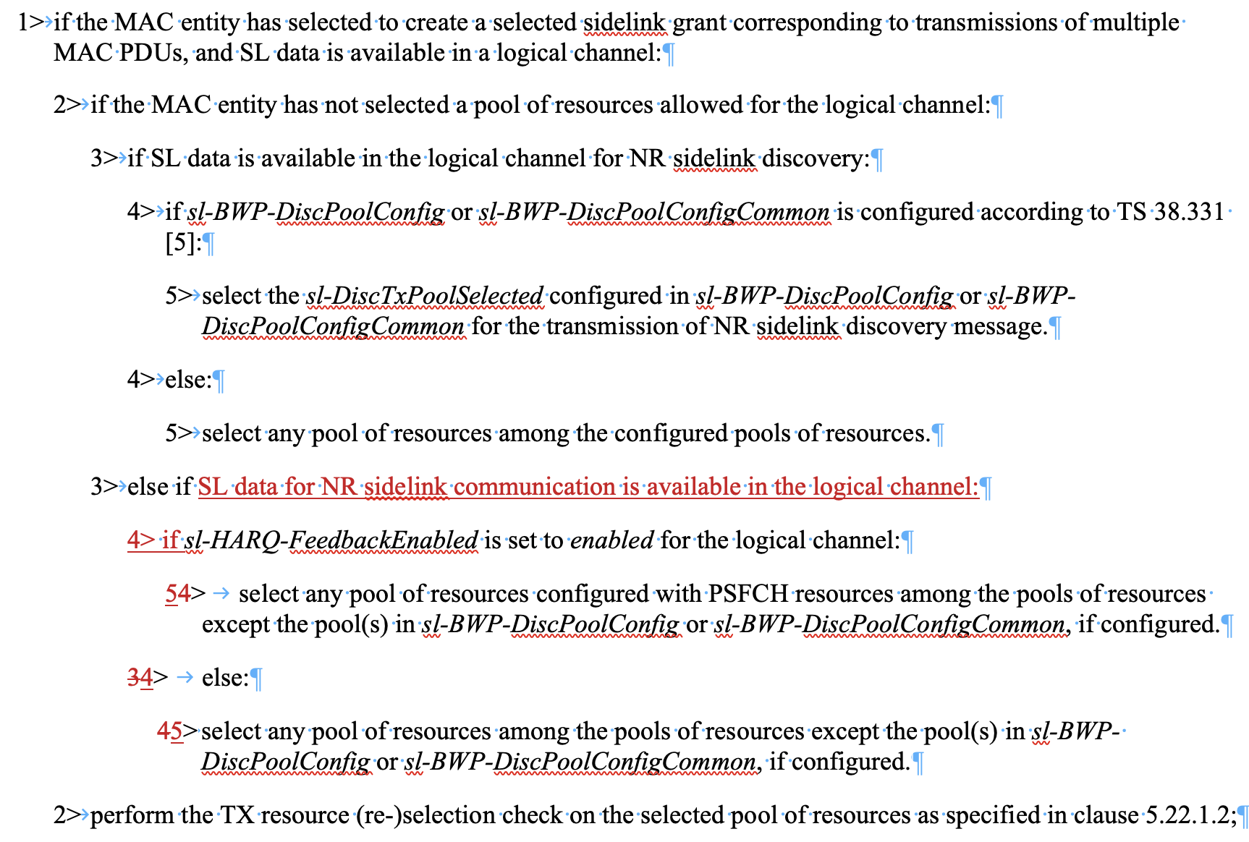

According to the current text in MAC TS 38.321, the level-1 bullet has already said “SL data is available in a logical channel”. So, other than the first level-3 “if SL data is available in the logical channel for NR sidelink discovery” branch, the remaining level-3 “else” case(s) can only refer to the case that “SL data for NR SL communication is available in the logical channel”. The underlying logic is: if the available traffic does not belong to NR SL discovery, then it must be for NR SL communication because there are no SL MAC CE to be considered for the “multiple MAC PDU” case in regards of resource pool selection. So, the current text also works, w/o the proposed change of the hierarchy.
The rapporteur understands that the procedure texts here are slightly different from single-MAC PDU case, because there is no need to describe pool selection for SL MAC CE (e.g. SL CSI Report MAC CE) in “multiple MAC PDU section”. But for the handling of SL data for NR SL communication, they are essentially same in the function level. Therefore, the rapporteur consider this change to be more of a cosmetic issue, not an essential correction.

Question 1: Do company agree with the rapporteur view that “the change is not essential” ?

Company | Yes/No | Comments
OPPO | No | First, we do not buy the arguments from rapp that “the procedure texts here are slightly different from single MAC PDU case, because there is no need to describe pool selection for SL MAC CE” We agree that SL-MAC CE does not need to be considered in multiple MAC PDU case, while we do not think this point will have impact on the pool selection procedure for discovery message transmission, whereas the procedural text should be supposed as aligned between single MAC PDU and multi MAC PDU cases.  Besides the issue of SL MAC CE mentioned by rapporteur, we think the logic will cause confusing if sticking to the original wording, since in the previous spec, we keep “if SL data is available in the logical channel for NR sidelink discovery” and “if sl-HARQ-FeedbackEnabled is set to enabled for the logical channel” as the same hierarchy, the misunderstanding can be that the original level-3 bullets  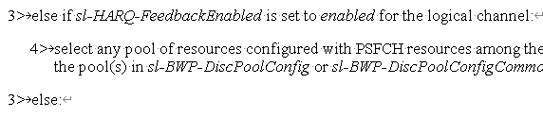  Are talking about a LCH for discovery (not necessary communication), when the buffer is empty, yet different HARQ feedback attributive, how to select the pool.  [Rapporteur] Just try to understand: in the following logical structure:  If (SL data is for discovery LCH):  else if ( ):  else:  why do you think the last two branches “else if” and “else” are still talking about a LCH for discovery?  [OPPO] because the if-condition is “SL data is available in the logical channel for NR sidelink discovery”. One may understand the else-condition is “SL data is unavailable in the logical channel for NR sidelink discovery”
Xiaomi | Yes | Agree with rapp. Level 1 already ask there is available data in LCH. So, empty buffer would not trigger resource pool selection. Also, following current structure, the else part only apply to sidelink communication.
Sharp | Yes | Agree with repporteur.
CATT | Yes | Agree with rapporteur，the reason of different between sidelink resource pool selection corresponding to transmissions of multiple MAC PDUs and single MAC PDU is that SL MAC CE is not considered for sidelink resource pool selection corresponding to transmissions of multiple MAC PDUs.
Nokia | Yes | There is no functional change and we see no ambiguity with the current text.
Samsung | Yes | Agree with Rapporteur
vivo | Yes | Agree with the rapporteur. The conditions of the same if/elseif/else loop would not cause misunderstanding. But we are also ok to follow majority view if they think alignment between single/multiple MAC PDU case is better.
MediaTek | Yes | Agree with Rapporteur
Ericsson | Yes | Agree with rapp
Qualcomm | Yes | It is not an essential change

Depending on the majority view of Q1, we may or may not pursue the CR. But there is no harm to collect some additional detail comments regarding the change itself, if any.

Question 2: If support to pursue the CR, do you have any further comments on the draftCR as provided in R2-2209501, please elaborate below if yes.

Company | Comments

4 Summary of Discussion
TBD

