3GPP TSG-RAN WG2 Meeting #119bis Electronic R2-22xxxxx
Online, October 10-19, 2022

Agenda item: 6.7.2.4
Source: Apple
Title: [Draft]Summary of [AT119bis-e][421][Relay] Rel-17 relay MAC CR (Apple)
Document for: Discussion and Decision

1 Introduction
This document is a report on the following email discussion:
- [AT119bis-e][421][Relay] Rel-17 relay MAC CR (Apple)
Scope: Check the CR in R2-2209501.
Intended outcome: Agreed CR (without CB if possible)
Deadline: Friday 2022-10-14 1000 UTC

Company input for the questionnaire is to be done before Thursday 2022-10-13 1000 UTC

The only documents related to this discussion is:
R2-2209501 Miscellaneous corrections for NR sidelink Relay in TS 38.321 OPPO draftCR Rel-17 38.321 17.2.0 NR_SL_relay-Core

2 Contact Points
Respondents to the email discussion are kindly asked to fill in the following table.
Company | Name | Email Address
Apple(rapporteur) | Zhibin Wu | zhibin_wu@apple.com

3 Discussion
As described in R2-2209571, the hierarchy of the procedure for resource pool selection for discovery transmission and SL data transmission in multiple MAC PDUs section is not aligned with that in single MAC PDU section, and it is claimed that caused ambiguity to the reader that the operation for single MAC PDU and multiple MAC PDUs are different.

The proposed change in section 5.22.1.1 of TS 38.321 is extracted and shown as follow:

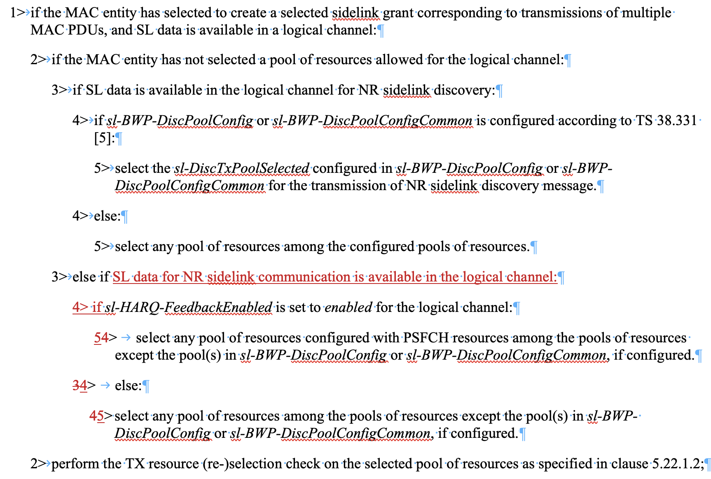

According to the current text in MAC TS 38.321, the level-1 bullet has already said “SL data is available in a logical channel”. So, other than the first level-3 “if SL data is available in the logical channel for NR sidelink discovery” branch, the remaining level-3 “else” case(s) can only refer to the case that “SL data for NR SL communication is available in the logical channel”. The underlying logic is: if the available traffic does not belong to NR SL discovery, then it must be for NR SL communication because there are no SL MAC CE to be considered for the “multiple MAC PDU” case in regards of resource pool selection. So, the current text also works, w/o the proposed change of the hierarchy.
The rapporteur understands that the procedure texts here are slightly different from single-MAC PDU case, because there is no need to describe pool selection for SL MAC CE (e.g. SL CSI Report MAC CE) in “multiple MAC PDU section”. But for the handling of SL data for NR SL communication, they are essentially same in the function level. Therefore, the rapporteur consider this change to be more of a cosmetic issue, not an essential correction.

Question 1: Do company agree with the rapporteur view that “the change is not essential” ?

Company | Yes/No | Comments

Depending on the majority view of Q1, we may or may not pursue the CR. But there is no harm to collect some additional detail comments regarding the change itself, if any.

Question 2: If support to pursue the CR, do you have any further comments on the draftCR as provided in R2-2209501, please elaborate below if yes.

Company | Comments

4 Summary of Discussion
TBD

