3GPP TSG-RAN WG2 Meeting #119bis Electronic R2-22xxxxx

E-Meeting, 10th – 19th Oct., 2022
Agenda item: 6.17.3
Source: Samsung
Title: Summary of [AT119bis-e][019][feMIMO] MAC related Corrections (Samsung)
Document for: Discussion & Decision

Introduction
This report summarizes the email discussion below that took place during RAN2#119bis-e meeting.
- [AT119bis-e][019][feMIMO] MAC related Corrections (Samsung)
Scope: Based on R2-2210796, referenced tdocs, online agreements and online comments, progress unclear points to determine agreeable parts. Capture agreeable parts in a CR.
Intended outcome: Report, In-principle-Agreed CR
Deadline: Schedule 1 (possibility for CB W2 if needed)

Contact information
Company | Contact Name | Email
Xiaomi | Yumin Wu | wuyumin@xiaomi.com
LGE | Hanul Lee | hanul.lee@lge.com
ZTE | Fei Dong | Dong.fei@zte.com.cn
Nokia | Samuli Turtinen | samuli.turtinen@nokia.com
Huawei, HiSilicon | David Lecompte | david.lecompte@huawei.com
Intel | Youn Heo | Youn.hyoung.heo@intel.com
Qualcomm | Ruiming Zheng | rzheng@qti.qualcomm.com
CATT | Erlin Zeng | erlin.zeng@catt.cn
OPPO | Zonda Du | duzhongda@oppo.com
Samsung | Seungri Jin | seungri.jin@samsung.com
Vivo | Chenli | Chenli5g@vivo.com

Discussion
RAN2 briefly discussed the MAC centric issues during the online session, and a number of agreements have made.

R2-2210796 [Pre119bis-e][001] Summary MAC centric corrections Samsung

DISCUSSION
P1
- Ericsson think there additionally is a sentence that need to be removed. Samsung think capturing R1 agreement is simplest. Intel think that the sentence need to remain to cover other types of coreset 0.
P2
- HW think the TP is not 100% accurate, but cannot explain in detail what it should be — think this is complicated. Chair think we can look at details offline if needed.
P3
- HW think the current TS is ok. Intel agrees, and think there are other ways to cancel. Vivo agrees this in an opt. Xiaomi as well. Samsung see no use case to continue the SR. Chair has some sympathy for Samsungs view but observes that there is no support for this proposal,
P4
- HW agrees. Vivo, Intel agrees as well
P5
- Bullet 4 change involves a functional change (mistake), should not be changed. Intel agrees

- P1: agreed, P2 can discuss based on comments (if needed)
- P3 not agreed
- P4 agreed
- P5 agreed as baseline except bullet 4 (which can be discussed)

TCI state indication of CORESET #0
Regarding below RAN1 agreements, RAN2 agreed below Proposal 1 and 2.
Agreement
UE does not expect CORESET#0 to be activated with two TCI states when it is associated with SS#0 for Type 0/0A/2 CSS
- Send an LS to inform RAN2 of the agreement

Proposal 1: Add a note to clarify the Eenhanced TCI State Indication for UE specific PDCCH MAC CE is not applicable to the CORESET configured by controlResourceSetZero if the CORESET is associated with the search space configured by searchSpaceZero for Type0/0A/2-PDCCH CSS.
Proposal 2: TP in R2-2209479 would be the baseline TP for Proposal 1.

6.1.3.44 Enhanced TCI States Indication for UE-specific PDCCH MAC CE
--skipped—
- CORESET ID: This field indicates a Control Resource Set identified with ControlResourceSetId as specified in TS 38.331 [5], for which the TCI State is being indicated. In case the value of the field is 0, the field refers to the Control Resource Set configured by controlResourceSetZero as specified in TS 38.331 [5]. The length of the field is 4 bits;
--skipped—
NOTE 1: The Enhanced TCI State Indication for UE specific PDCCH MAC CE is not applicable to any of the configured CORESETs in a BWP if the CORESETs are configured with different CORESETPoolindex values in the BWP.
NOTE 2: The Enhanced TCI State Indication for UE specific PDCCH MAC CE is applied only if sfnSchemePdcch is configured.
NOTE 3: The Enhanced TCI State Indication for UE specific PDCCH MAC CE is not applicable to the CORESET configured by controlResourceSetZero if the CORESET is associated with the search space configured by pdcch-ConfigSIB1 in MIB, or searchSpaceSIB1, searchSpaceZero, searchSpaceOtherSystemInformation, or pagingSearchSpace in PDCCH-ConfigCommon.

Question 1: Do companies agree on the proposed TP in R2-2209479? Please provide any comments if you have any.

Company | Yes/No | Additional comments
Xiaomi | Yes
LGE | Yes
ZTE | Yes
Nokia | Yes
Huawei, HiSilicon | Yes
Ericsson | yes
Intel | Yes
Qualcomm | Yes
CATT | Yes
OPPO | Yes
Samsung | Yes
Vivo | Yes | Proponent

SP/AP SRS TCI State Indication MAC CE

RAN2 agreed below Proposal 4 during the online session, and below TP in R2-2210771 could be acceptable because it implements the Proposal 4
Proposal 4: Clarify the BWP type in the field description of the TCI State BWP ID_{i} for SP/AP SRS TCI State Indication MAC CE. If value of unifiedTCI-StateType in the serving cell indicated by TCI State Serving Cell ID_{i} is joint, this field indicates a DL BWP. Otherwise, this field indicates a UL BWP.

- 6.1.3.59 SP/AP SRS TCI State Indication MAC CE
The SP/AP SRS TCI State Indication MAC CE is identified by a MAC subheader with eLCID as specified in Table 6.2.1-1b. It has a variable size with following fields:
--skipped--
- TCI State BWP ID_{i}: This field indicates a BWP as the codepoint of the DCI bandwidth part indicator field as specified in TS 38.212 [9], on which the TCI State used for SRS resource i is located. If value of unifiedTCI-StateType in the serving cell indicated by TCI State Serving Cell ID_{i} is joint, this field indicates a DL BWP. Otherwise, this field indicates a UL BWP. The length of the field is 2 bits;

Question 2: Do companies agree on the proposed TP in R2-2210771? Please provide any comments if you have any.

Company | Yes/No | Additional comments
Xiaomi | Yes
LGE | Yes
ZTE | Yes
Nokia | Yes (comment) | The “joint” should be Italic. Furthermore, could just explicitly put the UL BWP part: “If value of unifiedTCI-StageType in the serving cell indicated by TCI State Serving Cell IDi is separate, this field indicates a UL BWP.
Huawei, HiSilicon | Yes
Ericsson | yes
Intel | Yes
Qualcomm | Yes
CATT | Yes
OPPO | Yes
Samsung | Yes | Nokia’s suggestion is also fine.
vivo | Yes

Minor corrections
For below Proposal 5, RAN2 agreed below changes except for bullet 4 (i.e. yellow highlighted).
Proposal 5: Minor changes collected from the contributions are merged to the MAC Rap CR.
- Replace “mpe-ResourcePool” to “mpe-ResourcePoolToAddModList” in clause 5.4.6 Power Headroom Reporting.
- Change the term “to beam failure recovery of BFD-RS set(s)” into “to beam failure recovery of a BFD-RS set” in 5.4.4.
- Change the term “BFD-RS set” into “a BFD-RS set” in some use cases of 5.4.4.
- Remove duplicate text in clause 5.4.6 defining this MAC entity is configured with twoPHRMode and define whether the Serving Cell belongs to this MAC entity or the other MAC entity.
- Define the candidateBeamRSList for BFD-RS set as “list of candidate beams for beam failure recovery of a Serving Cell for BFR-RS set one/two”.

Question 3: Do companies have any feedback on the agreement? Please provide any comments if you have.
- P5 agreed as baseline except bullet 4 (which can be discussed)

Company | Additional comments
LGE | Regarding Bullet 4, we think the proposed CR is not needed and the current text is better.  For the first change in the proposed CR, as mentioned in online, the change involves a functional change. The original intention is that if the MAC transmitting PHR is configured with twoPHRMode and the other MAC entity is configured with twoPHRMode, two PH values are obtained for Serving Cell belonging to the other MAC entity if the Serving Cell is configured with mTRP PUSCH repetition.  However, according to the proposed text, for Serving Cell belonging to the other MAC entity, only one PH value is obtained according to the green highlighted part. This is not the intended behaviour and the first change is not needed.  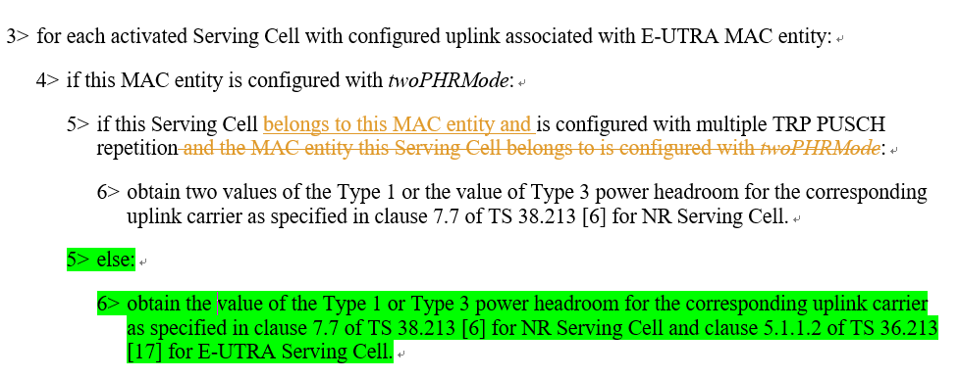  For the second change in the proposed CR, we don't think that the second change is more clear or has better readability than the original text.  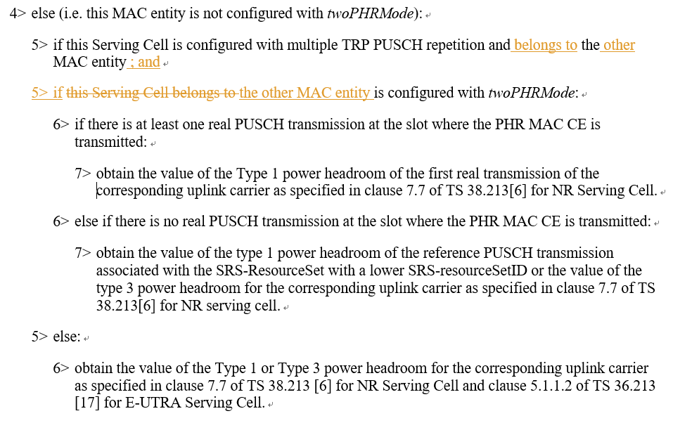
ZTE | Similar view with LG, seems no need to refine the current wording unless there is a critical issue can be found
Nokia (proponent) | Indeed, agree the first change was not correct and the intention was not to make a functional change. Perhaps we can clarify as in the following to make the specification text look more conventional and readable:  5> if this Serving Cell is configured with multiple TRP PUSCH repetition and this Serving Cell belongs to a MAC entity configured with twoPHRMode:
Huawei, HiSilicon | Agree with LGE.  About Nokia's further suggestion: it really makes no difference with current text, not more (or less) readable.
Intel | In our understanding, the intention of the changes seems correct. Especially, the second part doesn’t make any sense given that this MAC entity is not configured with twoPHRMode in 4> while the MAC entity this serving cell belongs to is configured with twoPHRmode.  4> else (i.e. this MAC entity is not configured with twoPHRMode):  5> if this Serving Cell is configured with multiple TRP PUSCH repetition and the MAC entity this Serving Cell belongs to is configured with twoPHRMode:  It seems that the above specification is introduced to capture the following RAN2 agreement.  - If PHR is transmitted towards a MAC entity NOT configured with twoPHRMode (LTE or NR),  Legacy PHR MAC CE is generated.  For all Serving Cells across the different MAC entities:  - UE should report one PH value for all serving cells  According to this agreement, all serving cells across the different MAC entities should report one PH value.  One simple correction would be to remove as follows.  4> else (i.e. this MAC entity is not configured with twoPHRMode):  5> if this Serving Cell is configured with multiple TRP PUSCH repetition and the MAC entity this Serving Cell belongs to is configured with twoPHRMode:  Please note that the serving cell can be configured with multiple TRP PUSCH repetition without twoPHRmode configured.
Qualcomm | Agree with LGE’s comments. The current spec is clear. Further text refinement is not needed.
CATT | Agree with LG E comments.
OPPO | For 1st change, agree with LGE. For 2nd change, we think the point from Intel is correct hence the suggested change is acceptable for us.
Samsung | Agree with LGE’s comments. The current spec is clear. Further text refinement is not needed.
vivo | Agree with LGE comments. Not sure whether this change is needed.

Conclusion
In summary, the following are proposed:

References

TCI state indication of CORESET#0
[1] R2-2209315 LS on TCI state indication of CORESET#0 associated with SS#0 (R1-2208203; contact: Intel, vivo) RAN1 LS in Rel-17 NR_FeMIMO-Core To:RAN2
[2] R2-2209479 Correction on TCI state indication of CORESET#0 associated with SS#0 vivo, Intel Corporation draftCR Rel-17 38.321 17.2.0 F NR_FeMIMO-Core
[3] R2-2209497 Draft CR on TCI state indication of CORESET#0 OPPO CR Rel-17 38.321 17.2.0 1409 - F NR_FeMIMO-Core
[4] R2-2209530 On LS on activating two TCI states for CORESET#0 Ericsson discussion Rel-17
[5] R2-2209868 Miscellaneous MAC Corrections on feMIMO Samsung CR Rel-17 38.321 17.2.0 1418 - F NR_FeMIMO-Core
[6] R2-2210080 Correction on Enhanced TCI States Indication for UE-specific PDCCH MAC CE Qualcomm Incorporated CR Rel-17 38.321 17.2.0 1422 - F NR_FeMIMO-Core
[7] R2-2210726 Corrections to FeMIMO MAC Huawei, HiSilicon CR Rel-17 38.321 17.2.0 1443 - F NR_FeMIMO-Core

Cancel the pending SR for BFR of BFD-RS set of SpCell
[8] R2-2209887 Corrections to M-TRP Beam Failure Recovery Samsung Electronics CR Rel-17 38.321 17.2.0 1420 - F NR_FeMIMO-Core

SP/AP SRS TCI State Indication MAC CE
[9] R2-2210771 CR on 38.321 for SPAP SRS TCI State Indication MAC CE ZTE Corporation, Sanechips CR Rel-17 38.321 17.2.0 1444 - F NR_FeMIMO-Core

Miscellaneous MAC corrections (i.e. small corrections)
[10] R2-2210125 Miscellaneous Corrections to TS 38.321 for feMIMO CATT draftCR Rel-17 38.321 17.2.0 F NR_FeMIMO-Core Late
[11] R2-2210190 Miscellaneous MAC corrections for feMIMO Nokia Germany CR Rel-17 38.321 17.2.0 1427 - F NR_FeMIMO-Core

