3GPP TSG-RAN WG2 Meeting #118 Electronic R2-220xxxx
Online, May 9-20, 2022

Agenda item: 6.15.2.4
Source: Apple
Title: [Draft]Summary of [AT118-e][708][V2X/SL] Inter-UE coordination (Apple)
Document for: Discussion and Decision

1 Introduction
This document is a report on the following email discussion:
- [AT118-e][708][V2X/SL] Inter-UE coordination (Apple)
Scope: Discuss proposals/corrections in AI 6.15.2.4 (except the pre-selected issues for online discussion).
Intended outcome: Summary discussion in R2-2206304. Email approval.
Deadline: 5/16 10:00am UTC

Based on the topics listed in the chairman’s notes to be excluded from this offline, the remaining documents related to this discussion are summarized below and divided as two categories: Proposals and Corrections:
The following papers have proposals to be discussed in this offline.
[1] R2-2204553 Remaining issues on resource selection for Inter-UE coordination SHARP Corporation discussion NR_SL_enh-Core
[2] R2-2204581 Discussion on left issue of inter-UE coordination OPPO discussion Rel-17 NR_SL_enh-Core (only P2/P3P4/P6/P7/P8/P9)
[3] R2-2204923 Remaining issues on inter-UE coordination MAC CE Huawei, HiSilicon discussion NR_SL_enh-Core (only P2)
[4] R2-2204924 Discussion on latency bound for inter-UE coordination Huawei, HiSilicon discussion NR_SL_enh-Core (only P2)
[5] R2-2204968 Remaining issues on inter-UE coordination Lenovo discussion Rel-17 (only P3)
[6] R2-2205103 Discussion on inter-UE coordination ZTE Corporation, Sanechips discussion Rel-17 NR_SL_enh-Core (only P3/P4)
[7] R2-2205344 Further Issues on Collision Avoidance of IUC messages Nokia, Nokia Shanghai Bell discussion Rel-17 NR_SL_enh-Core
[8] R2-2205366 Validity of IUCInformation Messages Nokia, Nokia Shanghai Bell discussion Rel-17 NR_SL_enh-Core
[9] R2-2205641 Lack of priority information for preferred resource set in IUC INFO Apple discussion Rel-17 NR_SL_enh-Core
[10] R2-2205703 Multiple MAC CE handling and remaining PDB related to inter-UE coordination vivo discussion Rel-17 (only P1/P2)
[11] R2-2205791 Open issues for Inter-UE coordination Intel Corporation discussion Rel-17 NR_SL_enh-Core (only P1a/P1b)

The following papers have corrections to be discussed in this offline:
[12] R2-2204576 Correction on user plane aspects for inter-UE coordination OPPO CR Rel-17 38.321 17.0.0 1223 - F NR_SL_enh-Core (depending on Proposal in [2])
[13] R2-2205137 Correction on inter-UE coordination ASUSTeK CR Rel-17 38.321 17.0.0 1258 - F NR_SL_enh-Core
[14] R2-2205604 Correction on SL grant selection procedure for inter UE coordination Samsung CR Rel-17 38.321 17.0.0 1274 - F NR_SL_enh-Core
[15] R2-2205881 Enabling unsolicited transmission of IUC Nokia, Nokia Shanghai Bell draftCR Rel-17 38.321 17.0.0 NR_SL_enh-Core

2 Contact Points
Respondents to the email discussion are kindly asked to fill in the following table.
Company | Name | Email Address
Apple(rapporteur) | Zhibin Wu | zhibin_wu@apple.com
OPPO | Qianxi Lu | qianxi.lu@oppo.com
Ericsson | Min Wang | min.w.wang@ericsson.com
Huawei, HiSilicon | Li Zhao | Zhaoli8@huawei.com

3 Discussion on Proposals

3.1 Multiple IUC-info MAC CE
There are multiple papers [2][8][9][10] (and including the “observation 3” of R2-2204784) discussing the issue possibly related to multiple IUC-info MAC CE, so let us discuss this first.
Based on the company contributions, there are several reasons/cases that multiple IUC-info MAC CE may be conveyed from UE A to UE B:
- Due to size limit of SL grant, the generated IUC-info may need to be delivered in multiple parts (consecutively).
- UE B may send multiple IUC requests to UE A, with one or more different parameters (e.g., resource type, SL priority, subchannel size, resource reservation interval, partially overlapping resource selection windows), then UE A may need respond with multiple IUC-info messages.
- UE A may send both IUC-info triggered by explicit request and IUC-info triggered by a condition.
The rapporteur view is that the current RAN2 specification does not restrain the UE behaviours for the above cases, So, it is true that multiple IUC-info MAC CE may exist. Also, RAN1 has discussed the handling of some specific cases, and have the following RAN1 agreements:
  - For UE-B’s behavior when UE-B receives multiple preferred resource sets from the same UE-A
    - It is up to UE-B implementation to use one or multiple of them in its resource (re)selection
  - Conclusion: UE-B’s behavior when UE-B receives multiple non-preferred resource sets from the same UE-A
    - No RAN1 specification change to TS38.214 is deemed necessary in RAN1#108-e
  - For UE-B’s behavior when UE-B receives both a single preferred resource set and a single non-preferred resource set from the same UE-A
    - FFS: It is up to UE-B implementation to use one or multiple of them in its resource (re)selection

Let us first try to confirm the company view of the problem exist or not.

Question 1-1: Based on current RAN2 specification (w/o adding restriction), do you agree that UE B may receive multiple IUC-info from UE A?
Company | Yes/No | Comments
OPPO | Yes
Ericsson | No | - Due to size limit of SL grant, the generated IUC-info may need to be delivered in multiple parts (consecutively).  - UE B may send multiple IUC requests to UE A, with one or more different parameters (e.g., resource type, SL priority, subchannel size, resource reservation interval, partially overlapping resource selection windows), then UE A may need respond with multiple IUC-info messages.  - UE A may send both IUC-info triggered by explicit request and IUC-info triggered by a condition  1 doesn’t make sense. If 1 is allowed, we would need to change trigger and cancelling rules for the IUC MAC CE, which is unnecessary.  2) and 3) can be resolved up to UE implementation.
Huawei HiSilicon | Yes

For how to deal with the multiple IUC-info, RAN2 companies provided the following inputs:

In [8], Regarding how to rely on UE implementation to solve this issue, it has been pointed out that there is no validity field entry in the IUC-info that can indicate for how long a set of preferred/non-preferred resources is deemed valid by UE-A. It is also unclear how UE-B shall process multiple consecutively received IUC-info messages. As a result of different implementations, UE-B may for example discard the any previous IUC-info and only keep the latest IUC-info or in contrast UE-B may form the union over a configurable number of IUCI-info messages. There is no clear guidance in IUC-info itself to concatenate the resource sets in multiple IUC-info messages. Therefore, the following proposal are given:

Proposal 1: RAN2 to request from RAN1 the introduction of a validity field entry in the IUCInformation messages, indicating for how long a proposed set of preferred/non-preferred resources is valid.

Proposal 2: RAN2 to request from RAN1 the introduction of a new field entry in the IUCInformation messages, indicating how UE-B should interpret the possible combinations of information conveyed by multiple IUCInformation messages.

In [9], it has been observed that Priority value (prio_TX) is not included in IUC-info. Then, UE B cannot know the full context of the generation of IUC-info message for Scheme 1 preferred resource set, when multiple IUC-info are received. As a result, it is clueless for UE-B implementation to determine whether to use the IUC INFO preferred resource set or not. To make the IUC Scheme 1 information self-contained, the priority field should be added for the preferred resource type. Hence, the following proposals have been provided so that RAN2 can directly solve the ambiguation issue for preferred resource set in IUC Scheme 1:

Proposal 1 Add the “priority” field in IUC INFO MAC CE for preferred resource type.

Proposal 2 Adopt the changes to the 38.321 given in the appendix.

In [10], it has been acknowledged that “If multiple MAC CEs can be received consecutively, then UE-B’s behaviour should be further discussed/clarified. E.g. Whether/how to combine or distinguish different IUC information MAC CEs”. Given this concern, it is better to simply the design (e.g, to make UE-B to receive only one IUC information MAC CE at a time for one TB transmission. Hence, the following proposals have been given to restrict the above cases:

Proposal 1: UE-A only send one IUC information MAC CE to contain all recommended resource combinations for one IUC request from UE-B.

Proposal 2: UE-B only generates IUC request signalling(s) for a new TB transmission to UE-A when the previous one has been received.

The above papers have present a variety of approaches to address the potential problems caused by multiple IUC-info. Let us then check company view on the general approach for this:

Question 1-2: which approach do you agree to handle “multiple IUC-info” situation?

Option a: Restrict the UE behaviors so that such a case will not occur (e.g., as proposed in[10]).

Option b: Send a LS to RAN1 to request a discussion of the potential problems and/or possible solution(s). (e.g., as proposed in [8]).

Option c: RAN2 make changes in IUC-info MAC CE format directly (e.g., as proposed in [9]).

Option d: please specify.
Company | Option | Comments
OPPO | d | We believe R1 conclusion on this issue is sufficient, nothing additional is needed.
Ericsson | d | As we commented, it may be sufficient to leave to UE implementation to resolve the issue or avoid the issue
Huawei HiSilicon | d up to UE implementation | Regarding how to handle multiple IUC message, RAN1 has already concluded to rely on UE implementation to choose one or multiple. See below. No need to re-discuss this issue in RAN2.  - For UE-B’s behavior when UE-B receives multiple preferred resource sets from the same UE-A  - It is up to UE-B implementation to use one or multiple of them in its resource (re)selection  - Conclusion: UE-B’s behavior when UE-B receives multiple non-preferred resource sets from the same UE-A  - No RAN1 specification change to TS38.214 is deemed necessary in RAN1#108-e

Based on the company view of Q1-2, we can further discuss the exact proposals in [8][9][10].

3.2 Truncated format IUC-info MAC CE
In [2], the following proposals have been given to introduce a truncated IUC MAC CE format, as similar to BSR/BFR MAC CE.
Proposal 2 For scheme-1 IUC-info MAC CE, allow truncated format if the SL grant size is not big enough to carry the full IUC-info MAC CE.
Proposal 3 For scheme-1 IUC-info MAC CE, if truncated format is used, include as many resource-set(s) as can be carried by the SL grant, and up to UE implementation to decide which resource-set(s) should be included.
Proposal 4 For scheme-1 IUC-info MAC CE, the event of IUC-info report is cancelled no matter full or truncated format is transmitted.

The rapporteur understands that this means some new format field, or a new SL-SCH LCID has to be added to support this new truncation format. So, let us check company view on this first.

Question 2: Do you support to introduce “truncated IUC-info MAC CE” format for IUC Scheme 1?
Company | Yes/No | Comments
OPPO | Yes | Proponent
Ericsson | No | This gives additional design complexity for IUC, given R17 is already declared completed 100%.  In our understanding, it is sufficient that UE-A sends IUC MAC CE limited by the grant size.
Huawei,HiSilicon | No | We don’t see the motivation to define a new type of IUC MAC CE. With the definition of maximum value “N”, UE is allowed to determine the number of the resource set according to the grant size and value “N”. If the grant is not large enough, UE can select some of the resource sets to be reported and which resource set to be included in the IUC MAC CE is all up to UE implementation. This is some kind of “truncated IUC MAC CE” since not all the resource sets are included in the MAC PDU, but we don’t need to define a new LCID.  The only usage to define a new LCID is to inform the peer UE there is still some follow-up resource sets and to ask the peer UE to wait a bit when performing resource selection in order to take the following information into account. However, the resource selection is triggered quite dynamically and the latency between two adjacent IUC MAC CE cannot be guaranteed short enough to fulfil the remaining PDB of the SL data. So it does not make much sense to wait for the following IUC information when resource selection is triggered and of course no need to define a new type of IUC MAC CE.

Based on the company view of Q2, we can further discuss the exact proposals in [2] for truncated IUC info MAC CE.

3.3 Groupcast/Broadcast Support
In [2], the following proposals are given:
Proposal 6 RAN2 not pursue IUC for GC/BC in this release.
Similar proposals are in [11],
Proposal 1a: RAN2 is proposed to focus on unicast based operation for inter-UE coordination (scheme 1 and scheme 2) in Rel-17 work.
Proposal 1b: The support of groupcast/broadcast-based operation for inter-UE coordination (scheme 1 and scheme 2) is deprioritized in Rel-17.

It is worth noted that RAN1 has already has the WA to support IUC Scheme 1 non-preferred for GC/BC.
The main issue for the support of GC/BC in RAN2 is that there is no SL MAC CE for GC/BC in NR SL communication so far. Also, if it has to be sent stand-alone, then the destination L2 ID is uncertain and may need upper layer support. But the rapporteur thinks sending IUC INFO MAC CE along with a GC/BC data transmission (i.e, piggyback) is still feasible from RAN2 perspective w/o need to involve SA2/CT1 for L2 destination ID.

Question 3: How to handle GC/BC support for IUC Scheme 1 non-preferred resource?

Option a: Deprioritize in Rel-17/ UE behaviors so that such a case will not occur (e.g., as proposed in[2][11]).

Option b: Wait for RAN1 further discussion.

Option c: Limited support, i.e., for GC/BC, RAN2 only support IUC-info sent along with GC/BC SL data.

Option d: please specify.

Company | Option | Comments
OPPO | A | Proponent.  We see no point to purse such things after the WI has been closed.
Ericsson | b | This is in RAN1 domain, we can just wait for RAN1 outcome. If RAN1 has no further discussion, we can down-prioritize the issue.
Huawei HiSilicon | a | Considering we have already completed this WI, we think only unicast should be supported for this release. Also we agreed that the UE-B configures the latency bound for IUC which is triggered by explicit request through PC5-RRC message, this mechanism is also not workable for BC/GC. Therefore, besides the DST L2 ID issue, how to configure the latency bound for BC/GC IUC should also be discussed and may have ASN.1 impact which should of course be avoided at this stage.
Sharp | Option a

3.4 Resource selection behaviour in UE A
In [1], it has been argued that Similar as SL-CSI reporting, when the request receiving UE (i.e. UE-A) is triggered for an IUC-info transmission, after UE-A determines the preferred/non-preferred resource set, and when UE-A selects the SL resources for IUC transmission, it shall take the latency requirement of the triggered IUC transmission, i.e. the latency bound, into consideration. So, the following proposal is given:
Proposal 1: When UE-A determines the resources for IUC transmission, it shall select the resources according to the latency requirement of the IUC transmission.

Question 4: Do you agree the above proposal in R2-2204553[1]?

Company | Yes/No | Comments on specification impact
OPPO | See comment | We understand this P is only for scheme-1.  If yes, as CSI-report, similar handling can be adopted.
Huawei HiSilicon | Yes | Similar as CSI MAC CE.
Sharp | Yes

3.5 Resource selection behaviour in UE B
In [1], for the case that IUC information is not received (cancelled by UE-A), the proponent company think it is straightforward to perform resource (re-)selection according to the sensing results if any. Thus, a proposal is given as below:
Proposal 2: The case when UE-B does not receive IUC from UE-A within the latency bound should be specified for resource (re-)selection of UE-B’s SL transmission.

Question 5-1 : Do you agree the above proposal in R2-2204553[1]?

Company | Yes/No | Comments
OPPO | See comment | We understand it is limited to scheme-1. If yes:  We agree there is missing case that UE-B failing to receive a IUC-info from UE-A.  Yet for the case where UE-B has received the IUC-info from UE-A, which however is not within the latency bound,  - The current spec is sufficient for the case when UE-B has sensing result, since it can be covered by “if there are no resources within the intersection that can be selected as the time and frequency resources for the one transmission opportunity according to the amount of selected frequency resources and the remaining PDB of SL data available in the logical channel(s) allowed on the carrier”  - Yet the current spec is not sufficient for the case when UE-B has no sensing result
Ericsson | Yes | We can adopt same handling as CSI reporting in case of Mode 2 operation.
Huawei HiSilicon | No | If no IUC information is received, then UE-B’s resource selection/reselection should follow the legacy behaviour, which is already specified in the spec. So we do not see any issue that needs to be addressed.
Sharp | Yes | Proponent.  As Huawei commented, we agree that if no IUC received within the latency bound, UE-B shall follow the legacy behaviour, while the case is not covered in current specs yet. It only specifies the behaviour when UE is configured enabling receiving IUC and successfully receives the IUC. Thus, it is needed to separately specify the case when UE is configured enabling receiving IUC and fails to receive the IUC.

In [2], how UE-B apply the received non-preferred resource(s) from the received IUC-info from UE A has been discussed.
So, the following proposal is given:
Proposal 7 For IUC scheme-1, for non-preferred resource set, MAC indicates the non-preferred resource set (as carried in MAC CE) to PHY layer.

Question 5-2 : Do you agree the above proposal in R2-2204581[2]?

Company | Yes/No | Comments
OPPO | Yes | Proponent
Ericsson | Yes
Huawei, HiSilicon | Yes | We agree with this proposal. Actually according to RAN1 agreement, PHY performs resource exclusion when the UE has sensing result, therefore MAC should indicate the non-preferred resource set to PHY. 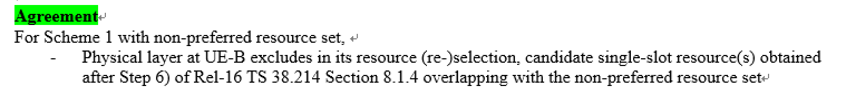

Then, another issue is for the UE with no sensing result, e.g. when the UE performs random resource selection, physical layer cannot perform results exclusion, because there is no candidate resource set generation operation as for sensing-based case at physical layer, and thus so far the related behaviour is captured in MAC specification only. Thus, for a UE-B without sensing result, the IUC mechanism for non-preferred resource set is not workable.
Some proposals are given in [2] as below:
Proposal 8 RAN2 to discuss whether to handle the non-preferred resource set issue in PHY or MAC specification and send LS to RAN1 to sync.
Proposal 9 If RAN2 agree to rely on MAC spec to handle, RAN2 agree the proposed change in draft CR in R2-2204576.

Question 5-3 : How to handle the non-preferred resource set for UE B without sensing results(e.g., random selection mode 2 UE?

Option a: MAC layer

Option b: PHY layer.

Option c: please specify.

Company | Option | Comments
OPPO | See comment | In case R2 would like to do down-selection between a and b, our preference is option-a, since our R1 understand it is hard to do such change in PHY spec now.  Otherwise, if R2 fail / does not want to down-select, we can ask for decision from R1 using LS (draft provided in [2]).
Ericsson | comments | Agree with OPPO
Huawei, HiSilicon | C neither MAC or PHY | We think neither MAC nor PHY should handle the non-preferred resource set for UE-B without sensing result. RAN1 has already discussed about this issue and their conclusion is that for UE-B without sensing result, UE-B will only handle the preferred resource set, see below.  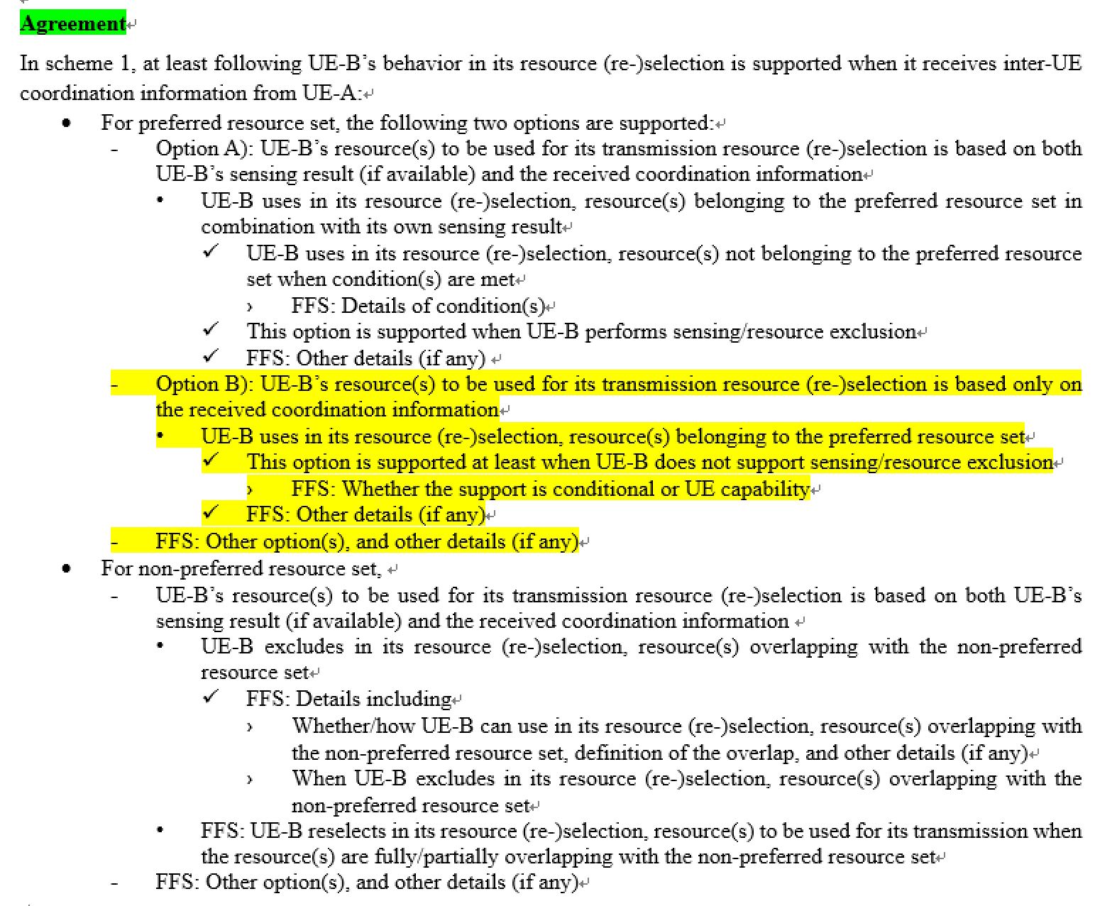  For UE-B without sensing result, even though MAC delivers the non-preferred resource set to PHY, PHY will do nothing.

3.6 Incompatible RA mode between UE A and UE B
In [4], the case when UE-A in mode 1 receiving latency bound timer value via PC5 RRC signalling from UE-B is discussed. It was agreed by RAN1 that inter-UE coordination is only feasible in mode 2 in Rel-17, thus in this case, if UE-A send PC5 RRCReconfigurationComplete message to UE-B, UE-B may think UE-A is able to provide IUC information. However, since UE-A is in mode 1, it cannot provided any IUC information to UE-B, and UE-B may further request IUC information to UE-A if there is no any response from UE-A.
Therefore, the following proposal is given:
Proposal 2: For UE-A in mode 1, UE-A sends PC5 RRCReconfiguration Failure message to UE-B when receiving latency bound timer value via PC5Reconfiguation, and an indication can be included in such Failure message.

In rapporteur view, an alternative way is to exchange mode 1 capability in PC5-RRC capability signaling so that IUC configuration will not be given by UE B to a mode 1 UE A in the first place. Then the problem can be avoided. Let us check the company view on this:

Question 6: Do you agree the above proposal in R2-2204924[4]?

Company | Yes/No | Comments
OPPO | No | Since the WI has been closed, seems not proper to go for such optimization.
Ericsson | No | UEA can just send RRCComplete message without any indicator. If UE-A in mode 1 receives a request message from UE-B, UE-B doesn’t provide IUC MAC CE. This can be just left to UE-A imp to handle.
Huawei HiSilicon | Yes | The solution proposed by rapporteur also works in some scenarios for example if UE-A does not support mode 1 at all then UE-B can send request if UE-A supports IUC. But if the UE-A supports mode 1, then this issue still exists, i.e., UE-B has no knowledge if UE-A operates in mode 1 or mode 2 at the moment when UE-B would like to send a IUC request to UE-A since mode 1 is actually supported by UE-A capability. Therefore, the solution proposed by rapporteur can only work for some cases, so our feeling is that simplest way is to exchange mode info between UE-A and UE-B. Or we use failure indication to inform the peer UE as proposed by the above proposal.

3.7 Resource selection triggered by stand-alone SL MAC CE
In [3], regarding whether resource selection can be triggered by stand alone MAC CE, it has been pointed out the SL DRX Command MAC CE can be transmitted alone or with data in the MAC PDU in RAN2, and it was agreed that SL Inter-UE Coordination Request MAC CE or SL Inter-UE Coordination Information MAC CE can be transmitted in a SL MAC PDU standalone. Therefore, standalone SL DRX Command MAC CE or SL Inter-UE Coordination Request MAC CE or SL Inter-UE Coordination Information MAC CE can trigger to create a selected SL grant, which is similar to the handling of SL-CSI reporting MAC CE in Rel-16. Hence, the following proposal is given:
Proposal 2: RAN2 to agree that standalone SL DRX Command MAC CE or SL Inter-UE Coordination Request MAC CE or SL Inter-UE Coordination Information MAC CE can trigger to create a selected SL grant.

Question 7: Do you agree the above proposal in R2-2204923[3]?

Company | Yes/No | Comments
OPPO | See comment | For IUC-info MAC-CE, whether a standalone one can trigger a grant selection is up to RRC setting, i.e., sl-TriggerConditionCoordInfo.  Otherwise, it is OK.
Ericsson | Yes | sl-TriggerConditionCoordInfo regarding how UE triggers IUC, which is a different issue.
Huawei HiSilicon | Yes | Proponent.
Sharp | Yes

3.8 Generation of Condition-triggered IUC-info
In [5], regarding how to generate the condition-triggered IUC-info
Proposal 3: UE is preconfigured with a reference format for the generation of an IUC Information MAC CE for cases when the IUC report was triggered by the UE itself based on some predefined trigger conditions.

The rapporteur think RAN1 has agreed that the parameters to generate preferred resource set (prio_TX, L_subCH, p_rsvp_TX) either depends on (pre-)configuration in RRC or left to UE implementation. So, it is not very clear what does the “preconfigured reference format” mean here. Let us see the company view on this proposal:

Question 8: Do you agree with the above proposal in R2-2204968[5]?

Company | Yes/No | Comments
OPPO | No | Not quite get the point, anyway, seems no obvious additional work needed.
Ericsson | No | RAN1 agreements are already clear, no need to define other format.
Huawei HiSilicon | No | We think according to RAN1 agreement, the IUC MAC CE applies to both explicit request based IUC and condition based IUC. So no need to define a reference IUC format for condition based IUC.

3.9 Resource pool selection for IUC UE
In [6], regarding how to select resource pool in UE A, the following RAN1 agreement has been cited for IUC Scheme 1:

- For inter-UE coordination information triggered by an explicit request in Scheme 1,
  - UE-A uses a TX resource pool used for UE-B’s request transmission to determine the set of resources and to transmit the set of resources to UE-B
- For inter-UE coordination information triggered by a condition rather than request reception in Scheme 1,
  - UE-A transmitting in a resource pool provides inter-UE coordination information associated with the same resource pool
However, current MAC specification only consider HARQ enable/disable and discovery in TX resource pool, selection, so it can not be ensured that a mode 2 UE will select a suitable resource pool to fulfill above RAN1’s decision. Therefore, resource pool selection procedure shall be enhanced to cover RAN1’s agreements with the following proposal:
Proposal 3: Resource pool selection shall take the transmission of request MAC CE/IUC MAC CE into consideration.

In rapporteur view, the RAN1 agreement has put some additional requirements for UE B and UE A to select TX pool to transmit IUC-REQ and IUC-info, respectively. Hence, the above proposal is needed.

Question 9-1: Do you agree the above proposal in R2-2205103[6]?

Company | Yes/No | Comments
OPPO | See comment (a NOTE is sufficient) | We are not so sure about the proposal since  IUC-info: Different from normal data, the IUC-info MAC CE is triggered either by request or condition, both of which means the pool to send the IUC-info has been decided before/upon the IUC-info MAC-CE generation, so there should be no such resource pool “selection” step.  IUC-request: this is similar, since IUC-request is also coupled with resource pool, i.e., UE-B may just want to get IUC-info of pool-1 but not pool-2, so the selection of resource pool should not be decoupled with IUC-request generation.  Considering the aspects above, a NOTE to clarify the intention of coupling between IUC-info / IUC-request should be sufficient, but not prefer the normative text of resource pool selection as for the other cases.
Ericsson | Yes | We are fine with either normative texts or Note
Huawei HiSilicon | Yes | Agree with rapporteur.
Sharp | Yes | Note is preferred.

Another issue is that the PSFCH resource for scheme2 is independent of PSFCH resource for HARQ feedback. And the PSFCH for scheme-2 is also configured per resource pool. Therefore, for UE-B’s TX resource pool selection to transmit IUC Scheme 2, another proposal is given for UE-B for IUC Scheme 2 in [6]:
Proposal 4：If UE-B select scheme2 for inter-UE coordination, UE-B should select the resource pool configured with PSFCH for scheme2.

In rapporteur view, IUC scheme 2 is mainly handle by PHY layer, so not very sure RAN2 need to discuss this issue for L1 signal transmission. Let us check company view on this:

Question 9-2 : Do you agree the above proposal in R2-2205103[6]?

Company | Yes/No | Comments
OPPO | No | Same view as rapp, MAC spec should not capture pool selection for PSFCH transmission.
Ericsson | No | Agree with RAPP. This is handled by PHY layer.
Huawei, HiSilicon | Yes | Similar logic as Q9-1. Resource pool selection is handled by MAC.

3.10 Collision Avoidance of IUC messages
In [7], regarding some further enhancements to avoid collision of IUC message transmissions, it is suggested to take advantage of unused bits in SCI-2C format in IUC-request to convey some resource information for UE A to use. The proposal is given as below
Proposal 1: The requesting UE (UE-B) shall use the so far unused (and zero-padded) field entry resource combinations in SCI format 2-C for the IUCRequest message to indicate the sidelink resources to be used by the responding UE (UE-A) in its IUCInformation message.

In rapporteur view, this could be a RAN1 design issue, but there is no harm to collect company view on this.

Question 10: Do you agree the above proposal in R2-2205344[7]?

Company | Yes/No | Comments
OPPO | No | Same view as rapp, should be an issue for R1.
Ericsson | No | This is RAN1 issue
Huawei, HiSilicon | No | Agree with rapporteur this is RAN1 issue.

4 Discussion on corrections
The correction in [12] is dependent on the proposal discussion in Q5-3. So, let us just skip now.

4.1 R2-2205137
[13] R2-2205137 Correction on inter-UE coordination ASUSTeK CR Rel-17 38.321 17.0.0 1258 - F NR_SL_enh-Core

The reasons for change are as follow:
(6.1.3.54) The Inter-UE Coordination request MAC CE should be a MAC CE with a fixed size based on the current field structure.

(6.1.3.54) The RT field indicates the type of resource preferred by the requesting UE (i.e. UE-B). In RRC configuration SL-InterUE-CoordinationConfig, a paramter sl-DetermineResourceType is used to indicate how to determine the resource set type to be provided by inter-UE coordination information transmission. Value "uea" means the resource set type is determined by UE-A’s implementation. Value "ueb" means the resource set type is determined by UE-B’s request. In Inter-UE Coordination request MAC CE, the RT field should be a reserved field (i.e. the resource set type is determined by UE-A’s implementation) when the value of sl-DetermineResourceType is set to value “uea”.

Question 11-1: Do you agree the intentions of in R2-2205137[13]?

Company | Yes/No | Comments
OPPO | Yes
Ericsson | Yes with comments | In Inter-UE Coordination request MAC CE, the RT field should be a reserved field (i.e. the resource set type is determined by UE-A’s implementation) when the value of sl-DetermineResourceType is set to value “uea”.  - The above wording is not accurate. RT field is already used, therefore, it is not a reserved field any more. We can just say that this RT field is skipped or ignored if the value of sl-DetermineResourceType is set to value “uea
Huawei, HiSilicon | Yes with comment | For the first change, we agree with the intention.  For the second change, we agree with Ericsson that according to the following RAN1 agreement, if sl-DetermineResourceType is set to "ueb", there is “1 bit” Resource set type indication. Otherwise “0 bit” means there is no such resource set type indication, but not to set the bit to “0”.  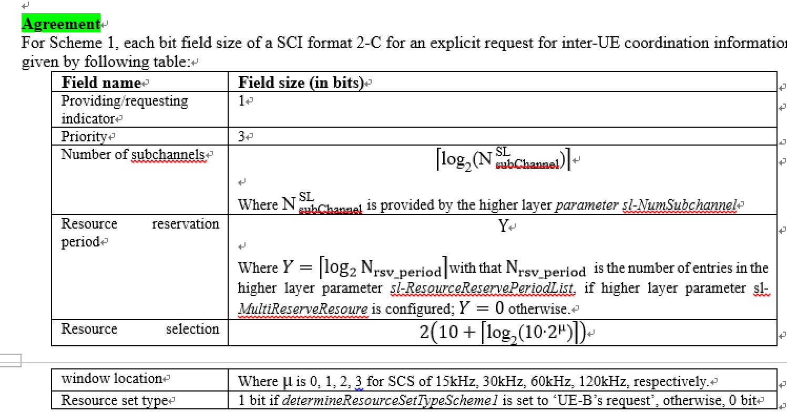

Question 11-2: If yes to Q11-1, Do you have some detailed comments on the changes in R2-2205137[13]?

Company | Yes/No | Comments
Ericsson | Yes | See comments above
Huawei, HiSilicon | Yes | Agree with Ericsson.

4.2 R2-2205604
[14] R2-2205604 Correction on SL grant selection procedure for inter UE coordination Samsung CR Rel-17 38.321 17.0.0 1274 - F NR_SL_enh-Core

The reasons for change are as follow:
In 5.22.1.1 the SL grant selection procedures for inter UE coordination schemes are specified with lower levels e.g., levels 5>, 6>, 7> but it seems that the use of these low levels is not needed for some cases.
For example, in the procedures below level 5 should be level 4 and level 6 should be level 5, respectively.

Question 12-1: Do you agree the intention(s) of in R2-2205604[14]?

Company | Yes/No | Comments
OPPO | Yes
Ericsson | Yes
Huawei, HiSilicon | Yes

Question 12-2: If yes to Q12-1, Do you have some detailed comments on the changes in R2-2205604[14]?

Company | Yes/No | Comments

4.2 R2-2205881
[15] R2-2205881 Enabling unsolicited transmission of IUC Nokia, Nokia Shanghai Bell draftCR Rel-17 38.321 17.0.0 NR_SL_enh-Core

The reasons for change are as follow:
The current version of the specification 38.321 does not support standalone triggering of the resource selection for IUC request and IUC information, but rather only supports triggering for
- SL data is available in a logical channel; or
- SL-CSI reporting is triggered
Resource selection should be triggered by IUC request and information

Question 13-1: Do you agree the intention(s) of in R2-2205881[15]?

Company | Yes/No | Comments
OPPO | See comment | We are fine with the change  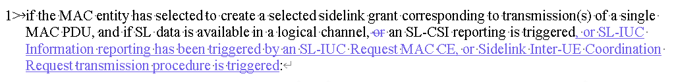  Otherwise, we are negative, please refer to Q9-1 for details.
Ericsson | Yes
Huawei, HiSilicon | Yes with comments | For the first change, we agree with the intention which is similar as Q7.  For the second change, we think some procedure text is needed for the resource pool selection for IUC request/IUC MAC CE transmission. But as indicated by Q9, UE needs to consider some additional restriction when performing resource pool selection according to RAN1 agreement.
Sharp | Yes

Question 13-2: If yes to Q13-1, Do you have some detailed comments on the changes in R2-2205881[15]?

Company | Yes/No | Comments
Huawei, HiSilicon | Yes | 1 We don’t think “or” before CSI MAC CE can be deleted.  2. SL DRX MAC CE should also be considered by the way.  So we propose to have the following change  if the MAC entity has selected to create a selected sidelink grant corresponding to transmission(s) of a single MAC PDU, and if SL data is available in a logical channel, or an SL-CSI reporting is triggered, or an Sidelink DRX Command is triggered, or an Sidelink Inter-UE Coordination Request is triggered, or an Sidelink Inter-UE Coordination Information is triggered:  For the second change, we think we need to make some conclusion based on Q9 and then come back to see how to reflect these conclusions in the specification.

5 Summary of Discussion
TBD

