3GPP TSG-RAN WG2 Meeting #118 Electronic R2-220xxxx
Online, May 9-20, 2022

Agenda item: 6.15.2.4
Source: Apple
Title: [Draft]Summary of [AT118-e][708][V2X/SL] Inter-UE coordination (Apple)
Document for: Discussion and Decision

1 Introduction
This document is a report on the following email discussion:
- [AT118-e][708][V2X/SL] Inter-UE coordination (Apple)
Scope: Discuss proposals/corrections in AI 6.15.2.4 (except the pre-selected issues for online discussion).
Intended outcome: Summary discussion in R2-2206304. Email approval.
Deadline: 5/16 10:00am UTC

Based on the topics listed in the chairman’s notes to be excluded from this offline, the remaining documents related to this discussion are summarized below and divided as two categories: Proposals and Corrections:
The following papers have proposals to be discussed in this offline.
[1] R2-2204553 Remaining issues on resource selection for Inter-UE coordination SHARP Corporation discussion NR_SL_enh-Core
[2] R2-2204581 Discussion on left issue of inter-UE coordination OPPO discussion Rel-17 NR_SL_enh-Core (only P2/P3P4/P6/P7/P8/P9)
[3] R2-2204923 Remaining issues on inter-UE coordination MAC CE Huawei, HiSilicon discussion NR_SL_enh-Core (only P2)
[4] R2-2204924 Discussion on latency bound for inter-UE coordination Huawei, HiSilicon discussion NR_SL_enh-Core (only P2)
[5] R2-2204968 Remaining issues on inter-UE coordination Lenovo discussion Rel-17 (only P3)
[6] R2-2205103 Discussion on inter-UE coordination ZTE Corporation, Sanechips discussion Rel-17 NR_SL_enh-Core (only P3/P4)
[7] R2-2205344 Further Issues on Collision Avoidance of IUC messages Nokia, Nokia Shanghai Bell discussion Rel-17 NR_SL_enh-Core
[8] R2-2205366 Validity of IUCInformation Messages Nokia, Nokia Shanghai Bell discussion Rel-17 NR_SL_enh-Core
[9] R2-2205641 Lack of priority information for preferred resource set in IUC INFO Apple discussion Rel-17 NR_SL_enh-Core
[10] R2-2205703 Multiple MAC CE handling and remaining PDB related to inter-UE coordination vivo discussion Rel-17 (only P1/P2)
[11] R2-2205791 Open issues for Inter-UE coordination Intel Corporation discussion Rel-17 NR_SL_enh-Core (only P1a/P1b)
[16] R2-2205105 Discussion on user plane FFS issues for SL DRX ZTE Corporation, Sanechips discussion Rel-17 NR_SL_enh-Core (only P4)

The following papers have corrections to be discussed in this offline:
[12] R2-2204576 Correction on user plane aspects for inter-UE coordination OPPO CR Rel-17 38.321 17.0.0 1223 - F NR_SL_enh-Core (depending on Proposal in [2])
[13] R2-2205137 Correction on inter-UE coordination ASUSTeK CR Rel-17 38.321 17.0.0 1258 - F NR_SL_enh-Core
[14] R2-2205604 Correction on SL grant selection procedure for inter UE coordination Samsung CR Rel-17 38.321 17.0.0 1274 - F NR_SL_enh-Core
[15] R2-2205881 Enabling unsolicited transmission of IUC Nokia, Nokia Shanghai Bell draftCR Rel-17 38.321 17.0.0 NR_SL_enh-Core
[17] R2-2205104 Correction on resource pool selection for IUC ZTE Corporation, Sanechips CR Rel-17 38.321 17.0.0 1252 - F NR_SL_enh-Core(depending on Proposals in [6])
[18] R2-2205182 Corrections of 38.321 on IUC MAC CE Ericsson draftCR Rel-17 38.321 17.0.0 F NR_SL_enh-Core

2 Contact Points
Respondents to the email discussion are kindly asked to fill in the following table.
Company | Name | Email Address
Apple(rapporteur) | Zhibin Wu | zhibin_wu@apple.com
OPPO | Qianxi Lu | qianxi.lu@oppo.com
Ericsson | Min Wang | min.w.wang@ericsson.com
Huawei, HiSilicon | Li Zhao | Zhaoli8@huawei.com
Nokia | Berthold Panzner | Berthold.Panzner@nokia.com

3 Discussion on Proposals

3.1 Multiple IUC-info MAC CE
There are multiple papers [2][8][9][10] (and including the “observation 3” of R2-2204784) discussing the issue possibly related to multiple IUC-info MAC CE, so let us discuss this first.
Based on the company contributions, there are several reasons/cases that multiple IUC-info MAC CE may be conveyed from UE A to UE B:
- Due to size limit of SL grant, the generated IUC-info may need to be delivered in multiple parts (consecutively).
- UE B may send multiple IUC requests to UE A, with one or more different parameters (e.g., resource type, SL priority, subchannel size, resource reservation interval, partially overlapping resource selection windows), then UE A may need respond with multiple IUC-info messages.
- UE A may send both IUC-info triggered by explicit request and IUC-info triggered by a condition.
The rapporteur view is that the current RAN2 specification does not restrain the UE behaviours for the above cases, So, it is true that multiple IUC-info MAC CE may exist. Also, RAN1 has discussed the handling of some specific cases, and have the following RAN1 agreements:
  - For UE-B’s behavior when UE-B receives multiple preferred resource sets from the same UE-A
    - It is up to UE-B implementation to use one or multiple of them in its resource (re)selection
  - Conclusion: UE-B’s behavior when UE-B receives multiple non-preferred resource sets from the same UE-A
    - No RAN1 specification change to TS38.214 is deemed necessary in RAN1#108-e
  - For UE-B’s behavior when UE-B receives both a single preferred resource set and a single non-preferred resource set from the same UE-A
    - FFS: It is up to UE-B implementation to use one or multiple of them in its resource (re)selection

Let us first try to confirm the company view of the problem exist or not.

Question 1-1: Based on current RAN2 specification (w/o adding restriction), do you agree that UE B may receive multiple IUC-info from UE A?
Company | Yes/No | Comments
OPPO | Yes
Ericsson | No | - Due to size limit of SL grant, the generated IUC-info may need to be delivered in multiple parts (consecutively).  - UE B may send multiple IUC requests to UE A, with one or more different parameters (e.g., resource type, SL priority, subchannel size, resource reservation interval, partially overlapping resource selection windows), then UE A may need respond with multiple IUC-info messages.  - UE A may send both IUC-info triggered by explicit request and IUC-info triggered by a condition  1 doesn’t make sense. If 1 is allowed, we would need to change trigger and cancelling rules for the IUC MAC CE, which is unnecessary.  2) and 3) can be resolved up to UE implementation.
Huawei HiSilicon | Yes
Nokia | Yes | Inline with understanding in RAN1
Apple | Yes

For how to deal with the multiple IUC-info, RAN2 companies provided the following inputs:

In [8], Regarding how to rely on UE implementation to solve this issue, it has been pointed out that there is no validity field entry in the IUC-info that can indicate for how long a set of preferred/non-preferred resources is deemed valid by UE-A. It is also unclear how UE-B shall process multiple consecutively received IUC-info messages. As a result of different implementations, UE-B may for example discard the any previous IUC-info and only keep the latest IUC-info or in contrast UE-B may form the union over a configurable number of IUCI-info messages. There is no clear guidance in IUC-info itself to concatenate the resource sets in multiple IUC-info messages. Therefore, the following proposal are given:

Proposal 1: RAN2 to request from RAN1 the introduction of a validity field entry in the IUCInformation messages, indicating for how long a proposed set of preferred/non-preferred resources is valid.

Proposal 2: RAN2 to request from RAN1 the introduction of a new field entry in the IUCInformation messages, indicating how UE-B should interpret the possible combinations of information conveyed by multiple IUCInformation messages.

In [9], it has been observed that Priority value (prio_TX) is not included in IUC-info. Then, UE B cannot know the full context of the generation of IUC-info message for Scheme 1 preferred resource set, when multiple IUC-info are received. As a result, it is clueless for UE-B implementation to determine whether to use the IUC INFO preferred resource set or not. To make the IUC Scheme 1 information self-contained, the priority field should be added for the preferred resource type. Hence, the following proposals have been provided so that RAN2 can directly solve the ambiguation issue for preferred resource set in IUC Scheme 1:

Proposal 1 Add the “priority” field in IUC INFO MAC CE for preferred resource type.

Proposal 2 Adopt the changes to the 38.321 given in the appendix.

In [10], it has been acknowledged that “If multiple MAC CEs can be received consecutively, then UE-B’s behaviour should be further discussed/clarified. E.g. Whether/how to combine or distinguish different IUC information MAC CEs”. Given this concern, it is better to simply the design (e.g, to make UE-B to receive only one IUC information MAC CE at a time for one TB transmission. Hence, the following proposals have been given to restrict the above cases:

Proposal 1: UE-A only send one IUC information MAC CE to contain all recommended resource combinations for one IUC request from UE-B.

Proposal 2: UE-B only generates IUC request signalling(s) for a new TB transmission to UE-A when the previous one has been received.

The above papers have present a variety of approaches to address the potential problems caused by multiple IUC-info. Let us then check company view on the general approach for this:

Question 1-2: which approach do you agree to handle “multiple IUC-info” situation?

Option a: Restrict the UE behaviors so that such a case will not occur (e.g., as proposed in[10]).

Option b: Send a LS to RAN1 to request a discussion of the potential problems and/or possible solution(s). (e.g., as proposed in [8]).

Option c: RAN2 make changes in IUC-info MAC CE format directly (e.g., as proposed in [9]).

Option d: please specify.
Company | Option | Comments
OPPO | d | We believe R1 conclusion on this issue is sufficient, nothing additional is needed.
Ericsson | d | As we commented, it may be sufficient to leave to UE implementation to resolve the issue or avoid the issue
Huawei HiSilicon | d up to UE implementation | Regarding how to handle multiple IUC message, RAN1 has already concluded to rely on UE implementation to choose one or multiple. See below. No need to re-discuss this issue in RAN2.  - For UE-B’s behavior when UE-B receives multiple preferred resource sets from the same UE-A  - It is up to UE-B implementation to use one or multiple of them in its resource (re)selection  - Conclusion: UE-B’s behavior when UE-B receives multiple non-preferred resource sets from the same UE-A  - No RAN1 specification change to TS38.214 is deemed necessary in RAN1#108-e
Nokia | B and C
Apple | B or C | We think it is important to get a clear solution and left to UE implementation does not really solve the design deficiencies.

Based on the company view of Q1-2, we can further discuss the exact proposals in [8][9][10].

3.2 Truncated format IUC-info MAC CE
In [2], the following proposals have been given to introduce a truncated IUC MAC CE format, as similar to BSR/BFR MAC CE.
Proposal 2 For scheme-1 IUC-info MAC CE, allow truncated format if the SL grant size is not big enough to carry the full IUC-info MAC CE.
Proposal 3 For scheme-1 IUC-info MAC CE, if truncated format is used, include as many resource-set(s) as can be carried by the SL grant, and up to UE implementation to decide which resource-set(s) should be included.
Proposal 4 For scheme-1 IUC-info MAC CE, the event of IUC-info report is cancelled no matter full or truncated format is transmitted.

The rapporteur understands that this means some new format field, or a new SL-SCH LCID has to be added to support this new truncation format. So, let us check company view on this first.

Question 2: Do you support to introduce “truncated IUC-info MAC CE” format for IUC Scheme 1?
Company | Yes/No | Comments
OPPO | Yes | Proponent  After reading the comment below, seems there is some misunderstanding: we are not trying to define another format, but just trying to say if we define a max-N, we are still not forcing the UE-A to send exact number of max-N resource-combination, yet can be fewer than it, and it would still cancel the IUC event. As long as this is satisfied, we are fine with it.
Ericsson | No | This gives additional design complexity for IUC, given R17 is already declared completed 100%.  In our understanding, it is sufficient that UE-A sends IUC MAC CE limited by the grant size.
Huawei,HiSilicon | No | We don’t see the motivation to define a new type of IUC MAC CE. With the definition of maximum value “N”, UE is allowed to determine the number of the resource set according to the grant size and value “N”. If the grant is not large enough, UE can select some of the resource sets to be reported and which resource set to be included in the IUC MAC CE is all up to UE implementation. This is some kind of “truncated IUC MAC CE” since not all the resource sets are included in the MAC PDU, but we don’t need to define a new LCID.  The only usage to define a new LCID is to inform the peer UE there is still some follow-up resource sets and to ask the peer UE to wait a bit when performing resource selection in order to take the following information into account. However, the resource selection is triggered quite dynamically and the latency between two adjacent IUC MAC CE cannot be guaranteed short enough to fulfil the remaining PDB of the SL data. So it does not make much sense to wait for the following IUC information when resource selection is triggered and of course no need to define a new type of IUC MAC CE.
Nokia | No | Share Ericsson’s view
Apple | No | Based on OPPO’s explanation, there is no intention to define a new “truncated IUC-info” MAC CE. In general, we think it is up to UE implementation to decide how many RCs are included as long as not exceeding L filed length.

Based on the company view of Q2, we can further discuss the exact proposals in [2] for truncated IUC info MAC CE.

3.3 Groupcast/Broadcast Support
In [2], the following proposals are given:
Proposal 6 RAN2 not pursue IUC for GC/BC in this release.
Similar proposals are in [11],
Proposal 1a: RAN2 is proposed to focus on unicast based operation for inter-UE coordination (scheme 1 and scheme 2) in Rel-17 work.
Proposal 1b: The support of groupcast/broadcast-based operation for inter-UE coordination (scheme 1 and scheme 2) is deprioritized in Rel-17.

It is worth noted that RAN1 has already has the WA to support IUC Scheme 1 non-preferred for GC/BC.
The main issue for the support of GC/BC in RAN2 is that there is no SL MAC CE for GC/BC in NR SL communication so far. Also, if it has to be sent stand-alone, then the destination L2 ID is uncertain and may need upper layer support. But the rapporteur thinks sending IUC INFO MAC CE along with a GC/BC data transmission (i.e, piggyback) is still feasible from RAN2 perspective w/o need to involve SA2/CT1 for L2 destination ID.

Question 3: How to handle GC/BC support for IUC Scheme 1 non-preferred resource?

Option a: Deprioritize in Rel-17/ UE behaviors so that such a case will not occur (e.g., as proposed in[2][11]).

Option b: Wait for RAN1 further discussion.

Option c: Limited support, i.e., for GC/BC, RAN2 only support IUC-info sent along with GC/BC SL data.

Option d: please specify.

Company | Option | Comments
OPPO | A | Proponent.  We see no point to purse such things after the WI has been closed.  After checking with our R1 guys, the issue is not included in the scope of this meeting, so we do not see a chance this thing being supported before ASN.1 frozen, and thus anyway R2 does not need to progress on this aspect.
Ericsson | b | This is in RAN1 domain, we can just wait for RAN1 outcome. If RAN1 has no further discussion, we can down-prioritize the issue.
Huawei HiSilicon | a | Considering we have already completed this WI, we think only unicast should be supported for this release. Also we agreed that the UE-B configures the latency bound for IUC which is triggered by explicit request through PC5-RRC message, this mechanism is also not workable for BC/GC. Therefore, besides the DST L2 ID issue, how to configure the latency bound for BC/GC IUC should also be discussed and may have ASN.1 impact which should of course be avoided at this stage.
Sharp | Option a
Nokia | b | Agree with Ericsson
Apple | b | If RAN1 confirms the WA, RAN2 can decide the limited support (i.e., option c) for R17 to avoid the L2 Dest ID issue.

3.4 Resource selection behaviour in UE A
In [1], it has been argued that Similar as SL-CSI reporting, when the request receiving UE (i.e. UE-A) is triggered for an IUC-info transmission, after UE-A determines the preferred/non-preferred resource set, and when UE-A selects the SL resources for IUC transmission, it shall take the latency requirement of the triggered IUC transmission, i.e. the latency bound, into consideration. So, the following proposal is given:
Proposal 1: When UE-A determines the resources for IUC transmission, it shall select the resources according to the latency requirement of the IUC transmission.

Question 4: Do you agree the above proposal in R2-2204553[1]?

Company | Yes/No | Comments on specification impact
OPPO | See comment | We understand this P is only for scheme-1.  If yes, as CSI-report, similar handling can be adopted.
Huawei HiSilicon | Yes | Similar as CSI MAC CE.
Sharp | Yes
Apple | Yes | We are not sure this is only for Scheme 1. The proposal just want to duplicate what we have written for SL-CSI reporting MAC CE.

3.5 Resource selection behaviour in UE B
In [1], for the case that IUC information is not received (cancelled by UE-A), the proponent company think it is straightforward to perform resource (re-)selection according to the sensing results if any. Thus, a proposal is given as below:
Proposal 2: The case when UE-B does not receive IUC from UE-A within the latency bound should be specified for resource (re-)selection of UE-B’s SL transmission.

Question 5-1 : Do you agree the above proposal in R2-2204553[1]?

Company | Yes/No | Comments
OPPO | See comment | We understand it is limited to scheme-1. If yes:  We agree there is missing case that UE-B failing to receive a IUC-info from UE-A.  Yet for the case where UE-B has received the IUC-info from UE-A, which however is not within the latency bound,  - The current spec is sufficient for the case when UE-B has sensing result, since it can be covered by “if there are no resources within the intersection that can be selected as the time and frequency resources for the one transmission opportunity according to the amount of selected frequency resources and the remaining PDB of SL data available in the logical channel(s) allowed on the carrier”  - Yet the current spec is not sufficient for the case when UE-B has no sensing result
Ericsson | Yes | We can adopt same handling as CSI reporting in case of Mode 2 operation.
Huawei HiSilicon | No | If no IUC information is received, then UE-B’s resource selection/reselection should follow the legacy behaviour, which is already specified in the spec. So we do not see any issue that needs to be addressed.
Sharp | Yes | Proponent.  As Huawei commented, we agree that if no IUC received within the latency bound, UE-B shall follow the legacy behaviour, while the case is not covered in current specs yet. It only specifies the behaviour when UE is configured enabling receiving IUC and successfully receives the IUC. Thus, it is needed to separately specify the case when UE is configured enabling receiving IUC and fails to receive the IUC.
Nokia | yes
Apple | See comments | We have decided to not use latency timer in UE B sending IUC-Req in the last meeting. If we agree this proposal, shall we ask UE B to run a timer to determine when to preform resource selection w/o IUC response.

In [2], how UE-B apply the received non-preferred resource(s) from the received IUC-info from UE A has been discussed.
So, the following proposal is given:
Proposal 7 For IUC scheme-1, for non-preferred resource set, MAC indicates the non-preferred resource set (as carried in MAC CE) to PHY layer.

Question 5-2 : Do you agree the above proposal in R2-2204581[2]?

Company | Yes/No | Comments
OPPO | Yes | Proponent
Ericsson | Yes
Huawei, HiSilicon | Yes | We agree with this proposal. Actually according to RAN1 agreement, PHY performs resource exclusion when the UE has sensing result, therefore MAC should indicate the non-preferred resource set to PHY. 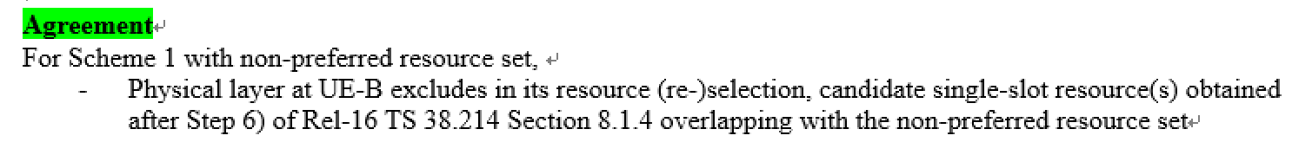
Nokia | Yes
Apple | Yes

Then, another issue is for the UE with no sensing result, e.g. when the UE performs random resource selection, physical layer cannot perform results exclusion, because there is no candidate resource set generation operation as for sensing-based case at physical layer, and thus so far the related behaviour is captured in MAC specification only. Thus, for a UE-B without sensing result, the IUC mechanism for non-preferred resource set is not workable.
Some proposals are given in [2] as below:
Proposal 8 RAN2 to discuss whether to handle the non-preferred resource set issue in PHY or MAC specification and send LS to RAN1 to sync.
Proposal 9 If RAN2 agree to rely on MAC spec to handle, RAN2 agree the proposed change in draft CR in R2-2204576.

Question 5-3 : How to handle the non-preferred resource set for UE B without sensing results(e.g., random selection mode 2 UE)?

Option a: MAC layer

Option b: PHY layer.

Option c: please specify.

Company | Option | Comments
OPPO | See comment | In case R2 would like to do down-selection between a and b, our preference is option-a, since our R1 understand it is hard to do such change in PHY spec now.  Otherwise, if R2 fail / does not want to down-select, we can ask for decision from R1 using LS (draft provided in [2]).  For the following issue raised by HW, after checking with R1:  The following R1 conclusion is not to exclude no-sensing UE-B and non-preferred resource, actually R1 did not specifically consider this combination. And our understanding is the combo may happen in reality so we are not convinced / clear how this combo can be fully avoided.  And our R1 observation is this is hard to do something for this issue in R1 spec (that is why our preference is in MAC spec).  Current in MAC spec, no spec at all if 1) scheme-1 IUC configured, 2) UE-B has no sensing result, and 3) non-preferred resource is received, i.e., the spec get stuck on this combo case..
Ericsson | comments | Agree with OPPO
Huawei, HiSilicon | C neither MAC or PHY | We think neither MAC nor PHY should handle the non-preferred resource set for UE-B without sensing result. RAN1 has already discussed about this issue and their conclusion is that for UE-B without sensing result, UE-B will only handle the preferred resource set, see below.  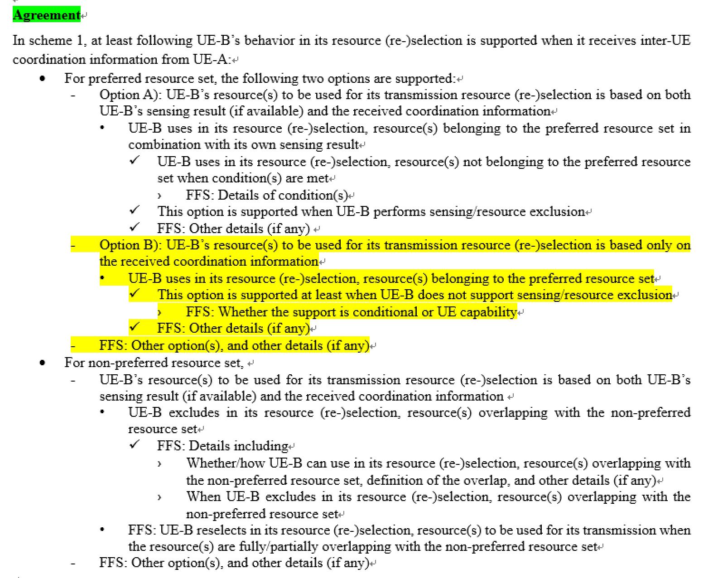  For UE-B without sensing result, even though MAC delivers the non-preferred resource set to PHY, PHY will do nothing.
Nokia | a
Apple | b or seek RAN1 clarification | We think this should be done in PHY layer, as resource exclusion is designed by RAN1. We are fine to send LS to R1 to check.

3.6 Incompatible RA mode between UE A and UE B
In [4], the case when UE-A in mode 1 receiving latency bound timer value via PC5 RRC signalling from UE-B is discussed. It was agreed by RAN1 that inter-UE coordination is only feasible in mode 2 in Rel-17, thus in this case, if UE-A send PC5 RRCReconfigurationComplete message to UE-B, UE-B may think UE-A is able to provide IUC information. However, since UE-A is in mode 1, it cannot provided any IUC information to UE-B, and UE-B may further request IUC information to UE-A if there is no any response from UE-A.
Therefore, the following proposal is given:
Proposal 2: For UE-A in mode 1, UE-A sends PC5 RRCReconfiguration Failure message to UE-B when receiving latency bound timer value via PC5Reconfiguation, and an indication can be included in such Failure message.

In rapporteur view, an alternative way is to exchange mode 1 capability in PC5-RRC capability signaling so that IUC configuration will not be given by UE B to a mode 1 UE A in the first place. Then the problem can be avoided. Let us check the company view on this:

Question 6: Do you agree the above proposal in R2-2204924[4]?

Company | Yes/No | Comments
OPPO | No | Since the WI has been closed, seems not proper to go for such optimization.
Ericsson | No | UEA can just send RRCComplete message without any indicator. If UE-A in mode 1 receives a request message from UE-B, UE-B doesn’t provide IUC MAC CE. This can be just left to UE-A imp to handle.
Huawei HiSilicon | Yes | The solution proposed by rapporteur also works in some scenarios for example if UE-A does not support mode 1 at all then UE-B can send request if UE-A supports IUC. But if the UE-A supports mode 1, then this issue still exists, i.e., UE-B has no knowledge if UE-A operates in mode 1 or mode 2 at the moment when UE-B would like to send a IUC request to UE-A since mode 1 is actually supported by UE-A capability. Therefore, the solution proposed by rapporteur can only work for some cases, so our feeling is that simplest way is to exchange mode info between UE-A and UE-B. Or we use failure indication to inform the peer UE as proposed by the above proposal.
Nokia | No
Apple | Yes with comment | It seems this is also related to the discussion to introduce :”an indication of partial failure” in PC5-RRC configuration for UC DRX. Maybe we can reuse the same conclusion. Also, we are fine with exchange mode information with PC5-RRC.

3.7 Resource selection triggered by stand-alone SL MAC CE
In [3], regarding whether resource selection can be triggered by stand alone MAC CE, it has been pointed out the SL DRX Command MAC CE can be transmitted alone or with data in the MAC PDU in RAN2, and it was agreed that SL Inter-UE Coordination Request MAC CE or SL Inter-UE Coordination Information MAC CE can be transmitted in a SL MAC PDU standalone. Therefore, standalone SL DRX Command MAC CE or SL Inter-UE Coordination Request MAC CE or SL Inter-UE Coordination Information MAC CE can trigger to create a selected SL grant, which is similar to the handling of SL-CSI reporting MAC CE in Rel-16. Hence, the following proposal is given:
Proposal 2: RAN2 to agree that standalone SL DRX Command MAC CE or SL Inter-UE Coordination Request MAC CE or SL Inter-UE Coordination Information MAC CE can trigger to create a selected SL grant.

Question 7: Do you agree the above proposal in R2-2204923[3]?

Company | Yes/No | Comments
OPPO | See comment | For IUC-info MAC-CE, whether a standalone one can trigger a grant selection is up to RRC setting, i.e., sl-TriggerConditionCoordInfo.  Otherwise, it is OK.
Ericsson | Yes | sl-TriggerConditionCoordInfo regarding how UE triggers IUC, which is a different issue.
Huawei HiSilicon | Yes | Proponent.
Sharp | Yes
Nokia | Yes
Apple | Yes

3.8 Generation of Condition-triggered IUC-info
In [5], regarding how to generate the condition-triggered IUC-info
Proposal 3: UE is preconfigured with a reference format for the generation of an IUC Information MAC CE for cases when the IUC report was triggered by the UE itself based on some predefined trigger conditions.

The rapporteur think RAN1 has agreed that the parameters to generate preferred resource set (prio_TX, L_subCH, p_rsvp_TX) either depends on (pre-)configuration in RRC or left to UE implementation. So, it is not very clear what does the “preconfigured reference format” mean here. Let us see the company view on this proposal:

Question 8: Do you agree with the above proposal in R2-2204968[5]?

Company | Yes/No | Comments
OPPO | No | Not quite get the point, anyway, seems no obvious additional work needed.
Ericsson | No | RAN1 agreements are already clear, no need to define other format.
Huawei HiSilicon | No | We think according to RAN1 agreement, the IUC MAC CE applies to both explicit request based IUC and condition based IUC. So no need to define a reference IUC format for condition based IUC.
Nokia | No
Apple | No

3.9 Resource pool selection for IUC UE
In [6], regarding how to select resource pool in UE A, the following RAN1 agreement has been cited for IUC Scheme 1:

- For inter-UE coordination information triggered by an explicit request in Scheme 1,
  - UE-A uses a TX resource pool used for UE-B’s request transmission to determine the set of resources and to transmit the set of resources to UE-B
- For inter-UE coordination information triggered by a condition rather than request reception in Scheme 1,
  - UE-A transmitting in a resource pool provides inter-UE coordination information associated with the same resource pool
However, current MAC specification only consider HARQ enable/disable and discovery in TX resource pool, selection, so it can not be ensured that a mode 2 UE will select a suitable resource pool to fulfill above RAN1’s decision. Therefore, resource pool selection procedure shall be enhanced to cover RAN1’s agreements with the following proposal:
Proposal 3: Resource pool selection shall take the transmission of request MAC CE/IUC MAC CE into consideration.

In rapporteur view, the RAN1 agreement has put some additional requirements for UE B and UE A to select TX pool to transmit IUC-REQ and IUC-info, respectively. Hence, the above proposal is needed.

Question 9-1: Do you agree the above proposal in R2-2205103[6]?

Company | Yes/No | Comments
OPPO | See comment (a NOTE is sufficient) | We are not so sure about the proposal since  IUC-info: Different from normal data, the IUC-info MAC CE is triggered either by request or condition, both of which means the pool to send the IUC-info has been decided before/upon the IUC-info MAC-CE generation, so there should be no such resource pool “selection” step.  IUC-request: this is similar, since IUC-request is also coupled with resource pool, i.e., UE-B may just want to get IUC-info of pool-1 but not pool-2, so the selection of resource pool should not be decoupled with IUC-request generation.  Considering the aspects above, a NOTE to clarify the intention of coupling between IUC-info / IUC-request should be sufficient, but not prefer the normative text of resource pool selection as for the other cases.
Ericsson | Yes | We are fine with either normative texts or Note
Huawei HiSilicon | Yes | Agree with rapporteur.
Sharp | Yes | Note is preferred.
Nokia | Yes
Apple | Yes | We are fine with normative text change, as NOTE is only informational.

Another issue is that the PSFCH resource for scheme2 is independent of PSFCH resource for HARQ feedback. And the PSFCH for scheme-2 is also configured per resource pool. Therefore, for UE-B’s TX resource pool selection to transmit IUC Scheme 2, another proposal is given for UE-B for IUC Scheme 2 in [6]:
Proposal 4：If UE-B select scheme2 for inter-UE coordination, UE-B should select the resource pool configured with PSFCH for scheme2.

In rapporteur view, IUC scheme 2 is mainly handle by PHY layer, so not very sure RAN2 need to discuss this issue for L1 signal transmission. Let us check company view on this:

Question 9-2 : Do you agree the above proposal in R2-2205103[6]?

Company | Yes/No | Comments
OPPO | No | Same view as rapp, MAC spec should not capture pool selection for PSFCH transmission.
Ericsson | No | Agree with RAPP. This is handled by PHY layer.
Huawei, HiSilicon | Yes | Similar logic as Q9-1. Resource pool selection is handled by MAC.
Nokia | No
Apple | Prefer No, but fine to check with RAN1 | We are fine to check with RAN1 with an LS

3.10 Collision Avoidance of IUC messages
In [7], regarding some further enhancements to avoid collision of IUC message transmissions, it is suggested to take advantage of unused bits in SCI-2C format in IUC-request to convey some resource information for UE A to use. The proposal is given as below
Proposal 1: The requesting UE (UE-B) shall use the so far unused (and zero-padded) field entry resource combinations in SCI format 2-C for the IUCRequest message to indicate the sidelink resources to be used by the responding UE (UE-A) in its IUCInformation message.

In rapporteur view, this could be a RAN1 design issue, but there is no harm to collect company view on this.

Question 10: Do you agree the above proposal in R2-2205344[7]?

Company | Yes/No | Comments
OPPO | No | Same view as rapp, should be an issue for R1.
Ericsson | No | This is RAN1 issue
Huawei, HiSilicon | No | Agree with rapporteur this is RAN1 issue.
Nokia | Yes
Apple | No

3.11 Handling multiple preferred resource sets from different UE A
In [16], it has been pointed out that for the following RAN1 agreement:
For UE-B’s behavior when UE-B receives multiple preferred resource sets from the different UE-As,
-UE-B uses each received preferred resource set for its resource selection for each TB to be transmitted to each UE-A providing the preferred resource set.
MAC PDU is determined after LCP and the transmission resource is determined during resource selection, UE does not know which destination will use this selected resource. Therefore, UE B cannot ensure when it applies the preferred resource from one particular UE-A, the resulting SL grant will always be used to send a TB to this UE-A, but not another UE A.
Therefore, it is suggested to send the LS to RAN1 to clarify current MAC procedure and ask RAN1 to revert this agreement as in proposal below
Proposal4: It is suggested RAN2 to send the LS to RAN1 to revert following agreement, since following agreement does not align with current MAC procedure:
For UE-B’s behavior when UE-B receives multiple preferred resource sets from the different UE-As,
-UE-B uses each received preferred resource set for its resource selection for each TB to be transmitted to each UE-A providing the preferred resource set.

In rapporteur view, this observation is correct because destination selection is done after resource selection. To implement RAN1 agreement, we need make considerable changes in MAC spec. It is better to avoid this kind of work in RAN2, as the WI is completed. So, it is better to inform RAN1 about this problem and seek a RAN1 solution.

Question 11: Do you agree the above proposal to send LS to RAN1 in R2-2205105[16]?

Company | Yes/No | Comments
OPPO |  | We believe this issue is not within the scope of this email discussion, so should not be included.  Scope: Discuss proposals/corrections in AI 6.15.2.4 (except the pre-selected issues for online discussion).  IUC-based resource allocation and LCP (e.g. in R2-2204968)?  And our view here is that we are against the major change in MAC spec on LCP, and we are not sure if a simple reverting works since anyway IUC-info is UE-A specific. Our view here is the situation is similar to DRX, i.e., we need to decide on some destination-specific parameter @ resource selection, which may or may-not aligned with the destination-selection @ LCP afterwards. So believe a similar approach can be adopted, i.e., up to UE implementation to solve it, without further specification effort.
Apple | Yes | We are not sure if this is Kyeongin’s intention to discuss this issue in online for LCP because the paper is not even under 6.15.2.4.  Our view is that this is indeed a problem and at least we can point out this to RAN1 and R1 can give this agreement a second look, e.g, change te handling to “up to UE B implementation”.

4 Discussion on corrections

4.1 R2-2204576
[12] R2-2204576 Correction on user plane aspects for inter-UE coordination OPPO CR Rel-17 38.321 17.0.0 1223 - F NR_SL_enh-Core (depending on Proposal in [2])
[17] R2-2205104 Correction on resource pool selection for IUC ZTE Corporation, Sanechips CR Rel-17 38.321 17.0.0 1252 - F NR_SL_enh-Core
[18] R2-2205182 Corrections of 38.321 on IUC MAC CE Ericsson draftCR Rel-17 38.321 17.0.0 F NR_SL_enh-Core

The correction in [12] is dependent on the proposal discussion in Q5-3. So, If you agree with to use MAC layer to address the issue in Q5-3, please check the CR content

Question 12: If yes to Q5-3, Do you have some detailed comments on the changes in R2-2204576[12]?

Company | Comments

4.2 R2-2205137
[13] R2-2205137 Correction on inter-UE coordination ASUSTeK CR Rel-17 38.321 17.0.0 1258 - F NR_SL_enh-Core

The reasons for change are as follow:
(6.1.3.54) The Inter-UE Coordination request MAC CE should be a MAC CE with a fixed size based on the current field structure.

(6.1.3.54) The RT field indicates the type of resource preferred by the requesting UE (i.e. UE-B). In RRC configuration SL-InterUE-CoordinationConfig, a paramter sl-DetermineResourceType is used to indicate how to determine the resource set type to be provided by inter-UE coordination information transmission. Value "uea" means the resource set type is determined by UE-A’s implementation. Value "ueb" means the resource set type is determined by UE-B’s request. In Inter-UE Coordination request MAC CE, the RT field should be a reserved field (i.e. the resource set type is determined by UE-A’s implementation) when the value of sl-DetermineResourceType is set to value “uea”.

Question 13-1: Do you agree the intentions of in R2-2205137[13]?

Company | Yes/No | Comments
OPPO | Yes
Ericsson | Yes with comments | In Inter-UE Coordination request MAC CE, the RT field should be a reserved field (i.e. the resource set type is determined by UE-A’s implementation) when the value of sl-DetermineResourceType is set to value “uea”.  - The above wording is not accurate. RT field is already used, therefore, it is not a reserved field any more. We can just say that this RT field is skipped or ignored if the value of sl-DetermineResourceType is set to value “uea
Huawei, HiSilicon | Yes with comment | For the first change, we agree with the intention.  For the second change, we agree with Ericsson that according to the following RAN1 agreement, if sl-DetermineResourceType is set to "ueb", there is “1 bit” Resource set type indication. Otherwise “0 bit” means there is no such resource set type indication, but not to set the bit to “0”.  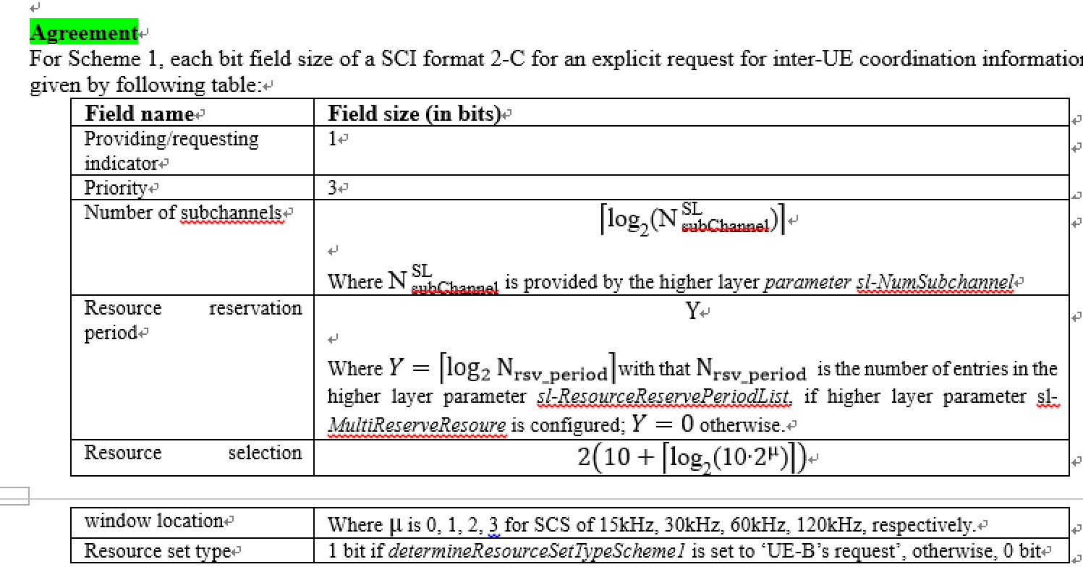
Nokia | Yes
Apple | Yes

Question 13-2: If yes to Q13-1, Do you have some detailed comments on the changes in R2-2205137[13]?

Company | Yes/No | Comments
Ericsson | Yes | See comments above
Huawei, HiSilicon | Yes | Agree with Ericsson.
Apple |  | Agree with Ericsson

4.3 R2-2205604
[14] R2-2205604 Correction on SL grant selection procedure for inter UE coordination Samsung CR Rel-17 38.321 17.0.0 1274 - F NR_SL_enh-Core

The reasons for change are as follow:
In 5.22.1.1 the SL grant selection procedures for inter UE coordination schemes are specified with lower levels e.g., levels 5>, 6>, 7> but it seems that the use of these low levels is not needed for some cases.
For example, in the procedures below level 5 should be level 4 and level 6 should be level 5, respectively.

Question 14-1: Do you agree the intention(s) of in R2-2205604[14]?

Company | Yes/No | Comments
OPPO | Yes
Ericsson | Yes
Huawei, HiSilicon | Yes
Apple | Yes

Question 14-2: If yes to Q14-1, Do you have some detailed comments on the changes in R2-2205604[14]?

Company | Comments

4.4 R2-2205881
[15] R2-2205881 Enabling unsolicited transmission of IUC Nokia, Nokia Shanghai Bell draftCR Rel-17 38.321 17.0.0 NR_SL_enh-Core

The reasons for change are as follow:
The current version of the specification 38.321 does not support standalone triggering of the resource selection for IUC request and IUC information, but rather only supports triggering for
- SL data is available in a logical channel; or
- SL-CSI reporting is triggered
Resource selection should be triggered by IUC request and information

Question 15-1: Do you agree the intention(s) of in R2-2205881[15]?

Company | Yes/No | Comments
OPPO | See comment | We are fine with the change  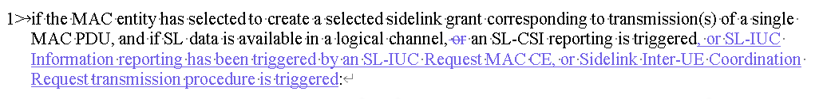  Otherwise, we are negative, please refer to Q9-1 for details.
Ericsson | Yes
Huawei, HiSilicon | Yes with comments | For the first change, we agree with the intention which is similar as Q7.  For the second change, we think some procedure text is needed for the resource pool selection for IUC request/IUC MAC CE transmission. But as indicated by Q9, UE needs to consider some additional restriction when performing resource pool selection according to RAN1 agreement.
Sharp | Yes
Nokia | Yes
Apple | Yes | Share the same view as Huawei

Question 15-2: If yes to Q15-1, Do you have some detailed comments on the changes in R2-2205881[15]?

Company | Yes/No | Comments
Huawei, HiSilicon | Yes | 1 We don’t think “or” before CSI MAC CE can be deleted.  2. SL DRX MAC CE should also be considered by the way.  So we propose to have the following change  if the MAC entity has selected to create a selected sidelink grant corresponding to transmission(s) of a single MAC PDU, and if SL data is available in a logical channel, or an SL-CSI reporting is triggered, or an Sidelink DRX Command is triggered, or an Sidelink Inter-UE Coordination Request is triggered, or an Sidelink Inter-UE Coordination Information is triggered:  For the second change, we think we need to make some conclusion based on Q9 and then come back to see how to reflect these conclusions in the specification.

4.5 R2-2205104
[17] R2-2205104 Correction on resource pool selection for IUC ZTE Corporation, Sanechips CR Rel-17 38.321 17.0.0 1252 - F NR_SL_enh-Core(depending on Proposal in [6])

The correction in [17] is dependent on the proposal discussion in Q9-1 and Q9-2 for the proposals in [6]. So, If you agree with at least one of the proposals, we have the following questions:

Question 16: If yes to Q9-1 or 9-2, Do you have some detailed comments on all or some of the changes in R2-2205104[17]?

Company | Comments
OPPO | As replied to Q9-1/2, we think note is sufficient.
Apple | We support the normative text for Scheme 1 case. But not change for Scheme 2 (at least we need check with RAN1 first)

4.6 R2-2205182
[18] R2-2205182 Corrections of 38.321 on IUC MAC CE Ericsson draftCR Rel-17 38.321 17.0.0 F NR_SL_enh-Core

The reasons for change of this CR are as follow:

Issue 1: in clause 5.22.1.1, UE actions are defined if there is no IUC configured has been captured with regards to the following bullet 3>
3> if not configured by RRC, interUECoordinationScheme1Explicit or interUECoordinationScheme1Condition enabling reception of preferred resource set and non-prefererred resource set:
However, a scenario where IUC is configured but UE has no IUC information received from the peer UE, is not captured.
Issue 2:
The text “if there are no resources within the intersection that” is used in several places in clause 5.22.1.1. The text is not accurate. It is more accurate to say “no sufficient resources”.

Issue 3:
The text “randomly select the time and frequency resources for one transmission opportunity from the resources indicated by the physical layer as specified in clause 8.1.4 of TS 38.214” is used in several places in clause 5.22.1.1. The text is not accurate. It is more accurate to say “randomly select the additional time and frequency resources”.
Issue 4:
In clause 5.22.1.1, the following is wrong placed.
4> use the randomly selected resource to select a set of periodic resources spaced by the resource reservation interval for transmissions of PSCCH and PSSCH corresponding to the number of transmission opportunities of MAC PDUs determined in TS 38.214 [7];
Issue 5:
In the following, the number of time and frequency resources is compared to the number of HARQ retransmissions, which is not correct. The number of HARQ retransmissions need to be updated as “the number of resources”.
6> if the number of time and frequency resources that has been maximally selected for one or more transmission opportunities from the available resources within the intersection is smaller than the selected number of HARQ retransmissions;
7> randomly select the time and frequency resources for the remaining transmission opportunities except for the selected resources within the intersection from the available resources outside the intersection but left in the resources indicated by the physical layer according to clause 8.1.4 of TS 38.214 [7], according to the amount of selected frequency resources, the selected number of HARQ retransmissions and the remaining PDB of SL data available in the logical channel(s) allowed on the carrier by ensuring the minimum time gap between any two selected resources in case that PSFCH is configured for this pool of resources and that a retransmission resource can be indicated by the time resource assignment of a prior SCI according to clause 8.3.1.1 of TS 38.212 [9].
In bullet 7>, it is more accurate to say “select the additional time and frequency resources”
Issue 6:
In clause 5.22.1.4.1.3, the priority order for Sidelink Inter-UE Coordination Request MAC CE and Sidelink Inter-UE Coordination Reporting MAC CE is captured as
Logical channels shall be prioritised in accordance with the following order (highest priority listed first):
- data from SCCH;
- Sidelink CSI Reporting MAC CE;
- Sidelink Inter-UE Coordination Request MAC CE and Sidelink Inter-UE Coordination Reporting MAC CE;
- Sidelink DRX Command MAC CE;
- data from any STCH.
However, this has not been agreed by RAN2 yet.
Issue 7: typos
In clause 5.28.2 Behaviour of UE receiving SL-SCH Data
When one or multiple SL DRX is configured, the MAC entity shall:
1> if multiple SL DRX Cycles that are mapped with multiple SL-QoS-Profiles of a Destination Layer-2 ID and interested cast type is associated to groupcast and broadcast:
2> select sl-drx-Cycle whose length of the sl-drx-cycle is the shortest one among multiple SL DRX Cycles that are mapped with multiple SL-QoS-Profiles associated with the Destination Layer-2 ID:
2> select sl-drx-onDurationTimer whose length of the sl-drx-onDurationTimer is the longest one among multiple SL DRX onduration timers that are mapped with multiple SL-QoS-Profiles associated with the Destination Layer-2 ID.
Cast type service type
Groupcast and broadcast groupcast or broadcast.

For the above issues, let us check company view if some or all of them can be agreed.

Question 17-1: Do you agree the intention(s) of in R2-2205182[18]?

Company | Yes/No | Comments
Apple | See comment | not agree with Issue 1, I think the “no IUC-info” case is as same as legacy case as RAN2 agreed to not use timer to track the response for IUC request in UE B side.  Agree with Issue 2 change  Not agree with issue 3.  Agree with issue 4 change  Not agree with issue 5 change  For issue 6, this is to be determined in online  We agree with change and/or in issue 7
OPPO |  | Issue-1: intention OK, but the change is wrong, since it hints the IUC can be combined with DRX (we should solve this issue by adding a sub-branch in the case where IUC is configured)  Issue-2, issue-3: seems just editorial, tend to be negative  Issue-4: fine  Issue-5: except the adding of additional, it is fine  Issue-6: can wait for R2 conclusion  Issue-7: not see the reason for changing cast to service.

Question 17-2: If yes to Q17-1, Do you have some detailed comments on the changes in R2-2205182[18]?

Company | Comments

5 Summary of Discussion
TBD

